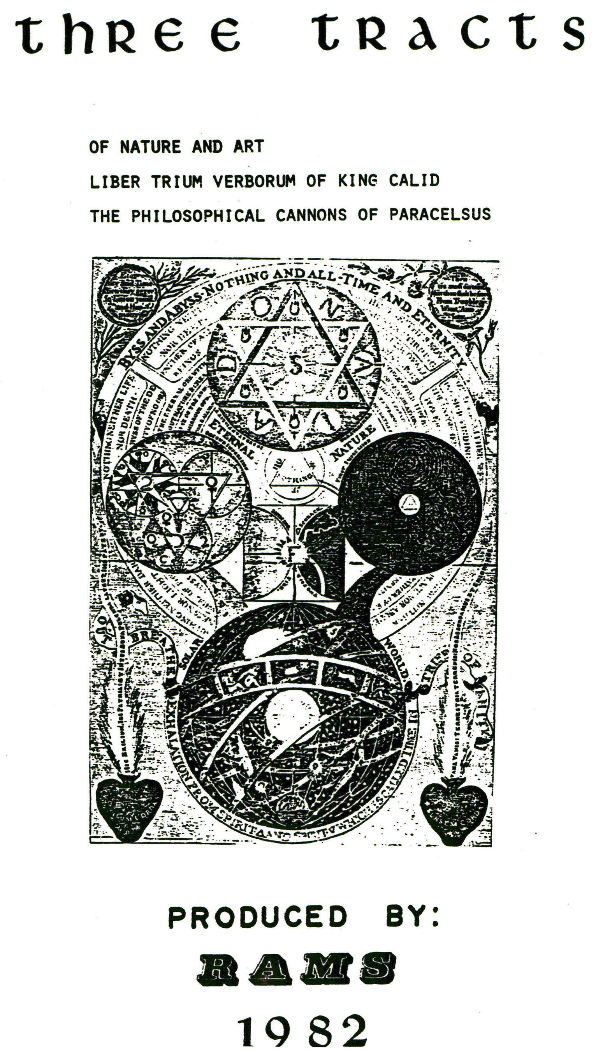

THE PHILOSOPHICAL CANNONS OF PARACELSUS
B. M. Sloane 3506

1. That which is near to perfection is easily brought to perfection.
2. The imperfects are by no means brought to perfection before they are deprived of their feculent Sulphur and Terrestrial thickness which is mixed to the Mercury and Sulphur, this is a perfect Medicine.
3. To make fixed the imperfect without the Spirit and Sulphur of the perfects is impossible.
4. Heaven of the Philosophers resolves all things in the first matter that is Mercury.
5. He who intends to reduce metals into Mercury without philosophical Heaven, or the metallic aque vitae, is cheated, for the impurity of Mercury may be seen in all other dissolutions.
6. Nothing is fixed perfectly which is not mixed indissolubely with the fixed.
7. The fusible gold may be altered and turned into blood.
8. For the fixing of Silver, it must not be turned into powder or dissolved into water, for this is destruction, but it must necessarely be reduced into Mercury.
9. Silver may not be turned into Gold but by the Philosophical Stone, except it be reduced into Mercury. Also is done with other Metals.
10. Imperfect bodys are brought to perfection and into perfect Gold, when they are first reduced into Mercury, adding to it white or red Sulphur.
11. All imperfect bodys are brought to perfection by reducing them into Mercury and afterwards by boiling them with Sulphur and appropriate fire, for then they are brought to Silver and Gold,

24.

and they are cheated and work in vain who intend to make Silver and Gold otherwise.
12. The Sulphur of Mars is the best, and this joined with the Sulphur of Gold makes a Medicine.
13. There is no Gold generated except it be Silver before.
14. Nature makes and generates minerals by degrees, also out of one root are generated all metals till the end of all which is Gold.
15. Mercury corrupts Gold and resolves it into Mercury and makes it volatile.
16. The Stone is composed of Sulphur and Mercury.
17. If the preparation of Mercury is not taught by an expert Artist, it win never be found out by the reading of books.
18. The preparation of the Mercury for the Philosophical Menstruum is called Mortificatio.
19. The Praxis of this Arcanum goes beyond all secrets of Nature and it be not revealed or taught, it will not be learned out of books.
20. Sulphur and Mercury are the matters of the Stone; therefore the knowledge of the Mercury is necessary for the election of a Mercury fit for the Work.
21. There is hidden a Mercury in a body prepared without any other preparation, but the Art of extracting is difficult.
22. The Mercury may be fixed and turned into gold and silver for the compendium or abbreviation of the work.
23. Fixing and congealing is one work, of one thing, in one vessel.
24. That which fixes and congeales the Mercury tinges it also in one and the same practise.
25. Your grading of fire are to be observed in the work, in THE FIRST the Mercury dissolves his body, in THE SECOND the Sulphur drys up the Mercury, in the THIRD AND FOURTH the Mercury is fixed.
26. Things radically mixed, afterwards grow inseparable; like snow mixed with water.

25.

27. Divers simples, put into putrefaction produce divers others.
28. The form and the matter must necessarily be of the same species.
29. The homogeneal Sulphur is of the same nature of which is Sol and Luna, and this Sulphur produces pure gold and Silver not in that form as it is seen with eyes, but as it is dissolved in Mercury.
30. Without the philosophical dissolution of gold into Mercury, may be extracted out of gold a fix sort of unetuosity, which takes the place of a ferment generating Sol and Luna and what is done
by a way of abbreviating which Geber calls Rebis.
31. Metals resolved into Mercury are reduced into a body again by adding a little quantity of ferment for else it retains always the form of Mercury.
32. The leaven of the Tartarus of the Philosophers which reduces all metals into Mercury is the metallick aqua vitae of the Philosophers, which also they call dissolved faeces.
33. Sulphur and Mercury are of the same homogeneal nature.
34. The Stone of the Philosophers is nothing but Gold and Silver exalted into a higher Tincture.
35. Sol arid Luna by themselves in their own species have riches enough. Them you must reduce into the nature of a ferment. This mass may be multiplied.
36. The most extremeries in Mercury are two, namely crudity and most exquisite decoction.
37. The Philosophers observe that all dry things quickly imbibe their humiditys.
38. The altered calx of Luna quickly imbibes his Mercury, the fundament of philosophic minerals.
39. The Sulphur is the Soul, but the Mercury is the Matter.
40. Mercury is congealed into an imperfect body and goes in the same species of the imperfect body by whose Sulphur it is congealed.
41. To make Sol and Luna with the Suiphurs of imperfect bodys

26.
is impossible for everything can give no more but what it has.
42. The Mercury of Metals, is the feminine seed, for by projection it goes through the qualities of all metals till gold.
43. For the extracting of the red Tincture, the Mercury must be animated with the ferment of Gold, and for the White with the ferment of Silver.
44. The Philosophers work is quickly done without any expences and that in every place, at all times, if they have but the true matter.
45. The Sulphurs of Sol and Luria fix the spirits of their species.
46. The Sulphurs of Sol and Luna are the true masculine seeds of the Stone.
47. All which have power of fixing must be necessarily permanent and fixed.
48. The Tincture giving perfection to imperfects is made out of the Fountain of Gold and Silver.
49. They who take the Sulphur of Venus are cheated.
50. Venus has naturally nothing which is useful or which can serve in the great Spagirica]. Work.
51. Sol converted into Mercury before the conjunction with the Menstruuin cannot be a ferment, a soul or a Sulphur.
52. The Work brought to an end by reiteration is made fiery.
53. In the abbreviation of the Work the perfect bodys must be reduced into a current Mercury which can rightly take the ferment.
54. The preparation of Mercury by sublimation is better than that which is done by amalgamation, but note that you must revive it.
55. The Soul cannot impress a form but by the help of a Spirit, which is nothing but Gold turned into Mercury.
56. The Mercury receives the form of Gold by the mediation of the Spirit.
57. Gold resolved into Mercury is Spirit and Soul.
58. The Sulphur of the Philosophers, Tincture and Ferment all signify one Thing.

27.

59. Vulgar Mercury is made equal to the nature of the Mercury of bodys.
60. The ferment makes the Mercury ponderous.
61. When the Mercury Vulgar is not animated or without a Soul it is then not fit either for an universal or particular operation.
62. Now the Soul is impressed into the mortified Mercury.
63. Sol may be prepared into a ferment also that one part of it animates ten parts of Mercury, and this work has no end.
64. The Mercury of the imperfect bodys takes place of that vulgar
Mercury, but the Art of extracting it is difficult.
65. The vulgar Mercury is turned into Gold by projection of the Philosophic Stone, therefore it may be exalted and made equal to all Mercurys of bodys.
66. Vulgar Mercury animated is a great secret.
67. All Mercury of metals by abbreviation of the work are turned into Gold or Silver.
68. Humid and gentle heat is called the fire of Egypt.
69. Note. Luna is not the Mother of vulgar Silver, but a Mercury endued with some quality of a Coelestial Luna.
70. The metallick Luna is of a metalline nature.
71. Vulgar Mercury takes on feminine nature because of its sterility.
72. The Mercury of the half minerals show the nature of Silver by similitude.
73. All things are produced out of Sol and Luna.
74. Man and Woman, that is Sol and Mercury congeal together.
75. Vulgar Mercury without preparation is remote from the Work.
76. Four parts of Mercury and one of Gold which is in the place of ferment make a matrimony.
77. The solution is done when Gold is resolved into Mercury.
78. Without putrefaction there is no dissolution.
79. Putrefaction lasts till Whiteness appears.
80. It is a great secret to mundify the Mercury with which is prepared the Menstruuin in which Gold is dissolved.
28.

81. Mercury resolves the Gold in form of a water, that is into current Mercury like it is itslef.
82. The dissolution is the beginning of congelation.
83. Sol dissolved into running Mercury in a short time remains in that form.
84. The ferment drys up the Mercury and makes it ponderous and fixes it.
85. The So]. of the Philosophers is called a Fountain.
86. The Matter by power of putrefaction is converted into a part which is the principle of congelation.
87. There is a compendious way by which the Sulphur of Sol and Luna is extracted by which all Mercury is fixed into Gold and Silver.
88. The Matter must never be removed from the fire that it may not grow cold or else it is spoiled.
89. When the Matter comes to be black then give the Second grade of fire.
90. The Washing of the Philosophers is but a similitude for the fire only perfects all.
91. Poison and stinkingness is taken away only by the fire for it is that which absolves all.
92. Fire by its penetrating arid acute virtue cleanses more than any other water.
93. When in any vegetable thing the heat or colour is extinguished there follows death.
94 & 95. The Spirit is the calor (colour?).
96. When the Matter is brought to Whiteness then may it not be destroyed.
97. All corruption of things is noted by a mortal poison.
98. The Glass or vessel is called Mother.
99. The virtue of the Sulphur may ‘be extended to a certain term.
100. You must observe the question why the Philosophers call their Matter a Menstruum.

29.

101. Sulphur dissolves the name of a form but the Menstruum the name of the Matter.
102. The Menstruum represents the little and inferiour Elements, namely the Earth and Water, Sulphur the Superiour as Fire and Air are the agents.
103. When you break the shell of the egg also that the chick comes out then it is killed, also if you open the vessel also that the matter feels the Air, then it is all spoiled.
104. Calcination done with Mercury in a reverberatory is good.
105. The methods of the philosophical stile must dilegently be noted, for by sublimation they understand the dissolution of bodys into Mercury by the first grade of fire, which is followed by the second operation which is the inspissation of Mercury with Sulphur. The third is the fixation of Mercury in a perfect and absolute body.
106. There is an infinite number of Errants who do not allow of Mercury as it is in its form mixed by the calx of perfect bodys, to be the matter of the Stone.
107. The White Medicine is brought to perfection in the third degree of fire, and this degree you must not transgress in the making of the White Medicine or else you will destroy the White Work.
108. The fourth degree of fire makes the matter red, and there appear divers colours.
109. The Work after White not brought to a high redness is imperfect not only the White but also the Red Tincture.
110. After the first degree of’ the Persian fire the matter ‘becomes more powerful]..
ill. The work is not brought to perfection except it be incerated arid made fusible like wax.
112. The work of ceration is done by addition of 2 and 3 parts of Mercury which gives the being to the Stone.
113. The inceration of the White Medicine is done by the White

30.
Water or the Mercury animated with Luna, but the inceration of the Red Medicine is done with Mercury animated with gold.
114. It is enough when the Matter after inceration remains like a paste.
115. Reiterate the inceration till it has the right consistence.
116. When the Mercury with which the inceration is done, flys away it signifies nothing.
117. The Medicine right and duly incerated explains enigma of the
King coming out of the Fountain.
118. Sol. reduced into its water or first matter, by means of the vulgar Mercury, if it grows cold it is spoiled.
119. The Philosopher takes the matter prepared by nature and reduces it into the first matter, for everything is reduced into that out of which it hath its original, like Snow is mixed with Water.
120. The Wise men bring years into months and months into weeks and weeks into days.
121. The first decoction of Mercury done by nature is the only cause of its simple perfection beyond which it cannot come, but you must help this simplicity; seminating gold in its own earth
which is nothing else but pure Mercury, which is by nature a little and not perfectly digested.
122. In the second decoction of mercury the virtue of mercury is ten times augmented.
123. The Stone of Mercury is made by reiterating the decoction adding to it gold and also man and woman are twice boiled.
124. Sol must be added to Mercury that it may be turned into Sulphur and then it is boiled into the Physical Stone.
125. Also some contemplate the philosophical Mercury, yet do they not know it.
126. Every Mercury of what original so ever represents the matter of the Stone, taken in a due manner.
127. Everything is the subject of the Stone out of which Mercury may be extracted.

31.

128. All who understand the writings of the Philosophers according to the letter are cheated, for they affirm but one Mercury. 129. (is missing in the original M.S.).
130. One Mercury exceeds another in more calidity, siccity, decoction, purity and perfection who without corruption of the form must be prepared and purged of his superfluities in which consists the secret of the Stone.
131. If the preparation of vulgar Mercury were known to Students of this Art there would be no other Mercury sought. for, nor any other aqua-vitae nor any other Mercurial Water for the common Mercury contains all this.
132. Every metallic Mercury by successive degrees may be ‘brought and exalted into the quality of any Mercury of bodys.
133. The vulgar Mercury ‘before due digestion is not the philosophical Mercury but after preparation it is called by that name containing in him a true way and method of extracting the Mercury out of other metals, and it is the beginning of the Work.
134. Prepared vulgar Mercury is the metallic aqua vitae.
135. The passive Mercury and the Menstruum do by no means loose the external form of Mercury.
136. Who ever uses in place of current Mercury any sublimate or calcined powder or precipitate is cheated.
137. Whoever resolves Mercury into clear Water for the making of the great Work are in error.
138. To make Mercury out of limpid water is in no bodys power, but only in the power of nature.
139. Necessarily in the philosophical work, it is that Mercury crude does dissolve gold into Mercury.
140. When Mercury is reduced into water it dissolves gold into water and in the work of the Stone it is necessary that it is dissolved into Mercury.
141. The Sperm and the Menstruuzn must be alike in the external form.

32.
142. It is said in the doctrine of the Philosophers that necessarily he must moisten the nature, but if the menstruum is dry, there is no dissolution hoped.
143. You must take the Seed of the Stone in the like and near nature of metals.
144. It is highly necessary that the Seed of the Philosophical Medicine is like vulgar Mercury.
145. The highest secret of all is to know that Mercury is both Matter and Menstruum, and that the Mercury of perfect bodys is the form.
146. Mercury by itself does, nothing in generation.
147. Mercury is the elemental earth in which gold is seminated.
148. The Seed of Gold is indued with multiplying virtue.
149. Perfect Mercury seeks for the work of generation a woman.
150. Every Mercury consists out of 2 elements, the Crude out of water and earth, boiled out of fire and air.
151. If anyone will turn Mercury into a metal, then you must add to it a little ferment that it may be to such a degree of perfection brought as you please.
152. The greatest Arcanum of the work, is the physical dissolution into Mercury,and reduction into Mercury.
153. The dissolution of gold must be perfected by nature and not by hands.
154. When gold is joined with its Mercury, then it is in the form of gold, but the most preparation is in the Calx.
155. There is a question amongst the Wise men, if the Mercury of Luna joined with the Mercury of gold may be had in the place of the philosophical Menstruum.
156. The Mercury of Luna keeps the nature of a man, and two men can generate no lesser than two women.
157. For the extracting of the Elixir you must get the most pure substance of Mercury.
158. He who will work, must work in the sublimation of the two luminaries.

33.

159. Gold gives a golden and Silver gives a silvery Tincture, but he who knows (how) to tinge the Mercury with Silver or Gold has a great secret.

FINIS

34.

