The 'Donum Dei'
The Pretiosissimum Donum Dei, 'the most precious gift of God', is an important early alchemical work, with a famous series of 12 illustrations. I have identified over 60 manuscripts of the Donum Dei, the earliest dating from the 15th century. Some of these versions ascribe the work to Georgius Aurach de Argentina [sometimes 'Anrach'] and date it to 1475. There are versions in Latin, German, French and Italian, and one in English in the British Library MS. Harley 6453, which I have transcribed and show here. I have added the engravings from J.D. Mylius' Anatomia Auri, 1628.

I have had the science of this Art only from the Inspiration of God, who to this servant has vouchsafed to declare the true reasons to judge and discern, giving strength hath less occasion to no man, nor any excusation from him. Forsooth if I feared not the day of Judgment I would never open anything of this science or publish it to any man. But I am willed to render my duty to faithful men as their Anchor of faith hath given it unto me. He that knoweth not the principles in himself is very far from the art of philosophy for he hath not the true book whereupon he should ground his intent. But if he do chiefly and principally know the natural causes of himself and know not the other, yet hath he the way to the way of the principles of the Art. And although a man know the Matter, yet there remaineth many things to the completement of the same. And it is necessary that our stone be drawn out of the natures of two bodies before the Elixir may be made complete, therefore it is worthily said: O water in form Pontic, or bitter which dissolves the Elements, O most greatest Nature, the creature of Nature which containeth Nature, and overcometh the nature of the meanys what cometh with light and with light it is engendered and she that is mother of all, how black a cloud hath she brought out.

The Chapter of the Green Lion and of what colour it is.
First in our green Lion is had the true matter and of what colour it is, and is called Adrop or Azocke, [clopum], Duenech. If thou will well understand this work, read it from part to part and thou shall see miracles wrought in our days, and unless I had seen them and touched them I could not so particularly have written them and painted them. I have not shown all the appearances and things necessary in this work, for there be some that be not lawful to be spoken of man, that I have set it out in pictures to the end or completement. And there was never no sure work so described and with authorities to the purpose. For it is impossible to be known without it be known of God or of a master which may fear him. Understand that it is a very long way, therefore patience and tarrying be very necessary. For in our Magistery there be some foolish and blind which saith they can make Aurum potable of common Gold or else they believe that it is most best to heal all infirmities. Also there are some Physicians which causeth ducats to be boiled in water saying this thing is most best for the health, but it is rather evil and not to be drunk. For it is clean contrary, saving their reverence, that that was Aurum Potabile or if that it was good for the health. For neither common gold or other metals be good to heal with, but they [are] rather evil as I have said and not able to be drunk. But I will grant they be good and most best to buy confections with and to pay the physician. Also they be good to be had basins full of ducats or fine gold and so show them to the sick man for it is a great comfort to see the gold, but the true aurum potabile of the philosophers is the Elixir complete. And this is Aurum potabile not visible but in power, which is the great medicine, which removeth all superfluities as well of many bodies and of metals, for it converteth all metals imperfect from Leprosy and from Infirmity, and likewise the bodies of man. And this is most certain. Note this is the intent of all philosophers, but these which doth understand it to be of common gold be blind and more than blind and deceivers. For if common gold should give of this perfection to another, then should he himself remain imperfect. Wherefore would you have this science reading only one book or finding the first regiment? Now following, the philosophers have said that the truth is not discerned without error, and nothing converteth more sorrow to the heart than error in this art. Therefore when I spared not my life in so great age to practice, lest peradventure because of the chiding's of this wisdom I might be dampened. First I shall praise God who is the beholder of all things nor any thing that is hid from him, to whom be honour and glory by all the world of worlds. Amen.
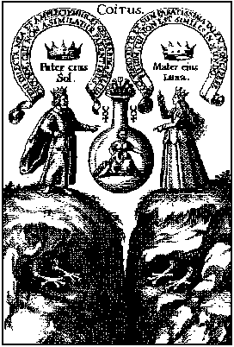
Of whom the father is a virgin saith, Come my well beloved that we may embrace together, and we shall engender a new form which shall not be like to his parents. The king therefore whose head is red, the eyes black and the feet white is the Magistery. The Mother hath not conceived, behold I come to thee, and am most ready to conceive a form, to whom is none like in the world. And he is borne between two mountains, you know the truth. This book is followed according to Hermes Trismegistus, he varieth not from him in any text for that you may know. Although he will not declare his name that all his ground and foundation is Hermes as aforesaid. No chapter of him that is left untouched in this book, wherefore be sure to follow it for there is no surer author nor none like, it varieth not from any that anciently hath written of this Art and he hath spoken more plainly than ever was written of any other, if God give grace that he that readeth it may perceive and understand, to whom be all honour and glory. Amen.

The Second Chapter.

How the bodies be dissolved into Argent Vive of Philosophers that is into water.
The Matter of the Stone is a gross water agent, or that is a cold, congealing the water. And believe those stones to be more precious, which proceedeth from the animals than the other, Thou canst not prepare any kind of stone without Duenech, the green and liquid which is born in our mines. Some behold the last Mountains which be on the right hand and the left, and ascend thither where our stone is found, and in the mountain which beareth all manner of kinds of Spirits and Aromatic or secret things, likewise in the mine of the stone which is necessary in this work, is of an augmate or a levinge thing. You shall find it every where, in the plains, on the mountains, and in the waters, as well the poor as the rich hath it. It is most vile and it is most dear. It groweth of flesh and blood. O how precious it is to him that knoweth it. O blessed greenness which engendereth all things. O blessed Nature, blessed is thine operation, for of an imperfect thou makest a perfect. Therefore take not this Nature but pure and clean, crude, clear, earthly, pure and right. If thou do otherwise it shall not profit thee nothing.
Let we go seek the nature of the 4 Elements, which the [Amptys - .imperctys - .amxtys] bring forth from the belly of the earth.
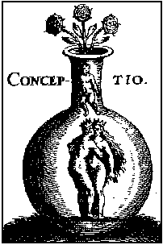
Here is made the Solution of philosophers and it is made our Argent vive.

The Third Chapter.

How the bodies be dissolved into water and is made a new body.
Our Stone is a body without sound mortifying and quickening, so that nothing contrary enter with our stone, but put himself only conjoin the servant to his odoriferous sister and between them the art shall be engendered. For if the white woman be married to the red man anon they do embrace and so [hawsinge] be coupled together, by themselves they be dissolved, and by themselves they be made, that they that were two is made as it were one body. And know that there be three perfect colours from the which all the others take there beginning. The first is black, the second white, and the third red, there be many other colours, but they be not to be cared for, for they vanish away oftentimes before the whiteness, Then is made the commixtion of two bodies, and it is necessary in our Magistery, and if there were but one only body of the two, in our Stone, it should now go be tincture by any manner of means, and therefore it is necessary the conjunction of these two bodies, which two when they be conjoined, and received in the commixtion of the Stone, the Stone is engendered in the belly of the wind, and that is that which the philosopher saith. The wind hath born him in his belly, it is plain that the wind is Air, and Air is life, and the life is the Soul, that is oil, and water. I that am exalted above all the circles of the world have four faces having one father, whereof one is in the mountains, an other in the Air, another in the Stones, and another in the caverns or hollow places.
Of the four Elements this Stone is compounded or made.
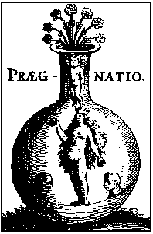
Here be the bodies wholly dissolved into our Argent vive, and is made water permanent fixed white as the tears of the eye.

The Fourth Chapter.

Here is made the putrefaction of Philosophers which was never seen and is called sulphur.
Convert the natures of the Elements and thou shalt find what thou seekest. To convert the natures is to make a body a spirit in our Magistery, first we make of gross thin, and of a body water, and by consequent we make that which is beneath as that which is above, and the contrary, for the bodies dissolved are reduced to the nature of spirits, and they be never separated asunder, like as water is mixed with water, and truly all the regiment and work is none other, but water permanent having in himself all things which we need. Therefore hold fast that water which is good operations, for he maketh white to white, and red to red, it is on and the same thing which hath in him flesh or soul; the agent, or calx, and the 4 Elements, to whom it hath dominion, it is not made of other Elements which agreeth not in his nature.
The putrefaction of the Philosophers is the head of the Crow a blackness transparent and shining.
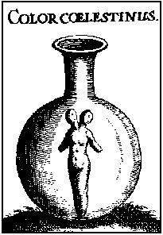
Here be the bodies put in putrefaction and be made black earth, and when you seest thy matter to be made black rejoice for that is the beginning of the operation. And it is necessary to be putrefied.

The Fifth Chapter.

The most part of this water is made black earth and feculent.
Therefore burn our Brass with easy fire as the hen doth nourish the egg until the body thereof be constituted or made and the tincture be drawn out, for thou shalt not draw it out all at once, but that a little, and a little may come out every day until it may be made complete in a long time. I am black of white, and red of white, and citrine of red, and certainly I am a true sayer and not liar. And know ye that this red of the art is the Crow which in the blackness of the night and in the clearness of the day flyeth without wings. Of the bitterness in his throat the colour is taken, from his body the redness, and from his back pure water. Understand the gift of God, receive it and hide it from all unwise philosophers, for it is not hidden from the caverns of the metals, which stone is mineral, and animal, shining colours, or high hill, and an open sea. Behold I have expound it to you, truly when it is first black, we call it the cave of the science which is not without blackness, for it is the tincture which we seek, for in every body we give or put colour, which thing was hidden in his brass, as the Soul in man's body. Therefore dear Son, when thou art in thy work, see first thou have the black colour, and then art thou sure thou dost putrefy and proceedest the right way, patience and tarrying be necessary in our work. O Blessed Nature and blessed is thine operation, for of imperfect thou makest perfect with true putrefaction, which is black and obscure. Then after thou shalt make to spring new, and divers things, which thy viridity or green lion makest divers colours appear.
The Head of the Crow is transparent blackness. This is upon the matter the black clouds, spirits or forms, This earth which is upon the matter descendeth in an other vessel to the bottom and thence worms be brought forth.
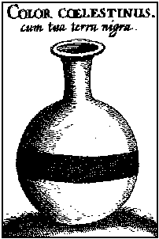
This is the black and feculent earth whereof all the Philosophers speaketh and standeth upon the water.

The Sixth Chapter.

How this earth black shall stand upon the water in the beginning, and by little and little is drowned in their profundity.
Yet seeing more the matter to wax thick and to sink to earth, and this thickness stood first upon the water, and so leaving by little and little the thickness they saw the earth drowned himself in the water and stand in the bottom of the vessel under the water, which earth was yellowish black and feculent, they said that this was perfect corruption. Kindle the fire in the furnace after the Philosophers manner, and cause that all the matter be dissolved into water. Afterwards govern it with easy fire till the most part be turned into black earth, which in 21 days will be done. Know that this science is none other thing than the perfect inspiration of God. For all the Magistery or art is but of one thing and we shall prove it by the saying of the philosophers. And as we have seen and touched with great labours and business, we have known this only thing perfect to the white and to the red, and we could never find other things where the perfection consisteth to the true transmutation of bodies and perfect preparation, but to be destroyed so made black for ever. Therefore be thou busy to thine operation in all his degrees patiently continuing decoction until such time the tincture be come out in black colour upon the water, and when thou seest the blackness appear in the said water, know thou all the body to be liquefieth, and then it behoveth to continue an easy fire upon it, until such time it hath conceived the dark cloud which it hath brought forth. The intent of the philosophers is that now the body dissolveth into black powder, may enter into this water and all may be made one. For then the water taketh the whiter as his own nature. Therefore without all be turned into water, thou shalt never come by any means to perfect perfection.
Caput Corvi.
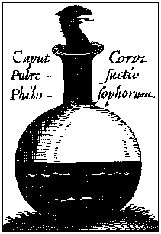
The Head of the Crow is black earth and feculent in the which be engendered worms, whereof the one devoureth the other, for the corruption of the one is the generation of the other.

The Seventh Chapter.

How this earth is dissolved into water and again into the colour of oil and is called the oil of Philosophers.
Here is required by how long time the stone is to be turned into blackness and what is the figure of true solution of the stone when blackness appeareth the first time it is figure of putrefaction and solution of the stone, but when it is vanished away and clearly gone it is a sign of the whole putrefaction of the stone and of the dissolution thereof, or else it is demanded if the black clouds endure in the foresaid stone by the space of 40 days, I answer sometimes it doth more, and sometimes less, this variation chanceth of the variety and quantity of the medicine, and according to the wisdom of the worker, wherefore the more quantity requireth more time, and the less the less. The wisdom of the worker helpeth the art of separation from the blackness. Item it is demanded by some long time this putrefaction shall endure and the cleansing of the earth, I make answer 4[0?] days and sometime more, and sometime less, according to the quantity of the earth and of the water.
The Head of the Crow
Oil of Philosophers.
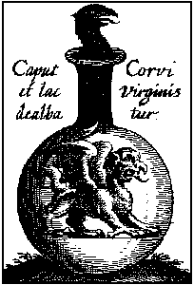
Here is our new black Son born, and the name of him shall be called Elixir. The black earth and feculent is turned into Argent vive as it was afore and dissolved in the colour of oil, and then it shall be called oil of Philosophers.

The Eighth Chapter.

How the Dragon is born in blackness and is fed with his Mercury and killeth himself and is drowned in the same and the water is somewhat made white.
Gold is dissolved that he may be reduced unto his first matter, that is that it may be made truly sulphur and Argent vive. For then we may make most best silver and Gold when it is converted into the matter of them. Therefore it must be so well washed until it be true Sulphur, and Argent Vive, for according to the Philosopher they be the very true matters of metals. Therefore he that can wed a wife, and get her with child and mortify and quicken again the kinds of generations, and can cleanse and bring in light, and to separate the shine thereof from blackness and darkness, shall be of most great dignity. Therefore we conjoining our king crowned to our red children and in an easy fire knitting them together, there shall be conceived and between them engendered a son, For his clouds which were upon him turneth again into his body as they came out. Therefore continue a temperate Balneo or bathe until such time all be dissolved into water impalpable, and that all the tincture come out in the colour of Blackness, which is the sign and token of Dissolution.
The dark house is
Sulphur of philosophers.
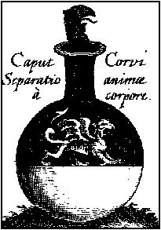
Here beginneth the Dragon to wax white and to eat his own wings.

The Ninth Chapter.

Here is the water cleansed wholly from blackness and remaineth in the colour of milk, and many colours doth appear in the blackness.
The dragon here eateth his own wings and showeth forth divers colours by many manner of ways and many times shall be moved from colour unto colour until such time it come unto whiteness, A fierce or a most cruel beast ought not to be fed but when it hath thirst and hunger, and know ye that after three days it hath not, then is the Dragon born, the house of him is darkness and blackness dwelling in all these; Truly death, and Darkness, flyeth this Sea, and the dragon flyeth from the bright beams of the Son which stops the holes, and our dead form shall leave, and the king shall come from the fire, and shall rejoice of his marriage. And hidden things shall appear, and the milk of the virgin shall be made white, and our child now quickened is made a tamer or overcomer of ye fire, and overcoming tincture.
The dark House.
Sulphur of Philosophers.
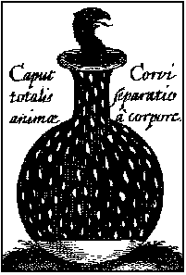
Here wholly the dragon is cleansed from blackness and is made white as milk.

The Tenth Chapter.

How the black clouds which were above the water in the vessel dissolveth into the body from whence they came.
Take black: blacker than black, for divers and many colours shall appear in it, and the virgins milk shall be made white, and our Son now revived shall be made an overcomer of the fire and excelling tinctures or colours, the cloud ascendeth from the Sea, and the rain upon the earth, for every heavy and dense or thick body falleth or slippeth to his centre. Argent vive sublimed from brass of the which all things be, is a clear water and a true tincture, which putteth away the shadow of ye brass, for it is white sulphur which only maketh brass white which the spirit is held that he can not fly, know that the neck of the vessel is the head of the Crow which you shalt kill, and thereof shall be brought forth a dove, and after that a phoenix. Be you fortunate or happy the whole science both to the white and to the red with these few words.
Ashes of Ashes.
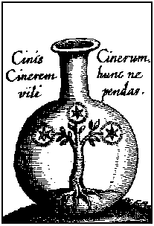
The black clouds descendeth unto the body from whence they came out and there is made connection between the earth and water and is made ashes.
The crow is black, the Dove is white, the Phoenix burneth herself that she may procreate or bring forth an other of the ashes.

The Eleventh Chapter.

This ashes is made white as marble Shining and it is the Elixir to the white and is made ashes.
Because Nature hath no moving but by the occasion of heat, Therefore if thou measure well the heat - water and fire be sufficient to thee. For they wash the body, they cleanse and nourish it and taketh away the darkness thereof. This water dwelling in the air doth draw to the earth as Iron the adamant stone. Therefore all these orders of preparation reiterate upon it four times. And at the last calcine it by his manner of calcining and flying, for so have you sufficiently governed the Earth of the Stone in administration. To calcine is no other thing then to dry and to turn in to ashes. Therefore burn it without fear, until it be ashes, which when it is so thou hast mixed it well. Despise not these ashes but give it them the sweat that they have cast out, and when the water is all drank up and turned into earth within certain days will be done. In this vessel shall appear all ye the colours of the world, when the humidity is dried up. Therefore let it stand certain days upon easy fire until it be done as aforesaid. That which goeth from him put again upon him until all be fixed and will no more go from him for ye fire, that is the blackness which is separate from the body let it be reduced upon the body from whence it came out and be made on body.
The White Rose.
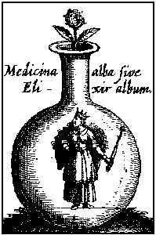
I am the Elixir to the white transforming all imperfect bodies into most pure silver better than the mine, whereof one part changeth a thousand of Argent vive into most pure Silver.

The Twelfth Chapter.

How this whiteness is converted into transparent redness as the Ruby, and this is the elixir to the red.
Take white laton and break your books to pieces lest your hearts be broken. For our Art is easy and a little help will serve. He that maketh me white shall make me red, for white and red proceedeth from one Root, that which is in the white is in the red, therefore work philosophically, and if thou make white and pass the limits, or end thereof, thou art blessed, this thing if thou shalt see it suddenly, admiration or marvel, fear and dread, shall come upon thee. Decant therefore grind, and reiterate, though the work be tedious and long, for it is done with long decoction, know ye that the flower of the stone is the stone of the Stone, roast it therefore by certain days until it be shining as Marble, and know when it is so, that it is the most greatest secret. For the stone is mixed to the stone. Now most dear friend thou hast learned to make the white.
Now it is to speak of the red, but if thou first make not white, never can there be made true red, for no man may come from the first to the third but by the second, So canst thou not come from black to the citrine but by the white, because that the citrine is made one compound of much white and a little black. Therefore make white the black, and make red the white and you have the art. For the year is divided into four parts, and so is our blessed work. The first is winter cold and moist, the second is ver, hot and moist, and flourishing. The third is the summer time, hot and dry, and red. The fourth is the harvest cold and dry, which is the time of gathering of fruit. This disposition colouring nature govern until such time it bring forth ripe fruit at pleasure. But now the winter is past, the showers be gone away. For the flowers hath appeared in our earth in the time of ver. But we go about the white rose for they made every imperfect or sick body to be turned into true silver.
Therefore when thou seest the whiteness appearing above in all parts be sure, that in that whiteness is there hidden redness. Therefore then you must draw out all the whiteness and decoct it until such time it be made red thoroughly.
The Red Rose.
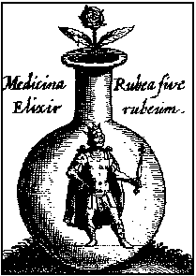
I am the Elixir to the red transforming all imperfect bodies into most pure gold better then the mine, for one part being cast upon a thousand of Argent Vive, we perceived that it congealed it and made it red, and converted it into most pure gold.

