Petrus Bonus - A form and method of perfecting base metals.
From Giovanni Lacinius Pretiosa margarita novella de thesauro, ac pretiosissimo philosophorum lapide, Venice, 1546. I have included here some of my own handcoloured versions of the fourteen figures that represent the alchemical process.
http://www.levity.com/alchemy/petrus_bonus.html

A form and method of perfecting base metals.
by Janus Lacinius Therapus, the Calabrian.

The art of Generating M or Q.
Some of the principles of our Art are apprehended mentally or intellectually, such as Chaos, Alteration, Power, Operation, Generation, and Digestion. Others are perceived by the senses, as wine, or the First Matter, body or form, elements, the perfect being, the forming ferment, colours, fermentation, separation. Some are apprehended both by mind and sense, e.g., Sky, or Heaven.
A. From CHAOS goes forth an intelligent Master, who, amidst the rude, confused, and undigested mass of the elements, perceives himself advancing towards M or Q, until by B, C, D, and by the primordial elements, which follow from Nature herself, he arrives thither.
B. The SUBSTANCE is that from which D arises when the Artificer works extrinsically. We also apply it. to the imperfect metals which are to be changed into M or Q.
C. The FORM is the intelligent outward influence (the Master), which, sets in motion. these Principles. It is that also which gives being to M or Q, and by which T, S, V, Z are changed into X or Y.
D. The Sky is the female principle, by which that which is received of the male is nourished and increased until it is wholly changed into M or Q.
E. The ELEMENTS are changed from B into D, and by way of C, on the other hand, F, G, H, I, are intermingled.
F. CONVERSION takes place, first of C into D, and then of D into C, finally of both in turn into M or Q. F also indicates the potency of which D is the Act, and through which pearls are made and generated artificially.
G. PERMIXTION is the union of the male and the female principle (e.g. C with D).
H. DISSOLUTION is the hermaphroditic conception which takes place in either C or D.
I. GENERATION is partly that by which C and D produce M, and partly that by which M and D produce Q. If we place the Substance in a closed vessel, it is brought about by Nature rather than by the aid of art.
K. Of COLOURS, the first is black, which is more difficult to bring about than the rest, from the fact that it is the first. It shews that C and D have united, and that conception has taken place, i.e. that M or Q will ultimately be produced. Then comes white, by which we gradually progress from C to M, and thence to Q; then saffron, which indicates that the conjunction of the substances is in progress, because the seed is diffused through the whole of D; the fourth colour is red, indicating the actual accomplishment of M or Q.
L. DIGESTION is the gradual development of that which is conceived, by gentle outward heat, e.g., the evolution of M out of C and D, or of Q out of M and D.
O. SEPARATION is the severing of elements, which, originating from B and D, are also separated from the same.
P. OPERATION is either the whole process of change by which B and the rest of the principles become M or Q, or the use of M and Q in transmuting base metals into silver or gold.
M. The PERFECT BEING is the efficient cause, or the form of that into which C and D are changed by way of E, F, G, H, I, K, L, O, P, and has power to perfect imperfect metals.
N. FERMENTATION is the wonderful principle by which M is developed into Q. It is brought about by the bland warmth of a gentle fire. Thus M is still wanting in some of the most potent properties of Q, which is the perfect Tincture. Q is capable of unlimited extension, not only quantitatively, but qualitatively. If you can change M into Q, you can multiply and perfect Q indefinitely.
Q. Then, is the formative tincture, consummately perfect, and consisting of the equilibrium of all the elements. Hence its virtue is far greater and more potent than that of M. It changes imperfect metals into silver or gold (X or Y), and it is an efficacious remedy for all mental and bodily disease in man, seeing that it expels all disturbing elements; it also makes and keeps men good and kindly disposed towards others. It is, finally, a sovereign cure of the weakness of old age.
Mix one part of gold (X) with twelve parts of Our Water; pound them small; place them in a moderately deep jar ; set over it an alembic in the ordinary way; stop up the jar and the apertures of the alembic, up to the beak, with clay; let it dry thoroughly; place it on the oven (not immediately over the coals, but on the iron) in such a way that the whole jar shall be covered by it as far as the alembic, and let the aperture between jar and furnace be also sealed with clay. Then light the fire, and there will come oil into the alembic, together with the water, and will float on the water with an orange colour. Continue the fire till all the water is distilled; let it cool; remove the recipient; separate the oil from the water, and open the jar: you will find a hard, brittle, and pulverisable body. If you like, repeat the whole process, pouring the same or other water over the body; distil as before. The water that comes out will not be so much as at first, and if you repeat the process a third time, there will be hardly any water at all. The body that remains will be a blackish powder, which you calcine in the following way:
If the body be one ounce, pour over it three ounces of Mercury, and pound them together, thus producing an amalgam like butter. Then place it in a glass vessel, and stop up the apertures with clay on the outer side. Set it on a trivet over a gentle fire of three or four coals, stirring it all the time with a small wooden rod, and be careful to shut your mouth and nose, because the fumes are destructive to the teeth. Continue to stir till all the Mercury has disappeared, and there remains a subtle body of more intense blackness. Repeat this even to the third time, till the body is pulverised and intensely black. Then take it, place it in a smaller vessel, and pour on it as much of the aforesaid oil as will moisten it; close the vessel, and let it stand over a lamp; in three days the body will be dried, and it will begin to assume a whitish appearance. Pour on more oil as before; dry by the same fire, and the substance will exhibit an increased whiteness. Repeat the process up to the fourth time; the substance will then have turned of a dazzling whiteness, delicate as an orient pearl of the purest water. Then proceed with our ore, salt, and gum, which must become one. A gentle fire can do no harm, but the warmth of horsedung is better.
The blackness of the substance, when it appears, is not the blackness of ink, but a bright ebony colour. When it has been changed into whiteness, we must then look out for the appearance of the saffron hue, which will in no long time be followed by a most glorious ruby colour. Between the appearance of M (the white colour) and Q (the ruby colour) there should be an interval of thirty days, during which the heat of the fire should be slightly increased, and the vessel kept carefully closed. The substance will then be perfect, and you should carefully preserve it for your own use and that of your friends. One part of it will transmute 2,000 parts of any base metal into its own glorious nature.
To change one drachm of M into Q, add to it three ounces of D and one ounce of C. Subject the whole to gentle coction for thirty days, till it passes through K, after which you will behold perfect. Q, round and red. When you have performed and accomplished all this, you may consider yourself as a great master; and you should render to the great and good God fervent and constant thanks for His unspeakable benefit. Thus I have bestowed upon you a gift, gentle reader, the vast value of which will be understood by generations to come.
S = lead. X = gold.
T = tin. Y = silver.
V = iron. Z = bronze.
Figures representing these seven metals

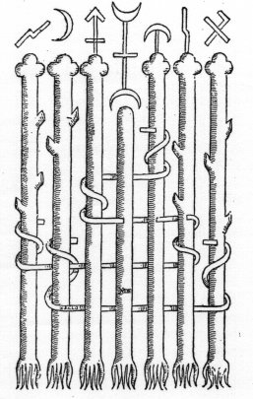
We have drawn the composition of the trees of the grove together; we will now describe their natures one by one, according to the best of our ability. We will, in the first place, begin with those trees upon the left, the scrolls whereof simply encircle the bark, and with their purgation as follows :-
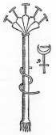
The first tree is hot, dry, red, like red-hot bronze. It becomes moist, dry, and black, like lead; cold and humid, like quicksilver; hot, humid, and saffron-coloured.
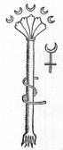
The second tree is hot and dry, like glowing brass; it becomes humid and black, like quicksilver; dry and white, like lead; hot, humid, and saffron-coloured, like blood-red gold.
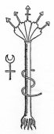
The third tree is hot, dry, and red. It becomes dry and black, like lead; humid and white, like tin or quicksilver; hot, humid, and saffron, like blood-red gold.
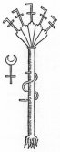
The first tree on the right-hand side has a scroll which enters the front and comes out on the other side; it is hot, humid, and saffron-coloured, like red-hot gold. It becomes dry and black, like earthy silver; humid, like silver; hot, dry, and red, like red-hot bronze.
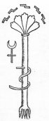
The second tree, which is pierced by its scroll, is dry and red, like red-hot bronze. It becomes dry and black, like lead; humid and white, like quicksilver; hot, humid, and saffron-coloured, like blood-red gold.
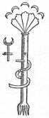
The third tree, which is pierced by its scroll, is hot, dry, and red, like red-hot bronze. It becomes dry and black, like lead; humid and white like tin; hot, humid, saffron-coloured, and of a bloody red.
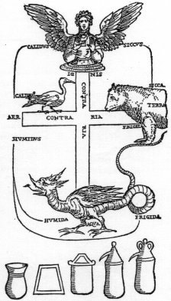

Exposition of the typical figures.
Three rules must be carefully observed in our art : first prepare the right substance; then carry on the work continuously, so that it may not be marred by interruption; thirdly, be patient, and follow always in the footsteps of Nature.
Get (as your substance) highly purified Water of Life, and keep it; but do not suppose that the liquid which moistens all things, is the bright and limpid liquid of Bacchus. For while you anxiously look about in out-of-the-way places for extraordinary events, you pass by the sparkling waves of the blessed stream.
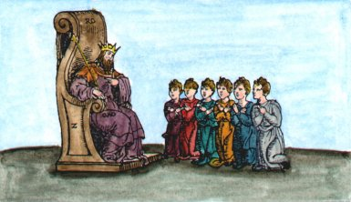
Enter the Palace in which are fifteen mansions, where the king, his brow circled with the diadem, sits on a lofty throne, holding in his hand the sceptre of the whole world before him, his son and five servants kneel in robes of different colours, imploring him to bestow upon his son and his servants a share of his power; but he does not even reply to their request.
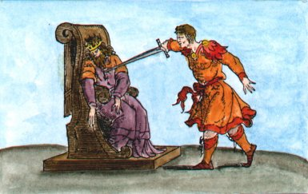
The son, incited by the servants, stabs the father as he sits on the throne. (Let an amalgam be made with highly purified water, etc.)
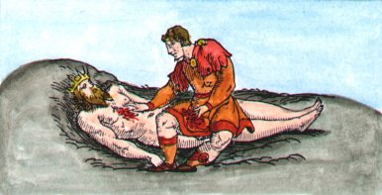
In the third picture we see the son catching his father's blood in his robe (which is the second process of our art, already explained in the method).
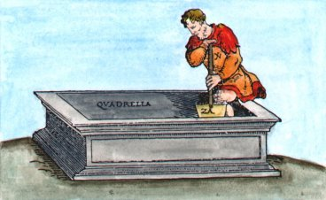
A grave is dug in the fourth mansion (which is the furnace). Its depth is two hand-breadths, and its width four inches.
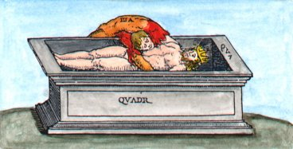
In the fifth mansion the son thought to throw his father into the grave, and to leave him there ; but (by means of our art) both fell in together.
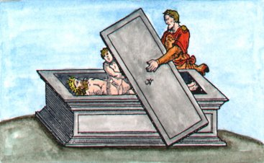
The sixth mansion is that in which the son still strives to get out, but one (who sprang from them in the second operation) comes, and prevents him from so doing.
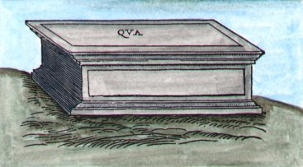
While the father and son are in the tomb, which is called the seventh mansion, there follows putrefaction in their ashes, or a very hot bath.
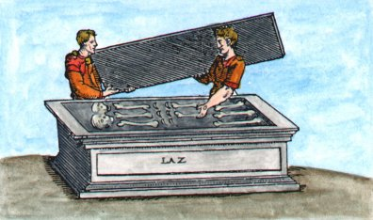
In the eighth mansion, that which happened during the putrefaction is inspected, the vase having become cold, etc.
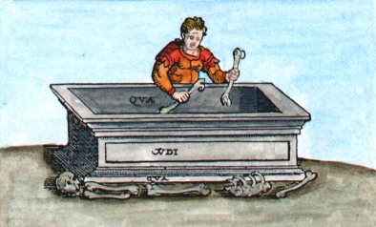
In the ninth mansion the bones are taken from the tomb. This happens when the whole body has been dissolved by successive solution, which, being done, keep it carefully.
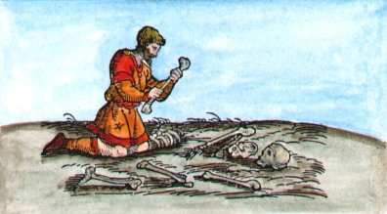
In the tenth mansion, the bones are divided into nine parts, the dissolved substance being subjected to gentle coction for nine days, till a portion of it turns black. Remove this latter, and keep it in another vessel in a hot place. Subject the water to gentle heat for another nine days. Again remove that which has turned black, and put it with the rest. Continue the operation till the water is clear and pure. Let its Water of Iife be poured over the black substance in a small glass vessel, so that it shall float over it to the height of an inch, and let it stand nine days over a gentle fire, renewing the water every day, if necessary. (Thus the earth will become clear and white, according to the teaching of the philosophers ; for this earth is putrefied and purified with its water.)
An angel is sent, who casts the bones on the purified and whitened earth (which is now mixed with its seed, and let the whole be placed in a closed jar with its alembic. Let the thicker substance be divided from the water by a more violent fire, and remain. as a hard substance at the bottom.)
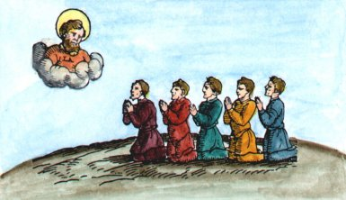
In the eleventh mansion the servants pray God to restore their king. Henceforth the whole work is concerned with his restoration.
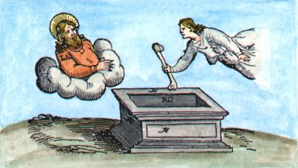
For this purpose a second angel is sent in the twelfth mansion, who places the other part of those bones on the earth (till they are all thickened : then a wonderful thing happens).
Thus, a succession of angels is sent, who cast the first, second, third, and fourth part of the bones on the earth, where they become white, transparent; and firm. The fifth and sixth parts are changed into yellow, and so also with the seventh, eighth, and ninth; the earth of the bones becomes as red as blood or rubies.
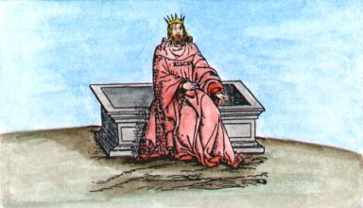
Then the king rises from the tomb, full of the grace of God. His body is now all spiritual and heavenly, and he has power to make all his servants kings.
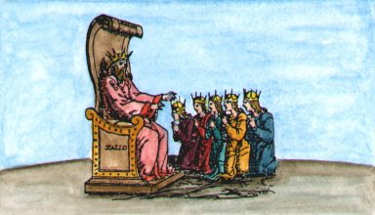
At last he exercises his power upon his servants and his son, placing crowns of gold upon their heads, and making them kings by his grace, since God had given him great power and majesty.
Let no impostor, greedy or wicked person, touch this glorious work with his unclean hands. Let the honest man and him of a wise heart come hither, and him who is capable of exploring the most hidden causes of things.

