Paracelsus 1493 - 1541
http://en.wikipedia.org/wiki/Paracelsus
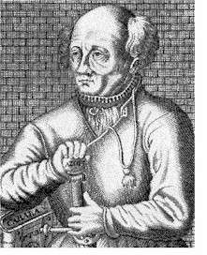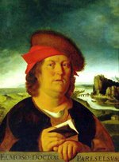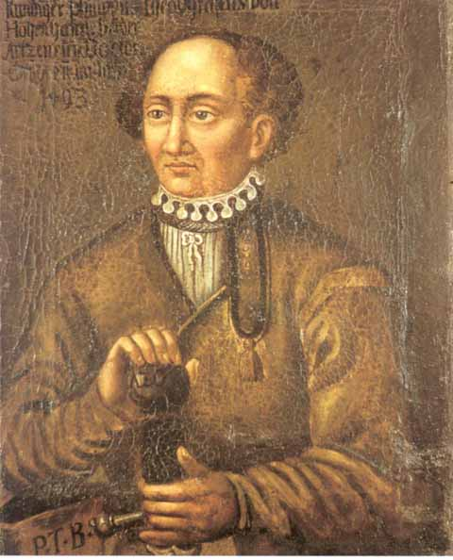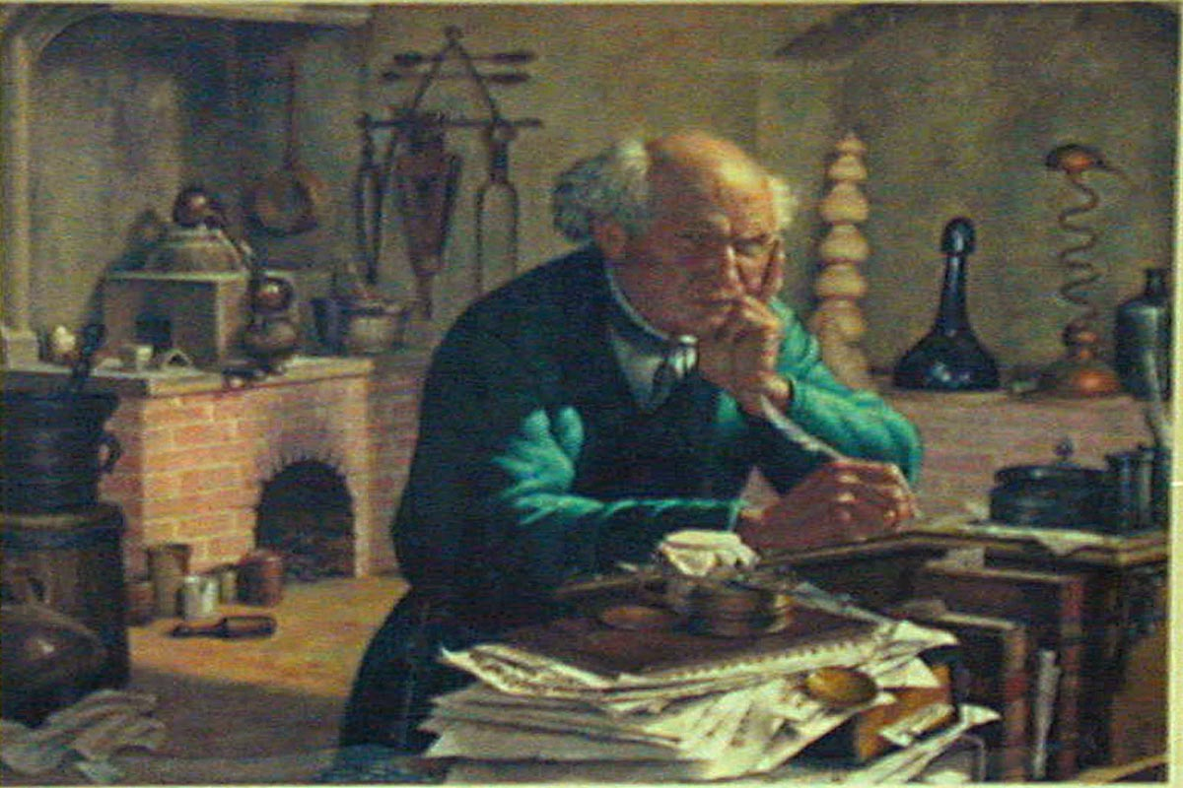
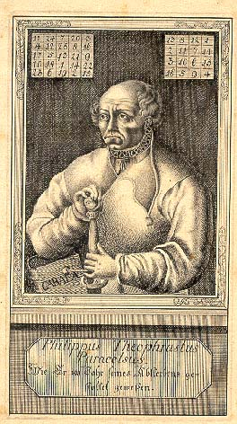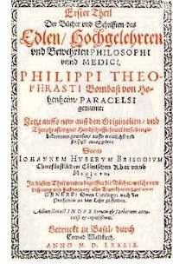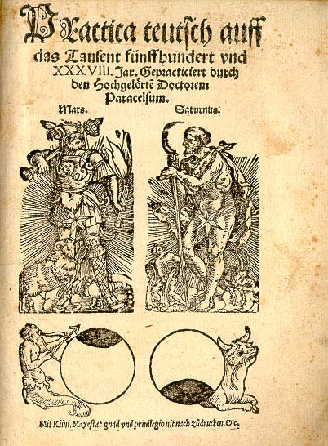
Theophrastus Philippus Aureolus Bombastus von Hohenheim (Paracelsus)

Paracelsus was born at Einsiedeln, Switzerland, of a Swabian (Wilhelm Bombast von Hohenheim) chemist father and a Swiss mother. He was brought up in Switzerland, and as a youth he worked in nearby mines as an analyst. He started studying medicine at the University of Basel at the age of 16, and later in Vienna. He gained his doctorate [1] degree from the University of Ferrara.
He later journeyed to Egypt, Arabia, the Holy Land, and Constantinople seeking alchemists from whom to learn. He pursued medical treatments that were considered ludicrous in the Western world. Paracelsus was the disseminator in Europe of the medieval Islamic alchemists. [2] Instead of pouring boiling oil onto wounds to cauterize them; or if they were on a limb, to let them become gangrenous and then to amputate the limb, Paracelsus learned that wounds would heal themselves if allowed to drain and prevented from becoming infected. On his return to Europe, his knowledge of these treatments won him fame.
Paracelsus rejected Gnostic traditions, but kept much of the Hermetic, neoplatonic, and Pythagorean philosophies; however, Hermetical science had so much Aristotelian theory that his rejection of Gnosticism was practically meaningless. In particular, Paracelsus rejected the magic theories of Agrippa and Flamel; Paracelsus did not think of himself as a magician and scorned those who did, though he was a practicing astrologer, as were most, if not all of the university-trained physicians working at this time in Europe. Astrology was a very important part of Paracelsus' medicine. In his Archidoxes of Magic Paracelsus devoted several sections to astrological talismans for curing disease, providing talismans for various maladies as well as talismans for each sign of the Zodiac. He also invented an alphabet called the Alphabet of the Magi, for engraving angelic names upon talismans.
Paracelsus pioneered the use of chemicals and minerals in medicine.
He used the name "zink" for the element zinc in about 1526, based on the sharp pointed appearance of its crystals after smelting and the old German word "zinke" for pointed. He used experimentation in learning about the human body. His hermetical views were that sickness and health in the body relied on the harmony of man, the microcosm, and Nature, the macrocosm. He took an approach different from those before him, using this analogy not in the manner of soul-purification but in the manner that humans must have certain balances of minerals in their bodies, and that certain illnesses of the body had chemical remedies that could cure them. (Debus & Multhauf, p.6-12)
He summarized his own views: "Many have said of Alchemy, that it is for the making of gold and silver. For me such is not the aim, but to consider only what virtue and power may lie in medicines." (Edwardes, p.47) (also in: Holmyard, Eric John. Alchemy. p. 170)
Indeed, the remnants of alchemical traditions can still be seen in modern medicine. For instance, the Caduceus has been adopted as the prime symbol of western medicine.
Monument to Paracelsus in Beratzhausen, Bavaria
Paracelsus gained a reputation for being arrogant, and soon garnered the anger of other physicians in Europe. He held the chair of medicine at the University of Basel for less than a year; while there his colleagues became angered by allegations that he had publicly burned traditional medical books. He was forced from the city after having legal trouble over a physician's fee he sued to collect.
He then wandered Europe, Africa and Asia Minor, in the pursuit of hidden knowledge. He revised old manuscripts and wrote new ones, but had trouble finding publishers. In 1536, his Die grosse Wundartzney (The Great Surgery Book) was published and enabled him to regain fame.
After his death, the movement of Paracelsianism was seized upon by many wishing to subvert the traditional Galenic physick- and thus did his therapies become more widely known and used.
His motto was "alterius non sit qui suus esse potest" which means "let no man belong to another that can belong to himself".
According to the Oxford English Dictionary, the origin of the word "bombastic" is not a play on Paracelsus's middle name, Bombastus. Instead, that dictionary cites "bombast": an old term for cotton stuffing. However, many books mentioning Paracelsus cite him as the origin of "bombastic" to describe his often arrogant speaking style.

Contributions to toxicology
Paracelsus, sometimes called the "father" of toxicology, wrote:
"The dose makes the poison." (A popular short version.)
The original quote is:
German: Alle Ding' sind Gift und nichts ohn' Gift; allein die Dosis macht, dass ein Ding kein Gift ist.
"All things are poison and nothing is without poison, only the dose permits something not to be poisonous."
In other words, the specific quality of a given amount of a substance is as important to a patient as the nature of the substance in general. For example, the quality of a small dose of aspirin can be beneficial to someone, but at very high doses, the quality of this common medicine for the same person can be deadly. In some individuals, even at very low doses, the quality of aspirin may be deadly.
Dose-response assesses the dose levels at which adverse effects were observed in test animals, and these dose levels are used to calculate an equal dose in humans.
He wrote the major work On the Miners' Sickness and Other Diseases of Miners (1567) documenting the occupational hazards of metalworking including treatment and prevention strategies.

Related
- Paracelsus is the title of a 1943 film by Georg Wilhelm Pabst. [3]
- Paracelsus is a lengthy dramatic poem by Robert Browning.
- Paracelsus and The Rose is a short story by Jorge Luis Borges.
- Paracelsus is one of the people featured on a Chocolate Frog card in the Harry Potter series. A bust of Paracelsus is also present in the castle at Hogwarts, near Gryffindor, between the entrance to the Gryffindor common room and the Owlry, as mentioned in Order of the Phoenix.
- In the Anime version of Fullmetal Alchemist, the father of Edward Elric and Alphonse Elric is called Hohenheim of Light. Having succeeded in his alchemical researches, he and his former lover, Dante, have achieved a costly pseudo-immortality, one of the traditional goals of alchemists, by using the legendary alchemical amplifier, the Philosopher's Stone, whose creation was another goal for alchemists. Hohenheim also created the first ever homunculus (400 years before the story takes place)
- In Star Ocean: Till the End of Time, the Paracelsus Table creates homonculi to make mock battles, used for the mini-game for characters to fight one another.
- In the Phantom comic strip, Paracelsus appeared in a story by Ulf Granberg and Jaime Vallvé from 1977 entitled The Ring. According to this story, it was Paracelsus who gave the first Phantom the Skull Ring.
- Paracelsus was the burn-scarred and masked nemesis and former ally of Father in the CBS television series Beauty and the Beast. He was portrayed by Tony Jay.
- In the Guilty Gear video games, the character A.B.A uses a key-shaped ax named Paracelsus as a weapon.
- At the end of Resident Evil 3: Nemesis, Jill Valentine discovers what appears to be a railgun of sorts in a deserted factory. Named Paracelsus's Sword, the weapon was designed by the U.S. government for the express purpose of destroying the most dangerous of the Umbrella Corporation's bio-organic weapons.
- In the book Esbae: A Winter's Tale, by Linda Haldeman, Professor Leo Ernst is a college professor teaching a Western Civilization class. While lecturing about witchcraft, sorcery, and magic in the Middle Ages, he briefly covers Paracelsus, including the fact that his real name was "Theophrastus Bombastus von Hohenheim! Now there's a name to conjure with." Later in the book, Chuck Holmes, unable to remember the proper incantations, uses the name to summon the demon Asmodeus.
- The DC Comics comic book The Human Race features a villain named Paracelsus who employs genetic engineering techniques.
- The Bruce Coville A.I. Gang trilogy includes a faux-AI chatterbot named Paracelsus, which is encased in the head of a Greek statue.
- "Paracelsus" is the title of a musical composition that was written by Mont Campbelland performed by the "Canterbury" jazzrock-band National Health in 1976. An excerpt appears on the NH compilation "Complete."
- Paracelsus appears as the villain in Peter David's 2006 Arthurian fantasy novel, Fall of Knight, in which he is depicted as both and alchemist and magician (despite his historical antipathy toward magic) who gained immortality, and like King Arthur, appears in the modern day world, having acquired the Spear of Destiny from the Nazis in 1945, and who tries to acquire the Holy Grail from Arthur in the early 21st Century.
- Paracelsus appears in the visual novel "Animamundi: Dark Alchemist" as a legendary figure who was thought to have succeeded in creating the Philosopher's Stone and the Elixer of Life. He helps the main character throughout the game, disguised as a young boy.
- Professor Bulwer in 1922 Murnau film 'Nosferatu' is a follower of Paracelsus

External links
Wikimedia Commons has media related to:
Paracelsus
Wikisource has original works written by or about:
Paracelsus
- Azogue: It is a section of the e-journal Azogue with original reproductions of paracelsian texts.
- The Zurich Paracelsus Project
- History of zinc
- Paracelsus and the medical revolution of the Renaissance - A 500th Anniversary Celebration from the National Library of Medicine, theme essay by Allen G. Debus.
- Theophrastus Paracelsus - Detailed entry from The Catholic Encyclopedia
- Biographical notes from The Galileo Project
- Paracelsus (from the Mystica)
- Paracelsus (from Alchemy Lab)
- The uses of enchantment, The Economist, January 19, 2006
==================================================================================================================

