Giordano Bruno 1548–1600
http://en.wikipedia.org/wiki/Giordano_Bruno
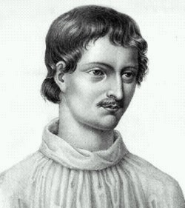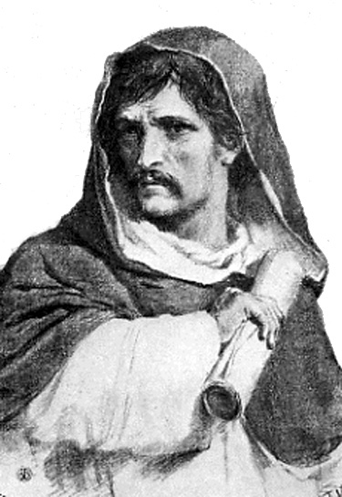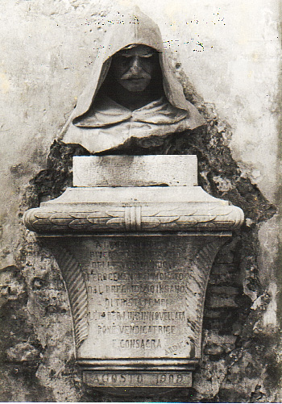
Giordano Bruno (Nola, 1548–Rome, February 17, 1600) was an Italian philosopher, priest, cosmologist, and occultist. Bruno is known for his system of mnemonics based upon organized knowledge and as an early proponent of the idea of an infinite and homogeneous universe. Burned at the stake as a heretic, Bruno is seen by some as a martyr to the cause of free thought ^{[1]}.

Contents
- 1 Early life
- 2 Travel years
- 3 Trial and death
- 4 The cosmology of Bruno's time
- 5 Bruno's cosmology
- 6 In film and fiction
- 7 Quotations
- 8 Notes
- 9 References
- 10 Legacy
- 11 External links

Early life
Born in Nola (in Campania, then part of the Kingdom of Naples) in 1548, he was originally named Filippo Bruno. His father was Giovanni Bruno, a soldier. At the age of eleven he traveled to Naples to study the Trivium. At 15, Bruno entered the Dominican Order, taking the name of Giordano. He continued his studies, completing his novitiate, and becoming an ordained priest in 1572.
He was interested in philosophy and was an expert on the art of memory; he wrote books on mnemonic technique, which Frances Yates contends may have been disguised Hermetic tracts. The writings attributed to Hermes Trismegistus had played an important role in the Renaissance Neoplatonic revival. At that time they were thought to date uniformly to the earliest days of ancient Egypt and to encode a form of "pristine wisdom" ("prisca philosophia"). They are now believed to date mostly from about 300 A.D. and are associated with Neoplatonism.
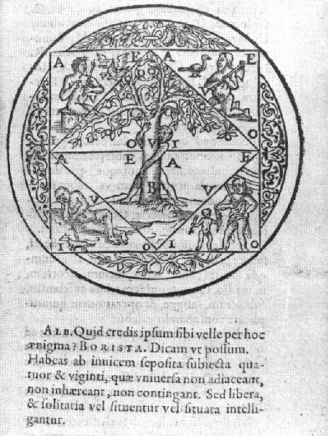
Woodcut illustration of one of Giordano Bruno's mnemonic devices: in the spandrels are the four classical elements: earth, air fire, water
While the Hermetic Tradition was a major influence on Bruno, he also absorbed and developed the heliocentric ideas of Copernicus. Other significant influences included Thomas Aquinas, whose works he had to study in depth as a novice and for whom he always expressed a curiously deep admiration ([3]), Averroes, whose idea of a universal mind resonates through Bruno's work, Duns Scotus, the Renaissance Neoplatonist Marsilio Ficino, and, last but certainly not least, Nicholas of Cusa's ideas on infinity and indeterminacy . Bruno developed a pantheistic hylozoistic system, essentially incompatible with orthodox Christian Trinitarian beliefs.
In 1576 he left Naples to avoid the attention of the Inquisition. He left Rome for the same reason and abandoned the Dominican order. He travelled to Geneva and briefly joined the Calvinists, before he was excommunicated, ostensibly for slandering the philosophy professor Antoine de la Faye. After Bruno apologised his excommunication was revoked, but in autumn 1579, deeply disappointed by Calvinist intolerance, he left for France.
He went first to Lyon, but he could not find work there and in late 1579 he arrived in Toulouse, at that time a Catholic stronghold, where he obtained a position as lecturer of philosophy. After the bitter experience in Geneva, he also tried to revert to mainstream Catholicism, but he was denied absolution by the Jesuit priest that he approached. After religious strife broke out in Toulouse in summer 1581, he moved to Paris, where first he held a cycle of thirty lectures on theological topics. At this time, he also began to gain fame for his prodigious memory. Bruno's feats of memory were based, at least in part, on his elaborate system of mnemonics, but some of his contemporaries found it easier to attribute them to magical powers. His talents attracted the benevolent attention of the king Henry III, who supported a conciliatory, middle-of-the-road cultural policy between Catholic and Protestant extremism.
In Paris he enjoyed the protection of his powerful French patrons. During this period, he published several works on mnemonics, a.o. "De umbris idearum" (The Shadows of Ideas, 1582), "Ars Memoriae" (The Art of Memory, 1582), "Cantus Circaeus" (Circe's Song, 1582), based on his model of organised knowledge, opposed to that of Petrus Ramus. In 1582 Bruno also published a comedy summarizing some of his philosophical positions, titled "Il Candelaio" ("The Torchbearer").

[] Travel years
In April 1583, he went to England with letters of recommendation from Henry III, working for the French ambassador, Michel de Castelnau. There he became acquainted with the poet Philip Sidney and with the Hermetic circle around John Dee. He also unsuccessfully sought a teaching position at Oxford, where however he held lectures. His views spurred controversy, notably with John Underhill, Rector of Lincoln College and from 1589 bishop of Oxford, and George Abbot, who later became Archbishop of Canterbury, who poked fun at Bruno for supporting “the opinion of Copernicus that the earth did go round, and the heavens did stand still; whereas in truth it was his own head which rather did run round, and his brains did not stand still.”([4]) and who reports accusations of plagiarising Ficino 's work. Still, the English period was a fruitful one. During that time Bruno completed and published some of his most important works, the "Italian Dialogues", including the cosmological tracts "La Cena de le Ceneri" (The Ash Wednesday Supper, 1584), "De la Causa, Principio et Uno" (On Cause, Prime Origin and the One, 1584), "De l'Infinito Universo et Mondi" (De l'Infinito Universo et Mondi, 1584) as well as "Lo Spaccio de la Bestia Trionfante" (The Expulsion of the Triumphant Beast, 1584) and "De gl' Heroici Furori" (On Heroic Frenzies, 1585). Some of the works that Bruno published in London, notably the "The Ash Wednesday Supper", appear to have given offense. It was not the first time, nor was it to be the last, that Bruno's controversial views coupled with his abrasive sarcasm lost him the support of his friends.
In October 1585, after the French embassy in London was attacked by a mob, he returned to Paris with Castelnau, finding a tense political situation. Moreover, his 120 theses against Aristotelian natural science and his pamphlets against the Roman Catholic mathematician Fabrizio Mordente soon put him in ill favor. In 1586, following a violent quarrel about Mordente's invention, "the differential compass", he left France for Germany.
In Germany he failed to obtain a teaching position at Marburg, but was granted permission to teach at Wittenberg, where he lectured on Aristotle for two years. However, with a change of intellectual climate there, he was no longer welcome, and went in 1588 to Prague, where he obtained 300 taler from Rudolf II, but no teaching position. He went on to serve briefly as a professor in Helmstedt, but had to flee again when he was excommunicated by the Lutherans, continuing the pattern of Bruno's gaining favor from lay authorities before falling foul of the ecclesiastics of whatever hue.
1591 found him in Frankfurt. Apparently, during the Frankfurt Book Fair, he received an invitation to Venice from the patrician Giovanni Mocenigo, who wished to be instructed in the art of memory, and also heard of a vacant chair in mathematics at the University of Padua. Apparently believing that the Inquisition might have lost some of its impetus, he returned to Italy.
He went first to Padua, where he taught briefly, and applied unsuccessfully for the chair of mathematics, that was assigned instead to Galileo Galilei one year later. Bruno accepted Mocenigo's invitation and moved to Venice in March 1592. For about two months he functioned as an in-house tutor to Mocenigo. When Bruno announced his plan to leave Venice to his host, the latter, who was unhappy with the teachings he had received and had apparently developed a personal rancour towards Bruno, denounced him to the Venetian Inquisition, that had Bruno arrested on May 22, 1592. Among the numerous charges of blasphemy and heresy brought against him in Venice, based on Mocenigo's denunciation, was his belief in the plurality of worlds, as well as accusations of personal misconduct. Bruno defended himself skillfully, stessing the philosophical character of some of his positions, denying others and admitting that he had had doubts on some matters of dogma. The Roman Inquisition, however, asked for his transferral to Rome. After several months and some quibbling the Venetian authorities reluctantly consented and Bruno was sent to Rome in February 1593.
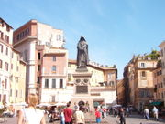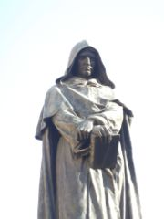
The monument to Bruno in the place he was executed, Campo de' Fiori in Rome.

Trial and death
In Rome he was imprisoned for seven years during his lengthy trial, lastly in the Tower of Nona. Some important documents about the trial are lost, but others have been preserved, among them a summary of the proceedings that was rediscovered in 1940.[5] The numerous charges against Bruno, based on some of his books as well as on witness accounts, included blasphemy, immoral conduct, and heresy in matters of dogmatic theology, and involved some of the basic doctrines of his philosophy and cosmology. Luigi Firpo lists them as follows ^{[2]}:
- Holding opinions contrary to the Catholic Faith and speaking against it and its ministers.
- Holding erroneous opinions about the Trinity, about Christ's divinity and Incarnation.
- Holding erroneoeus opinions about Christ.
- Holding erroneous opinions about Transubstantiation and Mass.
- Claiming the existence of a plurality of worlds and their eternity.
- Believing in metempsychosis and in the transmigration of the human soul into brutes.
- Dealing in magics and divination.
- Denying the Virginity of Mary.
Bruno continued his Venetian defensive strategy, which consisted in bowing to the Church's dogmatic teachings, while trying to preserve the basis of his philosophy. In particular Bruno held firm to his belief in the plurality of worlds, although he was admonished to abandon it. His trial was overseen by the inquisitor, Cardinal Robert Bellarmine, who demanded a full recantation, which Bruno eventually refused. Instead he appealed in vain to Pope Clement VIII, hoping to save his life through a partial recantation. The Pope expressed himself in favor of a guilty verdict. Consequently, Bruno was declared a heretic, handed over to secular authorities on February 8, 1600. At his trial he listened to the verdict on his knees, then stood up and said: "Perhaps you, my judges, pronounce this sentence against me with greater fear than I receive it." A month or so later he was brought to the Campo de' Fiori, a central Roman market square, his tongue in a gag, tied to a pole naked and burned at the stake, on February 17, 1600.
In 1885 an international committee for a monument to Bruno on the site of his execution was formed, including Victor Hugo, Herbert Spencer, Ernest Renan, Ernst Haeckel, Henrik Ibsen and Ferdinand Gregorovius([6]),([7]). The monument was sharply opposed by the clerical party, but was finally erected by the Rome Municipality and inaugurated in 1889.
All his works were placed on the Index Librorum Prohibitorum in 1603. Four hundred years after his execution, official expression of "profound sorrow" and acknowledgement of error at Bruno's condemnation to death was made, during the papacy of John Paul II. Attempts were made by a group of professors in the Catholic Theological Faculty at Naples, led by the Nolan Domenico Sorrentino, to obtain a full rehabilitation from the Catholic authorities.
Some authors have claimed Bruno as a "martyr of science". They see a parallel between his persecution and the Galileo affair, asserting that even though, unlike Galileo, Bruno's theological beliefs were a factor in his heresy trial, Bruno's Copernicanism and cosmological beliefs were also a factor.
Others maintain that the above "connection" may be exaggerated, or even plainly false. For example: according to the Stanford Encyclopedia of Philosophy, "…in 1600 there was no official Catholic position on the Copernican system, and it was certainly not a heresy. When…Bruno…was burned at the stake as a heretic, it had nothing to do with his writings in support of Copernican cosmology."^{[3]}
The Vatican webpage about Bruno's trial provides a different perspective: " In the same rooms where Giordano Bruno was questioned, for the same important reasons of the relationship between science and faith, at the dawning of the new astronomy and at the decline of Aristotle’s philosophy, sixteen years later, Cardinal Bellarmino, who then contested Bruno’s heretical theses, summoned Galileo Galilei, who also faced a famous inquisitorial trial, which, luckily for him, ended with a simple abjuration."^{[4]}

[] The cosmology of Bruno's time
In the second half of the 16th century, the theories of Copernicus began diffusing through Europe. Although Bruno did not wholly embrace Copernicus's preference for mathematics over speculation, he advocated the Copernican view that the earth was not the center of the universe, and extrapolated some consequences which were radical departures from the cosmology of the time.
According to Bruno, Copernicus's theories contradicted the view of a celestial sphere, immutable, incorruptible, and superior to the sublunary sphere or terrestrial region. Bruno went beyond the heliocentric model to envision a universe which, like that of Plotinus^{[citation needed]}, in the third century A.D., or like Blaise Pascal's nearly a century after Bruno, had its center everywhere and its circumference nowhere.
Few astronomers of Bruno's generation accepted even Copernicus's heliocentric model. Among those who did were the Germans Michael Maestlin (1550-1631), Cristoph Rothmann, and the Englishman Thomas Digges, author of A Perfit Description of the Caelestial Orbes. Galileo (1564-1642) and Johannes Kepler (1571-1630) were younger, so they do not figure at this time. Bruno himself was not an astronomer, but one of the first to embrace Copernicanism as a world view, rejecting geocentrism. In works published between 1584 and 1591, Bruno enthusiastically supported Copernicanism.
According to Aristotle and Plato, the universe was a finite sphere. Its ultimate limit was the primum mobile, whose diurnal rotation was conferred upon it by a transcendental God, not part of the universe, a motionless prime mover and first cause. The fixed stars were part of this celestial sphere, all at the same fixed distance from the immobile earth at the center of the sphere. Ptolemy had numbered these at 1,022, grouped into 48 constellations. The planets were each fixed to a transparent sphere.
Copernicus conserved the idea of planets fixed to solid spheres, but considered the apparent motion of the stars to be an actual motion of the earth; he also preserved the notion of an immobile center, but it was the Sun rather than the Earth. He expressed no opinion as to whether the stars were at a uniform distance on a fixed sphere or scattered through an infinite universe.

[] Bruno's cosmology
Bruno believed, as is now universally accepted, that the Earth revolves and that the apparent diurnal rotation of the heavens is an illusion caused by the rotation of the Earth around its axis. He also saw no reason to believe that the stellar region was finite, or that all stars were equidistant from a single center of the universe. In these respects, his views were similar to those of Thomas Digges in his A Perfit Description of the Caelestial Orbes (1576).
However, Digges considered the infinite region beyond the stars to be the home of God, the angels, and of the holy. Digges conserved the Ptolemaic notion of the planetary spheres, considered Earth the only possible realm of life and death, and a unique place of imperfection and change, compared against the perfect and changeless heavens.
In 1584, Bruno published two important philosophical dialogues, in which he argued against the planetary spheres. (Two years later, Rothmann did the same in 1586, as did Tycho Brahe in 1587.) Bruno's infinite universe was filled with a substance -- a "pure air", aether, or spiritus -- that offered no resistance to the heavenly bodies which, in Bruno's view, rather than being fixed, moved under their own impetus. Most dramatically, he completely abandoned the idea of a hierarchical universe. The Earth was just one more heavenly body, as was the Sun. God had no particular relation to one part of the infinite universe more than any other. God, according to Bruno, was as present on Earth as in the Heavens, an immanent God, the One subsuming in itself the multiplicity of existence, rather than a remote heavenly deity.
Bruno also affirmed that the universe was homogeneous, made up everywhere of the four elements (water, earth, fire, and air), rather than having the stars be composed of a separate quintessence. Essentially, the same physical laws would operate everywhere, although the use of that term is anachronistic. Space and time were both conceived as infinite. There was no room in his stable and permanent universe for the Christian notions of divine Creation and Last Judgement.
Under this model, the Sun was simply one more star, and the stars all suns, each with its own planets. Bruno saw a solar system of a sun/star with planets as the fundamental unit of the universe. According to Bruno, infinite God necessarily created an infinite universe, formed of an infinite number of solar systems, separated by vast regions full of Aether, because empty space could not exist. (Bruno did not arrive at the concept of a galaxy.) Comets were part of a synodus ex mundis of stars, and not -- as other authors sustained at the time -- ephemeral creations, divine instruments, or heavenly messengers. Each comet was a world, a permanent celestial body, formed of the four elements.
Bruno's cosmology is marked by infinitude, homogeneity, and isotropy, with planetary systems distributed evenly throughout. Matter follows an active animistic principle: it is intelligent and discontinuous in structure, made up of discrete atoms. This animism (and a corresponding disdain for mathematics as a means to understanding) is the most dramatic respect in which Bruno's cosmology differs from what today passes for a common-sense picture of the universe.
During the later 16th century, and throughout the 17th century, Bruno's ideas were held up for ridicule, debate, or inspiration. Margaret Cavendish, for example, wrote an entire series of poems against "atoms" and "infinite worlds" in Poems and Fancies in 1664. His true, if partial, rehabilitation would have to wait for the implications of Newtonian cosmology.
Bruno's overall contribution to the birth of modern science is still controversial. Some scholars follow Frances Yates stressing the importance of Bruno's ideas about the universe being infinite and lacking structure as a crucial crosspoint between the old and the new. Others disagree. Others yet see in Bruno's idea of multiple worlds instantiating the infinite possibilities of a pristine, indivisible One a forerunner of Everett's Many-worlds interpretation of quantum mechanics ^{[5]}. Four centuries after his ashes were dispersed, Bruno is still talking as loud as ever.

[] In film and fiction
- Biographical dramatic film Giordano Bruno directed by Giuliano Montaldo (1973) [8]
- Ægypt, a four-volume novel by John Crowley, includes a major storyline following the adventures of Giordano Bruno, positing among other things two meetings between Bruno and Dr. John Dee.
- More Light (1987), a play by British playwright Snoo Wilson, has Giordano Bruno as its protagonist and includes Queen Elizabeth I of England and a female Shakespeare among its characters.
- The Last Confession by Australian author Morris West (The Devil's Advocate, The Shoes of the Fisherman, The Ambassadors) is a fictional account of Giordano Bruno's imprisonment before he is convicted of heresy and burned at the stake during the Inquisition in 1600.
- Czesław Miłosz's poem "Campo di Fiori" interweaves the Italian masses indifference to the burning of Giordano Bruno with the Poles' indifference to the Germans' suppression of the Warsaw Ghetto Uprising.
- Robert Ashley's "Perfect Lives" also mentions Giordano Bruno.
- The movie The Ninth Gate partially attributes the book The Nine Gates of the Kingdom of Shadows to Bruno.
- The interstellar ship featured in the novel Children of God (1998) by Mary Doria Russell is named for Bruno.
- James Joyce mentions Bruno the Nolan towards the end of A Portrait of the Artist as a Young Man and has a passage largely about his trial and execution in Finnegans Wake.^{[6]}
- Margaret Gabrielle Long, writing as Marjorie Bowen, used a fictionalized version of Bruno ("Brother Felipe Bruno") as the protagonist of the novel The Triumphant Beast (1934).

[] Quotations
"Firstly, I say that the theories on the movement of the earth and on the immobility of the firmament or sky are by me produced on a reasoned and sure basis, which doesn’t undermine the authority of the Holy Sciptures […]. With regard to the sun, I say that it doesn’t rise or set, nor do we see it rise or set, because, if the earth rotates on his axis, what do we mean by rising and setting ..."
Giordano Bruno, from the Vatican summary of Bruno's trial ([9]).
"I fought, and that's a lot. I thought I could win ... but nature and luck curbed my endeavour. But it's already something that I took up the struggle, because I see that victory is in the hands of Fate. In me was what was possible and what no future century will be able to deny to me: what a winner could give from his own; that I did not fear death, that I did not submit, my face firm, to anyone of my breed; that I preferred courageous death to pavid life."
Giordano Bruno, De Monade

[] Notes
- ^ The Pope & the Heretic, Michael White
- ^ Luigi Firpo, Il processo di Giordano Bruno, 1993
- ^ Sheila Rabin, Nicolaus Copernicus in the Stanford Encyclopedia of Philosophy (online, accessed 19 November 2005).
- ^ Vatican Archives,[1] accessed 3 November 2006.
- ^ [2] Max Tegmark, Parallel Universes, 2003
- ^ Thornton Wilder, "Giordano Bruno's Last Meal in Finnegans Wake", Hudson Review vol. XVI (Spring, 1963), p. 74-79. reproduced online at TheModernWord.com.

[] References
- Cause, Principle and Unity : And Essays on Magic by Giordano Bruno, ISBN 0-521-59658-0
- The Cabala of Pegasus by Giordano Bruno, ISBN 0-300-09217-2
- "Writings of Giordano Bruno"
- The Pope & the Heretic, Michael White, 2002, ISBN 0-06-018626-7.
- Giordano Bruno, J. Lewis McIntyre.
- Giordano Bruno and Renaissance Science, Hilary Gatti, 2002, ISBN 0-8014-8785-4
- Giordano Bruno: His Life and Thought, With Annotated Translation of His Work -On the Infinite Universe and Worlds,Dorethea Singer,1950.
- Giordano Bruno: The Forgotten Philosopher, John Kessler.
- Giordano Bruno, Paul Oskar Kristeller, Collier's Encyclopedia, Vol 4, 1987 ed., pg. 634
- Giordano Bruno and the Hermetic Tradition, Frances Yates, ISBN 0-226-95007-7
- Eros and Magic in the Renaissance, Ioan P. Couliano, ISBN 0-226-12315-4.
- Il processo di Giordano Bruno, Luigi Firpo, 1993

[] Legacy
- The 20-km diameter crater Giordano Bruno, named in Bruno's honor, is located on the moon at 103°east lunar longitude, 36° north lunar latitude. It is believed to have been created by a meteorite impact in 1178, witnessed by five English monks as related in Carl Sagan's Cosmos.
- In 1926 the Theosophical Broadcasting Station Pty Ltd, owned by interests associated with the local branch of Theosophical Society Adyar, was granted a radio broadcasting licence in Sydney, Australia. The station's call sign, "2GB" was chosen to honour the Italian philosopher who was much admired by Theosophists. Although the ownership of the station subsequently passed to strictly commercial interests the call sign is retained.

[] External links
- O'Connor, John J., and Edmund F. Robertson. "Giordano Bruno". MacTutor History of Mathematics archive.
- Bruno's works: text, concordances and frequency list
- Detailed biography of Giordano Bruno
- Latin text of Bruno's Ars Memoriae
- Collection of short excerpts about Giordano Bruno, from many authors throughout history
- Short dedication to Giordano Bruno
- Bruno's Latin and Italian works online: Biblioteca Ideale di Giordano Bruno
============================================================================================================================
END

