Robert McNair Price 1954-
http://en.wikipedia.org/wiki/Robert_M._Price
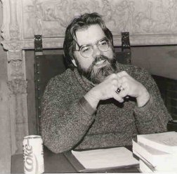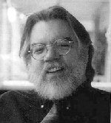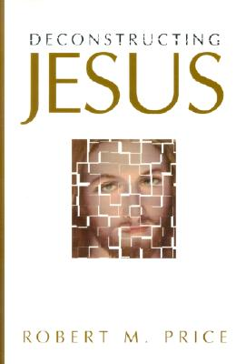
Robert McNair Price (born July 7, 1954 in Mississippi) is a Professor of Theology and Scriptural Studies at the Johnnie Colemon Theological Seminary in Miami Gardens, Florida. He is the author of many books and articles on religion and has also written about H. P. Lovecraft's Cthulhu Mythos.
Price hosts a weekly call-in webcast, The Bible Geek, in which he answers a wide range of questions pertaining to religion. He appeared in Brian Flemming's documentary film The God Who Wasn't There (2005). From 1994 until 2003, Price was the or of The Journal of Higher Criticism. [1]

Contents
- 1 Cthulhu Mythos
- 2 Books
  - 2.1 On religion
  - 2.2 On the Cthulhu Mythos (as or)
- 3 External links

Cthulhu Mythos
As or of the journal Crypt of Cthulhu (published by Necronomicon Press) and of a series of Cthulhu Mythos anthologies, Price has been a major figure in H. P. Lovecraft scholarship and fandom for many years. In essays that introduce the collections and the individual stories, Price traces the origins of Lovecraft's entities, motifs, and literary style. The Cthulhu Cycle, for example, saw the origins of the octopoid god in Alfred Lord Tennyson's "The Kraken" and particular passages from Lord Dunsany, while The Dunwich Cycle points to the influence of Arthur Machen on Lovecraft's "The Dunwich Horror".
Price's religious background often informs his Mythos criticism, seeing gnostic themes in Lovecraft's fictional god Azathoth and interpreting "The Shadow Over Innsmouth" as a kind of initiation ritual.

Books

On religion
- Beyond Born Again.
- The Widow Traditions in Luke-Acts: A Feminist-Critical Scrutiny. (ISBN 0-7885-0224-7)
- Deconstructing Jesus. (ISBN 1-57392-758-9)
- The Pre-Nicene New Testament. (ISBN 1-56085-194-5)
- The Da Vinci Fraud. (ISBN 1-59102-348-3)
- The Incredible Shrinking Son of Man. (ISBN 1-59102-121-9)
- The Reason Driven Life: What Am I Here on Earth For?. (ISBN 1-59102-476-5)
- The Buddha and the Bible.
- Jesus Christ Superstar: A Redactional Study of a Modern Gospel.
- Inerrant the Wind: The Evangelical Crisis of Biblical Authority (Forthcoming).
- Paul as Text: The Apostle and the Apocrypha (Forthcoming).

[] On the Cthulhu Mythos (as or)
- Acolytes of Cthulhu
- The Antarktos Cycle: Horror and Wonder at the Ends of the Earth
- Black Forbidden Things
- The Book of Eibon
- The Book of Iod
- The Dunwich Cycle
- The Hastur Cycle: She Who Is to Come
- The Horror of It All: Encrusted Gems from the "Crypt of Cthulhu"
- H.P. Lovecraft and the Cthulhu Mythos
- The Innsmouth Cycle: The Taint of the Deep Ones
- Lin Carter: A Look Behind His Imaginary Worlds
- Lin Carter's Anton Zarnak, Supernatural Sleuth
- Lovecraft: A Look Behind the Cthulhu Mythos (with Lin Carter)
- Mysteries of the Worm
- The Necronomicon
- The New Lovecraft Circle
- The Taint of Lovecraft
- The Ithaqua Cycle: The Wind-Walker of the Icy Wastes
- Shards of Darkness
- Shub Niggurath Cycle
- Tales of the Lovecraft Mythos
- Tales Out of Dunwich
- Tales Out of Innsmouth
- The Tsathoggua Cycle: Terror Tales of the Toad God
- The Xothic Legend Cycle: The Complete Mythos Fiction of Lin Carter

[] External links
- Price's web page
- Collection of Price's works
- James Patrick Holding has criticized Price's work in a number of essays from an orthodox Christian perspective.
===================================================================================================================
http://www.robertmprice.mindvendor.com/bio.htm

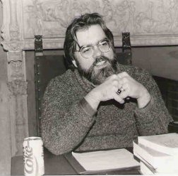

Robert M. Price (born July 7, 1954) is a Mississippian by birth, lived in New Jersey for most of his life, and has recently resettled in North Carolina. After early involvement in a fundamentalist Baptist church, he went on to become a leader in the Montclair State College chapter of the Inter-Varsity Christian Fellowship. Having developed a keen interest in apologetics (the defense of the faith on intellectual grounds), Bob went on to enroll at Gordon-Conwell Theological Seminary, where he received an MTS degree in New Testament. Billy Graham was the commencement speaker.
It was during this period, 1977-78, however, that Bob began to reassess his faith, deciding at length that traditional Christianity simply did not have either the historical credentials or the intellectual cogency its defenders claimed for it. Embarking on a wide program of reading religious thinkers and theologians from other traditions, as well as the sociology, anthropology, and psychology of religion, he soon considered himself a theological liberal in the camp of Paul Tillich. He received the Ph.D. degree in systematic theology from Drew University in 1981.
After some years teaching in the religious studies department of Mount Olive College in North Carolina, Price returned to New Jersey to pastor First Baptist Church of Montclair, the first pastorate, many years before, of liberal preacher Harry Emerson Fosdick. Price soon enrolled in a second doctoral program at Drew, receiving the Ph.D. in New Testament in 1993. These studies, together with his encounter with the writings of Don Cupitt, Jacques Derrida, and the New Testament critics of the Nineteenth Century, rapidly eroded his liberal Christian stance, and Price resigned his pastorate in 1994. A brief flirtation with Unitarian Universalism disenchanted him even with this liberal extreme of institutional religion. For six years Bob and Carol led a living room church called The Grail. Now, back in North Carolina, he attends the Episcopal Church and keeps his mouth shut.
Robert M. Price is Professor of Biblical Criticism at the Center for Inquiry Institute as well as the editor of The Journal of Higher Criticism. His books include Beyond Born Again, The Widow Traditions in Luke-Acts: A Feminist-Critical Scrutiny, Deconstructing Jesus, and The Incredible Shrinking Son of Man. Forthcoming titles are The Crisis of Biblical Authority, Jesus Christ Superstar: A Redactional Study of a Modern Gospel, The Da Vinci Controversy and The Amazing Colossal Apostle.
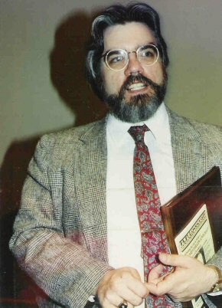
Occasionally someone familiar with Robert M. Price as a writer on religion comes across the same name attached to books related to H.P. Lovecraft, Robert E. Howard, etc., and inevitably wonders if it could possibly be the same person, all the more since one also finds titles on South Africa and on guns credited to a Robert M. Price. Those last two are not our man, but the horror writer and the religion writer are indeed the Jeckyll and Hyde sides of the same fellow. Click here to read about Price's Hyde side and how he has cultivated it.
The Wicked Clergyman
When did it begin? When was I first tainted by the cosmic contagion that is Lovecraft? Actually, it is no big mystery. Back in 1967, when I was first enthusiastically swimming in the paperback revival of pulp fiction from Ace, Lancer, Dell, and others, I was comparing notes one afternoon with my pal Russ Farrington, and he suggested I read these new Lancer paperbacks he had just finished, H.P. Lovecraft’s The Colour out of Space and The Dunwich Horror. I did. (At least that’s the way I remember it; Russ tells me he recalls me telling him about HPL!) And to this day I could probably tell you just where I was and how I felt while reading each one of those wonderful tales! I was thirteen years old, which I much later discovered is the optimum age for discovering Lovecraft. Encountering the Old Gent then can mark one for life. It certainly marked me! Lovecraft has loomed much larger in my life than he does right now, but he still casts a pretty long shadow over me, and I look forward to an opportunity to reread this or that tale again soon. And I’m planning on buying the Cthulhu action figure when it comes out.
Anyway, back to 1967: I was soon buying and reading the Arkham House Lovecraft collections, then the related works by other authors, including August Derleth, Ramsey Campbell, and Colin Wilson. Tales of the Cthulhu Mythos became a kind of Bible for me. Together with other material I was then reading (Robert E. Howard, Tolkien, Doc Savage, Lin Carter, Burroughs, etc.), Lovecraft and his Mythos composed an imaginative world I happily lived in as a junior high and then high school nerd. Soon my teenage fundamentalism swelled up to demand all my time and attention, but by 1978, I had exorcised fundamentalism and decided to look up some of my old favorite fantasy authors. The next year I discovered the Necronomicon Press journal Lovecraft Studies and decided to submit an article. I did, and editor S.T. Joshi accepted it, “Higher Criticism and the Necronomicon.”
Joshi, a cultured and gracious young man, kindly invited me to drive up to Providence, Rhode Island, to meet “the Providence Pals,” the gang who put together Necronomicon Press publications. It was great fun meeting publisher Marc Michaud, illustrator Jason Eckhardt, writers Don and Mollie Burleson (they weren’t married yet, but it wouldn’t be long) and Peter Cannon, and fan editor and collector Ken Neilly. What a bunch! What a hobby! We would walk around various Lovecraft sites in Providence (places he had lived, places he had mentioned) and would haunt bookshops and examine our finds over pizza. I treasure those times!
Soon I joined the merry crew again for a regional horror convention at Roger Williams College in Rhode Island (NeCon 1981) where I was delighted to hear Les Daniels, Peter Straub, Michael McDowell, and other genre pros, disappointed only that Stephen King had bowed out. It was here that I met another great friend and colleague, Will Murray. A few years later, I would be tagging along with Will through the streets of Lower Manhattan, looking for the exact spot where Richard Henry Savage, the prototype for the fictional Doc Savage, was killed in a cart accident (yes, that’s cart, not car). Around the same time, Will led a bunch of us on an eerie expedition through South Boston to recap the route to Pickman’s studio in “Pickman’s Model.” I will never forget rooting around in Copp’s Hill Burying Ground where we discovered that, just as in the story, it was honeycombed with a series of tunnels to which staircases beneath false tombstones led!
On that NeCon 1981weekend, the Providence Pals told me about the Esoteric Order of Dagon Amateur Press Association and suggested I join. All it required was cranking out a few pages of HPL-related material for the mailing list every three months. I figured I could do that with no trouble. And so Crypt of Cthulhu was born! My mother, Mable Price, a retired typist and executive secretary, once a high school yearbook editor, joined me in what would become our greatest hobby. I soon discovered local stores, then regional dealers, would sell Crypt and that I could make some money off it. The mag was a bizarre miscegenation; half Lovecraft Studies rip-off, half humor magazine, a “pulp thriller and theological journal.”
I decided to send out free copies to some big names in the field of Lovecraft scholarship and latter-day Lovecraftian fiction. Before long, the letters pages became the equivalent of a modern computer message board where unknown fans could trade barbs with their favorite authors. And I was able to persuade a number of those authors to contribute fiction and articles to the mag. It was great! Inevitably I began penning my own horror stories, most of them Mythos pastiches.
Occasionally we ran all-fiction issues of Crypt of Cthulhu, and for these I lined up new material by the pros (Lin Carter, Gary Myers, Brian Lumley, Frank Belknap Long) as well as old manuscripts by Howard, Carl Jacobi, and others. Crypt functioned very much like the old fanzines contemporary with Lovecraft and his generation, like The Acolyte, Fantasy Magazine, and Phantagraph. Lin Carter took an active interest in Crypt, and before long a bunch of us New Jersey and New York fans had begun meeting every other Saturday at his Manhattan apartment for the New Kalem Club. Sometimes the ancient Frank Belknap Long would make his way across the city for the meetings. We basked.
These fiction issues, filled with Mythos collector’s items and rare obscurities, led directly to the next phase of my Lovecraftian involvement, editing fiction anthologies. It was 1990, and a bunch of us were shooting the breeze at Eileen MacNamara’s apartment during the Lovecraft Centennial conference hosted by Brown University. Phil Rahman, kingpin of Fedogan & Bremer publishers, invited me to put together a hardcover anthology of Mythos tales, and the eventual result was Tales of the Lovecraft Mythos, followed many years later by The New Lovecraft Circle and Acolytes of Cthulhu. Three years after this, Chaosium Publishers approached me with the idea of my compiling collections of Mythos stories to answer the needs of a younger generation of fans who had discovered Lovecraft through the medium of fantasy role-playing games. The new series would focus on a Mythos deity, a magic book, a major locale familiar to the fans from their role-playing and allow them to catch up with the source material. I did a dozen or so of these, and several more are awaiting publication from Chaosium even now. I branched out to other publishers, including Arkham House, for whom I put together Flowers from the Moon and Other Lunacies, a collection of rare early Robert Bloch pulp tales. Now I’m trying to finish out the series of topical collections with new publishers including Mythos Books, Die, Monster, Die! Books, Lindesfarne Press, and Hippocampus Press.
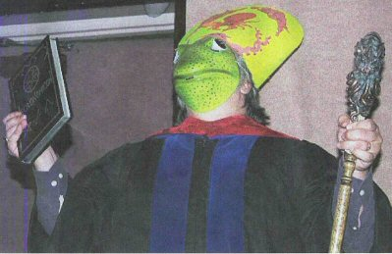
Perhaps my most bizarre (and most fun!) adventures in Lovecraftianity were the series of biennial “NecronomiCons,” or Cthulhu Mythos conventions, held in Danvers, Mass, or Providence. I loved pontificating on panels to packed rooms of Mythos addicts. Even more I loved hosting the Cthulhu Prayer Breakfasts which formed the climax of each Con. We would gather for a breakfast buffet and present lifetime achievement awards to elders of the movement including Robert Bloch, Gahan Wilson, L. Sprague de Camp, Ramsey Campbell, Brian Lumley, Dirk W. Mosig, Fred Chappell, and others. And then I would come on stage, dressed in Innsmouth finery, and give a sermon. I’d lead into it with some stand-up material, then do a serious and (I hoped relevant) homily, which would inevitably slide into a crazed display of Cthulhuvian tomfoolery, as I would begin to rant about the return of the Old Ones or to speak in tongues (R’lyehian, specifically), and lead the crowd in strategically reworded hymns. It was always a thrill. Too bad those days are over! My precious keepsake from back then is my copy of the first edition of the Schlangekraft-Barnes Necronomicon (you know, the one that looks like a high school yearbook), whose once-blank end pages are covered with the autographs of major Lovecraftian writers, many of them now dead and suffering Hell’s torments. I’m glad I thought of it before it was too late. Now no one could duplicate it.
These days, I have sold off most of my Lovecraft criticism volumes. I do not race to acquire the latest Lovecraft pastiche and don’t bother keeping up with them. Now my Lovecraft fixation tends to be a more private matter. Lovecraft remains indelibly a part of me, and I would never have it any other way.
Robert M. Price
September 2004

================================================================================================================
END

