James Still 1906-2001

http://en.wikipedia.org/wiki/James_Still

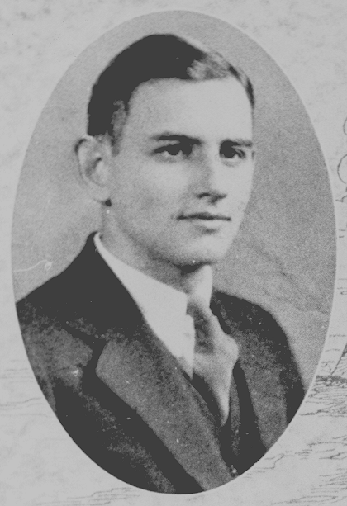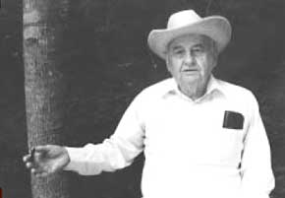

James Still (July 16, 1906 – April 28, 2001) was an Appalachian poet, novelist and folklorist who lived most of his life in a log house along the Dead Mare Branch of Little Carr Creek, Knott County, Kentucky. He was best known for the novel River of Earth which depicted the struggles of coal mining in eastern Kentucky.

Contents
- 1 Life
  - 1.1 Early life
  - 1.2 Education
  - 1.3 Career
  - 1.4 Literature
- 2 Bibliography
- 3 External links

Life

Early life
Still’s mother was sixteen when she moved to Alabama due to a tornado destroying the family home. His father was a horse doctor with no formal training . James Still was born July 16, 1906 near Lafayette, Chambers County, Alabama. Still was considered a quiet child but a hard worker. He along with his nine siblings worked the family farm. They farmed cotton, sugar cane, soybeans and corn. At the age of seven, Still began grade school. He found greater interest not in the school text books but at home where there was an edition of the Cyclopedia of Universal Knowledge. He became enriched with philosophy, physics and the great British poets – Shakespeare and Keats.

Education
After graduating from high school, Still attended Lincoln Memorial University of Harrogate, Tennessee. He worked at the rock quarry in the afternoons and as a library janitor in the evenings. He would often sleep at the library after spending the night reading countless literature. In 1929, he graduated from Lincoln and headed over to Vanderbilt University – Nashville, Tennessee. While there, he became involved in a controversial miner strike in Wilder, Tennessee. The miners were starving due to holding the picket line; Still delivered a truckload of food and clothing for the miners. After a year at Vanderbilt, he transferred to the University of Illinois and earned a graduate degree.

Career
Still tried various professions including the Civil Service Corps, Bible salesman and even had a stint picking cotton in Texas. His friend Don West – a poet, civil rights activist, among other things – offered Still a job organizing recreation programs for a Bible school in Knott County, Kentucky. Still accepted the position but soon became a volunteer librarian at the Hindman Settlement School. Knott County, KY would become Still’s lifelong home. James Still served as a Sergeant in the US Army in WWII and was stationed in Egypt in 1944.

Literature
Still moved into a two-story log cabin once occupied by a fine crafter of dulcimers, Jethro Amburgey. He would remain here till his death. Here, he began writing his masterpiece, River of Earth. It was published February 5, 1940. River of Earth depicts the struggles of a family trying to survive by either subsisting off the land or entering the coal mines of the Cumberland Plateau in the reaches of eastern Kentucky. Still depicts the Appalachian mining culture with ease. Mines close often and the family is forced to move and find other means to survive. Still received the Southern Author's Award shortly after publication which he shared with Thomas Wolfe for his work You Can’t Go Home Again. Still went on to publish a few collections of poetry and short stories, a juvenile novel and a compilation of Appalachian local color he collected over the years. He died April 28, 2001 at the age of 94.

Bibliography
- Hounds on the Mountain (1937)
- River of Earth (1940)
- On Troublesome Creek (1941)
- Way Down Yonder on Troublesome Creek: Appalachian Riddles and Rusties (1974)
- The Wolfpen Rusties: Appalachian Riddles and Gee-Haw Whimmy-Diddles (1975)
- Pattern of a Man (1976)
- Jack and the Wonder Bean (1977)
- Sporty Creek: A Novel about an Appalachian Boyhood (1977)
- The Run for the Elbertas (1980)
- The Wolfpen Poems (1986)

External links
- James Still Portal
- James Still Fellowship
- River of Earth – Paperback (ISBN 0-8131-1372-5)
==========================================================================================================================
END

