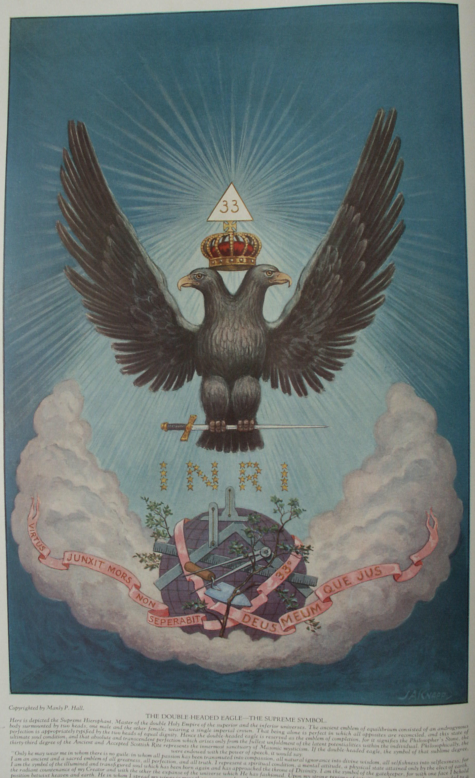

**The Mystery of the Apocalypse**

**The Secret Teachings of All Ages - Manly P. Hall 1928**

**THE MYSTERY OF THE APOCALYPSE  
The sacred city of Ephesus--The authorship of the Apocalypse--The Alpha and Omega--The Lamb of God-The Four Horsemen-The number of the beast.**

THE presence of the Temple of Diana at Ephesus marked that city as sacred to the Mystery religion, for the Seven Wonders of the ancient world were erected to indicate the repositories of recondite knowledge. Of Ephesus, H. P. Blavatsky writes:

"It was a focus of the universal 'secret' doctrines; the weird laboratory whence, fashioned in elegant Grecian phraseology, sprang the quintessence of Buddhistic, Zoroastrian, and Chaldean philosophy. Artemis, the gigantic concrete symbol of theosophico-pantheistic abstractions, the great mother Multimamma, androgyne and patroness of the 'Ephesian writings,' was conquered by Paul; but although the zealous converts of the apostles pretended to burn all their books on 'curious arts, τα περιεργα, enough of these remained for them to study when their first zeal had cooled off." (See *Isis Unveiled*.)

Being a great center of pagan learning, Ephesus has been the locale for many early Christian myths. The assertion has been made that it was the last domicile of the Virgin Mary; also that the tomb of St. John the Divine was located there. According to legend, St. John did not depart from this life in the usual manner but, selecting his vault, entered it while still alive, and closing the entrance behind him, vanished forever from mortal sight. A rumor was current in ancient Ephesus that St. John would sleep in his tomb until the return of the Savior, and that when the apostle turned over on his sepulchral couch the earth above moved like the coverlets of a bed.

Subjected to more criticism than any other book now incorporated in the New Testament, the Apocalypse--popularly accredited to St. John the Divine--is by far the most important but least understood of the Gnostic Christian writings. Though Justin Martyr declared the Book of Revelation to have been written by "John, one of Christ's apostles," its authorship was disputed as early as the second century after Christ. In the third century these contentions became acute and even Dionysius of Alexandria and Eusebius attacked the Johannine theory, declaring that both the Book of Revelation and the Gospel according to St. John were written by one Cerinthus, who borrowed the name of the great apostle the better to foist his own doctrines upon the Christians. Later Jerome questioned the authorship of the Apocalypse and during the Reformation his objections were revived by Luther and Erasmus. The once generally accepted notion that the Book of Revelation was the actual record of a "mystical experience" occurring to St. John while that seer was an exile in the Isle of Parmos is now regarded with disfavor by more critical scholars. Other explanations have therefore been advanced to account for the symbolism permeating the volume and the original motive for its writing. The more reasonable of these theories may be summed up as follows:

First, upon the weight of evidence furnished by its own contents the Book of Revelation may well be pronounced a pagan writing--one of the sacred books of the Eleusinian or Phrygian Mysteries. As a corollary, the real author of a work setting forth the profundities of Egyptian and Greek mysticism must have been an initiate himself and consequently obligated to write only in the symbolic language of the Mysteries.

Second, it is possible that the Book of Revelation was written to reconcile the seeming discrepancies between the early Christian and pagan religious philosophies. When the zealots of the primitive Christian Church sought to Christianize pagandom, the pagan initiates retorted with a powerful effort to paganize Christianity. The Christians failed but the pagans succeeded. With the decline of paganism the initiated pagan hierophants transferred their base of operations to the new vehicle of primitive Christianity, adopting the symbols of the new cult to conceal those eternal verities which are ever the priceless possession of the wise. The Apocalypse shows clearly the resultant fusion of pagan and Christian symbolism and thus bears irrefutable evidence of the activities of these initiated minds operating through early Christianity.

Third, the theory has been advanced that the Book of Revelation represents the attempt made by the unscrupulous members of a certain religious order to undermine the Christian Mysteries by satirizing their philosophy. This nefarious end they hoped to attain by showing the new faith to be merely a restatement of the ancient pagan doctrines, by heaping ridicule upon Christianity, and by using its own symbols toward its disparagement. For example, the star which fell to earth (Rev. viii. 10-11) could be construed to mean the Star of Bethlehem, and the bitterness of that star (called Wormwood and which poisoned mankind) could signify the "false" teachings of the Christian Church. While the last theory has gained a certain measure of popularity, the profundity of the Apocalypse leads the discerning reader to the inevitable conclusion that this is the least plausible of the three hypotheses. To those able to pierce the veil of its symbolism, the inspired source of the document requires no further corroborative evidence.

In the final analysis, true philosophy can be limited by neither creed nor faction; in fact it is incompatible with every artificial limitation of human thought. The question of the pagan or Christian origin of the Book of Revelation is, consequently, of little importance. The intrinsic value of the book lies in its magnificent epitome of the Universal Mystery--an observation which led St. Jerome to declare that it is susceptible of seven entirely different interpretations. Untrained in the reaches of ancient thought, the modem theologian cannot possibly cope with the complexities of the Apocalypse, for to him this mystic writing is but a phantasmagoria the divine inspiration of which he is sorely tempted to question. In the limited space here available it is possible to sketch but briefly a few of the salient features of the vision of the seer of Patmos. A careful consideration of the various pagan Mysteries will assist materially also in filling the inevitable gaps in this abridgment.

In the opening chapter of the Apocalypse, St. John describes the Alpha and Omega who stood in the midst of the seven golden candlesticks. Surrounded by his flaming planetary regents, this Sublime One thus epitomizes in one impressive and mysterious figure the entire sweep of humanity's evolutionary growth--past, present, and future.

"The first stages of man's earthly development," writes Dr. Rudolph Steiner, "ran their course at a period when the earth was still 'fiery'; and the first human incarnations were formed out of the element of fire; at the end of his earthly career man will himself radiate his inner being outwards creatively by the force of the element of fire. This continuous development from the beginning to the end of the earth reveals itself to the 'seer,' when he sees on the astral plane the archetype of evolving man. * * * The beginning of earthly evolution stands forth in the fiery feet, its end in the fiery countenance, and the complete power of the 'creative word,' to be finally won, is seen in the fiery source coming out of the mouth." (See *Occult Seals and Columns*.)

In his Restored New Testament, James Morgan Pryse traces the relationship of the various parts of the Alpha and Omega to the seven sacred planets of the ancients. To quote:

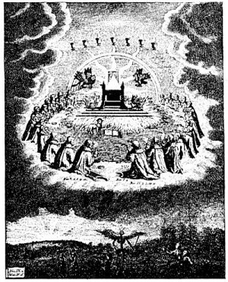  
THE THRONE OF GOD AND OF THE LAMB.

From Jacob Behmen's Works.

*Before the throne of God was the crystal sea representing the Schamayim, or the living waters which are above the heavens. Before the throne also were four creatures--a bull, a lion, an eagle, and a man. These represented the four corners of creation and the multitude of eyes with which they were covered are the stars of the firmament. The twenty-four elders have the same significance as the priests gathered around the statue of Ceres in the Greater Eleusinian Rite and also the Persian Genii, or gods of the hours of the day, who, casting away their crowns, glorify the Holy One. As symbolic of the divisions of time, the elders adore the timeless and enduring Spirit in the midst of them*.

"The Logos-figure described is a composite picture of the seven sacred planets: he has the snowy-white hair of Kronos ('Father Time'), the blazing eyes of 'wide-seeing' Zeus, the sword of Arcs, the shining face of Helios, and the *chiton* and girdle of Aphrodite; his feet are of mercury, the metal sacred to Hermes, and his voice is like the murmur of the ocean's waves (the 'many waters'), alluding to Selene, the Moon-Goddess of the four seasons and of the waters."

The seven stars carried by this immense Being in his right hand are the Governors of the world; the flaming sword issuing from his mouth is the Creative Fiat, or Word of Power, by which the illusion of material permanence is slain. Here also is represented, in all his symbolic splendor, the hierophant of the Phrygian Mysteries, his various insignia emblematic of his divine attributes. Seven priests bearing lamps are his attendants and the stars carried in his hand are the seven schools of the Mysteries whose power he administers. As one *born again* out of spiritual darkness, into perfect wisdom, this archimagus is made to say: "I am he that liveth, and was dead; and, behold, I am alive forever more, Amen; and have the keys of hell and of death."

In the second and third chapters St. John delivers to the "seven churches which are in Asia" the injunctions received by him from the Alpha and Omega. The churches are here analogous to the rungs of a *Mithraic* ladder, and John, being "in the spirit," ascended through the orbits of the seven sacred planets until he reached the inner surface of the Empyrean.

"After the soul of the prophet," writes the anonymous author of *Mankind: Their Origin and Destiny*, "in his ecstatic state has passed in its rapid flight through the seven spheres, from the sphere of the moon to that of Saturn, or from the planet which corresponds to Cancer, the gate of men, to that of Capricorn, which is the gate of the gods, a new gate opens to him in the highest heaven, and in the zodiac, beneath which the seven planets revolve; in a word, in the firmament, or that which the ancients called crystallinum primum, or the crystal heaven."

When related to the Eastern system of metaphysics, these churches represent the chakras, or nerve ganglia, along the human spine, the "door in heaven" being the *brahmarandra*, or point in the crown of the skull (Golgotha), through which the spinal spirit fire passes to liberation. The church of Ephesus corresponds to the *muladhara*, or sacral ganglion, and the other churches to the higher ganglia according to the order given in Revelation. Dr. Steiner discovers a relationship between the seven churches and the divisions of the Aryan race. Thus, the church of Ephesus stands for the Arch-Indian branch; the church of Smyrna, the Arch-Persians; the church of Pergamos, the Chaldean-Egyptian-Semitic; the church of Thyatira, the Grecian-Latin-Roman; the church of Sardis, the Teuton-Anglo-Saxon; the church of Philadelphia, the Slavic; and the church of Laodicea, the Manichæan. The seven churches also signify the Greek vowels, of which *Alpha* and *Omega* are the first and the last. A difference of opinion exists as to the order in which the seven planers should be related to the churches. Some proceed from the hypothesis that Saturn represents the church of Ephesus; but from the fact that this city was sacred to the moon goddess and also that the sphere of the moon is the first above that of the earth, the planets obviously should ascend in their ancient order from the moon to Saturn. From Saturn the soul would naturally ascend through the door in the Empyrean.

In the fourth and fifth chapters St. John describes the throne of God upon which sat the Holy One "which was and is, and is to come." About the throne were twenty-four lesser seats upon which sat twenty-four elders arrayed in white garments and wearing crowns of gold. "And out of the throne proceeded lightnings and thunderings and voices: and there were seven lamps of fire burning before the throne, which are the seven Spirits of God." He who sat upon the throne held in His right hand a book sealed with seven seals which no man in heaven or earth had been found worthy to open. Then appeared a Lamb (Aries, the first and chief of the zodiacal signs) which had been slain, having seven horns (rays) and seven eyes (lights). The Lamb took the book from the right hand of Him that sat upon the throne and the four beasts and all the elders fell down and worshiped God and the Lamb. During the early centuries of the Christian Church the lamb was universally recognized as the symbol of Christ, and not until after the fifth synod of Constantinople (the "Quinisext Synod," A.D. 692) was the figure of the crucified man substituted for that of Agnus Dei. As shrewdly noted by one writer on the subject, the use of a lamb is indicative of the Persian origin of Christianity, for the Persians were the only people to symbolize the first sign of the zodiac by a lamb.

Because a lamb was the sin offering of the ancient pagans, the early mystic Christians considered this animal as an appropriate emblem of Christ, whom they regarded as the sin offering of the world. The Greeks and the Egyptians highly venerated the lamb or ram, often placing its horns upon the foreheads of their gods. The Scandinavian god Thor carried a hammer made from a pair of ram's horns. The lamb is used in preference to the ram apparently because of its purity and gentleness; also, since the Creator Himself was symbolized by Aries, His Son would consequently be the little Ram or Lamb. The lambskin apron worn by the Freemasons over that part of the body symbolized by Typhon or Judas represents that purification

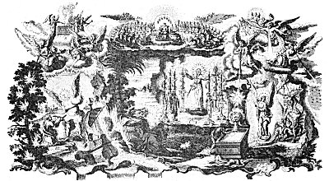  
EPISODES FROM THE MYSTERIES OF THE APOCALYPSE.

From Klauber's *Historiae Biblicae Veteris et Novi Testamenti*.

*In the central foreground, St. John the Divine is kneeling before the apparition of the Alpha and Omega standing in the midst of the seven lights and surrounded by an aureole of flames and smoke. In the heavens above the twenty-four elders with their harps and censers bow before the throne of the Ancient One, from whose hand the Lamb is taking the book sealed with seven seals. The seven spirit, of God, in the form of cups from which issue tongues of fire, surround the head of the Ancient One, and the four beasts (the cherubim) kneel at the corners of His throne. In the upper left-hand corner are shown the seven angels bearing the trumpets and also the altar of God and the angel with the censer. In the upper right are the spirits of the winds; below them is the virgin clothed wit h the sun, to whom wings were given that she might fly into the wilderness. To her right is a scene representing the spirits of God hurling the evil serpent into the bottomless pit. At the lower left St. John is shown receiving from the angelic figure, whose legs are pillars of fire and whose face is a shining sun, the little book which he is told to eat if he would understand the mysteries of the spiritual life.*

*The plate also contains a number of other symbols, including episodes from the destruction of the world and the crystal sea pouring forth from the throne of God. By the presentation of such symbolic conceptions in the form of rituals and dramatic episodes the secrets of the Phrygian Mysteries were perpetuated. When these sacred pageantries were thus revealed to all mankind indiscriminately and each human soul was appointed it own initiator into the holy rite, of the philosophic life, a boon was conferred upon humanity which cannot be fully appreciated until men and women have grown more responsive to those mysteries which are of the spirit.*

The sixth to eleventh chapters inclusive are devoted to an account of the opening of the seven seals on the book held by the Lamb. When the first seal was broken, there rode forth a man on a white horse wearing a crown and holding in his hand a bow. When the second seal was broken, there rode forth a man upon a red horse and in his hand was a great sword. When the third seal was broken there rode forth a man upon a black horse and with a pair of balances in his hand. And when the fourth seal was broken there rode forth Death upon a pale horse and hell followed after him. The four horsemen of the Apocalypse may be interpreted to signify the four main divisions of human life. *Birth* is represented by the rider on the white horse who comes forth conquering and to conquer; the impetuosity of *youth* by the rider on the red horse who took peace from the earth; *maturity* by the rider on the black horse who weighs all things in the scales of reason; and *death* by the rider on the pale horse who was given power over a fourth part of the earth. In the Eastern philosophy these horsemen signify the four *yugas*, or ages, of the world which, riding forth at: their appointed times, become for a certain span the rulers of creation.

Commenting on the twenty-fourth allocution of Chrysostom, in *The Origin of all Religious Worship*, Dupuis notes that each of the four elements was represented by a horse bearing the name of the god "who is set over the element." The first horse, signifying the fire ether, was called Jupiter and occupied the highest place in the order of the elements. This horse was winged, very fleet, and, describing the largest circle, encompassed all the others. It shone with the purest light, and on its body were the images of the sun, the moon, the stars, and all the bodies in the ethereal regions. The second horse, signifying the element of air, was Juno. It was inferior to the horse of Jupiter and described a smaller circle; its color was black but that part exposed to the sun became luminous, thus signifying the diurnal and nocturnal conditions of air. The third horse, symbolizing the element of water, was sacred to Neptune. It was of heavy gait and described a very small circle. The fourth horse, signifying the static element of earth, described as immovable and champing its bit, was the steed of Vesta. Despite their differences in temperature, these four horses lived harmoniously together, which is in accord with the principles of the philosophers, who declared the world to be preserved by the concord and harmony of its elements. In time, however, the racing horse of Jupiter burned the mane of the horse of earth; the thundering steed of Neptune also became covered with sweat, which overflowed the immovable horse of Vesta and resulted in the deluge of Deucalion. At last the fiery horse of Jupiter will consume the rest, when the three inferior elements--purified by reabsorption in the fiery ether--will come forth renewed, constituting "a new heaven and a new earth."

When the fifth seal was opened St. John beheld those who had died for the word of God. When the sixth seal was broken there was a great earthquake, the sun being darkened and the moon becoming like blood. The angels of the winds came forth and also another angel, who sealed upon their foreheads 144,000 of the children of Israel that they should be preserved against the awful day of tribulation. By adding the digits together according to the Pythagorean system of numerical philosophy, the number 144,000 is reduced to 9, the mystic symbol of man and also the number of initiation, for he who passes through the nine degrees of the Mysteries receives the sign of the cross as emblematic of his regeneration and liberation from the bondage of his own infernal, or inferior, nature. The addition of the three ciphers to the original sacred number 1.44 indicates the elevation of the mystery to the third sphere.

When the seventh seal was broken there was silence for the space of half an hour. Then came forth seven angels and to each was given a trumpet. When the seven angels sounded their trumpets--intoned the seven-lettered Name of the Logos--great catastrophes ensued. A star, which was called Wormwood, fell from heaven, thereby signifying that the secret doctrine of the ancients had been given to men who had profaned it and caused the wisdom of God to become a destructive agency. And another star--symbolizing the false light of human reason as distinguished from the divine reason of the initiate--fell from heaven and to it (materialistic reason) was given the key to the bottomless pit (Nature), which it opened, causing all manner of evil creatures to issue forth. And there came also a mighty angel who was clothed in a cloud, whose face was as the sun and his feet and legs as pillars of fire, and one foot was upon the waters and the other upon the land (the Hermetic *Anthropos*). This celestial being gave St. John a little book, bidding him eat it, which the seer did. The book is representative of the secret doctrine--that spiritual food which is the nourishment of the spirit. And St. John, being "in the spirit," ate his fill of the wisdom of God and the hunger of his soul was appeased.

The twelfth chapter treats of a great wonder appearing in the heavens: a woman clothed with the sun, the moon under her feet, and upon her head a crown of twelve stars. This woman represents the constellation of Virgo and also the Egyptian Isis, who, about to be delivered of her son Horus, is attacked by Typhon, the latter attempting to destroy the child predestined by the gods to slay the Spirit of Evil. The war in heaven relates to the destruction of the planet Ragnarok and to the fall of the angels. The virgin can be interpreted to signify the secret doctrine itself and her son the initiate born out of the "womb of the Mysteries." The Spirit of Evil thus personified in the great dragon attempted to control mankind by destroying the mother of those illumined souls who have labored unceasingly for the salvation of the world. Wings were given to the Mysteries (the virgin) and they flew into the wilderness; and the evil dragon tried to destroy them with a flood (of false doctrine) but the earth (oblivion) swallowed up the false doctrines and the Mysteries endured.

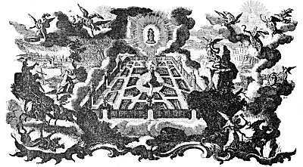  
JOHN'S VISION OF THE NEW JERUSALEM.

From Klauber's *Historiae Biblicae Veteris et Novi Testamenti*.

*In the upper left-hand corner is shown the destruction of Babylon, also the angel which cast the great millstone into the sea, saying, "Thus with violence shall that great city Babylon be thrown down and shall be found no more at all." Below is the horseman, called Faithful and True, casting the beast into the bottomless pit. At the lower right is the angel with the key to the bottomless pit, who with a great chain binds Satan for a thousand years. In the heavens above is represented one like unto the Son of Man, who carries a great sickle with which he reaps the harvest of the world. In the center is the Holy City, the New Jerusalem, with its twelve gates and the mountain of the Lamb rising in the midst thereof. From the throne of the Lamb pours the great river of crystal, or living water, signifying the spiritual doctrine: upon all who discover and drink of its waters are conferred immortality. Kneeling upon a high cliff, St. John gazes down upon the mystic city, the archetype of the perfect civilization yet to be. Above the New Jerusalem, in a great sunburst of glory, is the throne of the Ancient One, which is the light of those who dwell in the matchless empire of the spirit. Beyond the recognition of the uninitiated world is an ever-increasing aggregation composed of the spiritual elect. Though they walk the earth as ordinary mortals, they are of a world apart and through their ceaseless efforts the kingdom of God is being slowly but surely established upon earth. These illumined souls are the builders of the New Jerusalem, and their bodies are the living stones in its walls. Lighted by the torch of truth they carry on their work, through their activities the golden age will return to the earth and the power of sin and death will be destroyed. For this reason the declare that virtuous and illumined men, instead of ascending to heaven, will bring heaven down and establish it in the midst of earth itself.*

The thirteenth chapter describes a great beast which rose out of the sea, having seven heads and ten horns. Faber sees in this amphibious monster the Demiurgus, or Creator of the world, rising out of the Ocean of Chaos. While most interpreters of the Apocalypse consider the various beasts described therein as typical of evil agencies, this viewpoint is the inevitable result of unfamiliarity with the ancient doctrines from which the symbolism of the book is derived. Astronomically, the great monster rising out of the sea is the constellation of Cetus (the whale). Because religious ascetics looked upon the universe itself as an evil and ensnaring fabrication, they also came to regard its very Creator as a weaver of delusions. Thus the great sea monster (the world) and its Maker (the Demiurgus), whose strength is derived from the Dragon of Cosmic Power, came to be personified as a beast of horror and destruction, seeking to swallow up the immortal part: of human nature. The seven heads of the monster represent the seven stars (spirits) composing the constellation of the Great Dipper, called by the Hindus *Rishis*, or Cosmic Creative Spirits. The ten horns Faber relates to the ten primordial patriarchs. These may also denote the ancient zodiac of ten signs.

The number of the beast (666) is an interesting example of the use of Qabbalism in the New Testament and among early Christian mystics. In the following table Kircher shows that the names of Antichrist as given by Iranæus all have 666 as their numerical equivalent.

|  |  |  |  |  |  |  |  |
| --- | --- | --- | --- | --- | --- | --- | --- |
| Τ | 300 | Λ | 30 | Λ | 1 | Λ | 30 |
| ε | 5 | α | 1 | ν | 50 | α | 1 |
| ι | 10 | μ | 40 | τ | 300 | τ | 300 |
| τ | 300 | π | 80 | ε | 5 | ε | 5 |
| α | 1 | ε | 5 | μ | 40 | ι | 10 |
| ν | 50 | τ | 300 | ο | 70 | ν | 50 |
|  |  | ι | 10 | ς | 200 | ο | 70 |
|  |  | ς | 200 |  |  | ς | 200 |
|  | 666 |  | 666 |  | 666 |  | 666 |

James Morgan Pryse also notes that according to this method of figuring, the Greek term ἡ φρην, which signifies the lower mind, has 666 as its numerical equivalent. It is also well known to Qabbalists that Ἰησους, Jesus, has for its numerical value another sacred and secret number--888. Adding the digits of the number 666 and again adding the digits of the sum gives the sacred number--9 the symbol of man in his unregenerate state and also the path of his resurrection.

The fourteenth chapter opens with the Lamb standing on Mount Zion (the eastern horizon), about Him gathered the 144,000 with the name of God written in their foreheads. An angel thereupon announces the fall of Babylon--the city of confusion or worldliness. Those perish who do not overcome worldliness and enter into the realization that spirit--and not matter--is enduring; for, having no interests other than those which are material, they are swept to destruction with the material world. And St. John beheld One like unto the Son of Man (Perseus) riding upon a cloud (the substances of the invisible world) and bearing in his hand a sharp sickle, and with the sickle the Shining One reaped the earth. This is a symbol of the Initiator releasing into the sphere of reality the higher natures of those who, symbolized by ripened grain, have reached the point of liberation. And there came another angel (Boötes)--Death--also with a sickle (Karma), who reaped the vines of the earth (those who have lived by the false light) and cast them into the winepress of the wrath of God (the purgatorial spheres).

The fifteenth to eighteenth chapters inclusive contain an account of seven angels (the Pleiades) who pour their vials upon the earth. The contents of their vials (the loosened energy of the Cosmic Bull) are called the seven last plagues. Here also is introduced a symbolic figure, termed "the harlot of Babylon, "which is described as a woman seated upon a scarlet-colored beast having seven heads and ten horns. The woman was arrayed in purple and scarlet and bedecked with gold, precious stones, and pearls, having in her hand a golden cup full of abominations. This figure may be an effort (probably interpolated) to vilify Cybele, or Artemis, the Great Mother goddess of antiquity. Because the pagans venerated the *Mater Deorum* through symbols appropriate to the feminine generative principle they were accused by the early Christians of worshiping a courtesan. As nearly all the ancient Mysteries included a test of the neophyte's moral character, the temptress (the animal soul) is here portrayed as a pagan goddess.

In the nineteenth and twentieth chapters is set forth the preparation of that mystical sacrament called the marriage of the Lamb. The bride is the soul of the neophyte, which attains conscious immortality by uniting itself to its own spiritual source. The heavens opened once more and St. John saw a white horse, and the rider (the illumined mind) which sat upon it was called *Faithful* and *True*. Out of his mouth issued a sharp sword and the armies of heaven followed after him. Upon the plains of heaven was fought the mystic Armageddon--the last great war between light and darkness. The forces of evil under the Persian Ahriman battled against the forces of good under Ahura-Mazda. Evil was vanquished and the beast and the false prophet cast into a lake of fiery brimstone. Satan was bound for a thousand years. Then followed the last judgment; the books were opened, including the book of life. The dead were judged according to their works and those whose names were not in the book of life were cast into a sea of fire. To the neophyte, Armageddon represents the last struggle between the flesh and the spirit when, finally overcoming the world, the illumined soul rises to union with its spiritual Self. The judgment signifies the weighing of the soul and was borrowed from the Mysteries of Osiris. The rising of the dead from their graves and from the sea of illusion represents the consummation of the process of human regeneration. The sea of fire into which those are cast who fail in the ordeal of initiation signifies the fiery sphere of the animal world.

In the twenty-first and twenty-second chapters are pictured the new heaven and the new earth to be established at the close of Ahriman's reign. St. John, carried in the spirit to a great and high mountain (the brain), beheld the New Jerusalem descending as a bride adorned for her husband. The Holy City represents the regenerated and perfected world, the trued *ashlar* of the Mason, for the city was a perfect cube, it being written, "the length and the breadth and the height of it are equal." The foundation of the Holy City consisted of a hundred and forty-four stones in twelve rows, from which it is evident that the New Jerusalem represents the microcosm, patterned after the greater universe in which it: stands. The twelve gates of this symbolic dodecahedron are the signs of the zodiac through which the celestial impulses descend into the inferior world; the jewels are the precious stones of the zodiacal signs; and the transparent golden streets are the streams of spiritual light along which the initiate passes on his path towards the sun. There is no material temple in that city, for God and the Lamb are the temple; and there is neither sun nor moon, for God and the Lamb are the light. The glorified and spiritualized initiate is here depicted as a city. This city will ultimately be united with the spirit of God and absorbed into the Divine Effulgency.

And St. John beheld a river, the Water of Life, which proceeded out of the throne of the Lamb. The river represents the stream pouring from the First Logos, which is the life of all things and the active cause of all creation. There also was the Tree of Life (the spirit) bearing twelve manner of fruit, whose leaves were for the healing of the nations. By the tree is also represented the year, which every month yields some good for the maintenance of existing creatures. Jesus then tells St. John that He is the root and the offspring of David and the bright and morning star (Venus). St. John concludes with the words, "The grace of our Lord Jesus Christ be with you all. Amen."

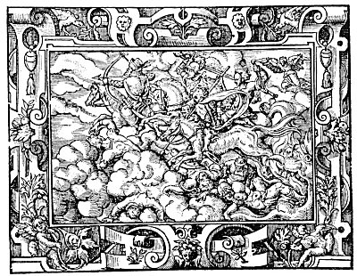  
THE FOUR HORSEMEN OF THE APOCALYPSE.

From *Solis' Biblische Figuren*.

*In the allegory of the four horsemen--according to the mysteries of philosophy--is set forth the condition of man during the stages of his existence. In his first and spiritual state he is crowed. As he descend into the realm of experience he carries the sword. Reaching physical expression--which is his least spiritual state--he carries the scales, and by the "philosophic death" is released again into the highest spheres. In the ancient Roman games the chariot of the sun was drawn by four horses of different colors and the horsemen of the Apocalypse may be interpreted to represent the solar energy riding upon the four elements which serve as media for its expression.*

===================================================================================================================================================

END