**Cheiro or Count Louis Hamon 1866 - 1936**

<http://en.wikipedia.org/wiki/Cheiro>

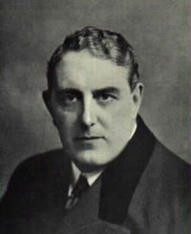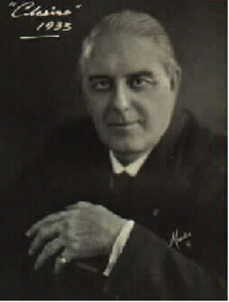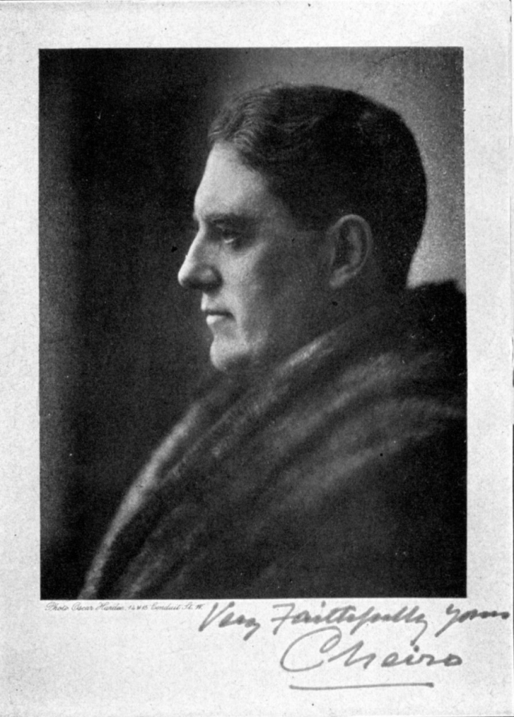

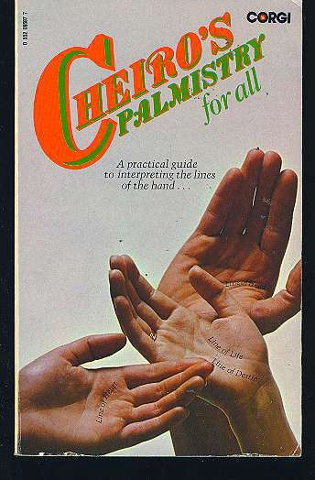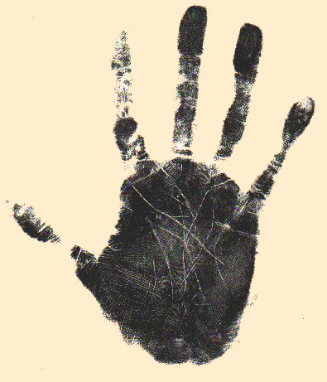

**Cheiro** (November 1, 1866 - October 8, 1936), was one of the most famous and colorful [occult](http://en.wikipedia.org/wiki/Occult) figures of the early Twentieth Century. Born in Dublin, Ireland as **William John Warner**, Cheiro also went by the name **Count Louis Hamon** (or **Count Leigh de Hamong**), claiming a noble ancestry that may or may not have been accurate. His name, Cheiro, derives from the word *cheiromancy* -- meaning palmistry. Cheiro was a supposed [clairvoyant](http://en.wikipedia.org/wiki/Clairvoyant) who taught [palmistry (or cheiromancy)](http://en.wikipedia.org/wiki/Chiromancy), [astrology](http://en.wikipedia.org/wiki/Astrology), and [Chaldean](http://en.wikipedia.org/wiki/Chaldea) [numerology](http://en.wikipedia.org/wiki/Numerology), and used these forms of divination to make predictions, both personal ones for clients, and more general ones about coming world events.

**Biography**

As mentioned in his memoirs, Cheiro acquired his magnificent expertise in [India](http://en.wikipedia.org/wiki/India). He went to India and landed at the [Mumbai](http://en.wikipedia.org/wiki/Mumbai) port when he was a teenager. There he met his [Guru](http://en.wikipedia.org/wiki/Guru), an Indian [Brahmin](http://en.wikipedia.org/wiki/Brahmin), who took him to his village situated in the valley of the [Konkan](http://en.wikipedia.org/wiki/Konkan) region of [Maharashtra](http://en.wikipedia.org/wiki/Maharashtra). After studying thoroughly for two years there he came back to London and started his career as a palmist.

Cheiro had a wide following of famous European and American clients during the late 19th and early 20th centuries. He read the palms and told the fortunes of famous celebrities like [Mark Twain](http://en.wikipedia.org/wiki/Mark_Twain), [W. T. Stead](http://en.wikipedia.org/wiki/W._T._Stead), [Sarah Bernhardt](http://en.wikipedia.org/wiki/Sarah_Bernhardt), [Mata Hari](http://en.wikipedia.org/wiki/Mata_Hari), [Oscar Wilde](http://en.wikipedia.org/wiki/Oscar_Wilde), [Grover Cleveland](http://en.wikipedia.org/wiki/Grover_Cleveland), [Thomas Edison](http://en.wikipedia.org/wiki/Thomas_Edison), the [Prince of Wales](http://en.wikipedia.org/wiki/Prince_of_Wales), [General Kitchener](http://en.wikipedia.org/wiki/Herbert_Kitchener%2C_1st_Earl_Kitchener), [William Gladstone](http://en.wikipedia.org/wiki/William_Gladstone), and [Joseph Chamberlain](http://en.wikipedia.org/wiki/Joseph_Chamberlain). He documented his sittings with these clients by asking them to sign a guest book he kept for the purpose, in which he encouraged them to comment on their experiences as subjects of his character analyses and predictions.

In his own autobiographical book, "Cheiro's Memoirs: The Reminiscences of a Society Palmist", he included accounts of his interviews with [King Edward VII](http://en.wikipedia.org/wiki/King_Edward_VII), William Gladstone, [Charles Stewart Parnell](http://en.wikipedia.org/wiki/Charles_Stewart_Parnell), [Henry Morton Stanley](http://en.wikipedia.org/wiki/Henry_Morton_Stanley), Sarah Bernhardt, Oscar Wilde, [Professor Max Muller](http://en.wikipedia.org/wiki/Max_M%C3%BCller), [Blanche Roosevelt](http://en.wikipedia.org/wiki/Blanche_Roosevelt), the [Comte de Paris](http://en.wikipedia.org/wiki/Comte_de_Paris), [Joseph Chamberlain](http://en.wikipedia.org/wiki/Joseph_Chamberlain), [Lord Russell of Killowen](http://en.wikipedia.org/wiki/Lord_Russell_of_Killowen), [Robert Ingersoll](http://en.wikipedia.org/wiki/Robert_G._Ingersoll), [Ella Wheeler Wilcox](http://en.wikipedia.org/wiki/Ella_Wheeler_Wilcox), [Lillie Langtry](http://en.wikipedia.org/wiki/Lillie_Langtry), Mark Twain, W.T. Stead (of Titanic fame), [Richard Croker](http://en.wikipedia.org/wiki/Richard_Croker), Natalia Janotha, and other prominent people of his era.

In the book Titanic's Last Secrets is a detailed account of one of Cheiro's palm readings with William Pirrie, chairman of Harland and Wolf, builders of the Titanic. Cheiro predicted that he would soon be in a fight for his life, talking about the battle surrounding the Titanic sinking.

So popular was Cheiro as a "Society Palmist" that even those who were not believers in the occult had their hands read by him. The skeptical Mark Twain wrote in Cheiro's visitor's book: "Cheiro has exposed my character to me with humiliating accuracy. I ought not to confess this accuracy, still I am moved to do so." - Mark Twain.

After some years in London, and many world travels, Cheiro moved to America. He spent his final years in Hollywood, seeing as many as twenty clients a day and doing some screenwriting before his death there in 1936 at the age of 69.

The occult books Cheiro wrote centered on fortune telling. They include two on astrology: "When Were You Born?" and "You and Your Stars"; four on palmistry: "Cheiro's Language of the Hand" (first [self-published](http://en.wikipedia.org/wiki/Self-publishing) in 1897), "Cheiro's Guide to the Hand", "You and Your Hand" and "Cheiro's Palmistry for All"; one on numerology: "Cheiro's Book of Numbers"; and one book of prognostications: "Cheiro's Book of World Predictions". In addition, he wrote a collection of attested tales of paranormal experiences called "True Ghost Stories." His only work of fiction, "A Study of Destiny" (also published as "The Hand of Fate"), was first released in 1898.

Many of Cheiro's books on occultism and fortune telling are still in print today and are available in both English and foreign language editions.

In 2006 the University of Tampa Press issued a critical new edition of his fictional work, "A Study of Destiny", as the second volume of "Insistent Visions", a series dedicated to reprinting little-known or neglected works of supernatural fiction, science fiction, mysteries, or adventure stories from the 19th century. The new edition is edited with an introduction, afterword, and notes by Sean Donnelly.

**See also**

* [numerology](http://en.wikipedia.org/wiki/Numerology)
* [palmistry](http://en.wikipedia.org/wiki/Palmistry)
* [astrology](http://en.wikipedia.org/wiki/Astrology)

**External links**

* Cheiro. [*Palmistry for All*](http://www.gutenberg.org/etext/20480) at [Project Gutenberg](http://en.wikipedia.org/wiki/Project_Gutenberg)