Forlong dux
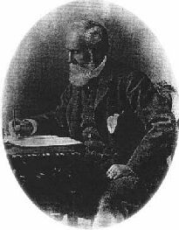

(1824 - 1904 e.v.)
by T. Apiryon
Copyright © 1995, 1997 Ordo Templi Orientis. All rights reserved.

http://www.hermetic.com/sabazius/forlong.htm

Major-General J.G.R. (James George Roche) Forlong was a Scottish military engineer in the Anglo-Indian Army, who received acclaim from the governments of England and India for his brilliant feats of road-building in the jungles of the Indian subcontinent during the Mahratta and Burmese wars.
Forlong's lifelong hobby was the comparative study of the religions of Man, a study which was facilitated by his knowledge of seven languages. He avidly pursued this avocation during his 33 extensive travels in India, as well as after retiring from the military in 1876. He is the author of two monumental works on the subject: Faiths of Man, a Cyclopaedia of Religions (1906) and Rivers of Life (1883). The latter is included in Section 1 of the A:. A:. reading list. Faiths of Man compares the various religions of mankind, demonstrating that many elements of the Christian mythos were borrowed from older religions. Rivers of Life traces the development of the great world religions back to their primitive origins in the worship of the sun and/or the phallus.
Dux (rhymes with "hooks") is Latin for "leader." In the late Roman Empire, a dux was a military chief commanding the troops in a frontier province, and is the origin of the title "Duke." The term "dux" is used in Scotland to denote a student who is academically first in his or her class.
References:
Allibone, S. Austin; Allibone's Dictionary of English Literature and British & American Authors, J.B. Lippincott & Co., Philadelphia 1871
Forlong, J.G.R.; Faiths of Man, a Cyclopaedia of Religions [Bernard Quaritch, 1906], University Books, NY 1964
Forlong, J.G.R.; Rivers of Life, or Sources and Streams of the Faiths of Man in all Lands, showing the Evolution of Faiths from the Rudest Symbolisms to the Latest Spiritual Developments, London 1883
2/1/97
Originally published in Red Flame No. 2 -- Mystery of Mystery: A Primer of Thelemic Ecclesiastical Gnosticism by Tau Apiryon and Helena; Berkeley, CA 1995 e.v.

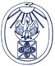
The Silent Language Exhibition
Foreword by J. R. Ritman
http://www.xs4all.nl/~bph/silent_foreword.html

‘Panta rei’. All life is movement and the symbol is her witness
The exhibition ‘The silent language. The symbols of Hermetic Philosophy’, which has been put together from the rich sources of the Bibliotheca Philosophica Hermetica, is, as far as I know, the first exhibition which demonstrates an integral relationship in the language of symbols used in hermetic philosophy, in mysticism, in alchemy and in the Rosicrucian movement.
These four main areas into which hermetic-Christian philosophy has been gathered within the Bibliotheca Philosophica Hermetica have, each in their separate way, produced a Silent Language, a Lingua Muta, which, in the form of the symbol, the hieroglyph, or other character, reflects a universal world of concepts, alive and directly accessible to all mankind, and as ancient as the road of humanity itself.
In his incomparable study Rivers of life, J.G.R. Forlong uncovers the history of the growth of the great spiritual movements of mankind, which go back over 10,000 years before our Christian era. The primal aspects of the major spiritual movements are represented by him in five symbols.
First of all there is the symbol of the sun as the wheel of life, explaining the sun mysteries of Mithra. Secondly, there is the symbol of fire, the so-called Aesch Majim, the fire-water principle in which the primal wisdom, as it is also visible in the Jewish Kabbala, finds its origin. Thirdly, there is the symbol of the tree, also called the tree of life and the tree of the knowledge of good and evil, in which both the life-creating principle, as well as the polarity of life manifesting itself within it, are brought to life, an image which in many successive spiritual movements has been each time explained anew. Fourthly, there is the symbol of the phallus, as the bearer of the life-giving principle itself, the seminal principle, which lies at the basis of the procreation, continuation, multiplication and fertility of life, and expresses itself in the human, animal, vegetable and mineral world. Finally, the symbol of the snake appears, a reference on the one hand to the paradisical myth, the Fall of Man, but in its most sublimated form the symbol of wisdom, the fullness of the pleroma, the reality of the gnosis, the knowledge of God, which has come about through Him, in Him and by Him, the All-One.
The force of the symbol lies in her practical allusion to the ancient principle ‘panta rei’: all life is movement. As the bird is an emblem of the sky, the fish an emblem of the water and the four-footed animal an emblem of earth, the living nature, so man has been placed by his creator, the cosmo-creator, as a microcosm in the centre of His creation, this being the symbol of an originally conceived place for the micro-creator - the little creator - to live and to exist in the world of the perennial continuation of life.
In the approximately sixty works in which the symbols of the hermetic philosophy are presented in this exhibition the focal role is revealed of the hermetic philosopher, the candidate in the mysteries, in his encounter with the fullness of the mystery, which is enacted as in a process. The candidate is placed before the age-old hermetic axiom: "Visita Interiora Terrae Rectificando Invenies Occultum Lapidem": Visit the Innermost of the Earth and by Rectifying you will find the Hidden Stone.
This hidden stone, referred to in the above axiom, in which the Latin initial letters acrostically form the word ‘vitriol’, is a symbolical allusion to obtaining the tincture of life, which has been held out to the candidate in the mysteries as a promise, so that, like a crown on his path of initiation, he may receive and apply it as a spiritual force, as the Philosophers’ Stone.
The old alchemists speak of the four elements of earth, water, air and fire, of the three principles salt, sulphur and mercury, of the two aspects of life, the male and female, and finally of the one principle, the tincture. Pythagoras already expressed this thousands of years ago in the symbol of the triangle in which this principle is at the same time a reflection of the ten prime numbers one to ten.
•
• •
• • •
• • • •
If we really wish to enter the world of symbols, we must also accept that each symbol has three aspects. There is the visible symbol, in itself a living, active force. Then there is the meaning of the symbol, the symbol’s allusion to a process of transfiguration, a process of transformation of inherently inspired life. Lastly, the symbol teaches us to understand the spiritual principle which motivates all forms of life. It is the spiritual world, the spiritual creative force itself, the All-One, through whom, by whom and for whom everything has come about.
That is why we have to view the world of symbols in the first place in her concrete and actual meaning, secondly as part of a process of inner gestation and growth, in order finally to break through to the origin itself, the pneuma out of which all life comes forth.
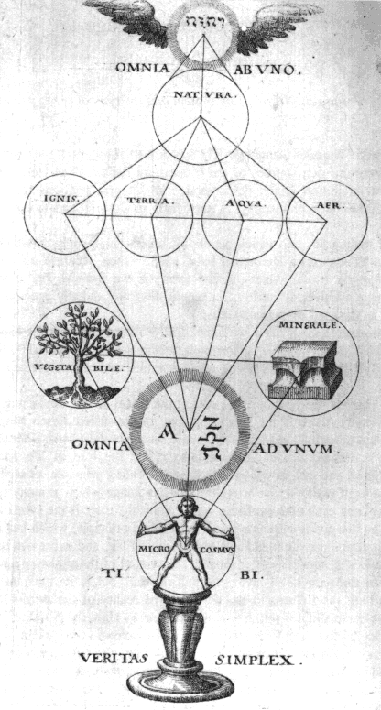
If we take a closer look at the catalogue which has been prepared for this exhibition, and also when we are able to study the symbols themselves when visiting the exhibition, we can experience how tremendously important the great influence of the symbol and the language of imagery is for the works collected in the Bibliotheca Philosophica Hermetica. It is a direct confrontation with the meaning of the symbol and also with the autonomous place which it occupies side by side with the written word. By means of a selection of works from the collections of the Bibliotheca Philosophica Hermetica, a period of three hundred years has been covered in which the symbol acts as the spritual carrier of the text.
From the opening work in the catalogue, Heinrich Suso’s work Das Buch genannt Seuse, printed in 1482, in which we see an image of Christ crucified on the tree of life with its blossoming roses, referring to the many works of Christ, through to the apotheosis of this exhibition, the Geheime Figuren der Rosenkreuzer, printed in Altona in 1785-88, containing an image of the tree of the knowledge of good and evil, we can find numerous expressions of the hermetic-Christian tradition.
It is the testimony of the living stream of knowledge and wisdom which came to the interpreters of this symbolic language as an exalted inspiration. It is at the same time the key to the Bibliotheca Philosophica Hermetica and her basic principle, ‘Ad fontes’, to the source.
We are standing in the middle of a historical development in which the meaning and the function of the symbol once again make themselves known to the communal consciousness, and in which man, as seeker, as candidate in the mysteries, must come to the Knowledge of the Heart, indeed, to Gnosis itself.
That is why the act of seeing and understanding the symbol is sometimes also explained as looking with the eyes of the heart. If we can come to the insight that an intellectual and rational approach to life can also turn us into the prisoners of our sensory perceptions, the moment has arrived for us to aspire, with the powers of the living, witnessing soul, to the meeting with the spiritual force of the divine creator, the source, the origin of life itself. This is the wish and the task which, like a key formula, informs this exhibition.
J.R. Ritman
Founder Bibliotheca Philosophica Hermetica

