OUSPENSKY, GURDJIEFF & the Work "FRAGMENTS OF AN UNKNOWN TEACHING"

To speak of Ouspensky is to speak of Gurdjieff and to speak of Ouspensky and Gurdjieff is to speak of the Esoteric Tradition which was unveiled, in a fragmentary way by Gurdjieff, with the substantial co-operation of Ouspensky.
The greatest difficulty when we approach esoteric problems consists in the fact that we live in an analytical society, above all, where civilisation has created, by means of specialisation which extends to infinity, a very cultured elite which has a certain characteristic particular to it: in general, each intellectual, taken apart, possesses an infinitesimal part of our total knowledge only. (Knowledge: in French "savoir").
Such a man is, undoubtedly, a very clever specialist in his own field, but has, as far as the rest is concerned, somewhat restricted and primitive notions. Yet because this "rest" embraces the ensemble of our life, which becomes more and more complex and feverish, that we must confront it at each instant,- we have been compelled to create, in addition to the division of Knowledge into separate compartments, a complete system of "buttons & switches" in order that any individual obtains the wanted effects, by pressing them, without being obliged to pass by the necessary studies and work. By paying what is required from him, of course.
Thus, the actual art of Living consists in summarising and in acquiring a profound knowledge in some narrow sector of the Ensemble which, on its own, is a process which gives access to fortune, to honours and to the rest, in knowing how to utilise that system of buttons cleverly it answers all our needs. It was certainly the same for the Greeks and the Romans, but because the antique world did not know about our actual specialisation which has been pushed to its extreme limits, the sector of "buttons and switches" was rather limited in those societies, while that of the "profound knowledge" extended -contrary to our case -to embrace all of the knowledge in those epochs.
The system of specialisation which, both in theoretical studies and in practical realisation, is only a judicious division of work and has, in fact, permitted us to achieve the marvels of progress but, as a counterpart it has accustomed modern man to think in depth no more, except in so far as his branch or field is concerned.
In its turn, such a state of affairs, has led to a disequilibrated formation of the elite in the contemporary man :- for next to the latter's very developed criticising spirit, AN UNSUSPECTED BENEVOLENT CREDULITY was also developed in his subconscious, in everything beyond his branch of specialisation and its closest neighbouring domains.
But the study of the Esoteric Tradition and the conquest of the aims it seeks to achieve require cautious circumspection and deep thought due to the specific nature it is endowed with. Nothing can be obtained there by pushing "buttons". On the contrary, credulity as that which we enjoy, while dialling any phone number, for example, and being sure of: getting the person we want to talk to at the other end, is full of the worst dangers, when applied to esoteric studies.
A criticising spirit, the ability to discern, a sound healthy judgement and good common sense are required here, even more than in positive scientific studies. After all, the total risk, in the latter is not as great as we may fear. It would be limited to unsuccessfulness, for the objects of our studies remain out of the range of our studies. On the contrary, the student, in esoteric studies, and the object of his studies are only one. While positive philosophy, studies abstract man, esoteric philosophy studies a given and specified man who is, precise]y starting to study. The method of introspection practiced by all esoteric schools, together with the exercises that arc subsequently attached to it; leave their mark upon the personality of the student, as from the beginning without any exception. For it is upon his own personality and not upon that of others, or upon theoretical notions, that the student is called upon to apply all his efforts from the start and this is, of course, in view of transforming it. Let us say that a wicked or cruel man can make any scientific discoveries, but that would be impossible for him in so far as esoteric matters are concerned. For before starting any constructive work, the student must, compulsorily, discipline himself and then equilibrate his Psyche: that is, his own personality.
Such a process would not create any danger, if the work is correctly done and successfully achieved. But when the work is left in mid way or pursued under the direction of an incompetent professor, or worse still, when it is work with an INTEREST, then it can lead to catastrophes. The habitual result is dissolution of the Personality.
The symptoms, of such a progressive dissolution, are a state of malaise, moral depression, black pessimism and a mania of being persecuted. In graver cases, it can lead to total disequilibrium that can go up to Self-denegation and this will open the way towards suicide.
* * * *
Critical analysis which constitutes the basic method of positive sciences is equally that of esoteric studies. In such a way, that the scientific value of both these two branches of Human knowledge arc absolutely equivalent. Yet, there is a difference in application between them, which we must indicate here.
In Positive Science, we can expose and demonstrate any given postulate publicly, for the object of study of the scientist is not identical with himself. His thesis is submitted to a hard critical analysis by other men of science, is not accepted as an article of science except after the thesis has been submitted to the test, passed and has been impossible of being rejected. In esoteric studies, however, the essential part of the work is introspectively led in the interior world of the searcher. And as the latter and the object of his researches are one and the same, it is materially impossible to submit his interior experiences to academic demonstration.
However, when different postulates are proposed to the students, they are never required to take them for granted, just like that, in so far as esoteric matters are concerned. They are, on the contrary, urgently required to avoid any tendency to credulity. But given that the object of their studies belongs to their interior world and because, on the other hand, such studies lead towards the NEW by their own nature, that is towards the UNKNOWN, it is recommended that these students do not seek to demolish the proposed postulates from the start to accept them later on, but on the contrary, to try to utilise them and to confirm their validity by their own lived experiences later on, in accordance with the methods traditionally indicated. And if, after having applied the postulates conscientiously and assiduously, they did not reach the pre-established results, they will then, have the full right of rejecting them.
The criticising spirit is then required in esoteric studies, in the same way as it is required in positive science. But whereas the latter starts from the centre and tries to reach the circumference at all its points, by means of the outward radiation of the specialisation, the former, starts from the periphery and tries to progress towards the centre.
It was quite useful to expose these few elementary notions, in order to facilitate this to the reader who would not be quite familiar with such matters, the intelligence and comprehension of the present subject whose object is:- OUSPENSKY,GURDJIEFF AND "THE FRAGMENTS OF AN UNKNOWN TEACHING".
When I first received my exemplary of "The Fragments of an Unknown Teaching" in 1951, I experienced a mixed sentiment. I had known Ouspensky quite intimately for a long time. At the base of our friendship there existed the spirit of research which animated both of us. I had assisted with the public conference he was giving in constantinopo1e in 1920-1921 and it was there that he had put me into contact with G. I. Gurdjieff. There I had, equally, been informed of the SYSTEM which the latter was vehicu1ating and transmitting. I have discussed it with Ouspensky, at Constantinople to begin with, then in Paris and in London later on.
Ouspensky, who was then residing in England since 1921, was writing his "Fragments" there, too, in Russian. Later on, he trusted the Baron O.A. Raush of Traudenberg, who was then settled in Paris to translate them, asking me to edit the translation.
The work slowly progressed during 1924 and the following years until Mrs. Raush died from tuberculosis in the summer of 1928 Ouspensky had asked me to transmit to him my critical objections in so far as the work itself was concerned, in addition to editing the translation. I consented and did that willingly, in part through the letters I was sending him, but more fully during the lengthy exchanges of our mutual views whenever he came from London to Paris. I took his manuscript mainly to be of service to him, for he did not know French well enough and, on the other hand, it was a good opportunity for me to discuss all the elements of the system with him. Since then, we did not always agree as to the interpretation of some of its aspects and sometimes, as to their profound meaning. That, nevertheless, never altered our reciprocal friendship whatsoever, for our discussions were always put under the aegis of the principle saying: "Amicos Plato, sed magis, arnica veritas".
*****
I met Ouspensky for the last time in may 1937, when I went to see him in London, more 'precisely, at the Chateau d’Etyne not far from the capital, for he had settled there together with his disciples. We obviously spoke about the "Fragments". I was hostile to the publication of "Fragments". It seemed to me that the esoteric doctrine, due to its specific nature, would not fit properly in detailed written exposition. 'That was, probably, the reason why St. John wrote:-"if they should be written in detail, I suppose that even the world itself would not contain the books that we would write.
I must say that Ouspensky was aware of that and he ended by sharing my point of view with me. The proof is that. he never published his “Fragments”, the text of which was completed nearly twenty years before his death.
There were two other reasons for my negative attitude. For Ouspensky, and much more so of course, those who were around him, made neither proper distinction nor any net cleavage between the MESSAGE & the MESSENGER. This does not mean that he had no idea about the problem. Though, he even discussed it in a way in his "Fragments" by using terms which betray his weakness. If in 1924, in fact, they separated, it was only a bodily separation, called in the Roman Church "Marriage". It had never been a divorce, in good and due form. For Ouspensky put the MESSENGER, that is Gurdjieff, at the exact centre of the events to which the turmoil was driving him. So much so that, in 1928, in Constantinopo1e he was still comparing him to Socrates, leaving it to be understood that his own role was that of Plato. But Socrates was a hero, while Gurdjieff enjoyed the jolly life. We should never minimise the merits of Gurdjieff and we must not forget that he brought his message when he was no more than a primitive man, not having fallen into grave contradictions with himself. We will truly evaluate the extent of his efforts when we remember that Ouspensky, who was a philosopher and a talented writer, took ten years to expose his writing and another ten years for the necessary rectifications.
Although the first work always leaves a seal of a lifetime on any man, Ouspensky, being a professional newspaper man, gave to the "Fragments", without being quite aware of it, the character of any article conceived in accordance with the latest fashion of the twentieth century that is with his own strong personal nuances. All in all, the "Fragments are nothing but Gurdjieff seen through the eyes of Ouspensky.
Nevertheless, the essential thing was to transplant the message to a proper soil so that it would extend its roots and bear fruits. It clearly appeared to me, at an early stage, that to do that, the message should have been placed in its HISTORICAL CONTEXT and I began to be well aware that, without such a condition, it was condemned to remain a dead letter, or even worse still, to engender dangerous deviations.
That which prevented Ouspensky from taking a clear position towards Gurdjieff, was that he strictly concerned himself with the message while leaving the messenger to his own adventure with all his qualities and all his defects. That was due to the fact that he was under a strong PERSONAL influence from the latter.
Ouspensky was unable to resist such an influence for many reasons. First, of all because of his own character. He was charming though, subject to fits of anger, -lovable, quite artful in the dialectic but he was not a strong man. In addition, he was a self-made man in science and philosophy etc... He did not even complete his secondary education. He was full of ideas, tender hearted and a talented writer and was not protected interiorly by that precious armour which is the scientific method. In him, everything floated, therefore, being open to exterior influences. In addition he led a very lonely and isolated life which did not spare him the worst deceptions. But Gurdjieff was, on the contrary, a man of firm character, though, of a limited horizon. He imposed himself upon Ouspensky. The latter aspired to the MARVELLOUS and in his naive credulity, he has always thought that, behind the ideas, the postulates and the schematic figures -which in their ensemble constitute the message– there was still an undeniable reserve of all kinds of marvels which, as he used to say, one must know "how to extract" from Gurdjieff. But as we shall see 1atcr on, there was nothing but caved emptiness and "magic" also. Ouspensky aspired to the "facts" and in spite of some sudden changes of mood; he expected these facts from Gurdjieff, with pure faith and naivety. He was, thus, well prepared for hypnotic suggestions and it was precisely that which allowed Gurdjieff to give him the facts he wanted to give. Thence, he was able to keep Ouspensky for himself for many consecutive years, taking advantage of him and using him, above all in finding the necessary funds for his "institutes". One can say, even without exaggerating, that without Ouspensky, Gurdjieff's career would, probably, not have surpassed the stage of endless conversations in the cafes. Gurdjieff's domination over Ouspensky was calculated and perfectly established since the very beginning. Ouspensky tells us, in his "Fragments", how he attracted him towards his circle and consolidated the bond thereafter.
It is common knowledge that a sound and healthy individual can, quite easily, resist the efforts of any hypnotist if he does not want to be hypnotised. That is why, professional hypnotists seek to create an atmosphere, first of all. That case was rendered still easier for Gurdjieff, in Ouspensky's case. For the latter aspired to "facts" and sought after the "marvellous" with all the virginal strength of his innocent credulity while still believing himself to be quite realistic.
The dominance over Ouspensky had already been established in such a strong way, in Moscow and then in Finland, that many years later when he was writing the "Fragments", he tells us quite innocently how Gurdjieff had told him -as Ouspensky is the author of a remarkable treatise called “TERTIUM ORGANUM” - that he did not understand what he himself had written.
We all know that when the will of the hypnotist is, so to say, taken to heart by the desire of the patient, it is almost impossible for a third person to de-hypnotise him. So much so, that it was useless to try to demonstrate all the ridicule of such an affirmation, to Ouspensky, to say nothing of its insolence. Hypnosis exerted its redoubtable effects. ']'he arguments of simple good common sense had, in this case, no value at all. He, just got irritable and said that I understood nothing. He did not know - and this is paradoxical -that NO superior knowledge what so ever, ever goes in a contrary direction to common sense.
Ouspensky and I, were once dining at the Baron de Raush's house. While leaving the table, the son of Mrs. O.A. Raush who was a little boy of l2, approached us with his album and asked us to write something for him, therein. I was the first to whom he gave his album. I wrote the following: - Whatever might happen to you in life, never lose, from sight that two multiplied by two make four. I then gave the album to Ouspensky who wrote the following under my sentence: - Whatever might happen to you in life, never lose, from sight, that two multiplied by two, never make four...
Some paradoxical joke! Certainly it is. But for the present moment, the aspect which interests us is that, all of Ouspensky can be found right there.
He, then smiled and threw a malicious look at me. Alek, the boy read what we had written and showed it to his mother. He then shut it and withdrew after having wished us a good night. His mother, who knew Ouspensky quite well, raised her shoulders slightly, looked at each of us, one after the other and said: - "well! I recognise each one of you, perfectly, by his maxim."
*****

For Gurdjieff, Ouspensky as well as the SYSTEM, were simply a way of attracting people to himself and, thereafter, to exert his direct influence upon them. Ouspensky was not the only one; other persons have played the role, after him, of pushing new preys towards Gurdjieff. But, at the time I made my observations, Ouspensky was undoubtedly, the principal figure.
Upon the people who orbited around him, Gurdjieff exerted his influence in a very simple way and even a brutal one. If we leave the contents of the message aside, it was what he called the "work". That WORK, making abstraction of the conversations and of the exercises, consisted in persuading his disciples that they were zeros in number. He used to tell them, face to face, without choosing his words, -and to each one of them -that they were, no more and no less than, pure dirt and the people accepted that. I have been told that, in the last period, when he had already left Fontainebleau-Avon for Paris, he accentuated the expressions he used, even more, telling people who approached him and who were hoping to find some revelation, that they were, in fact, nothing but a simple "shitty shit".
One must not be too astonished at such facts. Leaving the case of Cagliostro aside, the story of "Maitre Philippe" and that of Rasputin in the court of Russia, give us yet more striking examples. We must not believe, that these were specifically Russian phenomena either, appertaining to the falsely called "slavic soul". For after all "Maitre Philippe" was a French man; and if Rasputin was Russian, one must not forget that the imperial family was of pure Germanic blood. For the dukes of Holstein-Gottorp, who reigned for about one hundred and fifty years, in Russia, always married their empresses in Germany, (German princesses); and so the Russian court gradually ended by being strongly germanised. Yet Rasputin, a peasant, scarcely literate, exerted a decisive influence upon the Empress, born Alice of Darmstadt, and upon Nicolas II. Such an influence, held under its dominance, not only the courtesans, but several ministers, statesmen and deputies equally.
What was the goal of Gurdjieff in fact? Nobody has ever known. It is as difficult to try to deduce this, from his acts, as it is in the case of Rasputin. Ouspensky has told us -it is written in the "Fragments" -that he had asked Gurdjieff that question, at the start, and that the latter answered: - “I have, certainly, got an aim and a goal but you will allow me not to talk about it. For my aim can mean nothing to you. What counts for you now, is that you define our own goal. As for the Teaching itself it could have no goal. Its task is to indicate the best way for men to reach their goal whatever it. might be.

***
Another question arises here, naturally, as to where he got the contents of the message or that SYSTEM, as we have said, which incontestably bears traces of an antique wisdom ? Ouspensky, who was haunted by the idea of ESOTERIC SCHOOLS, of which he had quite a personal representation and which he sought after, unsuccessfully, in the Orient, believed that Gurdjieff knew almost everything and, he asked him one day, to elucidate the question for him. Here is what he got from him:-
== “Today, told him Gurdjieff, you would find no SPECIALISED SCHOOLS except in the Orient; there are no general schools any longer. Each master or GURU is a specialist in some subject. One is an astronomer, another a scu1ptor, the third a musician and the students must study that which is the speciality of their master, before anything else, after that they go onto another subject, and so on. It would take a thousand years to study the whole”.
== “But you!! How did you study this?”
== “I was not alone. There were all kinds of specialists among us. Each one of us studied according to the methods of his particular science. Then, when we were gathered together, we gave the exact account of the results we had obtained to each other.”
== “And where are all your companions now?”
Gurdjieff, according to Ouspensky's ta1e, remained silent, then looking far away, he said slowly:-
== “Some are dead, others continue their works, others arc cloistered.”
That expression of the monastic language -goes on Ouspensky -heard in a moment when I least expected it gave me a sentimental feeling of being ill at ease. Suddenly I was clearly aware that Gurdjieff was leading me astray, as if he deliberately tried to throw a word, from time to time, which would interest me and orient my thoughts towards a definite direction. When I tried to ask him, in a clearer way, where he had found his knowledge and the source he had drawn the sum of his knowledge from and to what extent, he would not give me a direct answer.
*****
Lying, in so far as esoteric matter is concerned, cannot and does not cover the totality of possible human relations. There are sectors where nobody CAN EVER LIE, or, at least, ever lie totally and integrally. The last of the questions which Ouspensky had asked Gurdjieff, belonged to that sector. But Ouspensky did not know that law and because of that, he did not know how to ask the question either, in the way it should have been asked. I sat with Gurdjieff once, at The Cafe de la Paix, on the Grand Boulevards in Paris and suddenly with no preliminaries, I told him:-
== “I find the SYSTEM at the base of the Christian Doctrine. What have you got to say about that subject?
== “It is the ABC, he answered, but they do not understand it at all.”
== “That SYSTEM, does it belong to you?
== “NO...
== “Where did you find it and where, then, did you get it?”
== “May be, I robbed it...

I am bound to say -to understand my relations with Gurdjieff better -that I occupied a somewhat special position with him. I had had several contacts with him at Constantinople, Fontainebleau and Paris, but I had never become part of his "Institutes"; in other and clearer: terms, I HAD NEVER REALLY DEPENDED UPON HIM in whatever manner, anywhere. I was, therefore, out of the zone of his personal influence which dominated his immediate surroundings. This the reader must well know - that hypnotic influence, like any other sort of influence in nature, is inversely proportional to the square of the distance. A distance which is physical, psychic, or either of them. In fact, the effects of Gurdjieff's influence upon his immediate surroundings were quite visible. He could have proposed any absurdity to his disciples, even a monstrosity perhaps, being sure, in advance, that it would be accepted with enthusiasm as if it were a revelation. Within the psychological state, so created, people were using their power of reasoning no longer. Everything was good because, THUS SPAKE ZARATHUSTRA. They did not know that it was a method. That method is well known all over the Orient, where the teaching leading to the truth, is wrapped in a tight cover of scandals and of the most shocking contradictions. This aims at finding a resistance and with an immediate aim which is, to put the disciple between two groups of forces, also: Attraction and repulsion. Thus, to provoke a disquieting stirring in him and from thence, the most intense interior fight possible, between affirmations and negations, to create that "rubbing" which is called to engender a HEAT which will finally set the FIRE alight. .FOR THE WAY TO THE TRUTH, says the Christian doctrine, PASSES THROUGH DOUBTS. By so multiplying the doubts, both in the mind and in the heart of the student, he is offered the occasion to cross the preliminary stage, much more rapidly.
That very efficient method, to which allusions and of which traces can be found in the Gospels as well as in the Apostles and in the Fathers of the Ecumenical Church, has that great inconvenience, nevertheless, of when being applied in excess, completely disorientates persons! But in the Orient nobody has many scruples about such an inconvenience; for there, disoriented people are considered to be some kind of a degenerate by-product of the fabrication. For, as they say, our lives are not ours and do not even belong to us; it is a loan given to us precisely, in order to engage in that major experience and if the latter has not succeeded, so much the worse... Does the Parable of the Talents not say so quite explicitly?
One must also say that Gurdjieff, while capable of creating such an atmosphere around him with a lot of savoir-faire, yet he took care by giving repeated warnings. He used to say and repeat with maliciousness that ALL PEOPLE ASPIRED TO BE DUPES and that THEY LIKE TO BELIEVE IN THE LEGENDS THEY HAVE CREATED FOR THEMSELVES. Yet a11 his warnings remained with no effect. Some of the disciples saw nothing in these warnings but mere jokes of the master; others, while taking them seriously applied them to their neighbours and a third faction said that such maxims were to be taken in a superior sense...
And so it can be easily understood that whenever an outsider like me tried to raise his voice against the idolatry which surrounded Gurdjieff and made of him another Cagliostro or a kind of Rasputin, they all looked at me with condescendence and even with some compassion too.
*****
It was evident to me from the start that for such a system to be brought to Moscow or to Petrograd it was necessary for it to pass through a long historical route -to pass through the laity and the religious centres of Egypt, ancient Greece and Anterior Asia to take refuge finally in the bosom of the Oriental Orthodoxy upon Russia's soil which is the last surviving country of the ancient world which has now vanished. Such were, in fact, the few indications which had reached me from the extensive research done in that field during the second and third quarters of the XIXth Century by Andre Mouravieff who consecrated a great part of his life travelling through the Near-East. He had travelled extensively to Egypt, to the Holy Places, to Asia Minor up to the land of Armenia and to Kurdistan searching for ancient manuscripts and ancient Traditions. He founded the convent of Saint-Andre at Mount Athos having occupied the post of chamberlain at the imperial court and was a member of the Holy Synod. He built a hosteller in Constantinople and dedicated it to the pilgrims. He died in Kiev in 1874 and left the mission of pursuing these researches to his preferred disciples in his legacy in the region of Kars and the lakes of Ourmiah and Van to go thereafter to Azerbaijan in Persia.
I have pursued my own researches while taking into account all the preceding and I have done several comparative studies besides dealing with the original elements of the Russian culture compared with the sources of the Oriental Orthodoxy and I think that I have finally arrived at situating the MESSAGE brought by Gurdjieff in its historical context. But to do this, I have been obliged to go back to the ancient beliefs -slavic and pre-Christian -to establish their relations with the beliefs of the Scythes, of the ancient Indians and the ancient Egyptians. I have been obliged to study monuments such as the Philokalia to recommence the study of the Gospels anew with the help of the keys thus obtained and finally to study the Psalm CXVIII of King David which contains that same system in a compact form.
As a result of such researches the MESSAGE appeared to me to be like a heap of "fragments" or like an unknown teaching. Situated in its historical frame and upon its proper soil it lost its sensational character and its "exotic" taste, to appear at last like a mixed old source of symbols, of parables and of various allusions present and widely traceable everywhere to a certain extent and known to all.
To appear, on the other hand also, as the base of the ancient beliefs of the Slavs and the Scythes which can be found in the traditions of the Byzanto-Russian Orthodoxy also.
I have been able to establish equally that in the so called high Middle Ages the "fragments" had also been known in the Occident and probably, inherited, as was the case in the Orient, from the esoteric teachings of the ancient world through primitive Christianity.
There are certain traces of it that still exist. They constitute the leading thread which awaits new explorers.

III
The death of Katherine Mansfield at the "Institute" produced a strong impression upon Ouspensky and it made him determined to break away from Gurdjieff. But a still stronger impression was made upon him by the automobile accident which happened to Gurdjieff at the crossing of the national routes from Paris to Fontainebleau (No.7) and from Versailles to Choisy-le Roy (No.168)
Gurdjieff was returning from Paris to the Prieure at night alone in his car. The immediate cause of the accident was never known but there remains the fact that he threw himself right at the trunk of a tree while going at more than sixty kilometres per hour and was gravely wounded. Having been informed of that a few days later, Ouspensky went from London to Paris and we both went to the scene of the catastrophe. Desolate and even crushed, Ouspensky told me after a lengthy silence:-
== “I am scared... It is frightful... The Institute of Georges Ivanovitch was precisely created to escape from the LAW OF HAZARD under which anyone of us spend our lives and now he has fallen under the empire of the same law...”
Then he continued:-
== “I am still asking myself if it is really pure hazard? - Gurdjieff has always sold the probity as well as the human Personality in general very cheaply. Has he not in fact surpassed the measure? -I tell you I am terribly scared!!”
We went back in silence. When we reached Fontainebleau we went to a restaurant there to have our breakfasts. He asked me to phone the Prieure to call his daughter-in-law and tell her that she was part of the "philosophers of the forest" but she was not there.
While eating Ouspensky came back, more than once, to the question of the real value of Probity. Obviously that problem constituted a kind of turning-point for him. Then following some thought associations that were too obscure for me he tied that question of probity with the accident of Gurdjieff.

*****

Yet, as we have already said, Ouspensky had never broken off with Gurdjieff except physically so to speak. Thereafter, he did not like to go back -at least in my presence and during our conversations -to the "phenomenon of Gurdjieff". After he had adroitly eluded the subject a few times, I asked him directly why he avoided that kind of conversation which, according to me, could be quite instructive and from which we could, at least draw a lesson? It was late one night in a bar in Montmartre where Ouspensky wanted to spend the rest of the night after a good dinner in a restaurant in Saint-Michel. Suddenly hi~ expression changed. I had the impression then that there existed before me ANOTHER MAN and no longer the one I spent such an agreeable evening with engaging in very interesting conversation. He turned towards me abruptly and said in a very odd tone:-
== “Imagine that if a member of the family had committed a grave infraction; nobody would want to talk about it.”
It was my turn to become scared that time. I felt that Ouspensky could not deal with these questions. It was as if he were clashing with himself against an interdiction when touching these subjects. Was it a hypnotic effect? I repeat, at that moment I felt a shiver run down my back.

*****
It was quite clear that while being away from Gurdjieff physically, Ouspensky was still bound to the latter and that the binding had been imposed upon him.
I was convinced, once again, that this curious phenomenon, apart from the particularities of Ouspensky's character, was due to the fact that the latter had not had that solid foundation deep inside him which is given to all those who have enjoyed an academic formation. We have already seen that the method of positive science, somewhat differently applied, remains rigorously applicable to esoteric research and, in fact, constitutes the only solid guarantee for any INTELLECTUAL when he starts that kind of study. That was precisely what Ouspensky lacked.
His wife, a much more voluntary and human type was more authoritative than her husband and she had remained a fervent disciple of Gurdjieff both before and after her husband's rupture with Gurdjieff. She belonged to the group of instructors who had been formed by the latter. These INSTRUCTORS gave a strange impression.
I have had the privilege of approaching them as an outsider and furthermore after long intermittent intervals of time during, which they had certainly forgotten what they had told me previously.
Concerning the work they were always repeating the same leitmotiv, directly copied from the master's formula. Without being aware of it they sometimes took the Caucasian accent of Gurdjieff slightly, while imitating his way of expressing himself in exposing the subjects and in imposing himself.
== “Having come here” they used to say in a condescending manner “you fell into an ambiance which renders you transparent. You are here as if you were stark naked under a glass bell. We can observe and watch you from all sides and on all points!”
Years later the story of the "glass bell" always came back in their conversations with the same smile, the same expressions and the same gestures as if they were robots inside which the same recorded disc played and played the same tune for ever...
They were plunged into a deep hypnotic sleep believing they were wide awake. It was the master's will which acted within them forcing them to repeat the lesson learnt by heart...
== “When I saw Georges Ivanovitch for the first time, Ouspensky told me at Lyne in 1937, may be for the tenth time since Constantinople in 1921, I told him "Georges Ivanovitch, I see something great in you!”
The thing which was misleading and disorienting to the people was the fact that these words were exact. For esoteric studies properly conducted will put all the mechanicity of our psyche in evidence rapidly, the absence of a stable and permanent "I" inside us and the impossibility for us to do anything, such as we are, for everything just happens to us. Nevertheless, words and acts, TO SEEM and TO BE are not the same thing. (To seem and to look like are defective translations for the French word: "paraitre".(note from the translators). We must, thereafter empty all shattering and "recorded discs" and set them apart and display considerable permanent efforts and specially conscious ones in order to recognise ourselves and then to overcome that human mechanicity so that we may become consistent men in masterly control of ourselves.
But with Gurdjieff, or rather in his environment, such ideas, quite well known in all esoteric schools and above all in the Esoteric Tradition of the Christian Orthodoxy, were being coloured with unhealthy hues:- such nuances as those given to these ideas by Gurdjieff's entourage were, no more, those relative to an object of study and research to be led in depth with a view of finding an issue to that labyrinthine personality of ours, if possible, which is no more than an enmeshed tissue of lies and contradictions but those of a brutal tool, if I may say so. This tool was calculated to make the new recruits lose the minimal quantity of free will still left to them and the remaining reflections of consciousness, that is to say, the simple and good common sense they had.
As for Gurdjieff, he only took account of those who could oppose and resist him. He esteemed those persons while feeling contempt for all others including his robot instructors. Above all, those who lived with him, were lodged, fed and taken care of at his expense in their capacity of "workers".
Among all the people I had the occasion to meet in those "Institutes" whether in Constantinople or in Fontainebleau and taking account of the preceding, I have never seen any person who was sufficiently PREPARED with the exception of Ouspensky who, but for the reasons exposed above, was NEUTRALISED.
The impression Gurdjieff produced upon Ouspensky and the seal he had left upon him for the rest of his life are also due to the fact that Ouspensky came to be informed and to know about the message which was not Gurdjieff's message who never pretended it was. Ouspensky was never capable of receiving that message correctly which made part of the esoteric Tradition which has been conserved in oriental Orthodoxy and which can be traced to Ancient Egypt and from thence to times immemorial.
Ouspensky knew the Gospels passably well but he did not know the Doctrine well enough, that is to say, the ensemble of the commentaries left by the fathers of the Ecumenical Church. And he had never been initiated to the ORAL TRADITION as far as I know, otherwise than through Gurdjieff. Yet, in spite of having a strong impression he did not possess any other point of reference which deprived him of any possibility of doing any counter-checks. He also plunged therein head first without pondering. He had confused the MESSAGE with the MESSENGER in his own mind.
We must, in spite of all that, be warned against drawing too many simplified conclusions. For the whole matter is subtle and requires sharp discernment. Let us remember that a reliable authority such as that of John of the Ladder said:- “If you see some defects in your guide in so far as he is a man do not hang unto that; follow his precepts for otherwise you will learn nothing.” We must therefore be cautious whenever we judge.

*****
To have a clear view of what we may call Gurdjieff's works we must distinguish between three categories of elements: -
1) The fragments of the Christian Esoteric Tradition;
2) A few fragments of certain Islamic traditions;
3) His own ideas and creations.
From the esoteric point of view the last two categories present no interest neither as to their content nor as to the method of application. What he brought from the Islamic traditions can present certain artistic interest. As for the third category it presents no interest at all except "curiosity" may be which is the "Gurdjieff Phenomenon" which has, as such, proved to be possible in the cultured circles of our epoch and which, under certain aspects, was analogous to the "Rasputin Phenomenon" which, in spite of being real is still more and more unbelievable. Gurdjieff has left a work which was published by his disciples in English first and then in French called BEELZEBUBS TALES 'I'O HIS GRANDSON and sub-titled "An Objectively Impartial Criticism of the Life of Man.” The reading of that immense interplanetary tale reminds us of the novels of Mrs. Krzanowska (Rochester) which have been crowned by the Academie Francaise and which were extensively in vogue among the Russian youth before the First World War. They also dealt with interplanetary trips and with excursions to the darkest unreachable past as well as in the future beyond the XXIst Century. In these works there was a real display of a very rich imagination in addition to artful and professional writing! Next to such books as "The Magi", "The Iron Chancellor of Ancient Egypt" or "The Arachnoids Web" the poor Beelzebub "All & Everything" looks really meagre and worthy of pity.
Reading attentively -a boring task -these endless pages have displayed, to sum up, about fifty interesting pages perhaps which can be grouped with the first cited category. The rest is a heap of hocus-pocus coupled with the most lurid details as, for example, the description of the most extraordinary physical apparition or the invention of the "queue Piano" which may be good for children of about ten.
The comparison of this work with the novels of Krzanowska is of special interest due to the fact that the writer has used the themes of "The fight of the magi" as well as "Reflections of the truth" well before the apparition of Gurdjieff in the horizons of Moscow and Petrograd. Gurdjieff has chosen the same themes to base his ballets upon although they never went beyond the stage of a tentative work and prepatory rehearsals.
Two other posthumous works are announced and it would certainly be too early to speak of them.
As for the first category of elements which Gurdjieff brought and which are of undiscussable value and which constitutes the contents of what we have called the "Message", they were exposed by Ouspensky in his "Fragments of an Unknown Teaching". We will come back to them further on.

*****
Gurdjieff died of ascitis in Paris in October 1949. The official version circulated was that the fluid had been tapped out of his body too rapidly -some eleven litres at one time - and that was the immediate cause of his death. Yet, in her diaries, Mrs. Dorothy Caruso, widow of the famous singer speaks of something else. Her testimony is all the more interesting since she was one of the female admirers of the camp of the so called "Thaumaturge". In the tale she wrote she never denied the presence of ascitis nor did she deny the brutal tapping of the fluid but she speaks of a car accident which occurred just a while before his death find she declares that he had many fractured ribs, face wounds, hand wounds and many contusions etc...
That was the third accident at least as far as I knew in which he was involved if we sum up. Was it the simple play of the "Law of Hazard, a thing which can happen to any mortal, or was it the effect of profound causes, the idea of which had thrown Ouspensky in such deep fear when the first accident occurred on the route to Fontainebleau ?
For such an occasion we should remember the words of St. Paul the Apostle: - Do not get induced into error: for we cannot mock God; what man has sown that also will he reap.

IV

Let us now go from Gurdjieff to Ouspensky and especially to his "Fragments."
Ouspensky gave the maximum he had while working upon that opus of his. But as we have already noted the weak point of that work consists of its character which is too personal and the reporter style used in its editing. To tell the truth it would be better to have written that volume all over again eliminating whatever gives it its subjective aspect. If half of it were suppressed it would certainly gain much but that is not all there is to it.
The message transmitted by the esoteric Tradition, the way it is exposed in Ouspensky's "Fragments" comprises a whole system of schematic figures. These have been created -nobody knows when or by whom -to facilitate the intelligence of the notions and the NEW representations to the student which require new efforts which are by definition difficult to be grasped and assimilated.
From the preceding we grasp another difficulty.
Positive studies are based upon the principle of information. For each subject the student assimilates a certain quantity of given data required by the program. Creative work is not compulsory but in esoteric teaching creative work is definitely required from the very first step. Without creative and conscious efforts the student would not be able to progress. In this domain, as in the Institutes of research, someone is called upon to CONQUER THE KNOWLEDGE. The professor exposes the matter within the strictly necessary and sufficient limits which will allow the student to go further and deeper by means of his own creative efforts taking each case separately.
Let us not forget that in the esoteric matters concerned the object of study and the student are but one. The professor, by means of the method of introspective observation will gradually introduce the student to his own interior world where the student must work like a man of science does in his laboratory full of avid passion for new discoveries.
It is certainly not enough to accumulate the information in this kind of work. Someone could learn the Gospel by heart for example but he would not become a saint there from. The student must proceed in depth in esoteric matters; the student should learn how to think by piercing as a screw does.

*****
That is why we have been perplexed while reading "Fragments of an Unknown Teaching".
I do not know who has prepared the text of that posthumous work for publication in the last instance. Without entering into any critical analysis of some of the passages, the writing of which seems very doubtful, I have objectively noted that even certain schematic figures which accompany the text are defective. Others are completely lacking. I do not think that it is Ouspensky himself who has deformed or omitted them. In any case I he never spoke to me of that before.
That fact is important let us, for example, take the schematic figure below this text which is THE MOST IMPORTANT ONE for all those who start their esoteric studies. We can see, at first glance that it is not complete and that in addition it contains grave and bad errors. Here is the diagram (the schematic figure) such as it appears in the "Fragments" together with its accompanying 1egend:-

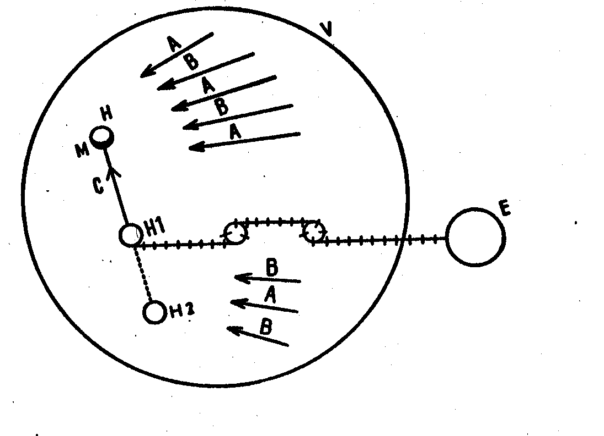

V = ...Life
h =...one man taken isolated
A =..Influences created inside life by life itself, first kind of Influences.
B =..Influences created outside life but thrown into the general turmoil of life; a second
kind of influences.
H 1 =.A man bound through successive leads to the esoteric center or pretending to be
bound to it
E =..Esoteric centre situated outside the general laws of life.
M =. .Magnetic centre of Man.
C =..Inf1uence of man H lover man H; in the case of the presence of a real bond with the
Esoteric centre whether the latter be a direct or an indirect bond, we are there before
a third kind of influence. Such an influence is conscious, and under its action exerted
upon the point M which indicates the magnetic centre a man becomes freed from the
law of accident.
h 2 = A man who dupes himself or dupes others having no bond whatsoever with the
Esoteric centre whether direct or indirect.

*****
Let us remind the reader while passing that the diagrams or schematic figures of the SYSTEM, like those of most of the esoteric texts and monuments, are conceived in such a way that they hide the one or the many means that would permit the verification of their authenticity within them and the detection of the errors committed by the "scribes and Translators". Without which their transmission through the centuries and beyond the extinct civilisations would have been, quite obviously, impossible. At the same time these means of verification offer the attentive student the possibility of going beyond their apparent meaning to grasp the deeper one.
One should not be astonished at that. This method is at the base and foundation of all esoteric teaching which requires the student to attach a particularly intensified attention, in such cases, both to the ensemble of the monument or the text being studied and the same measures to its most trifling details. To be convinced of the truth of the above it is enough to throw a rapid glance, for example, at the famous bas-relief of Eleusis which is attributed to the sculptor Phidias and figuring the scene of the sending of Triptoleme away. We are reproducing it opposite this text.

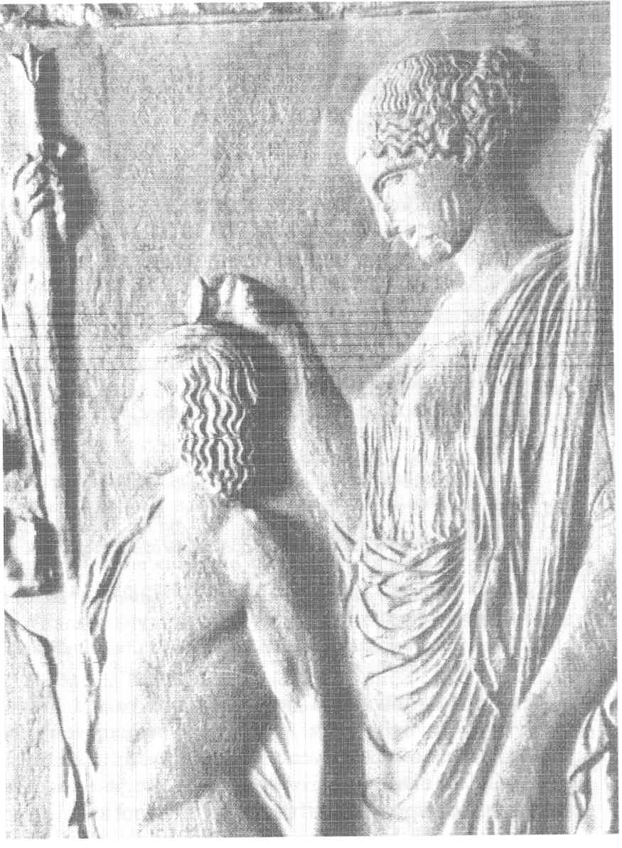

In that rather well known scene described and interpreted so often time after time, no importance is attached to the hand gesture of Persephone who is holding her bent index finger right over the sinciput of Triptoleme in quite an intentional way.
Can we really believe that it is only the result of a simple whim of the artist's fantasy, given specially that there can be no single shade of doubt as to the fact that the author of this masterpiece was certainly an EPOPT, that is, a man initiated to the Grand Mysteries of Eleusis ?
We must add besides, that it is this gesture which constitutes the KEY that will allow us access to the profound meaning of that Icon. Let us note here that EPOPT is a term which means SEER and let us also remember and think that, according to the oriental teachings, the Pineal gland which is precisely situated under the point where Persephone's index finger persistently indicates constitutes the organ of clairvoyance when duly developed by means of the appropriate exercises. Starting from this indication we will be able to decipher the meaning of the other details in that Icon or Tableau progressively to grasp the profound signification of the ensemble of the composition firmly -that which had been reserved so far for the Initiated only .
It is said that the Gospel is a book sealed by SEVEN LOCKS which means that, in order to reach the integral meaning of those writings, it is necessary to find the seven consecutive keys susceptible of unlocking it. But the first of these keys is already given for each one of them -in the symbolic images that accompany the images of the Evangelists on the icons: MAN, WINGED LION, BULL and EAGLE. These are the same images that accompany the ENNEAGRAM, the schematic figure at the base of everything which has been exposed in the "Fragments" and which includes all the SYSTEM within it. Finally, we can also find these same symbols on the armour of Augustus the emperor and a few of the first Roman Emperors.
As for the numbers 3 and 9 upon which the ENNEAGRAM and the whole of the MESSAGE rests, they can be found in all the esoteric traditions of the whole world. We should remember, for example, the famous wall of the imperial palace in Peking with the nine dragons upon it, the traditional plan for the habitation of some Negro tribes on the Ethiopian sides and much more data relating thereto. As far as Russia is concerned it is well known that the numbers 3 and 9 and 3 x 9, figure in almost all the ancient popular tales. Similarly, the orthodox Liturgy is conceived according to or on the basis of NINE fixed points, between which some variable elements will intervene -according to the seasons, the days, the feasts to be celebrated or the Saints to be venerated. Saint Basil the Beatific Cathedral was erected by Ivan IV the Redoubtable in commemoration of his victory of Kazan. It was erected in the Kremlin in 1550-1560; that masterpiece of Russian Architecture was the work and creation of Barma & Postnik and it represents a complex made of NINE Churches, one next to the other, crowned by NINE domes of bulbous form. We should not forget to mention either, that the Mysteries of Eleusis remained for NINE days and finally that Apollo the Musaget presided to an ensemble of NINE Muses.
Let us go back to the diagram or the schematic figure which was submitted for our analysis. Here is its exact aspect. (note from the translators: below, we are inserting the three versions which have been given by Boris Mouravieff the author of the article as well as in the three volumes of Gnosis:- Version (A) is the original which appeared in that article; version (B) is in the first edition of Gnosis, first volume and version (C) is the last one to prevail thereafter which is in the second edition of Gnosis I in the Greek translation and will also be in the Arabic translation which is yet to be published. The attentive reader will find that in version (A) the dark arrows or "A" influences are 17 couples counterbalanced by 17 "B" influences; in version (B) there are 28 couples of "A" influences counterbalanced by 7 "B" influences and lastly in version (C) there are 41 couples of "A" influences counterbalanced by 6 "B" influences. We have only one suggestion to add in order to elucidate that puzzling problem: the author has indicated in Gnosis, volumes I, II and III that the "A" influences are increasing in intensity and number in the world! But the question deserves a better and longer discussion. It is the super-importance of this diagram which has induced us to put the three versions we know of here).

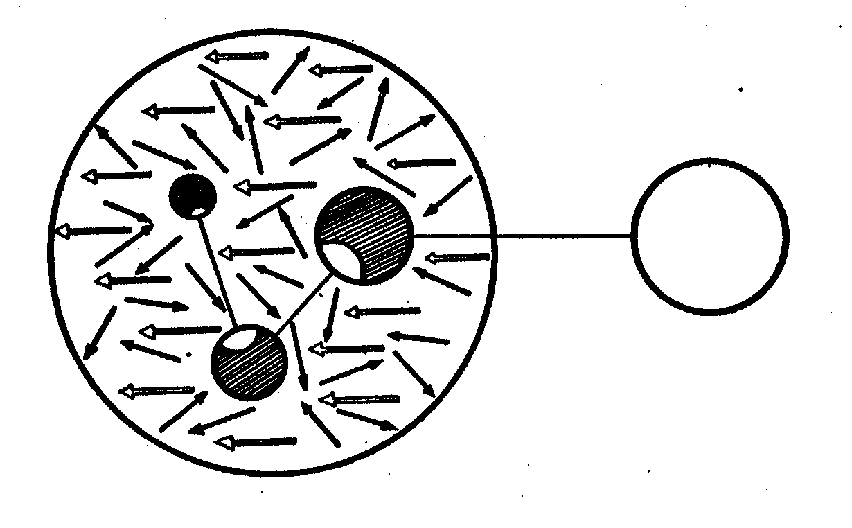

Version (A) originally published only in the present article

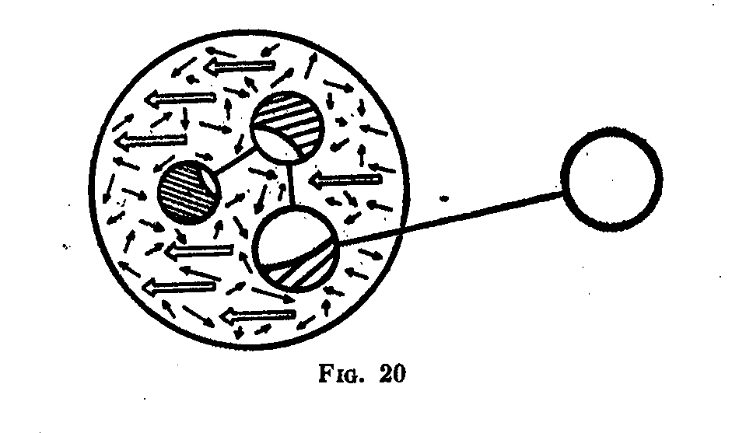
Version (B) published in the first edition of Gnosis I.

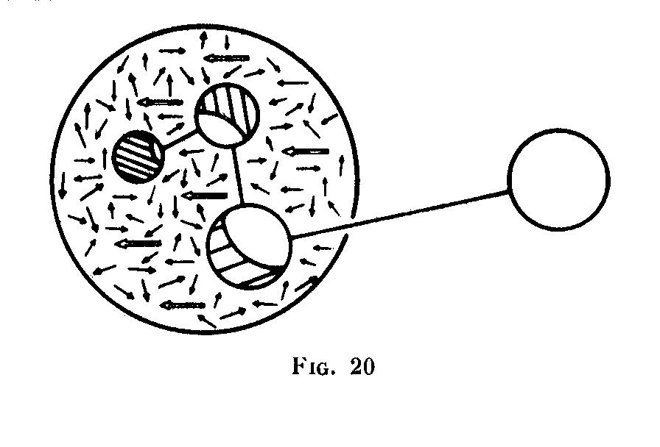
Version (C) : The one now prevailing.

The difference between Ouspensky's diagram and either one of the three others is more than obvious.
We shall now pass to the comments:-
--These arrows represent the influences created in life by life itself. This is a first sort of influences called the "A" influences. It should be noted that the black arrows cover the surface of the circle of life in an almost equal way. Their effect,
as in the case of all the radiating forces in nature, is inversely proportional to the square of the distance; that is why man is mostly submitted to the influence of the arrows of his closest environment and finds himself drawn at any moment by the results of the actual moment. The influences of the "A" arrows upon exterior man is imperative and compelling; always pushed, man wanders and errs inside the circle of his life from birth till death.
The ensemble of the "A" influences forms the LAW OF HAZARD under the dominion of which human fate is placed. But if we examine the diagram more closely we shall see that each black arrow is neutralised by being counter balanced by another arrow somewhere else, equal in force and diametrically opposed in direction -so had they been left to neutralise each other effectively their general result would have been equal to zero. This means, that in their ensemble the "A" influences are of an illusory nature, though their effect is real; that is the reason why man, in general, takes them for the only reality in life.
-The esoteric centre placed outside the general laws of life.
--The "B" influences are thrown inside life's turmoil by and from the Esoteric Centre. These influences which have been created outside life are represented in the schematic diagram (the figure) by white arrows. They are all oriented towards the same direction. In their ensemble they form a kind of magnetic field.
Since the "A" influences neutralise each other, the "B" influences constitute the sole reality in life and of life.
--Man taken isolated. He is represented in the schematic diagram by a finely partitioned circle, the surface of which is crossed by fine oblique lines save for the
little clear area. This means that the man’s involutive nature is not homogeneous; it is mixed. If man spends his life without distinguishing between the "A" & "B" influences, he will end it in the same way as he began it, that is to say, mechanically, moved by the law of hazard. But by the function of nature and the resulting force at each moment, he may be able to make a brilliant career or even to become a deputy, a minister or a man of science. He may be able to make remarkable speeches and discourses or write books. Nevertheless, he will come to his end having learned nothing at all or understood anything at all of reality and "earth will return unto earth">
Every individual will be submitted to a kind of PREPARATORY TEST in life. If he can discern the "B" influences and their existence, if he enjoys the taste of gathering them to him and of absorbing them and if he aspires to assimilate them more and more, then his interior nature which was mixed will, step by step, begin to undergo a certain evolution. And if his efforts to absorb the "B" influences are constant and strong enough, a MAGNETIC CENTER begins to be formed inside him. That magnetic centre is represented in the schematic diagram by the little white area.
If once born inside him and having been carefully developed that centre gets to a conspicuous size, then it will exert an influence, in its turn, on the results of the "A" arrows which are, of course, still functioning in such a way that a deviation will supervene. Such a deviation can be violent. It constitutes a transgression of the general laws of life and it provokes conflicts in and around him. If he loses the battle he will emerge there from with the conviction that the "B" influences are only an illusion and that the only reality which exists is represented by the "A" influences. Step by step, the magnetic centre that had been formed inside him will be re-absorbed and then it disappears. Thereafter his new situation will be worse than before when he had just begun to discern the "B" influences.
But if he wins in that first fight, then his magnetic centre consolidated and re-enforced, will attract him to a man of "C" influence -stronger than he is and in possession of a stronger magnetic centre than his own. And thus by way of succession since the man he had met has a relationship with a man of "D" influence -he will, in turn, put him into contact with the Esoteric Centre "E".
From now on that man will no longer be isolated in life. He will, of course, continue to live as he did before under the action of the "A" influences which will still exert their .dominance upon him for a long time; yet, step by step and thanks to the effect of the chain of influences B-C-D-E, his magnetic centre will develop more and more and he will evade the dominance of the law of hazard in line with the increase in growth of his magnetic centre -to enter into the domain of CONSCIOUSNESS.
If he succeeds in reaching that result before his death, then he can say that his life has not been lived in vain.

*****
Let us now examine the same diagram but under a different aspect:-
That second schematic diagram with its black magnetic centres represents the case where a man induced in error and believing he is absorbing the "B" influences, he absorbs, in fact, in making his selection, those "A" influences -the black arrows -which are in some way parallel to the white arrows of the "B" influences.
That will equally put him into relations with people in possession of magnetic centres of a similar nature to his own, who are dupes or dupe others and have no bond whatsoever, whether direct or indirect, with the Esoteric Centre.

*****
Lastly, what is the guarantee for man that he is not a dupe or in error and that he does not fall into the second category? The answer is simple: -THE PURITY OF THE MAGNETIC CENTER must be scrupulously followed from the start and all along the way to evolution.

*****
The proposed description of the schematic diagram in question is not exhaustive. Other comments about it are still possible; and all persons who study the system with assiduity are called upon to meditate upon it, to be able to go deeper and deeper into those possibilities.
Thinking about it, they will soon be aware that this schematic diagram comprises a whole series of laws of human life which are exposed in the Gospels in the form of parables and allusions.

V

Necessarily concise, the present study does not pretend to give a complete analysis of the "Gurdjieff Phenomenon" together with the work of Ouspensky. Its author would be amply satisfied if the readers of the one as well as those of the other are incited to re-think over their impressions or their experiences if that study ever falls under their eyes.
I have equally written this for the attention of my own students of the University of Geneva who are following my courses on the ESOTERIC TRADITION, IN THE ORIENTAL ORTHODOXY for the past three years.
As for me, I have always believed that, especially after the, car catastrophe of 1924, the Gurdjieff case was a failure. Had he been seduced by the mirage of money, women or by “power?” He has always evoked the image of a fallen angel for me. Sometimes it has seemed to me too that he was "searching for the resistance" which he never found.
Gurdjieff had no gift of Clairvoyance. But in Constantinople he wanted to enrich his "Institute" by associating with a famous "seer" and a powerful medium, the wife of a Russian diplomat. But since the first contacts she, definitively and decisively refused to collaborate with him at all.
I also believe that, after his first car accident -not to speak of the others -Gurdjieff never recovered his physical and moral capacities integrally. And if we admit that this accident was the result of previous DEVIATIONS -and since it was followed by others -then we must conclude that he never surmounted that mental deviation.
Yet, all in all, to sum up, he was not a "thaumaturge" like Cagliostro or Rasputin. The real thaumaturges of that kind do not die. They are to be killed. Gurdjieff was of a much smaller stature; he died as we know from a case of Ascites.
--What do you want? He used to say vehemently to his new recruits. Do you want to die like dogs?
This, he said to tell them later on that there is a way of escaping such a fate... and that he possessed it.
Has he escaped himself?
As for Ouspensky, he died because his kidneys ceased to function. To what was that due? It was probably due to the fact that he drank too much wine and alcohol! In the twenties when he used to travel from London to Paris often, we dined and this was compulsorily followed by libations in the prolonged evenings at Montmartre.
Such are the facts. They are indeed sad facts.
That is because esoteric researches offer a particularly difficult way and even a perilous one. The more the student progresses the more it raises obstacles and seductions before him -the so-called PRELESTI of the Orthodox Tradition. The latter occur over various planes and always in an unexpected manner. They are TESTS. They happen, sometimes, in an agreeable form: women, money, undeserved success and they are always followed of course, by pride and vanity. If this does not work they, sometimes, take a disagreeable form, principally by means of those closest to us. Has it not been said: - "A man's worst enemies are those of his own household?” It is enough to fall into the trap where we are engulfed as in a tricky hole -to be obliged to start everything all over again from zero thereafter and it will be more difficult to start a second time. However, if the seduction is agreeable, whether this be in appearance only, we leave the right way to follow the path of peril... The law is formal and implacable: there can be no compromise.

*****
Now to a practical question: - What must the attitude of the students be towards the "Gurdjieff Phenomenon" and the "Fragments" of Ouspensky? -The attentive reader will easily find the answer to that question by himself in the contents of our exposition: we must begin by separating the MESSAGE from the MESSENGER, and in the second case, go beyond the level of INFORMATION. The example we gave above demonstrates that we can, with that, discover and eliminate the errors.
There exists a fable which is well known all over the Orient. We are told, therein, that a race of swans exists which are particularly noble; the race of the "Royal Swan". They further add that if we put a recipient full of milk mixed with water in front of one of them, it separates the milk and drinks it and leaves the water alone. That must be the attitude of the students.
Lastly, let those who have profited or still make a profit among them from the "message" be sincerely grateful to the messenger and to the one who has interpreted it. If they know how to pray, let them pray for the salvation of their souls.

Fragments d'un Enseignement Inconnu, by P.D. Ouspensky, Edition stock, 1950. In the notice of the editors we can read the following:- A vast cosmogonic System,...a physiology and a psychology totally unknown ( at least in the Occident, Boris Mouravieff)...an ensemble of techniques allowing man, by working on himself, to acquire a veritable liberty... This is what the reader will find in this work....
P.D. Ouspensky, Fragments d'un Enseignement Inconnu, Edition stock, Paris 1950.
John, XXI, 25. (from the Slavonic text)
Fragments,p.5l9 & following (of the French text)
Ouspensky's CINEMODRAMA is a proper biography of the first part of his life. We see, therein, how & why he received no superior intellectual formation or even a secondary one.
Cf. Fragments, pp.45, 369, 370. (In French)
Ibid pp.45, 369
Ouspensky affirms it. He has had this idea since his first encounter with Gurdjieff (ibid p.131) was it suggested by G.?
Opus cited, p.3l and passim
Op. cited p.4l. The book's title is somewhat pretentious. Ouspensky had chosen it to put himself in a line of succession with Aristotle's Organon and Bacon's Novum Organon.
ibid.
Such is the way to exert hypnotic influence without plunging the subject into a trance.
Fragments, pp.35-36.
Compare with p.83 Fragments (French) 2nd paragraph, lines 6&7 we will translate the whole of that paragraph for the reader. The fourth way is sometimes called the way of the cunning man. The latter knows a secret that a fakir, the monk and the Yogi do not know. How did he learn that secret? Nobody knows. He may have found it in some old book, he may have inherited it, he may have Compare with p.83 Fragments (French) 2nd paragraph, lines 6&7 we will translate the whole of that paragraph for the reader. The fourth way is sometimes called the way of the cunning man. The latter knows a secret that a fakir, the monk and the Yogi do not know. How did he learn that secret? Nobody knows. He may have found it in some old book, he may have inherited it, he may have stolen it or he may have robbed it from someone. It all amounts to the same. The cunning man knows the secret and with it, he leaves the fakir, the monk and the Yogi far behind him. It is quite clear that Gurdjieff, to say the least, did not follow the regular course at all nor was he in contact or directly linked with the Great Esoteric Brotherhood to which St. Paul alluded in his epistle to the Romans. But a lot more can be said about the way he obtained that knowledge, the extent to which he reached and the aim he dreamed of, to reach with its help?...
This phenomenon is to be compared with that described by Dostoevsky in the VILLAGE OF STEPANTCHIKOYO.
Such an interior Fire is necessary to reach the "fusion" (or alliage) after which man's I becomes entire & permanent
Matthew, XXV, 24-30.
We are actually preparing a special work which we shall come back to (Boris Mouravieff). The author died in 1968 and has never published it. There may be a draft which we shall try to find.
Fragments, pp.534 & 535.
Ouspensky was quite cautious of not revealing his presence at Fontainebleau.
A doctor of the church born in Palestine around 525 AD & died in 605 AD. He was a director of the convent at Mount Sinai. His most important work is the "Climax" or the Ladder. He received his surnan1e from the latter
All & Everything in the english version & All und alles in german. The French version appeared in Paris in 1956. edition Janus in 1178 pages.
Apart from the accident of 1924 there was still another one which happened in Paris in 1932 while Gurdjieff was accompanied by Dr. L.R. De Stjiernvall.
Epistle of the Galatians, VI, 7
It is said that the Pineal gland duly developed assumes n bulbous form. That is why the architectural tradition in Russia gives that characteristic form to the domes of the churches.
an interesting article by J. Polivkat, Revue des Etudes Slaves Paris,l927,T.VII,pp.217-223,"The nos.9 & 3x9,"Tales of East Slavs
Matthew, X, 36; Micah, VII, 6.

