Bhagavata Purana, also known as Śrīmad Bhāgavatam
http://en.wikipedia.org/wiki/Bhagavata_Purana
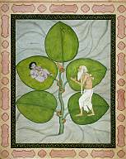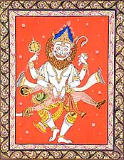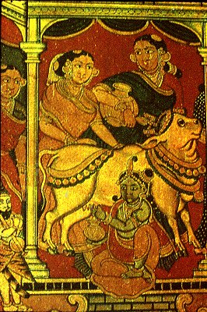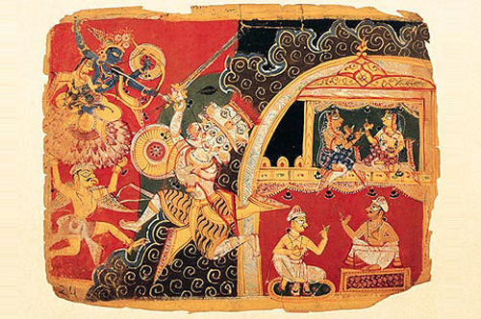
The Bhagavata Purana (also known as Śrīmad Bhāgavatam, or simply Bhāgavatam) is one of the Puranas, a part of the literature of Hinduism. Its primary focus is the process of bhakti yoga (loving devotion to the Supreme Lord) in which Vishnu or Krishna is understood as the Supreme all-embracing God of all Gods (Bhagavat). Earlier sections of the literature contain stories of devotees and objects of their devotion: the various avataras of Krishna or Vishnu. The most famous section is the 10th Canto, which deals in detail with the story of Krishna's appearance and pastimes in Vrindavan.

Contents
- 1 Significance
- 2 Origin
- 3 Contents
  - 3.1 Introduction
  - 3.2 Incarnations of Vishnu
  - 3.3 Krishna
- 4 Translations
- 5 See also
- 6 Notes and references
- 7 External links
- 8 Further reading

Significance
sarva-vedānta-sāraṁ hi
śrī-bhāgavatam īṣyate
tad-rasāmṛta-tṛptasya
nānyatra syād ratiḥ kvacit
"Śrīmad Bhāgavatam is accepted as the essence of all Vedic literature and Vedantic philosophy. Whoever tastes the transcendental mellow of Śrīmad Bhāgavatam is never attracted to any other literature."^{[1]}
Bhagavata Purana is considered a natural commentary on the Vedanta-sutra and is used as a textual source for Vaishnava Theology, Gaudiya Vaishnava Theology and Kamrupi Vaishnava Theology. It is the most well known and loved of all of the Puranas.

[] Origin
European historical scholarship suggests that the text was written in the 9th or 10th century as part of the development of the bhakti traditions.^{[2]} However, Hindu religious tradition holds it to be one of the works of Vyasa written at the beginning of Kali Yuga (about c.3100 BCE).^{[citation needed]}
Some argue that the Purana's mention of the Vedic Sarasvati River as a great river (maha-nadi) is evidence of the Purana's traditional date,^{[3]} since the river dried up about 2000 BCE.

[] Contents

[] Introduction
The Bhagavata Purana is a narration of a conversation. King Parīkshit of India, who has been cursed to die in seven days by a Brahmin, decides to give up his kingly duties to learn about the goal of life. As he prepares for his impending death, the saint Shuka (Śukadeva Gosvāmī), who has been searching for a suitable disciple to whom he might impart his great knowledge, approaches the king and agrees to teach him. Their conversation goes on uninterrupted for seven days, during which the king does not eat, drink or sleep. During this time the saint explains that one's goal in life is understanding the supreme absolute truth defined as the Supreme Personality of Godhead, Krishna.^{[4]}

[] Incarnations of Vishnu
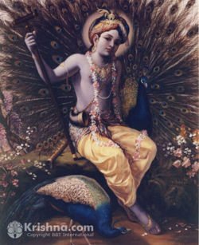
The avatar, Krishna, seated with peacocks, as described in the 10th Canto of the Bhagavata Purana. Artwork © courtesy of BBTI

The Bhagavata Puran first addresses the Supreme Personality of Godhead in all of His glory:
His eyes are the generating centers of all kinds of forms, and they glitter and illuminate. His eyeballs are like the sun and the heavenly planets. His ears hear from all sides and are receptacles for all the Vedas, and His sense of hearing is the generating center of the sky and of all kinds of sound. ^{[5]}
Mary Pat Fisher suggests that this is to emphasize the impossibility of understanding the cosmic conception of God. Therefore, the various incarnations of Vishnu are presented as something much easier to comprehend and adore.^{[6]}
The Bhāgavatam describes the various līlās of twenty-five avatāras (incarnations) of Vishnu.^{[7]}
- Catuhsana (four Kumāras)
- Nārada Muni
- Varāha (a boar)
- Matsya (a fish)
- Yajña
- Nara Narayana
- Kapila
- Dattatreya
- Hayaśīrsha (also called Hayagrīva)
- Hamsa (a swan)
- Priśnigarbha
- Rishabha
- Prithu
- Nrisimha
- Kūrma
- Dhanvantari
- Mohinī
- Vāmanadeva
- Bhārgava (also called Paraśurāma)
- Rāghavendra (also known as Sri Rama or Rāmachandra)
- Vyāsa
- Pralambāri Balarāma
- Krishna
- Buddha
- Kalki
Of the avatāras listed above, the following fourteen are called manvantara-avatāras: (1) Yajña, (2) Vibhu, (3) Satyasena, (4) Hari, (5) Vaikuntha, (6) Ajita, (7) Vāmana, (8) Sārvabhauma, (9) Rishabha, (10) Vishvaksena, (11) Dharmasetu, (12) Sudhāmā, (13) Yogeśvara, (14) Brihadbhānu. Out of these fourteen manvantara-avatāras, Yajña and Vāmana are also līlā-avatāras, and the rest are manvantara-avatāras. These fourteen manvantara-avatāras are also known as vaibhava-avatāras.^{[8]}

[] Krishna
The Bhagavata Purana speaks of Vishnu's incarnation as Krishna not as a wise teacher (as in the Bhagavad-Gita), but as a much-loved child raised by cowherds near Mathura on the Jumna River. The young Krishna enjoys earthly pleasures, such as theiving balls of butter or wandering through the forest. He also endures episodes of carefree bravery protecting the town from demons. More importantly, however, he steals the hearts of the cowherd girls. Through his magical ways, he multiplies himself to give each the attention needed to allow her to be so much in love with Krishna that she feels at one with him and only desires to serve him. This love, represented by the grief they feel when Krishna is called away on a heroic mission and their intense longing for him, is presented as models of the way of extreme devotion to the Supreme Lord.(Fisher 94)

[] Translations
- Gita Press has a two-volume English and Hindi translation (contains Sanskrit text and English translation).
- Kamala Subramanian has written a translation of this book in English.
- Swami Prabhupada, the founder of the International Society for Krishna Consciousness, has written a multi-volume ion that includes the Devanagari, its roman transliteration, word-for-word meanings, and a translation and commentary. It is available through ISKCON centers across the globe. The tenth canto was completed, and the eleventh and twelfth done, by his disciples.
- A Telugu version of this Purana was rendered by the poet Pothana in the fifteenth century
- A condensed Srimad Bhagavatam in Sanskrit, the Narayaneeyam, was composed by Melpathur Bhattathiri of Kerala in 1586.

[] See also
- Puranas
- Vishnu
- Krishna

[] Notes and references
- ^ Srimad Bhagavatam Canto 12 Chapter 13 Verse 15. Bhaktivedanta VedaBase Network. Retrieved on January 29, 2006.
- ^ Viraha-Bhakti - The Early History of Krsna Devotion in South India - Friedhelm Hardy. ISBN 0-19-564916-8; Werba, Verba Indoarica 1997:8 places it in the 10th century.
- ^ Srimad Bhagavatam Canto 9 Chapter 16 Verse 23. Bhaktivedanta VedaBase Network. Retrieved on January 29, 2006.
- ^ Srimad Bhagavatam Canto 1 Chapter 3 Verse 28. Bhaktivedanta VedaBase Network. Retrieved on January 29, 2006.
- ^ Srimad-Bhagavatam, second canto, "The Cosmic Manifestation," part one, chapter 6:3 and 1:39, translated by A.C. Bhaktivedanta Book Trust, 1972, pp. 59 and 275-276.
- ^ Fisher, Mary Pat (2005). Living Religions. New Jersey: Prentice-Hall. ISBN 0-13-193315-9.
- ^ "Srimad-Bhagavatam" by A.C. Bhaktivedanta Swami Prabhupada, Bhaktivedanta Book Trust.
- ^ Teachings of Lord Caitanya: Chapter 7: Unlimited Forms of Godhead. Bhaktivedanta VedaBase Network. Retrieved on January 29, 2006.

[] External links
- Complete Srimad Bhagavatam Online with original Sanskrit and purports translated by A.C. Bhaktivedanta Swami Prabhupada and disciples.
- Bhagavata Purana (Srimad-Bhagavatam) online in Sanskrit and English (cantos 1-10)
- Srimad Bhagavatam - glories, subjects, dating, concordance to Vedanta-sutra
- Bhagavata Purana - As a online readable story
- Srimad Bhagavatam as the topmost pramana
- Some Srimad Bhagavatam commentaries
- Meter in Srimad Bhagavatam
- Pothana Andhra Maha Bhagavatam (Telugu) select verses- Audio
- Tales From The Bhagavatham Retold For Children by P.S. Krishna Iyer

[] Further reading
- Mani, Vettam. Puranic Encyclopedia. 1st English ed. New Dehli: Motilal Banarsidass, 1975.
====================================================================================================================================
END

