

MESSAGE OF THE BHAGAVAT

http://www.wavesofdevotion.com/bhagavat/sb010101.html

Srimad Bhagavatam

First Canto, Chapter One
Text 1*
om namo bhagavate vasudevaya
janmady asya yato 'nvayad itaratas carthesv abhijnah svarat
tene brahma hrda ya adi-kavaye muhyanti yat surayah
tejo-vari-mrdam yatha vinimayo yatra tri-sargo 'mrsa
dhamna svena sada nirasta-kuhakam satyam param dhimahi
Synonyms
om-O my Lord; namah-offering my obeisances; bhagavate-unto the Personality of Godhead; vasudevaya-unto Vaasudeva (the son of Vasudeva), or Lord Sri Krishna, the primeval Lord; janma-adi-creation, sustenance and destruction; asya-of the manifested universes; yatah-from whom; anvayat-directly; itaratah-indirectly; ca-and; arthesu-purposes; abhijnah-fully cognizant; sva-rat-fully independent; tene-imparted; brahma-the Vedic knowledge; hrda-consciousness of the heart; yah-one who; adi-kavaye-unto the original created being; muhyanti-are illusioned; yat-about whom; surayah-great sages and demigods; tejah-fire; vari-water; mrdam-earth; yatha-as much as; vinimayah-action and reaction; yatra-whereupon; tri-sargah-three modes of creation, creative faculties; amrsa-almost factual; dhamna-along with all transcendental paraphernalia; svena-self-sufficiently; sada-always; nirasta-negation by absence; kuhakam-illusion; satyam-truth; param-absolute; dhimahi-I do meditate upon.
Translation
O my Lord, Sri Krishna, son of Vasudeva, O all-pervading Personality of Godhead, I offer my respectful obeisances unto You. I meditate upon Lord Sri Krishna because He is the Absolute Truth and the primeval cause of all causes of the creation, sustenance and destruction of the manifested universes. He is directly and indirectly conscious of all manifestations, and He is independent because there is no other cause beyond Him. It is He only who first imparted the Vedic knowledge unto the heart of Brahmaji, the original living being. By Him even the great sages and demigods are placed into illusion, as one is bewildered by the illusory representations of water seen in fire, or land seen on water. Only because of Him do the material universes, temporarily manifested by the reactions of the three modes of nature, appear factual, although they are unreal. I therefore meditate upon Him, Lord Sri Krishna, who is eternally existent in the transcendental abode, which is forever free from the illusory representations of the material world. I meditate upon Him, for He is the Absolute Truth.

Comments by Dhanurdhara Swami
That which is stated at the beginning and end of any book has special significance to it since the theme is usually most clearly expressed in the introduction and conclusion of a text. The first verse of Srimad Bhagavatam therefore naturally expresses its theme or subject—that Krishna is the Supreme Personality Godhead—and then further expands on this point by delineating the characteristics of God and ascribing them to Vaasudeva.
This type of direct expression of the nature of the Absolute Truth is considered to be somewhat bold, as it is very difficult for a person who is too materially affected to understand the personal nature of the Absolute Truth and to adopt the process of His humble service. The history of the compilation of Srimad Bhagavatam explains the impetus for the author to compose such a direct assertion.
Despite having compiled the entire canon of Vedic literature, Srila Vyasadeva felt uncharacteristically despondent. He was puzzled as to why he felt so unfulfilled and completely unable to imagine what he might have done wrong—especially considering that he had just completed the enormous task of compiling the Vedas for the welfare of the world. At the depth of his despondency His spiritual master, Srila Narada Muni, appeared and promptly diagnosed the root of his disciple's problem.
"Although you have repeatedly described the four principles of religion, you have not sufficiently described the glories of Vaasudeva." (Bhag. 1.5.9)
Narada Muni consequently advised Vyasadeva to think of the Lord's various pastimes in trance, and to repeat them for the liberation of the people in general. Following Narada's instructions, Vyasa left for his ashram in the Himalayas where he fixed his mind on the Absolute Truth by the process of devotional service. As a result, he developed the ability to clearly perceive the personal nature of the Absolute Truth along with His various energies.
Based on what he saw in his divine trance, and also remembering the chastisement of his teacher for not having directly described the glories of the Supreme Personality, Srila Vyasadeva, in the maturity of his realization, began his new exposition by confidently declaring the nature of the Absolute Truth:
om namo bhagavate vasudevaya—O my Lord, Sri Krishna, the son of Vasudeva, O all pervading Personality of Godhead, I offer my obseisances unto you.
Because this first verse of Srimad Bhagavatam describes the goal and thesis of the entire work, it deals with a very comprehensive subject. Consequently, on one occasion, Srila Bhaktisiddhanta chose to give a detailed discourse on this verse alone every day for three months. In consideration of the exhaustive meaning of this first verse, I will discuss the import in some detail, by going over the significance of some of the key words and phrases, beginning with the aforementioned initial phrase.
The first verse of Srimad Bhagavatam is a concise statement that is directly related to Vyasadeva's vision of the Absolute Truth. His contention that Lord Sri Krishna, the son of Vasudeva, is that Absolute Truth, is supported and explained throughout the Vedas. Srila Prabhupada therefore lists in his purport some of the key resources substantiating this, especially the Brahma-samhita, Jiva Goswami's Krishna-sandarbhas, and the Sama Upanishads.
It may appear contradictory that Krishna is being referred to as both bhagavate, the Absolute Truth, and vasudeva, the son of a particular father and apparently relative position. The meaning of the name used for Krishna in this verse, however, gives some insight into the resolution of this apparent disparity: Here, the term vasu is translated as “residence,” while the term deva takes on its characteristic meaning of divinity, or specifically, God. “Vaasudeva” therefore refers to that Supreme Being who is residing everywhere. Srila Prabhupada further interprets the term Vaasudeva to denote that He is the "son of Vasudeva” and “all-pervading Personality of Godhead.” This double meaning of Vaasudeva thereby explains the inconceivable nature of the Absolute Truth: Although God appears in a human like form in a particular family, he is not limited or ordinary. Indeed, He possesses inconceivable potency and is infinitely ubiquitous as the Supersoul in all beings.
namo—Offering my obeisances.
The inevitable outcome of realizing the nature of the Absolute Truth is that we become impelled to accept our own nature as His differentiated parts. This process begins with relinquishing the false ego, or the misconception that we are independent of Him. As Vyasadeva developed full realization of the Absolute Truth in his trance, he appropriately began his treatise with the word namah. The syllable “ma” indicates the false ego, while the prefix “na” negates it. “Namah,” therefore, indicates the proper way for the embodied soul to approach the Supreme Lord and to study Srimad Bhagavatam—in the mood of self-surrender and completely devoid of the illusion of independence.
janmady asya yatah—The primeval cause of all causes of the creation, sustenance, and destruction of the manifested universes.
In his first statement, Srila Vyasadeva clearly asserts the identity of God. With his second statement, he describes exactly why Krishna is God by listing Krishna's characteristics—those unique distinguishing characteristics of God that separate Him from any other living entity.
God is defined as that being to whom no greater entity can be conceived. Therefore, God cannot have a cause outside of Himself, as that would indicate some sort of lacking or deficiency within Him. Srila Vyasadeva therefore begins his description of Krishna as that person from whom everything else emanates.
Although Krishna has already been described as having taken birth or having come from Vasudeva, which seems to make His position relative, Srila Vyasadeva immediately clarifies this by explaining that Krishna's birth is in no way ordinary. This second statement confirms that, in fact, Krishna is the illimitable source of everything else.
By utilizing a historically prominent passage from the Vedanta-sutra, Srila Vyasadeva’s appropriation of the phrase janmady asya yatah indicates that Srimad Bhagavatam is also a commentary on that great treatise. This aphorism is also intended to refute Sankaracarya's contention that any differentiation in the Absolute must be an illusion, as it describes the energies of God as distinct manifestations from Him.
anvayat itaratas arthesv abhijnah sva-rat—He is directly and indirectly conscious of all manifestations and He is independent.
Srila Vyasadeva continues to describe the unique and distinguishing characteristics of the Absolute Truth, Lord Sri Krishna. In this regard, Srila Prabhupada points out the importance of the preceding phrase. "In this sloka,” he writes, “the particular words abhijnah and svarat are significant. These two words distinguish the Supreme Lord from any all other living entities. No other living entity is either abhijnah or svarat. That is, no one is either fully cognizant or fully independent."
Svarat literally means self-ruled. This attribute is particularly idiosyncratic with the definition of God because every other living entity must, at some point, submit to the dominion of a greater being.
Abhijnah means fully cognizant. God is the only fully omniscient being. Vyasadeva further describes God's omniscience as anvayat and itaratas—directly and indirectly conscious. “Directly conscious” means that God is aloof from his creation, but fully aware of it. He is the observer, or subject of experience. “Indirectly conscious” means that He is conscious of everything by dint of the fact that he is all-pervading, or the object of all experience. "Whatever happens to the body quickly becomes known to the embodied,” Srila Prabhupada explains. “Similarly, the creation is the body of the absolute whole. Therefore, the Absolute knows everything directly and indirectly that happens in creation."
In other words, one can be directly conscious of his or her hand by simply looking at it. Similarly, one can experience indirect consciousness of that hand by virtue of its connection to the entire body, which is pervaded and perceived by that person’s individual consciousness.
tene brahma hrda ya adi kavaye—It is He only who first imparted the Vedic knowledge into the heart of Brahmaji, the original living being.
To perform devotional service to Lord Krishna, one must have a clear conception of His identity as God. Obviously, if one considers any other entity besides Krishna to be God, there would be no good reason to dedicate one's life in devotional service to Krishna. One very common misconception is that there are many powerful gods and that Krishna is just one of them. Therefore, to remain fixed in Krishna consciousness, the supremacy of Lord Krishna is also indirectly affirmed in this passage by clearly stating that even the very powerful first-created being, Lord Brahma, is not the Supreme Lord.
Since Lord Brahama is the creator of the universe—referred to here as adi kavaye, the original person—it is easy to understand how one might mistake him for the Supreme Lord. Srila Vyasadeva therefore makes the relative position of Lord Brahma thoroughly indisputable by explaining that he is not the self-sufficient original creator, but in actuality, an admittedly powerful living entity both created and inspired by Lord Krishna with transcendental knowledge at the beginning of creation.
muhyanti yat surayoh—By him even the great sages and demigods are placed into illusion.
Srila Vyasadeva has pronounced Lord Sri Krishna as the Absolute Truth. The impersonalists, however, have a different conception. They say that Brahman, covered by maya, becomes the jiva and the isvara, and that Krishna, the isvara, is a product of illusion.
Vyasadeva, however, saw things quite differently in his divine trance. He understood that, rather than subduing Krishna, the illusory energy was under His direct subjugation—maya ca tad apasrayam.
The same point is affirmed here: The illusory potency that covers one's perception of the Absolute Truth is directly under Krishna's control. Vyasa therefore concludes, "By him even the great sages and demigods are placed into illusion."
Since the first verses of Srimad Bhagavatam introduce it's theme, it is not surprising that they, in many ways, parallel the Catur-sloki Bhagavatam—the original Bhagavatam spoken in four seed verses by Lord Krishna to Lord Brahma at the beginning of creation. For example, the first verse of the Catur-sloki Bhagavatam describes Lord Sri Krishna as the ultimate cause and substance of everything, while the first two lines of Srimad Bhagavatam also characterize Lord Sri Krishna's position as the Supreme Absolute. The second catur-sloki argues that because everything is ultimately connected with Krishna, the appearance of anything independent from Him is merely a product of the Lord's illusory energy. Similarly, the last two lines of the first verse of Srimad Bhagavatam also exclusively discuss the nature of His maya-sakti. The rest of the analysis of this first verse will therefore focus on a discussion of the Lord's maya-sakti.
I have already discussed Vyasadeva's statement concerning Krishna's relationship to the maya-sakti in which Vyasadeva explains that the Lord's illusory potency is Krishna's energy and, therefore, wholly under His control (muhyanta yat surayaoh). Vyasadeva then describes the exact nature of that maya-sakti. He says, tejo vari mrdam—illusion means to mistake one thing for another, like a mirage where one might see water where there is land, or land where there is actually water. Vyasadeva therefore describes the material world as unreal—yatra tri sargah amrsa: it becomes manifest by the three modes of material nature and gives an appearance of reality due to Krishna's illusory potency.
That the material world is only an appearance of reality does not mean that it is false. It is real in the sense that it is one of Krishna's energies. The illusion of this world is such that although it is Krishna's energy, and therefore designed for His service, we see it as separate from Him, falling under the gross misconception that its existence was intended for our exploitation and control. We also mistake the permutations and combinations of the inert material energy that appear as our body, it's relations, and the realm we live in, for our actual self, our eternal relationships, and the real world.
Thus both directly and indirectly Srila Vyasadeva has supported his claim that Lord Krishna, the son of Vasudeva, is the Supreme Personality of Godhead. In the first two lines of the first verse, Vyasa directly supports his claim by explaining why Sri Krishna has the characteristics of God. Similarly, the last two lines of the first verse indirectly support his assertion by the contention that anything not connected to Krishna is only an illusion. Srila Vyasadeva therefore concludes that we should meditate on the ultimate reality, Lord Sri Krishna, who is eternally existent in the transcendental abode, abandoning our absorption in the material world, which is just an appearance of that reality—dhamna svena sada nirasta-kuhakam satyam param dhimahi.
Perception is not just a matter of contacting the objects of the senses with the instrument of the senses. It also depends on the focus of the mind, correct knowledge, and a detached, objective attitude. For example, a man who is envious cannot see the qualities of his rival due to these particular feelings.
Similarly, although Srila Vyasadeva recommends that one should meditate on Sri Krishna, the clarity of our perception of the Lord depends largely on our level of detachment and our maturity of knowledge. For example, a person who is not reasonably detached from sense gratification will see Krishna's conjugal affairs with the gopis as mundane sex life; a person who is lacking in transcendental knowledge will hear about Krishna's birth and conclude that He is ordinary.
Considering that an advanced level of purity is required to properly meditate on the Absolute Truth, Srila Vyasadeva invokes the gaytri-mantra, or dhimahi—a mantra meant to gradually bring one to the liberated platform. In this regard, Srila Praphupada explains, "when one is successful in chanting the gayatri-mantra, he can enter into the transcendental position of the Lord."
In other words, although Srila Vyasadeva has strongly recommended that one meditate on Lord Sri Krishna's pastimes, he also cautions the reader on how to proceed. One must first temper the level of his meditation according to his personal purity, and then gradually qualify oneself to meditate on Krishna's pastimes by chanting the gayatri-mantra.
The word dhimahi also indicates that the Srimad Bhagavatam is itself a gayatri-mantra. Srila Vyasadeva is therefore also recommending a careful absorption of its message, chapter by chapter, as the process to become qualified to understand the Lord's intimate pastimes as found in the Tenth Canto.
Message of the Bhagavat Home
Waves of Devotion Home
wavesofdevotion.com © 2000
* Translation © Bhaktivedanta Book Trust Int.

http://www.geocities.com/krsnajoe/srimad.html

The Srimad-Bhagavatam
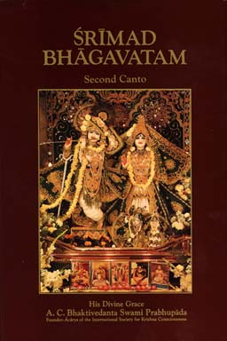
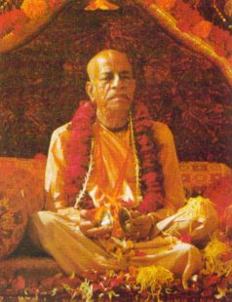
"Srmad-Bhagavatam is the "Cream of the Vedic literatures"of ancient India.Five thousand years ago the great sage Krsna Dvaipayana Vyasa composed this purana,or history,to explain the essence of spiritual knowledge"Srila Prabhupada said,"Srimad-Bhagavatam is the Transcendental science not only for knowing the ultimate source of everything but also for knowing our relation with Him(Krsna),and our duty toward perfection of the human society on the basis of this perfect knowledge.It is powerful reading matter in the Sanskrit language,and it is now rendered into English elaborately so that simply by a carful reading one will know God perfectly well,so much so that the reader will be sufficiently educated to defend himself from the onslaught of atheists.Over and above this,the reader will be able to convert others to accepting God as a concrete principle. Srimad-Bhagavatam begins with the definition of the ultimate source.It is a bona fide commentary on the Vedanta-sutra by the same auther,Srila Vyasadeva,and gradually it develops into nine cantos up to the highest state of God realization.""On the other hand that litrature which is full with descriptions of the transcendental glories of the name,Fame,Form and pastimes of the unlimited Supreme Lord is a transcendental creation meant to bring about a revolution in the impious life of a misdirected civilization.Such transcendental literatures,even though irregulaly composed,are heard,sung and accepted by purified men who are thoroughly honest."Om tat sat----A.C.Bhaktivedanta Swami
Because of space limitation,you will be reading a story from Srimad-Bhagavatam,Translation and commentary by His Divine Grace A.C.Bhaktivedanta Swami Prabhupada(appeared in "Back to Godhead" magazine,..If anyone is interested in getting Srila Prabhupada's books,please E-mail me at (krsnajoe@hotmail.com)
The Deliverance of Ajamila
There was once a young Brahmana(A priest or teacher),named Ajamila,who was a reservoir of good character and conduct.He was mild and gentle,always truthful,well versed in the Vedic scriptures,and very pure.One day,on the request of his father,Arjamila went to the forest to collect fruit,flowers and grasses.On the way home, he came upon a very lusty low-class man embracing and kissing a prostitute.Both of them were drunk,and the man was smiling,singing,and enjoying himself without shame.The prostitute's eyes were rolling in intoxication,and her dress had become loose.When Ajamila saw her,the lusty desires in his heart awakened,and in illusion he fell under thier control.Remembering the instuctions of the scripyures,Ajamila tried not to gaze at the woman.he strained to controlhis lusty desires with the help of his knowledge and intellect, but he failed and as a result lost all his good sense.In the days that followed he always thought about the prositute,and within a short time he took her as a servant in his house and abanoned all the braminical principles.Ajamila began spending the money he had inherited from his father on various gifts to satisfy the prostitute.He even abandoned his beautiful young wife,who came from a very respectable family.Thus Ajamila spent his long life irresponibly breaking all the rules and regulations of the holy scriptures.He was unclean and addicted to forbdden activities.Living extravagantly,he maintained his family by harrassing others,cheating,gambling and theft.Over the eighty-eight years of Ajamila's life,he fathered ten sons by the prostitute,Ajamila's youngest son,a baby named Narayana,was naturally very dear to both his father and mother. The child's broken language and awkward movements greaty endeared him to old Ajamila,who always took care of him and enjoyed his activities.Narayana is a name for God and thus unintentionally the old man was always chanting the holy name of the Lord.
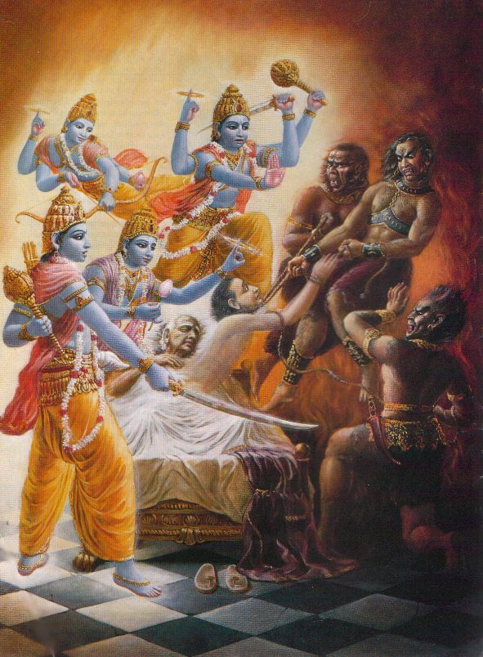
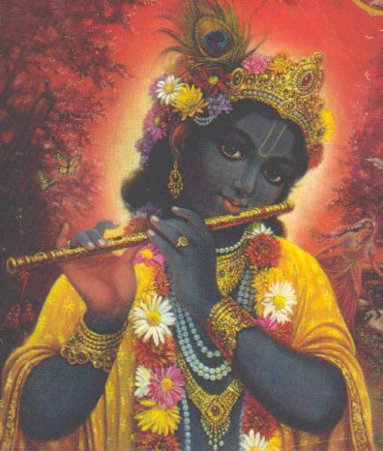
Although he was referring to his son and not the original Narayana,Ajamila was becoming purified because the holy name of Narayana is very powerful.Always taking care of his son and calling his name,Ajamila was not aware that his own life was now exhausted.As the time of death approached for the foolish Ajamila,he begane thinking exclusively of his son Narayana.At the moment of death,Ajamila saw three awkward persons with deformed bodily features,fierce and twisted faces,and hair standing erect on theirbodies.They were the Yamadutas(the servents of Yamaraja,the lord of death),and they had come to take Ajamila away to their masters abode.When Ajamila saw them,he became extremely bewilered,and because of his attachment to his child,who was playing a short distance away,he loudly and tearfully called the child's name:"Narayana!" Immediately the Visnudutas,the servents of the Supreme Lord Visnu(Narayana),Arrived on the spot.They had heard the holy name of their master from the mouth of the dying Ajamila,who had chanted without offense because he had chanted in complete anxiety.As the Visnuedutas arrived,the Yamadutas were snatching the soul from the body of the dying ajamila.With resounding voices,the messengers of Lord Visnu ordered them to stop and thus saved Ajamila from death.Although the servants of Yamaraja have jurisdiction over all sinful living beings,the messengers of Visnu are capable of punishing even Yamaraja himself if he wrongs a devotee of Visnu,the Supreme Lord.When the Yamadutas were thus forbidden from carrying out their mission,they exclaimed,"who are you,sirs,that you dare challenge the jurisdiction of Yamaraja?Whose servants are you,where have you come from,and why are you forbidding us to touch Ajamila?You may know that this man Ajamila did not undergo atonement for his sins.because of his sinful life,we must take him to the court of Yamaraga for punishment. According to the extent of his sinful acts,he will be punished and thus purified."The Visnuduta's replied,"Ajamila has alreadyatoned not only for sins performed in one life but for those performed in millions of lives,for in a helpless condition he chanted the holy name of Narayana.Although he was calling his sons name,he nevertheless uttered the four syllables Na-ra-ya-na.Simply by chanting the name of Narayana in this way,he sufficiently atoned for the sinful reactions of millions of lives.Chanting the holy name of the Lord is the best process of atonement for a thief,for a drukard,for one who betrays a friend or relative,for one who kills a brahmana,for one who indulges in sex with the wife of his guru or another superior,for one who murders women,the king or his father,for one who slaughters cows and for all other sinful men.Simply by chanting the holy name of the Lord,such sinfulpersons can attract His attention.At the time of death,Ajamila helplessly and very loudly chanted the holy name of the lord.That chanting alone has already freed him from the reactions of all sinful life.Therefore, O servants of Yamaraja,do not try to take him to your master for punishment.One who chants the holy name is immediately freed from the reactions of unlimited sins,even if he chants indirectly to indicate something else,jokingly,for musical enterainment,or even neglectfully. This is accepted by all the learned scholars of the scrptures.If one chants the holy names of Hari houghand then dies because of an accidental misfortune,one is immediately absolved from having to enter hellish life,even though he is sinful. "Although one may neutralize the reactions of sinful life through austerity,charity,vows and other such methods,these pious activities cannot uproot the material desires in ones heart.However,if one serves the Personality of Godhead,he is immediately freed from all such contaminations.If a person unaware of the effective potency of a certain medicine takes that medicine,itwill act even without his knowledge because the medicine's potency does not depend on the patient's understanding.Similarly,even though one does not know the value of chanting the holy name of the Lord,if one chants knowingly or unknowingly,the chanting will be very effective." The Visnudutas released the bramana Ajamila from bondage of the Yamadutas and thus saved him from death.Ajamila,now free from fear,came to his senses and immediately offered respects to the Visnudutas by bowing his head at their feet.He was extremly pleased by their presence,for they had saved him from the Yamadutas.When the Visnudutas saw that Ajamila was attempting to say something,they suddenly disappeared.Having heard the discourse between the Yamadutas and the Visnudutas,Ajamila could now understand the transcendental religious principles concerning the relationship between the living being amd the Supreme Personality of Godhead.Furthermore,since Ajamila had heard thier glorification of god,he was now a perfsctly pure devotee and could thus remmember all his past sinful activities,which he greatly regretted having performed."I am such a sinful person,"he said."But now since I have this opportunity,I must completely control my mind,life,and senses and always engage in devotional service so that I may not again fall into the deep darkness and ignorance of material life.Because I identified myself with my body,I was subjected to desires for sense gratification and thus performed many pious and impious acts.That was my material bondage.But now I shall disentangle myself from that bondage.Being a most fallen soul,I was victimized by illusions and was like a dancing dog led around by a woman's hand.Now I shall give up these lusty desires and free myself from these illusions.I shall become a merciful,well-wishing friend to all living entitties and always absorb myself in Krsna Consciousness."Because of a moment's association with devotees of the Supreme Lord,Ajamila was able to detached himself with a determination from the material conception of life.Freed from all material attraction,he immediately started for the city of Harwar on the Ganges River.In Hardwar,Ajamila stayed at a Visnu temple,where he executed bhackti-yoga,the process of devotional service.He controlled his senses and fully applied his mind in the service of the Lord.When his intelligence and mind were fixed on he form of the Lord,Ajamila once again saw before him the four celestrial messengers of Visnu.Recognizing them as the ones he had seen previously,he offered his respects by bowing down before them. The Visnudutas had gone away for some time to allow ajamila to become firmly fixed in meditation on the Lord.Now that his devotion had matured,they returned to take him back to the spiritual world.Upon seeing the Visnudutas,Ajamila gave up his material body and regained his original spiritual body,which was just suitable for an associate of the Lord.
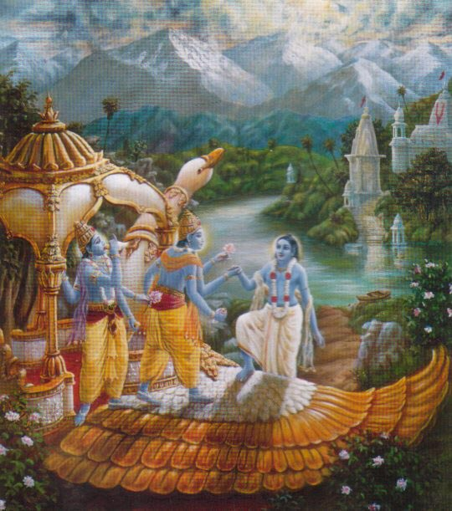
This is the result of perfection in Krsna Consciousness:after giving up the material body,one is immediately transferred to the spiritual world in one's original spiriyual body to become an associate of the Supreme Personality of Godhead.Accompanied by the Visnudutas,Ajamila then boarded a golden airplane that took him through the airways,directly to the abode of the Supreme Lord Visnu,the husband of the goddess of fortune. Although he had been destined to be carried away to hell by the Yamadutas,Ajamila was saved by the Visnudutas and was able to go back home,back to Godhead,because he chanted the holy name of the Lord at the time of his death.Therefore if a person faithfully and inoffensively chants the holy name of the Lord,who can doubt that he will return to Godhead?At the time of death one is certainly bewildered because his bodily functions are in disorder.At that time,even one who throughout his life has practiced chanting the holy name of the Lord may not be able to chant the Hare Krsna mantra very distinctly.Nevertheless,such a person receives all the benefits of chanting the holy name.While the body is fit therefore,we should chant the holy name of the lord loudly and distinctly.If one does so,it is quite possible that even at the time of death he will be able to properly chant the holy name of the Lord with love and faith and return home,back to Godhead,without a doubt.BY His Divine Grace SRILA PRABHUPADA
THERE IS SO MUCH IN THE 12 CANTOS OF SRIMAD_BHAGAVATAM THAT THERE IS NOT ENOUGH SPACE BUT I WILL TRY TO ADD AND THEN CHANGE SO KEEP CHECKING FOR MORE PASTIMES OF KRSNA AND HIS DEVOTEES.............krsnajoe@hotmail.com Please Email me (Questions?) (Comments?) Write to me,krsnajoe@hotmail.com

