Sri Aurobindo 1872-1950
http://en.wikipedia.org/wiki/Sri_Aurobindo
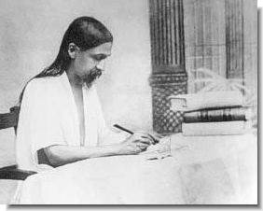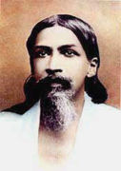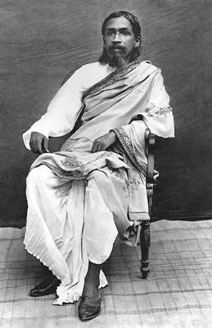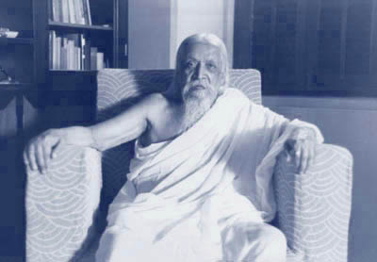
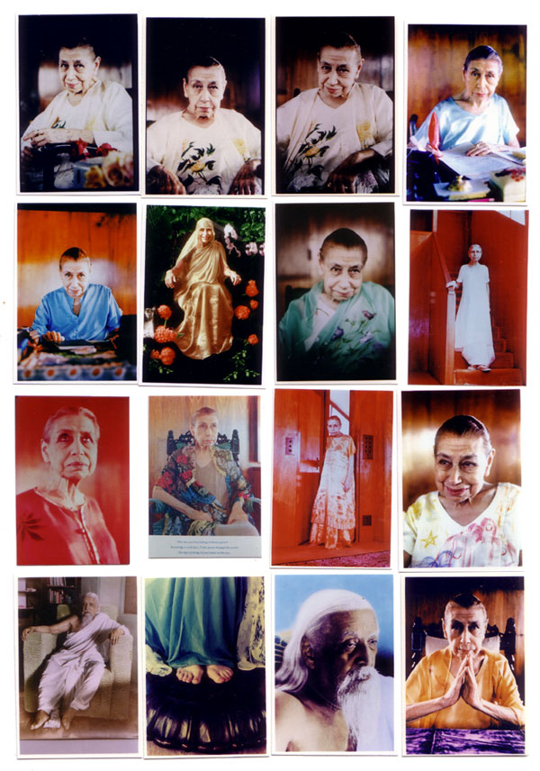
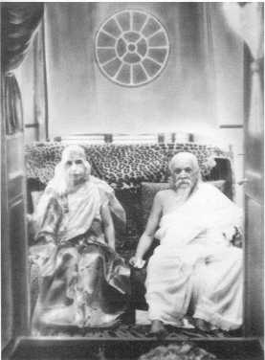
Sri Aurobindo and the Mother

Sri Aurobindo (Bangla: শ্রী অরবিন্দ Sri Ôrobindo, Sanskrit: श्री अरविन्द Srī Aravinda) (August 15, 1872–December 5, 1950) was an Indian nationalist, freedom fighter, scholar, poet, mystic, evolutionary philosopher, yogi and guru ^{[1]}. His followers further believe that he was an avatar, an incarnation of the Absolute.
Sri Aurobindo spent his life — through his vast writings and through his own development — working for the freedom of India, the path to the further evolution of life on earth, and to bring down what he called the Supermind to enable such progress. He referred to his teachings as the "integral yoga".

Contents
- 1 Early experiences
- 2 Final conversion
- 3 Philosophical and spiritual writings
- 4 The Mother
- 5 Contribution to Indian philosophy
- 6 Discovering the Hidden meaning of the Vedas
- 7 Sri Aurobindo's evolutionary philosophy
  - 7.1 Involution
  - 7.2 Evolution
- 8 Sri Aurobindo's integral yoga
- 9 Sri Aurobindo's influence
- 10 Quotations
- 11 Partial bibliography
- 12 See also
- 13 References
- 14 Further reading
- 15 External links

Early experiences
Sri Aurobindo was born Aurobindo Akroyd Ghose (pronounced and often written as Ghosh) in Kolkata (Calcutta), India, on 15th August, 1872. His father was Dr K. D. Ghose and his mother Swarnalata Devi. Dr Ghose, who had lived in Britain, and had studied at Aberdeen University, was determined that his children should have a completely European upbringing, sent Aurobindo and his siblings to the Loreto Convent School at Darjeeling. At the age of seven Aurobindo was taken along with his two elder brothers, Manmohan and Benoybhusan, to England. There, they were placed with a clergyman and his wife, a Mr and Mrs.Drewett, at Manchester. Mr and Mrs Drewett tutored Aurobindo privately. Mr Drewett, himself a capable scholar, grounded Aurobindo so well in Latin that Aurobindo was able to gain admission into St Paul's School in London. At St. Paul's Aurobindo mastered Greek and excelled at Latin. The last three years at St Paul's were spent in reading literature, especially English Poetry. At St. Paul's he received the Butterworth Prize for literature, the Bedford Prize for history and a scholarship to King's College, Cambridge University. He returned to India in 1893.
During the First Partition of Bengal from 1905 to 1912, he became a leader of the group of Indian nationalists known as the Extremists for their willingness to use violence and advocate outright independence, a plank more moderate nationalists had shied away from up to that point.He was one of the founders of Jugantar party, an underground revolutionary outfit. He was the or of a nationalist Bengali newspaper Vande Mataram (spelt and pronounced as Bônde Matôrom in the Bengali language) and came into frequent confrontation with the British Raj as a result. In 1907 attended a convention of Indian nationalists where he was seen as the new leader of the movement. But his life was beginning to take a new direction. In Baroda he met a Maharashtrian yogi called Vishnu Bhaskar Lele who convinced him to explore the ancient Hindu practices of yoga.
It was at this point that Rabindranath Tagore paid him a visit and wrote the now famous lines:
Rabindranath, O Aurobindo, bows to thee! O friend, my country's friend, O Voice incarnate, free, Of India's soul....The fiery messenger that with the lamp of God Hath come...Rabindranath, O Aurobindo, bows to thee.

[] Final conversion
His final conversion from an active nationalist into a profound sage and seer occurred while incarcerated for a year in the Alipur jail in Kolkata in the province of Bengal. While incarcerated he was inspired by his mating on the famed Hindu scripture of the Bhagavad Gita.
While in Alipore Jail, Sri Aurobindo claimed to be visited by the renowned Swami Vivekananda, a Hindu philosopher of great importance to Advaita Vedanta, in his mation. The swami guided Sri Aurobindo's yoga and helped him to scale great heights. It was there Sri Aurobindo saw the convicts, jailers, policemen, the prison bars, the trees, the judge, the lawyer etc., in the experience and realization of Vasudeva, a form of Vishnu. Sri Aurobindo was even able to see compassion, honesty and charity in the hearts of murderers.
The trial for which he was incarcerated was one of the important trials in Indian nationalism movement. There were 49 accused and 206 witnesses. 400 documents were filed and 5000 exhibits were produced including bombs, revolvers and acid. The English judge, C.B. Beechcroft, had been a student with Sri Aurobindo at Cambridge. The Chief Prosecutor Eardley Norton displayed a loaded revolver on his briefcase during the trial. The case for Sri Aurobindo was taken up by Chittaranjan Das. Chittaranjan Das, in his conclusion to the Judge, said: "... My appeal to you is this, that long after the controversy will be hushed in silence, long after this turmoil, this agitation will have ceased, long after he (Sri Aurobindo) is dead and gone, he will be looked upon as the poet of patriotism, as the prophet of nationalism and lover of humanity. Long after he is dead and gone, his words will be echoed and re-echoed, not only in India, but across distant seas and lands. Therefore, I say that the man in his position is not only standing before the bar of this Court, but before the bar of the High Court of History." The trial ("Alipore Bomb Case, 1908") lasted for one full year. Aurobindo was acquitted.
Afterwards Aurobindo started two new weeklies: the Karmayogin in English and the Dharma in Bengali. However, it appeared that the British government would not tolerate his nationalist program as Lord Minto wrote about him: I can only repeat that he is the most dangerous man we have to reckon with.
Sought again by the Indian police he was guided to the French settlements and on April 4, 1910 he finally found refuge with other nationalists in the French colony of Pondicherry.

[] Philosophical and spiritual writings
In 1914 after four years of concentrated yoga at Pondicherry, Sri Aurobindo launched Arya, a 64 page monthly review. For the next six and a half years this became the vehicle for most of his most important writings, which appeared in serialised form. These included The Life Divine, The Synthesis of Yoga, Essays on The Gita, The Secret of The Veda, Hymns to the Mystic Fire, The Upanishads, The Foundations of Indian Culture, War and Self-determination, The Human Cycle, The Ideal of Human Unity, and The Future Poetry. Sri Aurobindo however revised some of these works before they were published in book form.
He also wrote a small book entitled "THE MOTHER" which was first published in 1928. In a way, it is the "Instructions Manual" for "Sadhaka" - aspirant - the "Yogi" - of the "Integral Yoga". In this book (less than 16 full size pages), the "Seer of the Modern Age" has written about his "Seeing" the Supreme Divine Mother - The Divine Shakti; especially "Four great Aspects of the Mother, four of her leading Powers and Personalities (which) have stood in front in her guidance of the Universe and her dealings with the terrestrial play. ...". He clearly and very explicitly wrote the conditions to be fulfilled by the "Sadhaka" for receiving the Grace of the Divine Mother for the "... great transmutation". He is probably the only Spiritual Master who has very clearly and emphatically written about Money/Wealth. ".... This is indeed one of the three forces - power, wealth, sex- that have the strongest attraction for the human ego and.....".
After this prolific output, Sri Aurobindo's only literary works, apart from some poems and essays, was his epic poem Savitri, which he continued to revise for the rest of his life. However, following his retirement from public life in 1926, he maintained a voluminous correspondence with his disciples. His letters, most of which were written in the 1930s, numbered in the several thousands, and some of these were later published in three volumes as Letters on Yoga.
Although Sri Aurobindo wrote most of his material in English, his major works were later translated into a number of languages, including the Indian languages Hindi, Bengali, Oriya, Gujarati, Marathi, Sanskrit, Tamil, Telugu, Kannada, and Malayalam, as well as French, German, Italian, Dutch, Spanish, Chinese, Portuguese, Slovene and Russian. A large amount of his work in Russian translation is also available online.

[] The Mother
His closest collaborator in his yoga, Mirra Richard (b. Alfassa), was known as The Mother. She was born in Paris on February 21, 1878, to Turkish and Egyptian parents. Involved in the cultural and spiritual life of Paris, she counted among her friends Alexandra David-Neel. She went to Pondicherry on March 29, 1914, finally settling there in 1920. Sri Aurobindo considered her his equal and because of her astuteness as an organiser, left it to her to plan, run and build the growing ashram. After November 24, 1926, when Sri Aurobindo retired into seclusion, she supervised the organization of the ashram, the Sri Aurobindo International Centre of Education (which, with its pilot experiments in the field of education, very much impressed observers like Jawaharlal Nehru), and later institutes like Auroville, the international township near the town of Pondicherry. She became the leader of the community after Sri Aurobindo departed from his body; she is revered by followers of Sri Aurobindo as well. Executing the mandate she received from her Guru, she did not leave Pondicherry till her last breath on November 17, 1973. She was to play an active role in the merger of the French pockets in India and, according to Sri Aurobindo's wish, to make of Pondicherry a seat of cultural exchange between India and France.
The Mother's attempts to bring the new consciousness into life and her personal effort of physical transformation of her own body are described in the 13-volume series of books known as The Agenda.

[] Contribution to Indian philosophy
One of Sri Aurobindo's main philosophical achievements was to introduce the concept of evolution into Vedantic thought. Samkhya philosophy had already proposed such a notion centuries earlier, but Aurobindo rejected the materialistic tendencies of both Darwinism and Samkhya, and proposed an evolution of spirit rather than matter.
He rejects the Mayavada of Advaita Vedanta, and solves the problem of the linkage between the ineffable Brahman or Absolute and the world of multiplicity by positing a transitional hypostasis between the two, which he called The Supermind. The supermind is the active principle present in the transcendent Satchidananda; a unitary mind of which our individual minds and bodies are minuscule subdivisions.
Sri Aurobindo rejected a traditional Indian thinking that rejecting the World as Maya and living as a renunciate was the only way to Moksha. He says that people can be enlightened while enjoying the World, by following all the main Yogas -Gyan, Bhakti, Karma, Tantra as one philosophy, which he called Purna or Integral Yoga.

[] Discovering the Hidden meaning of the Vedas
One of the most significant contributions of Sri Aurobindo to Hinduism was his setting forth an Esoteric meaning of the Vedas. The Rig Veda is considered by some to be a book written by barbaric culture worshiping violent Gods. Aurobindo felt that this was due to the biased view of Westerners who had some preconceived views on Hindu culture.^{[citation needed]}
Aurobindo therefore searched hidden meanings in the Vedas. He looked at the Rig Veda as a psychological book inspiring the people to move towards God, but written in obscure language.
In this conception, Indra is the God of Indriya, that is, the senses (sight, touch, hearing, taste etc). Vayu represents air, but in esoteric terms means Pran, or the Life force. So when the Rig Vedas says “Call Indra and Vayu to drink Soma Rasa” they mean use the Senses and Pran to receive divine bliss(Soma means wine of Gods, but in several texts also means Divine Bliss, as in Right handed Tantra). Agni, or God of Fire, is the hidden Divine Spark in us, which one must fan, so it grows and engulfs our whole body. So the sacrifice of the Vedas could mean sacrificing ones ego to the internal Agni, or Divine spark.
These essays originally appeared in the Arya, but have been condensed as a book form as “The Secret of the Vedas” by Sri Aurobindo.

[] Sri Aurobindo's evolutionary philosophy
These philosophical and cosmological themes are applied to Sri Aurobindo's vision of cosmic and human evolution. He argues that mankind as an entity is not the last rung in the evolutionary scale, but can evolve spiritually beyond its current limitations, moving out of an essential Ignorance born of creation, to a future state of Supramental existence. This would be a Divine Life on Earth characterized by knowledge, truth, substance and energy of supramental consciousness. (Life Divine bk II, ch 27-8)
There are interesting parallels between Sri Aurobindo's vision and that of Teilhard de Chardin (see e.g. K.D. Sethna 1973 Teilhard de Chardin and Sri Aurobindo - a focus on fundamentals).

[] Involution
Sri Aurobindo's cosmology (described in his opus The Life Divine) explains the cosmos as coming about through the Absolute dividing into Existence, i.e. it existed; Consciousness-Force, i.e. It is a force and it is conscious of its existence; and Delight, i.e. it delights in the awareness of Its existence. This triune extended to a fourth aspect, the Supramental power that enabled the Consciousness Force to divide into an essential energy at rest. This is the plane of Life. That energy/life then moved, taking shape first as matter, then animus of life, then mind (predominantly in man). In other words, the supramental is the power that organized the spirit into the forms of creation. It divides the Conscious-Force so that it could take shape as individual forms of creation. All existence is thus forms of the original Force/Energy.
Process of Creation — The process of creation of the universe is the very same process by which an individual and any collective entity in the cosmos develops, grows, and evolves.
Purpose is Delight of Being — The universe created a universe in order to extend its own delight into the details of creation. When we discover our higher nature, that discovery results in the delight for which the Absolute enabled the cosmos.
Knowledge Enables Delight — The universe was born of ignorant forms. In discovering the highest consciousness, one moves from Ignorance to Knowledge, experiencing the delight of being for which the universe was created.
Reason for Ignorance — All forms were born of an inconscience, unconsciousness, and Ignorance. It was so because it allowed for the greatest multiplicity and possibility of forms, which would enable the greatest possibility for delight in discovery of its highest nature.

[] Evolution
The process of the universe emerging from the Absolute is referred in The Life Divine as involution. The subsequent process of life emerging from matter and mind from life is evolution. Each level that emerges in the evolution (matter, then the vital, then the mind) is already involved in the previous level, including the spirit in the deepest part of each. (The planes of Spirit/Supermind, Mind, and Life emerged in the descent of the Involution from out of the Conscious-Force, and then were involved, i.e. hidden in the evolution, where they reemerge in the universe after matter is created, through the emergence of animus of life and then mind and then spirit/supermind.)
The process of the evolution is to unfold in the universe the involved planes, and do so at levels of perfection and ultimate possibility, culminating in the supramentalization, spiritualization of everything in creation. It is also to reunite the Consciousness (lost in the Involution) with the (unconscious) Force (which is there in creation) by bringing the Spiritual Being into the Becomings of life, enabling a Divine life on earth, at each point aided by the supramental unifying action.
Evolution is described as a dual movement; inward, away from the surface consciousness and into the depths, culminating in the Psychic Being (the personal evolving soul); and then upward to higher levels of spiritual mind (Higher Mind, Illumined Mind, Intuitive Mind, and Overmind), culminating in the final stage of supramentalisation.

[] Sri Aurobindo's integral yoga
The metaphysical teaching is balanced by a practical method, called Integral Yoga.
Sri Aurobindo describes a method of evolution for individuals which he calls his "Integral Yoga." It is "integral" in the sense that it covers all aspects of life. It is called integral yoga because it includes and integrates much of the spiritual traditions and knowledge of the past, yet seeks to create something new that transcends all of these. It seeks to implement a new force in the universe, in the world, the Supramental Consciousness, into the process of spiritual evolution. His view is that the world is an integrated existence. Through the integral yoga one rises to fulfill the individual purpose as well as the universal and transcendent purpose of this integral existence.
As a result of these process, there emerges Gnostic, Supramentalized individuals who are the forerunners of an emerging Divine Life on earth, in which all of life moves to its highest spiritual and supramental status.
Sri Aurobindo provides the seeker with a road map to discover the truth of his theory and their true Nature. The broad principles of the search he advocates are:
1. Man must begin by detaching from his surface personality, time, space, ego and selfishness.
2. Man must disengage from the constructive consciousness of the mind and its divided awareness.
3. Man must discover his psychic center which is the secret entrance to the ascending grades of higher consciousness.
4. Man must climb back to and station himself in the Supramental consciousness where he will rediscover the Oneness of Existence.
5. Man must act from a poise of consciousness that permits him to live in Status and Extension simultaneously.
6. Man must act from that center as a point of self-conscious manifestation to transform life on earth to that of heaven on earth -- God in manifestation.

[] Sri Aurobindo's influence
Sri Aurobindo lived at a very crucial moment in the history of thought when Marxist materialism, Nietzschean individualism and Freudian vitalism were popular and fashionable. Besides, phenomenology and existentialism had their run along-side him. On the whole, along with the new-fangled science and Theosophy, these new philosophical formulations fermented enough confusion among the elite. In a way, the disparate positions arrived at in Western thought find their synthesis in Sri Aurobindo's philosophy. By aligning them with the ancient Indian wisdom, he comes up with an integral vision that breathes universality as well as contemporarity.
Thus, Kant's sublime, Hegel's absolute, Schopenhauer's will, Kierkegaard's passion, Marx's matter, Darwin's evolution, Nietzsche's overman, Bergson's élan vital, all find their due representation in Sri Aurobindo's grand exposition. His thought successfully overarchs cultural as well as religious chasms. S. K. Maitra and Haridas Chaudhuri are first among the academicians to discern the import of Sri Aurobindo's integral philosophy. D. P. Chattopadhyaya wrote a seminal treatise juxtaposing Sri Aurobindo and Marx to examine their utopian prophecies.
Sri Aurobindo's ideas about the further evolution of human capabilities influenced the thinking of Michael Murphy (who stayed at Sri Aurobindo's Ashram in India for eighteen months) – and indirectly, the human potential movement, through Murphy's writings. The American philosopher Ken Wilber, although influenced by Aurobindo, has tried to reduce the reliance on metaphysics in Aurobindo's thought; Wilber's interpretation has been strongly criticised by Rod Hemsell. New Age writer Andrew Harvey also looks to Aurobindo as a major inspiration. Cultural historian William Irwin Thompson is also heavily influenced by Sri Aurobindo and the Mother.

[] Quotations
- "They proved to me by convincing reasons that God does not exist; Afterwards I saw God, for he came and embraced me. And now what am I to believe- the reasoning of others or my own experience? Truth is what the soul has seen and experienced; the rest is appearance, prejudice and opinion." -From the Hour of God
- "The one aim of [my] yoga is an inner self-development by which each one who follows it can in time discover the One Self in all and evolve a higher consciousness than the mental, a spiritual and supramental consciousness which will transform and divinize human nature."
— "Sri Aurobindo On Himself "
- "Threefold are those supreme births of this divine force that is in the world, they are true, they are desirable; he moves there wide–overt within the Infinite and shines pure, luminous and fulfilling.... Of that which is in mortal in mortals, and possessed of the truth, is a God and established inwardly as an energy working out in our divine powers.... Become high uplifted, O Strength, pierce all veils, manifest in as the things of the Godhead."
—This is an opening quote of Book One of Sri Aurobindo's "The Life Divine" from Vamadeva — Rig Veda (IV.1 7; IV.2 1, IV 4.5)
- "Hidden nature is secret God" — The Life Divine

[] Partial bibliography
- Bases of Yoga, Lotus Press, Twin Lakes, Wisconsin ISBN 0-941524-77-9
- Bhagavad Gita and Its Message, Lotus Press, Twin Lakes, Wisconsin ISBN 0-941524-78-7
- Dictionary of Sri Aurobindo's Yoga, (compiled by M.P. Pandit), Lotus Press, Twin Lakes, Wisconsin ISBN 0-941524-74-4
- Essays on the Gita, Lotus Press, Twin Lakes, Wisconsin ISBN 0-914955-18-7
- The Future Evolution of Man, Lotus Press, Twin Lakes, Wisconsin ISBN 0-940985-55-1
- The Human Cycle: The Psychology of Social Development, Lotus Press, Twin Lakes, Wisconsin ISBN 0-914955-44-6
- Hymns to the Mystic Fire, Lotus Press, Twin Lakes, Wisconsin ISBN 0-914955-22-5
- The Ideal of Human Unity, Lotus Press, Twin Lakes, Wisconsin ISBN 0-914955-43-8
- The Integral Yoga: Sri Aurobindo's Teaching and Method of Practice, Lotus Press, Twin Lakes, Wisconsin ISBN 0-941524-76-0
- The Life Divine, Lotus Press, Twin Lakes, Wisconsin ISBN 0-941524-61-2
- The Mind of Light, Lotus Press, Twin Lakes, Wisconsin ISBN 0-940985-70-5
- The Mother, Lotus Press, Twin Lakes, Wisconsin ISBN 0-941524-79-5
- Rebirth and Karma, Lotus Press, Twin Lakes, Wisconsin ISBN 0-941524-63-9
- Savitri: A Legend and a Symbol, Lotus Press, Twin Lakes, Wisconsin ISBN 0-941524-80-9
- Secret of the Veda, Lotus Press, Twin Lakes, Wisconsin ISBN 0-914955-19-5
- Sri Aurobindo Primary Works Set 12 vol. US ion, Lotus Press, Twin Lakes, Wisconsin ISBN 0-941524-93-0
- Sri Aurobindo Selected Writings Software CD Rom, Lotus Press, Twin Lakes, Wisconsin ISBN 0-914955-88-8
- The Synthesis of Yoga, Lotus Press, Twin Lakes, Wisconsin ISBN 0-941524-65-5
- The Upanishads, Lotus Press, Twin Lakes, Wisconsin ISBN 0-914955-23-3
- Vedic Symbolism, Lotus Press, Twin Lakes, Wisconsin ISBN 0-941524-30-2

[] See also
- Integral thought
- Relationship between religion and science

[] References
- ^ Ghose A., McDermott Robert - Essential Aurobindo, SteinerBooks (1994) ISBN 0-940262-22-3

[] Further reading
- Nahar, Sujata (Ed.) India's rebirth - A selection from Sri Aurobindo’s writings, talks and speeches, 3rd ion, 2000, Hermanville, France: Institut de Recherches Évolutives. [1] (ISBN 2-902776-65-9 & ISBN 81-85137-57-9)
- Satprem, Sri Aurobindo, or the Adventure of Consciousness 1968, Ponicherry, India: --Sri Aurobindo Ashram Press. Exposition of the philosophy of Sri Aurobindo and the techniques of Integral Yoga.
- Georges van Vrekhem: Beyond Man - The Life and Work of Sri Aurobindo and The Mother, HarperCollins Publishers India, New Delhi 1999, ISBN 81-7223-327-2
- Georges van Vrekhem: Hitler and his God - The Background to the Hitler phenomenon, Rupa & Co, New Delhi 2006
- Georges van Vrekham: The Mother - The Story of Her Life, HarperCollins Publishers India, New Delhi 2000, ISBN 81-7223-416-3

[] External links
- Tantra and Transcendentalism – The Philosophies of Emerson and Aurobindo by Robert C. Gordon, PhD
- Publishers of Books by Sri Aurobindo & the Mother
- Sri Aurobindo Ashram, Pondicherry, India
- The Relevance of Aurobindo:Political Life & Teachings - Nadesan Satyendra
- New Insights into the Life & Teachings of Sri Aurobindo and The Mother
- Auroville - a universal city based on Sri Aurobindo's vision, Near Pondicherry, India
- The Sri Aurobindo Society Pondicherry, India
- Sri Aurobindo Information
- Information on Sri Aurobindo and The Mother
- Biography of Sri Aurobindo
- M.P. Pandit Information
- Lotus Press U.S. publisher Sri Aurobindo's writings
- Mations On Savitri
- Sri Aurobindo on Vedas
- Sri Aurobindo on Upanishads
- Writings of Sri Aurobindo
- Resource on Savitri by Sri Aurobindo
- Aurobindo's the different levels of spiritual development on the Mystical Site www.mysticism.nl
==============================================================================================================================
END

