Sarvepalli Radhakrishnan: Life and Writings 1888 - 1975

INTRODUCTION TO THE LIFE AND WORKS OF RADHAKRISHNAN, EXPERT IN VEDANTA, FORMER PRESIDENT OF INDIA.

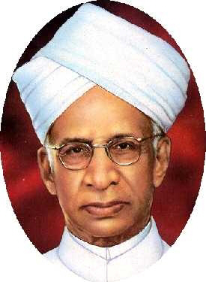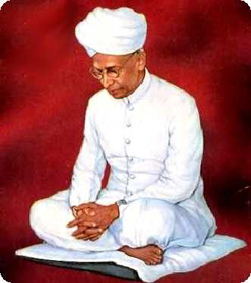

Sarvepalli Radhakrishnan was born on September 5, 1888, at Tiruttani, forty miles to the north-east of Madras, in South India. His early years were spent in Tiruttani and Tirupati, both famous as pilgrim centres.
He graduated with a Master's Degree in Arts from Madras University. In partial fulfilment for his M.A. degree, Radhakrishnan wrote a thesis on the ethics of the Vedanta titled "The Ethics of the Vedanta and Its Metaphysical Presuppositions", which was a reply to the charge that the Vedanta system had no room for ethics. Professor A.G. Hogg awarded the following testimonial for this thesis:
"The thesis which he prepared in the second year of his study for this degree shows a remarkable understanding of the main aspects of the philosophical problems, a capacity for handling easily a complex argument besides more than the average mastery of good English".
The thesis indicates the general trend of Radhakrishnan's thoughts... In his own words, "Religious feeling must establish itself as a rational way of living. If ever the spirit is to be at home in this world, and not merely a prisoner or a fugitive, spiritual foundations must be laid deep and preserved worthily. Religion must express itself in reasonable thought, fruitful action and right social institutions."
In April 1909, he was appointed to the Department of Philosophy at the Madras Presidency College. From then on, he was engaged in the serious study of Indian philosophy and religion, and was a teacher of Philosophy.
In 1918, he was appointed Professor of Philosophy in the University of Mysore. Three years later, he was appointed to the most important philosophy chair in India, King George V Chair of Mental and Moral Science in the University of Calcutta. Radhakrishnan represented University of Calcutta at the Congress of the Universities of the British Empire in June 1926 and the International Congress of Philosophy at the Harvard Univesity in September 1926. At the Philosophical Congress held at Harvard University, the lack of spiritual note in modern civilization was the focus of his address to the general meeting.
In 1929, Radhakrishnan was invited to take the post vacated by Principal J. Estin Carpenter in Manchester College, Oxford. This gave him the opportunity to lecture to the students of University of Oxford on Comparative Religion. During that visit, he also gave the Hibbert Lectures on "An Idealist View of Life" to audiences at the Universities of London and Manchester. In his own words, "It was a great experience for me to preach from Christian pulpits in Oxford and Birmingham, in Manchester and Liverpool. It heartened me to know that my addresses were liked by Christian audiences. Referring to my sermon on "Revolution through Suffering", an Oxford daily observed, "Though the Indian preacher had the marvellous power to weave a magic web of thought, imagination and language, the real greatness of his sermon resides in some indefinable spiritual quality which arrests attention, moves the heart and lifts us into an ampler air."
From 1936-39, Radhakrishnan was the Spalding Professor of Eastern Religions and Ethics at Oxford University. In 1939, he was elected Fellow of the British Academy. From 1939-48, he was the Vice-Chancellor of the Banaras Hindu University. He later held offices that dealt with India's national and international affairs. He was the leader of the Indian delegation to UNESCO during 1946-52. He was the Ambassador of India to U.S.S.R. during 1949-52. He was the Vice-President of India from 1952-1962 and the President, General Conference of UNESCO from 1952-54. He held the office of the Chancellor, University of Delhi, from 1953-62. From May 1962 to May 1967, he was the President of India.
Aldous Huxley observed that Dr. Radhakrishnan "is the master of words and no words."
Prof. H.N. Muirhead said, "Dr. Radhakrishnan has the rare qualification of being equally versed in the great European and the not less great Asiatic tradition which may be said to hold in solution between them the spiritual wisdom of the world, and of thus speaking as a philosophical bilinguist upon it."
George P. Conger said, "Among the philosophers of our time, no one has achieved so much in so many fields as has Sarvepalli Radhakrishnan of India ... William James was influential in religion, and John Dewey has been a force in politics. One or two American philosophers have been legislators. Jacques Maritain has been an ambassador. Radhakrishnan, in a little more than thirty years of work, has done all these things and more... Never in the history of philosophy has there been quite such a world-figure. With his unique appointment at Banaras and Oxford, like a weaver's shuttle, he has gone to and fro between the East and West, carrying a thread of understanding, weaving it into the fabric of civilization."
Sarvepalli Radhakrishnan passed away on April 17, 1975. In India, September 5 (his birthday) is celebrated as Teacher's Day in his honor.

Principal Writings of Dr. Sarvepalli Radhakrishnan:
The Ethics of Vedanta and Its Metaphysical Presuppositions (1908)
Essentials of Psychology (1912)
The Philosophy of Rabindranath Tagore (1918)
The Reign of Religion in Contemporary Philosophy (1920)
Indian Philosophy - Volume I (1923)
The Hindu View of Life (1926)
Indian Philosophy - Volume II (1927)
The Religion We Need (1928)
Kalki or the Future of Civilization (1929)
An Idealist View of Life (Hibbert Lectures) (1932)
East and West in Religion (1933)
The Heart of Hindustan (1936)
Freedom and Culture (1936)
Contemporary Indian Philosophy (1936)
Religion in Transition (1937)
Gautama, the Buddha (British Academy Lectures) (1938)
Eastern Religions and Western Thought (1939)
Mahatma Gandhi (Essays and Reflections on his Life and Work) (1939)
India and China (1944)
Education, Politics and War (A collection of addresses) (1944)
Is this Peace ? (1945)
Religion and Society (Kamala Lectures) (1947)
The Bhagavadgita (1948)
Great Indians (1949)
The Dhammapada (1950)
An Anthology (Of Radhakrishnan Writings) (1952)
The Religion of the Spirit and World's Need: Fragments of a Confession (1952)
History of Philosophy in Eastern and Western (2 Vols.) (1952)
The Principal upaniShads (1953)
East and West: Some Reflections (First series in Bently Memorial Lectures) (1955)
Recovery of Faith (1956)
Occasional Speeches and Writings - Vol I (1956), Vol II (1957)
A Source Book in Indian Philosophy (1957)
The brahma sutra: The Philosophy of Spiritual Life (1960)
The Concept of Man (1960)
Fellowship of Faiths (Opening address to the Center for the Study of World Religions, Harvard) (1961)
Occasional Speeches [July 1959 - May 1962] (1963)
President Radhakrishnan's Speeches and Writings 1962-1964 (1965)
On Nehru (1965)
Religion in a Changing World (1967)
President Radhakrishnan's Speeches and Writings 1964-1967 (1969)
Radhakrishnan Reader: An Anthology (1969)
The Creative Life (1975)
Living with a Purpose (1977)
True Knowledge (1978)
Indian Religions (1979)
Towards a New World (1980)

========================================================================================================

