KIRCHER'S TREE OF THE SEPHIROTH

http://dontyson.tripod.com/kircher.html

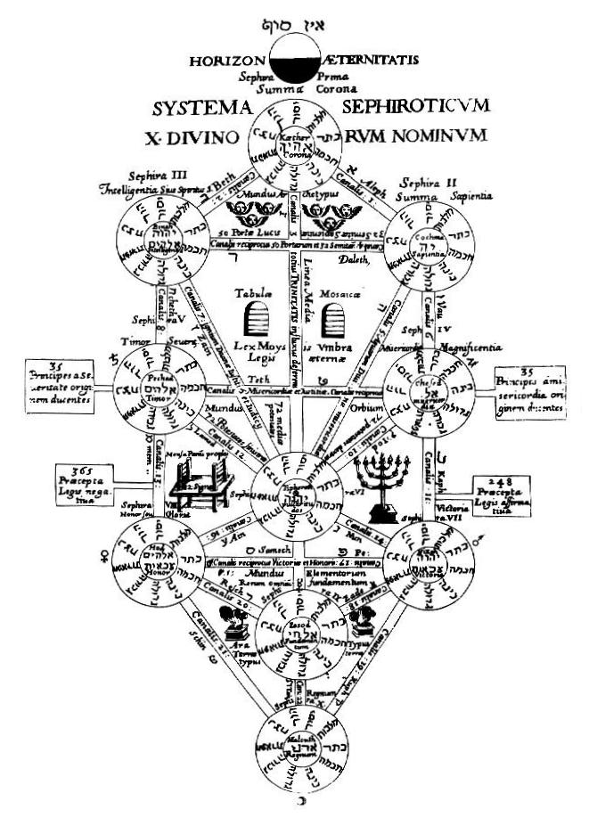
(Tree of the Sephiroth published in Kircher's Oedipus Aegyptiacus)

The version of the Tree of the Sephiroth adopted by the Hermetic Order of the Golden Dawn and its descendant organizations corresponds in almost all respects with the version given by Athanasius Kircher in his book Oedipus Aegyptiacus, published in 1652.
Kircher's version shows twenty-two channels or pathways connecting the Sephiroth, arranged in the same pattern as is found on the modern Tree. Each channel has been assigned one of the Hebrew letters.
The importance of Kircher's model of the Tree to Western magic cannot be overstated. This simple image represents the very heart of practical magic. Over the past century its influence has been growing rather than lessening. More than any other aspect of modern magic, it is this Tree of Life with its sets of occult correspondences that distinguishes modern magic from the magic of ancient times.

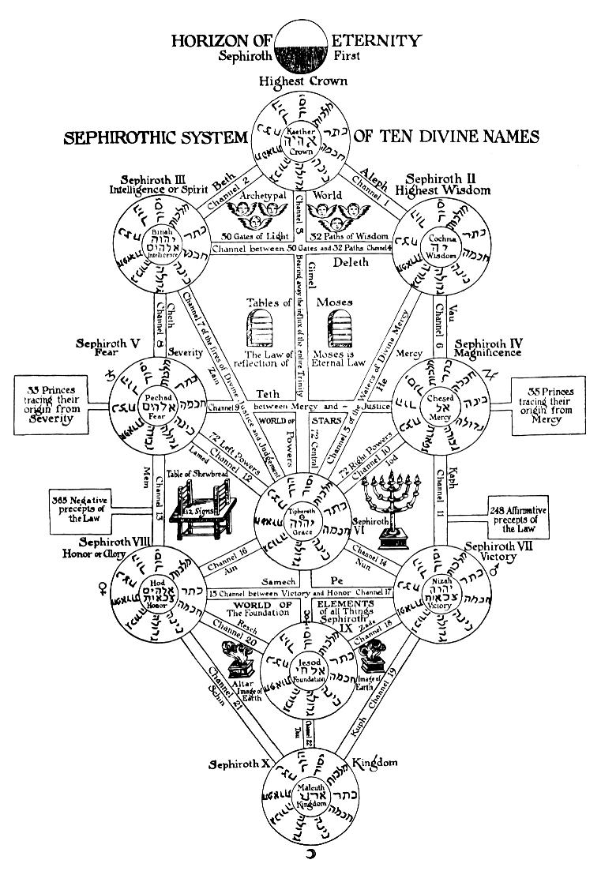
(Kircher's Tree translated from the Latin by Manly P. Hall)

The Latin text on Kircher's version of the Tree of the Sephiroth is almost impossible to make out, even in the original print. Fortunately, the Freemason Manly P. Hall published Kircher's Tree with English translations in place of the Latin.
Notice that Kircher appears to have intended that the horizontal channel between the seventh Sephirah, Hod, and the eighth Sephirah, Netzach, be numbered fifteen, and that the vertical channel between the sixth Sephirah, Tiphareth, and the ninth Sephirah, Yesod, be numbered seventeen. This is not absolutely clear, but seems most probable since on Kircher's original diagram we see the Latin text 15 Canalis reciprocus Victoriae et Honoris on the channel between Netzach and Hod, then upside down in the same channel the Latin text Canalis: 17. Because this second caption is inverted on Kircher's diagram (but not on Hall's translation), it was probably intended to be placed on the vertical channel between Tiphareth and Yesod.
This is the opposite of the Golden Dawn practice, where the horizontal channel between Netzach and Hod is numbered seventeenth in order from the top, and the vertical channel between Tiphareth and Yesod is numbered fifteenth (the actual Golden Dawn numbering of these channels is twenty-seven and twenty-five, because it was the Order practice to begin numbering the paths with eleven, rather than one). The Golden Dawn numbering of these two channels is more sensible than Kircher's numbering, based on the overall numbering on the Tree, but in my opinion is still not correct.
In my book New Millennium Magic I've given what I think is the correct numbering of the paths. I believe the Golden Dawn made a mistake in their numbering of the lower paths of Tiphareth (based purely on a logical analysis of the structure of the paths). Mathers numbered the vertical path between Tiphareth and Yesod fifteenth in sequence, and the diagonal path between Tiphareth and Hod sixteenth. In my view these numbers should be reversed. In all other respects the Golden Dawn numbering of the pathways is correct, for this particular pattern of the Tree (it is not the only possible pattern).
Kircher's assigned the seven traditional planets of astrology differently than their Golden Dawn assignment. From a Golden Dawn point of view, all of Kircher's planets are incorrectly place with the exception of the Sun in Tiphareth. However, Kircher's assignment does make a lot of good sense. In the Kabbalah, Malkuth is the bride of the son (Messiah) in Tiphareth, so it is not unreasonable to give it the Moon. Mercury is a balanced planet, so it makes sense to put it on the middle pillar of the Tree. Kircher put the two male planets Mars and Jupiter on the masculine right pillar of the Tree, and their female opposites, respectively Venus and Saturn, on the feminine left pillar of the Tree.
It may be argued that Saturn is male, not female. However from the esoteric perspective Saturn exhibits many feminine qualities. It is common in alchemy to make a sexual pairing between Mars and Venus, and also between Jupiter and Saturn.

