Sefer Yetzirah, Book of Creation
http://en.wikipedia.org/wiki/Sefer_Yetzirah
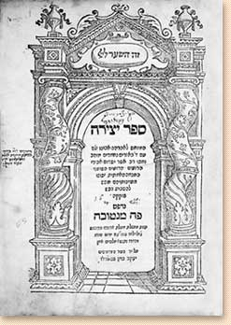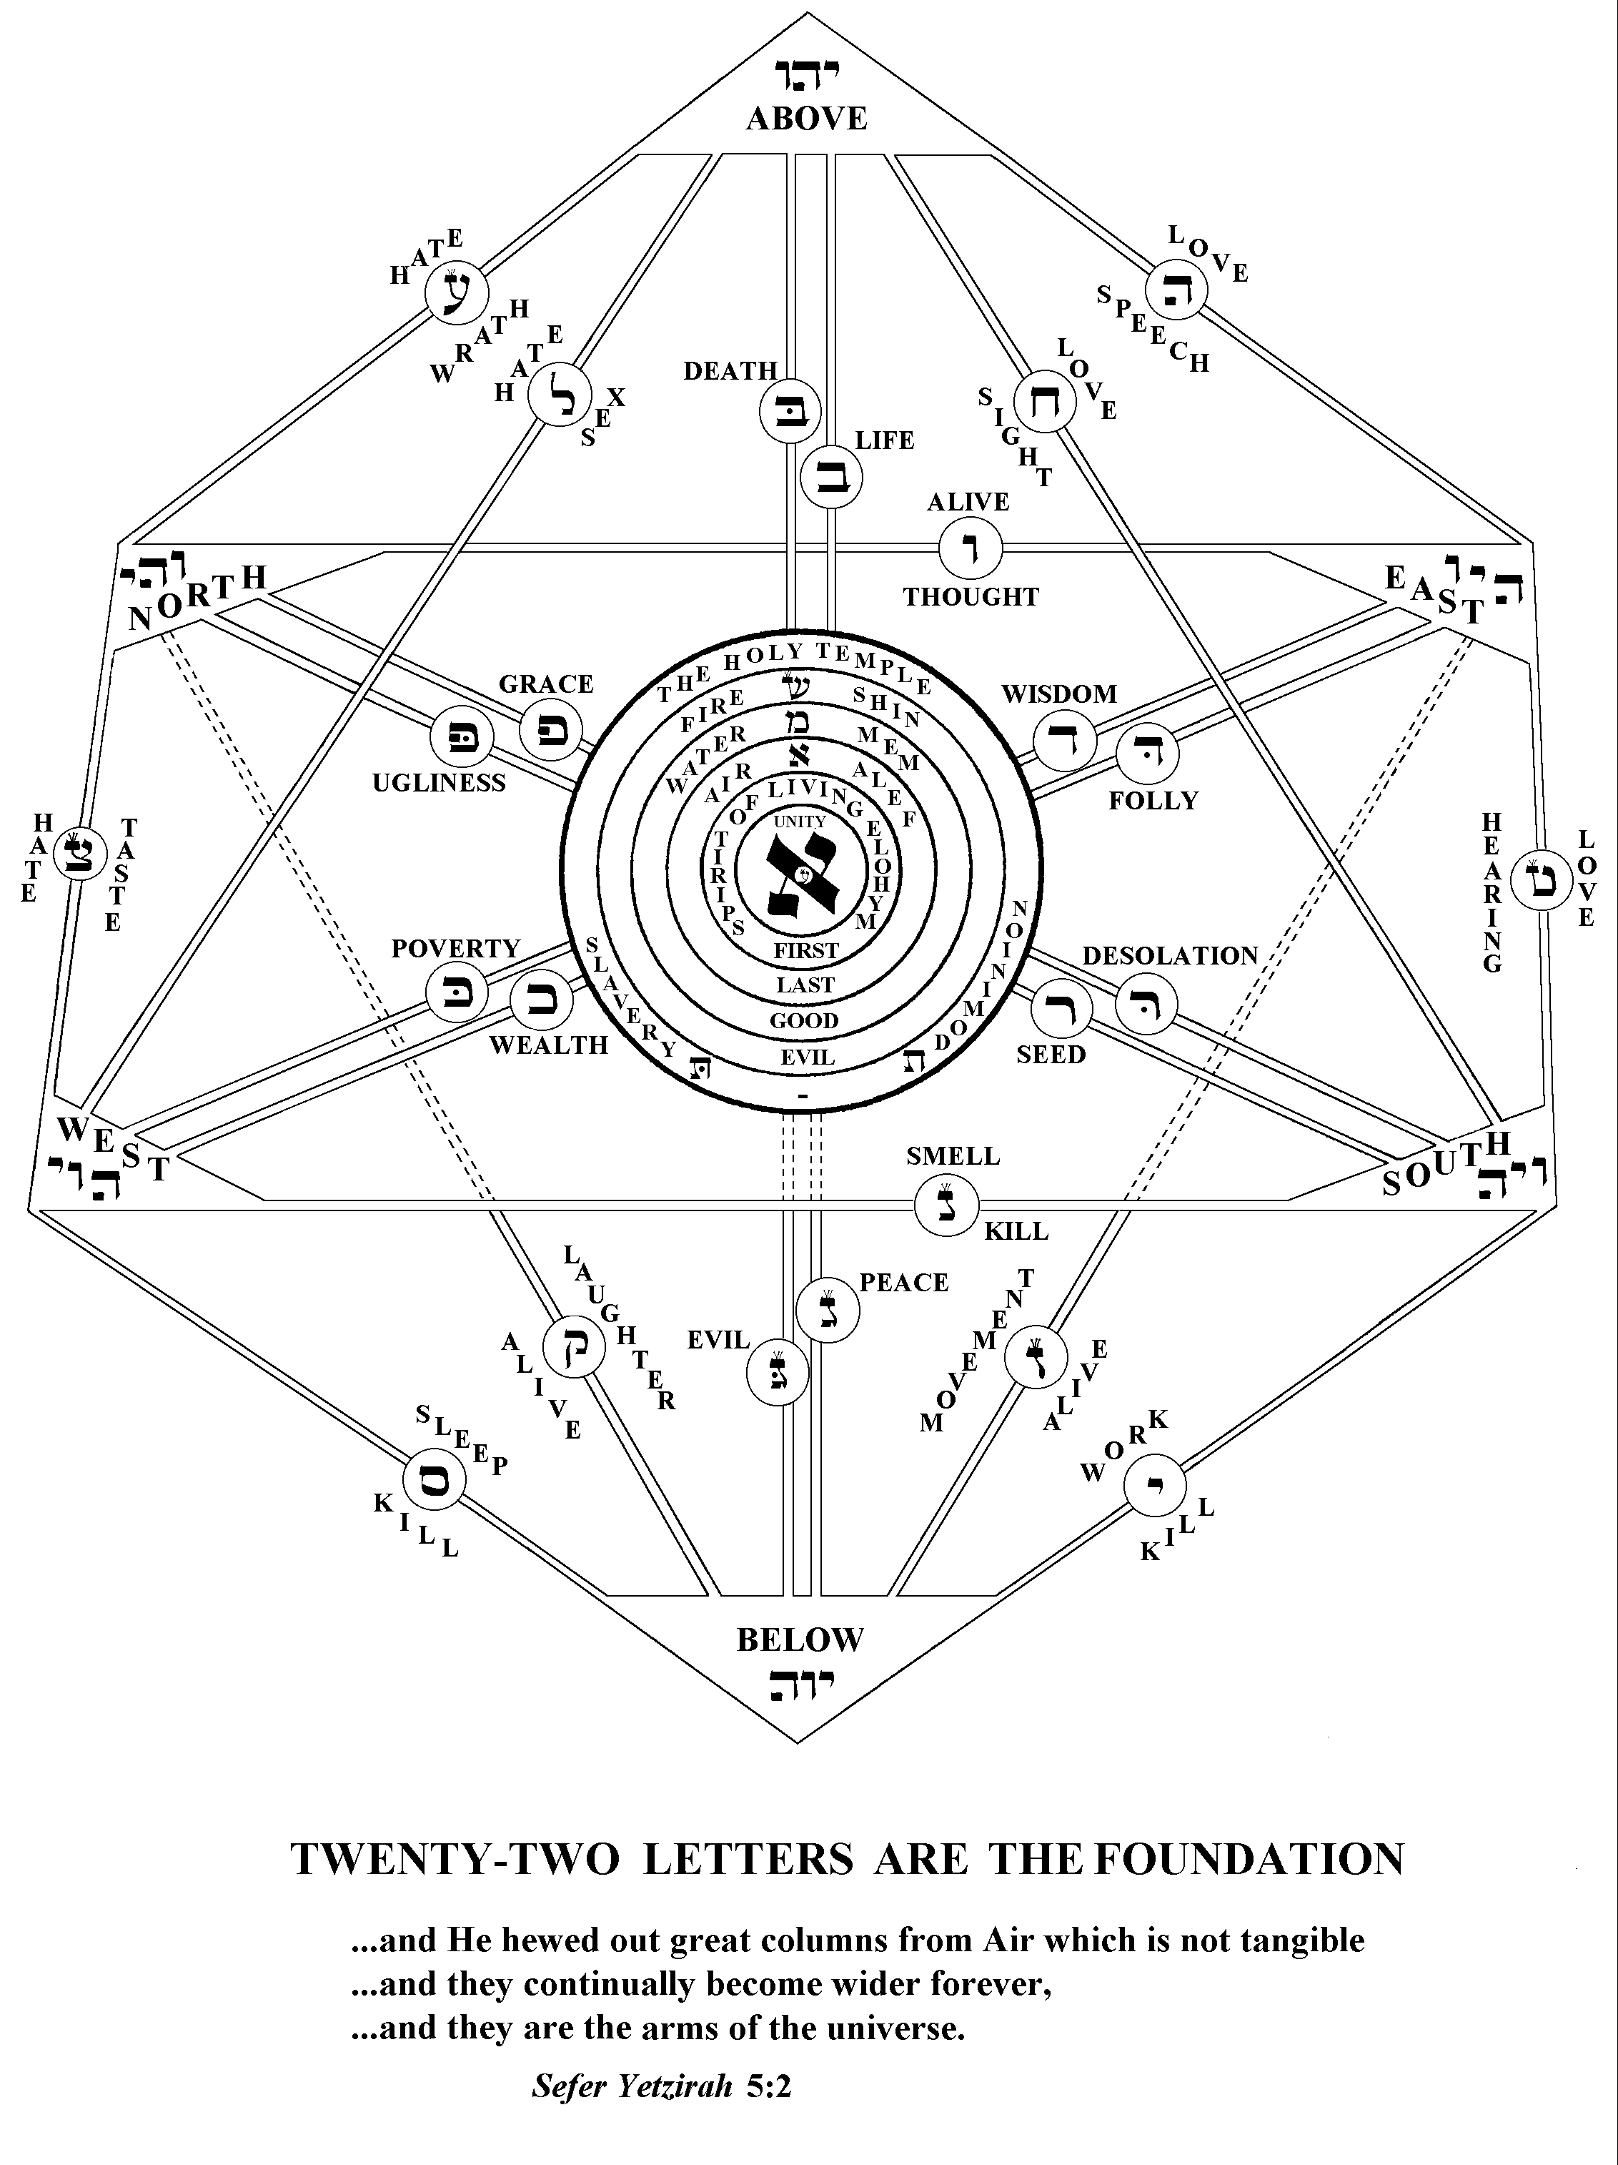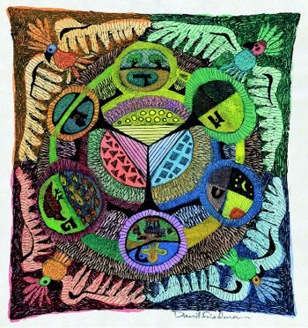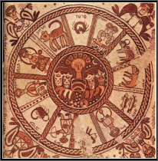
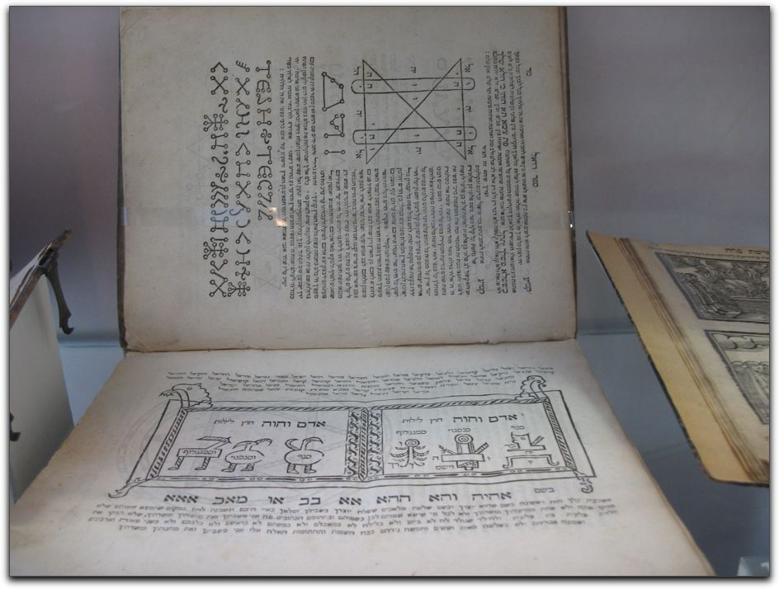
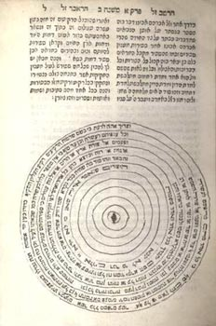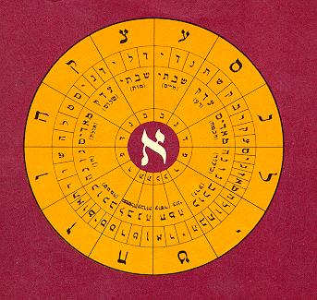

--------------------------------------------------------------------------------------------------------------------------------------------------------------------------------------------------------------------------------------
Sefer Yetzirah (Hebrew, "Book of Creation^{[1]}", ספר יצירה) is the title of the earliest book on Jewish esotericism.
The Sefer Yetzirah is devoted to speculations concerning God's creation of the world. The ascription of its authorship to the biblical patriarch Abraham shows the high esteem which it enjoyed for centuries. It may even be said that this work had a greater influence on the development of the Jewish mind than almost any other book after the completion of the Talmud.
The following text came from the 1906 Public Domain Jewish Encyclopedia [1]. This entry thus needs updating by people familiar with the subject.

Contents
- 1 Origin
- 2 Influence
- 3 Structure
- 4 The phonetic system
- 5 Teachings
- 6 The Creation
- 7 Theories of contrast in nature
- 8 Gnostic elements
- 9 Date
- 10 Thelmetic Interpretations
- 11 Foot notes
- 12 See also
- 13 External links

Origin
A cryptic story in the Babylonian Talmud states that "On the eve of every Shabbat, Judah ha-Nasi's pupils, Rab Hanina and Rab Hoshaiah, who devoted themselves especially to cosmogony, used to create a three-year-old calf by means of the Sefer Yetzirah, and ate it on the Sabbath" (Sanhedrin 65b, 67b). All the miraculous creations attributed to other rabbis of the Talmudic era are ascribed by rabbinic commentators to the use of the same book.
According to modern historians, some of the core ideas in the book seems to have a Babylonian origin. The idea of the creative power of the various sounds is possibly Egyptian. The division of the letters into the three classes of vowels, mutes, and sonants is Hellenic, although this classification necessarily underwent changes when applied to the Hebrew letters. The historical origin of the Sefer Yetzirah is accordingly placed by Reizenstein in the second century B.C.
A mishnah (vi. 15) declares that the Biblical patriarch Abraham was the recipient of the divine revelation of mystic lore; so that the rabbis of the classical rabbinic era, and philosophers as Saadia, Donnolo, and Judah ha-Levi never doubted that Abraham was the author of the book.
In a manuscript (cite?) in the British Museum, the Sefer Yetzirah is called the Hilkot Yetzirah and declared to be esoteric lore not accessible to anyone but the pious, and only to be used for Kabbalistic purposes.

[] Influence
The Sefer Yetzirah is devoted to speculations concerning God and the angels. The ascription of its authorship to Abraham, shows the high esteem which it enjoyed for centuries. It may even be said that this work had a greater influence on the development of the Jewish mind than almost any other book after the completion of the Talmud.
The Sefer Yetzirah is exceedingly difficult to understand on account of its obscure style. The difficulty is rendered still greater by the lack of a critical ion, the present text being much interpolated and altered. Hence there is a wide divergence of opinion regarding the age, origin, contents, and value of the book, since it is variously regarded as pre-Temple era.

[] Structure
The Sefer Yetzirah describes the universe as being created through Ten Numbers ('Sefirot,' the origin for the Sefirot of later Kabbalah), Three Mother Letters, Seven Double Letters and Twelve Elemental Letters and that God created the universe through these four structures. These structures correspond to the astrological symbols in the sky, the planets, human physical functions, the parts of the human body.

[] The phonetic system
The philological is discussed first, since it is necessary for an elucidation of the philosophical speculations of the work. The twenty-two letters of the Hebrew alphabet are classified both with reference to the position of the vocal organs in producing the sounds, and with regard to sonant intensity. In contrast to the Jewish grammarians, who assumed a special mode of articulation for each of the five groups of sounds, the Sefer Yetzirah says that no sound can be produced without the tongue, to which the other organs of speech merely lend assistance. Hence the formation of the letters is described as follows: with the tip of the tongue and the throat; between the lips and the tip of the tongue; in the middle of the tongue; by the tip of the tongue; and by the tongue, which lies flat and stretched, and by the teeth (ii. 3).
The letters are distinguished, moreover, by the intensity of the sound necessary to produce them, and are accordingly divided into; mutes, which are unaccompanied by sound, such as מ, which the book calls ; sibilants, such as ש, which is therefore called, the "hissing shin"; and aspirates, such as א, which holds a position between the mutes and sibilants, and is designated as the "airy א, which holds the balance in the middle" (iv. 1; in some eds. ii. 1). Besides these three letters, which are called "mothers," a distinction is also drawn between the seven "double" letters and the twelve "simple" letters, the remaining characters of the alphabet.

[] Teachings
Both the macrocosm (the universe) and the microcosm (man) are viewed in this system as products of the combination and permutation of these mystic characters, and such a use of the letters by the Jews for the formation of the Holy Name for thaumaturgical purposes is attested by magic papyri that quote an "Angelic Book of Moses," which was full of allusions to Biblical names.
The linguistic theories of the author of the Sefer Yetzirah are an integral component of his philosophy, its other parts being astrological and Gnostic cosmogony. The three letters are not only the three "mothers" from which the other letters of the alphabet are formed, but they are also symbolical figures for the three primordial elements, the substances which underlie all existence.
According to the Sefer Yetzirah, the first emanation from the spirit of God was the (= "spirit," "air") that produced fire, which, in its turn, formed the genesis of water. In the beginning, however, these three substances had only a potential existence, and came into actual being only by means of the three letters; and as these are the principal parts of speech, so those three substances are the elements from which the cosmos has been formed.
The cosmos consists of three parts, the world, the year (or time), and man, which are combined in such a way that the three primordial elements are contained in each of the three categories. The water formed the earth; heaven was produced from the fire; and the produced the air between heaven and earth. The three seasons of the year, winter, summer, and the rainy season, correspond to water, fire, and in the same way as man consists of a head (corresponding to fire), torso, and the other parts of the body (equivalent to water).
The seven double letters produced the seven planets, the "seven days," and the seven apertures in man (two eyes, two ears, two nostrils, and one mouth). Again, as the seven double letters vary, being pronounced either hard or soft, so the seven planets are in continuous movement, approaching or receding from the earth. The "seven days," in like manner, were created by the seven double letters whereat they change in time according to their relation to the planets. The seven apertures in man connect him with the outer world as the seven planets join heaven and earth. Hence these organs are subject to the influence of the planets, the right eye being under Saturn, the left eye under Jupiter, and the like.
The twelve "simple" letters created the twelve signs of the zodiac, whose relation to the earth is always simple or stable; and to them belong the twelve months in time, and the twelve "leaders" in man. The latter are those organs which perform functions in the body independent of the outside world, being the hands, feet, kidneys, gall, intestines, stomach, liver, pancreas, and spleen; and they are, accordingly, subject to the twelve signs of the zodiac.
In its relation to the construction of the cosmos, matter consists of the three primordial elements, which, however, are not chemically connected with one another, but modify one another only physically. Power (δύναμις) emanates from the seven and the twelve heavenly bodies, or, in other words, from the planets and the signs of the zodiac. The "dragon" rules over the world (matter and the heavenly bodies); the sphere rules time; and the heart rules over the human body. The author sums up this explanation in a single sentence: "The dragon is like to a king on his throne, the sphere like a king traveling in his country, and the heart like a king at war."

[] The Creation
To harmonize the Biblical statement of the creation "ex nihilo" with the doctrine of the primordial elements, the Sefer Yetzirah assumes a double creation, one ideal and the other real.
Their name is possibly derived from the fact that as numbers express only the relations of two objects to each other, so the ten Sefirot are only abstractions and not realities. Again, as the numbers from two to ten are derived from the number one, so the ten Sefirot are derived from one, the spirit of God. The spirit of God, however, is not only the commencement but also the conclusion of the Sefirot, "their end being in their beginning and their beginning in their end, even as the flame is connected with the coal"(i. 7). Hence the Sefirot must not be conceived as emanations in the ordinary sense of the word, but rather as modifications of the spirit of God, which first changes to, then becomes water, and finally fire, the last being no further removed from God than the first.
Besides these abstract ten Sefirot, which are conceived only ideally, the twenty-two letters of the alphabet produced the material world, for they are real, and are the formative powers of all existence and development. By means of these elements the actual creation of the world took place, and the ten Sefirot, which before this had only an ideal existence, became realities. This is, then, a modified form of the Talmudic doctrine that God created heaven and earth by means of letters (Berachot 58a). The explanation on this point is obscure since the relation of the twenty-two letters to the ten Sefirot is not clearly defined.
The first sentence of the book reads: "Thirty-two paths, marvels of wisdom, hath God engraved...," these paths being then explained as the ten Sefirot and the twenty-two letters. While the Sefirot are expressly designated as "abstracts", it is said of the letters: "Twenty-two letters: God drew them, hewed them, combined them, weighed them, interchanged them, and through them produced the whole creation and everything that is destined to come into being" (ii. 2).
The letters are neither independent substances nor yet as mere forms. They seem to be the connecting-link between essence and form. They are designated as the instruments by which the real world, which consists of essence and form, was produced from the Sefirot, which are merely formless essences.

[] Theories of contrast in nature
In addition to the doctrine of the Sefirot and the letters, the theory of contrasts in nature, or of the syzygies ("pairs"), as they are called by the Gnostics, occupies a prominent place in the Sefer Yetzirah.
This doctrine is based on the assumption that the physical as well as the moral world consists of a series of contrasts mutually at war, yet pacified and equalized by the unity, God. Thus in the three prototypes of creation the contrasting elements fire and water are equalized by air; corresponding to this are the three "mothers" among the letters, the mute מ contrasting with the hissing ש, and both being equalized by א.
Seven pairs of contrasts are enumerated in the life of man: life and death, peace and strife, wisdom and folly, wealth and poverty, beauty and ugliness, fertility and sterility, lordship and servitude (iv. 3). From these premises the Sefer Yezirah draws the important conclusion that "good and evil" have no real existence, for since everything in nature can exist only by means of its contrast, a thing may be called good or evil according to its influence over man by the natural course of the contrast.
The book teaches that man is a free moral agent. A person is rewarded or punished for their actions. The idea of heaven and hell are foreign to the book. Instead, the virtuous man is rewarded by a favorable attitude of nature, while the wicked finds it hostile to him.

[] Gnostic elements
The Sefer Yetzirah is similar to various Gnostic systems. As the Sefer Yetzirah divides the Hebrew alphabet into three groups, so the Gnostic Marcus divided the Greek letters into three classes, regarded by him as the symbolic emanations of the three powers which include the whole number of the upper elements.
Both systems attach great importance to the power of the combinations and permutations of the letters in explaining the genesis and development of multiplicity from unity. The Clementine writings present another form of gnosis which agrees in many points with the Sefer Yetzirah. As in the latter, God is not only the beginning but also the end of all things, so in the former He is the ἀρχή and τέλος of all that exists; and the Clementine writings furthermore teach that the spirit of God is transformed into πνεῦμα (= רוח), and this into water, which becomes fire and rocks, thus agreeing with the Sefer Yetzirah, where the spirit of God, רוח (= πνεῦμα), water, and fire are the first four Sefirot.
The remaining six Sefirot, or the limitations of space by the three dimensions in a twofold direction, are also found in the Clementina, where God is described as the boundary of the universe and as the source of the six infinite dimensions.
The "dragon," which plays such an important part in the astrology of the book, is probably an ancient Semitic figure; at all events its name is not Arabic, as scholars have hitherto assumed, but either Aramaic or possibly a Babylonian loan-word.

[] Date
The essential elements of the book are characteristic of the third or fourth century; for a work of this nature, composed in the geonic period, before the Jews had become acquainted with Arabic and Greek learning, could have been cast only in the form of Jewish gnosis, which remained stationary after the fourth century, if indeed it had not already become extinct.
The date and origin of the book can not be definitely determined so long as there is no critical text of it. The io princeps (Mantua, 1562) contains two recensions, which were used in the main by the commentators of the book as early as the middle of the tenth century. The shorter version (Mantua I.) was annotated by Dunash ibn Tamim or by Jacob b. Nissim, while Saadia and Donnolo wrote commentaries on the longer recension (Mantua II.). The shorter version was also used by most of the later commentators, such as Judah b. Barzillai and Nahmanides, and it was, therefore, published in the ordinary ions. The longer recension, on the other hand, was little known, the form given in the io princeps of the Sefer Yetzirah being probably a copy of the text found in Donnolo's commentary. In addition to these two principal recensions of the text, both versions contain a number of variant readings which have not yet been examined critically.
As regards the relation of the two recensions, it may be said that the longer form contains entire paragraphs which are not found in the shorter, while the divergent arrangement of the material often modifies the meaning essentially. Although the longer recensiondoubtless contains additions and interpolations which did not form part of the original text, it has many valuable readings which seem older and better than the corresponding passages in the shorter version, so that a critical ion of the text must consider both recensions.
The history of the study of the Sefer Yetzirah is one of the most interesting in the records of Jewish literature. With the exception of the Bible, scarcely any other book has been the subject of so much annotation.
An intimate relation exists between the Sefer Yetzirah and the later mystics, and that, although there is a marked difference between the later Kabbalah and the Sefer Yetzirah, the system laid down in the latter is the first visible link in the development of Kabbalistic ideas. Instead of the immediate creation ex nihilo, both works postulate a series of emanations of mediums between God and the universe; and both consider God as the first cause only, and not as the immediate efficient cause of the world. Although the Sefirot of the Kabbalists do not correspond to those of the Sefer Yetzirah, yet the underlying problem is identical in both. The importance of the Sefer Yetzirah for mysticism, finally, lies in the fact that the speculation about God and man had lost its sectarian character. This book, which does not even mention such words as "Israel" and "revelation," taught the Kabbalists to reflect on "God," and not merely on the "Ruler of Israel."
A book of the same name, which had nothing else in common with the Sefer Yetzirah described above, was circulated among German mystics between the eleventh and thirteenth centuries. This book seems to be a mystic work on the six days of creation, and corresponded in part to the small Midrash Seder Rabbah de-Bereshit.

[] Thelmetic Interpretations
Frater Achad in his magnum opus called The Anatomy of The Body of God has written interpretions of this book.

[] Foot notes
- ^ "Yetzirah" is more literally translated as "Formation"; the word "Briah" is used for "Creation"

[] See also
- Kabbalah
- mysticism
- Zohar
- Jewish views of astrology
- Kabbalistic astrology

[] External links
- English translation by W.W. Wescott (1887)
- Original Hebrew Text
- Short Version English translation by A Kaplan
- Sefer Yetzirah: Cube of Space
- Astrological Correspondences in the Sepher Yetsira
==========================================================================================================================
END

