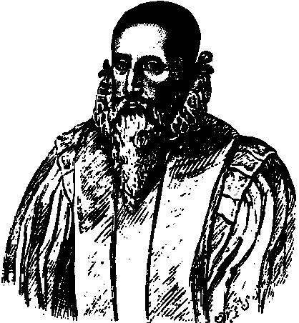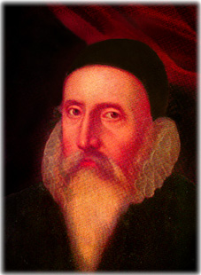
About Dr John Dee
Paul Lee, 01 September 1996.
http://www.johndee.org/DEE.html

Outline:
1. Visionary of the British Empire; coined the word Brittannia and developed a plan for the British Navy.
2. The first to apply Euclidean geometry to navigation; built the instruments to apply Euclid; trained the first great navigators; developed the maps; charted the Northeast and Northwest Passages.
3. An angel conjuror with his sidekick Kelley; the angels told him what Britain would have in their eventual empire; used an obsidian show stone which came from the Aztecs/Mayans and rests in the British Museum along with his conjuring table which contains the Enochian Alphabet he used as angel language.
4. Philosopher to Queen Elizabeth; did her horoscope; determined her coronation date astrologically; she came to visit him on her horse.
5. Founder of the Rosicrucian Order, the protestant response to the Jesuits.
6. An alchemist; hermeticist, cabalist, adept in esoteric and occcult lore.
7. Translator of Euclid and wrote the famous Mathematical Preface, mapping mathematical studies for the future, a kind of system of the sciences based on math.
8. Put a hex on the Spanish Armada which is why there was bad weather and England won.
9. Commissioned by Elizabeth to establish the legal foundation for colonizing North America; went back to Madoc, a Welsh Prince who took a group over to New England in the middle ages and established the first colony, and intermarried with the Indians, but with little or no historical trace but for the legend.
10. Instrumental in theatre arts and architecture.
11. Shakespeare depicted him as Prospero, and King Lear.
12. Sold the Voynich Manuscript, the most mysterious, a cipher as yet to be deciphered--"the Everest of cipher studies"--to the Holy Roman Emperor--Rudolph II--for a lot of gold. Resides at Yale in the Beineke Library. Probably an herbal and an almanac by Anthony Askham.
13. Had the greatest library in England over 4,000 books.
14. Biography by Peter French and everything by Francis Yates, his greatest advocate: cf. especially THE ROSICRUCIAN ENLIGHTENMENT.

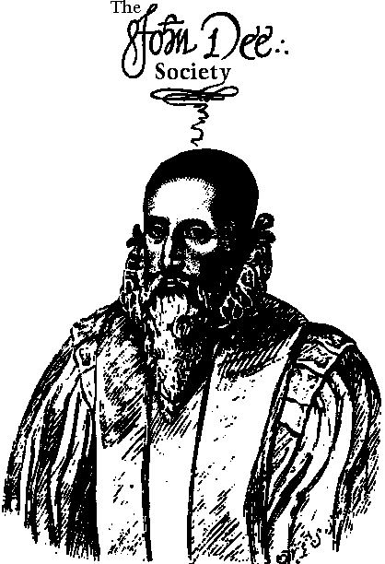
The John Dee Society:
The John Dee Society has been formed to accomplish several general and specific goals.
Our primary purpose is to produce a standard edition of the published and unpublished works of Elizabethan England's great polymath, antiquarian and magus Dr. John Dee, to make available to students of Renaissance philosophy and of Dee's Enochian magical system a coherent data base of primary source material for their researches.
Secondly, we seek to reconstruct John Dee's Library, based on his Catalogue of manuscripts and books of 1583, prior to its dispersal throughout Europe. To this end, we have begun assembling a microfilm archive of Dee's manuscripts and books from the libraries where they now reside, and are in the process of transcribing this material for eventual publication. This is a long-term project which will require the assistance of other archivists, libraries, antiquarians and translators.
Dee's library, at 4000 volumes, was the largest philosophical and scientific library collection in Elizabethan England, and arguably the greatest in all of Renaissance Europe, as is generally agreed by scholars; thus its reconstruction should be of interest to a broad cross-section of the academic community, as well as to students of the Western magical tradition.
Thirdly, the John Dee Society hopes to be a useful source-point for networking with others interested in pursuing such work, and for publishing original studies by individuals and groups furthering the researches begun by Dee in the 16th Century.
All of our offerings will appear here on our website. We will not be publishing on paper.

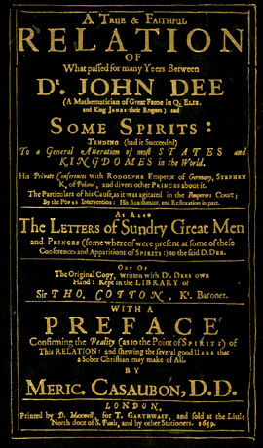
A True and Faithful Relation of What Paffed for many Yeers Between
by Meric Casaubon, D.D.
ISBN #0-939708-01-9
Publisher: Magickal Childe Publishing, Inc., 1992. Original text first published in 1659.

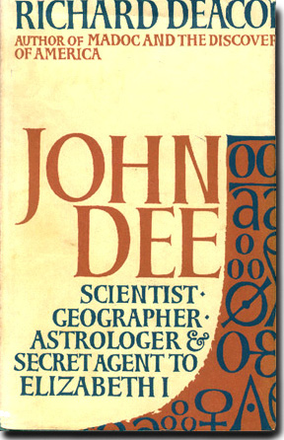
John Dee: Scientist, Geographer, Astrologer and Secret Agent to Elizabeth I
by Richard Deacon
Publisher: Frederick Muller, 1968

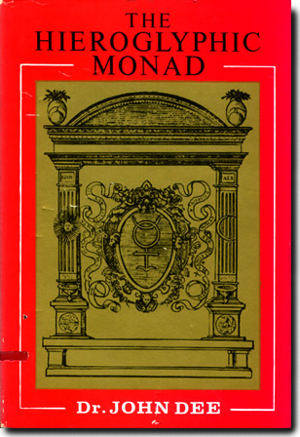
The Hieroglyphic Monad
by Dr. John Dee and translated with commentary by J.W. Hamilton Jones
ISBN #0-877-28-276-5
Publisher: Samuel Weiser, Inc., 1975


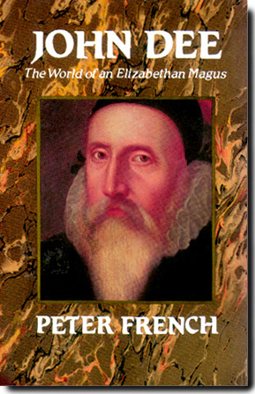
John Dee: The World of an Elizabethan Magus
by Peter French
ISBN #0-88029-445-0
Publisher: Dorset Press, 1972
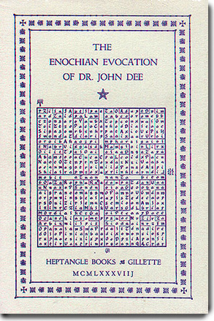
The Enochian Evocation of Dr. John Dee
edited and translated by Geoffrey James
ISBN #0-935214-06-2
Publisher: Heptangle Books and Gillette, 1984.
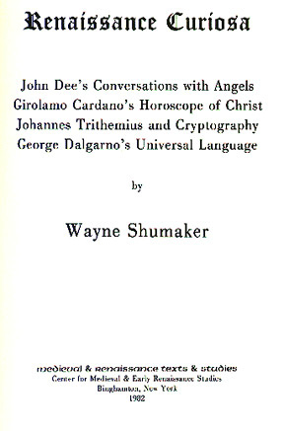
Renaissance Curiosa
by Wayne Shumaker along with "John Dee's Conversations with Angels"
ISBN #0-86698-014-8
Publisher: Medieval and Renaissance Texts and Studies, Binghamptom, New York, 1982.

