**Case of Drąsius Kedys**

<https://www.youtube.com/watch?v=dPTYSv06sjs>

SFrom Wikipedia, the free encyclopedia

Jump to: [navigation](https://en.wikipedia.org/wiki/Case_of_Dr%C4%85sius_Kedys#mw-head), [search](https://en.wikipedia.org/wiki/Case_of_Dr%C4%85sius_Kedys#p-search)

The **case of Drąsius Kedys** is a high-profile criminal case in [Lithuania](https://en.wikipedia.org/wiki/Lithuania) centering on allegations of [sexual molestation](https://en.wikipedia.org/wiki/Sexual_molestation) of the then four-year-old Lithuanian girl and a double homicide. In November 2008, Drąsius Kedys accused Laimutė Stankūnaitė of allowing Andrius Ūsas to sexually molest their underage daughter. Frustrated by lack of progress in the investigation, Kedys took the case public. He published a video with his daughter's testimony, sent out DVDs to politicians, and appeared in the media. Still no case was brought before trial. In October 2009, Jonas Furmanavičius, a district judge and accused [pedophile](https://en.wikipedia.org/wiki/Pedophile), and Violeta Naruševičienė, aunt of his daughter and accused [procurer](https://en.wikipedia.org/wiki/Procuring_(prostitution)), were found dead and Kedys became the main murder suspect.[[1]](https://en.wikipedia.org/wiki/Case_of_Dr%C4%85sius_Kedys#cite_note-1) While Kedys went into hiding, Lithuanian public sided with him portraying Kedys as a desperate father trying to protect his daughter against pedophiles. His body was found in April 2010 near [Kaunas Reservoir](https://en.wikipedia.org/wiki/Kaunas_Reservoir). His death was ruled an accident – choking on vomit after heavy drinking.[[2]](https://en.wikipedia.org/wiki/Case_of_Dr%C4%85sius_Kedys#cite_note-2) The main suspect in the pedophilia case, Andrius Ūsas, was found drowned in a lake after a motorcycle accident in June 2010. Posthumous trial of Ūsas found him innocent. A separate court ruling restored girl's custody to Stankūnaitė. Lithuanian public disagreed with the ruling and began a vigil at the house of Kedys' relatives in [Garliava](https://en.wikipedia.org/wiki/Garliava) where the girl lived at the time. Officials were able to take custody of the girl only with the help of riot police in May 2012. [The Way of Courage](https://en.wikipedia.org/wiki/The_Way_of_Courage), a political party founded by Kedys' sister and supporters, participated in the [Lithuanian parliamentary election, 2012](https://en.wikipedia.org/wiki/Lithuanian_parliamentary_election,_2012) and received almost 8% of the votes.

**Contents**

 [hide]

* [1 Pedophile scandal](https://en.wikipedia.org/wiki/Case_of_Dr%C4%85sius_Kedys#Pedophile_scandal)
* [2 Double homicide](https://en.wikipedia.org/wiki/Case_of_Dr%C4%85sius_Kedys#Double_homicide)
* [3 Death of Kedys](https://en.wikipedia.org/wiki/Case_of_Dr%C4%85sius_Kedys#Death_of_Kedys)
* [4 Death of Ūsas](https://en.wikipedia.org/wiki/Case_of_Dr%C4%85sius_Kedys#Death_of_.C5.AAsas)
* [5 Custody battle](https://en.wikipedia.org/wiki/Case_of_Dr%C4%85sius_Kedys#Custody_battle)
* [6 References](https://en.wikipedia.org/wiki/Case_of_Dr%C4%85sius_Kedys#References)
* [7 External links](https://en.wikipedia.org/wiki/Case_of_Dr%C4%85sius_Kedys#External_links)

**Pedophile scandal[**[**edit**](https://en.wikipedia.org/w/index.php?title=Case_of_Dr%C4%85sius_Kedys&action=edit&section=1)**]**

Drąsius Kedys (born 4 September 1972 in [Garliava](https://en.wikipedia.org/wiki/Garliava)) and his former girlfriend Laimutė Stankūnaitė (born 1986) had an out-of-wedlock daughter in February 2004. Stankūnaitė was still underage when she gave birth to Kedys' daughter. The unwed couple split up in 2006 and the parents got embroiled in a bitter custody battle. His former girlfriend, with the help from Andrius Ūsas, politician and advisor to the former [Speaker of the Seimas](https://en.wikipedia.org/wiki/Speaker_of_the_Seimas) [Viktoras Muntianas](https://en.wikipedia.org/wiki/Viktoras_Muntianas), obtained custody in November 2006. Kedys got visitation rights every other weekend.[[3]](https://en.wikipedia.org/wiki/Case_of_Dr%C4%85sius_Kedys#cite_note-chron-3)

On 29 November 2008 Kedys submitted a formal complaint to the police, claiming that Ūsas paid Stankūnaitė to sexually molest his daughter. On this basis, in December 2008, Kedys obtained full custody of his daughter with no visitation rights for Stankūnaitė, but the courts repeatedly confirmed that Stankūnaitė had no case to answer, thus dismissing Kedys' allegations against his former girlfriend as unsubstantiated. The pre-trial investigation against Ūsas, nevertheless, continued. In February 2009, Kedys further pressed accusations against Violeta Naruševičienė, sister of Stankūnaitė, claiming the former has taken part in allowing men to molest her 8-year-old daughter.[[3]](https://en.wikipedia.org/wiki/Case_of_Dr%C4%85sius_Kedys#cite_note-chron-3) In July 2009, Kedys also accused Jonas Furmanavičius, a district judge, and an unidentified individual known only as Aidas of partaking in the molestation. All of those people (except for the unidentified Aidas) professed their innocence, and in turn accused Kedys of slander, criminal libel, and death threats.

Frustrated with the apparent lack of progress in official investigations and convinced that the case is being deliberately stonewalled, Kedys sent out some 200 DVDs to Lithuanian politicians, media outlets, and law-enforcement agencies, featuring homemade video footage of his daughter's explicit testimony against three "uncles". He promised to send out the subtitled version to [Members of the European Parliament](https://en.wikipedia.org/wiki/Members_of_the_European_Parliament).[[4]](https://en.wikipedia.org/wiki/Case_of_Dr%C4%85sius_Kedys#cite_note-4) Many sources criticized Kedys, who acted as the cameraman, for asking his daughter leading questions and heavily editing the film (it contains some 50 segments filmed over nine separate times).[[5]](https://en.wikipedia.org/wiki/Case_of_Dr%C4%85sius_Kedys#cite_note-reab-5)

**Double homicide[**[**edit**](https://en.wikipedia.org/w/index.php?title=Case_of_Dr%C4%85sius_Kedys&action=edit&section=2)**]**

On 5 October 2009 Furmanavičius and Naruševičienė were shot dead in [Kaunas](https://en.wikipedia.org/wiki/Kaunas). Kedys became the prime suspect.[[6]](https://en.wikipedia.org/wiki/Case_of_Dr%C4%85sius_Kedys#cite_note-rastas-6) On the same day, a national search of Kedys was announced,[[7]](https://en.wikipedia.org/wiki/Case_of_Dr%C4%85sius_Kedys#cite_note-7) which was soon followed by an announcement of international search, as he was thought to have left the country shortly after the murders.[[8]](https://en.wikipedia.org/wiki/Case_of_Dr%C4%85sius_Kedys#cite_note-8) Kedys' friends Raimundas Ivanauskas and Eglė Barauskaitė were charged with accessory to murder. As of December 2013, that court case is ongoing.[[9]](https://en.wikipedia.org/wiki/Case_of_Dr%C4%85sius_Kedys#cite_note-9)

The story caused an uproar in Lithuania, much of the public siding with Kedys: in the public mind, the case was seen as largely a father's futile attempts in pursuing justice and trying to protect his daughter, and by being driven to desperate measures by anger at the injustice. Others questioned whether the killings were in fact commissioned by Kedys himself.

**Death of Kedys[**[**edit**](https://en.wikipedia.org/w/index.php?title=Case_of_Dr%C4%85sius_Kedys&action=edit&section=3)**]**

[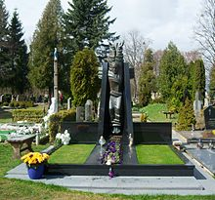](https://en.wikipedia.org/wiki/File:Dr%C4%85sius_Kedys-Jonu%C4%8Diai.JPG)

Tombstone of Drąsius Kedys in Jonučiai cemetery

After six months of police search, Drąsius Kedys' body was found near [Kaunas Reservoir](https://en.wikipedia.org/wiki/Kaunas_Reservoir) on 20 April 2010. According to the official report, the cause of death was "choking on the vomit" whilst being heavily intoxicated. However, his relatives were convinced that Kedys was murdered, pointing out to some wounds on his body.[[10]](https://en.wikipedia.org/wiki/Case_of_Dr%C4%85sius_Kedys#cite_note-10) Kedys' relatives demanded a second opinion from independent experts. In April 2011, a report was received from the Swedish National Forensic Service (*Rättsmedicinalverket*) which confirmed that Kedys had indeed died from alcohol and drug poisoning, and that he choked on the contents of his own stomach.

On 24 April the body of Kedys was buried in Jonučiai cemetery. According to various media reports, some six to ten thousand people from across the country attended the ceremony.[[11]](https://en.wikipedia.org/wiki/Case_of_Dr%C4%85sius_Kedys#cite_note-11)

**Death of Ūsas[**[**edit**](https://en.wikipedia.org/w/index.php?title=Case_of_Dr%C4%85sius_Kedys&action=edit&section=4)**]**

Ūsas, the main suspect in the pedophilia case, was officially charged with sexual molestation of a minor. However, he was found drowned in a swamp in June 2010. The death was ruled an accident. The court case against Ūsas continued. The court found him innocent in November 2012.[[5]](https://en.wikipedia.org/wiki/Case_of_Dr%C4%85sius_Kedys#cite_note-reab-5)

**Custody battle[**[**edit**](https://en.wikipedia.org/w/index.php?title=Case_of_Dr%C4%85sius_Kedys&action=edit&section=5)**]**

On 17 May 2012, following a court order, Kedys' daughter, who was previously living with Kedys' relatives in [Garliava](https://en.wikipedia.org/wiki/Garliava), was reunited with her mother Stankūnaitė.[[12]](https://en.wikipedia.org/wiki/Case_of_Dr%C4%85sius_Kedys#cite_note-12) Due to continuous presence of protesters disagreeing with the 5-month old court decision, the operation was carried out with the assistance of riot police, with 39 protesters detained. Previously, [Seimas](https://en.wikipedia.org/wiki/Seimas) (Lithuanian parliament) changed a law in order to allow the use of riot police in taking away the child.[[13]](https://en.wikipedia.org/wiki/Case_of_Dr%C4%85sius_Kedys#cite_note-13)

**References[**[**edit**](https://en.wikipedia.org/w/index.php?title=Case_of_Dr%C4%85sius_Kedys&action=edit&section=6)**]**

* 1. [**Jump up ^**](https://en.wikipedia.org/wiki/Case_of_Dr%C4%85sius_Kedys#cite_ref-1) [Prokuratūra: surinkta pakankamai duomenų, leidžiančių manyti, kad D.Kedys dalyvavo nužudant J.Furmanavičių ir V.Naruševičienę](http://www.delfi.lt/news/daily/kedys/prokuratura-surinkta-pakankamai-duomenu-leidzianciu-manyti-kad-dkedys-dalyvavo-nuzudant-jfurmanaviciu-ir-vnaruseviciene.d?id=47057255)
  2. [**Jump up ^**](https://en.wikipedia.org/wiki/Case_of_Dr%C4%85sius_Kedys#cite_ref-2) [D.Kedys užspringo, jo organizme aptikta 3,7 prom. alkoholio, o rastas ginklas – tas pats, kuriuo nušauti du žmonės (atnaujinta 19.20 val.)](http://www.15min.lt/naujiena/aktualu/nusikaltimaiirnelaimes/prokuratura-d-kedys-uzspringo-jo-organizme-aptikta-3-7-prom-alkoholio-o-salia-rastas-ginklas-tas-pats-kuriuo-nusauti-du-zmones-59-94418)
  3. ^ [Jump up to: ***a***](https://en.wikipedia.org/wiki/Case_of_Dr%C4%85sius_Kedys#cite_ref-chron_3-0) [***b***](https://en.wikipedia.org/wiki/Case_of_Dr%C4%85sius_Kedys#cite_ref-chron_3-1) [Pedofilijos bylos chronologija](http://www.balsas.lt/naujiena/385579/pedofilijos-bylos-chronologija/rubrika:naujienos-lietuva-regionai-kaunas)
  4. [**Jump up ^**](https://en.wikipedia.org/wiki/Case_of_Dr%C4%85sius_Kedys#cite_ref-4) [Lietuvai gresia pedofilijos skandalas](http://www.delfi.lt/news/daily/crime/lietuvai-gresia-pedofilijos-skandalas.d?id=23626830)
  5. ^ [Jump up to: ***a***](https://en.wikipedia.org/wiki/Case_of_Dr%C4%85sius_Kedys#cite_ref-reab_5-0) [***b***](https://en.wikipedia.org/wiki/Case_of_Dr%C4%85sius_Kedys#cite_ref-reab_5-1) [Teismas reabilitavo A.Ūsą](http://www.delfi.lt/news/daily/crime/teismas-reabilitavo-ausa.d?id=60119937)
  6. [**Jump up ^**](https://en.wikipedia.org/wiki/Case_of_Dr%C4%85sius_Kedys#cite_ref-rastas_6-0) [Rastas Drąsiaus Kedžio kūnas (atnaujinta 9.05 val., nuotraukos)](http://www.15min.lt/naujiena/aktualu/nusikaltimaiirnelaimes/rastas-drasiaus-kedzio-kunas-atnaujinta-19-27-val-59-94111)
  7. [**Jump up ^**](https://en.wikipedia.org/wiki/Case_of_Dr%C4%85sius_Kedys#cite_ref-7) [Policijos departamentas prie VRM](http://www.policija.lt/index.php?id=7232)
  8. [**Jump up ^**](https://en.wikipedia.org/wiki/Case_of_Dr%C4%85sius_Kedys#cite_ref-8) [Kedys Ispanijoje lanko gimines?](http://www.alfa.lt/straipsnis/10340204/?Kedys.Ispanijoje.lanko.gimines.=2010-04-08_15-43)
  9. [**Jump up ^**](https://en.wikipedia.org/wiki/Case_of_Dr%C4%85sius_Kedys#cite_ref-9) [Kauno žudynių byla: pagrindiniai liudytojai demaskuoja D. Kedį ir jo bendrus](http://www.delfi.lt/news/daily/crime/kauno-zudyniu-byla-pagrindiniai-liudytojai-demaskuoja-d-kedi-ir-jo-bendrus.d?id=63455186)
  10. [**Jump up ^**](https://en.wikipedia.org/wiki/Case_of_Dr%C4%85sius_Kedys#cite_ref-10) [Kriminologė: smurto žymės akivaizdžios, mirtis nenatūrali](http://www.diena.lt/naujienos/drasius-kedys/kriminologe-smurto-zymios-akivaizdzios-mirtis-nenaturali-pildoma-275568)
  11. [**Jump up ^**](https://en.wikipedia.org/wiki/Case_of_Dr%C4%85sius_Kedys#cite_ref-11) [D. Kedys atgulė amžinojo poilsio (papildyta)](http://kauno.diena.lt/naujienos/miestas/d-kedys-atgule-amzinojo-poilsio-papildyta-15-val-274765)
  12. [**Jump up ^**](https://en.wikipedia.org/wiki/Case_of_Dr%C4%85sius_Kedys#cite_ref-12) [Video record of events](http://www.ekspertai.eu/index.php?option=com_content&view=article&id=1865:mergaites-grobimo-trileris&catid=74:pedofilai-tm&Itemid=93)
  13. [**Jump up ^**](https://en.wikipedia.org/wiki/Case_of_Dr%C4%85sius_Kedys#cite_ref-13) [Lithuanian police detain 39 in child custody case (The Guardian)](https://www.theguardian.com/world/feedarticle/10246431)

**External links[**[**edit**](https://en.wikipedia.org/w/index.php?title=Case_of_Dr%C4%85sius_Kedys&action=edit&section=7)**]**

* [Video of the testimony of Deimantė Kedytė with English subtitles](https://www.youtube.com/watch?v=m9AfOxLh7QY)
* [Drąsiaus kelias](http://www.drasiauskelias.lt/)
* For 4 years already Lithuania is torn by the unfolding drama now called "The Garliava story", after a suburb of Kaunas. This is a group of intertwined criminal cases with at least 2 people murdered, 2 more people dead in mysterious circumstances. In the opinion of a significant part of Lithuania's population, morality and law stand on the different sides in the Garliava story.
* Here is an explanation of that story as one is likely to encounter the issue in Lithuania, in the form of public protests, jokes, and heated debates.
* **Girl's rape videotestimony shocks Lithuania**
* It all came to public attention in 2009 August when Drąsius Kedys, a father of then 5-year-old girl, provided every major media company with a copy of a video recording where his own daughter tells how she was molested and raped by paedophiles. Media reported this but refused to air the complete recording due to children rights protection. Instead, they interviewed Drąsius Kedys who claimed that due to the influence of purported paedophiles he was unable to find any redress in the Lithuanian justice system and was forced to adopt desperate measures.
* Drąsius Kedys then uploaded the full recording of his daughter's testimony on the internet, where it can still be seen today. There were supposedly three paedophiles involved: politician Andrius Ūsas, judge Jonas Furmanavičius and mysterious Aidas. If that would not be enough, Drąsius Kedys's daughter was supposedly pimped by her own mother Laimutė Stankūnaitė (a former girlfriend of Drąsius Kedys) and Stankūnaitė's sister Naruševičienė.
* 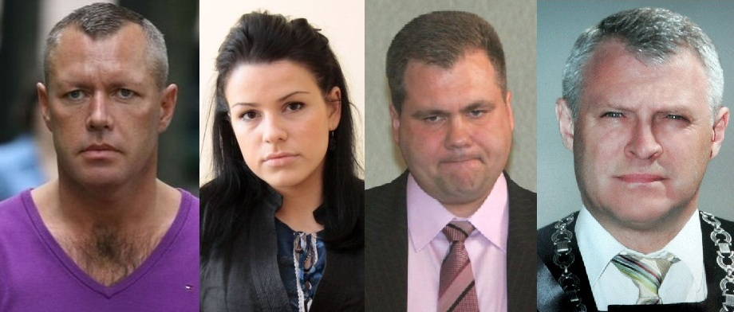
* D. Kedys, L. Stankūnaitė, A. Ūsas and J. Furmanavičius (from left to right).
* **Two alleged paedophiles murdered, Kedys revered**
* What started as an unprecedented avalanche of publicity took a sharp new turn in October 2009, when a premeditated murder of two people took place. The alleged paedophile judge Furmanavičius and Stankūnaitė's sister Naruševičienė were both gunned down in daytime Kaunas. Drąsius Kedys, the prime suspect, disappeared, triggering a major Europe-wide search. However, even though the majority believed Kedys to be the killer, surprisingly many people regarded him to be a hero, a Robin Hood-like fighter against the corrupt system when all other attempts failed. Since then, protests on the issue are regular in Lithuanian streets and even the Lithuanian communities abroad.
* Stankūnaitė and Ūsas received state-sponsored security as everybody knew that if Kedys is the killer, he would return for the remaining members of the five. A legal battle for the Kedys daughter (who now resided with Kedys's sister Venckienė) commenced in courts, echoed by another case where charges of paedophilia were brought against Ūsas. The defendants claimed that Kedys just never could live with the fact that Stankūnaitė left him for Ūsas, and this public smearing campaign is merely a cold-blooded revenge. The murder of Furmanavičius, they said, was masterminded by Venckienė, Kedys's sister and a judge in the same court as Furmanavičius. Many did not believe this, and each side gained vocal supporters from every stratum of Lithuanian society imaginable: artists, businessmen, students, lawyers, priests, sportsmen, workers, former freedom fighters, politicians and gangsters.
* Pro-Kedys side gained a better momentum, successfully mobilising internet and media. As the situation in courts made it seem likely that the girl would be awarded to Stankūnaitė, Kedys supporters established a permanent guard near Venckienė's house in Garliava suburb of Kaunas. The faces of the main characters of the story dominated TV news and many of the newspapers first pages. Numerous one-sided TV shows were created with many journalists empathically supporting only one side and smearing the other. Perhaps as many conspiracy theories were created on the issue as there are on the September 11, 2001, events in the USA. The likelihood of seeing the Garliava story heroes and villains on TV screen surpassed that of major sports stars and politicians. Four books were published on the case (one by Venckienė herself) and the story was dramatized in TV series. Paintings, songs, comics and countless internet memes were created.
* 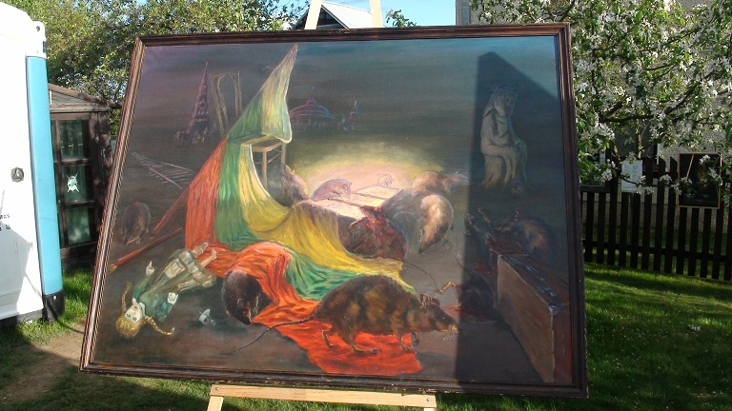
* Painting of rats devouring a doll and Lithuanian flags is a continuation of freedom-themed series of similar paintings from 1992.
* **Kedys and Ūsas found dead, conspiracy theories surge**
* Garliava story continued like a good thriller, giving a new sensational twist to its spectators every time some of them started to get bored. On April 20th, 2010 a body of Drąsius Kedys was found near Kaunas reservoir. He was dead for merely a day, raising questions on where was he hiding that was never answered. Tabloids suggested anything from his relatives house to a nearby bunker, to a psychiatric hospital where Kedys was supposedly put into by his enemies and eventually murdered. The official investigation said that Kedys died his own death. Multiple statues were erected by Kedys's supporters at the place of his death (Šlienava suburb of Kaunas) and another one marks his grave in Garliava cemetery.
* Additional several months and another strange death happened. This time, the purported paedophile Andrius Ūsas drowned in a shallow pond. Versions from lynching by pro-Kedys activists to a murder by fellow paedophiles or even a conspiracy involving the secret services ran abound. Official version: Ūsas died after his quad bike crashed (the quad was found nearby).
* The Kedys case was swiftly dubbed "The Killer Case" by the media. In addition to these four deaths, there were more deaths and injuries suffered by certain other people whose involvement in the Garliava story was minor. The deaths of Ūsas and Kedys did not stop the epic court battles as both of them continue to be tried posthumously at the request of their relatives, who seek acquittal of the deceased so their family honor could be restored.
* **Fight for girl custody mobilize many thousands**
* It was the third case, the one dealing with the custody of Kedys's daughter, that attracted the most interest, as court after the appellate court decided that the daughter should live with Stankūnaitė. The disgruntled Kedys supporters completely surrounded Venckienė's house, frequently disturbing even Stankūnaitė's attempts to exercise her right to meet her daughter, let alone take her home.
* In early 2012, a final decision was made by the courts without possible further appeal. The state had to end the stalemate to restore its credibility. The first serious attempt to enforce court decisions on March 2012 failed after 60-something policemen were eventually stopped by child rights agency because the brawl was deemed harmful to Kedys's daughter.
* **Lithuanian Woodstock in Garliava**
* Following this first major battle, Venckienė's courtyard became a kind of Woodstock for Kedys supporters. Constant guard of people, now forming a cohesive community, lived there, prepared their food, debated and celebrated. Regular gigs, shows, and other events took place, performed by pro-Kedys musicians and artists free of charge. Roman Catholic mass used to be held every evening, celebrated by pro-Kedys priests. Purple color prevailed, as it became the symbol of Kedys - solely because the most famous picture of him that was published in newspapers depicted him wearing a purple sweater. Slogans such as "How much of Drąsius do you have in yourself?" and paintings of rats (devouring a doll girl and Lithuanian national symbols), donated by a pro-Kedys painter, surrounded the yard, and it all used to be transmitted online live. Alternative celebrations of major holidays also took place in the Venckienė's courtyard.
* 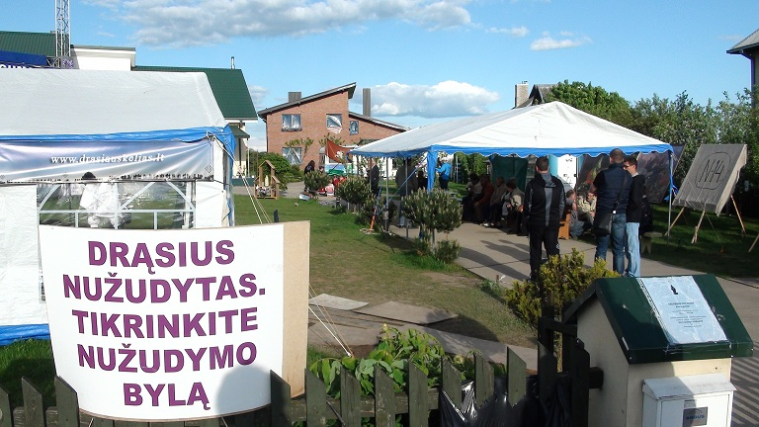
* Entrance to the courtyard of Venckienė during the months of the volunteer camp. Purple text declares: 'Drąsius was murdered. See the murder case.' ©Augustinas Žemaitis.
* Tension reached its apogee by May 2012 when the second attempt to take the child from Venckienė, now backed by a 250-strong police force, was successful. The Kedys's daughter was hidden from public view together with her mother, while major protests moved from Garliava to the streets of Vilnius and Kaunas. The aftershocks reached even Chicago, where the president of Lithuania Dalia Grybauskaitė, on an official visit, had her car blocked by local Kedys supporters who were chanting "Shame, shame".
* **The pro-Kedys movement turns political**
* Pro-Kedys activists were banned from establishing a camp in front of President's palace so they now protest there every day and leave at night with their posters. A worldwide protest movement "TIE-SOS" (a pun on words "Tiesos" meaning "[We request the] truth" and "SOS" distress signal) commenced. Other issues where Lithuanian government allegedly hides the truth due to corruption were also raised: such as the death of intelligence officer Vytautas Pociūnas.
* 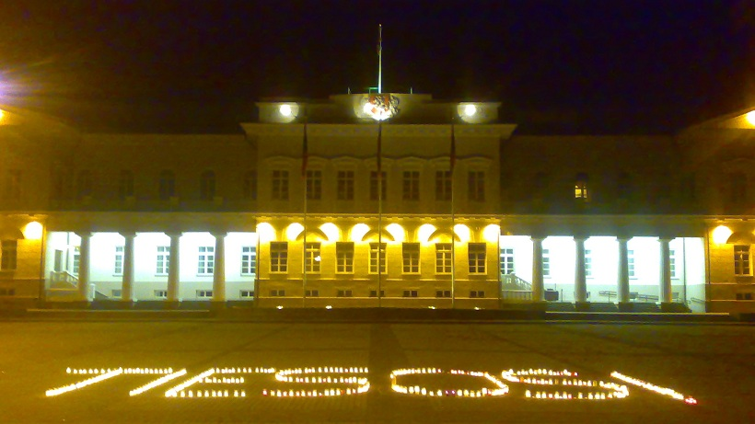
* TIESOS written by candles in front of president's residence in Vilnius. Artful presentations of this word became the core of worldwide 2012 protests by the pro-Kedys movement. ©Augustinas Žemaitis.
* Political party "Drąsos Kelias" (litterally "Way of Courage", but in fact a pun on Kedys's name "Drąsius" which means "The courageous one") was established by pro-Kedys activists, including Venckienė, her aunt Skučienė. It is led by priest Jonas Varkala, who was asked by his superiors to suspend his priesthood if he opts for political activity (he complied).
* Political scientists and the first polls were not optimistic, while Venckienė claimed that she would win the elections on 15th of October, 2012. The truth was somewhere in-between as "Drąsos Kelias" received 8% of votes (~17% of all votes in Kaunas, the closest city to Garliava), passing the necessary 5% threshold and entering parliament.
* The saga continues.
* *In everybody of us there is a parent and a child,  
  In everybody of us there is greed and moderation,  
  In every soul - a ray of light,  
  In every heart - Drąsius Kedys.  
  In every bullet there is a piece of truth,  
  In every family there is a little world,  
  In everyone's eyes there is a reflection of God,  
  Everybody of us is a judge,  
  Everybody of us is a thief.*
* (a translation of a refrain of a hip-hop song praising Drąsius Kedys)