[In Search of Black Assassins](https://mindcontrolblackassassins.com/)

**[UPDATE, CYBELE, SATANISTS, BLOOD-EATERS & THE ORLANDO HOMOSEXUAL FALSE FLAG CLUB MASSACRE](https://mindcontrolblackassassins.com/2016/07/04/update-cybele-satanists-blood-eaters-the-orlando-homosexual-false-flag-club-massacre/)**

4**07**2016

**“THE LIES GROW BIGGER AND BIGGER”**

Within conservative corporate mass media circles, *Judge Andrew P. Napolitano* is a well respected **Fox News Senior Judicial Analyst.**He is no lover of the people. On the **Orlando False Flag Massacre**, the mouthpieces for the**ILLUMINATI**are getting their signals crossed. On **Fox**, he said that nobody was killed at the **Pulse** night club until about **5:13 am** when the **SWAT** team moved in. He said it came from a summary of a **FBI**transcript of the events at the **Pulse Night Club** that included a **timeline**. So far, it doesn’t seem as if anyone including the   has challenged *Judge Napolitiano’s* timeline. There is not even direct evidence to challenge what he said. The **FBI** issued gag orders on the **Pulse Club Massacre** to *hush-up* local police, fire, emergency medical personnel, and hospital doctors and staff.

[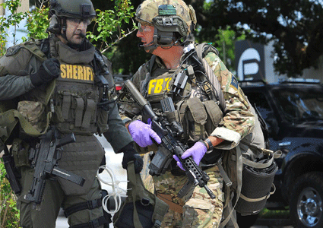](https://mindcontrolblackassassins.com/2016/07/04/update-cybele-satanists-blood-eaters-the-orlando-homosexual-false-flag-club-massacre/aaaaorlandoswat/)

**County, City and FBI Swat Teams were at Pulse Club False Flag Massacre**

In particular,**Pulse Club Massacre**mass media darling survivors**, Patience Carter**and **Tiara Parker,** have committed themselves to a story line that **Omar Mateen** shot and killed people in the bathroom hours before the Swat team moved in. But, which Swat team, **FBI, County** or **Orlando PD?** The **Orlando Pulse Night Club Massacre** official story line is a *very big problem* that is growing bigger and bigger by the days.

**“SCARE THEM, YOU CAN HERD THEM”**

[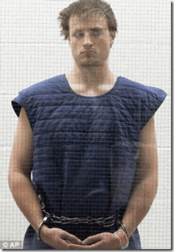](https://mindcontrolblackassassins.files.wordpress.com/2016/06/aaaaorlandojameswesley.gif)

In **Santa Monica, CA,**the following morning after Saturday’s June 12, 2016 2 a.m. **Pulse Club Massacre**, **James Wesley Howell,***20 years old*, of **Jeffersonville, IN** called police for protection. He said that the **CIA** was out to kill him.[[1]](https://mindcontrolblackassassins.com/Users/PrinceRay/SkyDrive/" \l "_ftn1_8375) He said that he had been part of a secret **5 (five)** member domestic terrorist team that was sent in on a mission by the **CIA**to assault Sunday’s **Los Angeles Gay Pride Festival and Parade.**Their mission had been coordinated with Saturday night’s *Orlando* **Pulse Club** terrorist attack. When **Howell**discovered the South’s team leader, **Omar Mateen**, was assassinated in performance of the mission in Orlando by a **SWAT Team**, he feared the **CIA** would also betray and assassinate him as a **PASTY**.[[2]](https://mindcontrolblackassassins.com/Users/PrinceRay/SkyDrive/" \l "_ftn2_8375) Local police found in **Howell’s** car, a loaded assault rifle with magazines rigged to allow 60 shots to be fired in quick succession and 15 pounds of chemicals mixed and ready to explode. He also had two other loaded rifles, ammunition, a stun gun, a buck knife and a *security badge*.[[3]](https://mindcontrolblackassassins.com/Users/PrinceRay/SkyDrive/" \l "_ftn3_8375)

[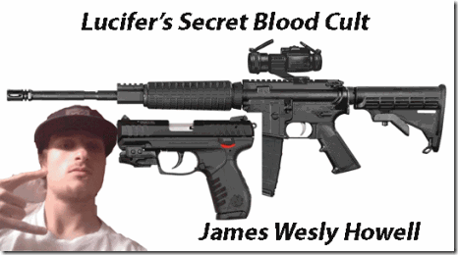](https://mindcontrolblackassassins.files.wordpress.com/2016/06/aaaaorlandolucifer.gif)

***Lucifer’s* CIA Pasty**

Actually, he had twenty-five (**25**) pounds of **Shoc-Shot**, an explosive used for blowing up targets by *high velocity* bullets most likely to cause a crowd widespread panic, and a possible escape by assailants in smoke and mass confusion. The two components needed to make the **Shoc-Shot** explosive had been mixed. **Howell** had an **AndersonManufacturing AM-115 .223–***high velocity round***caliber rifle**. The rifle had a round in its chamber and additional rounds in a 30-round magazine attached to it. *Another 30-round magazine was taped to the rifle*. He had a **.30-06** bolt-action rifle with a round in its chamber, and a *high velocity*.22-caliber **Ruger**semi-automatic pistol. He had a *mass murdering* commando assassin’s arsenal.[[4]](https://mindcontrolblackassassins.com/Users/PrinceRay/SkyDrive/" \l "_ftn4_8375)

[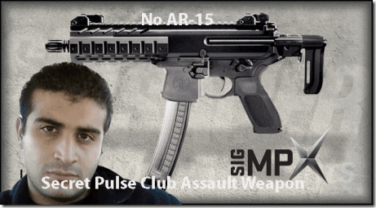](https://mindcontrolblackassassins.files.wordpress.com/2016/06/aaaaorlandonoar.gif)

**Omar Mateen- Multi-generational MK ULTRA Manchurian Candidate**

Actor, hermaphrodite/homosexual or a radical Islamist, they could turn **Omar** on a dime. The weapon used by a gunmen in Saturday night’s deadly attack at the **Pulse**gay nightclub in Orlando **was not**anAR-15 assault-style rifle as previously widely reported, according to the **Washington Post**. The Post, citing **Orlando Police** officials that the weapons used were a **SIG Saucer MCX***(high velocity* *sub-machine gun pistol)*,and a **9 mm Glock**.[[5]](https://mindcontrolblackassassins.com/Users/PrinceRay/SkyDrive/" \l "_ftn5_8375)

[](https://mindcontrolblackassassins.files.wordpress.com/2016/06/aaaaorlandoexitwounds.gif)

**Black Blood Cult Cybeleans- Patience Carter and Tiara Parker**

**Tiara Parker** claimed that she had been shot in the stomach with a *high velocity bullet*that went in the front right stomach area and exited downward out of bottom right side. I think she spent no more than a night of the shooting in the hospital before coming one of*corporate mass media* **Pulse Club Massacre** darling witnesses. Both **Carter**and **Parker**were treated at **Orlando Regional Medical Center**for alleged gunshot wounds.  It is widely reported that the hospital’s Emergency Room staff were **coerced** by **federal agents**into signing a [**Non-Disclosure Agreement**](https://www.superstation95.com/index.php/world/1488) for all aspects of the **Pulse Nightclub Shooting** incident.  Anyone that refused was allegedly walked right out the door by**federal agents.** So, if they actually suffered gunshot wounds, the type of injuries they suffered and weapons used that caused their injuries are now **state secrets**. Nevertheless, being shot with a *high velocity projectile* is not a matter of as I understand it, *oh well*, it went in here and came out there; then out and dancing through the tulips the next couple of days. *“As a missile passes through tissue, it decelerates, dissipating and transferring kinetic energy to the tissues; this is what causes the injury. The velocity of the projectile is a more important factor than its mass in determining how much damage is done; kinetic energy increases with the square of the velocity. In addition to injury caused directly by the object that enters the body, penetrating injuries may be associated with secondary injuries, due for example to a blast injury.”****[[6]](https://mindcontrolblackassassins.com/Users/PrinceRay/SkyDrive/" \l "_ftn6_8375)***

[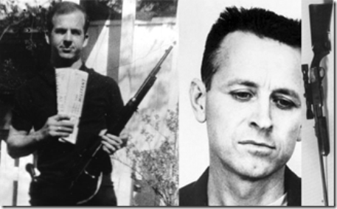](https://mindcontrolblackassassins.files.wordpress.com/2016/06/aaaaorlandorifle.gif)

**Omar’s**corporatemass media*damning* public purchase of an **AR-15** was a deliberate *false trail* to set him up for a *sensational* frame like legendary government intelligence pasties, **Lee Harvey Oswald** and **James Earl Ray**. So, where did the *sub-machine gun pistol come from?****[[7]](https://mindcontrolblackassassins.com/Users/PrinceRay/SkyDrive/" \l "_ftn7_8375)*  Howell** described to local police details of his *recruitment and training* by the **CIA**. **Howell**additionally stated that, *“everything has gone south. Dan was gone when I got here. They killed the leader of the Florida attack this morning. They are going to kill me. I need protection.”****[[8]](https://mindcontrolblackassassins.com/Users/PrinceRay/SkyDrive/" \l "_ftn8_8375)* Howell**indicated to officers who first made contact with him that he was *one of five people* involved in a planned Sunday attack on both the east and west coasts. **Howell**stated that he was suppose to “hook up” late Saturday night with his contact in LA who was suppose to have more weapons and chemicals to mix with the *Tannerite* he was in possession of. Finding his contact missing when he got to LA and having heard that **Omar Mateen** had been killed by a **FBI SWAT**team in Orlando, **Howell** determined he had been *double crossed* by the **CIA** and feared for his own life.[[9]](https://mindcontrolblackassassins.com/Users/PrinceRay/SkyDrive/" \l "_ftn9_8375)

Like *Omar Mateen*, **Howell** worked as an **armed** *security guard* for a multi-national security firm, **United Security Services, Inc**.[[10]](https://mindcontrolblackassassins.com/Users/PrinceRay/SkyDrive/" \l "_ftn10_8375) **United**is an annual **$2.5 Billion** vast security industry that specializes in all aspects, stages, and sizes of commercial and residential construction and projects from cabins to castles, from small local businesses to **federal facilities**.[[11]](https://mindcontrolblackassassins.com/Users/PrinceRay/SkyDrive/" \l "_ftn11_8375) Both **Howell** and **Mateen**‘s *security badges* and *weapons’ permits*were cleared under cover of national security firms. According to sources within the **Santa Monica Police Department**, he told them that *“We were all familiar with each other through an online fundamental Islamic knowledge seminary course-****we were recruited through the course and trained together at a camp in VIRGINIA****– we were taught how to shoot and make bombs – everyone knew their part – something went wrong….”****[[12]](https://mindcontrolblackassassins.com/Users/PrinceRay/SkyDrive/" \l "_ftn12_8375)***

[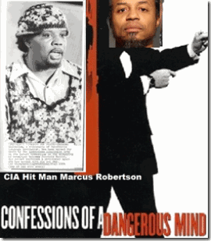](https://mindcontrolblackassassins.files.wordpress.com/2016/06/aaaaorlandociahitmen.gif)

**Howell’s** *fundamental Islamic knowledge seminary course* connect he and **Omar**to a government *5 member* **CIA** *domestic* “**hit squad**” not at all dissimilar from **Marcus Wayne Chenault’s** *5 member* **CIA** *domestic* “**hit squad,**” **the Troop**. Also, not dissimilar from the **SLA**– the **CIA**, the **SLA** was led and trained by black U.S. *military counterintelligence***/CIA***assassination specialist*, **Colston Westbrook**. **Howell** and **Omar’s** “**hit squad**” was led and trained by a black **U.S. Marine/CIA** *counterintelligence specialist*, and *ex-felon* *pseudo***Muslim**, **Marcus Dewayne Robertson**.

*Pulse Club Massacre & The Blood Eaters*

[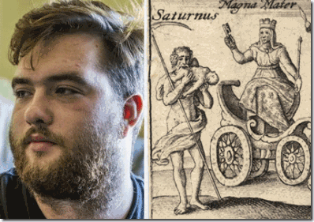](https://mindcontrolblackassassins.files.wordpress.com/2016/06/aaaaorlandogreeson.gif)

**Satanic Blood Eater, Joseph Greeson**

[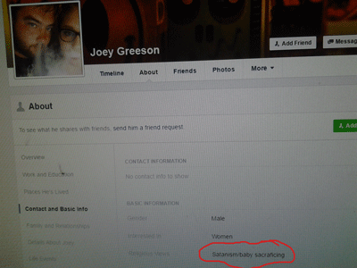](https://mindcontrolblackassassins.com/2016/07/04/update-cybele-satanists-blood-eaters-the-orlando-homosexual-false-flag-club-massacre/aaaaorlandosatanic/)

Some allege that **Howell** is gay. **Joseph Greeson** of **Clarksville, TN** surfaced in corporate mass media as **Howell’s** fake *Hermaphrodite* boyfriend. **Greeson’s** hometown just happens to be **Orlando, FL**. **Greeson** doesn’t seem to work anywhere. His religious views: **SATANISM/BABY SACRAFICING** [*Greeson’s Spelling*].[[13]](https://mindcontrolblackassassins.com/Users/PrinceRay/SkyDrive/" \l "_ftn13_8375)

[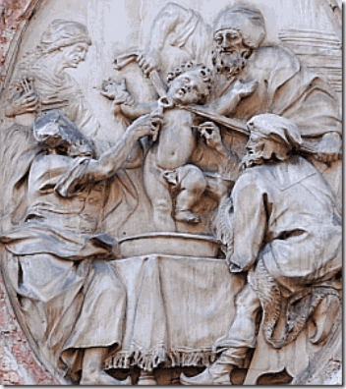](https://mindcontrolblackassassins.files.wordpress.com/2016/06/aaaaorlandobabykiller1.gif)

**Ancient Blood Cult- Baby Blood Eater Sacrifice**

He confessed in corporate mass media that he was a **homosexual**. He said that he was interested in these ***ghoulish things*** not me. Undoubtedly, **Greeson** is a **Satanist** that has a **Blood Oath with the DEVIL**with very extreme and serious implications. Human *sacrifice, flesh and blood eating* has existed in secrecy for ages. For some people, it constitutes a shadow spiritual religion. These people at this level of the *game of secret shadow government false flag operations* are well organized to back up a mass Orlando false flag *psychological warfare* operation.

[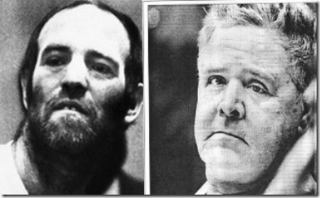](https://mindcontrolblackassassins.files.wordpress.com/2016/06/aaaaorlandootle.gif)

The infamous **Hermaphrodite/Homosexual** **Blood Eaters** and *Satanic Killers*, **Ottis Toole**and **Henry Lee Lucas**, above, claimed that they were trained by a *nationwide satanic cult*in a **mobile paramilitary training camp** in the Florida Everglades. They admitted to being part of a secret organization called “**The Hand of Death**,” which was a satanic “**BLOOD**” cult that *cannibalized* and killed.[[14]](https://mindcontrolblackassassins.com/Users/PrinceRay/SkyDrive/" \l "_ftn14_8375)

[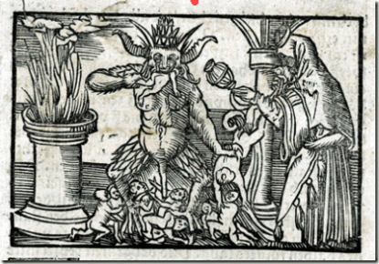](https://mindcontrolblackassassins.com/2016/07/04/update-cybele-satanists-blood-eaters-the-orlando-homosexual-false-flag-club-massacre/aaaaorlandobabydevil/)

From **Max Call’s** book, **Hand of Death**,

*“In the book Henry tells of his indoctrination into a nationwide Satanic cult, and says that he was trained by the cult in a mobile paramilitary camp in the Florida Everglades in the fine art of killing. Other training involved abduction and arson techniques. The first task he was given was the murder of one of the “students,”****a young black homosexual******who had betrayed his oath to the Devil.****He slit the man’s throat and later that same evening, a Satanic ritual was performed in which the dead man’s heart was cut out, his****blood drained****, and his body dismembered.****All of the initiated members of the Hand drank the dead man’s blood and ate pieces of his flesh.****The remains of the body were then burned at an altar.”****[[15]](https://mindcontrolblackassassins.com/Users/PrinceRay/SkyDrive/" \l "_ftn15_8375)***

They are **self regulating**. Satanist play actor**Greeson** says that he had been with **Howell**since June 1, 2016, *“I never really got, like, any bad signals,” said Greeson, 18. “Just that it was strange and kind of weird. He was an only child and just kind of lonerish. I don’t know. It’s hard to explain.”****[[16]](https://mindcontrolblackassassins.com/Users/PrinceRay/SkyDrive/" \l "_ftn16_8375)***

[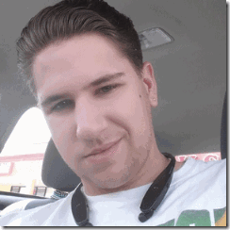](https://mindcontrolblackassassins.files.wordpress.com/2016/06/aaaaorlandoshantey.gif)

**AlliedBarton Officer, Michael Shantey?**

**Greeson’s***Facebook* **Friend** just happens to be **Michael Shantey**.[[17]](https://mindcontrolblackassassins.com/Users/PrinceRay/SkyDrive/" \l "_ftn17_8375),[[18]](https://mindcontrolblackassassins.com/Users/PrinceRay/SkyDrive/" \l "_ftn18_8375) **Shantey** has the entire *Orlando* **Pulse Club** logo on his **Facebook Page**.**Shantey** is a *security officer* for **AlliedBarton Security Services.** [[19]](https://mindcontrolblackassassins.com/Users/PrinceRay/SkyDrive/" \l "_ftn19_8375) Established in 1957 by the *ancient noble* *Iron Craft*French **Satanic** Jewish **Wendel (House) Group**with close historical ties to the**[Rothschilds](https://firstworldwarhiddenhistory.wordpress.com/2014/11/26/" \t "_blank)**, **AlliedBarton**is the largest American-owned security officer services company in the United States. **AlliedBarton** has more than 38,000 employees in 60 offices serving more than 2,000 customers coast to coast, including more than 100 Fortune 500 companies.[[20]](https://mindcontrolblackassassins.com/Users/PrinceRay/SkyDrive/" \l "_ftn20_8375) **AlliedBarton** was named to the “**G.I. Jobs Top 100 Military Employers List**“. These security firms are nothing less than the **ILLUMINATI’s** private *paramilitary* police and **ARMIES**.[[21]](https://mindcontrolblackassassins.com/Users/PrinceRay/SkyDrive/" \l "_ftn21_8375)

[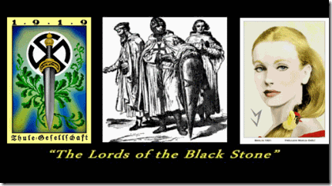](https://mindcontrolblackassassins.files.wordpress.com/2016/06/aaaaorlandolordsofblackston.gif)

At sometime, **AlliedBarton** was acquired by the **Zionist (Raymond, Ronald) Perelman Family**than they sold it to the **scary** global *Lords of the Black Stone*, the**Blackstone Group**.The **Blackstone Group** helped *Larry Silverstein* mortgage 9-11’s World Trade Center, Building 7. [Henry] **Kissinger McLarty Associates** has a “*strategic alliance*” with the **Blackstone Group**.[[22]](https://mindcontrolblackassassins.com/Users/PrinceRay/SkyDrive/" \l "_ftn22_8375) So, it isn’t surprising that *Jewish Mysticism* and the *Blood Sacrifice* *secretly* lies at the *spiritual* foundation of these companies.[[23]](https://mindcontrolblackassassins.com/Users/PrinceRay/SkyDrive/" \l "_ftn23_8375)

In 2010, the **International Association of Jewish Vocational Services (IAJVS)** and **AlliedBarton**formed a *national strategic partnership* that promises to promote and enhance training and employment opportunities for workers in the communities they jointly serve.[[24]](https://mindcontrolblackassassins.com/Users/PrinceRay/SkyDrive/" \l "_ftn24_8375) With their eyes clearly on the future, they say the **Mission of IAJVS** owes its **vision** to the words of the 12th century **Master of Kabbalah** (*Jewish Mysticism*) **Maimonides**, which they say are as relevant today as they were more than 800 years ago.[[25]](https://mindcontrolblackassassins.com/Users/PrinceRay/SkyDrive/" \l "_ftn25_8375) If they owe their future vision to the *Sephardic Jewish Philosopher and Astronomer***Maimonides** (1135- 1204) than it also secretly includes the “**Blood Sacrifice**.”

[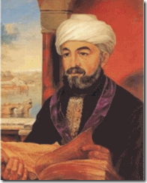](https://mindcontrolblackassassins.files.wordpress.com/2016/06/aaaaorlandomainamies.gif)

**Maimonides** states (“**Guide for the Perplexed**“, Book III, chapter XLVI, pg. 362 Dover ed.) that certain **cultures**who would *either eat blood or sit around a pot of blood, as they felt they would be favored by* “**spirits**“. After **Maimonides** explained the origin of the Torah prohibition against **eating blood**, he connects this prohibition to the a somewhat **qualified** prohibition to serve **Molech- Moloch**, a fire G-d.[[26]](https://mindcontrolblackassassins.com/Users/PrinceRay/SkyDrive/" \l "_ftn26_8375)

[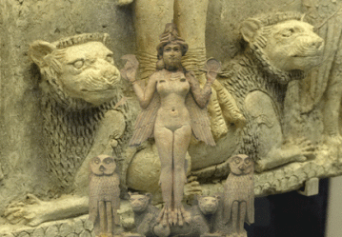](https://mindcontrolblackassassins.com/2016/07/04/update-cybele-satanists-blood-eaters-the-orlando-homosexual-false-flag-club-massacre/aaaaorlandoishtar/)

**Babylonian Goddess Ishtar and Cybele’s Twin Lions**

And**Solomon** did evil in the sight of the L**ord**, and went not fully after the **Lord,** as did David his father. Then did **Solomon** build an high place for **CHEMOSH,**the abomination of Moab, in the hill that is before Jerusalem, and for **MOLECH (Moloch),** the abomination of the children of Ammon. (**1 Kings 11: 6-7**)  Who was *CHEMOSH*? [CHEMOSH](https://en.wikipedia.org/wiki/Chemosh) was a god associated with the Mother-Goddess Ishtar– **CYBELE**and the**BLOOD SCARIFICE**.

[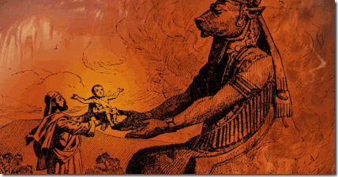](https://mindcontrolblackassassins.files.wordpress.com/2016/06/aaaaorlandomoloch.gif)

**Baby Passed Over the Fire to Lion Headed Molech- Moloch**

In 2012, **Universal Security Services** acquired **United Security**.[[27]](https://mindcontrolblackassassins.com/Users/PrinceRay/SkyDrive/" \l "_ftn27_8375) In May 2016, **AlliedBarton** acquired **Universal Security Services**.[[28]](https://mindcontrolblackassassins.com/Users/PrinceRay/SkyDrive/" \l "_ftn28_8375) That means that **Greeson’s** friend, **Michael Shantey,**worked for the same company as*James Wesley Howell.* **Omar Mateen**worked for **G4S**–**Wackenhut Corporation,**a Department of Homeland Security (**DHS**) contractor.[[29]](https://mindcontrolblackassassins.com/Users/PrinceRay/SkyDrive/" \l "_ftn29_8375),[[30]](https://mindcontrolblackassassins.com/Users/PrinceRay/SkyDrive/" \l "_ftn30_8375)**Rob Ryan**, Universal Security Services, President, Southeast Division (**Florida**), before joining **Universal Protection Service**, he served as the Northeast Region Vice President for **G4S–Wackenhut Corporation**.[[31]](https://mindcontrolblackassassins.com/Users/PrinceRay/SkyDrive/" \l "_ftn31_8375)

[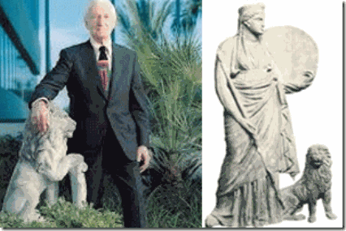](https://mindcontrolblackassassins.files.wordpress.com/2016/06/aaaaorlandolionwackenhut.gif)

**George Wackenhut, Lion & Cybele**

Founded in 1954 by an extreme right wing former FBI agent, **George Russell Wackenhut**, the security company has to be one of the most dangerous and clandestine **CIA- ILLUMINATI** *paramilitary/counterintelligence* private police forces in America. All of the below extremely dangerous *shadow government conspirators* are known to have been attached to **Wackenhut**.

**[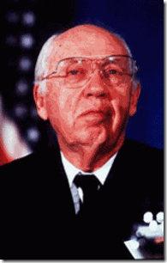](https://mindcontrolblackassassins.files.wordpress.com/2016/06/aaaaorlandocasey.gif)**

**William Casey**: OSS (*Operation PAPERCLIP*) agent, **CIA director**. Member of **Le Cercle**; **Knight of Malta**; Co-founded the Jamestown Organization, along with **Zbigniew Brzezinski**, **Dick Cheney**, and **Frank Carlucci**(**Carlyle Group, Wackenhut**). Used **P2**(*Propaganda Due Masonic Lodge*) to fund the Solidarists in Poland; Friend of **Roy Cohn**, who has been connected to the Mafia, **JFK** assassination and **Donald Drumpf***(Trump)*; helped fund the **Mujahedin**(*Osama Bin Laden*) with the help of the **CIA- BCCI bank**.[[32]](https://mindcontrolblackassassins.com/Users/PrinceRay/SkyDrive/" \l "_ftn32_8375)

**[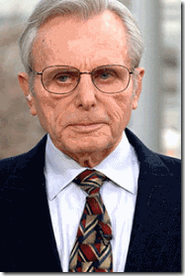](https://mindcontrolblackassassins.files.wordpress.com/2016/06/aaaaorlandofrank.gif)**

**Frank Carlucci**: **Knight of Malta**, member of the **Carlyle Group**, **CFR**, and **Wackenhut**. He is suspected of being a **9/11 Inside Job** criminal.[[33]](https://mindcontrolblackassassins.com/Users/PrinceRay/SkyDrive/" \l "_ftn33_8375)

**[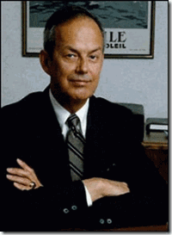](https://mindcontrolblackassassins.files.wordpress.com/2016/06/aaaaorlandoiman.gif)**

**Bobby Ray Inman**: Director of Office of Naval Intelligence**(ONI), DIA, NSA**, and **FBI**; **Knight of Malta**, **Director of Wackenhut**, **Director of the Trilateral Commission**; Member **CFR**; Head of the **Jet Propulsion Lab Oversight Committee** at **Cal Tech**.[[34]](https://mindcontrolblackassassins.com/Users/PrinceRay/SkyDrive/" \l "_ftn34_8375)

**Wackenhut** is a creature of the **FBI, CIA, U.S. Military Intelligence**, and the **Knights of Malta**. The *Sovereign Military Order of Malta* (**SMOM**) is directly allied with international **Freemasonry**, from where they recruit their new elite brethren. Hence, the [**Knights of Malta**](http://www.bibliotecapleyades.net/sociopolitica/esp_sociopol_malta01.htm)and the **Knights Templar** are the **Rosicrucian** upper-degrees of **Freemasonry**.  During the 15th Century in France,[**Baron Gilles de Rais’**](http://www.unexplainedstuff.com/Religious-Phenomena/The-Rise-of-Satanism-in-the-Middle-Ages-Gilles-de-rais-1404-1440.html) was publicly tried, convicted and executed for practicing the *secret* **“Old Religion”** of the **Knights Templar**– *Satanism, Baby Sacrifice* and *Human Flesh*and *Blood Eating*.

*Seizure of Satanist James Wesley Howell & the Patriot Act*

[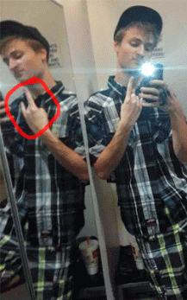](https://mindcontrolblackassassins.com/2016/07/04/update-cybele-satanists-blood-eaters-the-orlando-homosexual-false-flag-club-massacre/aaaaorlandosatanhowell/)

**DEVIL HORNS- James Wesley Howell- Satanist?**

he Federal authorities stepped in and assumed immediate control of **James W. Howell**from the **San Monica Police Department** under the **Patriot Act** and **National Security**because they operationally classified the **Orlando Pulse Club Massacre** as a terror incident, even though they did not say so publicly. In Orlando, the **FBI** swept in and took over the entire crime scene.[[35]](https://mindcontrolblackassassins.com/Users/PrinceRay/SkyDrive/" \l "_ftn35_8375) When the **FBI** entered and seized **Howell’s**investigative case, slapped the local police with a **gag order**,  the storyline suddenly changed. The **FBI**claimed that the local police were mistaken, **Howell** did not intend to harm anyone at the **L.A. Gay Pride Parade and Festival** to take the **CIA** off the hook. **Howell** was slapped with a Clark County, IN *child molestation* case that allegedly occurred on May 31, 2016 to keep him isolated in jail until the **CIA’s***post-hypnotic suggestion* specialists do their work, or they just terminate him.

[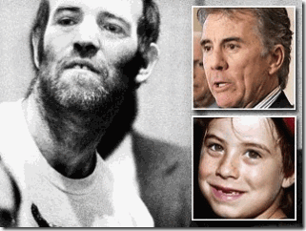](https://mindcontrolblackassassins.files.wordpress.com/2016/06/aaaaorlandoottis.gif)

**James W. Howell, Omar Mateen, Joseph Greeson**, and **Michael Shantey** all appear to be have been part of a national ultra secret subservient but powerful interrelated **ILLUMINATI***Luciferic*“**Blood Cult**” that even **Adam Walsh** of **America’s Most Wanted**was/is too afraid to breach even for the heinous slaughter and beheading of his son.[[36]](https://mindcontrolblackassassins.com/Users/PrinceRay/SkyDrive/" \l "_ftn36_8375)

*Mateen, Howell, Pseudo Muslims, U.S. Marines & the****CIA***

[](https://mindcontrolblackassassins.files.wordpress.com/2016/06/aaaaorlandociarobertson.gif)

**CIA/FBI Pseudo Muslim**, **Marcus Dewayne Robertson**

Like *Little Markie*, **Marcus Robertson** was from a **multi-generational***government/military intelligence* family. According to public record, U.S. District Court, Middle District of Florida, Orlando Div., **U.S.A v. Robertson**, Case NOS, 6:11-cr- 277- Orl- 3GJK; 6:12-cr- 63-Orl-36JK (4/24/15); “***ROBERTSON****was born in the late 1960’s to Clarence and Mable Robertson. Both …****holding******positions in government******their entire careers****. His father is retired from the Brooklyn, New York District Attorney’s Office. He recently (April 18, 2015) was honored with the Outstanding Citizen Award by Brooklyn’s Medgar Evers College where he had previously served as Vice-President… ROBERTSON, and all three of his siblings have served in the Armed Forces. His oldest brother,****Alonzo****, served in****Army intelligence****, the****CIA****, and then spent fifteen (15) years in the****NSA****. His brother, Malcolm, and his spouse both served in Iraq. Finally his youngest brother,****Martin,****was in the****military police with the Army****.”****[[37]](https://mindcontrolblackassassins.com/Users/PrinceRay/SkyDrive/" \l "_ftn37_8375)***

[](https://mindcontrolblackassassins.files.wordpress.com/2016/06/aaaaorlandomarcusrobertson.gif)

“***ROBERTSON****served in the United States Marine Corps from 1989 until his honorable discharge in 1994. While in the Marines, Mr.****ROBERTSON****was part of an elite counter-terrorism operations group of Marines known as the****Second Force Reconnaissance Company****… The Government acknowledges that****ROBERTSON****has provided extensive assistance to the authorities. Although it denies or cannot confirm that****ROBERTSON****undertook certain activities on its behalf, it acknowledges the following and****ROBERTSON****will testify concerning his other activities in camera at the sentencing proceedings:*

*1)****ROBERTSON****testified for the Government at a federal trial in 1999; 2) From 2004-2007, under the express authority of the****FBI Joint Terrorist Task Force (“JTTF”)****,****ROBERTSON****performed these inherently dangerous activities: a) He was an extraterritorial confidential source that was sent to****Mauritania****performing a role that can only be defined as “****espionage****.” See 18 U.S.C § 793; b) He served as a confidential source in domestic terrorism investigations from Atlanta to Los Angeles, wherein he was provided with actual authority to, inter alia: possess firearms in order to maintain his cover and fulfill the objectives set for him by the****JTTF.***

*Although****ROBERTSON****is not interested in exposing classified activities, he would like the Court to have a true picture of his service to his country. Therefore, he is reluctantly prepared to testify concerning the activities in which he engaged on behalf of the United States that the Government contends did not occur or cannot be documented.”*[[38]](https://mindcontrolblackassassins.com/Users/PrinceRay/SkyDrive/" \l "_ftn38_8375)

[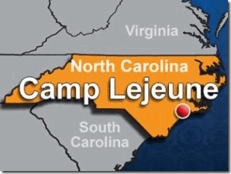](https://mindcontrolblackassassins.files.wordpress.com/2016/06/aaaaorlandocamplejeune.gif)

**Robertson’s** U.S. Marine **Second Force Reconnaissance Company** is stationed at *Camp Lejeune*, North Carolina. **Marine Corps Base Camp Lejeune** is a 246-square-mile U.S. military training facility in Jacksonville, NC . The base’s 14 miles of beaches make it a major area for amphibious assault  training, and its location between two deep-water ports (Wilmington and Morehead City)  allows for fast deployments. The main base is supplemented by six satellite facilities:Marine Corps Air Station New River, Camp Geiger, Stone Bay, Courthouse Bay, Camp Johnson,  and the latest addition to the facility, the Greater Sandy Run  Training Area. *Camp Lejeune,****just below Virginia****,* is part of America’s ultra secret **U.S.** **Military Homosexual/Hermaphrodite Complex**, and *Nato’s Secret Army- Operation Gladio* that had been primary setup by **SS-Obersturmbannführer Otto Skorzeny**and his*Junkerschule Commandos- Knights of t he Black Sun*.[[39]](https://mindcontrolblackassassins.com/Users/PrinceRay/SkyDrive/" \l "_ftn39_8375),[[40]](https://mindcontrolblackassassins.com/Users/PrinceRay/SkyDrive/" \l "_ftn40_8375)

*The U.S. Navy (Marines) & Gladio’s NATO Secret Army and the Sodomite BROTHERHOOD*

[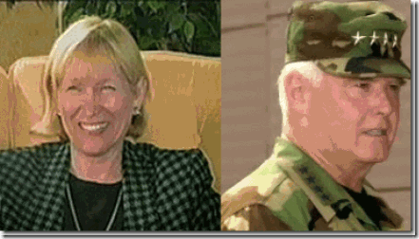](https://mindcontrolblackassassins.files.wordpress.com/2016/06/aaaaorlandogriggs.gif)

**Katherine Griggs** of Virginia Beach, VA was the wife of 11 years to alcoholic **ColonelGeorge Raymond Griggs**, **USMC**, **Intelligence Operations**, head of special (*psychological*) operations under **Admiral Celso** at **NATO**. **Roanoke** is approximately 500 miles outside of Virginia Beach. **Kay Griggs** was a member of the board in **NATO’s** wives club, and assistant director of the Virginia Center for World Trade in Norfolk, VA. **Marine Col. Griggs’** background includes **NATO’s** college at **Rome**, and then **Princeton**. His *intelligence spy* career began in Vietnam.[[41]](https://mindcontrolblackassassins.com/Users/PrinceRay/SkyDrive/" \l "_ftn41_8375) She maintains her former husband, **Marine Col. Griggs**, ran a military intelligence **Murder, Inc**. of trained assassins that he called the “**firm**” or “**The BROTHERHOOD**” that were “*sexually perverted*” (**Hermaphrodites**). **Kay Griggs** said that the **BROTHERHOOD** had its origins in the *secret German illness*, the **Pink Triangle–Sodomite SS and Nazis**out of [Operation PAPERCLIP](http://netteandme.blogspot.com/2015/03/part-13-of-15secret-agenda-operation.html). [[42]](https://mindcontrolblackassassins.com/Users/PrinceRay/SkyDrive/" \l "_ftn42_8375)**South Carolina**around **Columbia, Fort Jackson**, and the **Fort Bragg, NC** backwoods veils the **BROTHERHOOD’s** ultra secret U.S. military grounds, camps and fields for home-grown trained *pseudo false flag***9-11 Muslims** and **domestic terrorists**.

*Chris Sean Harper, Fort Jackson & the BROTHERHOOD*

[](https://mindcontrolblackassassins.files.wordpress.com/2016/06/aaaaorlandofortjackharper.gif)

**Chris Sean Harper**, 26 years old, the alleged October 1, 2015 **Umpgua Campus, Oregon Mass Murderer**, that killed 9 people and left 7-10 injured, had been taken from **Switzer Learning Center**, *a special needs school for emotionally disturbed students*, in Torrance, CA straight to **Fort Jackson, SC** for military training in the country’s backwoods.[[43]](https://mindcontrolblackassassins.com/Users/PrinceRay/SkyDrive/" \l "_ftn43_8375),[[44]](https://mindcontrolblackassassins.com/Users/PrinceRay/SkyDrive/" \l "_ftn44_8375)

[](https://mindcontrolblackassassins.files.wordpress.com/2016/06/aaaaorlandochrispills.gif)

**Chris Harper** was a severely disturbed “[head banger](http://www.nytimes.com/2015/10/06/us/mother-of-oregon-gunman-wrote-of-keeping-firearms.html?_r=0).” He was a seriously mentally and developmentally disabled individual that required a daily regiment of *psychotic drugs*including **LITHIUM** to control his behavior and **Multiple Personality Disorder** (**MPD**). **Poor Chris** couldn’t function without them.[[45]](https://mindcontrolblackassassins.com/Users/PrinceRay/SkyDrive/" \l "_ftn45_8375)

[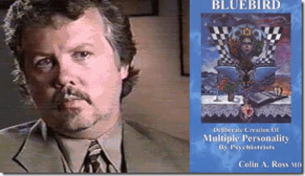](https://mindcontrolblackassassins.files.wordpress.com/2016/06/aaaaorlandorosschris.gif)

**Chris Harper**had been managed mentally and medically hands off **exclusively** by **Dr.Colin A. Ross’** *Institute for Psychological Trauma*, **Del Amo** **Behavior Health System of Southern CA** in Torrance, CA.[[46]](https://mindcontrolblackassassins.com/Users/PrinceRay/SkyDrive/" \l "_ftn46_8375) Yes, that is **Colin A. Ross, M.D.**, author of **Bluebird: Deliberate Creation of Multiple Personality by Psychiatrists**: **The CIA Doctors, Human Rights Violations by American Psychiatrists**.[[47]](https://mindcontrolblackassassins.com/Users/PrinceRay/SkyDrive/" \l "_ftn47_8375) He remains silent about **Chris**. If he didn’t have anything to do with **Chris**, he should say something. His silence remains a **very serious and big problem!**[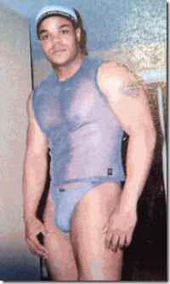](https://mindcontrolblackassassins.files.wordpress.com/2016/06/aaaaorlandoflanagan.gif) **Chris**never had a girlfriend. In his prepared **CIA** **HollyWeird** scripted manifesto, he idolized the late *Black Manchurian Candidate and Pasty* Virginia **Hermaphrodite/Homosexual,***Vester Lee Flanagan*. On August 31, 2015, he allegedly wrote a blog centered on a *post-script psychoanalysis* of **Vester Lee Flanagan**of **Roanoke, VA**, *” … I read some excerpts of his manifesto the media was releasing. And I have to say, anyone who knew him could have seen this coming. People like him have nothing left to live for, and the only thing left to do is lash out at a society that has abandoned them. His family described him as****alone, no partner/love****. A victim not only of his own perception but also of our social media soaked environment.”****[[48]](https://mindcontrolblackassassins.com/Users/PrinceRay/SkyDrive/" \l "_ftn48_8375)***

Yes. According to **Chris’ *“****lone nut”* psychological profile of **Flanagan**, the signs were present that he would become a serial killer. **Chris** didn’t write that script. *“In his***[Flanagan]***profile, he had a lot of dollar signs, and that was a sign to the people he was chatting with that he was willing to hook up for money,” says the family member. “He kept it a secret from his parents, but he did tell a few other family members in his generation who he thought might accept it. I won’t say he was proud of it, but he wasn’t ashamed, either.”****[[49]](https://mindcontrolblackassassins.com/Users/PrinceRay/SkyDrive/" \l "_ftn49_8375)***

*[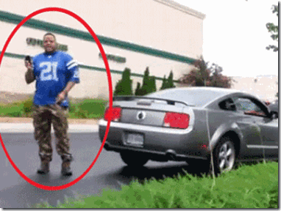](https://mindcontrolblackassassins.files.wordpress.com/2016/06/aaaaorlandoflanagancare.gif)*In a raid on **Flanagan’s**apartment in **Roanoke,** police reportedly confiscated a *gay pride flag*. They also found “**many**” **Sex Magick Tools**, which had fresh “**human genetic material**” on them.[[50]](https://mindcontrolblackassassins.com/Users/PrinceRay/SkyDrive/" \l "_ftn50_8375) *Sex toys* and *chat lines*, **Flanagan**was far from a lonely abandoned society outcast. He was still a very busy *veteran* *male prostitute*.

[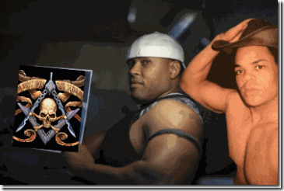](https://mindcontrolblackassassins.files.wordpress.com/2016/06/aaaaorlandofrenchy.gif)

**Frenchy, Freemasonry & Flanagan**

**Flanagan** had friends in his *closed trade and circle* like **Frenchy**, *Robert Lee Avent*, but nobody except me seems willing to discuss any of that. He also had his **Sex Magick***homosexual/hermaphrodite* “**clientele**” that paid his rent and taste for high end sport cars. I suspect **Flanagan**had a secret classified “**clientele**” that were *top level U.S. military personnel sodomites*of the **BROTHERHOOD**. **Virginia** has from **22** to **27** military bases. It has about **13 (thirteen)** **Naval and Marine** bases. **Roanoke**is a military housing zone.[[51]](https://mindcontrolblackassassins.com/Users/PrinceRay/SkyDrive/" \l "_ftn51_8375)*Flanagan’s*computer *hard drive, phones and telephone records* were taken, and have not resurfaced as a record of seized evidence.

[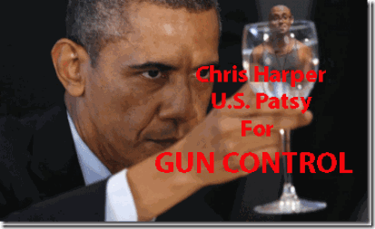](https://mindcontrolblackassassins.files.wordpress.com/2016/06/aaaaorlandoguncontrol.gif)

**Poor Chris** was a virtual *throw-away* child. What was the U.S. government training him to be- a *Manchurian Candidate Sleeper*, **FALSE FLAG PASTY**. There still remains **no video surveillance evidence** to show that **Chris** ever sat foot on **Umpgua College** on October 1. Where is his autopsy? We have just forgotten about **Chris Sean Harper**when there is far more to learn about the case that may help prevent another U.S. military government mass murder false flag domestic terrorist operation.

Back to **Marcus Wayne Chenault** for a moment. *Little Markie’s* **five (5) member team** of programmed assassins were called, ***The Troop***. **The Troop** assassination team targeting *national black religious leaders* was verified in **The Journal Herald**, Dayton, Ohio by Reporter *Arlene Gordon* in a copyrighted story, July 2, 1974. The team was also identified as the “**Greyhound Pastors**.” The assassins traveled by greyhound from city to city receiving money and assignments along the routes. *Little Markie* had traveled from Dayton, OH to Atlanta by **Greyhound Bus**to try to kill**Dr. King, Sr**. *Markie*said that he had once traveled to Chicago by **Greyhound Bus** to attempt to kill **Jesse Jackson**, but the mission was aborted at the last minute. **Markie’s**hitteam was led by **Walter E. Brooks, Jr**.. The **Troop** was ran out of the *ultra top secret* **Building 18, Area B, Wright Patterson Air Force Base,**Dayton, OH.

[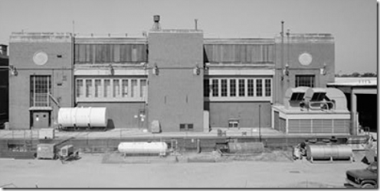](https://mindcontrolblackassassins.files.wordpress.com/2016/06/aaaaorlandobuilding18.gif)

**EXTERIOR WEST VIEW, BUILDING 18B (LABORATORY OFFICE)** (1991). – Wright-Patterson Air Force Base, Area B, Building 18, Power Plant Laboratory Complex, Northeast corner of C & Fifth Streets, Dayton, Montgomery County, OH

*At the time of the Assassination of****Mrs. King****,****Brooks****had been the maintenance man for the “****Blue Room****” and****Building 18, Area B****containing the****Roswell Flying Disk****under control of****Operation PAPERCLIP****Nazis,****SS Werhner von Braun****,****Dr. Alexander******Lippisch****and the****Blood Covenant SS****in the****Interest of U.S. National Security****.*[[52]](https://mindcontrolblackassassins.com/Users/PrinceRay/SkyDrive/" \l "_ftn52_8375)*According to****FBI****documents, at some point,****Brooks****was wanted for questioning in the assassination of two Midwest black preachers.*

*Little Professor & Fort Jackson, SC*

*[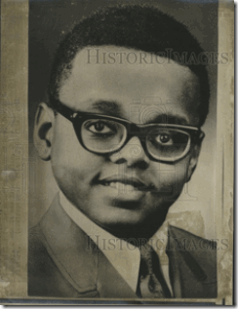](https://mindcontrolblackassassins.files.wordpress.com/2016/06/aaaaorlandolittemarkiepic.gif)*

*The “****Little Professor****” as he was at time called* *at Ohio University, with a large head, thick coke bottle glass lenses, and standing no more than 5 feet tall among a group of men would be an unforgettable and odd sight. It would be quite notable if he was seen moving into****Fort Jackson, SC****.*

*[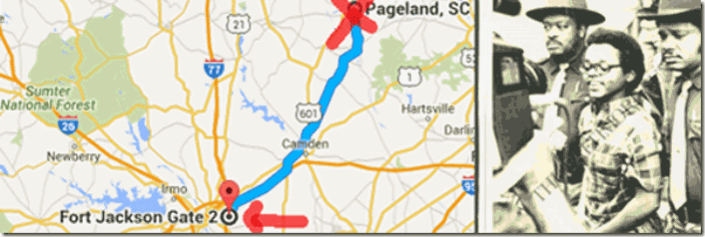](https://mindcontrolblackassassins.files.wordpress.com/2016/06/aaaaorlandolittlemarkiefort.gif)*

*Well, that is what actually happened. The****Columbia, SC FBI office****reported that an****eyewitness****reported to them on****July 2, 1974****that he saw an individual that looked very similar to****Little Markie****among men in three or four caravans of cars that had stopped several times at his store on****U.S. Route 9****to buy food and drinks.**He said that he hadn’t seen them for the past 2 years. He said that they moved south on****U.S. Route 9.****They had to have moved into the****Fort Jackson Gate.*****[[53]](https://mindcontrolblackassassins.com/Users/PrinceRay/SkyDrive/" \l "_ftn53_8375) Fort Jackson** (*U.S. Army Training Center*) encompasses more than **52,000** acres of land, including 100 ranges and field training sites and more than 1,000 buildings. **Fort Jackson** was incorporated into the city of **Columbia** in October 1968.[[54]](https://mindcontrolblackassassins.com/Users/PrinceRay/SkyDrive/" \l "_ftn54_8375) From witnesses in **South Carolina** along the route to **Fort Jackson**, *Little Markie* received secret U.S. Army basic military field training on several occasions. **Markie’s** secret military training was most likely the same as *Chris Harper, Howell, and Omar Matteen.*

From **U.S. v. Robertson**in regards to**Howell**and**Mateen**, we learn that *shadow government* counterintelligence *agent provocateurs*, *assassins* and *Manchurian Candidates* received *clandestine* weapons handling, sharp shooting, and explosives training from undercover **CIA/FBI** agents, and the **U.S. Army, Navy** or the **Marines**.

**Expeditionary Warfare Acronym: SMEAC**

They also received intense psychological military conditioning or layering. In **U.S. v. Robertson,**in the field **(streets**), undercover **CIA/FBI/Military Intelligence** agents indoctrinate their pasties with **SMEAC**(*Five Paragraph Field Order*). The military believe that they indoctrinate almost anyone in most mental conditions and simple mindlessness, *even Chris out of a special educational needs school*, with **SMEAC.** It is a standardized military method to tell *people/soldiers* what they want and expect them to accomplish.

The **five paragraph order** or **five paragraph field order** is a style of organizing information about a **military situation** for a unit in the field. It is an element of **U.S. Army**, **U.S. Marines** and **U.S. Navy Seabees** of small unit tactics, and similar order styles are used by military groups around the world. An order specifies the instruction to a unit in a structured format that makes it easy to find each specific requirement. The five paragraphs can be remembered with the acronym [**SMEAC**](https://en.wikipedia.org/wiki/Five_paragraph_order): “**S**” *Situation*, “**M**” *Mission*, “**E**” *Execution*, “**A**” *Administration/Logistics*, “**C**” *Command/Signal*.[[1]](https://mindcontrolblackassassins.com/tag/george-wackenhut/" \l "_ftn1_2802)

I often wondered the mechanics involved in conditioning a person under mind control to violate his or her, society’s moral code and the law to slay your brother. You wrap it up, layer it, and feed it to an alter in the form of a *military mission order* (**SMEAC**). I remember when we took down a **Black Manchurian Candidate** during the late 1960s at **Merritt Jr. College** in Oakland, there were at least 10 men wrestling with him to get a out of a leather shoulder hostler, and take him down. There was so many brothers wrestling with him, I couldn’t break the circle. I had studied wrestling in high school. I knew *take-down* techniques, but there were so many brothers in the flay. I didn’t get the chance to feel that *extraordinary strength*of a*Manchurian Candidate*on a blind mission to kill. We were able to remove the gun from him only after his eyes began to slowly lap to the back of his head. Foaming at the ends of his mouth, he lapsed into a state of unconsciousness. He weighted no more than 150 pounds, and stood no more than 5′ 6-7″.

I talked to and questioned him, extensively. I couldn’t figure it out. He appeared to a be a normal medium light skinned middle class/clean cut intelligent young man. He was far out of place at a **Black Nationalist** gathering in Oakland. Why he was there was a big **BLANK**. He didn’t know why he was there with a loaded gun. I didn’t get anything out of him. He seemed spirituality devoid. It was as if he had been cloned a week ago. The only papers I found on him was a California I.D. or Drivers’ License with a name and address, but I can’t remember the name. I sent two brothers to the address listed on the California document with a set of keys we took from him. It was **43 or 44nd Street** above **Telegraph Ave**. in **Oakland**. My introductions, bring me back something, telephone, gas and electric bill, pictures- anything from that address. Bring me something. They brought me nothing from the address. One of the brothers turned out to be a **state police infiltrator**. The other brother died mysteriously within a couple of years. I guess if they did bring back something, my faith also would have been sealed. I later discovered that the address and apartment in **North Oakland** was a **CIA** safe house that harbored Indiana State Police on special assignment, [Bill and Emily Harris of the SLA](http://www.maebrussell.com/Mae%20Brussell%20Articles/Why%20Was%20Hearst%20Kidnapped%201.html), and **Patty Hearst Kidnapping**.

The young man had been armed with a  snub nose 38 Smith & Wesson filed with outlawed exploding “*dum-dum*” bullets. He had been sent in on a **SMEAC** to kill somebody. His most likely target for assassination was **H. Rap Brown,**who was scheduled to show up on campus within hours. The shadow government wanted *H. Rap* **DEAD**very-very badly. When we took the Black Manchurian Candidate down, I was afraid of a back-up plan in case he failed. That’s another reason, I had him held until the nation’s most feared nationalist brothers, **H. Rap** and **Stokely Carmichael,**left the college campus and California.

I traveled to the *King Family’s* **Ebenezer Baptist Church** in Atlanta . For a moment, I sat in a place that I thought *Little Markie* may have sat on that day of tragedy for a weary family and people. Within the long traditional love, spirit and sacredness of the Black Church, there is no way in my *mind,* *heart, body and soul* that I could even for a moment rationalize or even envision anyone pulling a gun and striking down our beloved and most humble elders praying in that most *sacred and holy place* to our people. It only brought tears to my eyes as it does even today.

*Little Markie* didn’t get his mission’s target, **Dr. Marin Luther King, Sr**., but what he did sent shock waves through out Black communities across the nation, ***resist and die***. They will kill your mothers, fathers and elders. The people that programmed **Marcus Wayne Chenault**, and gave him the mission (**SMEAC**) to attack our beloved elders are still out there. His operational programming began inside **Wright Patterson Air Force Base**with **Reichsfuhrer Heinrich Himmler’ SS Peenemunde Rocket Team.**

Early in the murder investigation, the **FBI** switched its focus entirely from **The Troop**and**Nazis** at top secret **Building 18 B** (*Operation PAPERCLIP*) at **Wright Patterson** to a sect of hapless and powerless **U.S.** **Black Israelites**.

From July 9, 1973 – February 15, 1978, the **FBI Director** was **Clarence M. Kelley**. After the FBI, **Kelley**opened up an *investigative and security firm* as a subsidiary of the **Wackenhut Corporation** known as the **Kansas City Division**. **President Richard M. Nixon** nominated **Kelley**, a career *Southerner* FBI agent, to replace **Edgar J. Hoover** after he suddenly came up (*assassinated*) dead. He wasn’t an open high ranking **Freemason** like **Hoover**. *Kelley* belonged to the **underground confederate** fraternal brotherhood, **Sigma Nu** (*Secret Legion of Honor*). **Sigma Nu** was founded by **James Frank Hopkins** at **Virginia Military Institute (VMI)**in **Lexington, Virginia** in 1869. In **Hopkins‘** third year at **VMI**, he joined the **Masonic Lodge, No. 25** in **Lexington**. It was the **Masons** that inspired or instructed him to create a similar **Masonic**organization at **VMI**. **Sigma Nu’s** rituals *and initiation rites* are **Masonic rites**. **Sigma Nu** is a “**kindred kind**” to **Free and Accepted Masons**.

[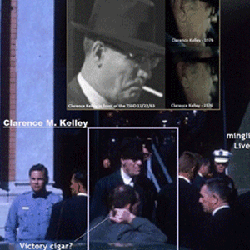](https://mindcontrolblackassassins.com/2016/07/04/update-cybele-satanists-blood-eaters-the-orlando-homosexual-false-flag-club-massacre/aaaaorlandoclarencekelley/)

**Clarence M. Kelley in Dallas at the Texas Book Depository- Lee Harvey Oswald**

**Nixon’s** running dog, **Kelley,** had a clear **FBI** “*hands off*” policy on **NASA**, **Operation PAPERCLIP Nazis**, and **Sturmführer SS Wernher von Braun**. He certainty appears to have been with the **Brotherhood** in Dallas when they ritually killed **President John F. Kennedy**.

*Chenault & Jacob*

*“Chenault advised he did the shooting at the church because the****GOD OF JACOB****told him to ….”*FBI Subject: **CHENAULT, MARCUS WAYNE**, FOIP No. 0965824-000

 After the murder of *Mrs. Martin Luther King, Sr.*, **Chenault**called himself, **Jacob Israel**. It was far from a random *multiple personality disorder***(MPD)***personality implantation*. **Jacob**(2000 BC- ?), *Son of Abraham, Brother of Joseph and Isaac*, is a biblical enigma warped inside a puzzle. Until going to college, **Chenault**had been raised in the Baptist Church since childhood. His killer alter personalities were designed carefully not to conflict with or substitute his religion with something alien, but supplement it with far deeper theological secrets, forbidden mysterious exoteric and esoteric knowledge of Christianity.

**Genesis 28: 17-19**

[](https://mindcontrolblackassassins.com/2016/07/04/update-cybele-satanists-blood-eaters-the-orlando-homosexual-false-flag-club-massacre/aaaaorlandojacobladder/)

**17** ” …. this is none other but the house of God, and this is the gate of heaven.” **18** And Jacob rose up early in the morning, and took the stone that he had put for his pillows, and set it up for a pillar, and poured oil upon the top of it. **19** And he called the name of that place **Bethel**. In the *Book of Genesis*, **Jacob** took his family to Egypt, and offered *a sacrifice to God*, for a blessing, guidance, and to seek God’s will.  **Abraham**and **Isaac** also honored **God** with *sacrifice*in Beer-Sheba. It honored the covenant. **Jacob**had not had a vision from **God**in a long time. **God** called him by name, and **Jacob** answered. **God** identified himself as **God of Isaac**. It is important to note the **God**of both **Abraham** and **Isaac**involve issues of **Human Sacrifice**. The sacrificial slaying of **Isaac** had been the ultimate test of **Abraham’s** faith. So, **Jacob’s God**was isolated from the broad conception of **GOD**, and uniquely named in the sense of a **God** that called for **Human Sacrifice** (*human slaughter*) as a test of faith.

**Jacob’s Dream** that is recorded in **Genesis** is also incredibly significant and important. The site of **Jacob’s Dream** is a *Canaanite city* named **Beth-El** (**House of (God) EL**). It seems almost certain that the God of the Jews evolved gradually from the **Canaanite El**, who was in all likelihood the **‘God of Abraham’**… If **El**was the high **God of Abraham**—Elohim, the prototype of **Yahveh**— **ASHERAH** was his wife, and there are archaeological indications that she was perceived as such before she was in effect ‘divorced’ in the context of emerging Judaism of the 7th century BCE. (See **2 Kings 23:15**)

[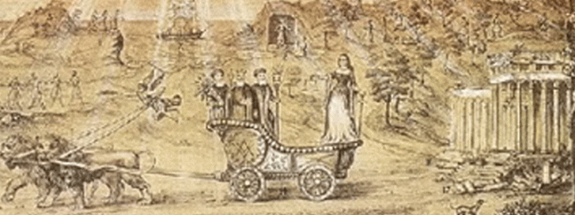](https://mindcontrolblackassassins.com/2016/07/04/update-cybele-satanists-blood-eaters-the-orlando-homosexual-false-flag-club-massacre/aaaaorlandocybeletemplemaso/)

**Asherah- CYBELE and the Three Founding Father of French Freemasonry**

According to **Freemasonry**, **Asherah**is **CYBELE.**

[](https://mindcontrolblackassassins.com/2016/07/04/update-cybele-satanists-blood-eaters-the-orlando-homosexual-false-flag-club-massacre/aaaaorlandonortedame/)

Above is a 12-13th Century relief called “[Cybele, philosophy](http://www.interfaithmary.net/pages/blackmadonna.html)” which is on the West portal of Notre-Dame of Paris. This *Lady Wisdom*, **Cybele**, has her feet on the **EARTH** and her head in the **CLOUDS**. She holds two books, one open and one closed, symbols for exoteric and esoteric knowledge, or wisdom gained from books and from interior prayer or meditation. Leaning on her is “**JACOB’S LADDER**”, *which represents the gradual way of knowledge of God leading to her scepter of wisdom, divine union*. The **stones** that **Jacob** *put for his pillows, and set up for a pillar in* **Bethel** **was/is** believed to be **METEORIC**.  **Cybele** is worshipped in form of a [BLACK METEORITE](http://www.angelfire.com/journal/ofapoet/cybele.html).

Thank God that **James Wesley Howell** didn’t follow through with his **SMEAC,**but  it does seem to appear that he didn’t abort his mission for any type of love and respect for mankind. He aborted his mission, because he figured that the **CIA**betrayed him.

*Too Close for Comfort, the  Columbia (Cybelean), South Carolina Incident*

On Monday, October 26, 2015, **Columbia**had been the site of that infamous student cell phone video that went viral that recorded a deeply horrifying and disturbing incident at Spring Valley High School. It graphically showed 6′ 3″ power weight lifter and football physical strength coach **Richland County Deputy Sheriff Ben Fields** attack a small defenseless *16 (sixteen) year old black female student* named **Shakara**.

**In Part II, Black Manchurian Candidate Chris Mercer Harper, Columbia, SC** …, I said that the case had to disappear quietly. The situation in **Columbia/Fort Jackson** veiled something far more deeper, greater and dangerous than you ever can imagine, and **U.S. Military Intelligence PSYOPS** and or the **U.S. Army Special Forces Psychological Warfare Operations** had been on top of this case since it first went viral globally on the internet- to *spin, re-write and re-image* everything your lying eyes witnessed, and much more.

[](https://mindcontrolblackassassins.files.wordpress.com/2016/06/aaaaorlandoleonlott.gif)

**Columbia’s Chief Law Enforcement Officer**, Richland County **Sheriff** **Leon Lott** is a **Luciferian 33rd degree Freemason**, **York Rite Master Mason, Scottish Rite Knights Templar** and a **PAGAN**.[[55]](https://mindcontrolblackassassins.com/Users/PrinceRay/SkyDrive/" \l "_ftn55_8375),[[56]](https://mindcontrolblackassassins.com/Users/PrinceRay/SkyDrive/" \l "_ftn56_8375) He was out of the town when the cell phone video brutal attack on **Shakara**went viral. **Sheriff Lott** had to take the first thing smoking back to **Columbia** to put all the ducks in order to quash and cover-up the incident as quickly as possible. And in fact,**Shakara** has disappeared from the public record. **Sheriff Lott** is the **SC State Guard Brigadier General** and **Deputy Commander of Special Operations Command**. He is an Honorary **Green Beret, Special Forces Association (S.C. chapter)**; Retired **Military Police Association; SC Combat Veterans Group**, **Special Forces Association**. **Special Forces** in American culture is tantamount to **Himmler’s Elite Waffen SS Officers**, and **“SS Otto Skorzeny’s Secret Global Terrorism Groups.”**[[57]](https://mindcontrolblackassassins.com/Users/PrinceRay/SkyDrive/" \l "_ftn57_8375)

**[](https://mindcontrolblackassassins.files.wordpress.com/2016/06/aaaaorlandocolumbia.gif)**

**Christopher Columbus** used to sign his name, **Colon**. The name **Columbus** was invented as yet more **BROTHERHOOD** symbolism. The Romans used to worship a deity they called *Venus Columba*, *Venus the Dove*. *Venus and dove* are associated with **Queen Semiramis**in Babylon. The word dove in French today is still **Colombre**. **Columba** is also an “**Aphrodite**” goddess which symbolizes the negative, death and destruction, aspects of the female energy.[[58]](https://mindcontrolblackassassins.com/Users/PrinceRay/SkyDrive/" \l "_ftn58_8375) **Semiramis** is the **Statue of Liberty** (*Libertas*). *Semiramis*/**CYBELE**, is the wife of **Nimrod** and **Queen of Babylon**.[[59]](https://mindcontrolblackassassins.com/Users/PrinceRay/SkyDrive/" \l "_ftn59_8375)

[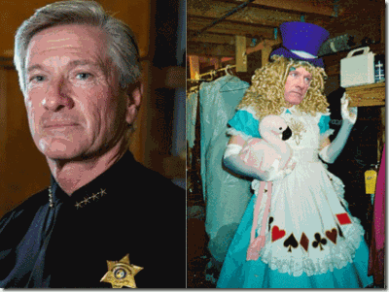](https://mindcontrolblackassassins.files.wordpress.com/2016/06/aaaaorlandolottdrag.gif)

**Here’s the kicker**. In 1998, **Sheriff Lott** was the first *drag queen*to win the title of *Columbia’s* **Vista Queen**. In the pageant, **Lott** donned *gay apparel* and was described to have *“fought it out like proper the****proper bitches****they are for the crown and the title of Vista Queen*.*”* For **Sheriff Lott**, it was both a ritual and initiation rite to enter an extremely ultra secret and high level rank among U.S. military elites and the **ILLUMINATI**–

[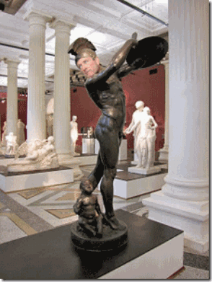](https://mindcontrolblackassassins.files.wordpress.com/2016/06/aaaaorlandocorybanteleon.gif)

**A Corybante**

[](https://mindcontrolblackassassins.files.wordpress.com/2016/06/aaaaorlandogallaelott.gif)

or **GALLAE**of **Goddess Cybele** of the **Secret Sodomite Army**.[[60]](https://mindcontrolblackassassins.com/Users/PrinceRay/SkyDrive/" \l "_ftn60_8375) **I CAN MAKE THIS STUFF UP!**

[](https://mindcontrolblackassassins.com/2016/07/04/update-cybele-satanists-blood-eaters-the-orlando-homosexual-false-flag-club-massacre/aaaaorlandogiuilani/)

**Elite Cybelean Gallae Homosexual Rite**, **Donald Drumpf** publicly kissing Former NY Mayor, *Rudolph Giuliani* (**Judy Ruliani**), in Drag (**Transvestism**).  At first, I didn’t what to call the *elite Satanic Homosexual Rituals* spreading across the nation. I suspected all along that there ancient *Roman* *homosexual rituals*, but I didn’t have a name. **Transvestism**, *global conquest*, ***secret blood sacrifices*** among an ultra powerful secret royal and imperial elite, it all fits in with **CYBELE.**

[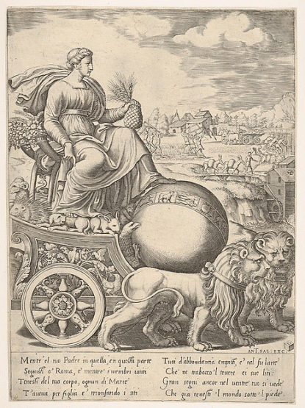](https://mindcontrolblackassassins.com/2016/07/04/update-cybele-satanists-blood-eaters-the-orlando-homosexual-false-flag-club-massacre/aaaaorlandocybeleworld1/)

**Cybele** has the ages old sacred symbolic **Pine Cone** in her hand. The **Pine Cone** is considered by many to be our biological **Third Eye**, the “**Seat of the Soul**,” the “**Epicenter of Enlightenment**“. For generations, she has had her foot on the **World**for her secret elite**Enlightened Worshipers.**

[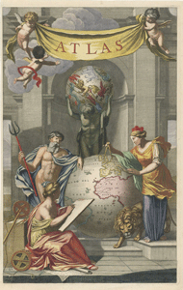](https://mindcontrolblackassassins.com/2016/07/04/update-cybele-satanists-blood-eaters-the-orlando-homosexual-false-flag-club-massacre/aaaaorlandocybeleworld/)

**Generations ago, the Cult of CYBELE**had plans for world domination of here worshipers. **Cybele** is an ancient **BLOOD CULT**from the dawn of history. She was the *mother goddess*of **Ancient Troy**, before there was a **Greece**. The *mighty majestic* and the *imperial elite* of **Rome** claimed descent from **Ancient Troy** and **Goddess CYBELE**. Her many names and worship has been preserved throughout the ages by secret fraternities, sororities, freemasonry and **Satanic Cults**. Her son is the **DEVIL** *God Pan* (**Baphomet**). She is the **WHORE OF BABYLON.**

Question: “[**What is the whore of Babylon / Mystery Babylon**](http://www.gotquestions.org/whore-Babylon-mystery.html)**?**” Answer: **Rev. 17: 1-2** tells us, “*Then one of the seven angels who had the seven bowls came and talked with me, saying to me, ‘****Come, I will show you the judgment of the great harlot who sits on many waters, with whom the kings of the earth committed fornication, and the inhabitants of the earth were made drunk with the wine of her fornication***.’” **Rev. 17: 5** goes on to say, “And on her forehead a name was written: **MYSTERY, BABYLON THE GREAT, THE MOTHER OF HARLOTS AND OF THE ABOMINATIONS OF THE EARTH**.” Who is this “*whore of Babylon*” and what is “*mystery Babylon*”?

**Rev. 17: 3** gives this description: “*Then the angel carried me away in the Spirit into a desert. There I saw a woman sitting on a scarlet beast that was covered with blasphemous names and had seven heads and ten horns*.” The beast mentioned in this verse is the same beast as in Revelation chapter 13:1, “*And I saw a beast coming out of the sea. He had ten horns and seven heads, with ten crowns on his horns, and on each head a blasphemous name.*” The **BEAST** in Revelation chapter 13 is understood to refer to the **Antichrist, the man of lawlessness** (*2 Thessalonians 2: 3-4; Daniel 9: 27*). So, the whore of Babylon, whoever it is, is closely affiliated with the **ANTI-CHRIST**.

[[1]](https://mindcontrolblackassassins.com/Users/PrinceRay/SkyDrive/" \l "_ftnref1_8375) <http://getoffthebs.com/five-suspects-involved-in-planned-attacks/>

[[2]](https://mindcontrolblackassassins.com/Users/PrinceRay/SkyDrive/" \l "_ftnref2_8375) Id.

[[3]](https://mindcontrolblackassassins.com/Users/PrinceRay/SkyDrive/" \l "_ftnref3_8375) <http://wlfi.com/2016/06/22/lawmaker-indiana-blew-it-by-not-ensuring-man-had-no-guns/>

[[4]](https://mindcontrolblackassassins.com/Users/PrinceRay/SkyDrive/" \l "_ftnref4_8375) <http://www.indystar.com/story/news/crime/2016/06/15/james-wesley-howell-charged-child-molestation/85925896/>

[[5]](https://mindcontrolblackassassins.com/Users/PrinceRay/SkyDrive/" \l "_ftnref5_8375) <http://www.tampabay.com/news/publicsafety/crime/washington-post-gun-used-by-omar-mateen-a-sig-sauer-mcx-not-an-ar-15/2281735>

[[6]](https://mindcontrolblackassassins.com/Users/PrinceRay/SkyDrive/" \l "_ftnref6_8375) <https://en.wikipedia.org/wiki/Penetrating_trauma>

[[7]](https://mindcontrolblackassassins.com/Users/PrinceRay/SkyDrive/" \l "_ftnref7_8375) <http://www.telegraph.co.uk/news/2016/06/12/orlando-shooting-gunman-omar-mateen-used-ar-15-assault-rifle-to/>

[[8]](https://mindcontrolblackassassins.com/Users/PrinceRay/SkyDrive/" \l "_ftnref8_8375) <https://lunaticoutpost.com/thread-663148.html>

[[9]](https://mindcontrolblackassassins.com/Users/PrinceRay/SkyDrive/" \l "_ftnref9_8375) Id.

[[10]](https://mindcontrolblackassassins.com/Users/PrinceRay/SkyDrive/" \l "_ftnref10_8375) <https://erickaecourtney.wordpress.com/2016/06/13/james-wesley-howell-intended-to-attack-the-lgbt-parade/>

[[11]](https://mindcontrolblackassassins.com/Users/PrinceRay/SkyDrive/" \l "_ftnref11_8375) <http://unitedsecurityservices.net/about/>

[[12]](https://mindcontrolblackassassins.com/Users/PrinceRay/SkyDrive/" \l "_ftnref12_8375) Id.

[[13]](https://mindcontrolblackassassins.com/Users/PrinceRay/SkyDrive/" \l "_ftnref13_8375) <https://www.facebook.com/MrGresson>

[[14]](https://mindcontrolblackassassins.com/Users/PrinceRay/SkyDrive/" \l "_ftnref14_8375) <http://www.skyscrapercity.com/showthread.php?t=299036>

[[15]](https://mindcontrolblackassassins.com/Users/PrinceRay/SkyDrive/" \l "_ftnref15_8375) Id.

[[16]](https://mindcontrolblackassassins.com/Users/PrinceRay/SkyDrive/" \l "_ftnref16_8375) <http://www.indystar.com/story/news/crime/2016/06/13/james-wesley-howells-ex-boyfriend-didnt-surprise-me-all/85836328/>

[[17]](https://mindcontrolblackassassins.com/Users/PrinceRay/SkyDrive/" \l "_ftnref17_8375) <https://www.facebook.com/michael.shanley.940?fref=pb&hc_location=friends_tab&pnref=friends.all>

[[18]](https://mindcontrolblackassassins.com/Users/PrinceRay/SkyDrive/" \l "_ftnref18_8375) <https://www.facebook.com/MrGresson/friends?source_ref=pb_friends_tl>

[[19]](https://mindcontrolblackassassins.com/Users/PrinceRay/SkyDrive/" \l "_ftnref19_8375) <https://www.facebook.com/michael.shanley.940/about?section=bio&pnref=about>

[[20]](https://mindcontrolblackassassins.com/Users/PrinceRay/SkyDrive/" \l "_ftnref20_8375)<https://www.sec.gov/Archives/edgar/data/1301566/000095013605005733/file002.htm>

[[21]](https://mindcontrolblackassassins.com/Users/PrinceRay/SkyDrive/" \l "_ftnref21_8375) <https://en.wikipedia.org/wiki/AlliedBarton>

[[22]](https://mindcontrolblackassassins.com/Users/PrinceRay/SkyDrive/" \l "_ftnref22_8375) <http://elitewatch.911review.org/Blackstone_Group.html>

[[23]](https://mindcontrolblackassassins.com/Users/PrinceRay/SkyDrive/" \l "_ftnref23_8375) <https://www.zacks.com/stock/news/180280/blackstone-pens-167b-deal-to-sell-alliedbarton-to-wendel>

[[24]](https://mindcontrolblackassassins.com/Users/PrinceRay/SkyDrive/" \l "_ftnref24_8375) <http://finance.yahoo.com/news/International-Association-of-iw-586340475.html>

[[25]](https://mindcontrolblackassassins.com/Users/PrinceRay/SkyDrive/" \l "_ftnref25_8375) <http://www.iajvs.org/>

[[26]](https://mindcontrolblackassassins.com/Users/PrinceRay/SkyDrive/" \l "_ftnref26_8375) <http://www.mesora.org/molech.html>

[[27]](https://mindcontrolblackassassins.com/Users/PrinceRay/SkyDrive/" \l "_ftnref27_8375) <http://www.prnewswire.com/news-releases/universal-protection-service-acquires-ar-security-services-inc-and-united-security-llc-168452686.html>

[[28]](https://mindcontrolblackassassins.com/Users/PrinceRay/SkyDrive/" \l "_ftnref28_8375) <http://www.alliedbarton.com/Media-Center/Press-Releases/View-Press-Release/ArticleId/965/AlliedBarton-Security-Services-and-Universal-Services-of-America-to-Merge-to-Create-Leading-Security-Company-in-North-America>

[[29]](https://mindcontrolblackassassins.com/Users/PrinceRay/SkyDrive/" \l "_ftnref29_8375) <http://silenceisconsent.net/revealed-dhs-contractor-employing-omar-mateen-fudged-his-psychological-evaluation/#sthash.O5Hd045A.dpbs>

[[30]](https://mindcontrolblackassassins.com/Users/PrinceRay/SkyDrive/" \l "_ftnref30_8375) Id.

[[31]](https://mindcontrolblackassassins.com/Users/PrinceRay/SkyDrive/" \l "_ftnref31_8375) <http://www.universalpro.com/execbio_ryan.html>

[[32]](https://mindcontrolblackassassins.com/Users/PrinceRay/SkyDrive/" \l "_ftnref32_8375) <https://deeppoliticsforum.com/forums/archive/index.php/t-2902.html?s=9de2ebec73c7b897c1a325f00170019e>

[[33]](https://mindcontrolblackassassins.com/Users/PrinceRay/SkyDrive/" \l "_ftnref33_8375) Id.

[[34]](https://mindcontrolblackassassins.com/Users/PrinceRay/SkyDrive/" \l "_ftnref34_8375) Id.

[[35]](https://mindcontrolblackassassins.com/Users/PrinceRay/SkyDrive/" \l "_ftnref35_8375) <http://www.veteranstoday.com/2016/06/12/mk-ultra-triple-play-in-orlando/>

[[36]](https://mindcontrolblackassassins.com/Users/PrinceRay/SkyDrive/" \l "_ftnref36_8375) <http://forum.bodybuilding.com/showthread.php?t=112730161>

[[37]](https://mindcontrolblackassassins.com/Users/PrinceRay/SkyDrive/" \l "_ftnref37_8375) <https://firstlook.org/wp-uploads/sites/1/2015/06/sent-memo1.pdf>

[[38]](https://mindcontrolblackassassins.com/Users/PrinceRay/SkyDrive/" \l "_ftnref38_8375) <https://firstlook.org/wp-uploads/sites/1/2015/06/sent-memo1.pdf>

[[39]](https://mindcontrolblackassassins.com/Users/PrinceRay/SkyDrive/" \l "_ftnref39_8375) <https://www.newspapers.com/newspage/31503416/>

[[40]](https://mindcontrolblackassassins.com/Users/PrinceRay/SkyDrive/" \l "_ftnref40_8375) <https://www.youtube.com/watch?v=AyVbieOy7_A>

[[41]](https://mindcontrolblackassassins.com/Users/PrinceRay/SkyDrive/" \l "_ftnref41_8375) <https://gabrielbenshalom.wordpress.com/2015/07/09/the-beirut-diary-an-interview-with-kay-griggs/>

[[42]](https://mindcontrolblackassassins.com/Users/PrinceRay/SkyDrive/" \l "_ftnref42_8375) <http://www.redicecreations.com/specialreports/2005/07jul/kgriggs.html>

[[43]](https://mindcontrolblackassassins.com/Users/PrinceRay/SkyDrive/" \l "_ftnref43_8375) <http://www.washingtontimes.com/news/2015/oct/2/chris-harper-mercer-was-discharged-from-army-penta/>

[[44]](https://mindcontrolblackassassins.com/Users/PrinceRay/SkyDrive/" \l "_ftnref44_8375) <http://www.mercurynews.com/crime-courts/ci_28916437/details-oregon-shooters-troubled-childhood-southern-california>

[[45]](https://mindcontrolblackassassins.com/Users/PrinceRay/SkyDrive/" \l "_ftnref45_8375) <http://www.oregonlive.com/pacific-northwest-news/index.ssf/2015/10/new_details_emerge_on_umpqua_c.html>

[[46]](https://mindcontrolblackassassins.com/Users/PrinceRay/SkyDrive/" \l "_ftnref46_8375)<http://events.r20.constantcontact.com/register/event;jsessionid=E6F7C2B52EBB75CED36A6346338322DC.worker_registrant?llr=tpcdhtlab&oeidk=a07e91iubxnd40ea1ad>

[[47]](https://mindcontrolblackassassins.com/Users/PrinceRay/SkyDrive/" \l "_ftnref47_8375) <http://www.rossinst.com/cia_doctors.html>

[[48]](https://mindcontrolblackassassins.com/Users/PrinceRay/SkyDrive/" \l "_ftnref48_8375) <http://static.conservativetribune.com/wp-content/uploads/2015/10/Harper-post.png>

[[49]](https://mindcontrolblackassassins.com/Users/PrinceRay/SkyDrive/" \l "_ftnref49_8375) <http://www.people.com/article/shooter-vester-lee-flanigan-once-paid-escort>

[[50]](https://mindcontrolblackassassins.com/Users/PrinceRay/SkyDrive/" \l "_ftnref50_8375) <http://www.thegatewaypundit.com/2015/08/killer-bryce-williams-left-dirty-sex-toys-for-investigators-would-throw-cat-sht-at-neighbors-balconies/>

[[51]](https://mindcontrolblackassassins.com/Users/PrinceRay/SkyDrive/" \l "_ftnref51_8375) <http://www.militaryauthority.com/wiki/military-bases/nationwide/virginia/>

[[52]](https://mindcontrolblackassassins.com/Users/PrinceRay/SkyDrive/" \l "_ftnref52_8375)<http://news.google.com/newspapers?nid=1356&dat=19740704&id=m4ZPAAAAIBAJ&sjid=iwUEAAAAIBAJ&pg=7148,571358>

[[53]](https://mindcontrolblackassassins.com/Users/PrinceRay/SkyDrive/" \l "_ftnref53_8375) 7/12/74, FBI FB 204 (Rev 3 359) Reporting Office: Columbia, Office of Origin: Atlanta; Title of Case, MARCUS WAYNE CHENAULT, aka; Mrs. MARTIN LUTHER KING, SR. VICTIM; EDWARD BOYKINS ….

[[54]](https://mindcontrolblackassassins.com/Users/PrinceRay/SkyDrive/" \l "_ftnref54_8375) <https://en.wikipedia.org/wiki/Fort_Jackson_(South_Carolina)>

[[55]](https://mindcontrolblackassassins.com/Users/PrinceRay/SkyDrive/" \l "_ftnref55_8375) <http://www.rcsd.net/bio.html>

[[56]](https://mindcontrolblackassassins.com/Users/PrinceRay/SkyDrive/" \l "_ftnref56_8375) <http://paganroundtable.org/2011/07/>

[[57]](https://mindcontrolblackassassins.com/Users/PrinceRay/SkyDrive/" \l "_ftnref57_8375) <http://www.rcsd.net/bio.html>

[[58]](https://mindcontrolblackassassins.com/Users/PrinceRay/SkyDrive/" \l "_ftnref58_8375) <http://www.abovetopsecret.com/forum/thread57816/pg1>

[[59]](https://mindcontrolblackassassins.com/Users/PrinceRay/SkyDrive/" \l "_ftnref59_8375) <http://www.whale.to/c/nimrod.html>

[[60]](https://mindcontrolblackassassins.com/Users/PrinceRay/SkyDrive/" \l "_ftnref60_8375) <http://jaspercolumbia.net/blog/?p=1485>

Comments : [Leave a Comment »](https://mindcontrolblackassassins.com/2016/07/04/update-cybele-satanists-blood-eaters-the-orlando-homosexual-false-flag-club-massacre/#respond)   
Tags: [9-11 inside job](https://mindcontrolblackassassins.com/tag/9-11-inside-job/), [adam walsh](https://mindcontrolblackassassins.com/tag/adam-walsh/), [alliedbarton security services](https://mindcontrolblackassassins.com/tag/alliedbarton-security-services/), [baby sacrifice](https://mindcontrolblackassassins.com/tag/baby-sacrifice/), [ben fields](https://mindcontrolblackassassins.com/tag/ben-fields/), [blood cults](https://mindcontrolblackassassins.com/tag/blood-cults/), [blood eaters](https://mindcontrolblackassassins.com/tag/blood-eaters/), [blood oath secrecy](https://mindcontrolblackassassins.com/tag/blood-oath-secrecy/), [blood sacrifice](https://mindcontrolblackassassins.com/tag/blood-sacrifice/), [bobby ray inman](https://mindcontrolblackassassins.com/tag/bobby-ray-inman/), [brotherhood](https://mindcontrolblackassassins.com/tag/brotherhood/), [Building 18-b](https://mindcontrolblackassassins.com/tag/building-18-b/), [building 7](https://mindcontrolblackassassins.com/tag/building-7/), [camy lejeune](https://mindcontrolblackassassins.com/tag/camy-lejeune/), [chris sean harper](https://mindcontrolblackassassins.com/tag/chris-sean-harper/), [christopher columbus](https://mindcontrolblackassassins.com/tag/christopher-columbus/), [CIA](https://mindcontrolblackassassins.com/tag/cia/), [col. george Raymond griggs](https://mindcontrolblackassassins.com/tag/col-george-raymond-griggs/), [Colombia](https://mindcontrolblackassassins.com/tag/colombia/), [Colston Westbrook](https://mindcontrolblackassassins.com/tag/colston-westbrook/), [corybante](https://mindcontrolblackassassins.com/tag/corybante/), [cybele](https://mindcontrolblackassassins.com/tag/cybele/), [del amo behavior health system](https://mindcontrolblackassassins.com/tag/del-amo-behavior-health-system/), [dr. colin a. ross](https://mindcontrolblackassassins.com/tag/dr-colin-a-ross/), [ebenezer baptist church](https://mindcontrolblackassassins.com/tag/ebenezer-baptist-church/), [Fort Bragg](https://mindcontrolblackassassins.com/tag/fort-bragg/), [fort jackson](https://mindcontrolblackassassins.com/tag/fort-jackson/), [frank carlucci](https://mindcontrolblackassassins.com/tag/frank-carlucci/), [freemasons](https://mindcontrolblackassassins.com/tag/freemasons/), [frenchy](https://mindcontrolblackassassins.com/tag/frenchy/), [gallae](https://mindcontrolblackassassins.com/tag/gallae/), [gay agenda](https://mindcontrolblackassassins.com/tag/gay-agenda/), [gay parade](https://mindcontrolblackassassins.com/tag/gay-parade/), [george wackenhut](https://mindcontrolblackassassins.com/tag/george-wackenhut/), [gladio](https://mindcontrolblackassassins.com/tag/gladio/), [gs4](https://mindcontrolblackassassins.com/tag/gs4/), [hand of death](https://mindcontrolblackassassins.com/tag/hand-of-death/), [Henry Kissinger](https://mindcontrolblackassassins.com/tag/henry-kissinger/), [henry lee lucas](https://mindcontrolblackassassins.com/tag/henry-lee-lucas-2/), [hermaphrodite](https://mindcontrolblackassassins.com/tag/hermaphrodite/), [homosexual](https://mindcontrolblackassassins.com/tag/homosexual/), [Illuminati](https://mindcontrolblackassassins.com/tag/illuminati/), [James Earl Ray](https://mindcontrolblackassassins.com/tag/james-earl-ray/), [james wesley howell](https://mindcontrolblackassassins.com/tag/james-wesley-howell/), [joey greeson](https://mindcontrolblackassassins.com/tag/joey-greeson/), [joseph greeson](https://mindcontrolblackassassins.com/tag/joseph-greeson/), [katherine griggs](https://mindcontrolblackassassins.com/tag/katherine-griggs/), [Lee Harvey Oswald](https://mindcontrolblackassassins.com/tag/lee-harvey-oswald/), [leon lott](https://mindcontrolblackassassins.com/tag/leon-lott/), [lords of the black stone](https://mindcontrolblackassassins.com/tag/lords-of-the-black-stone/), [maimonides](https://mindcontrolblackassassins.com/tag/maimonides/), [manchurian candidates](https://mindcontrolblackassassins.com/tag/manchurian-candidates/), [marcus dewayne robertson](https://mindcontrolblackassassins.com/tag/marcus-dewayne-robertson/), [marcus robertson](https://mindcontrolblackassassins.com/tag/marcus-robertson/), [Marcus Wayne Chenault](https://mindcontrolblackassassins.com/tag/marcus-wayne-chenault/), [max call](https://mindcontrolblackassassins.com/tag/max-call/), [michael shantely](https://mindcontrolblackassassins.com/tag/michael-shantely/), [molech](https://mindcontrolblackassassins.com/tag/molech-2/), [moloch](https://mindcontrolblackassassins.com/tag/moloch-2/), [multiple personality disorder](https://mindcontrolblackassassins.com/tag/multiple-personality-disorder/), [NATO](https://mindcontrolblackassassins.com/tag/nato/), [omar mateen](https://mindcontrolblackassassins.com/tag/omar-mateen/), [orlando](https://mindcontrolblackassassins.com/tag/orlando/), [orlando homophobic massacre](https://mindcontrolblackassassins.com/tag/orlando-homophobic-massacre/), [ottis toole](https://mindcontrolblackassassins.com/tag/ottis-toole-2/), [Otto Skorzeny](https://mindcontrolblackassassins.com/tag/otto-skorzeny/), [patience carter](https://mindcontrolblackassassins.com/tag/patience-carter/), [pink triangle](https://mindcontrolblackassassins.com/tag/pink-triangle/), [pulse club](https://mindcontrolblackassassins.com/tag/pulse-club/), [secret sodomite army](https://mindcontrolblackassassins.com/tag/secret-sodomite-army/), [semiramis](https://mindcontrolblackassassins.com/tag/semiramis/), [smeac](https://mindcontrolblackassassins.com/tag/smeac/), [statue of liberty](https://mindcontrolblackassassins.com/tag/statue-of-liberty/), [switzer learning center](https://mindcontrolblackassassins.com/tag/switzer-learning-center/), [The Troop](https://mindcontrolblackassassins.com/tag/the-troop/), [tiara parker](https://mindcontrolblackassassins.com/tag/tiara-parker/), [u.s. army](https://mindcontrolblackassassins.com/tag/u-s-army/), [u.s. marines](https://mindcontrolblackassassins.com/tag/u-s-marines/), [umpgua college](https://mindcontrolblackassassins.com/tag/umpgua-college/), [united security services](https://mindcontrolblackassassins.com/tag/united-security-services/), [universal security services](https://mindcontrolblackassassins.com/tag/universal-security-services/), [Vester Lee Flanagan III](https://mindcontrolblackassassins.com/tag/vester-lee-flanagan-iii/), [vista drag queen](https://mindcontrolblackassassins.com/tag/vista-drag-queen/), [vril](https://mindcontrolblackassassins.com/tag/vril/), [wackenhut](https://mindcontrolblackassassins.com/tag/wackenhut/), [william casey](https://mindcontrolblackassassins.com/tag/william-casey/), [Zbigniew Brzezinski](https://mindcontrolblackassassins.com/tag/zbigniew-brzezinski/)   
Categories : [1000 Year Reich](https://mindcontrolblackassassins.com/category/1000-year-reich/), [9-11](https://mindcontrolblackassassins.com/category/9-11/), [albert pike](https://mindcontrolblackassassins.com/category/albert-pike/), [Aryan Supremacy](https://mindcontrolblackassassins.com/category/aryan-supremacy/), [baby scarifrice](https://mindcontrolblackassassins.com/category/baby-scarifrice/), [black children](https://mindcontrolblackassassins.com/category/black-children/), [black christianity](https://mindcontrolblackassassins.com/category/black-christianity/), [Black Manchurian Candidates](https://mindcontrolblackassassins.com/category/black-manchurian-candidates/), [blood covenants](https://mindcontrolblackassassins.com/category/blood-covenants/), [blood oaths](https://mindcontrolblackassassins.com/category/blood-oaths/), [blood sacrifice](https://mindcontrolblackassassins.com/category/blood-sacrifice/), [CIA](https://mindcontrolblackassassins.com/category/cia/), [COINTELPRO](https://mindcontrolblackassassins.com/category/cointelpro/), [Crimes Against Democracy](https://mindcontrolblackassassins.com/category/crimes-against-democracy/), [cybele](https://mindcontrolblackassassins.com/category/cybele/), [DIA](https://mindcontrolblackassassins.com/category/dia/), [division five](https://mindcontrolblackassassins.com/category/division-five/), [false flags](https://mindcontrolblackassassins.com/category/false-flags/), [fbi](https://mindcontrolblackassassins.com/category/fbi-2/), [h. rap brown](https://mindcontrolblackassassins.com/category/h-rap-brown/), [Heinrich Himmler](https://mindcontrolblackassassins.com/category/heinrich-himmler/), [Hip Hop](https://mindcontrolblackassassins.com/category/hip-hop/), [human sacifrice](https://mindcontrolblackassassins.com/category/human-sacifrice/), [illuminati](https://mindcontrolblackassassins.com/category/illuminati-2/), [illuminati sacrifice](https://mindcontrolblackassassins.com/category/illuminati-sacrifice/), [imperium](https://mindcontrolblackassassins.com/category/imperium-2/), [Knight of Malta](https://mindcontrolblackassassins.com/category/knight-of-malta/), [Knights of the Black Sun](https://mindcontrolblackassassins.com/category/knights-of-the-black-sun/), [lucifer's servants](https://mindcontrolblackassassins.com/category/lucifers-servants-2/), [luciferians](https://mindcontrolblackassassins.com/category/luciferians/), [Marcus Wayne Chenault](https://mindcontrolblackassassins.com/category/marcus-wayne-chenault/), [maria orsic](https://mindcontrolblackassassins.com/category/maria-orsic/), [Martin Luther King](https://mindcontrolblackassassins.com/category/martin-luther-king/), [masonic sacrifice](https://mindcontrolblackassassins.com/category/masonic-sacrifice/), [michael flanagan](https://mindcontrolblackassassins.com/category/michael-flanagan/), [mk ultra, cia occult bureau, temple of set](https://mindcontrolblackassassins.com/category/mk-ultra-cia-occult-bureau-temple-of-set/), [MK-ULTRA](https://mindcontrolblackassassins.com/category/mk-ultra/), [Molech](https://mindcontrolblackassassins.com/category/molech/), [Moloch](https://mindcontrolblackassassins.com/category/moloch/), [MOSSAD](https://mindcontrolblackassassins.com/category/mossad/), [mulitiple personality disorder](https://mindcontrolblackassassins.com/category/mulitiple-personality-disorder/), [nato](https://mindcontrolblackassassins.com/category/nato-2/), [Nazis](https://mindcontrolblackassassins.com/category/nazis/), [new world order](https://mindcontrolblackassassins.com/category/new-world-order-2/), [nwo](https://mindcontrolblackassassins.com/category/nwo/), [order of teutonic knights](https://mindcontrolblackassassins.com/category/order-of-teutonic-knights/), [Paperclip Project](https://mindcontrolblackassassins.com/category/paperclip-project/), [post amnesia barriers](https://mindcontrolblackassassins.com/category/post-amnesia-barriers/), [post hypnotic suggestions](https://mindcontrolblackassassins.com/category/post-hypnotic-suggestions/), [President John F. Kennedy](https://mindcontrolblackassassins.com/category/president-john-f-kennedy/), [psychological warfare campaign against Christianity](https://mindcontrolblackassassins.com/category/psychological-warfare-campaign-against-christianity/), [Reichsfurhrer SS-1 Heinrich Himmler](https://mindcontrolblackassassins.com/category/reichsfurhrer-ss-1-heinrich-himmler/), [Ritual Satanic Abuse](https://mindcontrolblackassassins.com/category/ritual-satanic-abuse/), [ritual satanic sexual abuse](https://mindcontrolblackassassins.com/category/ritual-satanic-sexual-abuse/), [ritually abused children](https://mindcontrolblackassassins.com/category/ritually-abused-children/), [Satanic Global High Cabal](https://mindcontrolblackassassins.com/category/satanic-global-high-cabal/), [Satanism](https://mindcontrolblackassassins.com/category/satanism/), [Schutzsteffel](https://mindcontrolblackassassins.com/category/schutzsteffel/), [scottsish rite](https://mindcontrolblackassassins.com/category/scottsish-rite/), [south carolina](https://mindcontrolblackassassins.com/category/south-carolina/), [SS](https://mindcontrolblackassassins.com/category/ss/), [Strumbannfuhrer SS Dr. Wernher von Braun](https://mindcontrolblackassassins.com/category/strumbannfuhrer-ss-dr-wernher-von-braun/), [Symbionese Liberation Army](https://mindcontrolblackassassins.com/category/symbionese-liberation-army/), [trauma-based mind control](https://mindcontrolblackassassins.com/category/trauma-based-mind-control/), [underground reich](https://mindcontrolblackassassins.com/category/underground-reich/), [underground third reich](https://mindcontrolblackassassins.com/category/underground-third-reich/), [vril](https://mindcontrolblackassassins.com/category/vril/), [Zbigniew Brzezinski](https://mindcontrolblackassassins.com/category/zbigniew-brzezinski/), [ZIONIST](https://mindcontrolblackassassins.com/category/zionist/)

FLICKR PHOTOS

[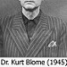](https://www.flickr.com/photos/princeray/3726693391/)[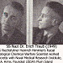](https://www.flickr.com/photos/princeray/3727392870/)[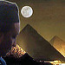](https://www.flickr.com/photos/princeray/3718819886/)

[More Photos](https://www.flickr.com/photos/princeray/)

Top of Form



Bottom of Form

EMAIL SUBSCRIPTION

Top of Form

Enter your email address to subscribe to this blog and receive notifications of new posts by email.

Join 1,583 other followers





Bottom of Form

[PRINCE RAY](http://twitter.com/princebullock)

* PRINCERAY Y-DNA= TA- SETI LA BANTU[bullockblackfamily.wordpress.com/2017/10/06/pri…](https://bullockblackfamily.wordpress.com/2017/10/06/princeray-y-dna-ta-seti-la-bantu/)<https://t.co/E0sFS7B1bx>[6 months ago](http://twitter.com/princebullock/statuses/916425896323674112)
* Where is the gun at Scott's feet?[1 year ago](http://twitter.com/princebullock/statuses/779385934735216640)
* [#charlestongoddamn](http://twitter.com/search?q=%23charlestongoddamn) Dylann Storm [Trooper] Roof- Devil & CIA- MK ULTRA in the Details <http://t.co/sNAOSUpNEe>[2 years ago](http://twitter.com/princebullock/statuses/613154933433470976)
* [#charlestowngoddam](http://twitter.com/search?q=%23charlestowngoddam), Slavocracy Lost Cause & Secret 2nd Civil War Against Blacks, [bit.ly/1GwduFt](http://bit.ly/1GwduFt)[2 years ago](http://twitter.com/princebullock/statuses/613153032407113728)
* The police didn't make it to Emanuel AME to save our elders in Charleston- planned diversion, Active Shooter Drill[bit.ly/1e0qZqc](http://bit.ly/1e0qZqc) [2 years ago](http://twitter.com/princebullock/statuses/613152370957004800)

* [Follow](https://mindcontrolblackassassins.com/tag/george-wackenhut/)

:)