**LIST OF KNOWN NAMES CONNECTED TO SATANIC CULTS / PEDOPHILIA / CHILD-TRAFFICKING IN AMERICA:**

**● Hillary Clinton**  
**● Bill Clinton**  
**● George Nader (Businessman)**  
**● Huma Aberdin**  
**● Laura Silsby**  
**● Rachel Chandler**  
**● Jeffrey Epstein**  
**● Ghislaine Maxwell**  
**● John Podesta**  
**● Michael Podesta**  
**● James Alefantis**  
**● Anthony Wiener**  
**● Leslie Wexner (Limited Inc Chairman)**  
**● Herbert Strauss**  
**● Isidor Strauss**  
**● Martin A. Nowak**  
**● Steven Spielberg**  
**● Edgar Bronfman Sr. (Seagram Chairman)**  
**● Charles Bronfman (Seagram Co)**  
**● Michael Steinhardt (former hedge-fund manager)**  
**● Sara Bronfman**  
**● Clare Bronfman**  
**● Niles Lehman (Professor at Portland State University)**  
**● Seth Roger**  
**● Ruth Ginsberg**  
**● Alison Mack**  
**● Rachel Chandler**  
**● Robert Maxwell**  
**● Wendi Murdoch**  
**● Jonathan Cheban**  
**● Naomi Campbell**  
**● Maximiliam Chow**  
**● Val Kilmer**  
**● Marina Abramovic**

**LIST OF HOLLYWOOD PEDO-NAMES:**

**● Steven Spielberg**  
**● Michael Jackson**  
**● Kevin Spacey**

**● Alison Mac**  
**● Marc Collins-Rector (Founder of Den)**  
**● Chad Shackley**  
**● Brock Pierce**  
**● David Geffen**  
**● Tom Hanks**  
**● Dustin Hoffman**  
**● Andrew Kreisberg (American television writer, producer)**  
**● Bryan Singer**  
**● Harvey Weinstein**  
**● Bob Weinstein**  
**● Roman Polanski**  
**● Ruma Hazard**  
**● Charlie Sheen**  
**● Madonna**  
**● Kate Perry**  
**● Miley Cyrus**  
**● Errol Flynn**  
**● Billy Graham**  
**● Walt Disney**  
**● Michael Laney (Former Walt Disney vice president)**  
**● James Gunn (Disney)**

**LIST OF NAMES OF CELEBS CONNECTED TO THE DEEPSTATE, CIA & MOSSAD:**

**● Heidi Fleiss**  
**● Jeffrey Epstein**

**LIST OF NAMES CONNECTED TO SATANIC CULTS:**

**● Alison Mack**  
**● Stormy Daniels**  
**● Rachel Chandler**  
**● Ghislaine Maxwell**

**LIST OF NAMES OF VISITORS ON EPSTEIN ISLAND:**

**● Ghislaine Maxwell**  
**● Chris Tucker**  
**● Larry Summers**  
**● Lisa Summers**  
**● Bill Murray**  
**● Bill Hammond**  
**● Ehud Barak**  
**● Andrés Pastrana (Former President of Colombia 1998-2002)**  
**● Jean Luc Brunel**  
**● Doug Band**  
**● Ron Burkle**  
**● Woody Allen**  
**● Sarah Kellen**  
**● Ray Barzanna**  
**● Sandy Burger**  
**● Andrea Mitrovitch**  
**● Peter Marino**  
**● Shelley Lewis**  
**● Paul Hala(t) (d) a**  
**● Richardo Legoretta**  
**● Tom Pritzker**  
**● Kelly Spamm**  
**● Tiffany Gramza**  
**● Claire Hazel**  
**● Paula Epstein**  
**● Mark Epstein**  
**● Ralph Elison**  
**● Sophie Biddle**  
**● Audrey Raimbault**  
**● Shelley Harrison**  
**● Melinda Luntz**  
**● Gwendolyn Beck**  
**● Albert Pinto**  
**● Linda Pinto**  
**● Gary Roxburgh**  
**● Mandy Elison**  
**● Jean Michelle Gathy**  
**● Virginia Roberts**  
**● Kristy Rodgers (Kristina Real Rodgers)**  
**● Greg Holbert**  
**● Alyssa Rodgers**  
**● Juliette Bryant**  
**● Heather Mann**  
**● Ed Tuttle**  
**● Glen Dubin**  
**● Ellen Spencer**  
**● Chris Wagner**  
**● Casey Wasserman**  
**● Laura Wasserman**  
**● Paul Mellon**  
**● Oliver Sachs**  
**● Henry Rosovsky**  
**● Lynn Forester (de Rothschild)**  
**● Joe Pagano**  
**● Naomi Campbell**  
**● Nicole Junkermann**  
**● Rodney Slater**  
**● Magali Blachon (Deperrier)**  
**● Svetlana Griaznova**  
**● Emmy Tayler**  
**● Larry Visoski**  
**● Teala Davies**  
**● Juan (Pablo) Molyneux**  
**● Freya Willemoes) Wissing**  
**● Adam Perry Lang**  
**● Fleur Perry Lang**  
**● Caren Casey**  
**● Hank Coller**  
**● Cindy Lopez**  
**● Mark Lloyd**  
**● Alan Dershowitz**  
**● Seth Green**  
**● James Gunn**  
**● Steven Spielberg**  
**● Tom Hanks**  
**● Steven Colbert**  
**● Jimmy Kimmel**  
**● Barack Obama**  
**● Kevin Spacey**  
**● Kathy Griffin**  
**● Oprah Winfrey**  
**● Shawn Carter**  
**● Beyoncé Knowles**  
**● Anthony Kiedis**  
**● John Legend**  
**● Chrissy Tiegen**  
**● Jim Carrey**  
**● Steven Tyler**  
**● Ben Affleck**  
**● Stephen Collins**  
**● Will Ferrell**  
**● Aliaune Damala Badara Thiam (Akon)**  
**● Marshall Matters**  
**● Jeffrey Jones**  
**● Victor Salva**  
**● Mark Collins Rector**  
**● Charlie Sheen**  
**● Tyler Grasham**  
**● Madonna Ciccone**  
**● Katheryn Hudson**  
**● Gwen Stefani**  
**● Stefani Germanotta**  
**● James Franco**  
**● Will Smith**  
**● Justin Roland**  
**● John Cusack**  
**● Anderson Cooper**  
**● Demi Moore**  
**● Brian Affleck**  
**● Meryl Streep**  
**● Wanda Sykes**  
**● Chelsea Handler**  
**● Michelle Wolf**  
**● David Yarovesky**  
**● Pharrell Williams**  
**● Quentin Tarantino**  
**● Courtney Love**  
**● Alec Baldwin**  
**● Robert Downey Jr.**  
**● Disney Corporation (Offering kids “scuba-diving” trips, to the Epstein Island)**

[***Link: the Epstein flight log documents***](https://www.documentcloud.org/documents/1507315-epstein-flight-manifests.html)

**LIST OF NAMES CONNECTED TO THE STANDARD HOTELS**

**● Andre Balazs (Owner of the Standard Hotels and connected to the Rockefellers)**  
**● Jay Z**  
**● Beyoncé Knowles**  
**● John Belushi**  
**● Britney Spears**  
**● Errol Flynn**  
**● Dennis Hopper**  
**● Helmut Newton**  
**● Jim Morrison**  
**● James Dean**  
**● Billy Idol**  
**● Victoria Beckham**  
**● Heath Ledger**  
**● Sienna Miller**  
**● Balthazar Getty**  
**● Scarlet Johansen**

**MORE NAMES TO ADD TO THE LIST-**  
**INDIVIDUALS THAT’S DIRECTLY CONNECTED TO JEFFREY EPSTEIN & THE EPSTEIN ISLAND:**

● **Elon Musk**

**● Mark Zuckerberg**

**● Lawrence M. Krauss**  
**● Steven Pinker**  
**● Mick Jagger**  
**● Courtney Love**  
**● Joan Rivers (deceased)**  
**● Kevin Spacey**  
**● Chris Rock**  
**● Eli** **Weisel (Nobel Prize winning Holocaust profiteer)**  
**● Lauren Hutton (Top fashion model)**  
**● Duke & Duchess of York**  
**● Earl Spencer (Late Diana’s brother)**  
**● Richard Bronson (English businessman)**  
**● Tony Blair (Former UK prime minister)**  
● **David Koch (1/2 of a brother team)**  
**● David Rockefeller**  
**● Evelyn de Rothschild**  
**● Eduouard de Rothschild**

**JOURNALISTS THAT’S DIRECTLY CONNECTED TO JAMES ALEFANTIS, COMET PING PONG & BUCKS FISHING, WASHINGTON DC:**

**● Jake Tapper (CNN)**  
**● Jennifer Tapper (wife of Jake Tapper)**

**● Maple Inc**

**● Me Over Seas**

**JOURNALISTS THAT’S DIRECTLY CONNECTED TO JEFFREY EPSTEIN & THE EPSTEIN ISLAND:**

**● Barbara Walters**  
**● Mort Zuckerman**  
**● Eric Margolis**  
**● Rupert Murdock**  
**● Conrad & Barbara Black; Baron Black of Crossharbour**

**POLITICS THAT’S DIRECTLY CONNECTED TO JEFFREY EPSTEIN & THE EPSTEIN ISLAND:**

**● Bill Clinton (Former president of America)**  
**● Jon & Mary Kaye Huntsman**  
**● Governor Charles Turnbull (US Virgin Islands)**  
**● Henry Kissinger**  
**● Ethel Kennedy**  
**● Bobby & Mary Kennedy**  
**● Senator Edward Kennedy (deceased)**  
**● Ted Kennedy Jr.**  
**● Andrew & Kerry Kennedy Cuomo**  
**● Maria Shriver (Kennedy relative/Schwarznegger’s ex)**

**THE DTLA STANDARD HOTEL CONNECTIONS:**  
**(Vacant 1992-2002)**

**● Keck Family (Standard Oil / Founders of The Standard Hotel)**  
**● Perry Mason**  
**● Bank of California**  
**● JP Morgan – Standard Oil**  
**● Jeffrey Epstein**  
**● Bear Stearns Group**  
**● Standard Holdings**  
**● Colombia Development**

***_note:_***

**(It appears to be an obvious connection between the; STANDARD HOTEL DTLA and the underground military base at the CHINA LAKE NAVAL MILITARY TEST-BASE.)**

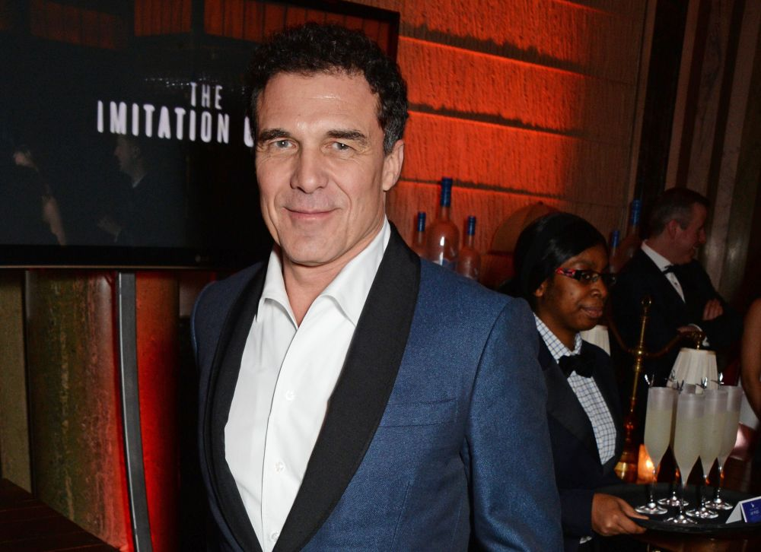

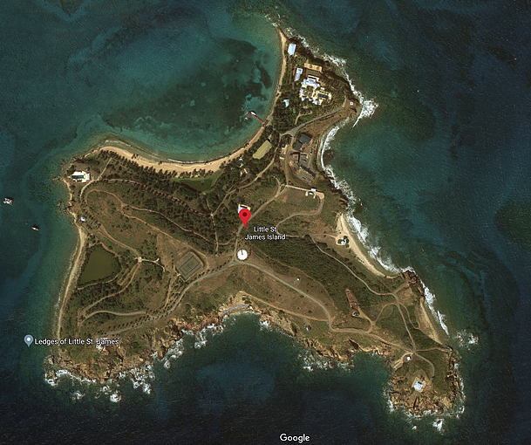

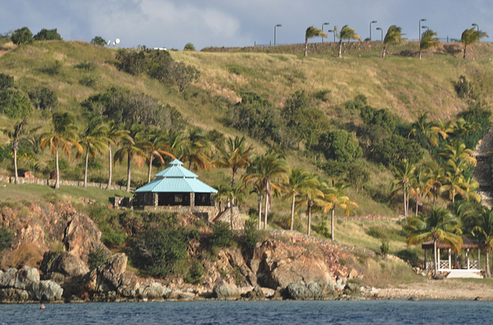

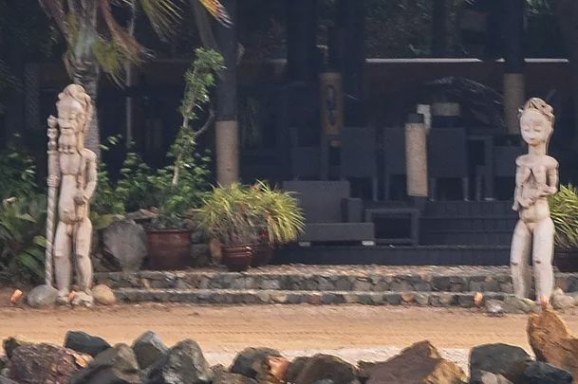

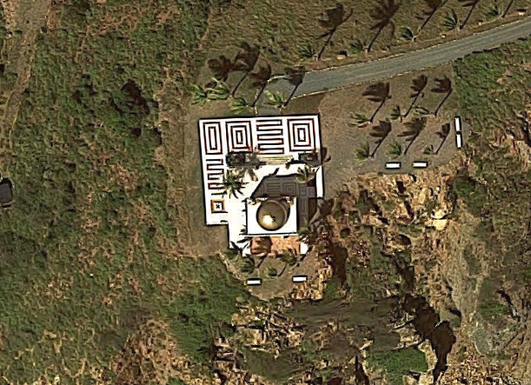



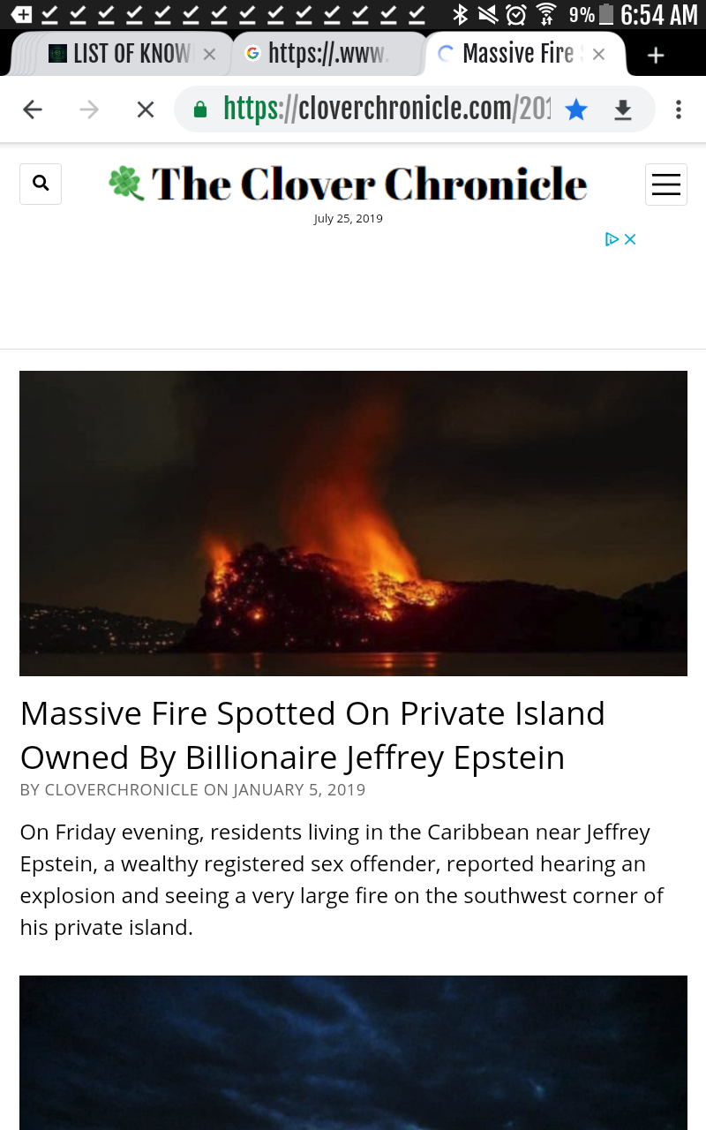

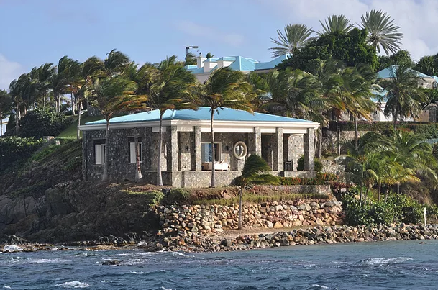

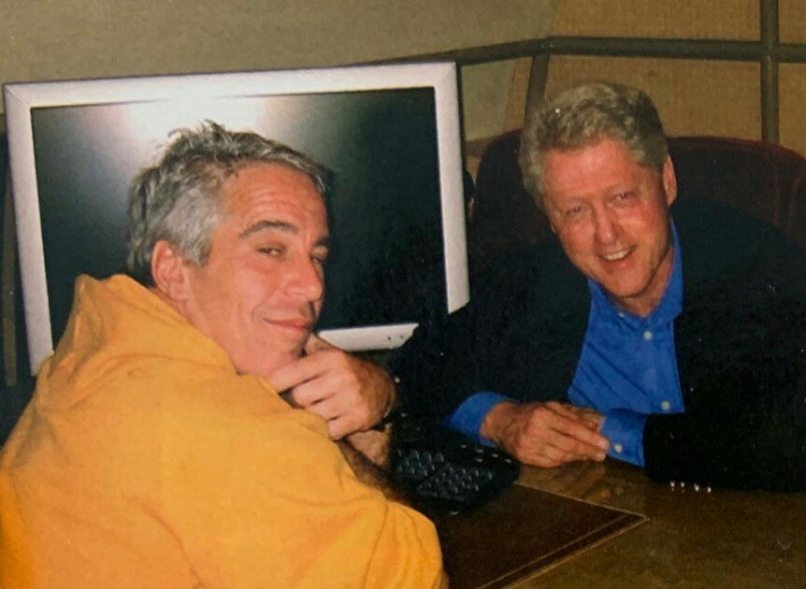

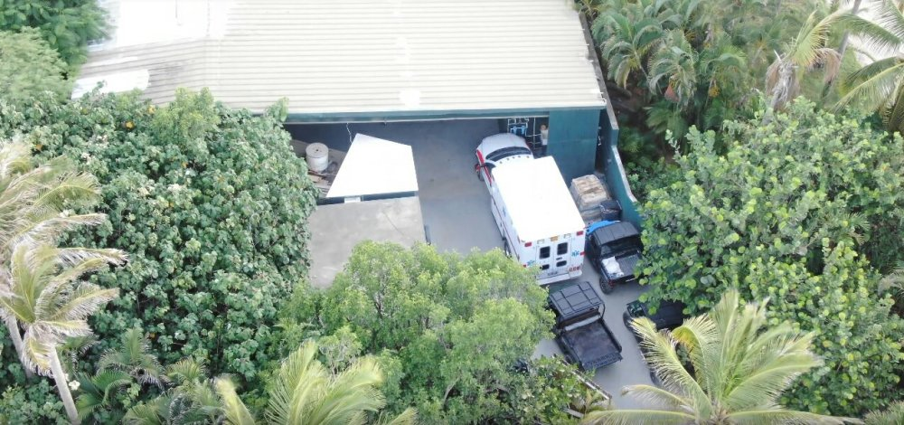

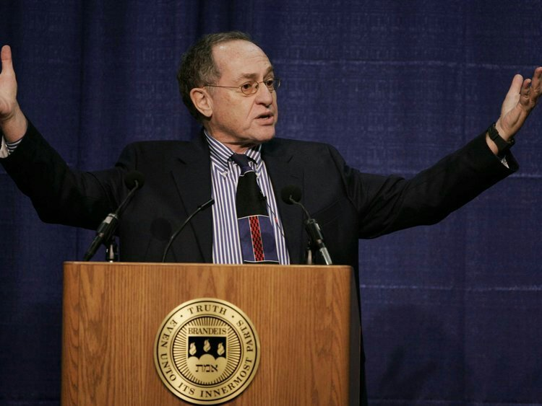

**Share this Article:**

* [Share](https://exposingpedovore.wordpress.com/2019/07/24/list-of-known-names-connected-to-satanic-cults-pedophilia-child-trafficking-in-america/)