**Reginald Scot or Scott 1538-1599**

**http://en.wikipedia.org/wiki/Reginald_Scot**

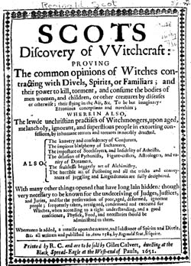 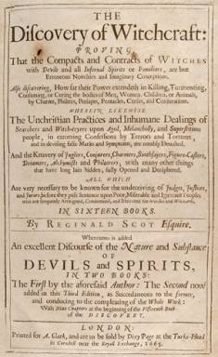

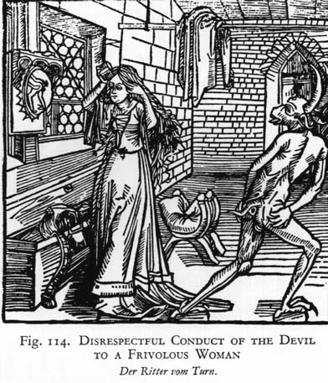 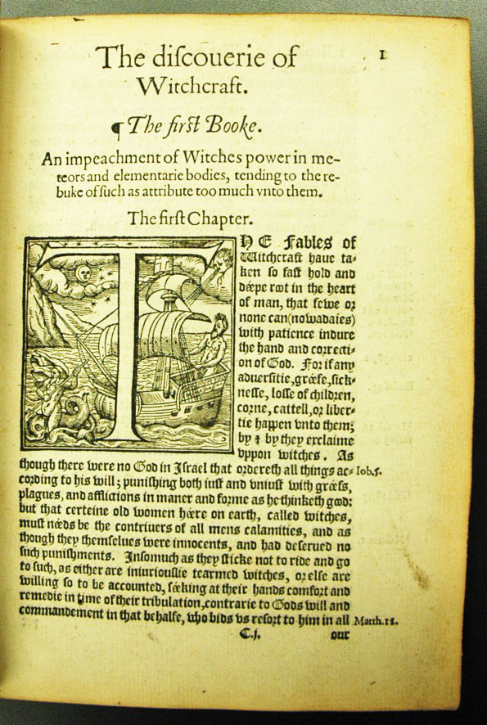

**Reginald Scot** (or **Scott**) (c. 1538 – October 9, 1599) was an English country gentleman and Member of Parliament, now remembered as the author of [*The Discoverie of Witchcraft*](http://en.wikipedia.org/wiki/The_Discoverie_of_Witchcraft), which was published in 1584. It was written against the belief in witches, to show that [witchcraft](http://en.wikipedia.org/wiki/Witchcraft) did not exist. Part of its content exposes how (apparently miraculous) feats of magic were done, and the book is often deemed the first textbook on [conjuring](http://en.wikipedia.org/wiki/Magic_%28illusion%29).

|  |
| --- |
| **Contents**  [[hide](javascript:toggleToc())]   * [1 Life](http://en.wikipedia.org/wiki/Reginald_Scot#Life) * [2 Works](http://en.wikipedia.org/wiki/Reginald_Scot#Works) * [3 Bibliography](http://en.wikipedia.org/wiki/Reginald_Scot#Bibliography) * [4 External links](http://en.wikipedia.org/wiki/Reginald_Scot#External_links) |

**Life**

He was son of Richard Scot, second son of Sir John Scot (died 1533) of Scots Hall in [Smeeth](http://en.wikipedia.org/wiki/Smeeth), [Kent](http://en.wikipedia.org/wiki/Kent). His mother was Mary, daughter of George Whetenall, sheriff of Kent in 1527. The father died before 1544, and his widow remarried Fulk Onslow, clerk of the parliament; dying on 8 October 1582, she was buried in the church of [Hatfield, Hertfordshire](http://en.wikipedia.org/wiki/Hatfield,_Hertfordshire). Reginald or Reynold (as he signed his name in accordance with contemporary practice) was born about 1538.

When about seventeen, Scot entered [Hart Hall, Oxford](http://en.wikipedia.org/wiki/Hart_Hall,_Oxford), but left the university without a degree. His writings show some knowledge of law, but he is not known to have joined any [inn of court](http://en.wikipedia.org/wiki/Inn_of_court). Marrying in 1568, he seems to have spent the rest of his life in his native county. His time was mainly passed as an active country gentleman, managing property which he inherited from his kinsfolk about Smeeth and [Brabourne](http://en.wikipedia.org/wiki/Brabourne), or directing the business affairs of his first cousin, Sir Thomas Scot, who proved a generous patron, and in whose house of Scots Hall he often stayed. He was collector of subsidies for the lathe of Shepway in 1586 and 1587, and he was perhaps the Reginald Scot who acted in 1588 as a captain of untrained foot-soldiers at the county muster. He was returned to the parliament of 1588–9 as member for [New Romney](http://en.wikipedia.org/wiki/New_Romney_%28UK_Parliament_constituency%29), and he was probably a [justice of the peace](http://en.wikipedia.org/wiki/Justice_of_the_peace). He describes himself as ‘esquire’ in the title-page of his ‘Discoverie,’ and is elsewhere designated ‘armiger.’

He made his own will (drawing it with his own hand) on 15 September 1599. He died at Smeeth on 9 October following, and was probably buried in the church there. He married at Brabourne, on 11 October 1568, Jane Cobbe of Cobbes Place, in the parish of [Aldington](http://en.wikipedia.org/wiki/Aldington). By her he had a daughter Elizabeth, who married Sackville Turnor of [Tablehurt](http://en.wikipedia.org/w/index.php?title=Tablehurt&action=edit&redlink=1), [Sussex](http://en.wikipedia.org/wiki/Sussex). Subsequently Scot married a second wife, a widow named Alice Collyar, who had a daughter Mary by her former husband. His small properties about Brabourne, Aldington, and Romney Marsh he left to his widow. The last words of his will run: ‘Great is the trouble my poor wife hath had with me, and small is the comfort she hath received at my hands, whom if I had not matched withal I had not died worth one groat.’

**Works**

For more details on this topic, see [Discoverie of Witchcraft](http://en.wikipedia.org/wiki/Discoverie_of_Witchcraft).

In 1574 he published his *Perfect Platform of a Hop-garden, and necessary instructions for the making and maintenance thereof, with Notes and Rules for Reformation of all Abuses.* The work, which is dedicated to Serjeant William Lovelace of Bethersden, is the first practical treatise on [hop](http://en.wikipedia.org/wiki/Hops) culture in England; the processes are illustrated by woodcuts. Scot, according to a statement of the printer, was out of London while the work was going through the press. A second edition appeared in 1576, and a third in 1578.

His work on witchcraft was *The Discouerie of Witchcraft, wherein the Lewde dealing of Witches and Witchmongers is notablie detected, in sixteen books … whereunto is added a Treatise upon the Nature and Substance of Spirits and Devils*, 1584. Scot enumerates 212 authors whose works in Latin he had consulted, and twenty-three authors who wrote in English. He studied the superstitions respecting witchcraft in courts of law in country districts, where the prosecution of witches was constant, and in village life, where the belief in witchcraft flourished. He set himself to prove that the belief in witchcraft and magic was rejected alike by reason and religion, and that spiritualistic manifestations were either wilful impostures or illusions due to mental disturbance in the observers.

**Bibliography**

* Haight, Anne Lyon (1978). *Banned Books, 387 B.C. to 1978 A.D.*. updated and enl. by Chandler B. Grannis (4th ed. ed.). New York: R.R. Bowker. [ISBN](http://en.wikipedia.org/wiki/International_Standard_Book_Number) [0-8352-1078-2](http://en.wikipedia.org/wiki/Special:BookSources/0-8352-1078-2).

**External links**

* [Excerpts from books I and XV of *The Discovery of Witchcraft* from history.hanover.edu](http://history.hanover.edu/courses/excerpts/260scot.html)
* [Full text of book XV from the Esoteric Archives](http://www.esotericarchives.com/solomon/scot16.htm)

Attribution

*This article incorporates text from the entry* [***Scott, Reginald***](http://en.wikisource.org/wiki/Scott,_Reginald_%28DNB00%29) *in the* [Dictionary of National Biography](http://en.wikipedia.org/wiki/Dictionary_of_National_Biography) *(1885–1900), a publication now in the* [*public domain*](http://en.wikipedia.org/wiki/Public_domain)*.*

=============================================================================================================================================