**Harry Houdini (Ehrich Weiss) 1874-1926**

http://en.wikipedia.org/wiki/Harry_Houdini

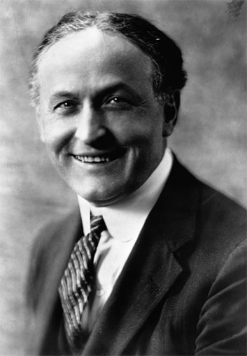 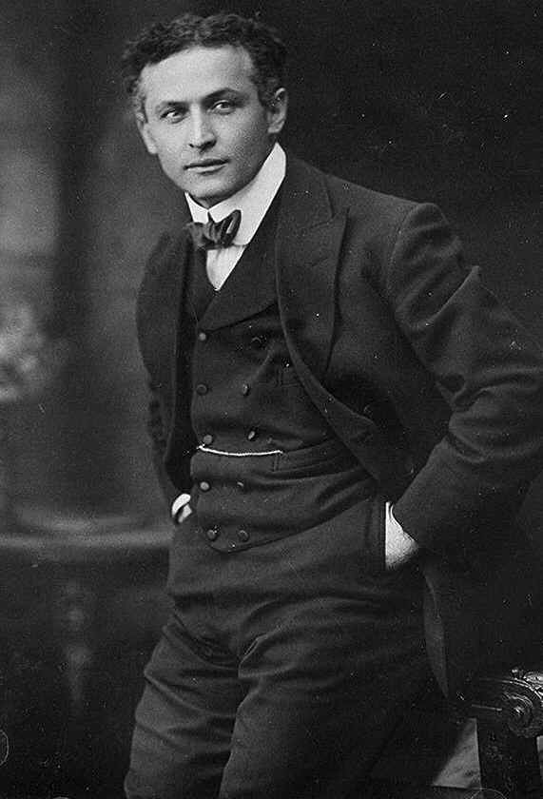 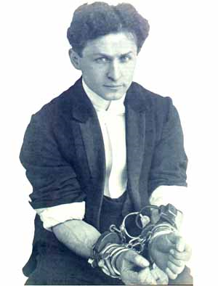 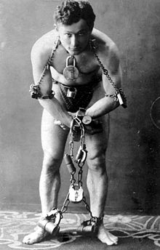

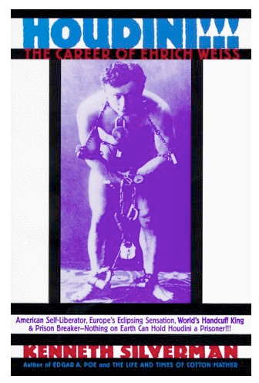 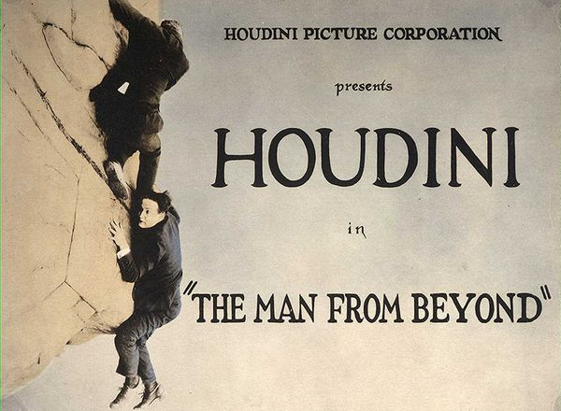

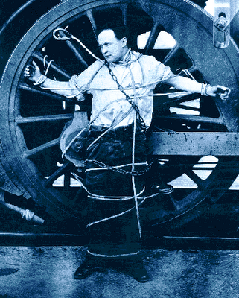 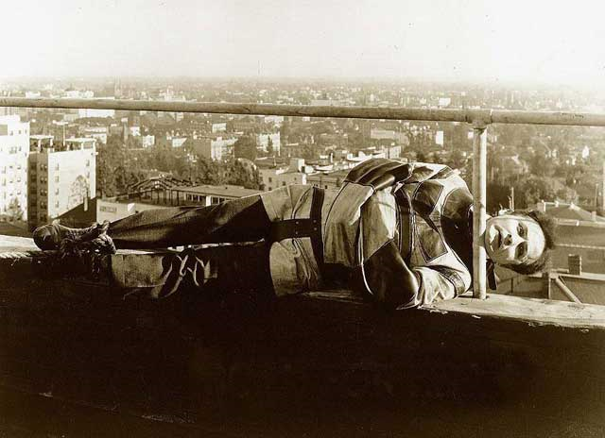

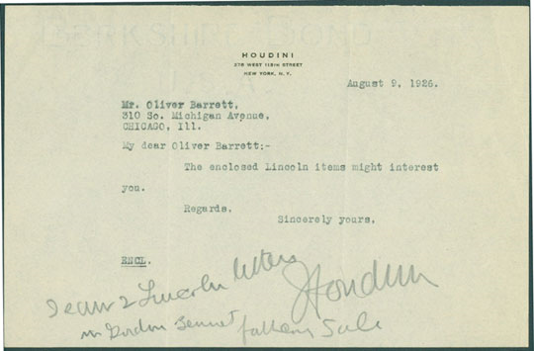

**Harry Houdini** (March 24, 1874 - October 31, 1926) was an Hungarian-American [magician](http://en.wikipedia.org/wiki/Magic_%28illusion%29) and [escapologist](http://en.wikipedia.org/wiki/Escapologist), [stunt performer](http://en.wikipedia.org/wiki/Stunt_performer), actor and [film producer](http://en.wikipedia.org/wiki/Film_producer). He was also a [skeptic](http://en.wikipedia.org/wiki/Skepticism) who set out to expose frauds purporting to be [supernatural](http://en.wikipedia.org/wiki/Supernatural) phenomena.

|  |
| --- |
| **Contents**  [[hide](javascript:toggleToc())]   * [1 Early life](http://en.wikipedia.org/wiki/Harry_Houdini#Early_life) * [2 Magic career](http://en.wikipedia.org/wiki/Harry_Houdini#Magic_career)   + [2.1 Notable escapes](http://en.wikipedia.org/wiki/Harry_Houdini#Notable_escapes)     - [2.1.1 The Mirror Handcuff Challenge](http://en.wikipedia.org/wiki/Harry_Houdini#The_Mirror_Handcuff_Challenge)     - [2.1.2 The Milk Can](http://en.wikipedia.org/wiki/Harry_Houdini#The_Milk_Can)     - [2.1.3 The Chinese Water Torture Cell](http://en.wikipedia.org/wiki/Harry_Houdini#The_Chinese_Water_Torture_Cell)     - [2.1.4 Suspended straitjacket escape](http://en.wikipedia.org/wiki/Harry_Houdini#Suspended_straitjacket_escape)     - [2.1.5 Overboard Box Escape](http://en.wikipedia.org/wiki/Harry_Houdini#Overboard_Box_Escape)     - [2.1.6 Buried Alive](http://en.wikipedia.org/wiki/Harry_Houdini#Buried_Alive) * [3 Movie career](http://en.wikipedia.org/wiki/Harry_Houdini#Movie_career) * [4 Pioneer aviator](http://en.wikipedia.org/wiki/Harry_Houdini#Pioneer_aviator) * [5 Debunking spiritualists](http://en.wikipedia.org/wiki/Harry_Houdini#Debunking_spiritualists)   + [5.1 Yearly séances](http://en.wikipedia.org/wiki/Harry_Houdini#Yearly_s.C3.A9ances) * [6 Appearance and voice](http://en.wikipedia.org/wiki/Harry_Houdini#Appearance_and_voice) * [7 Artifacts](http://en.wikipedia.org/wiki/Harry_Houdini#Artifacts) * [8 Death](http://en.wikipedia.org/wiki/Harry_Houdini#Death)   + [8.1 Funeral](http://en.wikipedia.org/wiki/Harry_Houdini#Funeral) * [9 Proposed exhumation](http://en.wikipedia.org/wiki/Harry_Houdini#Proposed_exhumation) * [10 Legacy](http://en.wikipedia.org/wiki/Harry_Houdini#Legacy) * [11 Publications](http://en.wikipedia.org/wiki/Harry_Houdini#Publications) * [12 Films](http://en.wikipedia.org/wiki/Harry_Houdini#Films) * [13 See also](http://en.wikipedia.org/wiki/Harry_Houdini#See_also) * [14 References](http://en.wikipedia.org/wiki/Harry_Houdini#References)   + [14.1 Notes](http://en.wikipedia.org/wiki/Harry_Houdini#Notes)   + [14.2 Biographies](http://en.wikipedia.org/wiki/Harry_Houdini#Biographies)   + [14.3 Further reading](http://en.wikipedia.org/wiki/Harry_Houdini#Further_reading) * [15 External links](http://en.wikipedia.org/wiki/Harry_Houdini#External_links) |

**Early life**

Harry Houdini was born in Budapest, Hungary, to a Jewish family, his birth name was Erich Weiss.[[1]](http://en.wikipedia.org/wiki/Harry_Houdini#cite_note-0) A copy of his [birth certificate](http://en.wikipedia.org/wiki/Birth_certificate) was found and published in *The Houdini Birth Research Committee's Report.* (1973). As to his birth date, from 1907 onwards, Houdini claimed in interviews to have been born in [Appleton, Wisconsin](http://en.wikipedia.org/wiki/Appleton,_Wisconsin), on April 6 1874.

Houdini's father was [Rabbi](http://en.wikipedia.org/wiki/Rabbi) Mayer (Mayo) Samuel Weisz (1829–1892), and his mother was Cecilia Steiner (1841–1913). Houdini had 7 siblings: Herman M. (1863–1885); Nathan J. (1870–1927); Gottfried William (1872–1925); [Theodore "Theo"](http://en.wikipedia.org/wiki/Theodore_Hardeen) (1876–1945);[[2]](http://en.wikipedia.org/wiki/Harry_Houdini#cite_note-1) Leopold D. (1879–1962); and Gladys Carrie (1882-?)

He immigrated with his family to the United States on July 3, 1878, from [Hungary](http://en.wikipedia.org/wiki/Hungary) at the age of four, on the SS *Fresia* with his mother (who was pregnant) and his four brothers. Houdini's name was listed as Ehrich Weiss.[[3]](http://en.wikipedia.org/wiki/Harry_Houdini#cite_note-2) Friends called him "Ehrie" or "Harry." In 1918 he registered for selective service as Harry Handcuff Houdini.[[4]](http://en.wikipedia.org/wiki/Harry_Houdini#cite_note-3)

At first, they lived in Appleton, [Wisconsin](http://en.wikipedia.org/wiki/Wisconsin), where his father served as Rabbi of the Zion Reform Jewish Congregation. In 1880, the family was living on Appleton Street.[[5]](http://en.wikipedia.org/wiki/Harry_Houdini#cite_note-4) On June 6, 1882, Rabbi Weiss became an American citizen. After losing his tenure, he moved to New York City with Ehrich in 1887. They lived in a boarding house on East 79th Street. Rabbi Weiss later was joined by the rest of the family once he found more permanent housing. As a child, Ehrich took several jobs, then became a champion [cross country](http://en.wikipedia.org/wiki/Cross_country_running) runner. He made his public début as a 9-year-old trapeze artist, calling himself "Ehrich, the prince of the air". Weiss became a professional [magician](http://en.wikipedia.org/wiki/Magic_%28illusion%29) and began calling himself "Harry Houdini" because he was heavily influenced by the French magician [Jean Eugène Robert-Houdin](http://en.wikipedia.org/wiki/Jean_Eug%C3%A8ne_Robert-Houdin), and his friend Jack Hayman erroneously told him that in French, adding an "i" to Houdin would mean "like Houdin" the great magician. In later life, Houdini would claim that the first part of his new name, Harry, was a homage to [Harry Kellar](http://en.wikipedia.org/wiki/Harry_Kellar), whom Houdini admired a great deal.

**Magic career**

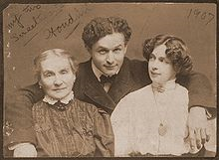

"My Two Sweethearts" - Houdini with his mother and wife, ca. 1907

Initially, Houdini's magic career resulted in little success. He performed in dime museums and sideshows, and even doubled as "the Wild Man" at a circus. Houdini initially focused on traditional card tricks. At one point, he billed himself as the "King of Cards". But he soon began experimenting with [escape acts](http://en.wikipedia.org/wiki/Escapology). In 1893, while performing with his brother "[Dash](http://en.wikipedia.org/wiki/Theodore_Hardeen)" at [Coney Island](http://en.wikipedia.org/wiki/Coney_Island) as "The Houdini Brothers", Harry met fellow performer [Wilhelmina Beatrice (Bess) Rahner](http://en.wikipedia.org/wiki/Bess_Houdini), whom he married. Bess replaced Dash in the act, which became known as "The Houdinis." For the rest of Houdini's performing career, Bess would work as his stage assistant.

Harry Houdini's "big break" came in 1899 when he met manager [Martin Beck](http://en.wikipedia.org/wiki/Martin_Beck_%28vaudeville%29) in rural [Woodstock, Illinois](http://en.wikipedia.org/wiki/Woodstock,_Illinois). Impressed by Houdini's [handcuffs](http://en.wikipedia.org/wiki/Handcuffs) act, Beck advised him to concentrate on escape acts and booked him on the Orpheum [vaudeville](http://en.wikipedia.org/wiki/Vaudeville) circuit. Within months, he was performing at the top vaudeville houses in the country. In 1900, Beck arranged for Houdini to tour Europe.

Houdini became widely known as "The Handcuff King." He toured England, Scotland, the Netherlands, Germany, France, and Russia. In each city, Houdini would challenge local police to restrain him with [shackles](http://en.wikipedia.org/wiki/Shackles) and lock him in their jails. In many of these challenge escapes, Houdini would first be [stripped nude and searched](http://en.wikipedia.org/wiki/Strip_search). In Moscow, Houdini escaped from a [Siberian prison](http://en.wikipedia.org/wiki/Siberia#Katorga_and_Gulag) transport van. Houdini publicly stated that, had he been unable to free himself, he would have had to travel to Siberia, where the only key was kept. In [Cologne](http://en.wikipedia.org/wiki/Cologne), he sued a police officer, Werner Graff, who claimed he made his escapes via bribery.[[6]](http://en.wikipedia.org/wiki/Harry_Houdini#cite_note-5) Houdini won the case when he opened the judge's safe (he would later say the judge had forgotten to lock it). With his new-found wealth and success, Houdini purchased a dress said to have been made for [Queen Victoria](http://en.wikipedia.org/wiki/Queen_Victoria). He then arranged a grand reception where he presented his mother in the dress to all their relatives. Houdini said it was the happiest day of his life. In 1904, Houdini returned to the U.S. and purchased a house for $25,000, a [brownstone](http://en.wikipedia.org/wiki/Brownstone) at 278 W. 113th Street in [Harlem](http://en.wikipedia.org/wiki/Harlem), New York.[[7]](http://en.wikipedia.org/wiki/Harry_Houdini#cite_note-6) The house still stands today.

From 1907 and throughout the 1910s, Houdini performed with great success in the United States. He would free himself from jails, handcuffs, chains, ropes, and [straitjackets](http://en.wikipedia.org/wiki/Straitjacket), often while hanging from a rope in plain sight of street audiences. Because of imitators and a dwindling audience, on January 25, 1908, Houdini put his "handcuff act" behind him and began escaping from a locked, water-filled milk can. The possibility of failure and death thrilled his audiences. Houdini also expanded his challenge escape act — in which he invited the public to devise contraptions to hold him — to include nailed packing crates (sometimes lowered into the water), riveted boilers, wet-sheets, mailbags, and even the belly of a [Whale](http://en.wikipedia.org/wiki/Whale#whalesinculture) that washed ashore in Boston. Brewers challenged Houdini to escape from his milk can after they filled it with beer.[[8]](http://en.wikipedia.org/wiki/Harry_Houdini#cite_note-7) Many of these challenges were prearranged with local merchants in what is certainly one of the first uses of mass tie-in marketing. Rather than promote the idea that he was assisted by spirits, as did the [Davenport Brothers](http://en.wikipedia.org/wiki/Davenport_Brothers) and others, Houdini's advertisements showed him making his escapes via [dematerializing](http://en.wikipedia.org/wiki/Teleportation),[[9]](http://en.wikipedia.org/wiki/Harry_Houdini#cite_note-8) although Houdini himself never claimed to have supernatural powers.

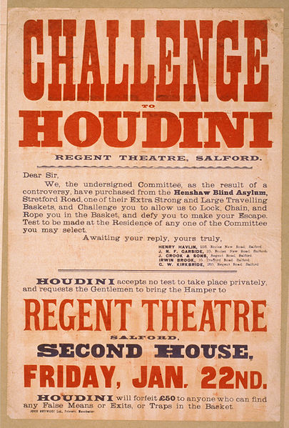

Poster promoting Houdini taking up the challenge of escaping an "extra strong and large traveling basket"

In 1912, Houdini introduced perhaps his most famous act, the [Chinese Water Torture Cell](http://en.wikipedia.org/wiki/Chinese_Water_Torture_Cell), in which he was suspended upside-down in a locked glass-and-steel cabinet full to overflowing with water. The act required that Houdini hold his breath for more than three minutes. Houdini performed the escape for the rest of his career. Despite two Hollywood movies depicting Houdini dying in the Torture Cell, the escape had nothing to do with his demise.

Houdini explained some of his tricks in books written for the magic brotherhood throughout his career. In *Handcuff Secrets* (1909), he revealed how many locks and handcuffs could be opened with properly applied force, others with shoestrings. Other times, he carried concealed [lockpicks](http://en.wikipedia.org/wiki/Lock_picking) or keys, being able to [regurgitate](http://en.wikipedia.org/wiki/Professional_regurgitator) small keys at will. When tied down in ropes or [straitjackets](http://en.wikipedia.org/wiki/Straitjacket), he gained wiggle room by enlarging his shoulders and chest, moving his arms slightly away from his [body](http://en.wikipedia.org/wiki/Body), and then dislocating his shoulders. His straitjacket escape was originally performed behind curtains, with him popping out free at the end. However, Houdini's brother, who was also an escape artist billing himself as [Theodore Hardeen](http://en.wikipedia.org/wiki/Theodore_Hardeen), after being accused of having someone sneak in and let him out and being challenged to escape without the curtain, discovered that audiences were more impressed and entertained when the curtains were eliminated so they could watch him struggle to get out. They both performed straitjacket escapes dangling upside-down from the roof of a building for publicity on more than one occasion. It is said that Hardeen once handed out bills for his show while Houdini was doing his suspended straitjacket escape. This enraged Houdini as people thought it was Hardeen in suspension and not himself.

For the majority of his career, Houdini performed his act as a headliner in [vaudeville](http://en.wikipedia.org/wiki/Vaudeville). For many years, he was the highest-paid performer in American vaudeville. One of Houdini's most notable non-escape stage illusions was performed at New York's Hippodrome Theater when he vanished a full-grown elephant (with its trainer) from a stage, beneath which was a swimming pool. In 1923, Houdini became president of [Martinka](http://en.wikipedia.org/wiki/Martinka) & Co., America's oldest magic company. The business is still in operation today. He also served as President of the Society of American Magicians (aka S.A.M.) from 1917 until his death in 1926. In the final years of his life (1925/26), Houdini launched his own full-evening show, which he billed as "3 Shows in One: Magic, Escapes, and Fraud Mediums Exposed."

### [[edit](http://en.wikipedia.org/w/index.php?title=Harry_Houdini&action=edit&section=3)] Notable escapes

#### [[edit](http://en.wikipedia.org/w/index.php?title=Harry_Houdini&action=edit&section=4)] The Mirror Handcuff Challenge

In 1904, the [London](http://en.wikipedia.org/wiki/London) [*Daily Mirror*](http://en.wikipedia.org/wiki/Daily_Mirror) newspaper challenged Houdini to escape from a special handcuff that it claimed had taken Nathaniel Hart, a locksmith from [Birmingham](http://en.wikipedia.org/wiki/Birmingham), seven years to make. Houdini accepted the challenge for March 17 during a matinée performance at London's Hippodrome theater. It was reported that 4000 people and more than 100 journalists turned out for the much-hyped event. The escape attempt dragged on for over an hour, during which Houdini emerged from his "ghost house" (a small screen used to conceal the method of his escape) several times. On one occasion, he asked if the cuff could be removed so he could take off his coat. The *Mirror* representative, Frank Parker, refused, saying Houdini could gain an advantage if he saw how the cuff was unlocked. Houdini promptly took out a pen-knife and, holding the knife in his teeth, used it to cut his coat from his body. Some 56 minutes later, Houdini's wife appeared on stage and gave him a kiss. It is believed that in her mouth was the key to unlock the special handcuff. Houdini then went back behind the curtain. After an hour and ten minutes, Houdini emerged free. As he was paraded on the shoulders of the cheering crowd, he broke down and wept. Houdini later said it was the most difficult escape of his career.[[10]](http://en.wikipedia.org/wiki/Harry_Houdini#cite_note-9)

After Houdini's death, his friend, Martin Beck , published in his book, *Sensational Tales of Mystery Men*, that Houdini was bested that day and appealed to his wife, Bess, for help. Goldstone goes on to claim that Bess begged the key from the *Mirror* representative, then slipped it to Houdini in a glass of water. However, it was stated in the book "The Secret Life of Houdini" that the key required to open the specially designed Mirror handcuffs was 6" long, and so could not be smuggled to Houdini via a glass or his wife's mouth.

Goldstone offered no proof of his account, and many modern biographers have found evidence (notably in the custom design of the handcuff itself) that the entire *Mirror* challenge was pre-arranged by Houdini and the newspaper, and that his long struggle to escape was pure showmanship.[[11]](http://en.wikipedia.org/wiki/Harry_Houdini#cite_note-10) In support of this, it has been reported that the sterling silver replica of the Mirror cuffs presented to Houdini in honor of his escape was actually made the year before the escape actually took place (again from "The Secret Life of Houdini").

#### [[edit](http://en.wikipedia.org/w/index.php?title=Harry_Houdini&action=edit&section=5)] The Milk Can

In 1901, Houdini introduced his own original invention, the Milk Can escape.[[12]](http://en.wikipedia.org/wiki/Harry_Houdini#cite_note-11) In this effect, Houdini would be handcuffed and sealed inside an over-sized milk can filled with water and make his escape behind a curtain. As part of the effect, Houdini would invite members of the audience to hold their breath along with him while he was inside the can. Advertised with dramatic posters that proclaimed "Failure Means A Drowning Death", the escape proved to be a sensation.[[13]](http://en.wikipedia.org/wiki/Harry_Houdini#cite_note-12) Houdini soon modified the escape to include the Milk Can being locked inside a wooden chest, being chained or padlocked, and even inside another Milk can. Houdini only performed the Milk Can escape as a regular part of his act for four years, but it remains one of the effects most associated with the escape artist. Houdini's brother, Theodore Hardeen, continued to perform the Milk Can (and the wooden chest variation)[[14]](http://en.wikipedia.org/wiki/Harry_Houdini#cite_note-13) into the 1940s.

#### [[edit](http://en.wikipedia.org/w/index.php?title=Harry_Houdini&action=edit&section=6)] The Chinese Water Torture Cell

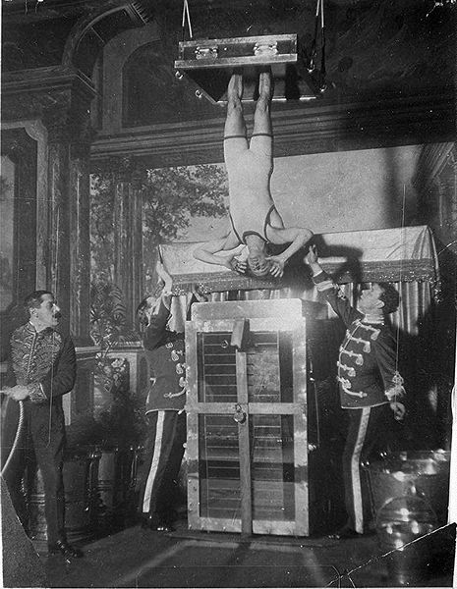

Houdini performing the Chinese Water Torture Cell

In 1912, the vast number of imitators prompted Houdini to replace his Milk Can act with the [Chinese Water Torture Cell](http://en.wikipedia.org/wiki/Chinese_Water_Torture_Cell). In this escape, Houdini's feet would be locked in stocks, and he would be lowered upside down into a tank filled with water. The mahogany and metal cell featured a glass front, through which audiences could clearly see Houdini. The stocks would be locked to the top of the cell, and a curtain would conceal his escape. In the earliest version of the Torture Cell, a metal cage was lowered into the cell, and Houdini was enclosed inside that. While making the escape more difficult (the cage prevented Houdini from turning), the cage bars also offered protection should the front glass break.

The original cell was built in England, where Houdini first performed the escape for an audience of one person as part of a one-act play he called "Houdini Upside Down". This was so he could copyright the effect and have grounds to sue imitators (which he did). While the escape was advertised as "The Chinese Water Torture Cell" or "The Water Torture Cell", Houdini always referred to it as "the Upside Down" or "USD". The first public performance of the USD was at the Circus Busch in Berlin, on September 21, 1912. Houdini continued to perform the escape until his death in 1926. Despite two Hollywood movies depicting Houdini dying in the Torture Cell, the escape had nothing to do with his demise.

#### [[edit](http://en.wikipedia.org/w/index.php?title=Harry_Houdini&action=edit&section=7)] Suspended straitjacket escape

One of Houdini's most popular publicity stunts was to have himself strapped into a regulation straitjacket and suspended by his ankles from a tall building or crane. Houdini would then make his escape in full view of the assembled crowd. In many cases, Houdini would draw thousands of onlookers who would choke the street and bring city traffic to a halt. Houdini would sometimes ensure press coverage by performing the escape from the office building of a local newspaper. In New York City, Houdini performed the suspended straitjacket escape from a crane being used to build the New York subway. After flinging his body in the air, Houdini escaped from the straitjacket. Starting from when he was hoisted up in the air by the crane, to when the straitjacket was completely off, it took Houdini two minutes and thirty-seven seconds. There is film footage of Houdini performing the escape in The Library of Congress. After being battered against a building in high winds during one escape, Houdini performed the escape with a visible safety wire on his ankle so that he could be pulled away from the building if necessary.

#### [[edit](http://en.wikipedia.org/w/index.php?title=Harry_Houdini&action=edit&section=8)] Overboard Box Escape

Another one of Houdini's most famous publicity stunts(Dalton) was to escape from a nailed and roped packing crate after it had been lowered into the water. Houdini first performed the escape in New York's East River on July 7, 1912. Police forbade him from using one of the piers, so Houdini hired a tugboat and invited press on board. Houdini was locked in handcuffs and leg-irons, then nailed into the crate which was roped and weighed down with two hundred pounds of lead. The crate was then lowered into water. Houdini escaped in fifty-seven seconds. The crate was pulled to the surface and found to still be intact with the manacles inside. Houdini would perform this escape many times, and even performed a version on stage, first at Hamerstein's Roof Garden (where a 5,500-gallon tank was specially built), and later at the New York Hippodrome.[[15]](http://en.wikipedia.org/wiki/Harry_Houdini#cite_note-14)

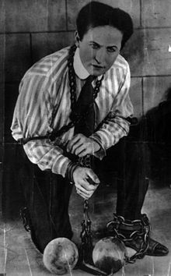

Houdini

#### Buried Alive

Throughout his career, Houdini performed three variations on a "[Buried Alive](http://en.wikipedia.org/wiki/Premature_burial)" stunt/escape. The first was near Santa Ana, California in 1917, and it almost cost Houdini his life. Houdini was buried, without a casket, in a pit of earth six feet deep. He became exhausted and panicky trying to dig his way to the surface and called for help. When his hand finally broke the surface, he fell unconscious and had to be pulled from the grave by his assistants. Houdini wrote in his diary that the escape was "very dangerous" and that "the weight of the earth is killing."[[16]](http://en.wikipedia.org/wiki/Harry_Houdini#cite_note-15)

Houdini's second variation on Buried Alive was an endurance test designed to expose mystical Egyptian performer, Rahman Bey, who claimed to use supernatural powers to remain in a sealed casket for an hour. Houdini bettered Bey on August 5, 1926, by remaining in a sealed casket submerged in the swimming pool of New York's Hotel Shelton for one hour and a half. Houdini claimed he did not use any trickery or supernatural powers to accomplish this feat, just controlled breathing.[[17]](http://en.wikipedia.org/wiki/Harry_Houdini#cite_note-16) Houdini repeated the feat at the YMCA in Worcester MA on September 28, 1926, this time remaining sealed for one hour and eleven minutes.[[18]](http://en.wikipedia.org/wiki/Harry_Houdini#cite_note-17)

Houdini's final Buried Alive was an elaborate stage escape that was to feature in his full evening show. The stunt would see Houdini escape after being strapped in a strait-jacket, sealed in a casket, and then buried in a large tank filled with sand. While there are posters advertising the escape (playing off the Bey challenge they boasted "Egyptian Fakirs Outdone!"), it is unclear whether Houdini ever performed Buried Alive on stage. The stunt was to be the feature escape of his 1927 season, but Houdini died in October 1926. The bronze casket Houdini created for Buried Alive was used to transport Houdini's body from Detroit back to New York following his death on [Halloween](http://en.wikipedia.org/wiki/Halloween).[[19]](http://en.wikipedia.org/wiki/Harry_Houdini#cite_note-18)

## [[edit](http://en.wikipedia.org/w/index.php?title=Harry_Houdini&action=edit&section=10)] Movie career

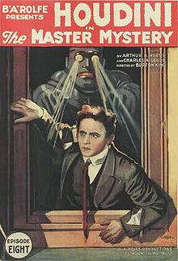

"The Houdini Serial", 1919

In 1906 Houdini started showing films of his outside escapes as part of his vaudeville act. In Boston he presented a short film called *Houdini Defeats Hackenschmidt*. [Georg Hackenschmidt](http://en.wikipedia.org/wiki/Georg_Hackenschmidt) was a famous wrestler of the day, but the nature of their contest is unknown as the film is lost.[[20]](http://en.wikipedia.org/wiki/Harry_Houdini#cite_note-19) In 1909 Houdini made a film in Paris for Cinema Lux titled *Merveilleux Exploits du Célébre Houdini à Paris* (The Adventures of Houdini in Paris).[[21]](http://en.wikipedia.org/wiki/Harry_Houdini#cite_note-20) It featured a loose narrative designed to showcase several of Houdini's famous escapes, including his straitjacket and underwater handcuff escapes. In 1916 he served as special-effects consultant on the Pathé thriller, *The Mysteries of Myra*. That same year he got an offer to star as [Captain Nemo](http://en.wikipedia.org/wiki/Captain_Nemo) in a silent version of [*20,000 Leagues Under the Sea*](http://en.wikipedia.org/wiki/20,000_Leagues_Under_the_Sea), but the project never made it into production.[[22]](http://en.wikipedia.org/wiki/Harry_Houdini#cite_note-21)

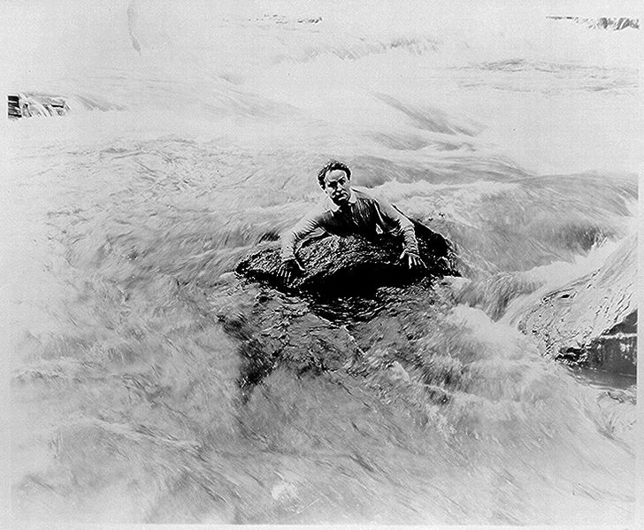

Houdini swims above [Niagara Falls](http://en.wikipedia.org/wiki/Niagara_Falls) in a scene from [*The Man from Beyond*](http://en.wikipedia.org/w/index.php?title=The_man_from_beyond&action=edit&redlink=1) (1922)

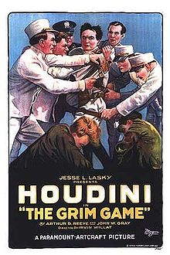

"The Grim Game", 1919

In 1918 Houdini signed a contract with [film producer](http://en.wikipedia.org/wiki/Film_producer) [B.A. Rolfe](http://en.wikipedia.org/wiki/B.A._Rolfe) to star in a 15-part [serial](http://en.wikipedia.org/wiki/Serial_%28film%29), [*The Master Mystery*](http://en.wikipedia.org/w/index.php?title=The_Master_Mystery&action=edit&redlink=1) (released in January 1919). As was common at the time, the film serial was released simultaneously with a novel. Financial difficulties resulted in [B.A. Rolfe Productions](http://en.wikipedia.org/wiki/Rolfe_Photoplays_Inc.) going out of business, but *The Master Mystery* led to Houdini being signed by [Famous Players-Lasky Corporation](http://en.wikipedia.org/wiki/Famous_Players-Lasky_Corporation)/[Paramount Pictures](http://en.wikipedia.org/wiki/Paramount_Pictures), for whom he made two pictures, [*The Grim Game*](http://en.wikipedia.org/wiki/The_Grim_Game) (1919) and *Terror Island* (1920). While filming an aerial stunt for *The Grim Game*, two biplanes collided in mid-air with a stuntman doubling Houdini dangling by a rope from one of the planes. Publicity was geared heavily toward promoting this dramatic "caught on film" moment, claiming it was Houdini himself dangling from the plane. While filming these movies in Los Angeles, Houdini rented a home in [Laurel Canyon](http://en.wikipedia.org/wiki/Laurel_Canyon,_Los_Angeles,_California).

Following his two-picture stint in Hollywood, Houdini returned to New York and started his own film production company called the "Houdini Picture Corporation". He produced and starred in two films, *The Man From Beyond* (1921) and *Haldane of the Secret Service* (1923). He also founded his own film laboratory business called The Film Development Corporation (FDC), gambling on a new process for developing motion picture film. Houdini’s brother, [Theodore Hardeen](http://en.wikipedia.org/wiki/Theodore_Hardeen), left his own career as a magician and escape artist to ran the company. Magician [Harry Kellar](http://en.wikipedia.org/wiki/Harry_Kellar) was a major investor.[[23]](http://en.wikipedia.org/wiki/Harry_Houdini#cite_note-22)

Neither Houdini's acting career nor FDC found success, and he gave up on the movie business in 1923, complaining that "the profits are too meager". But his celebrity was such that, years later, he would be given a star on the [Hollywood Walk of Fame](http://en.wikipedia.org/wiki/Hollywood_Walk_of_Fame) (at 7001 Hollywood Blvd).

As of 2007 only *The Man From Beyond* had been commercially released on DVD. Incomplete versions of *The Master Mystery* and *Terror Island* were released by private collectors on VHS. Complete 35 mm prints of *Haldane of the Secret Service* and *The Grim Game* exist only in private collections. *Haldane of the Secret Service* was screened in Los Angeles in 2007.[[24]](http://en.wikipedia.org/wiki/Harry_Houdini#cite_note-23)

In April 2008 Kino International released a DVD box set of Houdini's surviving silent movies. The set includes *The Master Mystery*, *Terror Island*, *The Man From Beyond*, *Haldane of the Secret Service*, and five minutes from *The Grim Game*. The set also includes newsreel footage of Houdini's escapes from 1907 to 1923, and a section from *Merveilleux Exploits du Célébre Houdini à Paris* (although it is not identified as such).[[25]](http://en.wikipedia.org/wiki/Harry_Houdini#cite_note-24)

## [[edit](http://en.wikipedia.org/w/index.php?title=Harry_Houdini&action=edit&section=11)] Pioneer aviator

In 1909, Houdini became fascinated with aviation. That same year, he purchased a French [Voisin](http://en.wikipedia.org/wiki/A%C3%A9roplanes_Voisin) biplane for $5000 and hired a full-time mechanic, Antonio Brassac. Houdini painted his name in bold [block letters](http://en.wikipedia.org/wiki/Block_letters) on the Voisin's sidepanels and tail. After crashing once, Houdini made his first successful flight on November 26 in Hamburg, Germany.

In 1910, Houdini toured Australia. He brought with him his Voisin biplane and achieved the first powered flight over Australia, on March 18 at [Diggers Rest, Victoria](http://en.wikipedia.org/wiki/Diggers_Rest,_Victoria) (near Melton), just north of [Melbourne](http://en.wikipedia.org/wiki/Melbourne,_Victoria).[[26]](http://en.wikipedia.org/wiki/Harry_Houdini#cite_note-25) [Colin Defries](http://en.wikipedia.org/wiki/Colin_Defries) preceded him, but he crashed the plane on landing.[[27]](http://en.wikipedia.org/wiki/Harry_Houdini#cite_note-26) Houdini proudly claimed to reporters that, while the world may forget about him as a magician and escape artist, it would never forget Houdini the pioneer aviator.

After his Australia tour, Houdini put the Voisin into storage in England. Although he announced he would use it to fly from city to city during his next Music Hall tour, Houdini never flew again.[[28]](http://en.wikipedia.org/wiki/Harry_Houdini#cite_note-27)

A celebration commemorating the centenary of Houdini’s first flight was held at Diggers Rest in 2010. The weekend long event included the dedication of a new monument, a Houdini-Centenary air-show, magic performances, and the display of a one-third scale model of Houdini’s Voisin.[[29]](http://en.wikipedia.org/wiki/Harry_Houdini#cite_note-28)

## [[edit](http://en.wikipedia.org/w/index.php?title=Harry_Houdini&action=edit&section=12)] Debunking spiritualists

## 

## Houdini demonstrates how a photographer could produce fraudulent "spirit photographs" that documented the apparition and social interaction of deceased individuals[[30]](http://en.wikipedia.org/wiki/Harry_Houdini#cite_note-29)

In the 1920s, after the death of his mother, Cecilia, he turned his energies toward debunking self-proclaimed [psychics](http://en.wikipedia.org/wiki/Parapsychology) and [mediums](http://en.wikipedia.org/wiki/Mediumship), a pursuit that would inspire and be followed by later-day conjurers. Houdini's training in magic allowed him to expose frauds who had successfully fooled many scientists and academics. He was a member of a [*Scientific American*](http://en.wikipedia.org/wiki/Scientific_American) committee that offered a cash prize to any medium who could successfully demonstrate [supernatural](http://en.wikipedia.org/wiki/Supernatural) abilities. None was able to do so, and the prize was never collected. The first to be tested was medium George Valentine of Wilkes Barre, Pennsylvania. As his fame as a "ghostbuster" grew, Houdini took to attending [séances](http://en.wikipedia.org/wiki/S%C3%A9ance) in disguise, accompanied by a reporter and police officer. Possibly the most famous medium whom he debunked was the [Boston](http://en.wikipedia.org/wiki/Boston,_Massachusetts) medium [Mina Crandon](http://en.wikipedia.org/wiki/Mina_Crandon), also known as "Margery". Houdini chronicled his debunking exploits in his book, *A Magician Among the Spirits*.

These activities cost Houdini the friendship of [Sir Arthur Conan Doyle](http://en.wikipedia.org/wiki/Arthur_Conan_Doyle), the creator of [Sherlock Holmes](http://en.wikipedia.org/wiki/Sherlock_Holmes). Conan Doyle, a firm believer in [Spiritualism](http://en.wikipedia.org/wiki/Spiritualism_%28religious_movement%29) during his later years, refused to believe any of Houdini's exposés. Conan Doyle came to believe that Houdini was a powerful spiritualist medium, had performed many of his stunts by means of paranormal abilities and was using these abilities to block those of other mediums that he was 'debunking' (see Conan Doyle's *The Edge of The Unknown*, published in 1931, after Houdini's death). This disagreement led to the two men becoming public antagonists.

### [[edit](http://en.wikipedia.org/w/index.php?title=Harry_Houdini&action=edit&section=13)] Yearly séances

Bess Houdini, the magician's widow, held yearly [séances](http://en.wikipedia.org/wiki/Seances) on [Halloween](http://en.wikipedia.org/wiki/Halloween) for ten years after Houdini's death, but Houdini never appeared. In 1936, after a last unsuccessful séance on the roof of the [Knickerbocker Hotel](http://en.wikipedia.org/wiki/Knickerbocker_Hotel_%28Los_Angeles%29), she put out the candle that she had kept burning beside a photograph of Houdini since his death, later saying in 1943 that "ten years is long enough to wait for any man." The tradition of holding a séance for Houdini continues by magicians throughout the world to this day; the Official Houdini Séance is currently organized by [Sidney Hollis Radner](http://en.wikipedia.org/wiki/Sidney_Hollis_Radner), a Houdini aficionado from upstate New York.[[31]](http://en.wikipedia.org/wiki/Harry_Houdini#cite_note-30) Yearly Houdini Séances are also conducted in Chicago at the [Excaliber](http://en.wikipedia.org/wiki/Excalibur_%28nightclub%29) nightclub by "[necromancer](http://en.wikipedia.org/wiki/Necromancer)" [Neil Tobin](http://en.wikipedia.org/wiki/Neil_Tobin) on behalf of the Chicago Assembly of the [Society of American Magicians](http://en.wikipedia.org/wiki/Society_of_American_Magicians)[[32]](http://en.wikipedia.org/wiki/Harry_Houdini#cite_note-31); and at the Houdini Museum in Scranton by magician [Dorothy Dietrich](http://en.wikipedia.org/wiki/Dorothy_Dietrich) who previously held them at New York's famous Magic Towne House with such magical notables as Houdini biographers [Walter B. Gibson](http://en.wikipedia.org/wiki/Walter_B._Gibson) and [Milbourne Christopher](http://en.wikipedia.org/wiki/Milbourne_Christopher). [Walter B. Gibson](http://en.wikipedia.org/wiki/Walter_B._Gibson) was asked by Bess Houdini to carry on the tradition. Before he died Walter passed on the tradition to [Dorothy Dietrich](http://en.wikipedia.org/wiki/Dorothy_Dietrich).

## [[edit](http://en.wikipedia.org/w/index.php?title=Harry_Houdini&action=edit&section=14)] Appearance and voice

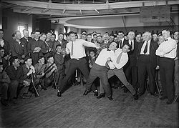

Heavyweight boxer [Jack Dempsey](http://en.wikipedia.org/wiki/Jack_Dempsey) mock punching Houdini (held back by lightweight boxer [Benny Leonard](http://en.wikipedia.org/wiki/Benny_Leonard))

Unlike the image of the classic magician, Houdini was short and stocky and typically appeared on stage in a long frock coat and tie. Most biographers peg his height as 5'5", but descriptions vary. Houdini was also said to be slightly [bow-legged](http://en.wikipedia.org/wiki/Bow-legged), which aided in his ability to gain slack during his rope escapes. In the 1996 biography *Houdini!!!: The Career of Ehrich Weiss*, author [Kenneth Silverman](http://en.wikipedia.org/wiki/Kenneth_Silverman) summarizes how reporters described Houdini's appearance during his early career:

|  |  |  |
| --- | --- | --- |
| **“** | They stressed his smallness – "somewhat undersized" – and angular, vivid features: "He is smooth-shaven with a keen, sharp-chinned, sharp-cheekboned face, bright blue eyes and thick, curly, black hair." Some sensed how much his complexly expressive smile was the outlet of his charismatic stage presence. It communicated to audiences at once warm amiability, pleasure in performing, and, more subtly, imperious self-assurance. Several reporters tried to capture the charming effect, describing him as "happy-looking", "pleasant-faced", "good natured at all times", "the young Hungarian magician with the pleasant smile and easy confidence."[[33]](http://en.wikipedia.org/wiki/Harry_Houdini#cite_note-32) | **”** |

The only known recording of Houdini's voice reveals it to be heavily accented. Houdini made these recordings on Edison [wax cylinders](http://en.wikipedia.org/wiki/Phonograph_cylinder) on October 29, 1914, in [Flatbush, New York](http://en.wikipedia.org/wiki/Flatbush,_New_York). On them, Houdini practices several different introductory speeches for his famous [Chinese Water Torture Cell](http://en.wikipedia.org/wiki/Chinese_Water_Torture_Cell). He also invites his sister, Gladys, to recite a poem. Houdini then recites the same poem in German. The six wax cylinders were discovered in the collection of magician John Mulholland after his death in 1970.[[34]](http://en.wikipedia.org/wiki/Harry_Houdini#cite_note-33) They are currently part of the [David Copperfield](http://en.wikipedia.org/wiki/David_Copperfield_%28illusionist%29) collection.

**[**[**edit**](http://en.wikipedia.org/w/index.php?title=Harry_Houdini&action=edit&section=15)**] Artifacts**

Houdini's brother, [Theodore Hardeen](http://en.wikipedia.org/wiki/Theodore_Hardeen), who returned to performing after Houdini's death, inherited his brother's effects and props. Houdini's will stipulated that all the effects should be "burned and destroyed" upon Hardeen's death. Hardeen sold much of the collection to magician and Houdini enthusiast [Sidney Hollis Radner](http://en.wikipedia.org/wiki/Sidney_Hollis_Radner) during the 1940s, including the Water Torture Cell.[[35]](http://en.wikipedia.org/wiki/Harry_Houdini#cite_note-34) Radner allowed choice pieces of the collection to be displayed at The Houdini Magical Hall of Fame in [Niagara Falls](http://en.wikipedia.org/wiki/Niagara_Falls), Canada. In 1995, a fire destroyed the museum. While the Water Torture Cell was reported to have been destroyed, its metal frame remained, and the cell was restored by illusion builder John Gaughan.[[36]](http://en.wikipedia.org/wiki/Harry_Houdini#cite_note-35) Many of the props contained in the museum such as the Mirror Handcuffs, Houdini's original packing crate, a Milk Can, and a straight-jacket, survived the fire and were auctioned off in 1999 and 2008.

Radner archived the bulk of his collection at the Houdini Museum in Appleton, Wisconsin, but pulled it in 2003 and auctioned it off in Las Vegas on October 30, 2004.[[37]](http://en.wikipedia.org/wiki/Harry_Houdini#cite_note-36)

**[**[**edit**](http://en.wikipedia.org/w/index.php?title=Harry_Houdini&action=edit&section=16)**] Death**

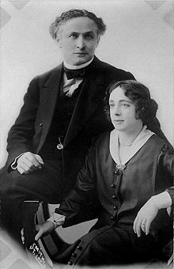

Houdini and his wife Bess

Harry Houdini died of [peritonitis](http://en.wikipedia.org/wiki/Peritonitis), secondary to a [ruptured appendix](http://en.wikipedia.org/wiki/Appendicitis). It has been speculated that Houdini was killed by a [McGill University](http://en.wikipedia.org/wiki/McGill_University) student, J. Gordon Whitehead, who delivered multiple blows to Houdini's abdomen while he was in [Montreal](http://en.wikipedia.org/wiki/Montreal), in order to test Houdini's claim that he was able to take a blow to the body above the waist without injury.

The eyewitnesses were students named Jacques Price and Sam Smilovitz (sometimes called Jack Price and Sam Smiley), whose accounts generally corroborated one another. The following is Price's description of events:

Houdini was reclining on his couch after his performance, having an art student sketch him. When Whitehead came in and asked if it was true that Houdini could take any blow to the stomach, Houdini replied groggily in the affirmative. In this instance, he was hit three times before Houdini could tighten up his stomach muscles to avoid serious injury. Whitehead reportedly continued hitting Houdini several more times and Houdini acted as though he were in some pain.

Houdini stated that if he had time to prepare himself properly he would have been in a better position to take the blows.[[38]](http://en.wikipedia.org/wiki/Harry_Houdini#cite_note-autogenerated3-37)

Houdini had apparently been suffering from appendicitis for several days prior and yet refused medical treatment. His appendix would likely have burst on its own without the trauma.[[39]](http://en.wikipedia.org/wiki/Harry_Houdini#cite_note-38) Although in serious pain, Houdini continued to travel without seeking medical attention.

When Houdini arrived at the Garrick Theater in [Detroit, Michigan](http://en.wikipedia.org/wiki/Detroit,_Michigan) on October 24, 1926, for what would be his last performance, he had a fever of 104°F (40°C). Despite a diagnosis of acute appendicitis, Houdini took the stage. He was reported to have passed out during the show, but was revived and continued. Afterwards, he was hospitalized at Detroit's Grace Hospital.[[40]](http://en.wikipedia.org/wiki/Harry_Houdini#cite_note-39) Houdini died of [peritonitis](http://en.wikipedia.org/wiki/Peritonitis) from a ruptured [appendix](http://en.wikipedia.org/wiki/Vermiform_appendix) at 1:26 p.m. in Room 401 on October 31, at the age of 52.

After taking statements from Price and Smilovitz, Houdini's insurance company concluded that the death was due to the dressing-room incident and paid [double indemnity](http://en.wikipedia.org/wiki/Double_indemnity).[[38]](http://en.wikipedia.org/wiki/Harry_Houdini#cite_note-autogenerated3-37)

### [[edit](http://en.wikipedia.org/w/index.php?title=Harry_Houdini&action=edit&section=17)] Funeral

Houdini's funeral was held on November 4, 1926 in New York, with more than 2,000 mourners in attendance.[[41]](http://en.wikipedia.org/wiki/Harry_Houdini#cite_note-40) He was interred in the [Machpelah Cemetery](http://en.wikipedia.org/wiki/Machpelah_Cemetery_%28Queens,_New_York%29) in [Queens, New York](http://en.wikipedia.org/wiki/Queens,_New_York), with the crest of the [Society of American Magicians](http://en.wikipedia.org/wiki/Society_of_American_Magicians) inscribed on his gravesite. To this day the Society holds a [broken wand ceremony](http://en.wikipedia.org/wiki/Broken_wand_ceremony) at the grave site in November. Houdini's widow, Bess, died in February 1943 and expressed a wish to be buried next to him but instead was interred at the [Gate of Heaven Cemetery](http://en.wikipedia.org/wiki/Gate_of_Heaven_Cemetery) in [Westchester, New York](http://en.wikipedia.org/wiki/Westchester,_New_York). She was not permitted to be interred with him because she was not Jewish.[[42]](http://en.wikipedia.org/wiki/Harry_Houdini#cite_note-41)

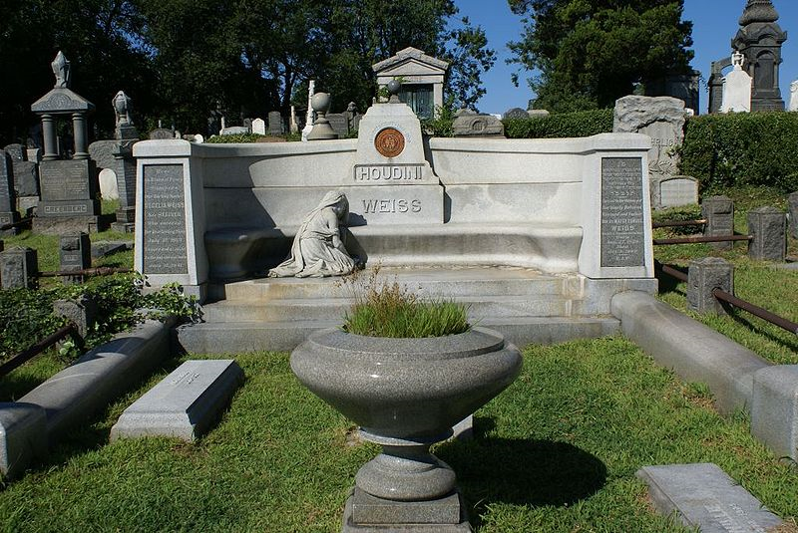 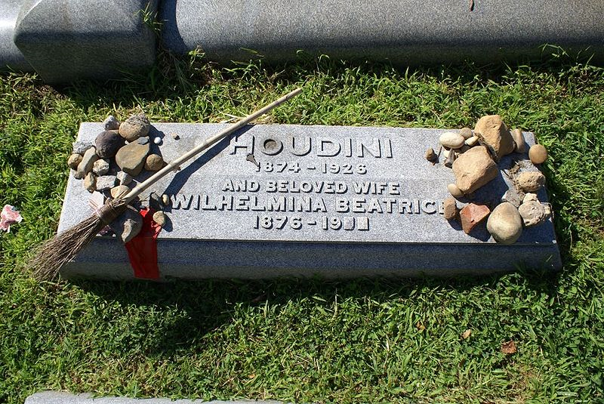

The gravesite of Harry Houdini The grave marker at Harry Houdini's burial site

## Proposed exhumation

On March 22, 2007, his great-nephew (the grandson of Houdini's brother Theo) George Hardeen announced that the courts would be asked to allow [exhumation](http://en.wikipedia.org/wiki/Exhumation) of Houdini's body. The purpose was to look for evidence that Houdini was poisoned by Spiritualists, as suggested in *The Secret Life of Houdini*.[[43]](http://en.wikipedia.org/wiki/Harry_Houdini#cite_note-42) In a statement given to the [Houdini Museum](http://en.wikipedia.org/wiki/Houdini_Museum) in Scranton, the family of Bess Houdini, who had no legal standing in the matter, opposed the application and suggested it was a publicity ploy for the book.[[44]](http://en.wikipedia.org/wiki/Harry_Houdini#cite_note-43) The Washington Post added to the furore by "revealing" that the press conference was not orchestrated by the family of Houdini, but by *Secret Life* authors William Kulash and Larry Sloman, who hired the PR firm Dan Klores Communications to promote the book.[[45]](http://en.wikipedia.org/wiki/Harry_Houdini#cite_note-44) In 2008 it was revealed the parties involved never filed legal papers to perform an exhumation.[[46]](http://en.wikipedia.org/wiki/Harry_Houdini#cite_note-45)

## [[edit](http://en.wikipedia.org/w/index.php?title=Harry_Houdini&action=edit&section=19)] Legacy

* 1936 - On October 31, 1936, Houdini's widow held the "Final Houdini Séance" atop of the roof of The Knickerbocker Hotel in Hollywood, California. A recording of the séance was made and issued as a record album.
* 1953 - [*Houdini*](http://en.wikipedia.org/wiki/Houdini_%28film%29), a mostly fictionalized biopic of Houdini's life, was made. This movie, starring [Tony Curtis](http://en.wikipedia.org/wiki/Tony_Curtis) and [Janet Leigh](http://en.wikipedia.org/wiki/Janet_Leigh), has contributed, in part, to several misconceptions about Houdini's life. For example, it portrays the cause of Houdini's death to be the magician's failure to escape from the [Chinese Water Torture Cell](http://en.wikipedia.org/wiki/Chinese_Water_Torture_Cell). (Curtis's Houdini agrees to seek medical attention "when the tour is over.") Houdini actually developed the Chinese Torture Cell trick fourteen years before he died and performed it numerous times.
* 1968 - The [Houdini Magical Hall of Fame](http://en.wikipedia.org/w/index.php?title=Houdini_Magical_Hall_of_Fame&action=edit&redlink=1) was opened on [Clifton Hill](http://en.wikipedia.org/wiki/Clifton_Hill_%28Niagara_Falls%29) in [Niagara Falls, Ontario](http://en.wikipedia.org/wiki/Niagara_Falls,_Ontario), Canada. At its opening, this museum contained the majority of Houdini's personal collection of magic paraphernalia. One of Houdini's death wishes was that his entire collection be given to his brother Theodore (also known as the magician *Hardeen*) and burned upon Theodore's death. Against his wishes, forty years after Houdini's death, the items were taken from storage and sold. Two entrepreneurs purchased the items and renovated a former meat-packing plant on Clifton Hill, Ontario, Canada, to house the museum. The Hall of Fame was moved in 1972 to its final location on the top of Clifton Hill. Séances were held every year at the museum on October 31, the anniversary of Houdini's death. A fire destroyed the museum on April 30, 1995.
* 1968 - [Stuart Damon](http://en.wikipedia.org/wiki/Stuart_Damon) plays Houdini in a lavishly staged London musical, *Man of Magic*.
* 1975 - Canadian magician [Doug Henning](http://en.wikipedia.org/wiki/Doug_Henning) successfully duplicates Houdini's Chinese Water Torture trick for the first time since its original performance, on an ABC TV special.
* 1975 - Houdini received a star on the [Hollywood Walk of Fame](http://en.wikipedia.org/wiki/Hollywood_Walk_of_Fame). The star is located on the northwest corner of Hollywood Blvd. and Orange Drive, just across from the [Grauman's Chinese Theater](http://en.wikipedia.org/wiki/Grauman%27s_Chinese_Theater) and down the street from [The Magic Castle](http://en.wikipedia.org/wiki/The_Magic_Castle).
* 1975 - Houdini repeatedly appears in [E. L. Doctorow](http://en.wikipedia.org/wiki/E._L._Doctorow)'s historical novel [Ragtime](http://en.wikipedia.org/wiki/Ragtime_%28novel%29).
* 1976 - Houdini was played by [Paul Michael Glaser](http://en.wikipedia.org/wiki/Paul_Michael_Glaser), of [*Starsky and Hutch*](http://en.wikipedia.org/wiki/Starsky_and_Hutch) fame, in a 1976 TV movie called [*The Great Houdinis!*](http://en.wikipedia.org/wiki/The_Great_Houdinis) (aka [*The Great Houdini*](http://en.wikipedia.org/wiki/The_Great_Houdini)), which was also highly fictionalized. The film focused on Houdini's relationship with his wife and mother, who were portrayed as frequently bickering because his wife was a devout Christian and his mother almost fanatical in her Judaism to the point of being anti-Christian (although, in reality, they had cordial relations) and on his fascination with life after death. The cast also included [Sally Struthers](http://en.wikipedia.org/wiki/Sally_Struthers), [Vivian Vance](http://en.wikipedia.org/wiki/Vivian_Vance), [Bill Bixby](http://en.wikipedia.org/wiki/Bill_Bixby), and [Ruth Gordon](http://en.wikipedia.org/wiki/Ruth_Gordon). [Peter Cushing](http://en.wikipedia.org/wiki/Peter_Cushing) appeared as Arthur Conan Doyle; Cushing had previously played Doyle's creation, Sherlock Holmes. Actor/Houdini authority Patrick Culliton played Houdini's assistant Franz Kukol.
* 1982 - English singer/songwriter [Kate Bush](http://en.wikipedia.org/wiki/Kate_Bush) includes a song about Houdini on her album [*The Dreaming*](http://en.wikipedia.org/wiki/The_Dreaming_%28album%29).
* 1985 - The City of [Appleton, Wisconsin](http://en.wikipedia.org/wiki/Appleton,_Wisconsin), constructed the Houdini Plaza on the site of the magician's childhood home.
* 1985 - [Wil Wheaton](http://en.wikipedia.org/wiki/Wil_Wheaton) played Houdini in *Young Harry Houdini,* a made-for-TV movie that aired on ABC as a "Disney Sunday Movie." The film also featured [Jeffrey DeMunn](http://en.wikipedia.org/wiki/Jeffrey_DeMunn) as the adult Houdini. DeMunn first played Houdini in the film version of *Ragtime.*[[47]](http://en.wikipedia.org/wiki/Harry_Houdini#cite_note-greatesc-46)
* 1989 - Canadian [synth pop](http://en.wikipedia.org/wiki/Synth_pop) act [Kon Kan](http://en.wikipedia.org/wiki/Kon_Kan) release "Harry Houdini," the third single from the [*Move to Move*](http://en.wikipedia.org/wiki/Move_to_Move) album.
* 1993 - The film [*Last Action Hero*](http://en.wikipedia.org/wiki/Last_Action_Hero) is released, in which a magical movie ticket, which grants the bearer entry to a film's world, allegedly belonged to Houdini, prior to being passed off to the character by the name of Nick.
* 1997 - Actor [Harvey Keitel](http://en.wikipedia.org/wiki/Harvey_Keitel) plays Houdini and [Peter O'Toole](http://en.wikipedia.org/wiki/Peter_O%27Toole) Conan Doyle in the film [*FairyTale: A True Story*](http://en.wikipedia.org/wiki/FairyTale:_A_True_Story), set during World War I and portraying the alleged photographing of live fairies by two English schoolgirls. The two are shown as collegial even though they disagree as to the validity of spiritualism; in reality, Conan Doyle's fervent belief and Houdini's avowed skepticism sparked a bitter feud between the two that was never resolved. Keitel hired Patrick Culliton and Stanley Palm as "Houdini advisors."
* 1998 - [*Ragtime*](http://en.wikipedia.org/wiki/Ragtime_%28musical%29), the Broadway musical version of the movie, premiered on January 18, 1998. It featured Houdini as a character and has a song called "Harry Houdini, Master Escapist." The book was written by [Terrence McNally](http://en.wikipedia.org/wiki/Terrence_McNally), with music and lyrics by [Stephen Flaherty](http://en.wikipedia.org/wiki/Stephen_Flaherty) and [Lynn Ahrens](http://en.wikipedia.org/wiki/Lynn_Ahrens). The play ran on [Broadway](http://en.wikipedia.org/wiki/Broadway_theatre) until January 16, 2000, and won four [Tony Awards](http://en.wikipedia.org/wiki/Tony_Awards). Both the movie and the play are based on E.L. Doctorow's 1975 novel of the same title.
* 1998 - [Johnathon Schaech](http://en.wikipedia.org/wiki/Johnathon_Schaech) played Houdini in the TNT original movie *Houdini*. The film co-starred [Stacy Edwards](http://en.wikipedia.org/wiki/Stacy_Edwards) as Bess and [Mark Ruffalo](http://en.wikipedia.org/wiki/Mark_Ruffalo) as his brother, Dash (aka Theo. [Hardeen](http://en.wikipedia.org/wiki/Hardeen)). The TV movie first aired on December 6, 1998.
* 1999 - Six Flags Great Adventure opens a Mad House ride named "Houdini's Great Escape", with the ride and pre-show based on bringing Houdini's spirit back into the world.
* 2001 - The Houdini Seance is mounted as a theatrical piece in Chicago by [Neil Tobin](http://en.wikipedia.org/wiki/Neil_Tobin) and becomes an annual Halloween event at [Excalibur (nightclub)](http://en.wikipedia.org/wiki/Excalibur_%28nightclub%29).[[48]](http://en.wikipedia.org/wiki/Harry_Houdini#cite_note-47)
* 2002 - The [United States Postal Service](http://en.wikipedia.org/wiki/United_States_Postal_Service) issued a [postage stamp](http://en.wikipedia.org/wiki/Postage_stamp) with a replica of Houdini's favorite publicity poster on July 3, 2002.[[49]](http://en.wikipedia.org/wiki/Harry_Houdini#cite_note-48)
* There is a [Houdini Museum](http://houdini.org) in [Scranton, Pennsylvania](http://en.wikipedia.org/wiki/Scranton,_Pennsylvania). It is the only building in the world entirely dedicated to Houdini and is run by magicians Dick Brooks and [Dorothy Dietrich](http://en.wikipedia.org/wiki/Dorothy_Dietrich). The museum also holds an annual Houdini séance.
* While touring in the United States, Houdini met Joe Keaton and his family vaudeville act. It's said that after Joe's young son fell down a flight of stairs unscathed, Houdini remarked, "Your kid is quite the buster" (buster being a stage name for a fall) and gave a name to comedy legend [Buster Keaton](http://en.wikipedia.org/wiki/Buster_Keaton) (the kid).
* 2007 - A movie, [Death Defying Acts](http://en.wikipedia.org/wiki/Death_Defying_Acts), starring [Guy Pearce](http://en.wikipedia.org/wiki/Guy_Pearce) and [Catherine Zeta Jones](http://en.wikipedia.org/wiki/Catherine_Zeta_Jones) was made which is based on Houdini's life.
* 2008 - Escape artist Curtis Lovell II dedicated his buried alive stunt to Harry Houdini. It took Lovell 16 minutes to escape and over 2000 people came to witness this Houdini style stunt in the city of Grand Terrace California. CBS, KCAL9 and local newspapers covered the event.
* 2008 - Australian rock band [Nick Cave & The Bad Seeds](http://en.wikipedia.org/wiki/Nick_Cave_%26_The_Bad_Seeds) releases their album [Dig, Lazarus, Dig!!!](http://en.wikipedia.org/wiki/Dig,_Lazarus,_Dig%21%21%21) based on Houdini's attempt to discredit spiritualists.
* 2008 - Houdini's star on the [Hollywood Walk of Fame](http://en.wikipedia.org/wiki/Hollywood_Walk_of_Fame) is restored and rededicated in a ceremony attended by [Neil Patrick Harris](http://en.wikipedia.org/wiki/Neil_Patrick_Harris), [Penn & Teller](http://en.wikipedia.org/wiki/Penn_%26_Teller), [Aron Houdini](http://en.wikipedia.org/w/index.php?title=Aron_Houdini&action=edit&redlink=1), [Tippi Hedren](http://en.wikipedia.org/wiki/Tippi_Hedren), [Milt Larsen](http://en.wikipedia.org/wiki/Milt_Larsen), and other notables from the world of magic and movies.
* 2009 - [*Ragtime*](http://en.wikipedia.org/wiki/Ragtime_%28musical%29) (music by Stephen Flaherty, lyrics by Lynn Ahrens, and book by Terrence McNally, based on the novel by E. L. Doctorow) is revived on Broadway at the Neil SimonTheatre. Houdini, played by Jonathan Hammond, wore costumes designed by the legendary [Santo Loquasto](http://en.wikipedia.org/wiki/Santo_Loquasto) (Woody Allen's designer of choice). Houdini made a grand entrance hanging upside down on a wire, suspended high above the stage.
* 2009 - Summit Entertainment purchased the film rights to *The Secret Life of Houdini* and announced plans to produce a series of films featuring Houdini as an action hero in the vein of Indiana Jones and Sherlock Holmes.[[50]](http://en.wikipedia.org/wiki/Harry_Houdini#cite_note-49)
* 2009 - The Perth Mint releases a limited supply of dollar coins commemorating Houdini’s first flight in Australia on March 18, 1910.[[51]](http://en.wikipedia.org/wiki/Harry_Houdini#cite_note-50)
* 2009 - [Assassin's Creed II](http://en.wikipedia.org/wiki/Assassin%27s_Creed_II) used "Houdini's Chinese Water Torture Cell" picture in a puzzle where you had to find the Apple, a piece of Eden.
* 2010 - A celebration commemorating the centenary of Houdini’s first flight in Australia was held at Diggers Rest near Melbourne. The weekend long event included the dedication of a new monument, a Houdini-Centenary air-show, magic performances, and the display of a one-third scale model of Houdini’s Voisin bi-plane.[[52]](http://en.wikipedia.org/wiki/Harry_Houdini#cite_note-51)
* 2010 - A major exhibition of Houdini memorabilia will open at the [Jewish Musem](http://en.wikipedia.org/wiki/Jewish_Museum_%28New_York%29) in New York on October 31st.[[53]](http://en.wikipedia.org/wiki/Harry_Houdini#cite_note-52)

## [[edit](http://en.wikipedia.org/w/index.php?title=Harry_Houdini&action=edit&section=20)] Publications

Houdini published numerous books during his career (some of which were written by his good friend [Walter Brown Gibson](http://en.wikipedia.org/wiki/Walter_Brown_Gibson), the creator of [The Shadow](http://en.wikipedia.org/wiki/The_Shadow)):[[54]](http://en.wikipedia.org/wiki/Harry_Houdini#cite_note-53)

* *The Right Way to Do Wrong* (1906)
* *Handcuff Secrets* (1907)
* *The Unmasking of* [*Robert Houdin*](http://en.wikipedia.org/wiki/Jean_Eug%C3%A8ne_Robert-Houdin) (1908)
* *Magical Rope Ties and Escapes* (1920)
* *Miracle Mongers and their Methods* (1920)
* *Houdini's Paper Magic* (1921)
* *A Magician Among the Spirits* (1924)
* [*Under the Pyramids*](http://en.wikipedia.org/wiki/Under_the_Pyramids) (1924) with [H. P. Lovecraft](http://en.wikipedia.org/wiki/H._P._Lovecraft).

## [[edit](http://en.wikipedia.org/w/index.php?title=Harry_Houdini&action=edit&section=21)] Films

Films starring Houdini:

* [*Merveilleux Exploits du Célébre Houdini à Paris*](http://en.wikipedia.org/w/index.php?title=Merveilleux_Exploits_du_C%C3%A9l%C3%A9bre_Houdini_%C3%A0_Paris&action=edit&redlink=1) - Cinema Lux (1909) - playing self.
* [*The Master Mystery*](http://en.wikipedia.org/w/index.php?title=The_Master_Mystery&action=edit&redlink=1) - Octagon Films (1918) - playing Quentin Locke.
* [*The Grim Game*](http://en.wikipedia.org/wiki/The_Grim_Game) - Famous Players Lasky/Paramount (1919) - playing Harvey Handford.
* [*Terror Island*](http://en.wikipedia.org/w/index.php?title=Terror_Island&action=edit&redlink=1) - Famous Players Lasky/Paramount (1920) - playing Harry Harper.
* [*The Man From Beyond*](http://en.wikipedia.org/w/index.php?title=The_Man_From_Beyond&action=edit&redlink=1) - Houdini Picture Corporation (1922) - playing Howard Hillary.
* [*Haldane of the Secret Service*](http://en.wikipedia.org/w/index.php?title=Haldane_of_the_Secret_Service&action=edit&redlink=1) - Houdini Picture Corporation/FBO (1922) - playing Heath Haldane.

Biographical films:

* [*Houdini*](http://en.wikipedia.org/wiki/Houdini_%28film%29) (1953) - played by [Tony Curtis](http://en.wikipedia.org/wiki/Tony_Curtis)
* [*The Great Houdini*](http://en.wikipedia.org/wiki/The_Great_Houdini_%28film%29) aka *The Great Houdinis* (1976) - played by [Paul Michael Glaser](http://en.wikipedia.org/wiki/Paul_Michael_Glaser) ([TV movie](http://en.wikipedia.org/wiki/Television_movie))
* [*Ragtime*](http://en.wikipedia.org/wiki/Ragtime_%28film%29) (1981) - played by [Jeffrey DeMunn](http://en.wikipedia.org/wiki/Jeffrey_DeMunn)
* [*Young Harry Houdini*](http://en.wikipedia.org/w/index.php?title=Young_Harry_Houdini&action=edit&redlink=1) (1987) - played by [Wil Wheaton](http://en.wikipedia.org/wiki/Wil_Wheaton) & Jeffrey DeMunn (TV movie)
* [*A Night at the Magic Castle*](http://en.wikipedia.org/w/index.php?title=A_Night_at_the_Magic_Castle&action=edit&redlink=1) (1988) - played by [Arte Johnson](http://en.wikipedia.org/wiki/Arte_Johnson)
* [*FairyTale: A True Story*](http://en.wikipedia.org/wiki/FairyTale:_A_True_Story) (1997) - played by [Harvey Keitel](http://en.wikipedia.org/wiki/Harvey_Keitel)
* [*Houdini*](http://en.wikipedia.org/w/index.php?title=Houdini_%28TV_film%29&action=edit&redlink=1) (1998) - played by [Johnathon Schaech](http://en.wikipedia.org/wiki/Johnathon_Schaech) (TV movie)
* [*Cremaster 2*](http://en.wikipedia.org/wiki/Cremaster_2#Cremaster_2_.281999.29) (1999) - played by [Norman Mailer](http://en.wikipedia.org/wiki/Norman_Mailer)
* [*Death Defying Acts*](http://en.wikipedia.org/wiki/Death_Defying_Acts) (2007) - played by [Guy Pearce](http://en.wikipedia.org/wiki/Guy_Pearce)

## [[edit](http://en.wikipedia.org/w/index.php?title=Harry_Houdini&action=edit&section=22)] See also

* [American Museum of Magic](http://en.wikipedia.org/wiki/American_Museum_of_Magic)
* [Martinka](http://en.wikipedia.org/wiki/Martinka)
* [*Wonder of the Worlds*](http://en.wikipedia.org/wiki/Wonder_of_the_Worlds)

## [[edit](http://en.wikipedia.org/w/index.php?title=Harry_Houdini&action=edit&section=23)] References

### [[edit](http://en.wikipedia.org/w/index.php?title=Harry_Houdini&action=edit&section=24)] Notes

1. [**^**](http://en.wikipedia.org/wiki/Harry_Houdini#cite_ref-0) *Houdini!!! The Career of Ehrich Weiss, American self-liberator, Europe's eclipsing sensation, world's handcuff king & prison breaker* by Kenneth Silverman, Harper Collins, New York 1996, [ISBN 0-06-016978-8](http://en.wikipedia.org/wiki/Special:BookSources/0060169788). p. 8.
2. [**^**](http://en.wikipedia.org/wiki/Harry_Houdini#cite_ref-1) "Hardeen Dead, 69. Houdini's Brother. Illusionist, Escape Artist, a Founder of Magician's Guild. Gave Last Show May 29.". New York Times. June 13, 1945, Wednesday. "Theodore Hardeen, a brother of the late Harry Houdini, illusionist and a prominent magician in his own right, died yesterday in the Doctors Hospital. His age was 69."
3. [**^**](http://en.wikipedia.org/wiki/Harry_Houdini#cite_ref-2) US National Archives Microfilm serial: M237; Microfilm roll: 413; Line: 38; List number: 684.
4. [**^**](http://en.wikipedia.org/wiki/Harry_Houdini#cite_ref-3) ["Larger Images"](http://www.archives.gov/southeast/exhibit/popups.php?p=4.1.5). Archives.gov. <http://www.archives.gov/southeast/exhibit/popups.php?p=4.1.5>. Retrieved 2010-02-14.
5. [**^**](http://en.wikipedia.org/wiki/Harry_Houdini#cite_ref-4) [1880 US Census](http://en.wikipedia.org/wiki/1880_US_Census) with Samuel M. Weiss, Cecelia (wife), Armin M., Nathan J., Ehrich, Theodore, and Leopold.
6. [**^**](http://en.wikipedia.org/wiki/Harry_Houdini#cite_ref-5) *Houdini!!!: The Career of Ehrich Weiss* by Kenneth Silverman, 1996, page 81.
7. [**^**](http://en.wikipedia.org/wiki/Harry_Houdini#cite_ref-6) *Houdini!!!: The Career of Ehrich Weiss* by Kenneth Silverman, 1996, p. 109.
8. [**^**](http://en.wikipedia.org/wiki/Harry_Houdini#cite_ref-7) <http://www.dontdothingsbyhalf.com/Content.aspx>
9. [**^**](http://en.wikipedia.org/wiki/Harry_Houdini#cite_ref-8) *The Secret Life of Houdini: The Making of America's First Superhero* by William Kalush and Larry Sloman, 2006.
10. [**^**](http://en.wikipedia.org/wiki/Harry_Houdini#cite_ref-9) *Houdini's Mirror Handcuff Challenge, Getting Closer to the Truth* by Mick Hanzlik, 2007, reproduction in full of *Daily Mirror* article "Houdini's Great Victory" March 18, 1904.
11. [**^**](http://en.wikipedia.org/wiki/Harry_Houdini#cite_ref-10) *Houdini!!!: The Career of Ehrich Weiss* by Kenneth Silverman, 1996, pp. 59–62.
12. [**^**](http://en.wikipedia.org/wiki/Harry_Houdini#cite_ref-11) *Houdini: His Life and Art* by James Randi and Bert Sugar, 1976, pp. 175–178.
13. [**^**](http://en.wikipedia.org/wiki/Harry_Houdini#cite_ref-12) *Houdini: His Life and Art* by James Randi and Bert Sugar, 1976, Milk Can poster on page 177.
14. [**^**](http://en.wikipedia.org/wiki/Harry_Houdini#cite_ref-13) *Houdini A Pictorial Life* by Milbourne Christopher, 1976, p. 54.
15. [**^**](http://en.wikipedia.org/wiki/Harry_Houdini#cite_ref-14) *Houdini His Legend and His Magic* by Doug Henning, 1977, p. 160.
16. [**^**](http://en.wikipedia.org/wiki/Harry_Houdini#cite_ref-15) *Houdini: The Untold Story* by Milbourne Christopher, 1969, p. 140.
17. [**^**](http://en.wikipedia.org/wiki/Harry_Houdini#cite_ref-16) *Houdini!!!: The Career of Ehrich Weiss* by Kenneth Silverman, 1997, pp. 397–403.
18. [**^**](http://en.wikipedia.org/wiki/Harry_Houdini#cite_ref-17) ["Uncovering Houdini’s second underwater test"](http://www.houdini-lives.com/Houdini_Lives/NEWS/Entries/2010/1/26_Uncovering_Houdinis_second_underwater_test.html). <http://www.houdini-lives.com/Houdini_Lives/NEWS/Entries/2010/1/26_Uncovering_Houdinis_second_underwater_test.html>. Retrieved January 26, 2010.
19. [**^**](http://en.wikipedia.org/wiki/Harry_Houdini#cite_ref-18) *Houdini!!!: The Career of Ehrich Weiss* by Kenneth Silverman, 1997, p. 406.
20. [**^**](http://en.wikipedia.org/wiki/Harry_Houdini#cite_ref-19) ["Houdini Defeats Hackenschmidt and other revelations from Disappearing Tricks"](http://www.houdini-lives.com/Houdini_Lives/NEWS/Entries/2010/1/31_Houdini_Defeats_Hackenschmidt_and_other_revelations_from_Disappearing_Tricks.html). <http://www.houdini-lives.com/Houdini_Lives/NEWS/Entries/2010/1/31_Houdini_Defeats_Hackenschmidt_and_other_revelations_from_Disappearing_Tricks.html>. Retrieved January 31, 2010.
21. [**^**](http://en.wikipedia.org/wiki/Harry_Houdini#cite_ref-20) *Disappearing Tricks* by [Matthew Solomon](http://en.wikipedia.org/w/index.php?title=Matthew_Solomon&action=edit&redlink=1), 2010, p. 95.
22. [**^**](http://en.wikipedia.org/wiki/Harry_Houdini#cite_ref-21) *Houdini!!!: The Career of Ehrich Weiss* by [Kenneth Silverman](http://en.wikipedia.org/wiki/Kenneth_Silverman), 1996, p. 205.
23. [**^**](http://en.wikipedia.org/wiki/Harry_Houdini#cite_ref-22) *Houdini!!!: The Career of Ehrich Weiss* by Kenneth Silverman, 1996, pp. 226–249.
24. [**^**](http://en.wikipedia.org/wiki/Harry_Houdini#cite_ref-23) ["Haldane wows at LA screening"](http://web.mac.com/zencato/Houdini_Lives/NEWS/Entries/2007/1/12_Haldane_wows_at_LA_screening.html). <http://web.mac.com/zencato/Houdini_Lives/NEWS/Entries/2007/1/12_Haldane_wows_at_LA_screening.html>. Retrieved January 12, 2007.
25. [**^**](http://en.wikipedia.org/wiki/Harry_Houdini#cite_ref-24) ["Houdini’s silent movies coming to DVD"](http://www.houdini-lives.com/Houdini_Lives/NEWS/Entries/2008/1/18_Houdini_silent_movies_coming_to_DVD.html). <http://www.houdini-lives.com/Houdini_Lives/NEWS/Entries/2008/1/18_Houdini_silent_movies_coming_to_DVD.html>. Retrieved January 18, 2008.
26. [**^**](http://en.wikipedia.org/wiki/Harry_Houdini#cite_ref-25) [Australian National Aviation Museum - Early Australian Aviation](http://www.aarg.com.au/Aviation-EarlyAustralian.htm) at www.aarg.com.au.
27. [**^**](http://en.wikipedia.org/wiki/Harry_Houdini#cite_ref-26) [Australian Aviation Pioneers, 1850-2000](http://www.ctie.monash.edu.au/hargrave/biography1.html) at www.ctie.monash.edu.au
28. [**^**](http://en.wikipedia.org/wiki/Harry_Houdini#cite_ref-27) *Houdini!!!: The Career of Ehrich Weiss* by Kenneth Silverman, 1996, pp. 137–154.
29. [**^**](http://en.wikipedia.org/wiki/Harry_Houdini#cite_ref-28) ["Diggers Rest gears up for Houdini celebrations"](http://www.houdini-lives.com/Houdini_Lives/NEWS/Entries/2009/12/12_Diggers_Rest_gears_up_for_Houdini_celebrations.html). <http://www.houdini-lives.com/Houdini_Lives/NEWS/Entries/2009/12/12_Diggers_Rest_gears_up_for_Houdini_celebrations.html>. Retrieved December 12, 2010.
30. [**^**](http://en.wikipedia.org/wiki/Harry_Houdini#cite_ref-29) Notes to *Houdini and the ghost of Abraham Lincoln*, [Library of Congress](http://memory.loc.gov/cgi-bin/query/r?ammem/varstg:@FIELD%28NUMBER%283a27314%29%29). Retrieved October 3, 2007.
31. [**^**](http://en.wikipedia.org/wiki/Harry_Houdini#cite_ref-30) [Houdini Facts from the History Museum at the Castle](http://www.foxvalleyhistory.org/houdini/facts.asp).
32. [**^**](http://en.wikipedia.org/wiki/Harry_Houdini#cite_ref-31) [Houdini's Halloween](http://wgntv.trb.com/news/local/morningnews/wgntv-news-102805larrysworld,0,2750659.story?coll=wgntv-morning-news-1) from [WGN-TV](http://en.wikipedia.org/wiki/WGN-TV) and Red Eye, October 28, 2005
33. [**^**](http://en.wikipedia.org/wiki/Harry_Houdini#cite_ref-32) *Houdini!!!: The Career of Ehrich Weiss* by Kenneth Silverman, 1996, p. 31.
34. [**^**](http://en.wikipedia.org/wiki/Harry_Houdini#cite_ref-33) Houdini Up To Old Tricks Through Magic of Edison, *Los Angeles Times,* July 4, 1970.
35. [**^**](http://en.wikipedia.org/wiki/Harry_Houdini#cite_ref-34) "In Sadness, Prime Houdini Artifact Collector Puts Items on Auction Block". New York Times. October 29, 2004. "... Mr. Radner, aka Rendar the Magician, owns one of the world's biggest and most valuable collections of Harry Houdini artifacts, including the Chinese Water Torture Cell, one of Houdini's signature props from 1912 until his death in 1926. Most of the items were given to Mr. Radner in the 1940s by Houdini's brother, another escape artist who went by the stage name Hardeen. Hardeen considered Mr. Radner, then a student at Yale with a reputation for jumping from diving boards in handcuffs, as his protégé. Until early this year, the collection was on display at the Outagamie Museum in [Appleton, Wisconsin](http://en.wikipedia.org/wiki/Appleton,_Wisconsin), where Houdini's father was the town rabbi in the 1870s. But after a rancorous falling out between Mr. Radner and museum officials, the 1,000-piece collection was packed up and shipped here, where it will be auctioned on Saturday in the windowless back room at the Liberace Museum and on eBay. ..."
36. [**^**](http://en.wikipedia.org/wiki/Harry_Houdini#cite_ref-35) ["The Mystery of the Two Torture Cells"](http://web.mac.com/zencato/iWeb/Houdini_Lives/NEWS/19A4B856-4024-450B-80F9-B8721F851DCB.html). *Houdini Lives!*. <http://web.mac.com/zencato/iWeb/Houdini_Lives/NEWS/19A4B856-4024-450B-80F9-B8721F851DCB.html>. Retrieved 2007-05-14.
37. [**^**](http://en.wikipedia.org/wiki/Harry_Houdini#cite_ref-36) [houdini auction](http://www.houdini.com/houdiniauction.htm).
38. ^ [***a***](http://en.wikipedia.org/wiki/Harry_Houdini#cite_ref-autogenerated3_37-0) [***b***](http://en.wikipedia.org/wiki/Harry_Houdini#cite_ref-autogenerated3_37-1) *The Man Who Killed Houdini* by Don Bell, Vehicule Press, 2004.
39. [**^**](http://en.wikipedia.org/wiki/Harry_Houdini#cite_ref-38) Benoit, Tod (May 2003). *Where Are They Buried? How Did They Die?*. [Black Dog & Leventhal Publishers](http://en.wikipedia.org/wiki/Black_Dog_%26_Leventhal_Publishers). p. 469. [ISBN](http://en.wikipedia.org/wiki/International_Standard_Book_Number) [1-57912-287-6](http://en.wikipedia.org/wiki/Special:BookSources/1-57912-287-6).
40. [**^**](http://en.wikipedia.org/wiki/Harry_Houdini#cite_ref-39) Houdini laid on his death bed for eight days after being given just seven hours to live with a ruptured appendix and a 105 degree fever.[Urban Legends Reference Pages: Death of Houdini](http://www.snopes.com/horrors/freakish/houdini.asp).
41. [**^**](http://en.wikipedia.org/wiki/Harry_Houdini#cite_ref-40) [Final Escape for the Master of Illusion? Houdini's Family Press for Exhumation](http://www.buzzle.com/articles/131797.html).
42. [**^**](http://en.wikipedia.org/wiki/Harry_Houdini#cite_ref-41) [Bess Houdini dies in 1943](http://houdini.net/besshoudinideath.php).
43. [**^**](http://en.wikipedia.org/wiki/Harry_Houdini#cite_ref-42) ["Grandnephew seeks to 'set record straight' about Houdini's death"](http://www.cbc.ca/arts/media/story/2007/03/23/houdini-exhume.html). *Canadian Broadcasting Corporation*. <http://www.cbc.ca/arts/media/story/2007/03/23/houdini-exhume.html>. Retrieved March 23, 2007.
44. [**^**](http://en.wikipedia.org/wiki/Harry_Houdini#cite_ref-43) ["Family Statement re: exhumation"](http://houdini.org/HoudiniFamilyLetter.html). <http://houdini.org/HoudiniFamilyLetter.html>. Retrieved March 26, 2007.
45. [**^**](http://en.wikipedia.org/wiki/Harry_Houdini#cite_ref-44) Segal, David (March 24, 2007). ["Why Not Just Hold a Seance?"](http://www.washingtonpost.com/wp-dyn/content/article/2007/03/23/AR2007032301850.html). *The Washington Post*. <http://www.washingtonpost.com/wp-dyn/content/article/2007/03/23/AR2007032301850.html>. Retrieved March 24, 2007.
46. [**^**](http://en.wikipedia.org/wiki/Harry_Houdini#cite_ref-45) ["So when do we start digging?"](http://www.houdini-lives.com/Houdini_Lives/NEWS/Entries/2008/3/16_So_when_do_we_start_digging.html). <http://www.houdini-lives.com/Houdini_Lives/NEWS/Entries/2008/3/16_So_when_do_we_start_digging.html>. Retrieved March 16, 2008.
47. [**^**](http://en.wikipedia.org/wiki/Harry_Houdini#cite_ref-greatesc_46-0) *The Great Escape: Hollywood's Struggle to Bring Houdini Back to Life* by John Cox, MAGIC Magazine, October 2006.
48. [**^**](http://en.wikipedia.org/wiki/Harry_Houdini#cite_ref-47) [HOUDINI'S HALLOWEEN | Morning News | WGNTV.com | WGN TV | Chicago's CW](http://wgntv.trb.com/news/local/morningnews/wgntv-news-102805larrysworld,0,2750659.story?coll=wgntv-morning-news-1).
49. [**^**](http://en.wikipedia.org/wiki/Harry_Houdini#cite_ref-48) USPS Press Release (October 31, 2001) [Harry Houdini Returns To World Stage](http://www.usps.com/news/2001/philatelic/sr01_074_print.htm), *usps.com*.
50. [**^**](http://en.wikipedia.org/wiki/Harry_Houdini#cite_ref-49) ["Summit set to turn Houdini into action hero"](http://www.houdini-lives.com/Houdini_Lives/NEWS/Entries/2009/3/27_Summit_set_to_turn_Houdini_into_action_hero.html). *Houdini Lives*. <http://www.houdini-lives.com/Houdini_Lives/NEWS/Entries/2009/3/27_Summit_set_to_turn_Houdini_into_action_hero.html>. Retrieved March 27, 2009.
51. [**^**](http://en.wikipedia.org/wiki/Harry_Houdini#cite_ref-50) ["Australia mints coin commemorating Houdini’s first flight"](http://www.houdini-lives.com/Houdini_Lives/NEWS/Entries/2009/11/5_Australia_mints_coin_commemorating_Houdini_first_flight.html). *Houdini Lives*. <http://www.houdini-lives.com/Houdini_Lives/NEWS/Entries/2009/11/5_Australia_mints_coin_commemorating_Houdini_first_flight.html>. Retrieved November 5, 2009.
52. [**^**](http://en.wikipedia.org/wiki/Harry_Houdini#cite_ref-51) ["100 years ago today Harry Houdini showed Australia that a man can fly"](http://www.houdini-lives.com/Houdini_Lives/NEWS/Entries/2010/3/18_100_years_ago_today_Houdini_showed_Australia_that_a_man_can_fly.html). <http://www.houdini-lives.com/Houdini_Lives/NEWS/Entries/2010/3/18_100_years_ago_today_Houdini_showed_Australia_that_a_man_can_fly.html>. Retrieved March 18, 2010.
53. [**^**](http://en.wikipedia.org/wiki/Harry_Houdini#cite_ref-52) ["Jewish Museum plans Houdini exhibition"](http://www.houdini-lives.com/Houdini_Lives/NEWS/Entries/2010/3/20_Jewish_Museum_plans_Houdini_exhibition.html). <http://www.houdini-lives.com/Houdini_Lives/NEWS/Entries/2010/3/20_Jewish_Museum_plans_Houdini_exhibition.html>. Retrieved March 20, 2010.
54. [**^**](http://en.wikipedia.org/wiki/Harry_Houdini#cite_ref-53) [James Randi's Swift - July 14, 2006](http://www.randi.org/jr/2006-07/071406vortex.html#i1) at www.randi.org.

### [[edit](http://en.wikipedia.org/w/index.php?title=Harry_Houdini&action=edit&section=25)] Biographies

* Brandon, Ruth. *The Life and Many Deaths of Harry Houdini* (Seeker & Warburg, Ltd. GB, 1993) [ISBN 0-8129-7042-X](http://en.wikipedia.org/wiki/Special:BookSources/081297042X); [ISBN 978-0-8129-7042-5](http://en.wikipedia.org/wiki/Special:BookSources/9780812970425) (USA edition): [ISBN 0-679-42437-7](http://en.wikipedia.org/wiki/Special:BookSources/0679424377) [ISBN 978-0-679-42437-6](http://en.wikipedia.org/wiki/Special:BookSources/9780679424376).
* [Christopher, Milbourne](http://en.wikipedia.org/wiki/Milbourne_Christopher). *Houdini: The Untold Story* (Thomas Y. Crowell Co, 1969). [ISBN 0-89190-981-8](http://en.wikipedia.org/wiki/Special:BookSources/0891909818); [ISBN 978-0-89190-981-1](http://en.wikipedia.org/wiki/Special:BookSources/9780891909811); [ISBN 0-690-40431-X](http://en.wikipedia.org/wiki/Special:BookSources/069040431X); [ISBN 978-0-690-40431-9](http://en.wikipedia.org/wiki/Special:BookSources/9780690404319).
* Fleischman, Sid. *Escape! The Story of The Great Houdini*, (Greenwillow Books, 2006). [ISBN 978-0-06-085094-4](http://en.wikipedia.org/wiki/Special:BookSources/9780060850944).
* [Gresham, William Lindsay](http://en.wikipedia.org/wiki/William_Lindsay_Gresham) *Houdini: The Man Who Walked Through Walls* (Henry Holt & Co, NY, 1959).
* [Henning, Doug](http://en.wikipedia.org/wiki/Doug_Henning) with Charles Reynolds. *Houdini: His Legend and His Magic* (Times Books, NY, 1978). [ISBN 0-446-87328-4](http://en.wikipedia.org/wiki/Special:BookSources/0446873284); [ISBN 978-0-446-87328-4](http://en.wikipedia.org/wiki/Special:BookSources/9780446873284).
* Kalush, William and Larry Sloman. *The Secret Life of Houdini: The Making of America's First Superhero*, 2006 [ISBN 0-7432-7207-2](http://en.wikipedia.org/wiki/Special:BookSources/0743272072).
* Kellock, Harold. *Houdini: His Life-Story* *from the recollections and documents of Beatrice Houdini,* (Harcourt, Brace Co., June, 1928).
* Kendall, Lance. *Houdini: Master of Escape* (Macrae Smith & Co., NY, 1960). [ISBN 0-06-092862-X](http://en.wikipedia.org/wiki/Special:BookSources/006092862X).
* Meyer, M.D., Bernard C.*Houdini: A Mind in Chains* (E.P. Dutton & Co. NY, 1976). [ISBN 0-8415-0448-2](http://en.wikipedia.org/wiki/Special:BookSources/0841504482).
* [Randi, James](http://en.wikipedia.org/wiki/James_Randi) & Bert Randolph Sugar. *Houdini: His Life and Art* (Grosset & Dunlap, NY, 1977).[ISBN 978-0-448-12546-6](http://en.wikipedia.org/wiki/Special:BookSources/9780448125466); [ISBN 0-448-12546-3](http://en.wikipedia.org/wiki/Special:BookSources/0448125463).
* [Silverman, Kenneth](http://en.wikipedia.org/wiki/Kenneth_Silverman). *Houdini!!!: The Career of Ehrich Weiss* 1996 [ISBN 0-06-092862-X](http://en.wikipedia.org/wiki/Special:BookSources/006092862X).
* Williams, Beryl & Samuel Epstein. *The Great Houdini: Magician Extraordinary* (Julian Messner, Inc., NY, 1950).

### [[edit](http://en.wikipedia.org/w/index.php?title=Harry_Houdini&action=edit&section=26)] Further reading

* *Houdini's Escapes and Magic* by [Walter B. Gibson](http://en.wikipedia.org/wiki/Walter_B._Gibson), *Prepared from Houdini’s private notebooks* Blue Ribbon Books, Inc., 1930. Reveals some of Houdini's magic and escape methods (also released in two separate volumes: *Houdini's Magic* and *Houdini's Escapes*).
* *The Secrets of Houdini* by J.C. Cannell, Hutchinson & Co., London, 1931. Reveals some of Houdini's escape methods.
* *Houdini and Conan Doyle: The Story of a Strange Friendship* by Bernard M. L. Ernst, Albert & Charles Boni, Inc., NY, 1932.
* *Sixty Years of Psychical Research* by Joseph F. Rinn, Truth Seeker Co., 1950, Rinn was a long time close friend of Houdini. Contains detailed information about the last Houdini message (there are 3) and its disclosure.
* *Houdini's Fabulous Magic* by [Walter B. Gibson](http://en.wikipedia.org/wiki/Walter_B._Gibson) and Morris N. Young Chilton, NY, 1960. Excellent reference for Houdini’s escapes and some methods (includes the Water Torture Cell).
* *The Houdini Birth Research Committee’s Report*, Magico Magazine (reprint of report by The Society of American Magicians), 1972. Concludes Houdini was born March 24, 1874 in Budapest.
* *Mediums, Mystics and the Occult* by [Milbourne Christopher](http://en.wikipedia.org/wiki/Milbourne_Christopher), Thomas T. Crowell Co., 1975, pp. 122–145, *Arthur Ford-Messages from the Dead,* contains detailed information about the Houdini messages and their disclosure.
* *Arthur Ford: The Man Who Talked with the Dead* by Allen Spraggett with William V. Rauscher, 1973, pp. 152–165, Chapter 7, *The Houdini Affair* contains detailed information about the Houdini messages and their disclosure.
* *Houdini: Escape into Legend, The Early Years: 1862–1900* by Manny Weltman, Finders/Seekers Enterprises, Los Angeles, 1993. Examination of Houdini’s childhood and early career.
* *Houdini Comes To America* by Ronald J. Hilgert, The Houdini Historical Center, 1996. Documents the Weiss family’s immigration to the United States on July 3, 1878 (when Ehrich was 4).
* *Houdini Unlocked* by Patrick Culliton, Two volume box set: *The Tao of Houdini* and *The Secret Confessions of Houdini*, Kieran Press, 1997.
* *The Houdini Code Mystery: A Spirit Secret Solved* by William V. Rauscher, Magic Words, 2000.
* *Final Séance. The Strange Friendship Between Houdini and Conan Doyle* by Massimo Polidoro, Prometheus Books, 2001.
* *The Man Who Killed Houdini* by Don Bell, Vehicle Press, 2004. Investigates J. Gordon Whitehead and the events surrounding Houdini's death.
* *Disappearing Tricks: Silent Film, Houdini, and the New Magic of the Twentieth Century* by Matthew Solomon, University of Illinois Press, 2010. Contains new information about Houdini's early movie career.

## [[edit](http://en.wikipedia.org/w/index.php?title=Harry_Houdini&action=edit&section=27)] External links

|  |  |
| --- | --- |
| [Search Wikimedia Commons](http://commons.wikimedia.org/wiki/Special:Search/Harry_Houdini) | Wikimedia Commons has media related to: [***Harry Houdini***](http://commons.wikimedia.org/wiki/Special:Search/Harry_Houdini) |

* [Houdini Tribute](http://www.HoudiniTribute.com) 400+ Photos, videos, multimedia, and hear Houdini's voice.
* [Harry Houdini: His Life and His Art](http://www.thegreatharryhoudini.com)
* [Houdini Lives!](http://www.houdini-lives.com) - Website devoted to what's new in the world of Houdini; books, DVDs, auctions, movies, events, and pop culture references.
* [Timeline of Houdini's life](http://www.pbs.org/wgbh/amex/houdini/timeline/index.html)
* [The Houdini Museum in Scranton Pennsylvania.](http://www.houdini.org)
* [House of Deception](http://www.houseofdeception.com/Houdini%27s_Writing.html) article on Houdini's handwriting & signature.
* [Harry Houdini](http://www.findagrave.com/cgi-bin/fg.cgi?page=gr&GRid=509) at [Find a Grave](http://en.wikipedia.org/wiki/Find_a_Grave)
* [CFI's 10th Annual Houdini Séance - Halloween 2006](http://www.pointofinquiry.org/?p=81) - seance held to get in touch with Houdini, [Point of Inquiry](http://en.wikipedia.org/wiki/Point_of_Inquiry), October 31, 2006.
* [Michigan Time Traveler, Lansing State Journal, Harry Houdini and Michigan magic.](http://www.michigan.gov/documents/hal_mhc_mhm_houdini_10-09-2002_92657_7.pdf)
* [MSNBC report on possible murder of Houdini and the attempts to exhume his body.](http://www.msnbc.msn.com/id/17741602/)
* [The History Museum](http://www.myhistorymuseum.org/) operated by the [Local History Museum in Appleton, WI](http://en.wikipedia.org/wiki/The_History_Museum_at_the_Castle) home of the [AKA Houdini Exhibit.](http://www.akahoudini.org/htdocs/index.php)
* [Houdini in Russia.](http://www.cron.nnov.ru/en/city_legends/132/houdini_in_russia_eng) (in Russian).
* [Collection of Houdini's personal equipment.](http://www.pinballhistory.com/houdini.html)
* [The Final Halloween Houdini Seance - audio documentary.](http://www.archive.org/details/TheFinalHalloweenHoudiniSeance_860)
* [Festival of Flight](http://www.houdini.diggersrest.com) Official website for Houdini Centenary celebrations.
* ["Tricks of Fake Mediums"](http://libertymagazine.com/icons_houdini.htm) by Harry Houdini. [*Liberty*](http://en.wikipedia.org/wiki/Liberty_%281924%E2%80%931950%29), November 25, 1925

============================================================================================================================================