Mediamship Pictures

http://www.survivalafterdeath.org/photographs.htm

Sir WILLIAM CROOKES
with Florence Cook, materialisation medium
Photograph 1
This photograph taken by the eminent physicist and chemist Sir William Crookes, using magnesium light, is perhaps the most crucial.  "Sceptics" often attempt to explain away materialisations by claiming the medium and the materialised form are the same person, i.e. the medium somehow play-acts the whole thing by impersonating different individuals using an array of costumes, accents, etc. This photograph proves otherwise. Both the medium and the materialised figure can be seen at the same time - proving they were two separate entities.  Sir William Crookes said in his work Researches into the Phenomena of Modern Spiritualism "... it was a common thing for the seven or eight of us in the laboratory to see Miss Cook and Katie at the same time, under the full blaze of the electric light".  Having entered into a trance state, the medium Florence Cook (left) has slumped from the couch over the arm of the chair. The towering ectoplasm shape behind her is just beginning to compress into a fully materialised form. She called herself "Katie King". | 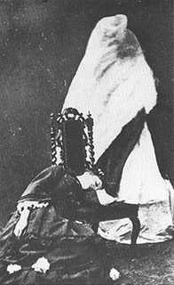

Sir WILLIAM CROOKES
with Florence Cook, materialisation medium
Photograph 2
This photograph shows the fully materialised figure of Katie King.
"Photography", said Crookes in Researches into the Phenomena of Modern Spiritualism, "is as inadequate to depict the perfect beauty of Katie's face as words are powerless to describe her charms of manner. Photography may, indeed, give a map of her countenance; but how can it reproduce the brilliant purity of her complexion, or the ever-varying expression of her most mobile features."
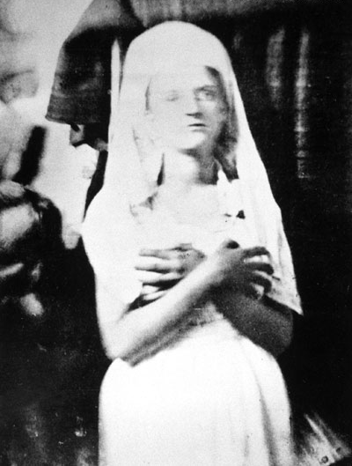

Photograph 3
This photograph was taken by the President of the Royal Society, Sir William Crookes, and shows the surgeon Dr. James M. Gully recording the pulse of Katie King.
The experiments were held under strict test conditions, imposed by Crookes, who recorded physical differences in complexion, hair colouring, height, heart-beat, blisters, skin type, face and finger sizes, plus manners and ways of expression between the materialised figure Katie King and the medium Florence Cook.
All physical comparisons were different, proving they were two separate entities.
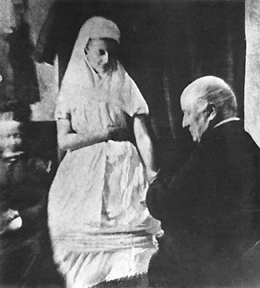

Sir WILLIAM CROOKES
with Florence Cook, materialisation medium
Photograph 4
Crookes stands arm-in-arm with the fully solid and materialised Katie King.
"I pass on to a séance held last night at Hackney (London, March 29th 1874). Katie never appeared to greater perfection, and for nearly two hours she walked about the room, conversing familiarly with those present. On several occasions she took my arm when walking, and the impression conveyed to my mind that it was a living woman by my side, instead of a visitor from the other world... Mr. Volckman will be pleased to know that I can corroborate his statement that the "ghost" (not "struggling" however) was as material a being as Miss Cook herself" said Crookes in his book Researches into the Phenomena of Modern Spiritualism.
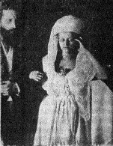

Sir WILLIAM CROOKES
with Florence Cook, materialisation medium
Photograph 5
The photograph below shows Katie King in the process of materialisation.
Some investigators claim that lesser-complete materialised forms offer stronger evidence of survival as they are near-impossible to duplicate by normal or fraudulent means. Over a period of three years Katie King appeared to Crookes and his fellow investigators in many states of solidity.
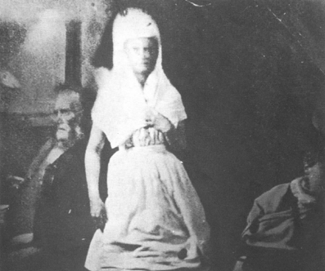

Sir WILLIAM CROOKES
with Florence Cook, materialisation medium
Photograph 6
This photograph was taken by Sir William Crookes using electric light. Seated to the right is the surgeon Dr. James M. Gully.  "One evening I timed Katie's pulse. It beat steadily at 75, whilst Miss Cook's pulse a little time after was going at its usual rate of 90. On applying my ear to Katie's chest I heard a heart beating rhythmically inside, and pulsating even more steadily than did Miss Cook's heart when she allowed me to try a similar experiment after the séance. Tested in the same way, Katie's lungs were found to be sounder than her medium's, for at the time I tried my experiment Miss Cook was under medical treatment for a severe cough."  Taken from Crookes' article The Last of Katie King. | 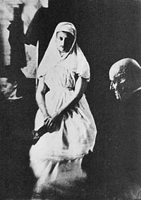

Sir WILLIAM CROOKES
with Florence Cook, materialisation medium
Photograph 7
"Before concluding this article I wish to give some of the points of difference, which I have observed between Miss Cook and Katie. Katie's height varies; in my house I have seen her six inches taller than Miss Cook. Last night, with bare feet, and not "tiptoeing," she was four-and-a-half inches taller than Miss Cook. Katie's neck was bare last night; the skin was perfectly smooth both to touch and sight, whilst on Miss Cook's neck is a large blister, which under similar circumstances is distinctly visible and rough to the touch. Katie's ears are unpierced, whilst Miss Cook habitually wears earrings. Katie's complexion is very fair, while that of Miss Cook is very dark, Katie's fingers are much longer than Miss Cook's, and her face is also larger. In manners and ways of expression there are also many decided differences."  Taken from Crookes' Spirit Forms. | 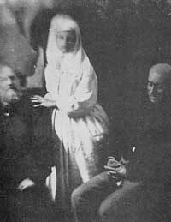

Photograph 8
"Having seen so much of Katie lately, when she has been illuminated by the electric light, I am enabled to add to the points of difference between her and her medium which I mentioned in a former article. I have the most absolute certainty that Miss Cook and Katie are two separate individuals so far as their bodies are concerned. Several little marks on Miss Cook's face are absent on Katie's. Miss Cook's hair is so dark a brown as almost to appear black; a lock of Katie's, which is now before me, and which she allowed me to cut from her luxuriant tresses, having first traced it up to the scalp and satisfied myself that it actually grew there, is a rich golden auburn."  Taken from Crookes' The Last of Katie King. | 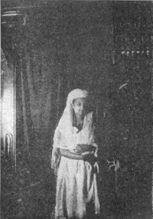

Photograph 9
"One of the most interesting of the pictures is one in which I am standing by the side of Katie; she has her bare foot upon a particular part of the floor. Afterwards I dressed Miss Cook like Katie, placed her and myself in exactly the same position, and we were photographed by the same cameras, placed exactly as in the other experiment, and illuminated by the same light. When these two pictures are placed over each other, the two photographs of myself coincide exactly as regards stature, etc., but Katie is half a head taller than Miss Cook, and looks a big woman in comparison with her. In the breadth of her face, in many of the pictures, she differs essentially in size from her medium, and the photographs show several other points of difference."  Taken from Crookes' article The Last of Katie King. | 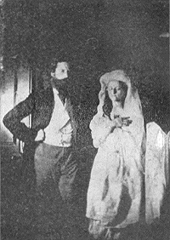

Dr CHARLES RICHET
with Marthe Béraud (Eva C), physical medium
Photograph 1
Marthe is seen seated. Note the helmet covered with drapery, the height of the figure which is in front of Marthe, not apparently supported by lower limbs. Her steroscopic photograph is much better than this one.  Charles Richet notes in Thirty Years of Psychical Research:  "The materializations produced were very complete. The phantom of Bien Boa appeared five or six times under satisfactory conditions in the sense that he could not be Marthe masquerading in a helmet and sheet. Marthe would have had not only to bring, but also to conceal afterwards, the helmet, the sheet, and the burnous. Also Marthe and the phantom were both seen at the same time.  "To pretend that Bien Boa was a doll is more absurd still; he walked and moved, his eyes could be seen looking round, and when he tried to speak his lips moved.  "He seemed so much alive that, as we could hear his breathing, I took a flask of baryta water to see if his breath would show carbon dioxide. The experiment succeeded. I did not lose sight of the flask from the moment when I put it into the hands of Bien Boa who seemed to float in the air on the left of the curtain at a height greater than Marthe could have been even if standing up. While he blew into the tube the bubbling could be heard."  Click here to read Richet's account of Marthe Béraud (Eva C) and Bien Boa in Thirty Years of Psychical Research. | 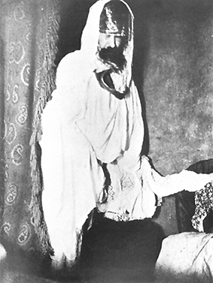

Dr CHARLES RICHET
with Marthe Braud (Eva C), physical medium
Photograph 2
Materialisation of M. Furtado, with a death's-head (after Mme. Frondoni-Lacombe).  Charles Richet notes in Thirty Years of Psychical Research:  "On December 18, 1914, Countess Castelvitch, Mme. Ponsa, Mme. Furtado, M. and Mme. Lacombe were present in the house of the Countess Castelvitch. Through the table Mme. Furtado's husband was alleged to be present, but that he would not allow himself to be photographed because he had forgotten what his face was like, but he said that his companion would come in his place. This companion was his mistress, he having been separated from his wife; and in fact a veiled woman was photographed, causing great fear in Mme. Furtado, who declared she would never be present at any more séances. At the next séance (December 27, 1914), M. Furtado announced his presence again and said, "I have no face, but I will make one," and the phantom photographed is a tall person clothed in white, but the face is that of a death's-head.  "It is difficult or impossible to imagine that these are frauds or illusions. Fraud was not easy. In order to show a French officer, a nun, a phantom with a death's-head, and an Arab soldier a whole series of costumes would be needed, to be bought at a shop and to be used at the séances where hands were held, if not rigorously, yet sufficiently well. And why should this be done? If Mme. Lacombe wished to deceive she might have given stranger things. There is no reason to suspect the good faith of Mme. Furtado, who was very sceptical, nor of Mme. Ponsa, who was Mme. Lacombe's intimate friend."  Click here to read Richet's account of Countess Castelvitch in Thirty Years of Psychical Research. | 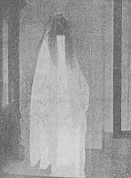

Prof. Albert Baron von Schrenck-Notzing
with Eva Carriere, materialisation medium
Photograph 1
Here we see the materialisation medium "Eva C" producing ectoplasm - or "teleplasm", as it is often referred to - under controlled test conditions.
Those present at this experiment, carried out 13th March 1911, included Mme. Bisson, Bisson's sister, Prof. Charles Richet, M. de Fontenary and Prof. Schrenck-Notzing.
"Sceptics" often complain that genuine psychic phenomena has not been repeated in any laboratory anywhere in the world - therefore science can not accept it.
However, the vast majority are completely unaware that in Prof. Schrenck-Notzing's book "Phenomena of Materialisation" there are some 225 ectoplasmic photographs - all performed under strict controlled test conditions. This does not include the experiments carried out by scientists such as Dr. Charles Richet, Sir William Crookes, Dr. T. Glen Hamilton, Dr. Gustave Geley, Dr. W. J. Crawford, to name a few.
In the photograph below, Eva C's left hand is being held by Dr. Charles Richet and her right by Prof. Schrenck-Notzing.
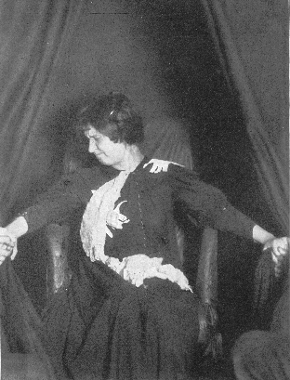

Prof. Albert Baron von Schrenck-Notzing
with Eva Carriere, materialisation medium
Photograph 2
An ectoplasmic face can be seen excluding from the neck of the materialisation medium Eva C, who according to her belongs to an entity named "Estelle".
This experiment, conducted with Mme. Bisson and Prof. Schrenck-Notzing as observers, was performed 30th December 1911.
Note: I have reproduced only one photograph from a collection of five that were taken at the same experiment using five different cameras. Such procedures, which were common practice in Prof. Schrenck-Notzing's experiments, greatly help to eliminate the possibility of fraud.
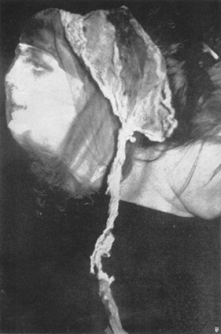

Prof. Albert Baron von Schrenck-Notzing
with Eva Carriere, materialisation medium
Photograph 3
Taken by Prof. Schrenck-Notzing on 8th May 1912, these two photographs show a remarkable half-finished ectoplasmic structure arrested in its development. (Note: the second photograph is a close-up of the first).
Those present include Mme Bisson, Prof Schrenck-Notzing and his wife.
Prof. Schrenck-Notzing said about these photographs; "The surface of the formation is covered by numerous folds, holes, and creases, while the lower half appears to consist of several broadcloth or paper bands unfolded, placed one upon the other, and organically joined and felted up with a veiling material. A crumpled mask, such as can be bought, would have a more complete appearance, and would hardly be organically connected with cloth fragments and veils, as is the case with the present structure." ("Phenomena of Materialisations" Shrenck-Notzing, pg.159)
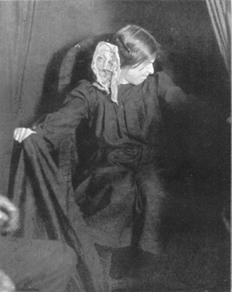
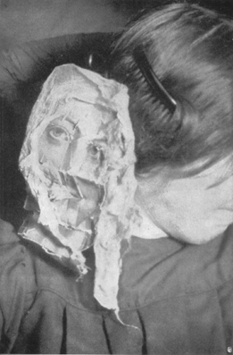

Prof. Albert Baron von Schrenck-Notzing
with Eva Carriere, materialisation medium
Photograph 4
Here are four micro-photographs of Eva's hair (first and third from the top) and "Estelle's" hair (second and fourth from the top).
(Note: Eva was the medium and "Estelle" was a materialisation. See photograph 2)
Prof. Schrenck-Notzing said "While Eva's hair showed altogether a brunette character, the hair taken from the small head ("Estelle") was light blonde. This impression is completely corroborated by the chemical examination and mircrophotography of the samples of hair of Eva and "Estelle" (the name by which the medium denotes the face photographed), which was made by Dr Steiner in Munich". He goes on to conclude, "It is therefore probable that both samples of hair belong to different individuals." ("Phenomena of Materialisations" Shrenck-Notzing, pg.133)
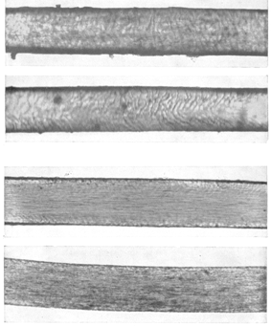

Photograph 5
This experiment was held on 1st June 1912 with Mme. Bisson and Prof. Schrenck-Notzing present.
Below are two remarkable materialisation photographs of Alexandre Bisson - the husband of Mme. Bisson - and the entity named "Berthe".
Prof. Schrenck-Notzing gave a very interesting account of this experiment in his book Phenomena of Materialisations. A section of it reads (pg.165) - "In spite of the three flash-light exposures, the phenomena continued. The structure now appeared on the left shoulder. Eva illuminated it first with the red and then with the white electric torch, but the image, in which I distinctly perceived a male bearded face, with a high forehead, would not suffer the light, and disappeared behind the back of Eva's chair towards the back of the cabinet, without Eva having changed the position of her hands. Since I had closely followed the image from the shoulder, I did not let it go out of sight, but rose and put my head deep into the cabinet, bending over Eva as she sat quietly, and keeping the curtain closed under my chin. In this way a ray of light passed over my head, through the top of the curtain, on to the back of the cabinet, without disturbing the medium. The male face then stood facing me like a male portrait in life-size, fixed on the back wall, remained for about six seconds, and then revolved about its own axis flat on the wall, the upper part of the face falling down, and finally disappeared towards the floor behind the medium's back. During this whole observation Eva's body was motionless, and under my observation. The image was entirely separated from her. Its motion and disappearance appeared to be under the control of an unseen power".
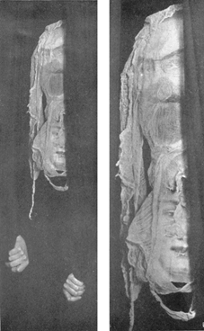

Prof. Albert Baron von Schrenck-Notzing
with Stanislava P, materialisation medium
Photograph 6
Below are two photographs, taken from two different angles, of the same ectoplasmic structure produced by the materialisation medium Stanislava P.
The attendees of this experiment, conducted February 15th 1913, included Mrs von Schrenck-Notzing., who superintended the mediums dressing, Countess K., Dr E. von Kaiser and Prof. Schrenck-Notzing.
Prof. Schrenck-Notzing said of these ectoplasmic structures, "The mediumistic products of the 25th and 31st January and of 15th February exhibit throughout a woolly character. With the help of wadding, one might perhaps produce similar pictures, but on further examination of the enlargements one does not anywhere find the characteristic fibrous composition of wadding. Besides, in manipulating wadding some fibres almost always adhere to the clothing, which could not be removed in the dark, and would have been found. Automatic motion is not found in any of the forms". ("Phenomena of Materialisations" Prof. Schrenck-Notzing, pg.256)
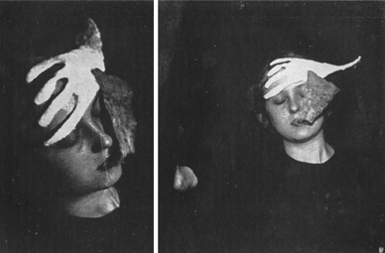

Photograph 7
This experiment, conducted 23rd June 1913, was attended by Herr von Kaiser, Herr Sch., Princess R., and Prof. Schrenck-Notzing.
As was common procedure in all of Prof. Schrenck-Notzing's experiments, the medium put on her specially-made costume in the presence of Mrs Schott and was examined by Dr. E. and Prof. Schrenck-Notzing. This costume was made out of fine transparent material to rule out the possibility of hidden packets, veils and material. Only her naked body was under the costume. She was not allowed to wear shoes. An examination of the hair, done up in a braid, and of the ears, mouth, etc, was also carried out by Dr. E and Prof. Schrenck-Notzing as part of the regular procedure.
In the photograph below Stanislava is wearing a whole tricot, with wide full bags for her hands, and a veil covering over her head. The fastening of the head veil and the tricot were lead-sealed.
After each experiment an examination of the medium and cabinet was always undertaken. This again further eliminated the possibility of fraud. In the experiment below the veils and lead seals were left intact after the experiment and during the process of materialisation - as they were in all the experiments.
Prof. Schrenck-Notzing says on page 257 in his book Phenomena of Materialisations, "It is interesting to note the difference between the regular square thread structure of the white veil, covering the hands, and the marking of the mediumistic product. A piece of the black veil seems to be drawn back into the mouth by Stanislava, so that the process of the penetration of the veil is not clearly shown. For this reason the experiment was repeated under the same conditions, with the head veil drawn more tightly, and the suggestion was made not to draw it into the mouth. But the experiment, in any case, is evidential, since the medium had no materials at her disposal with which she could have brought about such a result, outside her dress".
The repeated experiments, carried out 1st July 1913, were once again successful. The tighten veils on the mediums hands and head were untouched. Prof. Schrenck-Notzing said "The conditions of attachment in the experiment of the 1st July did not allow any further possibility of a fraudulent production of these phenomena." (Phenomena of Materialisation, pg.258)
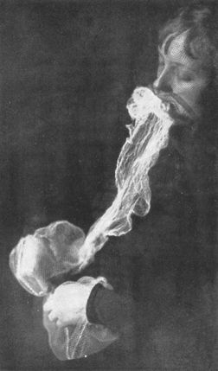

Prof. Gustave Geley
Paraffin Wax Gloves
Photograph 1
Here we see a photograph of a cast in plaster of a pair of materialised hands, from the paraffin wax "glove".  They were produced in the laboratory of the International Metapsychic Institute (Paris). The dark spots are defects in the plaster probably due (as in other cases) to crumbs of the blue colouring matter used to dye the paraffin.  Stanley de Brath, fellow psychical investigator with Dr. Gustave Geley, argues in his book Psychical Research, Science and Religion that experiments with hollow moulds of hands and feet, taken in paraffin wax, are among the most undeniable proofs of the reality of materialisation. | 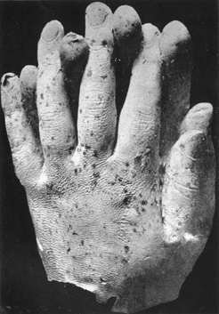

Photograph 2
Merging between Prof. Geley (left) and Stanely De Brath (right) is a case of direct-writing produced on the negative.  None of the mediums were, of course, permitted to touch the plates (which were specially marked and sealed by the Imperial Dry Plate Company) in any way, or to take part in the manipulation, which was done entirely by Stanley De Brath. | 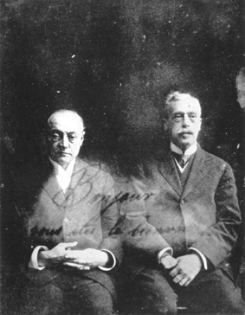

Prof. Gustave Geley
Etheric Photography
Photograph 3
The portrait of a lady can be seen overshadowing Prof. Geley (left). She was identified as an associate of Stanley De Brath and his wife for seventeen years, who had been deceased for six years at the time the photograph was taken.  In his book Psychical Research, Science and Religion, Stanely De Brath says, "This photograph did not reproduce any existing photograph but was instantly recognised by five persons who had known her well, including her own brother, a non-spiritualist and sceptically disposed". (Pg. 41)  De Brath also says, "I certify that this photograph was taken at Crewe by Mr Hope (medium), Nov 1919, on plates bought in London same day, opened by me and signed, not lost sight of during the whole process. Recognised by the lady's brother (non-spiritualist) and by three intimate friends. She "died" Aug, 1913. There is no similar portrait extant. S. De Brath. M.Inst.C.E" | 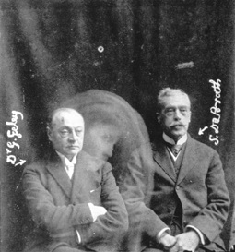

Prof. Gustave Geley
Etheric Photography
Photograph 4
The top photograph, was taken at the British College of Psychic Science, July 24th 1924, on a plate marked and sealed by the Imperial Dry Plate Company.  It shows the image of a suspended face above the head of Stanley De Brath. Notice also the ectoplasmic connection between the three people.  The photograph below is an enlargement of the above photograph, which has been tilted approximately 60 degress to the left.  The suspended image you can see towards the upper left hand corner of the photograph is the face of Dr. Geley, who was killed in a aeroplane crash in Warsaw, July 15th 1924. | 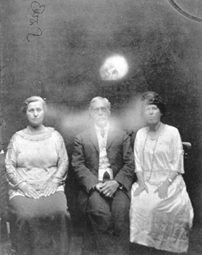  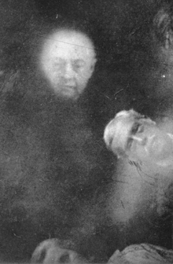

Helen Duncan, materialisation medium
Early experimental materialisations
Photograph 1
Here we see ectoplasm emerging from the nostril of one of Scotland's most famous materialisation mediums ever, Helen Duncan.
This photograph was taken by Harvey Metcalfe, F.C.I.S., during Helen Duncan's early stages of development as a materialisation medium. It should be pointed out that the materialisations at this stage were experimental and were not intended to resemble deceased persons.
As can be clearly seen below, Helen Duncan's feet were tied up and both hands were held by two sitters. The materialisation clears shows an attempt to materialise a baby. (The blindfold is to minimise the shock which the flashlight could cause to the eyes of the medium, who is extremely sensitive during this stage of the phenomena.)
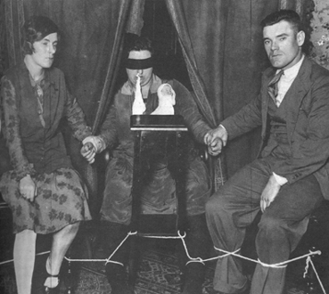

Jack Webber, independent direct-voice medium
Ectoplasm
Photograph 2
Here we see a photograph of the independent direct-voice medium Jack Webber. Clearly, a very long ectoplasmic structure can be seen oozing from his mouth.  Depending on the level of ability possessed by the medium, this ectoplasm will very often continue to develop until it becomes independent from the medium forming its own intelligence. This intelligence, however, does not originate from the medium's mind. It is controlled by the intelligence of etheric (deceased) individuals who use this substance to clothe their etheric bodies during materialisation experiments. This allows them to be seen, touched and heard in our physical world by all those present. | 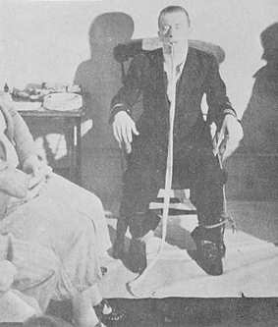

Jack Webber, independent direct-voice medium
Ectoplasm
Photograph 3
This photograph, the last secured through Jack Webber's mediumship shows the back of his coat in front of his body, while the sleeves are on the arms under the ropes. It is normally impossible to reproduce this effect.  At the beginning of this experiment Webber's coat was in its normal position. As part of the regular procedure his hands and legs were tied to the chair to eliminate the possibility of producing this effect fraudulently. | 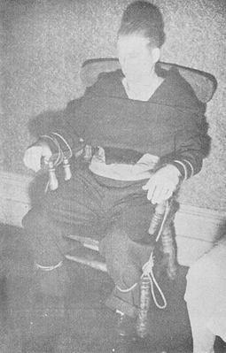

END

