**Boleskine House: New fire rips through Aleister Crowley's former home**

* 31 July 2019
* [Share this with Facebook](https://www.bbc.com/news/uk-scotland-highlands-islands-49186622?fbclid=IwAR17ih3Zmpk7kP6Q5FNg7RjYA1KCzvG9tDqsx0iTv9XDEwTtnLYGivysG7k)

* [Share this with Messenger](https://www.bbc.com/news/uk-scotland-highlands-islands-49186622?fbclid=IwAR17ih3Zmpk7kP6Q5FNg7RjYA1KCzvG9tDqsx0iTv9XDEwTtnLYGivysG7k)

* [Share this with Twitter](https://www.bbc.com/news/uk-scotland-highlands-islands-49186622?fbclid=IwAR17ih3Zmpk7kP6Q5FNg7RjYA1KCzvG9tDqsx0iTv9XDEwTtnLYGivysG7k)

* [Share this with Email](mailto:?subject=Shared%20from%20BBC%20News&body=https%3A%2F%2Fwww.bbc.com%2Fnews%2Fuk-scotland-highlands-islands-49186622)

* [Share](https://www.bbc.com/news/uk-scotland-highlands-islands-49186622?fbclid=IwAR17ih3Zmpk7kP6Q5FNg7RjYA1KCzvG9tDqsx0iTv9XDEwTtnLYGivysG7k#share-tools)

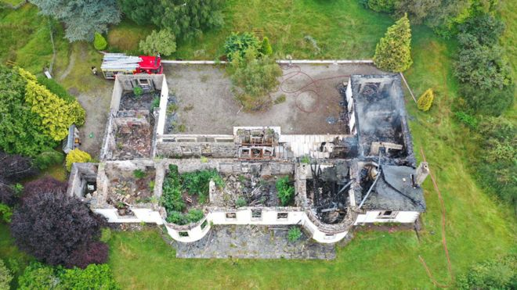Image copyrightANDREW SMITHImage captionFirefighters were called to the derelict property on Wednesday afternoon

**Firefighters have tackled another blaze at the ruined former home of notorious occultist Aleister Crowley.**

Boleskine House along, overlooking Loch Ness, was badly damaged by [**a blaze in 2015**](https://www.bbc.co.uk/news/uk-scotland-highlands-islands-35171061) and the ruin was sold earlier this year.

Crowley was said to have performed occultist rituals at the property when he lived there between 1899 and 1913

The B-listed Georgian building was later owned by musician Jimmy Page, of Led Zeppelin.

The Scottish Fire and Rescue Service said the alarm was raised shortly before 16:00 on Wednesday and two appliances were sent to the property.

Police Scotland said it believed the fire was started deliberately and has appealed for witnesses.

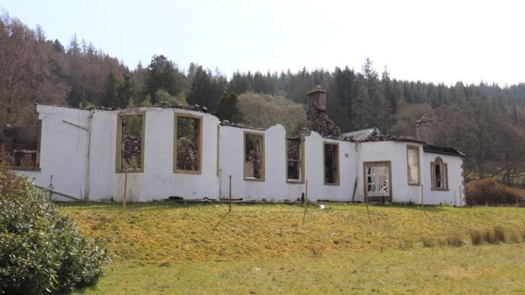Image copyrightGALBRAITHSImage captionThe house was left in ruins after a fire in 2015

Crews tackled separate blazes in Boleskine House and the neighbouring coach house.

The Friends of Boleskine House later posted on Facebook that the coach house had been saved but what was left of the roof of Boleskine House had collapsed.

The group said the fires were started deliberately.

Crowley, who died in 1947, was infamous in the late 19th Century and early 20th Century for his promotion of the occult.

During World War I, he wrote anti-British propaganda.

He was also an experienced climber and was part of an ill-fated attempt to scale K2, in modern day Pakistan, in 1902.

Jimmy Page bought Boleskine House in the 1970s because of the Crowley connection, before later selling it.

Police and fire service officers have started an investigation into Wednesday's fire.

Det Insp Eddie Ross said: "Our inquiries are at an early stage, although our initial assessment is that this fire was started deliberately.

"We would encourage anybody may have seen any activity around Boleskine House or nearby to come forward as soon as they can.

"It should go without saying that deliberately setting fires is incredibly dangerous as you have limited control over how they may develop."