The Eye of Providence or the All-Seeing Eye

http://en.wikipedia.org/wiki/Eye_of_Providence

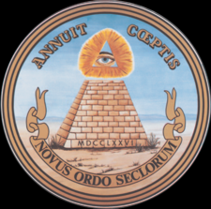
The 'Eye of Providence' floating above an unfinished pyramid on the reverse of the Great Seal of the United States.

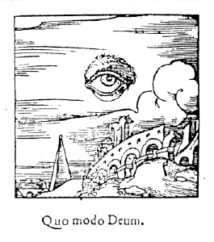
An alchemical woodcut, showing the all-seeing eye of God floating in the sky

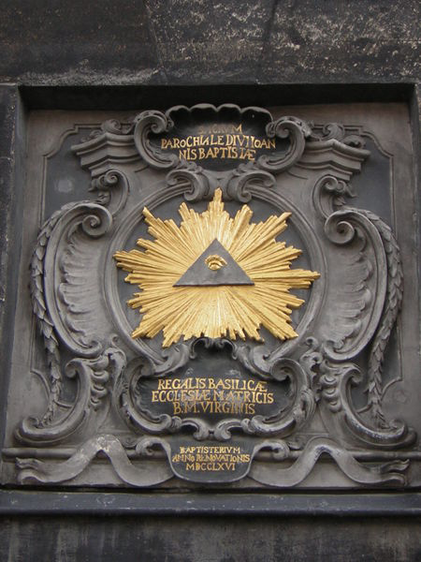
An all-seeing eye that appears on the tower of Aachen Cathedral

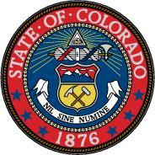
The eye on the Seal of Colorado

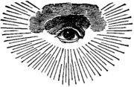
An early Masonic version of the Eye of Providence with clouds and a semi-circular glory.
The Eye of Providence or the all-seeing eye is a symbol showing an eye surrounded by rays of light or a glory, and usually enclosed by a triangle. It is commonly interpreted as representing the eye of God keeping watch on humankind (see Divine Providence).

Contents
- 1 Origin
- 2 United States
- 3 Freemasonry
- 4 Salt Lake Temple
- 5 Virgin of Garabandal
- 6 UFO Lore
- 7 Cao Dai
- 8 Illuminati
- 9 Current and recent usage
- 10 See also
- 11 External links
- 12 References

Origin
In its current form, the symbol first appeared in the west during the 17th & 18th centuries, but representations of an all-seeing eye can be traced back to Egyptian mythology and the Eye of Horus. 17th-century depictions of the Eye of Providence sometimes show it surrounded by clouds. The later addition of an enclosing triangle is usually seen as a more explicit trinitarian reference to the God of Christianity.

United States
In 1782 the Eye of Providence was adopted as part of the symbolism on the reverse side of the Great Seal of the United States. The Eye was introduced by the original design committee of 1776, and is thought to be the suggestion of the artistic consultant, Pierre Eugene du Simitiere.
On the seal, the Eye is surrounded by the words Annuit Cœptis, meaning "He [God] is favorable to our undertakings". The Eye is positioned above an unfinished pyramid with thirteen steps, representing the original thirteen states and the future growth of the country. The combined implication is that the Eye, or God, favors the prosperity of the United States.
The Great Seal is used to endorse official United States documents. As such, it is reproduced, along with the Eye of Providence, on the back of every one dollar bill.

[] Freemasonry
The Eye of Providence also appears as part of the iconography of the Freemasons. Here it represents the all-seeing eye of God, and is then a reminder that a Mason's deeds are always observed by God (who is referred to in Masonry as the Great Architect of the Universe). Typically the Masonic Eye of Providence has a semi-circular glory below the eye — often the lowest rays extend further down. Sometimes the Eye is enclosed by a triangle. Other variations of the symbol can also be found, with the eye itself being replaced by the letter ‘G’, representing both the art of geometry and God.
The first official Masonic reference to the Eye of Providence is in The Freemasons Monitor by Thomas Smith Webb in 1797, some years after the Great Seal was designed. The Masonic use of the Eye does not incorporate a pyramid, although the enclosing triangle is often interpreted as one.
It is a popular urban legend or conspiracy theory that the Eye of Providence and unfinished pyramid show the influence of Freemasonry in the founding of the United States. This was dramatised in the 2004 Disney film National Treasure.
Among the original design committee for the Great Seal of the United States, only Benjamin Franklin was a Mason, but his ideas were not adopted by the committee and he may not even have been aware of it. Many masonic organisations have denied any special connection to the original creation of the Seal. However, Henry A. Wallace, a prominent Freemason, claims the Masonic resonance of the "eye in the pyramid" influenced President Roosevelt to incorporate the eye into the design of the one dollar bill in 1935. "Roosevelt, as he looked at the colored reproduction of the Seal, was first struck with the representation of the all-seeing eye—a Masonic representation of the Great Architect of the Universe. Next, he was impressed with the idea that the foundation for the new order of the ages had been laid in 1776 but that it would be completed only under the eye of the Great Architect. Roosevelt was a 32nd Degree Mason. He suggested that the Seal be put on the dollar bill." [1]
Iowa State University has in its collection a photocopy of a one dollar bill bearing the words “A Token of the New Deal. Henry A. Wallace”. [2]

[] Salt Lake Temple
The Salt Lake Temple of The Church of Jesus Christ of Latter-day Saints uses the symbol in its architecture as a reminder that God sees all.

[] Virgin of Garabandal
According to some sources ^{[citation needed]}during the first apparition of the Virgin Mary at the village of Garabandal, she was accompanied by two identical angels on either side of her, and the flaming Eye above them all.

[] UFO Lore
According to some UFO witnesses, there have been several sightings of Men in Black wearing a symbol resembling the Eye in the Pyramid, sometimes with a lightning bolt through the eye. This symbol can allegedly often be found on their cars or lapels.

[] Cao Dai
The Vietnamese religion Cao Dai, as well as a number of other churches, uses the Eye of Providence (specifically, the left eye) within a triangle to represent God.

[] Illuminati
Today some conspiracy theorists link the symbol with conspiracy organizations, especially Adam Weishaupt's Bavarian Illuminati. This is possibly the only context in which the Eye of Providence is shown actually embedded in a pyramid. Some say the eye is meant to represent the Eye of Horus ("the new born Son," "God's Son.") or even the eye of Lucifer.^{[1][2]} The all-seeing eye is also mentioned along with Illuminati in Dan Brown's Book Angels and Demons

[] Current and recent usage
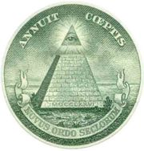
The Great Seal of the United States on a dollar bill
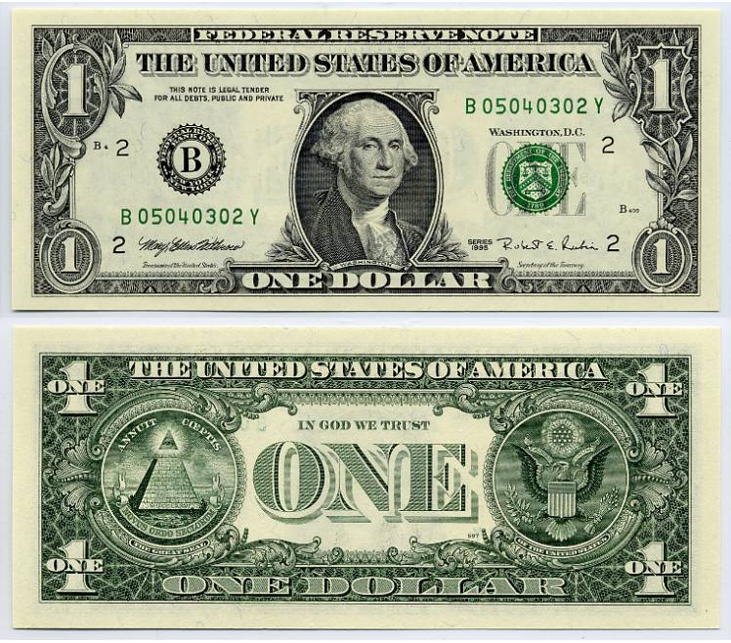
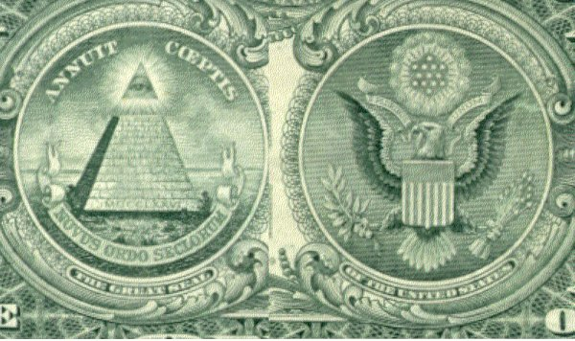

- Great Seal of the United States
  - Several American organisations also incorporate the Eye of Providence in their logos, through association with its use on the Great Seal
  - Dollar bill
  - Former logo of the Information Awareness Office
- Ukrainian 500 hryvnia bill (see image)
- Steve Jackson Games
- The logo of The All-Seeing Eye. A computer software application designed to help Internet gamers find game servers.
- In The Lord of the Rings, Sauron is described as having an all-seeing eye. In the Peter Jackson trilogy, Sauron himself is physically manifested as an eye.
- The pyramid and all-seeing eye are depicted on the covers of various albums by the 1960's psychedelic band the 13th Floor Elevators.

[] See also
- Eye of Horus - an Ancient Egyptian symbol of protection and power.
- The Third eye common to Buddhism, Hinduism, Surat Shabda Yoga and Rosicrucianism.
- Odin - One eyed due to his quest for knowledge.
- Evil eye - widely distributed element of folklore or superstition.
- Eye of Sauron - from J. R. R. Tolkien's The Lord of the Rings.
- Seeing Eye - guide dog training school.

[] External links
- Rosslyn Templars a modern Freemason's debunking of the myth of a connection between Freemasonry and the Great Seal of the United States.
- grand lodge of British columbia and yukon - response to claims of masonic origins of symbol
- grand lodge of British columbia and yukon - graphics from the kneph
- wealth4freedom.com/dollarbill - collection of links regarding the symbol and discussion regarding them

[] References
- ^ The Illuminati (2005), by Chris Everard and The Enigma Channel
- ^ The Illuminati Vol. II - The Antichrist Conspiracy (2006), by Chris Everard and The Enigma Channel
Retrieved from "http://en.wikipedia.org/wiki/Eye_of_Providence"
Categories: Articles with unsourced statements | Symbols
==================================================================================================================================
END

