Bohemian Club & Bohemian Grove

http://en.wikipedia.org/wiki/Bohemian_Club
http://en.wikipedia.org/wiki/Bohemian_Grove

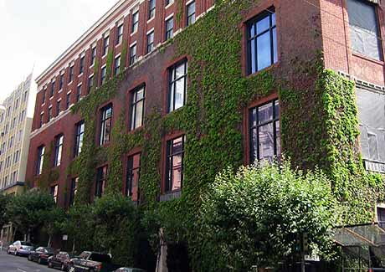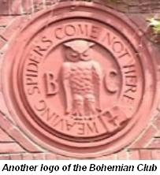



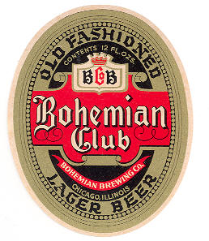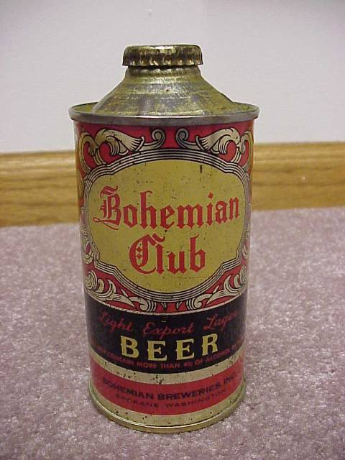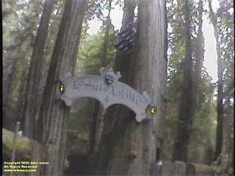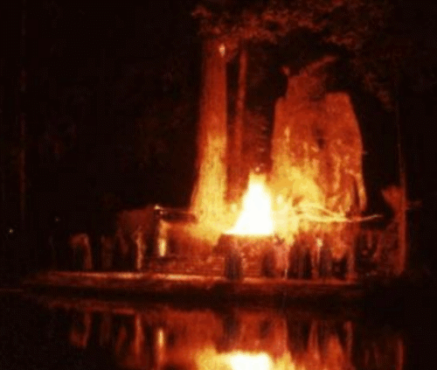

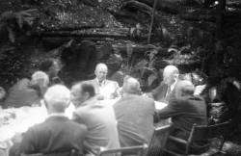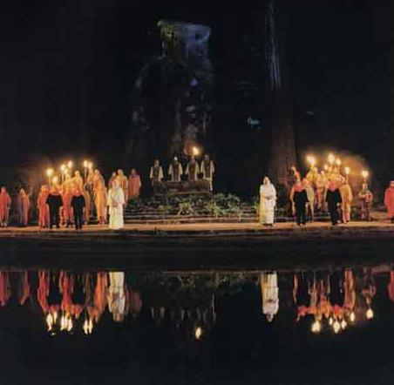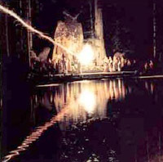
Lawrence lunching with future president Eisenhower and past president
Hoover at Bohemian Grove, July 23, 1950.

The Bohemian Club (founded in 1874) is a private men's art club based in San Francisco, California, with a membership of many prominent local and global leaders. In its diverse membership, and ranging from artists and musicians to leading businessmen, it was modelled on the prominent Century Club, based in New York.
The club was originally formed exclusively by journalists, who lamented the lack of art and culture in the post-gold rush San Francisco, and wanted to capture something of "la vie boheme" which had become popularized among the avant garde of the United States at the time. It was quickly apparent that the group needed to relax its rules for membership, and start permitting some people with no artistic talent but with major financial resources to join. Pretty soon, the "bohemian" writers were on their way out and the wealthy and powerful were in control of the club—which remains true today. The membership lists are private and only a few people outside of the club have ever seen them. Some prominent figures are given honorary membership only, Richard Nixon and William Randolph Hearst being two notable examples.
Members include some U.S. presidents (usually before they are elected to office), many cabinet officials, and CEOs of large corporations, including major financial institutions. Major military contractors, oil companies, banks (including the Federal Reserve), utilities, and national media have high-ranking officials as club members or guests. Many members are, or have been, on the board of directors of several of these corporations. However, artists and lovers of art are still among the most active members of the club and the Club's bylaws still require that there be a certain number of artists, writers, and other academics.
Every year the club hosts an annual two week camp at Bohemian Grove, which is notable for its illustrious guest list and its eclectic Cremation of Care ceremony involving a mock human sacrifice at the feet of a forty-foot stone owl. In addition to that ritual, there are also two outdoor performances, often with elaborate set design and orchestral accompaniment. The more elaborate of the two is called the High Jinx, the less elaborate and expensive of the two is the Low Jinx. More often than not, the productions are original creations of the "Talent" members, and the stage crew is composed of the regular members; corporate CEOs, bank presidents, politicians, etc. The club's motto, "Weaving Spiders Come Not Here", is featured in the club's logo, around a stern-looking owl.

See also
- Bohemian Grove for a more detailed description of the campout
- The book PiHKAL by Ann & Alexander Shulgin includes a description of some activities of one "Shura Borodin" (presumably Alexander Shulgin) as a member of the "Owl Club" (presumably the Bohemian Club).

Notes

External links
- Place of "The Cremation of Care Ceremony" Wikimapia
- More Information Who Rules America
- G. William Domhoff A sociologist who has obtained access to the Club and the Grove.
- A photograph of an elaborate ceremony taken at one of the Club's camps in 1915.
- A labour dispute involving the Bohemian Club.
======================================================================================================================================

Bohemian Grove

http://en.wikipedia.org/wiki/Bohemian_Grove

Bohemian Grove is an 11 km² (2700-acre) campground located at 20601 Bohemian Ave, in Monte Rio, California^{[1]} belonging to a private San Francisco-based men's fine arts club known as the Bohemian Club. In mid-July each year, Bohemian Grove hosts a two-week encampment of some of the most powerful men in the world.

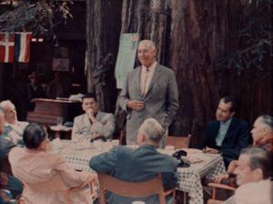
Ronald Reagan, Glenn T. Seaborg and Richard Nixon at the Bohemian Grove

Contents
- 1 Introduction
- 2 History
- 3 Past attendees
- 4 Facilities
- 5 Symbolism and rituals
  - 5.1 Cremation of Care
- 6 Rumors, Protests and Controversies
- 7 Quotations
- 8 Further reading
- 9 See also
- 10 References
- 11 External links

Introduction
The Bohemian Club's membership includes many artists, particularly musicians, as well as many high-ranking business leaders, government officials (including some US Presidents) and senior media executives. As a measure of the Club's exclusivity, it is reported the waiting list for membership is from 15 to 20 years, though a fast track, three-year membership process is possible. Two current members must sponsor a prospective member. An initiation fee of $25,000 as of 2006 is required in addition to yearly membership dues. Elected members are also allowed to prorate the initiation fee into equal annual payments until they reach the age of 45.
After 40 years of membership the men earn "Old Guard" status, giving them reserved seating at the Grove's daily talks, as well as other perquisites. Members may also invite guests to the Grove, who are subject to a rigorous screening procedure. These guests come from across America and overseas. Californian guests are generally limited to attendance at the "Spring Jinks", in June, preceding the main July encampment.
The Grove motto is "Weaving Spiders Come Not Here", which implies that outside concerns and business deals are to be left outside. However, there is demonstrable evidence of political and business deals having been developed at the Grove. The Grove is particularly famous for a Manhattan Project planning meeting that took place there in September of 1942, which subsequently led to the atomic bomb. Those attending, apart from Ernest Lawrence and military officials, included the president of Harvard and representatives of Standard Oil and General Electric. Grove members take particular pride in this event and often relate the story to new attendees.^{[2]}

[] History
Bohemian Grove was established over time, shortly after the founding of the Bohemian Club in 1872. For several years, the members of the Club camped together at various locations, including the present Muir Woods, Samuel P. Taylor State Park, and a separate redwood grove near Duncan Mills, down river from the current location. Regular July encampments similar to those held today began in 1899.
The first parcel of the grove was purchased from Melvin Cyrus Meeker who developed a successful logging operation in the area. Gradually over the next decades, members of the Club purchased land surrounding the original location to the perimeter of the basin in which it resides. This was done to secure the rights to the water, so that its water supply would not be affected by uphill operations.
Not long after the Club's establishment by newspaper journalists, it was commandeered by prominent San Francisco-based businessmen, who provided the financial resources necessary to acquire further acreage and facilities at the Grove. They still retained the "bohemians" however — the artists and musicians — who continued to entertain international members and guests.
The Grove itself consists of redwood trees over 1,500 years old. It is a spectacular nature preserve, untouched by logging, and containing many elevated walkways. The longevity of the redwoods stands as emblematic of an untouched natural setting, far removed from modern day vulgarity. This traditional "purity" underpins the Cremation of Care ceremony (see below).

[] Past attendees
The Bohemian Club is a private club; only active members of the Club (known as "Bohos") and their guests may visit the Grove. These guests have been known to include politicians and notable figures from countries outside the US. Particularly during the midsummer encampment, the number of guests is strictly limited due to the small size of the facilities and membership in the Bohemian Club does not necessarily confer the right to attend the annual encampment. Nevertheless, up to 1,500 members and guests have been reported as attending some of the annual encampments.
Both the annual Club Membership and Grove Guest Lists are kept secret but a few dedicated researchers have gained access to some of them. [See Peter Martin Phillips' Dissertation, Kerry Richardson and Joel van der Reijden's comprehensive Membership List (refer External Links below) for references to these names.] From these varied sources, reportedly, notable past attendees have included:
- Jeb Bush  - Henry Kissinger  - George Shultz  - Earl Warren  - Robert Kennedy  - David Rockefeller  - David Rockefeller, Jr.  - Nelson Rockefeller  - James Wolfensohn  - Alan Greenspan  - Paul Volcker  - Colin Powell  - Jack Welch  - David Packard  - Riley P. Bechtel  - Henry Ford II  - Prince Philip  - John Major  - Helmut Schmidt  - Lee Kuan Yew  - James A. Baker III  - Newt Gingrich  - Arnold Schwarzenegger  - Bob Novak  - Malcolm Forbes  - David S. Broder  - Neil Armstrong  - Mark Twain  - Francis Ford Coppola  - Charlton Heston  - Clint Eastwood  - Walter Cronkite  - Billy Gibbons  - Mickey Hart  - Donald Rumsfeld | From the current administration:  - George W. Bush  - Dick Cheney  - Karl Rove  American Presidents  - George Herbert Walker Bush  - Bill Clinton  - Ronald Reagan  - Jimmy Carter  - Gerald Ford  - Richard Nixon  - Dwight D. Eisenhower  - Harry Truman  - Herbert Hoover  - Calvin Coolidge  - William Howard Taft  - Theodore Roosevelt

[] Facilities
The primary activities taking place at the Grove are varied and expensive entertainment, such as an elaborate Grove Play (known as "High Jinx") and musical comedies ("Low Jinx") — where female roles are played by men in drag — produced by the members and associate members of the Club. Thus, the majority of common facilities are entertainment venues, interspersed among the giant redwoods.
There are also sleeping quarters, or "camps" scattered throughout the grove, of which it is reported there were a total of 104 as of 2005. These camps, which are frequently patrilineal, are the principal means through which high-level business and political contacts and friendships are formed. For senior corporate executives, the camps are said to be the pinnacle of socio-political networking in the US.
According to Joel van der Reijden (see External Links below for a full list of camps and substantive details on the past affiliations of the camps' members), the pre-eminent camps are:
- Mandalay (Big Business/Defense Contractors/Politics/US Presidents);
- Hill Billies (Big Business/Banking/Politics/Universities/Media);
- Cave Man (Think Tanks/Oil Companies/Banking/Defense Contractors/Universities/Media);
- Stowaway (Rockefeller Family Members/Oil Companies/Banking/Think Tanks);
- Uplifters (Corporate Executives/Big Business);
- Owls Nest (US Presidents/Military/Defense Contractors);
- Hideaway (Foundations/Military/Defense Contractors);
- Isle of Aves (Military/Defense Contractors);
- Lost Angels (Banking/Defense Contractors/Media);
- Silverado squatters (Big Business/Defense Contractors);
- Sempervirens (Californian-based Corporations);
- Hillside (Military — Joint Chiefs of Staff)
- Grove Stage — it is an amphitheatre with seating for 2,000 used primarily for the Grove Play production, on the last Friday of the midsummer encampment. The stage extends up the hill side, and is also home to the second largest outdoor pipe organ in the world.
- Field Circle — a bowl-shaped amphitheatre used for the mid-weekend, "Low Jinx" musical comedy, as well as for variety shows.
- Campfire Circle — has a campfire pit in the middle of the circle, surrounded by carved redwood log benches. Used for smaller shows in a more intimate setting.
- Museum Stage — a semi-outdoor venue with a covered stage. Lectures and small ensembles shows.
- Dining Circle — seating approximately 1500 diners simultaneously.
- Club House — built in 1903, it is the site of the Manhattan Project planning meeting held in 1942 (see above).
- The Owl Shrine and the Lake — an artificial lake in the middle of the grove, used for the noon-time concerts and also the venue of the Cremation of Care, that takes place on the first Saturday of the encampment. It is also the location of the daily (12.30pm) "Lakeside Talks." Professor G. William Domhoff (see below) states these significant informal talks (many on public policy issues) have been given over the years by entertainers, professors, astronauts, business leaders, cabinet officers, CIA directors, future presidents and former presidents; these have been the subject of ongoing controversy, as the transcripts of these talks have never been released to the public.

[] Symbolism and rituals
Since the founding of the club, the Bohemian Grove's symbol has been the owl, long held as a representative of wisdom. A forty-foot concrete owl stands at the head of the lake in the Grove and, since 1929, has served as the site of the yearly "Cremation of Care" ceremony (see below). The club's motto, Weaving Spiders Come Not Here, is taken from the second scene of Act 2 from A Midsummer Night's Dream; it signifies that the Grove is limited to exchanging friendship and the free sharing of common passion, summarized in the term, "the Bohemian Spirit."
The Club's patron saint is John of Nepomuk, who legend says suffered death at the hands of a Bohemian monarch rather than disclose the confessional secrets of the queen. A large wood carving of St. John in cleric robes with his index finger over his lips stands at the shore of the lake in the Grove, symbolising the secrecy kept by the Grove's attendees throughout its long history.

[] Cremation of Care
The Cremation of Care was devised in 1893 by a member named Joseph D. Redding, a lawyer from New York. During the ceremony, which serves as the opening to the Grove encampment, a mock human sacrifice representing "dull care" is cremated to symbolize the liberation of the participants.
Today, the ritual consists of hooded members accepting the effigy representing "dull care" from a ferryman traveling across a creek. Music and fireworks accompany the ritual, for dramatic effect. The mock human sacrifice is placed on an altar and set on fire. The ritual represents the act of embracing the revelry of Bohemian Grove while setting aside the "dull cares" of the outside world.
The ceremony takes place next to a 45-foot (15 m) high concrete owl statue. During the ceremony, audio plays through nearby speakers providing the illusion of a speaking statue. The voice of the former-newsman Walter Cronkite, a member of the Bohemian Club, is used as the voice of The Owl during the ceremony.
The ceremony involves the poling of a small boat across a lake containing an effigy of Care. Contrary to rumor, Care is not a child. Although "dead", Care has a speaking part and a deep voice. As suggested by the title, Care is eventually burned under the Owl statue towards the end of ceremony. This cremation symbolizes that within the Bohemian Grove members leave the care of the outside world. Contrary to rumor, no parts of the script contain reference to prisoners of the Druids representing enemy tribes such as the Gauls and Celts.
G.W. Domhoff, a sociologist, was able to obtain an unusual amount of access to the Bohemian Club's records and membership and was able to thoroughly research the group because of this. He was able to detail the Cremation of Care ceremony, along with the High and Low Jinx and other ceremonies and plays of the Club.
The ceremony is meant to represent the destruction or burning of worldly concern. Alex Jones infiltrated the Bohemian Grove in 2000 and filmed the final portion of the ceremony for his film Dark Secrets: Inside Bohemian Grove. The grove and Jones' investigation were also covered by Jon Ronson in Channel 4's four-part documentary, Secret Rulers of the World.

[] Rumors, Protests and Controversies
With the combination of secrecy, power, and an elite bias, the Bohemian Grove has been targeted annually for years. Specifically, the Bohemian Grove Action Network organizes protests and has aided journalists who wish to penetrate the secrecy surrounding the encampment. Over the years, individuals have infiltrated the Grove then later published video and claimed accounts of the activities at Bohemian Grove.
On July 15, 2000, Austin, Texas-based journalist and filmmaker Alex Jones and his cameraman, Mike Hanson, became the first people to successfully infiltrate the Grove and make it out with documented evidence. With hidden cameras, Jones and Hanson were able to film the Cremation of Care ritual. The footage was the centerpiece of Jones' documentary, Dark Secrets: Inside Bohemian Grove. Jones states that a large number of men were in attendance during an "ancient Canaanite, Luciferian, Babylon mystery religion ceremony" involving a 45-foot statue of an owl which he named Moloch.
A fellow British journalist, Jon Ronson of Channel 4, documented his view of the ritual in his book, Them: Adventures With Extremists. Ronson's interpretation of the ritual was more sanguine; he felt it was a startlingly immature and weird way for world leaders to behave on their summer vacation, but did not see evidence of covert Satanism.
In the summer of 2005, a Grove employee named "Kyle" clandestinely shot more revealing footage and sent it to Alex Jones, who made it the centerpiece of a sequel, The Order of Death, which was released in 2005. This new footage reveals the Owl statue is hollow with a stone exterior. The Grove's public address system is controlled from within the statue, which is also apparently used as a storage area. Various effigies of Care were also found here. "Kyle" was also able to obtain two brochures about the festivities and a membership list.
Actor/writer Harry Shearer (This is Spinal Tap, Saturday Night Live), who has attended at least one Bohemian Club event, wrote and directed The Teddy Bears' Picnic, a parody of the Bohemian Grove conspiracy.

[] Quotations
- "The Bohemian Grove, that I attend from time to time — the (inaudible) and the others come there — but it is the most faggy goddamn thing that you would ever imagine. The San Francisco crowd, it's just terrible. I can't even shake hands with anybody from San Francisco." — President Richard M. Nixon, Bohemian Club member starting in 1953 (Domhoff, p 15);
- "If I were to choose the speech that gave me the most pleasure and satisfaction in my political career, it would be my Lakeside Speech at the Bohemian Grove in July 1967. Because this speech traditionally was off the record it received no publicity at the time. But in many important ways it marked the first milestone on my road to the presidency." — President Richard Nixon again, in a more mellow mood, in his Memoirs (1978), cited by Domhoff below. (The rule that sitting presidents are not allowed to attend the Grove was sparked by a media clamour to cover a Lakeside Talk that Nixon wanted to give in 1971, but was forced by the directors of the Grove to withdraw.)
- "The mood is reminiscent of high school. There's no end to the pee-pee and penis jokes, suggesting that these men, advanced in so many other ways, were emotionally arrested sometime during adolescence" — Philip Weiss, Spy Magazine journalist, who infiltrated the Grove in 1989.
- "So, I was there witnessing something right out of the medieval painter Hieronymus Bosch’s Visions of Hell: burning metal crosses, priests in red and black robes with the high priest in a silver robe with a red cape, a burning body screaming in pain, a giant stone great-horned owl, world leaders, bankers, media and the head of academia engaged in these activities. It was total insanity" — Alex Jones, describing the Cremation of Care ceremony he witnessed at the Grove in 2000 (see External Links below).

[] Further reading
- For a definitive look at the history of the Grove and the composition of Bohemian Club members and their social, business and political affiliations, updating Domhoff's book (below), see: A Relative Advantage: Sociology of the San Francisco Bohemian Club by Peter Martin Phillips, current Professor of Sociology at Sonoma State University in California. The dissertation covers 167 pdf pages and contains appendices and a bibliography. Phillips attended the Grove and conducted scores of interviews with attendees in his research.[2]
- Domhoff, G. William, The Bohemian Grove and Other Retreats: A study in ruling class cohesiveness, Harper and Row, 1974.
- Field, Charles K. , The Cremation of Care, 1946, 1953
- Fletcher, Robert H., The Annals of the Bohemian Club, Hicks-Judd, 1900
- Hanson, Mike, Bohemian Grove: Cult Of Conspiracy, iUniverse Inc, 2004
- Hoover, Herbert, Memoirs, Vol 2: The Cabinet and the Presidency, Macmillan, 1952. Hoover was a prominent figure in the Grove's history and coined the phrase: "The Greatest Men's Party on Earth".
- Ickes, Harold L. , The Secret Diary of Harold L. Ickes, Vol 1. The First Thousand Days, 1933-36. Simon and Schuster, 1953. Ickes was Secretary of the Interior during the New Deal.
- Isaacson, Walter, Kissinger: A Biography, New York: Simon & Schuster, 1992, (updated) 2005. Contains a brief reference to his attendance at the Grove and fame for his performances in various skits.
- Maupin, Armistead, Significant Others Chatto and Windus 1988. A fictionalised account of the grove, as described from the point of view of one of the major characters in this the fourth of the 'Tales from the city' series. Sympathetic and well informed, it includes an accurate description of the cremation of care ceremony. .
- McCartney, Laton, Friends in High Places: The Bechtel Story: The Most Secret Corporation and how It Engineered the World, Ballantine Books, Updated ion,1989. For the remarkable network of links between the Californian-based and privately-owned Bechtel Corporation and members of Reagan's Cabinet, along with their Camp membership in the Grove.
- Nader, Ralph, The Big Boys, Pantheon, 1987. Contains a chapter on high-level businessmen and the tightly-held secrecy of their Club membership.
- Nixon, Richard, RN : The Memoirs of Richard Nixon, Grosset & Dunlap, 1978.
- Quigley, Carroll, Tragedy And Hope: A History of the World in Our Time, G. S. G. & Associates, Incorporated, 1975. The seminal book by the history professor of Georgetown University that serves as the basis for many current conspiracy theories and studies of socio-economic elites.
- Santilli, Armand, The Boys at Bohemian Grove, Xlibris Corporation, 2004
- Schmidt, Helmut, Men and Powers : A Political Retrospective, Random House, 1990. He states in his memoirs that Germany had similar institutions, some of which included such rituals as Cremation of Care, but that his favorite was the Bohemian Grove.
- Shultz, George P., Turmoil and Triumph: Diplomacy, Power and the Victory of the American Ideal, Macmillan Publishing Company, 1993.
- van der Zee, John, Power at Ease: Inside the Greatest Men's Party on Earth, Harcourt Brace Javonovich, 1974. The author waited tables at the Grove in the summer of 1972. The book has a comprehensive history of the Grove and an extensive bibliography.
- Warren, Earl, The Memoirs of Chief Justice Earl Warren , Madison Books, 2001. A frequent attendee, Warren mentions the Grove in his reminiscences.
- Watson, Thomas J. Jr., & Peter Petre, Father, Son & Co. : My Life at IBM and Beyond, Bantam, 2000. A rare glimpse by a top IBM CEO of an insider's business perspective on the Grove.

[] See also
- Sun Valley Conferences — Annual meetings held over five days in early July in Idaho of top media/communications/IT business leaders/CEO's. Known also as Allen & Company conferences for its investment bank founder, regular attendees have included Bill Gates, Warren Buffett and Rupert Murdoch.
- Pacific-Union Club — An elite San Francisco-based club whose membership interlinks with the Bohemian Club and Grove.
- Rancheros visitadores — Annual meetings held in Santa Barbara in May.
Other international gatherings of high-level business/political/media officials:
- World Economic Forum — Annual meetings, mostly held in Davos, Switzerland
- Bilderberg Group — Annual meetings, rotated through the US, Canada, Europe and Asia
- Trilateral Commission — Annual meetings, rotated through the US, Europe and Asia

[] References
- ^ Google Earth, 37 25.818' N, 122 05.36' W.
- ^ Peter Martin Phillips, A Relative Advantage: Sociology of the San Francisco Bohemian Club, 1994[1]

[] External links
- Social Cohesion & the Bohemian Grove: The Power Elite at Summer Camp By G. William Domhoff, the current Research Professor at the University of California, Santa Cruz, who has attended the Grove.
- A Relative Advantage: Sociology of the Bohemian Grove, A Doctoral Dissertation by Peter Phillips, Ph.D., Professor of Sociology/Director of Project Censored, Sonoma State University.
- Article on the Bohemian Grove by Joël van der Reijden 2005 (Project for the Exposure of Hidden Institutions) Contains a detailed timeline on the history of the Club and Grove, an analysis of the possible origins of the Cremation of Care ritual, a list of known "Camps", and Club membership and attendees of the Grove.
- An Elite Alliance March 2006, article on former NASA head and current LSU Chancellor Sean O'Keefe's participation in the Bohemian Grove.
- Sonoma County Free Press: Bohemian Grove Action Network The protest group BGAN was formed in 1980 by Mary Moore and is still operative; it has employee contacts inside the Grove and has been given selected Grove Camp Membership (2004) and Guest (1979) lists.
- Kerry Richardson Index of Bohemian Grove Reportage Web site of a Santa Rosa, California based photographer and researcher; contains both text and photographs of camp attendees.
- Masters of the Universe Go to Camp: Inside the Bohemian Grove Spy Magazine journalist Philip Weiss infiltrated the Grove in 1989.
- Free Press International: Bohemian Grove Contains articles and names of attendees.
- FAIR: The Story People Magazine Won't Let You Read An account of a People Magazine journalist who infiltrated the Grove only to be evicted by his boss, a Time-Warner executive.
- Université Tangente See "Decipher the System" section and select "The Ring, upper social class." [Contains a purported authentic list (pdf) of Grove Camps' Membership (2002), but the list is not sourced.]
- "Downtime: Constructing Leisure" See a site-related installation by the collective Bureau d'études that focuses on the history and impact of the Bohemian Club and its annual retreat at the Grove.
- Bureau d'études installation view Gallery view of the Bureau d'études Bohemian Club project (4th slide).
- Ralph Nader interview on the Bohemian Grove On Sonoma County Radio Station KSRO with Pat Thurston, in July, 2005 (audio files).
- The Bohemian Grove Is an Offshoot of Skull and Bones — New, Exclusive Photos
- Old Bohemia, New Bohemia Compares Bohemian Grove and Burning Man, Forbes Magazine.
- Sacramento News & Review article
- Rotten Library Entry on the Bohemian Grove
- On The Right Mentions Newt Gingrich, National Review.
- Transcript Of US Secretary of Defence Donald Rumsfeld at the tribute to Milton Friedman: He regrets missing the 2001 birthday lunch that Ed Feulner hosted every year on the road to Bohemian Grove.
- Teddy Bears' Picnic IMDB page.
- Alex Jones interview Goes into detail about how he managed to infiltrate the Grove in July, 2000.
- David Gergen confronted in public with questions about Bohemian Grove
- Archive of Bohemian Grove material
- Research Material : Bohemian Grove & Club Tidbits Contains excerpts from various articles/books on the Grove.
- Information page on Bohemian Grove and The Cremation of Care
- Fairness & Accuracy in Reporting Article on Bohemian Grove that mentions the ceremony
- Example of international policy being set at Bohemian Grove: see http://hnn.us/roundup/entries/18069.html or http://anglonoel.blogspot.com/2005/11/piece-on-bohemian-grove.html
- Joke/Prankster Rapper MC Weak conducts a "lyrical investigation" of the Bohemian Grove.

- Maps and aerial photos Coordinates: 38.462057° -122.992201°
  - Satellite image from WikiMapia, Google Maps or Windows Live Local
  - Street map from MapQuest or Google Maps
  - Topographic map from TopoZone
  - Aerial image from TerraServer-USA
- Place of "The Cremation of Care Ceremony" Wikimapia
- Map Drawing Who Rules America
=================================================================================================================================
END

