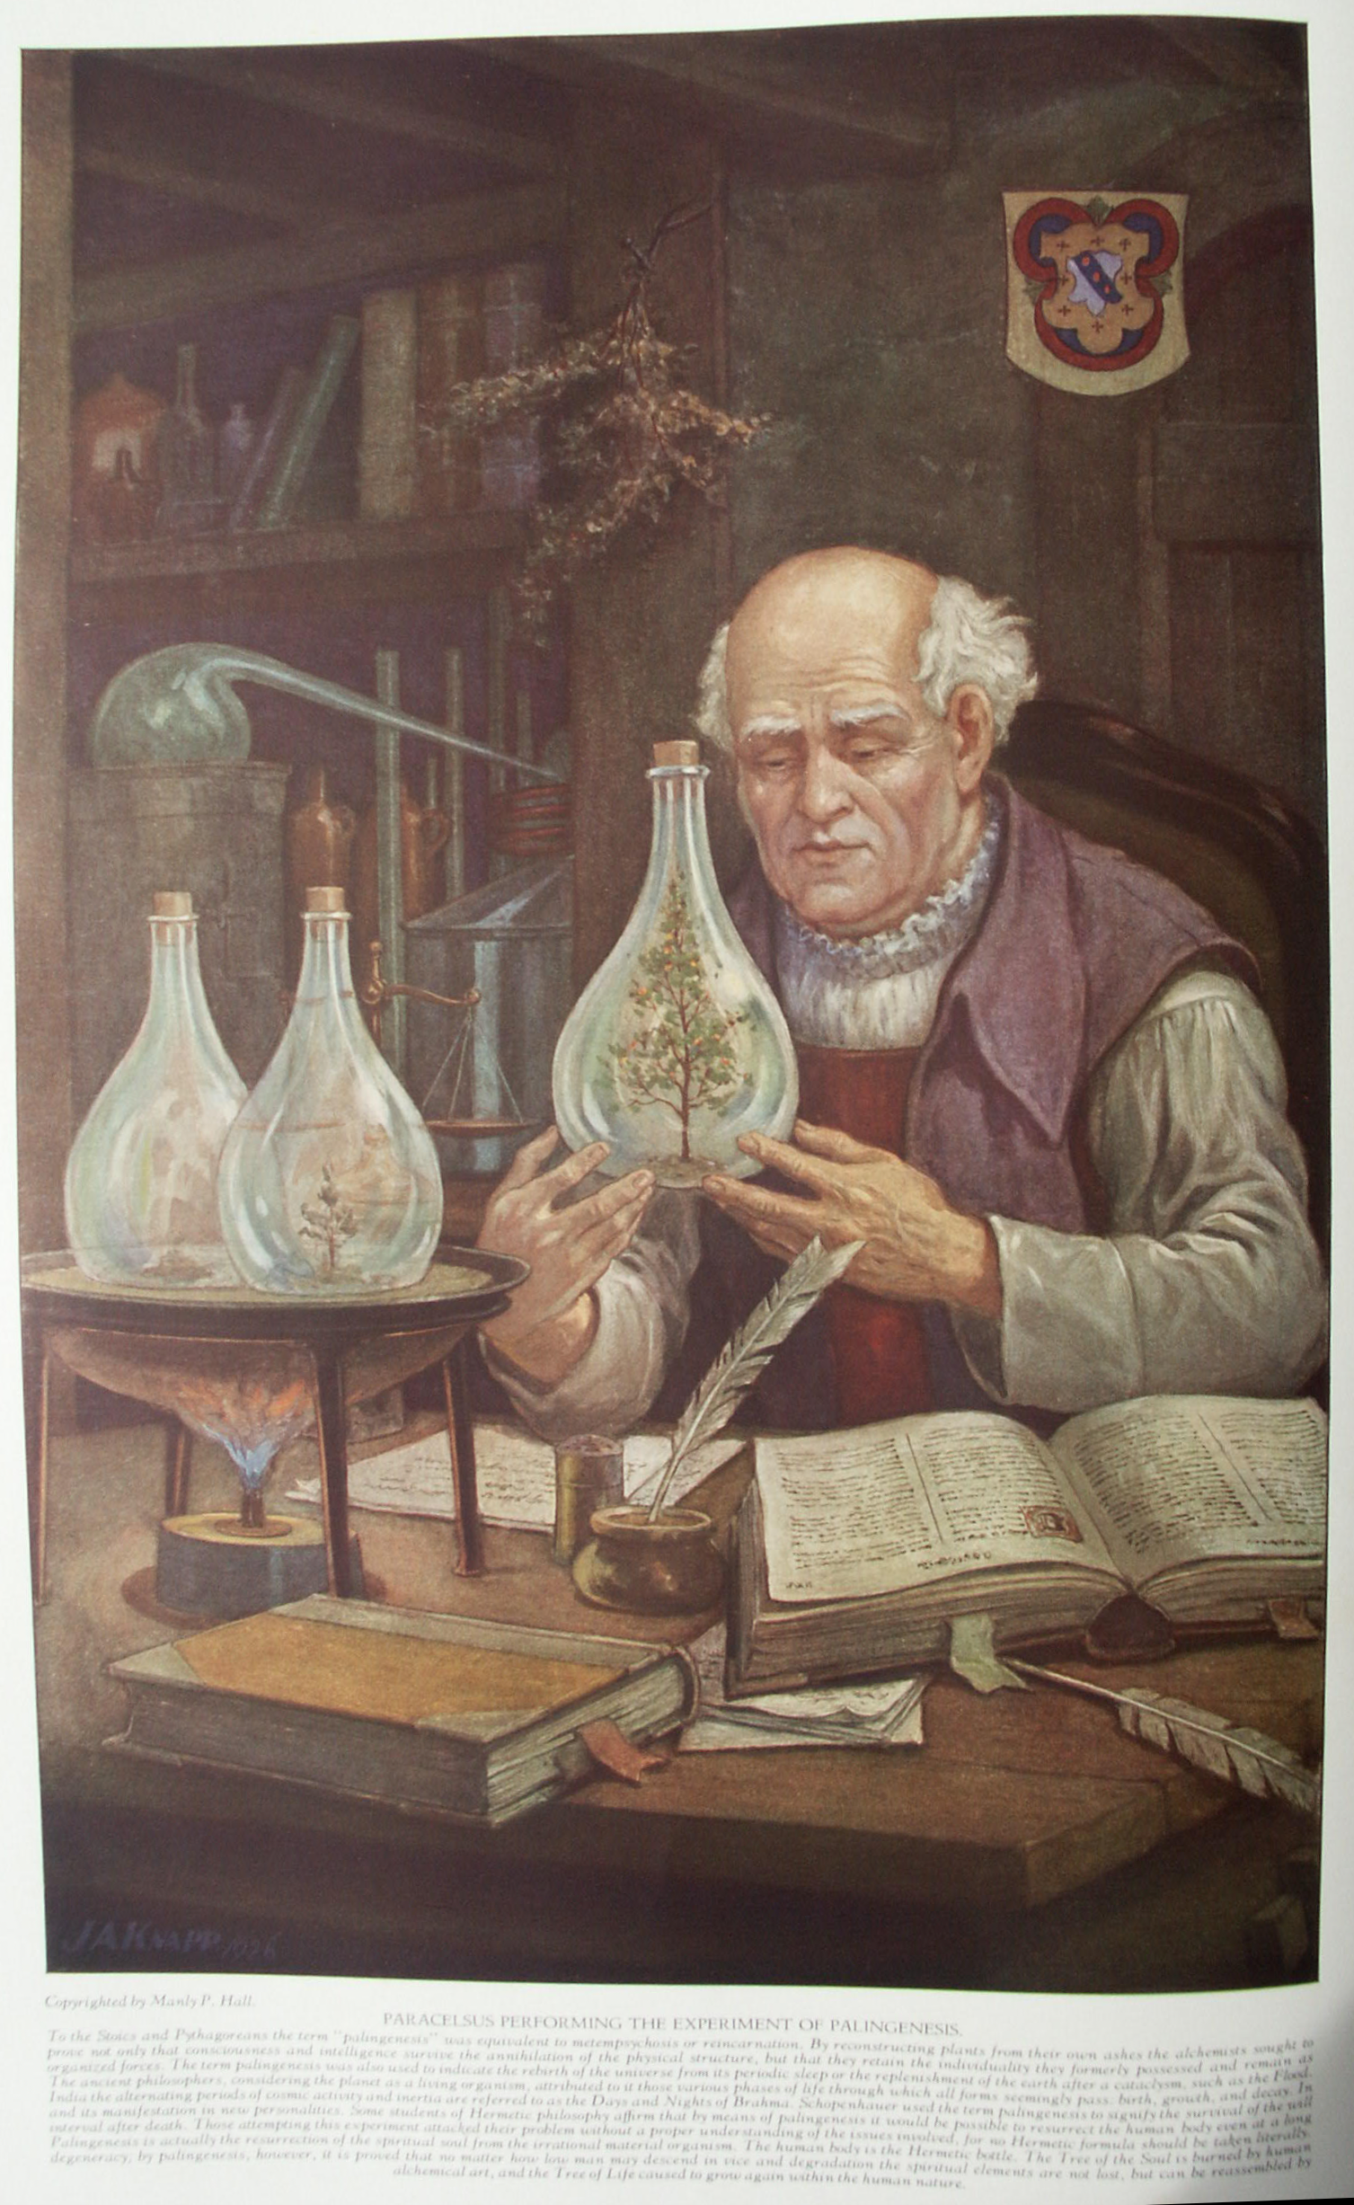

Alchemy
The Secret Teachings of All Ages - Manly P. Hall 1928

ALCHEMY AND ITS EXPONENTS
The multiplication of metals--The medal of Emperor Leopold I--Paracelsus of Hohenheim--Raymond Lully--Nicholas Flarnmel--Count Bernard of Treviso.
THE THEORY AND PRACTICE OF ALCHEMY
The origin of alchemical philosophy--Alexander the Great and the talking trees--Nature and art--Alchemical symbolism--The Song of Solomon--The Philosopher's Gold.
THE THEORY AND PRACTICE OF ALCHEMY, PART II
The alchemical prayer--The Emerald Tablet of Hermes--A letter from the Brothers of R.C.--The magical Mountain of the Moon--An alchemical formula--The dew of the sages.

Alchemy and Its Exponents
IS the transmutation of base metals into gold possible? Is the idea one at which the learned of the modern world can afford to scoff? Alchemy was more than a speculative art: it was also an operative art. Since the time of the immortal Hermes, alchemists have asserted (and not without substantiating evidence) that they could manufacture gold from tin, silver, lead, and mercury. That the galaxy of brilliant philosophic and scientific minds who, over a period of two thousand years, affirmed the actuality of metallic transmutation and multiplication, could be completely sane and rational on all other problems of philosophy and science, yet hopelessly mistaken on this one point, is untenable. Nor is it reasonable that the hundreds declaring to have seen and performed transmutations of metals could all have been dupes, imbeciles, or liars.
Those assuming that all alchemists were of unsound mentality would be forced to put in this category nearly all the philosophers and scientists of the ancient and mediæval worlds. Emperors, princes, priests, and common townsfolk have witnessed the apparent miracle of metallic metamorphosis. In the face of existing testimony, anyone is privileged to remain unconvinced, but the scoffer elects to ignore evidence worthy of respectful consideration. Many great alchemists and Hermetic philosophers occupy an honored niche in the Hall of Fame, while their multitudinous critics remain obscure. To list all these sincere seekers after Nature's great arcanum is impossible, but a few will suffice to acquaint the reader with the superior types of intellect who interested themselves in this abstruse subject.
Among the more prominent names are those of Thomas Norton, Isaac of Holland, Basil Valentine (the supposed discoverer of antimony), Jean de Meung, Roger Bacon, Albertus Magnus, Quercetanus Gerber (the Arabian who brought the knowledge of alchemy to Europe through his writings), Paracelsus, Nicholas Flarnmel, John Frederick Helvetius, Raymond Lully, Alexander Sethon, Michael Sendivogius, Count Bernard of Treviso, Sir George Ripley, Picus de Mirandola, John Dee, Henry Khunrath, Michael Maier, Thomas Vaughan, J. B. von Helmont, John Heydon, Lascaris, Thomas Charnock, Synesius (Bishop of Ptolemais), Morieu, the Comte di Cagliostro, and the Comte de St.-Germain. There are legends to the effect that King Solomon and Pythagoras were alchemists and that the former manufactured by alchemical means the gold used in his temple.
Albert Pike takes sides with the alchemical philosophers by declaring that the gold of the Hermetists was a reality. He says: "The Hermetic science, like all the real sciences, is mathematically demonstrable. Its results, even material, are as rigorous as that of a correct equation. The Hermetic Gold is not only a true dogma, a light without Shadow, a Truth without alloy of falsehood; it is also a material gold, real, pure, the most precious that can be found in the mines of the earth." So much for the Masonic angle.
William and Mary jointly ascended the throne of England in 1689, at which time alchemists must have abounded in the kingdom, for during the first year of their reign they repealed an Act made by King Henry IV in which that sovereign declared the multiplying of metals to be a crime against the crown. In Dr. Sigismund Bacstrom's Collection of Alchemical Manuscripts is a handwritten copy of the Act passed by William and Mary, copied from Chapter 30 of Statutes at Large for the first year of their reign. The Act reads as follows: "An Act to repeal the Statute made in the 5th year of King Henry IV, late king of England, [wherein] it was enacted, among other things, in these words, or to this effect, namely: 'that none from henceforth should use to multiply Gold or Silver or use the craft of multiplication, and if any the same do they shall incur the pain of felony.' And whereas, since the making of the said statute, divers persons have by their study, industry and learning, arrived to great skill & perfection in the art of melting and refining of metals, and otherwise improving and multiplying them and their ores, which very much abound in this realm, and extracting gold and silver our of the same, but dare not to exercise their said skill within this realm, for fear of falling under the penalty of the said statute, but exercise the said art in foreign parts, to the great loss and detriment of this realm: Be it therefore enacted by the King's and Queen's most excellent Majesties, by and with the advice and consent of the Lords spiritual and temporal and Commons in this present parliament assembled, that from henceforth the aforesaid branch, article, or sentence, contained in the said act, and every word, matter and thing contained in the said branch or sentence, shall be repealed, annulled, revoked, and for ever made void, any thing in the said act to the contrary in any wise whatsoever notwithstanding. Provided always, and be it enacted by the authority aforesaid, that all the gold and silver that shall be extracted by the aforesaid art of melting or refining of metals, and otherwise improving and multiplying of them and their ores, as before set forth, be from henceforth employed for no other use or uses whatsoever but for the increase of monies; and that the place hereby appointed for the disposal thereof shall be their Majesties mint, within the Tower of London, at which place they are to receive the full and true value of their gold and silver, so procured, from time to time, according to the assay and fineness thereof, and so for any greater or less weight, and that none of that metal of gold and silver so refined and procured be permitted to be used or disposed of in any other place or places within their Majesties dominions." After this repealing measure had become effective, William and Mary encouraged the further study of alchemy.
Dr. Franz Hartmann has collected reliable evidence concerning four different: alchemists who transmuted base metals into gold not once but many times. One of these accounts concerns a monk of the Order of St. Augustine named Wenzel Seiler, who discovered a small amount of mysterious red powder in his convent. In the presence of Emperor Leopold I, King of Germany, Hungary, and Bohemia, he transmuted quantities of tin into gold. Among other things which he dipped into his mysterious essence was a large silver medal. That part of the medal which came in contact with the gold-producing substance was transmuted into the purest quality of the more precious metal. The rest remained silver. With regard to this medal, Dr. Hartmann writes:
"The most indisputable proof (if appearances can prove anything) of the possibility of transmuting base metals into gold, may be seen by everyone who visits Vienna; it being a medal preserved in the Imperial treasury chamber, and it is stated that this medal, consisting originally of silver, has been partly transformed into gold, by alchemical means, by the same Wenzel Seiler who was afterwards made a knight by the Emperor Leopold I. and given the title Wenzeslaus Ritter von Reinburg. "(In the Pronaos of the Temple of Wisdom.)
Space limitations preclude a lengthy discussion of the alchemists. A brief sketch of the lives of four should serve to show the general principles on which they worked, the method by which they obtained their knowledge, and the use which they made of it. These four were Grand Masters of this secret science; and the stories of their wanderings and strivings, as recorded by their own pens and by contemporaneous disciples of the Hermetic art, are as fascinating as any romance of fiction.

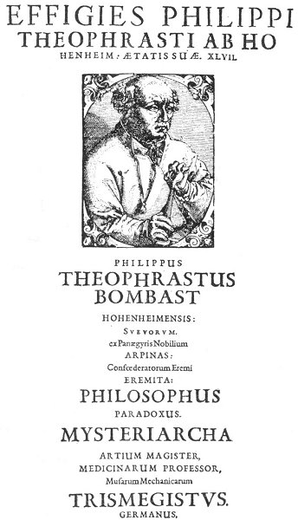
PARACELSUS.
From The Complete Writings of Paracelsus, of Hohenheim.
In his Biographia Antiqua, Francis Barrett appends to the name of Paracelsus the following titles of distinction: "The Prince of Physicians and Philosophers by Fire; Grand Paradoxical Physician; The Trismegistus of Switzerland; First Reformer of Chymical Philosophy; Adept in Alchymy, Cabala, and Magic; Nature's Faithful Secretary; Master of the Elixir of Life and The Philosopher's Stone," and the "Great Monarch of Chymical Secrets"

PARACELSUS OF HOHENHEIM
The most famous of alchemical and Hermetic philosophers was Philippus Aureolus Theophrastus Bombastus von Hohenheim. This man, who called himself Paracelsus, declared that some day all the doctors of Europe would turn from the other schools and, following him, revere him above every other physician. The accepted date of the birth of Paracelsus is December 17, 1493. He was an only child. Both his father and mother were interested in medicine and chemistry. His father was a physician and his mother the superintendent of a hospital. While still a youth, Paracelsus became greatly interested in the writings of Isaac of Holland, and determined to reform the medical science of his day.
When twenty years old he began a series of travels which continued for about twelve years. He visited many European countries, including Russia. It is possible that he penetrated into Asia. It was in Constantinople that the great secret of the Hermetic arts was bestowed upon him by Arabian adepts. His knowledge of the Nature spirits and the inhabitants of the invisible worlds he probably secured from the Brahmins of India with whom he came in contact either directly or through their disciples. He became an army physician, and his understanding and skill brought him great success.
Upon his return to Germany, he began his long-dreamed-of reformation of the medical arts and sciences. He was opposed on every hand and criticized unmercifully. His violent temper and tremendously strong personality undoubtedly precipitated many storms upon his head which might have been avoided had he been of a less caustic disposition. He flayed the apothecaries, asserting that they did not use the proper ingredients in their prescriptions and did not consider the needs of their patients, desiring only to collect exorbitant fees for their concoctions.
The remarkable cures which Paracelsus effected only made his enemies hate him more bitterly, for they could not duplicate the apparent miracles which he wrought. He not only treated the more common diseases of his day but is said to have actually cured leprosy, cholera, and cancer. His friends claimed for him that he all but raised the dead. His systems of healing were so heterodox, however, that slowly but surely his enemies overwhelmed him and again and again forced him to leave the fields of his labors and seek refuge where he was not known.
There is much controversy concerning the personality of Paracelsus. That he had an irascible disposition there is no doubt. His barred for physicians and for women amounted to a mania; for them he had nothing but abuse. As far as can be learned, there was never a love affair in his life. His peculiar appearance and immoderate system of living were always held against him by his adversaries. It is believed that his physical abnormalities may have been responsible for much of the bitterness against society which he carried with him throughout all his intolerant and tempestuous life.
His reputed intemperance brought upon him still more persecution, for it was asserted that even during the time of his professorship in the University of Basel he was seldom sober. Such an accusation is difficult to understand in view of the marvelous mental clarity for which he was noted at all times. The vast amount of writing which he accomplished (the Strassburg Edition of his collected works is in three large volumes, each containing several hundred pages) is a monumental contradiction of the tales regarding his excessive use of alcoholics.
No doubt many of the vices of which he is accused were sheer inventions by his enemies, who, not satisfied with hiring assassins to murder him, sought to besmirch his memory after they had revengefully ended his life. The manner in which Paracelsus met his death is uncertain, but: the most credible account is that he died as the indirect result of a scuffle with a number of assassins who had been hired by some of his professional enemies to make away with the one who had exposed their chicanery.
Few manuscripts are extant in the handwriting of Paracelsus, for he dictated the majority of his works to his disciples, who wrote them down. Professor John Maxson Stillman, of Stanford University, pays the following tribute to his memory: "Whatever be the final judgment as to the relative importance of Paracelsus in the upbuilding of medical science and practice, it must be recognized that he entered upon his career at Basel with the zeal and the self-assurance of one who believed himself inspired with a great truth, and destined to effect a great advance in the science and practice of medicine. By nature he was a keen and open-minded observer of whatever came under his observation, though probably also not a very critical analyst of the observed phenomena. He was evidently an unusually self-reliant and independent thinker, though the degree of originality in his thought may be a matter of legitimate differences of opinion. Certainly once having, from whatever combination of influences, made up his mind to reject the sacredness of the authority of Aristotle, Galen and Avicenna, and having found what to his mind was a satisfactory substitute for the ancient dogmas in his own modification of the neo-Platonic philosophy, he did not hesitate to burn his ships behind him.
"Having cut loose from the dominant Galenism of his time, he determined to preach and teach that the basis of the medical science of the future should be the study of nature, observation of the patient, experiment and experience, and not the infallible dogmas of authors long dead. Doubtless in the pride and self-confidence of his youthful enthusiasm he did not rightly estimate the tremendous force of conservatism against which he directed his assaults. If so, his experience in Basel surely undeceived him. From that time on he was to be a wanderer again, sometimes in great poverty, sometimes in moderate comfort, but manifestly disillusioned as to the immediate success of his campaign though never in doubt as to its ultimate success--for to his mind his new theories and practice of medicine were at one with the forces of nature, which were the expression of God's will, and eventually they must prevail."
This strange man, his nature a mass of contradictions, his stupendous genius shining like a star through the philosophic and scientific darkness of mediæval Europe, struggling against the jealousy of his colleagues as well as against the irascibility of his own nature, fought for the good of the many against the domination of the few. He was the first man to write scientific books in the language of the common people so that all could read them.
Even in death Paracelsus found no rest. Again and again his bones were dug up and reinterred in another place. The slab of marble over his grave bears the following inscription: "Here lies buried Philip Theophrastus the famous Doctor of Medicine who cured Wounds, Leprosy, Gout, Dropsy and other incurable Maladies of the Body, with wonderful Knowledge and gave his Goods to be divided and distributed to the Poor. In the Year 1541 on the 24th day of September he exchanged Life for Death. To the Living Peace, to the Sepulchred Eternal Rest."
A. M. Stoddart, in her Life of Paracelsus, gives a remarkable testimonial of the love which the masses had for the great physician. Referring to his tomb, she writes: "To this day the poor pray there. Hohenheim's memory has 'blossomed in the dust' to sainthood, for the poor have canonized him. When cholera threatened Salzburg in 1830, the people made a pilgrimage to his monument and prayed him to avert it from their homes. The dreaded scourge passed away from them and raged in Germany and the rest of Austria." It was supposed that one early teacher of Paracelsus was a mysterious alchemist who called himself Solomon Trismosin. Concerning this person nothing is known save that after some years of wandering he secured the formula of transmutation and claimed to have made vast amounts of gold. A beautifully illuminated manuscript of this author, dated 1582 and called Splendor Solis, is in the British Museum. Trismosin claimed to have lived to the age of 150 as the result of his knowledge of alchemy. One very significant statement appears in his Alchemical Wanderings, which work is supposed to narrate his search for the Philosopher's Scone: "Study what thou art, whereof thou art a part, what thou knowest of this art, this is really what thou art. All that is without thee also is within, thus wrote Trismosin."
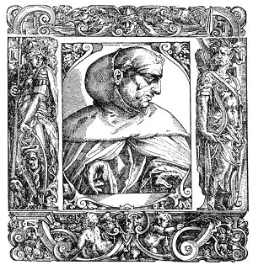
ALBERTUS MAGNUS.
From Jovius' Vitae Illustrium Virorum.
Albert de Groot was born about 1206 and died at the age of 74. It has been said of him that he was "magnus in magia, major in philosophia, maximus in theologia." He was a member of the Dominican order and the mentor of St. Thomas Aquinas in alchemy and philosophy. Among other positions of dignity occupied by Albertus Magnus was that of Bishop of Regensburg. He was beatified in 1622. Albertus was an Aristotelian philosopher, an astrologer, and a profound student of medicine and physics. During his youth, he was considered of deficient mentality, but his since service and devotion were rewarded by a vision in which the Virgin Mary appeared to him and bestowed upon him great philosophical and intellectual powers. Having become master of the magical sciences, Albertus began the construction of a curious automaton, which he invested with the powers of speech and thought. The Android, as it was called, was composed of metals and unknown substances chosen according to the stars and endued with spiritual qualities by magical formulæ and invocations, and the labor upon it consumed over thirty years. St. Thomas Aquinas, thinking the device to be a diabolical mechanism, destroyed it, thus frustrating the labor of a lifetime. In spite of this act, Albertus Magnus left to St. Thomas Aquinas his alchemical formulæ, including (according to legend) the secret of the Philosopher's Stone.
On one occasion Albertus Magnus invited William II, Count of Holland and King of the Romans, to a garden party in midwinter. The ground was covered with snow, but Albertus, had prepare a sumptuous banquet in the open grounds of his monastery at Cologne. The guests were amazed at the imprudence of the philosopher, but as they sat down to eat Albertus, uttered a few words, the snow disappeared, the garden was filled with flowers and singing birds, and the air was warm with the breezes of summer. As soon as the feast was over, the snow returned, much to the amazement of the assembled nobles. (For details, see The Lives of Alchemystical Philosophers.)

RAYMOND LULLY
This most famous of all the Spanish alchemists was born about the year 1235. His father was seneschal to James the First of Aragon, and young Raymond was brought up in the court surrounded by the temptations and profligacy abounding in such places. He was later appointed to the position which his father had occupied. A wealthy marriage ensured Raymond's financial position, and he lived the life of a grandee.
One of the most beautiful women at: the court of Aragon was Donna Ambrosia Eleanora Di Castello, whose virtue and beauty had brought her great renown. She was at that time married and was not particularly pleased to discover that young Lully was rapidly developing a passion for her. Wherever she went Raymond followed, and at last over a trivial incident he wrote some very amorous verses to her, which produced an effect quite different from what he had expected. He received a message inviting him to visit the lady. He responded with alacrity. She told him that it was only fair that he should behold more of the beauty concerning which he wrote such appealing poems and, drawing aside part of her garments, disclosed that one side of her body was nearly eaten away by a cancer. Raymond never recovered from the shock. It turned the entire course of his life. He renounced the frivolities of the court and became a recluse.
Sometime afterwards while doing penance for his worldly sins a vision appeared to him in which Christ told him to follow in the direction in which He should lead. Later the vision was repeated. Hesitating no longer, Raymond divided his property among his family and retired to a hut on the side of a hill, where he devoted himself to the study of Arabic, that he might go forth and convert the infidels. After six years in this retreat he set out with a Mohammedan servant, who, when he learned that Raymond was about to attack the faith of his people, buried his knife in his master's back. Raymond refused to allow his would-be assassin to be executed, but later the man strangled himself in prison.
When Raymond regained his health he became a teacher of the Arabic language to those who intended traveling in the Holy Land. It was while so engaged that he came in contact: with Arnold of Villa Nova, who taught him the principles or alchemy. As a result of this training, Raymond learned the secret of the transmutation and multiplication of metals. His life of wandering continued, and during the course of it he arrived at Tunis, where he began to debate with the Mohammedan teachers, and nearly lost his life as the result of his fanatical attacks upon their religion. He was ordered to leave the country and never to return again upon pain of death. Notwithstanding their threats he made a second visit to Tunis, but the inhabitants instead of killing him merely deported him to Italy.
An unsigned article appearing in Household Words, No. 273, a magazine conducted by Charles Dickens, throws considerable light on Lully's alchemical ability. "Whilst at Vienna he [Lully] received flattering letters from Edward the Second, King of England, and from Robert Bruce, King of Scotland, entreating him to visit them. He had also, in the course of his travels, met with John Cremer, Abbot of Westminster, with whom he formed a strong friendship; and it was more to please him than the king, that Raymond consented to go to England. [A tract by John Cremer appears in the Hermetic Museum, but there is no record in the annals of Westminster of anyone by that name.] Cremer had an intense desire to learn the last great secret of alchemy--to make the powder of transmutation--and Raymond, with all his friendship, had never disclosed it. Cremer, however, set to work very cunningly; he was not long in discovering the object that was nearest to Raymond's heart--the conversion of the infidels. He told the king wonderful stories of the gold Lully had the art to make; and he worked upon Raymond by the hope that King Edward would be easily induced to raise a crusade against the Mahommedans, if he had the means.
"Raymond had appealed so often to popes and kings that he had lost all faith in them; nevertheless, as a last hope, he accompanied his friend Cremer to England. Cremer lodged him in his abbey, treating him with distinction; and there Lully at last instructed him in the powder, the secret of which Cremer had so long desired to know. When the powder was perfected, Cremer presented him to the king, who received him as a man may be supposed to receive one who could give him boundless riches. Raymond made only one condition; that the gold he made should not be expended upon the luxuries of the court or upon a war with any Christian king; and that Edward himself should go in person with an army against the infidels. Edward promised everything and anything.
"Raymond had apartments assigned him in the Tower, and there he tells us he transmuted fifty thousand pounds weight of quicksilver, lead, and tin into pure gold, which was coined at the mint into six million of nobles, each worth about three pounds sterling at the present day. Some of the pieces said to have been coined out of this gold are still to be found in antiquarian collections. [While desperate attempts have been made to disprove these statements, the evidence is still about equally divided.] To Robert Bruce he sent a little work entitled Of the Art of Transmuting Metals. Dr. Edmund Dickenson relates that when the cloister which Raymond occupied at Westminster was removed, the workmen found some of the powder, with which they enriched themselves.
"During Lully's residence in England, he became the friend of Roger Bacon. Nothing, of course, could be further from King Edward's thoughts than to go on a crusade. Raymond's apartments in the Tower were only an honorable prison; and he soon perceived how matters were. He declared that Edward would meet with nothing but misfortune and misery for his breach of faith. He made his escape from England in 1315, and set off once more to preach to the infidels. He was now a very old man, and none of his friends could ever hope to see his face again.
"He went first to Egypt, then to Jerusalem, and thence to Tunis a third time. There he at last met with the martyrdom he had so often braved. The people fell upon him and stoned him. Some Genoese merchants carried away his body, in which they discerned some feeble signs of life. They carried him on board their vessel; but, though he lingered awhile, he died as they came in sight of Majorca, on the 28th of June, 1315, at the age of eighty-one. He was buried with great honour in his family chapel at St. Ulma, the viceroy and all the principal nobility attending."

NICHOLAS FLAMMEL
In the latter part of the fourteenth century there lived in Paris one whose business was that of illuminating manuscripts and preparing deeds and documents. To Nicholas Flammel the world is indebted for its knowledge of a most remarkable volume, which he bought for a paltry sum from some bookdealer with whom his profession of scrivener brought him in contact. The story of this curious document, called the Book of Abraham the Jew, is best narrated in his own words as preserved in his Hieroglyphical Figures: "Whilst therefore, I Nicholas Flammel, Notary, after the decease of my parents, got my living at our art of writing, by making inventories, dressing accounts, and summing up the expenses of tutors and pupils, there fell into my hands for the sum of two florins, a guilded book, very old and large. It was not of paper, nor of parchment, as other books be, but was only made of delicate rinds (as it seemed to me) of tender young trees. The cover of it was of brass, well bound, all engraven with letters, or strange figures; and for my part I think they might well be Greek characters, or some such like ancient language. Sure I am. I could not read them, and I know well they were not notes nor letters of the Latin nor of the Gaul, for of them we understand a little.

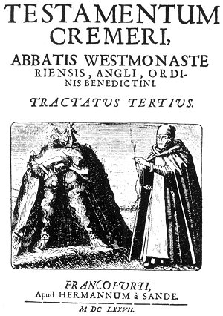
TITLE PAGE OF ALCHEMICAL TRACT ATTRIBUTED TO JOHN CREMER.
From Musæum Hermeticum Reformatum et Amplificatum.
John Cremer, the mythical Abbot of Westminster, is an interesting personality in the alchemical imbroglio of the fourteenth century. As it is not reasonably certain that m abbot by such a name ever occupied the See of Westminster, the question naturally arises, "Who was the person concealing his identity under the Pseudonym of John Cremer?" Fictitious characters such as John Cremer illustrate two important practices of mediæval alchemists: (1) many persons of high political or religious rank were secretly engaged in Hermetic chemical research but, fearing persecution and ridicule, published their findings under various pseudonyms; (2) for thousands of years it was the practice of those initiates who possessed the true key to the great Hermetic arcanum to perpetuate their wisdom by creating imaginary persons, involving them in episodes of contemporaneous history and thus establishing these beings as prominent members of society--in some cases even fabricating complete genealogies to attain that end. The names by which these fictitious characters were known revealed nothing to the uniformed. To the initiated, however, they signified that the personality to which they were assigned had no existence other than a symbolic one. These initiated chroniclers carefully concealed their arcanum in the lives, thoughts, words. and acts ascribed to these imaginary persons and thus safely transmitted through the ages the deepest secrets of occultism as writings which to the unconversant were nothing more than biographies.

"As for that which was within it, the leaves of bark or rind, were engraven and with admirable diligence written, with a point of iron, in fair and neat Latin letters colored. It contained thrice seven leaves, for so were they counted in the top of the leaves, and always every seventh leaf there was painted a virgin and serpent swallowing her up. In the second seventh, a cross where a serpent was crucified; and the last seventh, there were painted deserts, or wildernesse, in the midst whereof ran many fair fountains, from whence there issued out a number of serpents, which ran up and down here and there. Upon the first of the leaves, was written in great capital letters of gold, Abraham the Jew, Prince, Priest, Levite, Astrologer, and Philosopher, to the Nation of the Jews, by the Wrath of God dispersed among the Gauls, sendeth Health. After this it was filled with great execrations and curses (with this word Maranatha, which was often repeated there) against every person that should cast his eyes upon it, if he were not Sacrificer or Scribe.
"He that sold me this book knew not what it was worth nor more than I when I bought it; I believe it had been stolen or taken from the miserable Jews, or found in some part of the ancient place of their abode. Within the book, in the second leaf, he comforted his nation, counselling them to fly vices, and above all idolatry, attending with sweet patience the coming of the Messias, Who should vanquish all the kings of the earth and should reign with His people in glory eternally. Without doubt this had been some very wise and understanding man.
"In the third leaf, and in all the other writings that followed, to help his captive nation to pay their tributes unto the Roman emperors, and to do other things, which I will not speak of, he taught them in common words the transmutation of metals; he painted the vessels by the sides, and he advertised them of the colors, and of all the rest, saving of the first agent, of the which he spake not a word, but only (as he said) in the fourth and fifth leaves entire he painted it, and figured it with very great cunning and workman ship: for although it was well and intelligibly figured and painted, yet no man could ever have been able to understand it, without being well skilled in their Cabala, which goeth by tradition, and without having well studied their books.
"The fourth and fifth leaves therefore, were without any writing, all full of fair figures enlightened, or as it were enlightened, for the work was very exquisite. First he painted a young man with wings at his ancles, having in his hand a Caducean rod, writhen about with two serpents, wherewith he struck upon a helmet which covered his head. He seemed to my small judgment, to be the God Mercury of the pagans: against him there came running and flying with open wings, a great old man, who upon his head had an hour glass fastened, and in his hand a book (or syrhe) like death, with the which, in terrible and furious manner, he would have cut off the feet of Mercury. On the other side of the fourth leaf, he painted a fair flower on the top of a very high mountain which was sore shaken with the North wind; it had the foot blue, the flowers white and red, the leaves shining like fine gold: and round about it the dragons and griffons of the North made their nests and abode.
"On the fifth leaf there was a fair rose tree flowered in the midst of a sweet garden, climbing up against a hollow oak; at the foot whereof boiled a fountain of most white water, which ran headlong down into the depths, notwithstanding it first passed among the hands of infinite people, who digged in the earth seeking for it; but because they were blind, none of them knew it, except here and there one who considered the weight. On the last side of the fifth leaf there was a king with a great fauchion, who made to be killed in his presence by some soldiers a great multitude of little infants, whose mothers wept at the feet of the unpitiful soldiers: the blood of which infants was afterwards by other soldiers gathered up, and put in a great vessel, wherein the sun and the moon came to bathe themselves.
"And because that this history did represent the more part of that of the innocents slain by Herod, and that in this book I learned the greatest part of the art, this was one of the causes why I placed in their church-yard these Hieroglyphic Symbols of this secret science. And thus you see that which was in the first five leaves.
"I will not represent unto you that which was written in good and intelligible Latin in all the other written leaves, for God would punish me, because I should commit a greater wickedness, than he who (as it is said) wished that all the men of the World had but one head that he might cut it off with one blow. Having with me therefore this fair book, I did nothing else day nor night, but study upon it, understanding very well all the operations that it showed, but not knowing with what matter I should begin, which made me very heavy and solitary, and caused me to fetch many a sigh. My wife Perrenella, whom I loved as myself, and had lately married was much astonished at this, comforting me, and earnestly demanding, if she could by any means deliver me from this trouble. I could not possibly hold my tongue, but told her all, and showed this fair book, whereof at the same instant that she saw it, she became as much enamoured as myself, taking extreme pleasure to behold the fair cover, gravings, images, and portraits, whereof notwithstanding she understood as little as I: yet it was a great comfort to me to talk with her, and to entertain myself, what we should do to have the interpretation of them."
Nicholas Flammel spent many years studying the mysterious book. He even painted the pictures from it all over the walls of his house and made numerous copies which he showed to the learned men with whom he came in contact, but none could explain their secret significance. At last he determined to go forth in quest of an adept, or wise man, and after many wanderings he met a physician--by name Master Canches--who was immediately interested in the diagrams and asked to see the original book. They started forth together for Paris, and or, the way the physician adept explained many of the principles of the hieroglyphics to Flammel, but before they reached their journey's end Master Canches was taken ill and died. Flammel buried him at Orleans, but having meditated deeply on the information he had secured during their brief acquaintance, he was able, with the assistance of his wife, to work out the formula for transmuting base metals into gold. He performed the experiment several times with perfect success, and before his death caused a number of hieroglyphic figures to be painted upon an arch of St. Innocent's churchyard in Paris, wherein he concealed the entire formula as it had been revealed to him from the Book of Abraham the Jew.

COUNT BERNARD OF TREVISO
Of all those who sought for the Elixir of Life and the Philosopher's Scone, few passed through the chain of disappointments that beset Count Bernard of Treviso, who was born in Padua in 1406 and died in 1490. His search for the Philosopher's Stone and the secret of the transmutation of metals began when he was but fourteen years of age. He spent not only a lifetime but also a fortune in his quest. Count Bernard went from one alchemist and philosopher to another, each of whom unfolded some pet theorem which he eagerly accepted and experimented with but always without the desired result. His family believed him to be mad and declared that he was disgracing his house by his experiments, which were rapidly reducing him to a state of penury. He traveled in many countries, hoping that in distant places he would find wise men capable of assisting him. At last as he was approaching his seventy-sixth year, he was rewarded with success. The great secrets of the Elixir of Life, the Philosopher's Stone, and the transmutation of metals were revealed to him. He wrote a little book describing the results of his labors, and while he lived only a few years to enjoy the fruitage of his discovery he was thoroughly satisfied that the treasure he had found was worth the lifetime spent in search of it. An example of the industry and perseverance displayed by him is to be found in one of the processes which some foolish pretender coaxed him to attempt and which resulted in his spending twenty years calcining egg shells and nearly an equal period distilling alcohol and other substances. In the history of alchemical research there never was a more patient and persevering disciple of the Great Arcanum.
Bernard declared the process of dissolution, accomplished not with fire but with mercury, to be the supreme secret of alchemy.
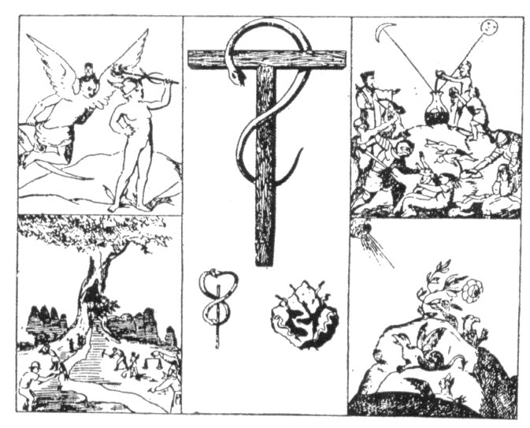
THE SYMBOLS OF ABRAHAM THE JEW.
From Flammel's Hieroglyphical Figures.
. Robert H. Fryar, in a footnote to his reprint of the Hieroglyphical Figures by Nicholas Flammel, says: "One thing which seems to prove the reality of this story beyond dispute, is, that this very book of Abraham the Jew, with the annotations of 'Flammel,' who wrote from the instructions he received from this physician, was actually in the hands of Cardinal Richelieu, as Borel was told by the Count de Cabrines, who saw and examined it."

===================================================================================================================================================

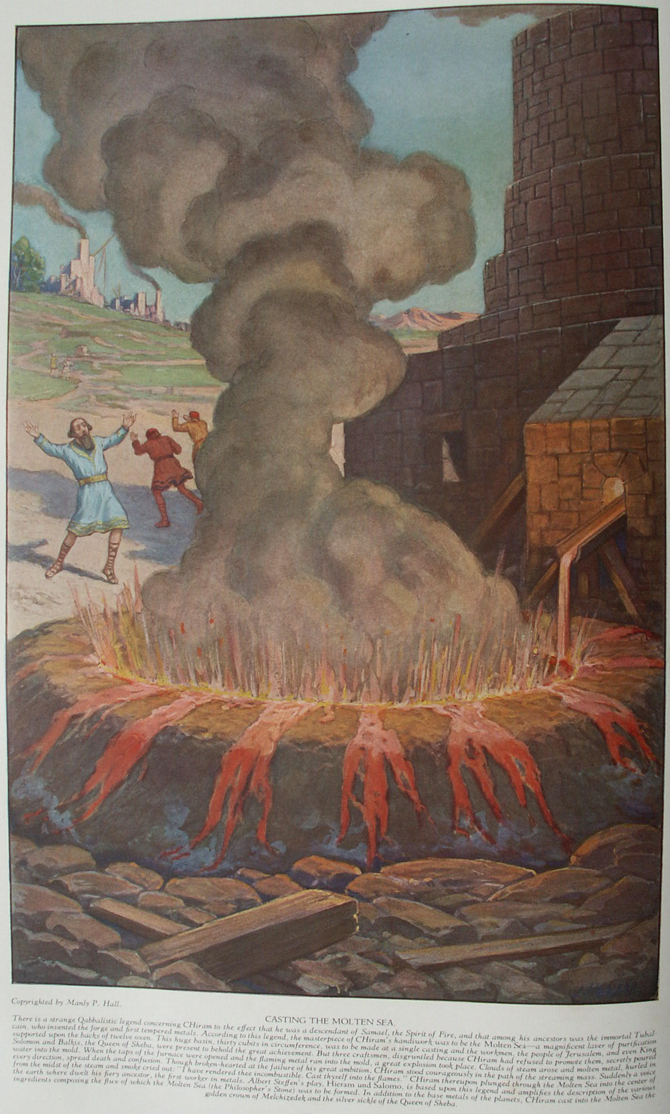

The Theory and Practice of Alchemy

Part One
ALCHEMY, the secret art of the land of Khem, is one of the two oldest sciences known to the world. The other is astrology. The beginnings of both extend back into the obscurity of prehistoric times. According to the earliest records extant, alchemy and astrology were considered as divinely revealed to man so that by their aid he might regain his lost estate. According to old legends preserved by the Rabbins, the angel at the gate of Eden instructed Adam in the mysteries of Qabbalah and of alchemy, promising that when the human race had thoroughly mastered the secret wisdom concealed within these inspired arts, the curse of the forbidden fruit would be removed and man might again enter into the Garden of the Lord. As man took upon himself "coats of skins" (physical bodies) at the time of his fall, so these sacred sciences were brought by him into the lower worlds incarnated in dense vehicles, through which their spiritual transcendental natures could no longer manifest themselves. Therefore they were considered as being dead or lost.
The earthly body of alchemy is chemistry, for chemists do not realize that half of The Book of Torah is forever concealed behind the veil of Isis (see the Tarot), and that so long as they study only material elements they can at best discover but half of the mystery. Astrology has crystallized into astronomy, whose votaries ridicule the dreams of ancient seers and sages, deriding their symbols as meaningless products of superstition. Nevertheless, the intelligentsia of the modern world can never pass behind the veil which divides the seen from the unseen except in the way appointed--the Mysteries.
What is life? What is intelligence? What is force? These are the problems to the solution of which the ancients consecrated their temples of learning. Who shall say that they did not answer those questions? Who would recognize the answers if given? Is it possible that under the symbols of alchemy and astrology lies concealed a wisdom so abstruse that the mind of this race is not qualified to conceive its principles?
The Chaldeans, Phœnicians, and Babylonians were familiar with the principles of alchemy, as were many early Oriental races. It was practiced in Greece and Rome; was the master science of the Egyptians. Khem was an ancient name for the land of Egypt; and both the words alchemy and chemistry are a perpetual reminder of the priority of Egypt's scientific knowledge. According to the fragmentary writings of those early peoples, alchemy was to them no speculative art. They implicitly believed in the multiplication of metals; and in the face of their reiterations both the scholar and the materialist should be more kindly in their consideration of alchemical theorems. Evolutionists trace the unfoldment of the arts and sciences up through the growing intelligence of the prehistoric man, while others, of a transcendental point of view, like to consider them as being direct revelations from God.
Many interesting solutions to the riddle of alchemy's origin have been advanced. One is that alchemy was revealed to man by the mysterious Egyptian demigod Hermes Trismegistus. This sublime figure, looming through the mists of time and bearing in his hand the immortal Emerald, is credited by the Egyptians as being the author of all the arts and sciences. In honor of him all scientific knowledge was gathered under the general title of The Hermetic Arts. When the body of Hermes was interred in the Valley of Ebron (or Hebron), the divine Emerald was buried with it. Many centuries afterward the Emerald was discovered--according to one version, by an Arabian initiate; according to another, by Alexander the Great, King of Macedon. By means of the power of this Emerald, upon which were the mysterious inscriptions of the Thrice Great Hermes--thirteen sentences in all--Alexander conquered all the then known world. Not having conquered himself, however, he ultimately failed. Regardless of his glory and power, the prophecies of the talking trees were fulfilled, and Alexander was cut down in the midst of his triumph. (There are persistent rumors to the effect that Alexander was an initiate of high order who failed because of his inability to withstand the temptations of power.)
E. Y. Kenealy, quoting from the Cosmodromium of Doctor Gobelin Persona, describes the incident of Alexander and the talking trees, into the presence of which the King of Macedon is said to have been brought while on his campaign in India: "And now Alexander marched into other quarters equally dangerous; at one time over the tops of mountains, at another through dark valleys, in which his army was attacked by serpents and wild beasts, until after three hundred days he came into a most pleasant mountain, on whose sides hung chains or ropes of gold. This mountain had two thousand and fifty steps all of purest sapphire, by which one could ascend to the summit, and near this Alexander encamped. And on a day, Alexander with his Twelve Princes, ascended by the aforenamed steps to the top of the Mountain, and found there a Palace marvellously beautiful, having Twelve Gates, and seventy windows of the purest gold, and it was called the Palace of the Sun, and there was in it a Temple all of gold, before whose gates were vine trees bearing bunches of carbuncles and pearls, and Alexander and his Princes having entered the Palace, found there a Man lying on a golden bedstead; he was very stately and beautiful in appearance, and his head and beard were white as snow. Then Alexander and his princes bent the knee to the Sage who spake thus: 'Alexander, thou shalt now see what no earthly man hath ever before seen or heard.' To whom Alexander made answer: 'O, Sage, most happy, how dost thou know me?' He replied: 'Before the wave of the Deluge covered the face of the earth I knew thy works.' He added: 'Wouldst thou behold the most hallowed Trees of the Sun and Moon, which announce all future things?' Alexander made answer: 'It is well, my lord; greatly do we long to see them.' * * *
"Then the Sage said: 'Put away your rings and ornaments, and take off your shoes, and follow me.' And Alexander did so, and choosing out three from the Princes, and leaving the rest to await his return, he followed the Sage, and came to the Trees of the Sun and Moon. The Tree of the Sun has leaves of red gold, the Tree of the Moon has leaves of silver, and they are very great, and Alexander, at the suggestion of the Sage questioned the Trees, asking if he should return in triumph to Macedon? to which the Trees gave answer, No, but that he should live yet another year and eight months, after which he should die by a poisoned cup. And when he inquired, Who was he who should give him that poison? he received no reply, and the Tree of the Moon said to him, that his Mother, after a most shameful and unhappy death, should lie long unburied, but that happiness was in store for his sisters." (See The Book of Enoch, The Second Messenger of God.)
In all probability, the so-called talking trees were merely strips of wood with tables of letters upon them, by means of which oracles were evoked. At one time books written upon wood were called "talking trees." The difficulty in deciding the origin of alchemy is directly due to ignoring the lost continent of Atlantis. The Great Arcanum was the most prized of the secrets of the Atlantean priestcraft. When the land of Atlas sank, hierophants of the Fire Mystery brought the formula to Egypt, where it remained for centuries in the possession of the sages and philosophers. It gradually moved into Europe, where its secrets are still preserved intact.
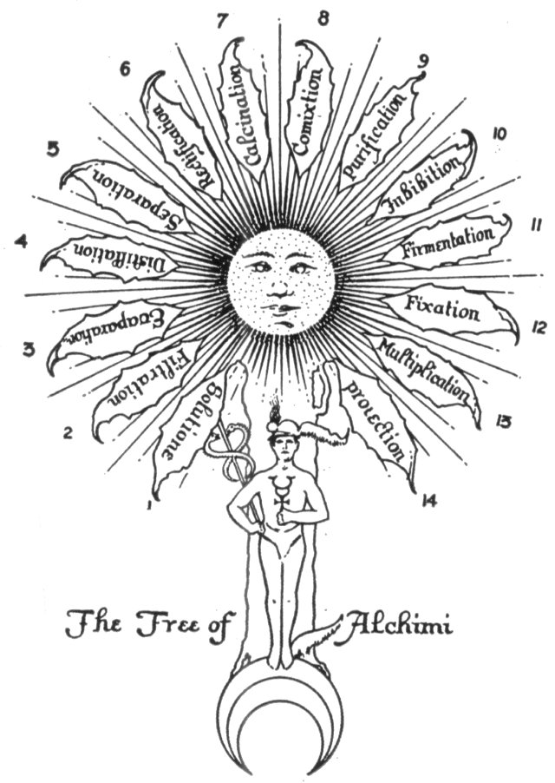
THE LEAVES OF HERMES' SACRED TREE.
Redrawn from an original manuscript dated 1577.
In his Key to Alchemy, Samuel Norton divides into fourteen parts the processes or states through which the alchemical substances pass from the time they are first placed in the test tube until ready as medicine for plants, minerals, or men:
1. Solution, the act of passing from a gaseous or solid condition, into one of liquidity.
2. Filtration, the mechanical separation of a liquid from the undissolved particles suspended in it.
3. Evaporation, the changing or converting from a liquid or solid state into a vaporous state with the aid of heat.
4. Distillation, an operation by which a volatile liquid may be separated from substances which it holds in solution.
5. Separation, the operation of disuniting or decomposing substances.
6. Rectification, the process of refining or purifying any substance by repeated distillation.
7. Calcination, the conversion into a powder or calx by the action of heat; expulsion of the volatile substance from a matter.
8. Commixtion, the blending of different ingredients into new compounds or mass.
9. Purification (through putrefaction), disintegration by spontaneous decomposition; decay by artificial means.
10. Inhibition, the process of holding back or restraining.
11. Fermentation, the conversion of organic substances into new compounds in the presence of a ferment.
12. Fixation, the act or process of ceasing to be a fluid and becoming firm; state of being fixed.
13. Multiplication, the act or process of multiplying or increasing in number, the state of being multiplied.
14. Projection, the process of turning the base Metals into gold.

Those disagreeing with the legend of Hermes and his Emerald Tablet see in the two hundred angels who descended upon the mountains, as described by the Prophet: Enoch, the first instructors in the alchemical art. Regardless of its originator, it was left to the Egyptian priests to preserve alchemy for the modern world. Egypt, because of the color of its earth, was called "the black empire" and is referred to in the Old Testament as "the land of darkness." By reason of its possible origin there, alchemy has long been known as "the black art, " not in the sense of evil but in the sense of that darkness which has always enshrouded its secret processes.
During the Middle Ages, alchemy was not only a philosophy and a science but also a religion. Those who rebelled against the religious limitations of their day concealed their philosophic teachings under the allegory of gold-making. In this way they preserved their personal liberty and were ridiculed rather than persecuted. Alchemy is a threefold art, its mystery well symbolized by a triangle. Its symbol is 3 times 3--three elements or processes in three worlds or spheres. The 3 times 3 is part of the mystery of the 33rd degree of Freemasonry, for 33 is 3 times 3, which is 9, the number of esoteric man and the number of emanations from the root of the Divine Tree. It is the number of worlds nourished by the four rivers that pour out of the Divine Mouth as the verbum fiat. Beneath the so-called symbolism of alchemy is concealed a magnificent concept, for this ridiculed and despised craft still preserves intact the triple key to the gates of eternal life. Realizing, therefore, that alchemy is a mystery in three worlds--the divine, the human, and the elemental--it can easily be appreciated why the sages and philosophers created and evolved an intricate allegory to conceal their wisdom.
Alchemy is the science of multiplication and is based upon the natural phenomenon of growth. "Nothing from nothing comes," is an extremely ancient adage. Alchemy is not the process of making something from nothing; it is the process of increasing and improving that which already exists. If a philosopher were to state that a living man could be made from a stone, the unenlightened would probably exclaim, "Impossible!" Thus would they reveal their ignorance, for to the wise it is known that in every stone is the seed of man. A philosopher might declare that a universe could be made out of a man, but the foolish would regard this as an impossibility, not realizing that a man is a seed from which a universe may be brought forth.
God is the "within" and the "without" of all things. The Supreme One manifests Himself through growth, which is an urge from within outward, a struggle for expression and manifestation. There is no greater miracle in the growing and multiplication of gold by the alchemist than in a tiny mustard seed producing a bush many thousands of times the size of the seed. If a mustard seed produces a hundred thousand times its own size and weight when planted in an entirely different substance (the earth), why should not the seed of gold be multiplied a hundred thousand times by art when that seed is planted in its earth (the base metals) and nourished artificially by the secret process of alchemy?
Alchemy teaches that God is in everything; that He is One Universal Spirit, manifesting through an infinity of forms. God, therefore, is the spiritual seed planted in the dark earth (the material universe). By arc it is possible so to grow and expand this seed that the entire universe of substance is tinctured thereby and becomes like unto the seed--pure gold. In the spiritual nature of man this is termed regeneration; in the material body of the elements it is called transmutation. As it is in the spiritual and material universes, so it is in the intellectual world. Wisdom cannot be imparted to an idiot because the seed of wisdom is not within him, but wisdom may be imparted to an ignorant person, however ignorant he may be, because the seed of wisdom exists in him and can be developed by art and culture. Hence a philosopher is only an ignorant man within whose nature a projection has taken place.
Through art (the process of learning) the whole mass of base metals (the mental body of ignorance) was transmuted into pure gold (wisdom), for it was tinctured with understanding. If, then, through faith and proximity to God the consciousness of man may be transmuted from base animal desires (represented by the masses of the planetary metals) into a pure, golden, and godly consciousness, illumined and redeemed, and the manifesting God within that one increased from a tiny spark to a great and glorious Being; if also the base metals of mental ignorance can, through proper endeavor and training, be transmuted into transcendent genius and wisdom, why is the process in two worlds or spheres of application not equally true in the third? If both the spiritual and mental elements of the universe can be multiplied in their expression, then by the law of analogy the material elements of the universe can also be multiplied, if the necessary process can be ascertained.
That which is true in the superior is true in the inferior. If alchemy be a great spiritual fact, then it is also a great material fact. If it can take place in the universe, it can take place in man; if it can take place in man, it can take place in the plants and minerals. If one thing in the universe grows, then everything in the universe grows. If one thing can be multiplied, then all things can be multiplied, "for the superior agrees with the inferior and the inferior agrees with the superior." But as the way for the redemption of the soul is concealed by the Mysteries, so the secrets for the redemption of the metals are also concealed, that they may not fall into the hands of the profane and thereby become perverted.
If any would grow metals, he must first learn the secrets of the metals: he must realize that all metals--like all stones, plants, animals, and universes--grow from seeds, and that these seeds are already in the body of Substance (the womb of the World Virgin); for the seed of man is in the universe before he is born (or grows), and as the seed of the plant exists for all time though the plant live but a part of that time, so the seeds of spiritual gold and material gold are ever present in all things. The metals grow throughout the ages, because life is imparted to them from the sun. They grow imperceptibly, in form like tiny shrubs, for everything grows in some way. Only the methods of growth differ, according to kind and magnitude.
One of the great axioms is, "Within everything is the seed of everything," although by the simple processes of Nature it may remain latent for many centuries, or its growth may be exceedingly slow. Therefore, every grain of sand contains not only the seed of the precious metals as well as the seed of the priceless gems, but also the seeds of sun, moon, and stars. As within the nature of man is reflected the entire universe in miniature, so in each grain of sand, each drop of water, each tiny particle of cosmic dust, are concealed all the parts and elements of cosmos in the form of tiny seed germs so minute that even the most powerful microscope cannot detect them. Trillions of times smaller than the ion or electron, these seeds--unrecognizable and incomprehensible--await the time assigned them for growth and expression. (Consider the monads of Leibnitz.)
There are two methods whereby growth may be accomplished. The first is by Nature, for Nature is an alchemist forever achieving the apparently impossible. The second is by art, and through art is produced in a comparatively short time that which requires Nature almost endless periods to duplicate. The true philosopher, desiring to accomplish the Magnum Opus, patterns his conduct according to the laws of Nature, recognizing that the art of alchemy is merely a method copied from Nature but with the aid of certain secret formulæ greatly shortened by being correspondingly intensified. Nature, in order to achieve her miracles, must work through either extensiveness; or intensiveness. The extensive processes of Nature are such as are used in the transmutation of the pitch of black carbon into diamonds, requiring millions of years of natural hardening. The intensive process is art, which is ever the faithful servant of Nature (as Dr. A. Dee says), supplementing her every step and cooperating with her in all her ways. "So, in this philosophical work, Nature and Art ought so lovingly to embrace each other, as that Art may not require what Nature denies, nor Nature deny what may be perfected by Art. For Nature assenting, she demeans herself obediently to every artist, whilst by their industry she is helped, not hindered. " (Dr. A. Dee in his Chemical Collections.)
By means of this art the seed which is within the soul of a stone may be made to germinate so intensively that in a few moments a diamond is grown from the seed of itself. If the seed of the diamond were not in the marble, granite, and sand, a diamond could not be grown therefrom. But as the seed is within all these things, a diamond may be grown out of any other substance in the universe. In some substances, however, it is easier to perform this miracle because in them these germs have already been long fertilized and are thus more nearly prepared for the vivifying process of the art. Likewise, to teach some men wisdom is easier than to teach others, for some already have a foundation upon which to work, while in others the thinking faculties are entirely dormant. Alchemy, therefore, should be regarded as the art of increasing and bringing into perfect flower with the greatest possible expedition. Nature may accomplish her desired end or, because of the destructiveness exercised by one element over another, she may not; but with the aid of the true art, Nature always accomplishes her end, for this art is not subject either to the wastings of time or to the vandalism of elemental reactions.
In his History of Chemistry, James Campbell Brown, late professor of chemistry in the University of Liverpool, sums up the ends which alchemists sought to achieve, in the following paragraphs:
"This, therefore, was the general aim of the alchemists--to carry out in the laboratory, as far as possible, the processes which Nature carried out in the interior of the earth. Seven leading problems occupied their attention:--
"1. The preparation of a compound named elixir, magisterium medicine, or philosopher's stone, which possessed the property of transmuting the baser metals into gold and silver, and of performing many other marvelous operations. * * *
"2. The creation of homunculi, or living. beings, of which many wonderful but incredible tales are told.
"3. The preparation of the alcahest or universal solvent, which dissolved every substance which was immersed in it. * * *
"4. Palingenesis, or the restoration of a plant from its ashes. Had they succeeded in this, they would have hoped to be able to raise the dead. [Professor Brown takes a great deal for granted.]
"5. The preparation of spiritus mundi, a mystic substance possessing many powers, the principal of which was its capacity of dissolving gold.
"6. The extraction of the quintessence or active principle of all substances.
"7. The preparation of aurum potabile, liquid gold, a sovereign remedy, because gold being itself perfect could produce perfection in the human frame."

ALCHEMICAL SYMBOLISM
In alchemy there are three symbolic substances: mercury, sulphur, and salt. To these was added a fourth mysterious life principle called Azoth. Concerning the first three, Herr von Welling has written: "There are three basic chemical substances which are called by the philosophers salt, sulphur, and mercury, but which are not to be confounded in any way with the crude salt, sulphur, and mercury taken from the earth or secured from the apothecary. Salt, sulphur, and mercury each has a triune nature, for each of these substances contains, in reality, also the other two substances, according to the secret arcanum of the wise. The body of salt is, therefore, threefold, namely salt, sulphur, and mercury; but in the body of salt one of the three (salt) predominates. Mercury is likewise composed of salt, sulphur, and mercury with the latter element predominating. Sulphur, similarly, is actually salt, sulphur, and mercury, with sulphur predominating. These nine divisions--3 times 3, plus Azoth (the mysterious universal life force), equals 10, the sacred decad of Pythagoras. Concerning the nature of Azoth there is much controversy. Some view it as the invisible, eternal fire; others as electricity; still others as magnetism. Transcendentalism refer to it as the astral light.
"The universe is surrounded by the sphere of the stars. Beyond that sphere is the sphere of Schamayim, which is the Divine fiery water, the first outflow of the Word of God, the flaming river pouring from the presence of the Eternal. Schamayim, the fiery androgynous water, divides. The fire becomes the solar fire and the water becomes the lunar water. Schamayim is the universal mercury--sometimes called Azoth--the measureless spirit of life. The spiritual fiery original water--Schamayim--comes through Eden (in Hebrew, vapor) and pours itself into four main rivers [the elements]. This is the river of living water--Azoth [the fiery mercurial essence] that flows out from the throne of God and the Lamb. In this Eden [vaporous essence or mist] is the spiritual earth [incomprehensible and intangible], or the dust Aphar, out of which God formed Adam min Haadamah, the spiritual body of man, which body must sometime become revealed."
In another part of his writings von Welling also says that there was no material universe until Lucifer, attempting to perform the cosmic alchemy, misused the Schamayim, or the Divine Fire. In order to reestablish the Schamayim which Lucifer had perverted, this universe was formed as a means of liberating it from the dark cloud within which it was locked by the failure of Lucifer's attempt to control it. These statements clearly emphasize the fact that the early philosophers recognized in the Bible a book of chemical and alchemical formulæ. It is essential that this point be kept in mind at all times. Woe to that seeker who accepts as literal the rambling allegories of the alchemists. Such a one can never enter the inner sanctuary of truth. Elias Ashmole in his Theatrum Chemicum Britannicum thus describes the methods employed by the alchemists to conceal their true doctrines: "Their chiefest study was to wrap up their Secrets in Fables, and spin out their Fancies in Vailes and shadows, whose Radii seems to extend every way, yet so, that they meet in a Common Center, and point onely at One thing."
The fact that the Scriptures reveal a hidden knowledge, if considered allegorically, is clearly demonstrated by a parable describing King Solomon, his wives, concubines, and virgins, which parable occurs in Geheime Figuren der Rosenkreuzer, published in Ultona in 1785. Dr. Hartmann, who translated part of this work into English, declared that the wives of Solomon represented the arts, the concubines the sciences, and the virgins the still unrevealed secrets of Nature. By order of the King the virgins were forced to remove their veils, thus signifying that by means of wisdom (Solomon) the mystic arts were forced to disclose their hidden parts to the philosopher, while to the uninitiated world only the outside garments were visible. (Such is the mystery of the veil of Isis.)
As the alchemist must do his work in four worlds simultaneously if he would achieve the Magnum Opus, a table showing the analogies of the three principles in the four worlds may clarify the relationship which the various parts bear to each other. The early masters of the art of alchemical symbolism did not standardize either their symbols or their terms. Thus it required great familiarity with the subject combined with considerable intuitive power to unravel some of their enigmatical statements. The third and fourth divisions of the following table are given alternative renderings, owing to the fact that some authors did not draw a clear line between spirit and soul. According to the Scriptures, spirit is indestructible, but soul is destructible. Obviously, then, they are not synonymous. It is clearly stated that "the soul that sinneth, it shall die," but "the spirit shall return unto God who gave it." The table of analogies, as nearly as they can be established, is as follows:
The Triune Power in Four Worlds
WORLD OF | Father | Son | Mother
1. God | Father | Son | Holy Ghost
2. Man | Spirit | Soul | Body
3. Elements | Air | Fire | Water
4. Chemicals | Mercury | Sulphur | Salt
The alternative renderings of 3 and 4 are:
WORLD OF | Father | Son | Mother
3. Elements | Fire | Air | Water
4. Chemicals | Sulphur | Mercury | Salt
Paracelsus made a different arrangement, somewhat Aristotelian, in which the three phases of the Triune God are omitted, combining only the elements of the second, third, and fourth worlds:
WORLD OF | Father | Son | Mother
2. Man | Spirit | Soul | Body
3. Elements | Air | Water | Earth
4. Chemicals | Sulphur | Mercury | Salt
The main point, however, is proved: the alchemical philosophers used the symbols of salt, sulphur, and mercury to represent not only chemicals but the spiritual and invisible principles of God, man, and the universe. The three substances (salt, sulphur, and mercury) existing in four worlds, as shown in the table, sum up to the sacred number 12. As these 12 are the foundations of the Great Work, they are called in Revelation the twelve foundation stones of the sacred city. In line with the same idea Pythagoras asserted that the dodecahedron, or twelve-faced symmetrical geometric solid, was the foundation of the universe. May there not be a relation also between this mysterious 3 times 4 and the four parties of three which in the legend of the third degree of Freemasonry go forth to the four angles of the cherubim, the composite creature of four parts?
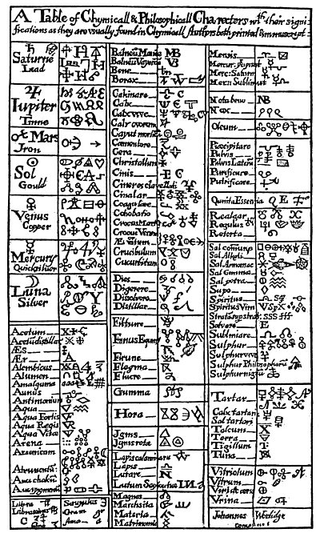
A TABLE OF MEDIÆVAL ALCHEMICAL SYMBOLS.
From Valentine's The Last Will and Testament.
Hermetists used the curious symbols shown in this rare table to represent various chemical elements and alchemical processes. The full meaning of these strange characters has never been revealed, the characters concealing effectually within their own forms the occult secrets regarding the spiritual nature of the metals and elements which they represent.
In their allegories the alchemists also wed human, animal, and plant emblems; sometimes weird composite figures, such as the dragon, the winged serpent, the unicorn, and the phœnix. In almost every case they symbolized gold as a king with a crown on his head and often with a scepter in his hand. Sometimes they depicted him with the ace of the solar disc surrounded by rays. Silver was personified as a woman who they called the queen. She wore no crown but often stood upon a lunar crescent: much after the fashion of the Madonna. Mercury was typified as a youth with wings, often with two heads, carrying serpents or sometimes the caduceus. Lead they symbolized by an old man with a scythe in his hand; iron by a soldier dressed in armor. To aqua fortis was given the curious name "the ostrich's stomach," and to the attainment of the "Great Work" they assigned the symbol of the phœnix sitting upon a nest of fire. The union of elements they symbolized by a marriage, the Process of putrefaction by a skull, antimony by a dragon.

The following table shows the angles to which the parties of three (salt, sulphur, and mercury) go in search of CHiram:
The Four "Corners" of Creation | East | South | West | North
The Fixed Signs of the Zodiac | Aquarius | Leo | Scorpio | Taurus
The Parts of the Cherubim | Man | Lion | Eagle | Bull
The Four Seasons | Spring | Summer | Autumn | Winter
The Ages of Man | Childhood | Youth | Maturity | Age
The Stages of Existence | Birth | Growth | Maturity | Decay
The Parts of Man's Constitution | Spirit | Soul | Mind | Body
The Four Elements | Air | Fire | Water | Earth
One more table should prove of interest to Masonic scholars: one showing the relationship existing between the three substances, salt, sulphur, and mercury, and certain symbols with which Masons are familiar. This table also has an alternative rendering, based on the interblending of philosophic principles, which are difficult--if not impossible--to separate into chronological order.
1. The Three Lights | Stellar Fire | Solar Fire | Lunar Fire
2. The Three Grand Masters | Hiram | Solomon | Hiram of Tyre
3. The Geometric Solids | Sphere | Pyramid | Cube
4. Alchemical Substances | Mercury | Sulphur | Salt
The alternative rendering of No. 2 is:
2. The Three Grand Masters | Solomon | Hiram | Hiram of Tyre
In alchemy is found again the perpetuation of the Universal Mystery; for as surely as Jesus died upon the cross, Hiram (CHiram) at the west gate of the Temple, Orpheus on the banks of the river Hebros, Christna on the banks of the Ganges, and Osiris in the coffin prepared by Typhon, so in alchemy, unless the elements first die, the Great Work cannot be achieved. The stages of the alchemical processes can be traced in the lives and activities of nearly all the world Saviors and teachers, and also among the mythologies of several nations. It is said in the Bible that "except a man be born again, he cannot see the kingdom of God." In alchemy it is declared that without putrefaction the Great Work cannot be accomplished. What is it that dies on the cross, is buried in the tomb of the Mysteries, and that dies also in the retort and becomes black with putrefaction? Also, what is it that does this same thing in the nature of man, that he may rise again, phœnix-like, from his own ashes (caput mortuum)?
The solution in the alchemical retort, if digested a certain length of time, will turn into a red elixir, which is called the universal medicine. It resembles a fiery water and is luminous in the dark. During the process of digestion it passes through many colors which has given rise to its being called the peacock because of its iridescence during one of the periods of its digestion. If the augmentations of its power be carried too far, the test tube containing the substance will explode and vanish as dust. This commonly occurs and is the greatest danger involved in the preparation of the medicine for men and metals. If developed too far, it will also seep through the glass, for there is no physical container sufficiently strong to hold it, The reason for this is that it is no longer a substance but a divine essence partaking of the interpenetrative power of Divinity. When it is properly developed, this universal solvent in liquid form will dissolve into itself all other metals. In this high state the universal salt is a liquid fire. This salt dissolved with the proper amount of any metal and run through the different stages of digestion and rotations; of augmentations will eventually become a medicine for the transmuting of inferior metals.
The True Way of Nature by Hermes Trismegistus, given out by a genuine Freemason, I.C.H., describes the danger of over-augmenting the universal salt: "But this multiplication cannot be carried on ad infinitum but it attains completeness in the ninth rotation. For when this tincture has been rotated nine times it cannot be exalted any further because it will not permit any further separation. For as soon as it perceives only the smallest degree of material fire it goes instantly into a flux and passes through the glass like hot oil through paper."
In classifying the processes through which the chemical elements must pass before the Hermetic medicine is produced, lack of uniformity in terminology is evidenced, for in The True Way of Nature seven stages are given, while in the Dictionnaire Mytho-Hermétique twelve are noted. These twelve are linked with the signs of the zodiac in a manner worthy of consideration.
1. Aries, Calcination | 5. Leo, Digestion | 9. Sagittarius, Incineration
2. Taurus, Congelation | 6. Virgo, Distillation | 10. Capricorn, Fermentation
3. Gemini, Fixation | 7. Libra, Sublimation | 11. Aquarius, Multiplication
4. Cancer, Dissolution | 8. Scorpio, Separation | 12. Pisces, Projection
This arrangement opens an interesting field of speculation which may be of great service if intelligently carried out. These twelve "steps" leading up to the accomplishment of the Magnum Opus are a reminder of the twelve degrees of the ancient Rosicrucian Mysteries. To a certain degree, Rosicrucianism was chemistry theologized and alchemy philosophized. According to the Mysteries, man was redeemed as the result of his passage in rotation through the twelve mansions of the heavens. The twelve processes by means of which the "secret essence" may be discovered remind the student forcibly of the twelve Fellow Craftsmen who are sent forth in search of the murdered Builder of the Universe, the Universal Mercury.
According to Solomon Trismosin, the stages through which matter passes in its journey towards perfection are divided into twenty-two parts, each of which is represented by an appropriate drawing. There is an important connection between the twenty-two emblems of Trismosin, the twenty-two major cards of the Tarot, and the twenty-two letters of the Hebrew alphabet. These mysterious Tarot cards are themselves an alchemical formula, if properly interpreted. As if to substantiate the claims of mediæval philosophers that King Solomon was a master of alchemy, Dr. Franz Hartmann has noted that the much-abused and misunderstood Song of Solomon is in reality an alchemical formula. The student of natural philosophy will immediately recognize the "dark maid of Jerusalem," not as a person but as a material sacred to the sages. Dr. Hartmann writes: "The 'Song of Solomon,' in the Old Testament, is a description of the processes of Alchemy. In this Song the Subjectum is described in Cant. i., 5; the Lilium artis in C. ii., 1; the Preparation and Purification in C. ii., 4; the Fire in C. ii., 7, and C. iv., 16, the Putrefaction in C. iii., 1; Sublimation and Distillation in C. iii., 6, Coagulation and Change of Colors, C. v., 9 to 14; Fixation, C. ii., 12, and C. viii., 4; Multiplication, C. vi., 7; Augmentation and Projection, C. viii., 8, etc., etc."
A tiny particle of the Philosopher's Scone, if cast upon the surface of water, will, according to an appendix to the work on the universal salt by Herr von Welling, immediately begin a process of recapitulating in miniature the history of the universe, for instantly the tincture--like the Spirits of Elohim--moves upon the face of the waters. A miniature universe is formed which the philosophers have affirmed actually rises out of the water and floats in the air, where it passes through all the stages of cosmic unfoldment and finally disintegrates into dust again. Not only is it possible to prepare a medicine for metals; it is also possible to prepare a tincture for minerals by means of which pieces of granite and marble can be turned into precious stones; also stones of inferior quality may be improved.
As one of the great alchemists fittingly observed, man's quest for gold is often his undoing, for he mistakes the alchemical processes, believing them to be purely material. He does not realize that the Philosopher's Gold, the Philosopher's Stone, and the Philosopher's Medicine exist in each of the four worlds and that the consummation of the experiment cannot be realized until it is successfully carried on in four worlds simultaneously according to one formula. Furthermore, one of the constituents of the alchemical formula exists only within the nature of man himself, without which his chemicals will not combine, and though he spend his life and fortune in chemical experimentation, he will not produce the desired end. The paramount reason why the material scientist is incapable of duplicating the achievements of the mediæval alchemists--although he follow every step carefully and accurately--is that the subtle element which comes out of the nature of the illuminated and regenerated alchemical philosopher is missing in his experimentation.
On this subject Dr. Franz Hartmann in a footnote to his translation of extracts from Paracelsus clearly expresses the conclusions of a modern investigator of alchemical lore: "I wish to warn the reader, who might be inclined to try any of the alchemical prescriptions * * *, not to do so unless he is an alchemist, because, although I know from personal experience that these prescriptions are not only allegorically but literally true, and will prove successful in the hands of an alchemist, they would only cause a waste of time and money in the hands of one who has not the necessary qualifications. A person who wants to be an alchemist must have in himself the 'magnesia', which means, the magnetic power to attract and 'coagulate' invisible astral elements."
In considering the formulæ on the following pages, it must be recognized that the experiments cannot be successfully conducted unless the one who performs them be himself a Magus. If two persons, one an initiate and the other unilluminated in the supreme art, were to set to work, side by side, using the same vessels, the same substances, and exactly the same modus operandi, the initiate would produce his "gold" and the uninitiated would not. Unless the greater alchemy has first taken place within the soul of man, he cannot perform the lesser alchemy in the retort. This is an invariable rule, although it is cunningly hidden in the allegories and emblems of Hermetic philosophy. Unless a man be "born again" he cannot accomplish the Great Work, and if the student of alchemical formulæ will remember this, it will save him much sorrow and disappointment. To speak of that part of the mystery which is concerned with the secret life principle within the actual nature of man, is forbidden, for it is decreed by the Masters of the art that each shall discover that for himself and on this subject it is unlawful to speak at greater length.

===================================================================================================================================================

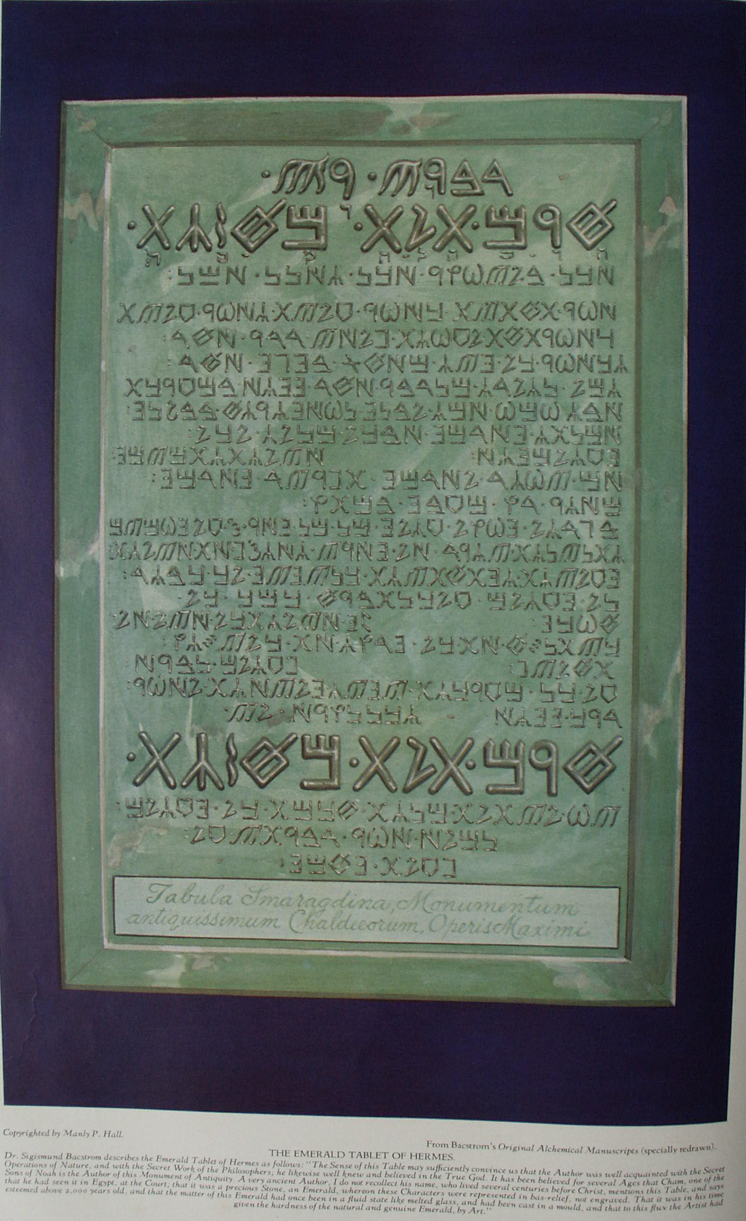

The Theory and Practice of Alchemy

Part Two
All true Philosophers of the natural or Hermetic sciences begin their labors with a prayer to the Supreme Alchemist of the Universe, beseeching His assistance in the consummation of the Magnum Opus. The prayer that follows, written in a provincial German centuries ago by an adept now unknown, is representative: "O holy and hallowed Trinity, Thou undivided and triple Unity! Cause me to sink into the abyss of Thy limitless eternal Fire, for only in that Fire can the mortal nature of man be changed into humble dust, while the new body of the salt union lies in the light. Oh, melt me and transmute me in this Thy holy Fire, so that on the day at Thy command the fiery waters of the Holy Spirit draw me out from the dark dust, giving me new birth and making me alive with His breath. May I also be exalted through the humble humility of Thy Son, rising through His assistance out of the dust and ashes and changing into a pure spiritual body of rainbow colors like unto the transparent, crystal-like, paradisiacal gold, that my own nature may be redeemed and purified like the elements before me in these glasses and bottles. Diffuse me in the waters of life as though I were in the wine cellar of the eternal Solomon. Here the fire of Thy love will receive new fuel and will blaze forth so that no streams can extinguish it. Through the aid of this divine fire, may I in the end be found worthy to be called into the illumination of the righteous. May I then be sealed up with the light of the new world that I may also attain unto the immortality and glory where there shall be no more alternation of light and darkness. Amen."

THE ORIGIN OF ALCHEMICAL FORMULÆ
Apparently but few of the mediæval alchemists discovered the Great Arcanum without aid, some authors declaring that none of them attained the desired end without the assistance of a Master or Teacher. In every instance the identity of these Masters has been carefully concealed, and even during the Middle Ages speculation ran rife concerning them. It was customary to call such illuminated sages adepts, a title which indicated that they possessed the true secrets of transmutation and multiplication. These adepts were polyonymous individuals who unexpectedly appeared and disappeared again, leaving no trace of their whereabouts. There are indications that a certain degree of organization existed among them. The most powerful of the alchemical organizations were the Rosicrucians, the Illuminati, and certain Arabian and Syrian sects.
I n the documents which follow, references are made to the "Brethren "or "Brothers. " These are to signify that those who had actually accomplished the Magnum Opus were banded together and known to each other by cipher codes and secret signs or symbols. Apparently a number of these illuminated adepts dwelt in Arabia, for several of the great European alchemists were initiated in Asia Minor. When a disciple of the alchemical arts had learned the supreme secret, he guarded it jealously, revealing to no man his priceless treasure. He was not permitted to disclose it even to the members of his immediate family.
As the years passed, one who had discovered the secret--or, more properly, one to whom it had been revealed--sought for some younger man worthy to be entrusted with the formulæ. To this one, and to this one only, as a rule, the philosopher was permitted to disclose the arcanum. The younger man then became the "philosophical son" of the old sage, and to him the latter bequeathed his secrets. Occasionally, however, an adept, on finding a sincere and earnest seeker, would instruct him in the fundamental principles of the art, and if the disciple persisted, he was quietly initiated into the august fraternity of the Brethren. In such manner the alchemical processes were preserved, but the number of those who knew them did not increase rapidly.
During the sixteenth, seventeenth, and eighteenth centuries a considerable number of alchemical adepts made their way from place to place throughout Europe, appearing and disappearing apparently at will. According to popular tradition, these adepts were immortal, and kept themselves alive by means of the mysterious medicine that was one of the goals of alchemical aspiration. It is asserted that some lived hundreds of years, taking no food except this elixir, a few drops of which would preserve their youth for a long period of time. That such mysterious men did exist there can be little doubt, as their presence is attested by scores of reliable witnesses.
It is further asserted that they are still to be found by those who have qualified themselves to contact them. The philosophers taught that like attracts like, and that when the disciple has developed a virtue and integrity acceptable to the adepts they will appear to him and reveal those parts of the secret processes which cannot be discovered without such help. "Wisdom is as a flower from which the bee its honey makes and the spider poison, each according to its own nature." (By an unknown adept.)
The reader must bear in mind at all times that the formulæ and emblems of alchemy are to be taken primarily as allegorical symbols; for until their esoteric significance has been comprehended, their literal interpretation is valueless. Nearly every alchemical formula has one element purposely omitted, it being decided by the mediæval philosophers that those who could not with their own intelligence discover that missing substance or process were not qualified to be entrusted with secrets which could give them control over great masses of humanity and likewise subject to their will the elemental forces of Nature.

THE EMERALD TABLE OF HERMES
The oldest and most revered of all the alchemical formulæ is the sacred Emerald Tablet of Hermes. Authorities do not agree as to the genuineness of this Table, some declaring it to be a post-Christian fraud, but there is much evidence that, regardless of its author, the Table is of great antiquity. While the symbol of the Emerald Table is of special Masonic import--relating as it does to the personality of CHiram (Hiram)--it is first and fundamentally an alchemical formula, relating both to the alchemy of the base metals and the divine alchemy of human regeneration.
In Dr. Sigismund Bacstrom's collection of alchemical manuscripts is a section devoted to the translations and interpretations of this remarkable Tablet, which was known to the ancients as the Tabula Smaragdina. Dr. Bacstrom was initiated into the Brotherhood of the Rose Cross on the island of Mauritius by one of those unknown adepts who at that time called himself Comte de Chazal. Dr. Bacstrom's translations and notes on the Emerald Tablet are, in part, as follows, the actual text being reproduced in capital letters:
"The Emerald Table, the Most Ancient Monument of the Chaldeans concerning the Lapis Philosophorum (the stone of the philosophers).
"The Emerald Table furnishes the origin of the allegorical history of King Hiram (rather Chiram). The Chaldeans, Egyptians, and Hebrews in what concerns Chiram have taken their knowledge from one and the same fountain; Homerus, who relates this history in a different manner, followed that original, and Virgil followed Homerus, as Hesiodus took the subject for his Theogony likewise from thence, which Ovidius took afterwards for a pattern for his Metamorphosis. The knowledge of Nature's secret operations constitutes the principal sense of all these ancient writings, but ignorance framed out of it that external or veiled mythology and the lower class of people turned it into idolatry.
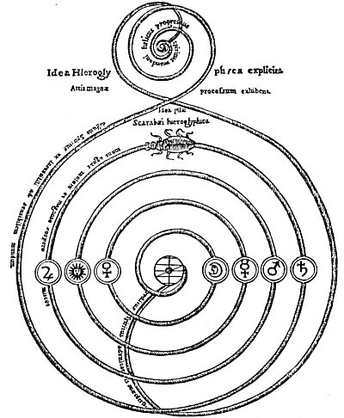
THE KEY TO ALCHEMY ACCORDING TO THE EGYPTIANS.
From Kircher's Œdipus Ægyptiacus.
The priests of Egypt not only used the scarab as a symbol of regeneration but also discovered in its habits many analogies to the secret process whereby base metals could be transmuted into gold. They saw in the egg of the scarab the seed of the metals, and the above figure shows the path of this seed through the various planetary bodies until, finally reaching the center, it is perfected and then returns again to its source. The words in the mall spiral at the top read: "The spiral Progress of the mundane spirit." After the scarab has wound its way around the spiral to the center of the lower part of the figure, it returns to the upper world along the path bearing the words: "Return of the spirit to the center of unity."

"The Genuine Translation from the Original Very Ancient Chaldee is as Follows:
"THE SECRET WORKS OF CHIRAM ONE IN ESSENCE, BUT THREE IN ASPECT.
"(The two first large words mean the Secret Work.)
"(The second line in large letters, reads: Chiram Telat Machasot, i.e. Chiram the Universal Agent, One in Essence but three in aspect.)
'IT IS TRUE, NO LIE, CERTAIN, AND TO BE DEPENDED UPON, THE SUPERIOR AGREES WITH THE INFERIOR, AND THE INFERIOR WITH THE SUPERIOR, TO EFFECT THAT ONE TRULY WONDERFUL WORK. AS ALL THINGS OWE THEIR EXISTENCE TO THE WILL OF THE ONLY ONE, SO ALL THINGS OWE THEIR ORIGIN TO THE ONE ONLY THING, THE MOST HIDDEN, BY THE ARRANGEMENT OF THE ONLY GOD. THE FATHER OF THAT ONE ONLY THING IS THE SUN, ITS MOTHER IS THE MOON, THE WIND CARRIES IT IN ITS BELLY; BUT ITS NOURSE IS A SPIRITUOUS EARTH. THAT ONE ONLY THING (after God) IS THE FATHER OF ALL THINGS IN THE UNIVERSE. ITS POWER IS PERFECT, AFTER IT HAS BEEN UNITED TO A SPIRITUOUS EARTH.
"(Process--First Distillation.) SEPARATE THAT SPIRITUOUS EARTH FROM THE DENSE OR CRUDE BY MEANS OF A GENTLE HEAT, WITH MUCH ATTENTION.
"(Last Digestion.) IN GREAT MEASURE IT ASCENDS FROM THE EARTH UP TO HEAVEN, AND DESCENDS AGAIN, NEWBORN, ON THE EARTH, AND THE SUPERIOR AND THE INFERIOR ARE INCREASED IN POWER. The Azoth ascends from the Earth, from the bottom of the Glass, and redescends in Veins and drops into the Earth and by this continual circulation the Azoth is more and more subtilized, Volatilizes Sol and carries the volatilized Solar atoms along with it and thereby becomes a Solar Azoth, i.e. our third, and genuine Sophic Mercury, and this circulation of the Solar Azoth must continue until it ceases of itself, and the Earth has sucked it all in, when it muse become the black pitchy matter, the Toad [the substances in the alchemical retort and also the lower elements in the body of man], which denotes complete putrefaction or Death of the Compound.
"BY THIS THOU WILT PARTAKE OF THE HONOURS OF THE WHOLE WORLD. Without doubt as the black, pitchy matter will and must of necessity become White and Red, and the Red having been carried to perfection, medicinally and for Metals, is then fully capable to preserve mentem sanam in corpore sano until the natural period of Life and promise us ample means, in infinitum multipliable, to be benevolent and charitable without any diminution of our inexhaustible resources, therefore well may it be called the Glory [Honours] of the Whole World, as truly the study and contemplation of the L. P. [Lapis Philosophorum], harmonising with Divine Truths, elevates the mind to God our Creator and merciful Father, and if He should permit us to possess it practically must eradicate the very principle of Avarice, Envy, and Evil Inclinations, and cause our hearts to melt in gratitude toward Him that has been so kind to us! Therefore the Philosophers say with great Truth, that the L. P. either finds a good man or makes one.
"AND DARKNESS WILL FLY FROM THEE. By invigorating the Organs the Soul makes use of for communicating with exterior objects, the Soul must acquire greater powers not only for conception but also for retention, and therefore if we wish to obtain still more knowledge, the organs and secret springs of physical life being wonderfully strengthened and invigorated, the Soul must acquire new powers for conceiving and retaining, especially if we pray to God for knowledge, and confirm our prayers by faith, all Obscurity must vanish of course. That this has not been the case with all possessors, was their own fault, as they contented themselves merely with the Transmutation of Metals.
"(Use.) THIS IS THE STRENGTH OF ALL POWERS. This is a very strong figure, to indicate that the L. P. positively does possess all the Powers concealed in Nature, not for destruction but for exaltation and regeneration of matter, in the three Departments of Nature.
"WITH THIS THOU WILT BE ABLE TO OVERCOME ALL THINGS, AND TO TRANSMUTE ALL WHAT IS FINE (☉☽) AND WHAT IS COARSE (♃♄ ♀ ♂ ☿ 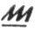). It will conquer every subtil Thing, of course, as it refixes the most subtil Oxygen into its own fiery Nature and that with more power, penetration and virtue, in a tenfold ratio, at every multiplication, and each time in a much shorter period, until its power becomes incalculable, which multiplied power also penetrates [overcomes] every Solid Thing, such as unconquerable Gold and Silver, the otherwise unalterable Mercury, Crystals and Glass Fluxes, to which it is able to give natural hardness and fixity, as Philaletha does attest, and is proved by an artificial Diamond, in my father's time, in possession of Prince Lichtenstein in Vienna, valued at Five Hundred Thousand Ducats, fixed by the Lapis [Philosopher's Stone].
"IN THIS MANNER THE WORLD WAS CREATED; THE ARRANGEMENTS TO FOLLOW THIS ROAD ARE HIDDEN. FOR THIS REASON I AM CALLED CHIRAM TELAT MECHASOT, ONE IN ESSENCE, BUT THREE IN ASPECT. IN THIS TRINITY IS HIDDEN THE WISDOM OF THE WHOLE WORLD (i.e., in Chiram and its Use). It is thought that Hermes was Moses or Zoroaster, otherwise Hermes signifies a Serpent, and the Serpent used to be an Emblem of Knowledge or Wisdom. The Serpent is met with everywhere amongst the Hieroglyphics of the ancient Egyptians, so is the Globe with Wings, the Sun and Moon, Dragons and Griffins, whereby the Egyptians denoted their sublime knowledge of the Lapis Philosophorum, according to Suidas, the hints in the Scriptures, and even De Non where he speaks of the sanctuaries of the ancient Egyptian Temples.
"IT IS ENDED NOW, WHAT I HAVE SAID CONCERNING THE EFFECTS OF THE SUN. FINISH OF THE TABULA SMARAGDINA. What I have said or taught of the Solar Work, is now finished. The perfect Seed, fit for multiplication.
"This I know is acknowledged to be the genuine Tabula Smaragdina Hermetis."
A LETTER FROM THE BROTHERS OF R. C. (ROSE CROSS)
Although Eugenius Philalethes disclaimed membership in the Rosicrucian Fraternity, it is believed that for a number of years he was the head of that Order. In a little work called Lumen de Lumine, or A New Magical Light Discovered and Communicated to the World, published in London in 1651, Eugenius Philalethes gives a remarkable letter, presumably from the Rosicrucian Order. Accompanying the letter is an emblematic figure setting forth in symbolic form the processes and formulæ of the Philosopher's Stone. This epistle is an excellent example of the Rosicrucian system of combining abstract theological speculations with concrete chemical formulæ. With the aid of the material contained in various parts of this present book the student would do well to set himself the task of solving the riddle contained in this hieroglyph.
"A Letter from the Brothers of R. C. Concerning the Invisible, Magical Mountain, And the Treasure therein Contained.
"Every man naturally desires a superiority, to have treasures of Gold and Silver [intellect and soul], and to seem great in the eyes of the world. God indeed created all things for the use of man, that he might rule over them, and acknowledge therein the singular goodness and omnipotence of God, give Him thanks for His benefits, honor Him and praise Him. But there is no man looks after these things, otherwise than by spending his days idly; they would enjoy them without any previous labor and danger; neither do they look them out of that place where God hath treasured them up, Who expects also that man should seek for them there, and to those that seek will He give them. But there is not any that labors for a possession in that place, and therefore these riches are not found: For the way to this place, and the place itself hath been unknown for a long time, and it is hidden from the greatest part of the world. But notwithstanding it be difficult and laborious to find Out this way and place, yet the place should be sought after.
"But it is not the will of God to conceal anything from those that are His, and therefore in this last age, before the final judgment comes, all these things shall be manifested to those that are worthy: As He Himself (though obscurely, lest it should be manifested to, the unworthy) hath spoken in a certain place: There is nothing covered that shall not be revealed, and hidden that shall not be known. We therefore being moved by the Spirit of God, do declare the will of God to the world, which we have also already performed and published in several languages. But most men either revile, or contemne that, our Manifesto, (the Fama and Confessio Fraternitatis) or else waiving the Spirit of God, they expect the proposals thereof from us, supposing we will straightway teach them how to make gold by Art, or furnish them with ample treasures, whereby they may live pompously in the face of the world, swagger, and make wars, turn usurers, gluttons, and drunkards, live unchastely, and defile their whole life With several other sins, all which things are contrary to the blessed will of God. These men should have learnt from those Ten Virgins (whereof five that were foolish demanded oil for their lamps, from those five that were wise) how that the case is much otherwise.
"It is expedient that every man should labor for this treasure by the assistance of God, and his own particular search and industry. But the perverse intentions of these fellows we understand out of their own writings, by the singular grace and revelation of God. We do stop our ears, and wrap ourselves as it were in clouds, to avoid the bellowings and howlings of those men, who in vain cry out for gold. And hence indeed it comes to pass that they brand us with infinite calumnies and slanders, which notwithstanding we do not resent but God in His good time will judge them for it. But after that we had well known (though unknown to you) and perceived also by your writing how diligently you are to peruse the Holy Scripture, and seek the true knowledge of God: we have also above many thousands, thought you worthy of some answer, and we signify this much to you by the will of God and the admonition of the Holy Ghost.
"There is a mountain situated in the midst of the earth, or center of the world, which is both small and great. It is soft, also above measure hard and stony. It is far off, and near at hand, but by the providence of God, invisible. In it are hidden most ample treasures, which the world is not able to value. This mountain by envy of the devil, who always opposeth the glory of God and the happiness of man, is compassed about with very cruel beasts and other [sic] ravenous birds, which make the way thither both difficult and dangerous; and therefore hitherto, because the time is not yet come, the way thither could not be sought after nor found out. But now at last the way is to be found by those that are worthy, but notwithstanding by every man's self-labor and endeavors.
"To this mountain you shall go in a certain night (when it: comes) most long and most dark, and see that you prepare yourselves by prayer. Insist upon the way that: leads to the mountain, but ask not of any man where the way lies: only follow your Guide, who will offer himself to you, and will meet you in the way but you shall not know him. This Guide will bring you to the mountain at midnight, when all things are silent and dark. It is necessary that you arm yourselves with a resolute heroic courage, lest you fear those things that will happen, and so fall back. You need no sword, nor any other bodily weapons, only call upon God sincerely and heartily.
"When you have discovered the mountain, the first miracle that will appear is this. A most vehement and very great wind, that will shake the mountain and shatter the rocks to pieces. You shall be encountered also by lions and dragons and other terrible beasts, but fear not any of these things. Be resolute and rake heed that you return not, for your Guide who brought you thither will not suffer any evil to befall you. As for the treasure, it is not yet discovered but it is very near. After this wind will come an earthquake, that will overthrow those things which the wind hath left and make all flat. But be sure that you fall not off.
"The earthquake being past, there shall follow afire, that will consume the earthly rubbish, and discover the treasure, but as yet you cannot see it. After all these things and near the daybreak there shall be a great calm, and you shall see the Day-Star arise and the dawning will appear, and you shall perceive a great treasure. The chiefest thing in it, and the most perfect, is a certain exalted tincture, with which the world (if it served God and were worthy of such gifts) might be tinged and turned into most pure gold.
"This tincture being used, as your Guide shall reach you, will make you young when you are old, and you shall perceive no disease in any part of your bodies. By means of this tincture also you shall find pearls of that excellency which cannot be imagined. But do not you arrogate anything to yourselves because of your present power, but be contented with that which your Guide shall communicate to you. Praise God perpetually for this His gift, and have a special care that you use it not for worldly pride, but employ it in such works which are contrary to the world. Use it rightly and enjoy it so, as if you had it not. Live a temperate life, and beware of all sin, otherwise your Guide will forsake you, and you shall be deprived of this happiness. For know this of a truth, whosoever abuseth this tincture and lives not exemplarly, purely, and devoutly before men he shall lose this benefit, and scarce any hope will there be left ever to recover it afterwards."
If, as transcendentalists believe, the initiations into the Fraternity of the Rose Cross were given in the invisible worlds which surround and interpenetrate the visible universe, it is not beyond the range of possibility that this allegory is to be considered in the light of an initiatory ritual as well as an alchemical formula.
As has been noted, it is difficult to secure a complete formula for any of the alchemical operations. The one presented here is the most nearly complete of any available. The collecting of the rays and energies of the celestial bodies as precipitated in dew is a process which Paracelsus used with great success. Bear constantly in mind that these processes are only for those who have been properly instructed in the secret art.
"A TRUE REVELATION OF THE MANUAL OPERATION FOR THE UNIVERSAL MEDICINE COMMONLY CALLED 'THE PHILOSOPHER'S STONE.' By the celebrated philosopher of Leyden, as attested upon his deathbed with his own Blood, Anno Domini 1662. To my Loving Cousin and Son, the True Hermetic Philosopher--
"Dear Loving Cousin and Son:
"Although I had resolved never to give in writing to any person the secret of the Ancient Sages, yet notwithstanding out of peculiar affection and love to you, I have taken it upon me, to which the nearness of our relation obliges me, and especially because this temporal life is short, and Art is very dark and you may therefore not attain the wished for end;--but my Son because so precious a jewel belongs not to swine; and also this so great a gift of God may be treated carefully and Christianlike, in consideration thereof I do so largely declare myself to thee.
"I conjure thee with hand and mouth sacredly;
"1st. That most especially thou faithfully keep the same from all wicked, lustful and criminal persons.
"2dly. That thou exalt not thyself in any way.
"3dly. That thou seek to advance the honor of thy Creator of all things and the good of thy neighbor, preserve it sacredly that thy Lord may not have cause to complain of thee at the last day. I have written here in this treatise such a part of the Kingdom of Heaven, just as I myself have worked this treasure and finished it with my fingers, therefore I have subscribed all this work with my blood, lying on my deathbed in Leyden.
"THE PROCESS--In the Name of God, take of the purest and cleanest salt, sea salt, so as it is made by the sun itself, such as is brought by shipping from Spain, (I used salt that came from St. Uber) let it be dried in a warm stove, grind it in a stone mortar, as fine as possible to a powder that it may be so much the easier dissolve and taken up by our Dew-water, which is thus to be had in the months of May or June: When the Moon is at the full, observe when the dew falls with an East or South East wind. Then you must have sticks about one and a half feet high above the ground when driven in the Earth. Upon two or three such sticks, lay some four square plates of glass, and as the dew falls it easily fastens on the glass like a vapour, then have glass Vessels in readiness, let the dew drain from the sides of the glasses into your vessels. Do this until you have enough. The full of the Moon is a good season, afterwards it will be hard."
The solar rays descending from the sun carry with them solar sulphur--the Divine Fire. These rays are crystallized by contact with the lunar rays. The solar rays are also met by the emanations pouring upward from the earth's surface and are thus still further crystallized into a partly tangible substance, which is soluble in pure water. This substance is the "Magical Mountain of the Moon" referred to in the R. C. letter. The crystallization of the solar and lunar rays in water (dew) produces the virgin earth--a pure, invisible substance, uncontaminated by material matter. When the virgin earth crystals are wet, they appear green; when dry, white.

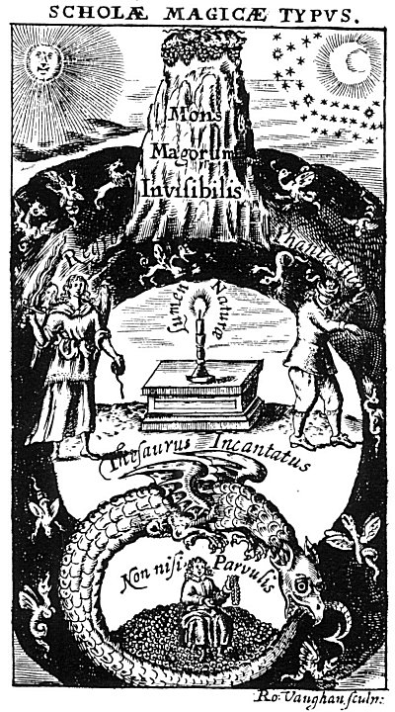
THE INVISIBLE MAGICAL MOUNTAIN.
From Phililethales' Lumen de Lumine.
On Page 24 of Lumen de Lumine, Eugenius Philalethes describes the magical mountain as follows:
"This is that emblematical magical type, which Thalia delivered to me in the invisible Guiana. The first and superior Part of it represents the Mountains of the Moon. The philosophers commonly call them the Mountains of India, on whose tops grows their secret and famous Lunaria. It is an Herb easy to be found, but [for the fact] that men are blind discovers itself and shines after night like pearl. The earth of these mountains is very red and soft beyond all expression. It is full of crystalline rocks, which the philosophers call their glass and their stone: birds and fish (say they) bring it to them. Of these mountains speaks Hali the Arabian, a most excellent judicious author: 'Go, my son, to the Mountains of India, and to their quarries or caverns, and take thence our precious stones which dissolve or melt in water, when they are mingled therewith. Much indeed might be spoken of these mountains, if it were lawful to publish their mysteries, but one thing I shall not forbear to tell you. They are very dangerous places after night, for they are haunted with fires and other strange apparitions, (as a I am told by the Magi) by certain spirits, which dabble lasciviously with the sperm of the world and imprint their imaginations in, producing many times fantastic and monstrous generations. The access and pilgrimage to this place, with the difficulties which attend them, are faithfully and magisterially described by the Brothers of R.C." (Set accompanying letter.)

Von Welling makes a suggestion for the extraction of the solar life from stagnant water, but is reticent both as to naming the essence extracted and also as to the various processes through which it must pass to be refined and increased in power. His hint, however, is both valuable and unusual:
"Take sweet clean water and seal it in a large bottle, leaving about one-fourth empty. Place the bottle in the sun for some weeks until it rots, showing a precipitation in the bottom. This precipitation, when properly manipulated by distillation, will produce a clear, fiery, burning oil, the constituents and use of which are only known to the wise."
The philosopher of Leyden continues: "Now when you have enough of your dew close your glasses exactly, and keep it till you use it, that none of its spirits may evaporate, which may easily happen. Set it therefore in a cool place, that no warmth may come to it, or else the subtle spirit will rise and be gone; which will not so happen if after you have filled your glasses with Dew quite full, you close them very well with wax.
"Now in the Name of God, take of this Dew-water as much as thou wilt, put in a clean dissolving glass, then cast a little of your forementioned powdered salt into it to be dissolved, and continue to put it in till your Dew-water will dissolve no more or till the salt lies in it four days without being dissolved, then it has enough, and unto your Dew is given its proper powder. Of this compounded water, take as much as thou wilt, I took about a pound and a half, and put it into a round vial with a short neck, fill it with out water and lute it with a good lute, a cover and stopple that fits it well, that the subtle and living spirit of the dew may not fume away, for if they should the soul of the salt will never be stirred up, nor the work ever brought to a right end. Let the lute dry very well of itself, and set it in the furnace of B. M. to putrefy. Make a slow fire and let it digest for forty days or fifty, and that the fume of the water be continually round about it, and you will see your matter grow black, which is a token of its putrefaction.
"As soon as you have taken it out, have your dry furnace ready. Set your glass with the matter into an inner globe to coagulate, give it a slow degree of fire, continue it equally for twelve or fifteen days, and your matter will begin to coagulate and to fasten round about your glass like a gray salt, which as soon as you see and before it be two days, slacken the fire that it may cool leisurely. Then have in readiness your putrefying furnace as before. Set your glass therein and give the same degree of fire as before. Let it stand twelve days, and again you will see the matter resolve and open as before, and open itself, but you must every time see that the lute and your glass is not hurt. When you set your glass in the putrefying furnace, take care that the neck of your glass is covered with a wooden or glass stopper that fits it exactly, that the moisture of the water may not come at it.
"When you see it black set your glass as before to coagulate and when it begins to be of a grayish color and whitish, set it in a third time to putrefy, and coagulate to the fifth time, until you see that your water in its dissolution is clean, pellucid and clear, and that it appears in its Calcination of a fine white like Snow. Then it is prepared and becomes a Salt fixed which will melt on hot Silver plate like wax; but before you set this your Salt out, set it again [in] the furnace of putrefaction that it may dissolve of itself, then let it cool, open your Glass and you will find your Matter lessened a third part. But instead of your former Salt Water you will have a fine Sweet and very penetrating Water which the Philosophers have hid under very wonderful Names--It is the Mercury of all true Philosophers, the Water out of which comes Gold and Silver, for they say its Father is Gold and its Mother is Silver. Thus hast thou the strength of both these Luminaries conjoined in this Water, most true, in its right Pondus.
"Prescription. 5 Drops of this Water taken inwardly strengthens the understanding and memory, and opens to us most wonderful and sweet things, of which no man hath heard, and of which I dare not further write, because of the Oath I made God to the contrary. Time and the holy use of this blessed Water will teach us, as soon as you have taken it inwardly such influence will happen to thee as if the whole heavens and all the stars with their powers are working in thee. All Knowledge and secret Arts will be opened to thee as in a dream, but the most excellent of all is, you will perfectly learn rightly to know all creatures in their Nature, and by means thereof, the true understanding of God, the Creator of us, Heaven and Earth, like David and Moses and all the Saints of God, for the wisdom of our fountain of living Water will instruct thee as it did Solomon and the Brethren of our fraternity."
In his rare treatise on Salt, Sulphur and Mercury, von Welling discloses a secret: not generally revealed in alchemical writings, namely, that the alchemists were concerned not only with the transmutation of metals but had a complete cosmological and philosophical system based upon the Qabbalah.
According to von Welling, the universal salt (in watery form) is a positive cure for all the physical ailments of mankind; it is in every living thing, but from some things it is more easily secured than from others: especially is this true of virgin earth; it is the universal solvent, the alkahest. The same writer also states that in the first stages of its preparation this salt will cure any and all diseases of the heart. The anonymous philosopher of Leyden continues:
"Would you now proceed further with our blessed Water to the forementioned intention of preparing a Tincture for Metals, hearken my Son--
"Take in the NAME of the Lord, of thy Paradisiacal Water, of heavenly Water of Mercury, as much as thou wilt, put it into a glass to dissolve, and set it in a slow heat of Ashes, that it may just feel the warmth, then have ready well purified Gold for the Red, or Silver for the White Elixir, for in both the Processes are the same. Let your Gold or Silver be beaten as thin as leaf Gold, cast it by degrees into your dissolving Glass, that contains your blessed Water, as you did in the beginning with your Salt, and it will melt like Ice in Warm Water, and continue so to do till your Gold or Silver lie therein four days without dissolving, then it has received its due Pondus. Then put this dissolution as before into a round Glass, fill it two thirds parts full, seal it hermetically as before, let your Sigillum be well dried. Set it in the furnace of Balneum Vapori, make a fire and let it remain forty days, as before, then will the Gold or Silver be dissolved radically and will turn of the deepest black in the world, which as soon as you see, have your other drying furnace in readiness."
Continuing: "Philosophers say there is no true solution of the body without a proceeding coagulation of the spirit, for they are interchangeably mixed in a due proportion, whereby the bodily essence becomes of a spiritual penetrating nature. On the other hand, the incomprehensible spiritual essential virtue is also made corporeal by the fire, because there is made between them so near a relation or friendship, like as the heavens operate to the very Depth of Earth, and producing from thence all the treasures and riches of the whole World.
"Admirandum Naturæ Operationem in Archidoxes Cognitam.
"With this Powder--You may as follows project on metals. Take five parts of fine Gold or Silver according as you work, and melt it in a Crucible. Wrap up your Medicine in Wax, cast it therein, give a strong fire for an hour, then take the Crucible out, as it were, calcined, then cast one part on ten parts of imperfect metals, be it what it will, and the same will be immediately changed into purer Metal, than what is brought out of the Mines and produced by Melting; and when you augment it in strength and virtue by resolving and coagulating, the fifth time it will resolve itself in three days and be coagulated in twenty-four hours time, to an incredible and most highly pellucid Stone or Red Shining burning Coal. For the white work it will become like a white stream of Lightning.
"Of this last coagulation take one part, cast it upon five thousand of melted Gold or Silver as before. It changes the same into perfect Medicine, one part whereof will tinge one hundred thousand parts of melted imperfect Metals into the very finest Gold or Silver. So far I have brought and further I would not come, for as I would set in the matter [to distill] six times in twelve hours, it subtilized so highly that the most part (like somewhat most wonderful to behold) past through the Glass causing an inexpressible odoriferous Smell. Take heed that it happens not to you.
"Many more wonders of this holy Art might be added, namely how to prepare therewith all sorts of precious Stones, and other most admirable things, but it would require too great a book to express the whole as it ought to be, especially as the Art is endless and not to be apprehended with one view, and my purpose has been, Loving Cousin and Son, devoutly to lead thee into the Mysteries of Nature and this holy Science, and I have faithfully performed it."
In conclusion, the letter states: "Go thou to work as I have done before thee, fear God, Love thy neighbour from the bottom of thy Soul sincerely. So will in the Manual operation, everything to thee, and when thou art at work therein many of our brethren will reveal themselves to thee, of our holy order, privately; For I have on my part by the Eternal God wrote the truth which I found out by prayer and searching into Nature, which work I have seen with my eyes, and with my hands extracted. Therefore also I have subscribed this Testament with my own blood, the last day of my Life on my deathbed. Actum Leyden, 27 March 1662."

===================================================================================================================================================
END

