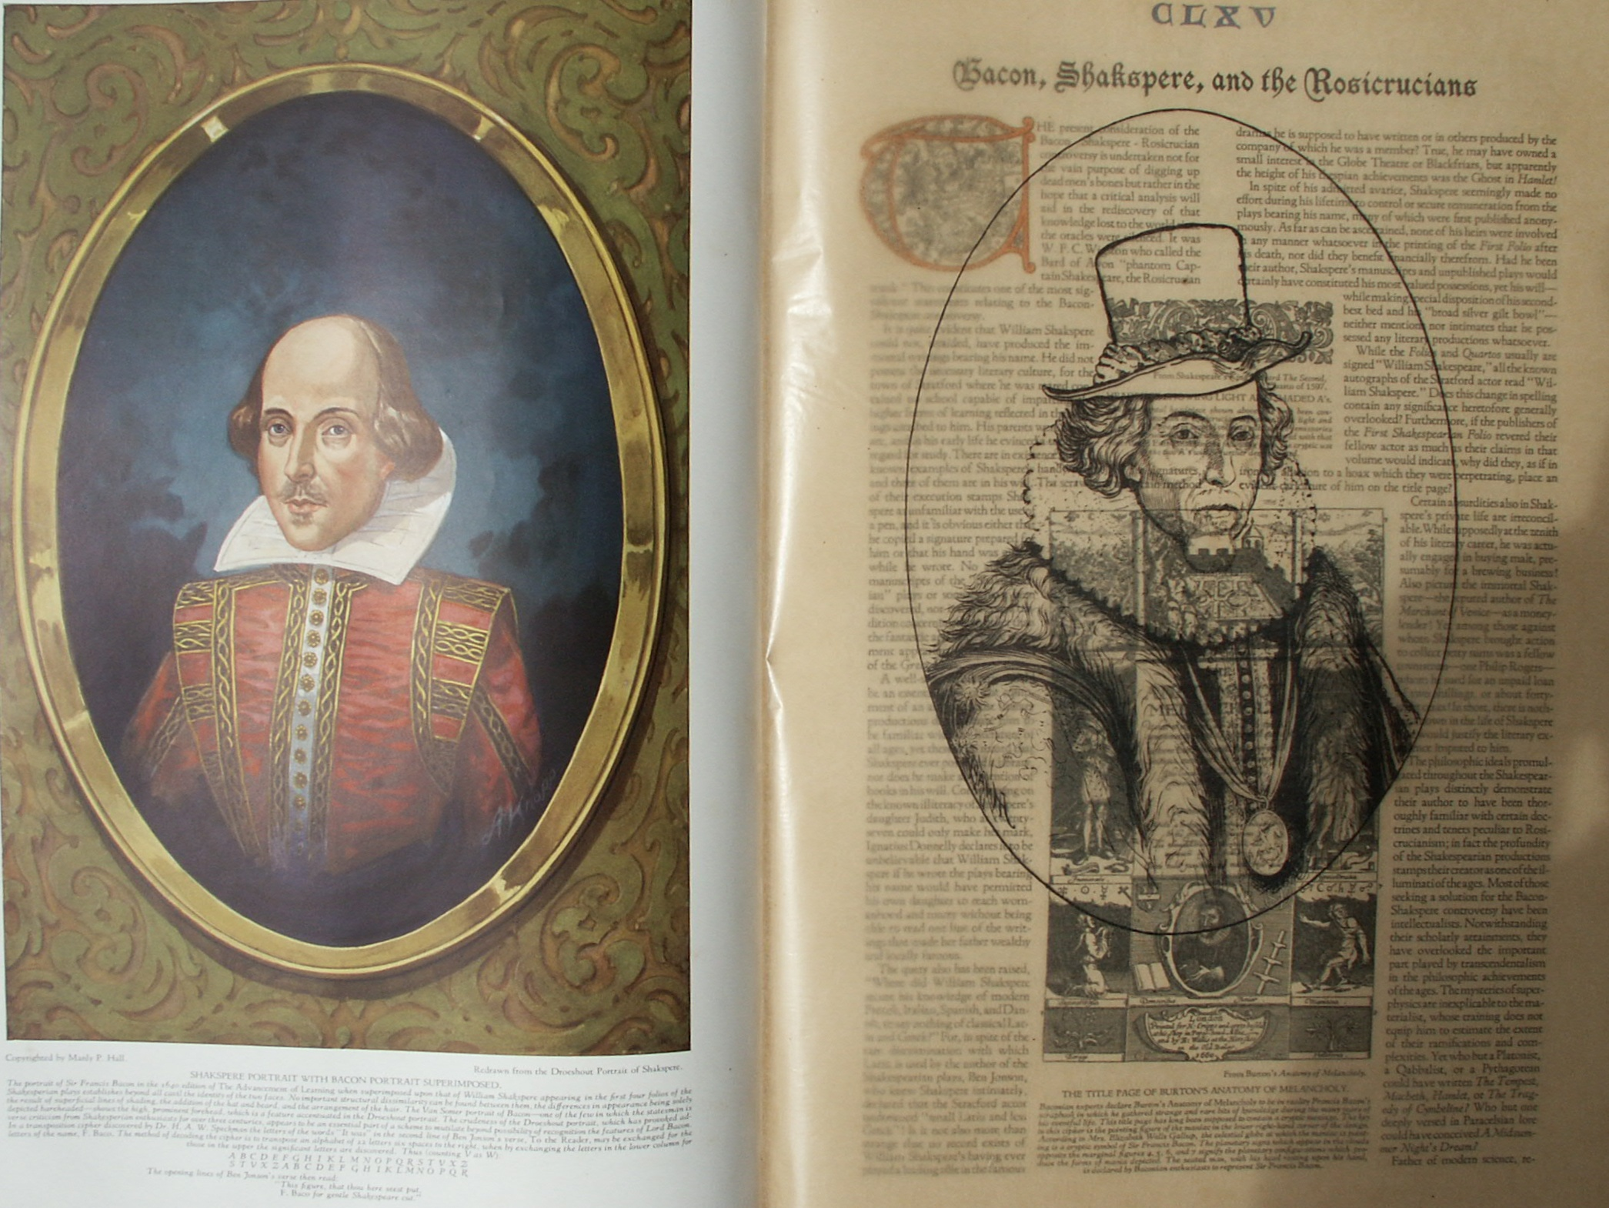

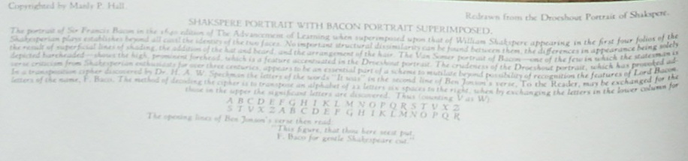

**Bacon, Shakspeare and the Rosicrucians**

**The Secret Teachings of All Ages - Manly P. Hall 1928**

**BACON, SHAKSPEARE, AND THE ROSICRUCIANS  
The Rosicrucian mask--Life of William Shakspere--Sir Francis Bacon--The acrostic signatures--The significant number thirty-three--The philosophic death.**

THE present consideration of the Bacon--Shakspere--Rosicrucian controversy is undertaken not for the vain purpose of digging up dead men's bones but rather in the hope that a critical analysis will aid in the rediscovery of that knowledge lost to the world since the oracles were silenced. It was W. F. C. Wigston who called the Bard of Avon "phantom Captain Shakespeare, the Rosicrucian mask." This constitutes one of the most significant statements relating to the Bacon-Shakspere controversy.

It is quite evident that William Shakspere could not, unaided, have produced the immortal writings bearing his name. He did not possess the necessary literary culture, for the town of Stratford where he was reared contained no school capable of imparting the higher forms of learning reflected in the writings ascribed to him. His parents were illiterate, and in his early life he evinced a total disregard for study. There are in existence but six known examples of Shakspere's handwriting. All are signatures, and three of them are in his will. The scrawling, uncertain method of their execution stamps Shakspere as unfamiliar with the use of a pen, and it is obvious either that he copied a signature prepared for him or that his hand was guided while he wrote. No autograph manuscripts of the "Shakespearian" plays or sonnets have been discovered, nor is there even a tradition concerning them other than the fantastic and impossible statement appearing in the foreword of the *Great Folio*.

A well-stocked library would be an essential part of the equipment of an author whose literary productions demonstrate him to be familiar with the literature of all ages, yet there is no record that Shakspere ever possessed a library, nor does he make any mention of books in his will. Commenting on the known illiteracy of Shakspere's daughter Judith, who at twenty-seven could only make her mark, Ignatius Donnelly declares it to be unbelievable that William Shakspere if he wrote the plays bearing his name would have permitted his own daughter to reach womanhood and marry without being able to read one line of the writings that made her father wealthy and locally famous.

The query also has been raised, "Where did William Shakspere secure his knowledge of modern French, Italian, Spanish, and Danish, to say nothing of classical Latin and Greek?" For, in spite of the rare discrimination with which Latin is used by the author of the Shakespearian plays, Ben Jonson, who knew Shakspere intimately, declared that the Stratford actor understood "small Latin and less Greek"! Is it not also more than strange that no record exists of William Shakspere's having ever played a leading rôle in the famous dramas he is supposed to have written or in others produced by the company of which he was a member? True, he may have owned a small interest in the Globe Theatre or Blackfriars, but apparently the height of his thespian achievements was the Ghost in *Hamlet*!

In spite of his admitted avarice, Shakspere seemingly made no effort during his lifetime to control or secure remuneration from the plays bearing his name, many of which were first published anonymously. As far as can be ascertained, none of his heirs were involved in any manner whatsoever in the printing of the *First Folio* after his death, nor did they benefit financially therefrom. Had he been their author, Shakspere's manuscripts and unpublished plays would certainly have constituted his most valued possessions, yet his will--while making special disposition of his second-best bed and his "broad silver gilt bowl" neither mentions nor intimates that he possessed any literary productions whatsoever.

While the Folios and Quartos usually are signed "William Shakespeare," all the known autographs of the Stratford actor read "William Shakspere." Does this change in spelling contain any significance heretofore generally overlooked? Furthermore, if the publishers of the *First Shakespearian Folio* revered their fellow actor as much as their claims in that volume would indicate, why did they, as if in ironical allusion to a hoax which they were perpetrating, place an evident caricature of him on the title page?

Certain absurdities also in Shakspere's private life are irreconcilable. While supposedly at the zenith of his literary career, he was actually engaged in buying malt, presumably for a brewing business! Also picture the immortal Shakspere--the reputed author of *The Merchant of Venice*--as a moneylender! Yet among those against whom Shakspere brought action to collect petty sums was a fellow townsman--one Philip Rogers--whom he sued for an unpaid loan of two shillings, or about forty-eight cents! In short, there is nothing known in the life of Shakspere that would justify the literary excellence imputed to him.

The philosophic ideals promulgated throughout the Shakespearian plays distinctly demonstrate their author to have been thoroughly familiar with certain doctrines and tenets peculiar to Rosicrucianism; in fact the profundity of the Shakespearian productions stamps their creator as one of the illuminati of the ages. Most of those seeking a solution for the Bacon-Shakspere controversy have been intellectualists. Notwithstanding their scholarly attainments, they have overlooked the important part played by transcendentalism in the philosophic achievements of the ages. The mysteries of superphysics are inexplicable to the materialist, whose training does not equip him to estimate the extent of their ramifications and complexities. Yet who but a Platonist, a Qabbalist, or a Pythagorean could have written *The Tempest*, *Macbeth*, *Hamlet*, or *The Tragedy of Cymbeline*? Who but one deeply versed in Paracelsian lore could have conceived, *A Midsummer Night's Dream*?

Father of modern science, remodeler of modern law, editor of the modem Bible, patron of modem democracy, and one of the founders of modern Freemasonry, Sir Francis Bacon was a man of many aims and purposes. He was a Rosicrucian, some have intimated *the* Rosicrucian. If not actually the Illustrious Father C.R.C. referred to in the Rosicrucian manifestoes, he was certainly a high initiate of the Rosicrucian Order, and it is his activities in connection with this secret body that are of prime importance to students of symbolism, philosophy, and literature.

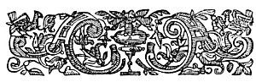  
HEADPIECE SHOWING LIGHT AND SHADED A's.

From Shakespeare's *King Richard The Second*, Quarto of 1597.

*The ornamental headpiece shown above has long been considered a Baconian or Rosicrucian signature. The light and the dark A's appear in several volumes published by emissaries of the Rosicrucians. If the above figure be compared with that from the Alciati Emblemata on the following pages, the cryptic use of the two A's will be further demonstrated.*

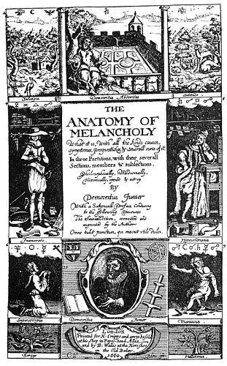  
THE TITLE PAGE OF BURTON'S ANATOMY OF MELANCHOLY.

From Burton's *Anatomy of Melancholy*.

*Baconian experts declare Burton's Anatomy of Melancholy to be in reality Francis Bacon's scrapbook in which he gathered strange and rare bits of knowledge during the many years of eventful life. This title page has long been supposed to contain a cryptic message. The key to this cipher is the pointing figure of the maniac in the lower right-hand corner of the design. According to Mrs. Elizabeth Wells Gallup, the celestial globe at which the maniac is pointing is a cryptic symbol of Sir Francis Bacon. The planetary signs which appear in the clouds opposite the marginal figures 4, 5;, 6, and 7 signify the planetary configurations, which produce the forms of mania depicted. The seated man, with his head resting upon his hand. is declared by Baconian enthusiasts to represent Sir Francis Bacon.*

Scores of volumes have been written to establish Sir Francis Bacon as the real author of the plays and sonnets popularly ascribed to William Shakspere. An impartial consideration of these documents cannot but convince the open-minded of the verisimilitude of the Baconian theory. In fact those enthusiasts who for years have struggled to identify Sir Francis Bacon as the true "Bard of Avon" might long since have won their case had they emphasized its most important angle, namely, that Sir Francis Bacon, the Rosicrucian initiate, wrote into the Shakespearian plays the secret teachings of the Fraternity of R.C. and the true rituals of the Freemasonic Order, of which order it may yet be discovered that he was the actual founder. A sentimental world, however, dislikes to give up a traditional hero, either to solve a controversy or to right a wrong. Nevertheless, if it can be proved that by raveling out the riddle there can be discovered information of practical value to mankind, then the best minds of the world will cooperate in the enterprise. The Bacon-Shakspere controversy, as its most able advocates realize, involves the most profound aspects of science, religion, and ethics; he who solves its mystery may yet find therein the key to the supposedly lost wisdom of antiquity.

It was in recognition of Bacon's intellectual accomplishments that King James turned over to him the translators' manuscripts of what is now known as the King James Bible for the presumable purpose of checking, editing, and revising them. The documents remained in his hands for nearly a year, but no information is to be had concerning what occurred in that time. Regarding this work, William T. Smedley writes: " It will eventually be proved that the whole scheme of the Authorised Version of the Bible was Francis Bacon's." (See *The Mystery of Francis Bacon*.) The first edition of the King James Bible contains a cryptic Baconian headpiece. Did Bacon cryptographically conceal in the Authorized Bible that which he dared not literally reveal in the text--the secret Rosicrucian key to mystic and Masonic Christianity?

Sir Francis Bacon unquestionably possessed the range of general and philosophical knowledge necessary to write the Shakespearian plays and sonnets, for it is usually conceded that he was a composer, lawyer, and linguist. His chaplain, Doctor William Rawley, and Ben Jonson both attest his philosophic and poetic accomplishments. The former pays Bacon this remarkable tribute: "I have been enduced to think that if there were a beame of knowledge derived from God upon any man in these modern times, it was upon him. For though he was a great reader of books; yet he had not his knowledge from books but from some grounds and notions from within himself. " (See Introduction to the *Resuscitado*.)

Sir Francis Bacon, being not only an able barrister but also a polished courtier, also possessed that intimate knowledge of parliamentary law and the etiquette of the royal court revealed in the Shakespearian plays which could scarcely have been acquired by a man in the humble station of the Stratford actor. Lord Verulam furthermore visited many of the foreign countries forming the background for the plays and was therefore in a position to create the authentic local atmosphere contained therein, but there is no record of William Shakspere's ever having traveled outside of England.

The magnificent library amassed by Sir Francis Bacon contained the very volumes necessary to supply the quotations and anecdotes incorporated into the Shakespearian plays. Many of the plays, in fact, were taken from plots in earlier writings of which there was no English translation at that time. Because of his scholastic acquirements, Lord Verulam could have read the original books; it is most unlikely that William Shakspere could have done so.

Abundant cryptographic proof exists that Bacon was concerned in the production of the Shakespearian plays. Sir Francis Bacon's cipher number was 33. In the *First Part of King Henry the Fourth*, the word "Francis" appears 33 times upon one page. To attain this end, obviously awkward sentences were required, as: "Anon Francis? No Francis, but tomorrow Francis: or Francis, on Thursday: or indeed Francis when thou wilt. But Francis."

Throughout the Shakespearian *Folios* and *Quartos* occur scores of acrostic signatures. The simplest form of the acrostic is that whereby a name--in these instances Bacon's--was hidden in the first few letters of lines. In *The Tempest*, Act I, Scene 2, appears a striking example of the Baconian acrostic:

"Begun to tell me what I am, but stopt  
And left me to a bootelesse Inquisition,  
Concluding, stay: not yet."

The first letters of the first and second lines together with the first three letters of the third line form the word *BACon*. Similar acrostics appear frequently in Bacon's acknowledged writings.

The tenor of the Shakespearian dramas politically is in harmony with the recognized viewpoints of Sir Francis Bacon, whose enemies are frequently caricatured in the plays. Likewise their religious, philosophic, and educational undercurrents all reflect his personal opinions. Not only do these marked similarities of style and terminology exist in Bacon's writings and the Shakespearian plays, but there are also certain historical and philosophical inaccuracies common to both, such as identical misquotations from Aristotle.

"Evidently realizing that futurity would unveil his full genius, Lord Verulam in his will bequeathed his soul to God above by the oblations of his Savior, his body to be buried obscurely, his name and memory to men's charitable speeches, to foreign nations, to succeeding ages, *and to his own countrymen after some time had elapsed*. That portion appearing in italics Bacon deleted from his will, apparently fearing that he had said too much.

That Sir Francis Bacon's subterfuge was known to a limited few during his lifetime is quite evident. Accordingly, stray hints regarding the true author of the Shakespearian plays may be found in many seventeenth century volumes. On page 33 (Bacon's cipher number) of the 1609 edition of Robert Cawdry's *Treasurie or Storehouse* *of Similes* appears the following significant allusion: "Like as men would laugh at a poore man, if having precious garments lent him to act and play the part of some honourable personage upon a stage, when the play were at an ende he should keepe them as his owne, and bragge up and downe in them."

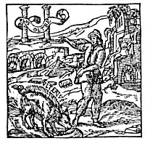  
A BACONIAN SIGNATURE.

From *Alciati Emblemata*.

*The curious volume from which this figure is taken was published in Paris in r618. The attention of the Baconian student is immediately attracted by the form of the hog in the foreground. Bacon often used this animal as a play upon his own name, especially because the name Bacon was derived from he word beech and the nut of this tree was used to fatten hogs. The two pillars in the background have considerable Masonic interest. The two A's nearly in the center of the picture--one light and one shaded--are alone almost conclusive proof of Baconian influence. The most convincing evidence, however, is the fact that 17 is the numerical equivalent of the letters of the Latin farm of Bacon's name (F. Baco) and there are 17 letters in the three words appearing in the illustration.*

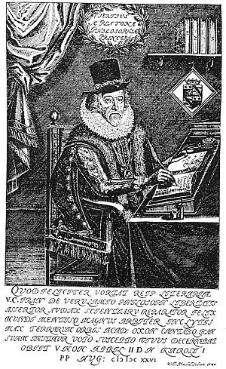  
FRANCIS BACON, BARON VERULAM, VISCOUNT ST. ALBANS.

From Bacon's *Advancement of Learning*.

*Lord Bacon was born in 1561 and history records his death in 1626. There are records in existence, however, which would indicate the probability that his funeral was a mock funeral and that, leaving England, he lived for many years under another name in Germany, there faithfully serving the secret society to the promulgation of whose doctrines he had consecrate his life. Little doubt seems to exist in the minds of impartial investigators that Lord Bacon was the legitimate son of Queen Elizabeth and the Earl of Leicester.*

Repeated references to the word *hog* and the presence of cryptographic statements on page 33 of various contemporary writings demonstrate that the keys to Bacon's ciphers were his own name, words playing upon it, or its numerical equivalent. Notable examples are the famous statement of Mistress Quickly in *The Merry Wives of Windsor*: "Hang-hog is latten for Bacon, I warrant you"; the title pages of *The Countess of Pembroke's Arcadia* and Edmund Spenser's *Faerie Queene*; and the emblems appearing in the works of Alciatus and Wither. Furthermore, the word *honorificabilitudinitatibus* appearing in the fifth act of Love's Labour's Lost is a Rosicrucian signature, as its numerical equivalent (287) indicates.

Again, on the title page of the first edition of Sir Francis Bacon's *New Atlantis*, Father Time is depicted bringing a female figure out of the darkness of a cave. Around the device is a Latin inscription: "In time the secret truth shall be revealed." The catchwords and printer's devices appearing in volumes published especially during the first half of the seventeenth century were designed, arranged, and in some cases mutilated according to a definite plan.

It is evident also that the mispaginations in the Shakespearian *Folios* and other volumes are keys to Baconian ciphers, for re-editions--often from new type and by different printers--contain the same mistakes. For example, the *First* and *Second Folios* of Shakespeare are printed from entirely different type and by different printers nine years apart, but in both editions page 153 of the *Comedies* is numbered 151, and pages 249 and 250 are numbered 250 and 251 respectively. Also in the 1640 edition of Bacon's *The Advancement and Proficience of Learning*, pages 353 and 354 are numbered 351 and 352 respectively, and in the 1641 edition of *Du Bartas' Divine Weeks* pages 346 to 350 inclusive are entirely missing, while page 450 is numbered 442. The frequency with which pages ending in numbers 50, 51, 52,53, and 54 are involved will he noted.

The requirements of Lord Verulam's biliteral cipher are fully met in scores of volumes printed between 1590 and 1650 and in some printed at other times. An examination of the verses by L. Digges, dedicated to the memory of the deceased "Authour Maister W. Shakespeare," reveals the use of two fonts of type for both capital and small letters, the differences being most marked in the capital *T*'s, *N*'s, and *A*'s, (Seethe *First Folio*.) The cipher has been deleted from subsequent editions.

The presence of hidden material in the text is often indicated by needless involvement of words. On the sixteenth unnumbered page of the 1641 edition of Du Bartas' *Divine Weeks* is a boar surmounting a pyramidal text. The text is meaningless jargon, evidently inserted for cryptographic reasons and marked with Bacon's signature--the hog. The year following publication of the *First Folio* of Shakespeare's plays in 1623, there was printed in "Lunæburg" a remarkable volume on cryptography, avowedly by Gustavus Selenus. It is considered extremely probable that this volume constitutes the cryptographic key to the *Great Shakespearian Folio*.

Peculiar symbolical head- and tail-pieces also mark the presence of cryptograms. While such ornaments are found in many early printed books, certain emblems are peculiar to volumes containing Baconian Rosicrucian ciphers. The light and dark shaded *A* is an interesting example. Bearing in mind the frequent recurrence in Baconian symbolism of the light and dark shaded *A* and the hog, the following statement by Bacon in his *Interpretation of Nature* is highly significant: "If the sow with her snout should happen to imprint the letter A upon the ground, wouldst thou therefore imagine that she could write out a whole tragedy as one letter?"

The Rosicrucians and other secret societies of the seventeenth century used watermarks as mediums for the conveyance of cryptographic references, and books presumably containing Baconian ciphers are usually printed upon paper bearing Rosicrucian or Masonic watermarks; often there are several symbols in one book, such as the Rose Cross, urns, bunches of grapes, and others.

At hand is a document which may prove a remarkable key to a cipher beginning in *The Tragedy of Cymbeline*. So far as known it has never been published and is applicable only to the 1623 *Folio* of the Shakespearian plays. The cipher is a line-and-word count involving punctuation, especially the long and short exclamation points and the straight and slanting interrogation points. This code was discovered by Henry William Bearse in 1900, and after it has been thoroughly checked its exact nature will be made public.

No reasonable doubt remains that the Masonic Order is the direct outgrowth of the secret societies of the Middle Ages, nor can it be denied that Freemasonry is permeated by the symbolism and mysticism of the ancient and mediæval worlds. Sir Francis Bacon knew the true secret of Masonic origin and there is reason to suspect that he concealed this knowledge in cipher and cryptogram. Bacon is not to be regarded solely as a man but rather as the focal point between an invisible institution and a world which was never able to distinguish between the messenger and the message which he promulgated. This secret society, having rediscovered the lost wisdom of the ages and fearing that the knowledge might be lost again, perpetuated it in two ways: (1) by an organization (Freemasonry) to the initiates of which it revealed its wisdom in the form of symbols; (2) by embodying its arcana in the literature of the day by means of cunningly contrived ciphers and enigmas.

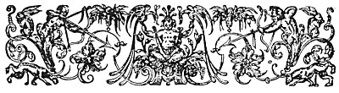  
A CRYPTIC HEADPIECE.

From Ralegh's *History of the World*.

*Many documents influenced by Baconian philosophy--or intended m conceal Baconian or Rosicrucian cryptograms--use certain conventional designs at the beginning and end of chapters, which reveal to the initiated the presence of concealed information. The above ornamental has long been accepted as of the presence of Baconian influence and is to be found only in a certain number of rare volumes, all of which contain Baconian cryptograms. These cipher messages were placed in the books either by Bacon himself or by contemporaneous and subsequent authors belonging to the same secret society which Bacon served with his remarkable knowledge of ciphers and enigmas. Variants of this headpiece adorn the Great Shakespearian Folio (1623); Bacon's Novum Organum (1620); the St. James Bible (1611); Spencer's Faerie Queene (1611); and Sir Walter Ralegh's History of the World (1614) (See American Baconiana.)*

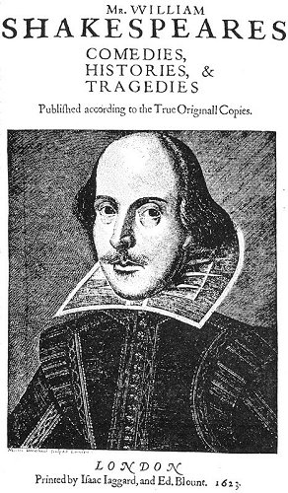  
THE DROESHOUT PORTRAIT OF SHAKSPERE.

From Shakespeare's *Great Folio* of 1623.

*There are no authentic portraits of Shakspere in existence. The dissimilarities the Droeshout, Chandos, Janssen, Hunt, Ashbourne, Soest, and Dunford portraits prove conclusively that the artists were unaware of Shakspere's actual features. An examination of the Droeshout portrait discloses several peculiarities. Baconian enthusiasts are convinced that the face is only a caricature, possibly the death mask of Francis Bacon. A comparison of the Droeshout Shakspere with portraits and engravings of Francis Bacon demonstrates the identity of the structure of the two faces, the difference in expression being caused by lines of shading. Not also the peculiar line running from the ear down to the chin. Does this line subtly signify that the face itself a mask, ending at the ear? Notice also that the head is not connected with the body, but is resting on the collar. Most strange of all is the coat: one-half is on backwards. In drawing the jacket, the artist has made the left arm correctly, but the right arm has the back of the shoulder to the front. Frank Woodward has noted that there are 157 letters on the title page. This is a Rosicrucian signature of first importance. The date, 1623, Plus the two letters "ON" from the word "LONDON," gives the cryptic signature of Francis Bacon, by a simple numerical cipher. By merely exchanging the 26 letters of the alphabet for numbers, 1 became A, 6 becomes F, 2 becomes B, and 3 becomes C, giving AFBC. To this is added the ON from LONDON, resulting in AFBCON, which rearranged forms F. BACON.*

Evidence points to the existence of a group of wise and illustrious *Fratres* who assumed the responsibility of publishing and preserving for future generations the choicest of the secret books of the ancients, together with certain other documents which they themselves had prepared. That future members of their fraternity might not only identify these volumes bur also immediately note the significant passages, words, chapters, or sections therein, they created a symbolic alphabet of hieroglyphic designs. By means of a certain key and order, the discerning few were thus enabled to find that wisdom by which a man is "raised" to an illumined life.

The tremendous import of the Baconian mystery is daily becoming more apparent. Sir Francis Bacon was a link in that great chain of minds which has perpetuated the secret doctrine of antiquity from its beginning. This secret doctrine is concealed in his cryptic writings. The search for this divine wisdom is the only legitimate motive for the effort to decode his cryptograms.

Masonic research might discover much of value if it would turn its attention to certain volumes published during the sixteenth and seventeenth centuries which bear the stamp and signet of that secret society whose members first established modern Freemasonry but themselves remained as an intangible group controlling and directing the activities of the outer body. *The unknown history and lost rituals of Freemasonry may be rediscovered in the symbolism and cryptograms of the Middle Ages*. Freemasonry is the bright and glorious son of a mysterious and hidden father. It cannot trace its parentage because that origin is obscured by the veil of the superphysical and the mystical. The *Great Folio* of 1623 is a veritable treasure house of Masonic lore and symbolism, and the time is at hand when that Great Work should be accorded the consideration which is its due.

Though Christianity shattered the material organization of the pagan Mysteries, it could not destroy the knowledge of supernatural power which the pagans possessed. Therefore it is known that the Mysteries of Greece and Egypt were secretly perpetuated through the early centuries of the church, and later, by being clothed in the symbolism of Christianity, were accepted as elements of that faith. Sir Francis Bacon was one of those who had been entrusted with the perpetuation and dissemination of s the arcana of the superphysical originally in the possession of the pagan hierophants, and to attain that end either formulated the Fraternity of R.C. or was admitted into an organization already existing under that name and became one of its principal representatives.

For some reason not apparent to the uninitiated there has been a continued and consistent effort to prevent the unraveling of the Baconian skein. Whatever the power may be which continually blocks the efforts of investigators, it is as unremitting now as it was immediately following Bacon's death, and those attempting to solve the enigma still feel the weight of its resentment.

A misunderstanding world has ever persecuted those who understood the secret workings of Nature, seeking in every conceivable manner to exterminate the custodians of this divine wisdom. Sir Francis Bacon's political prestige was finally undermined and Sir Walter Ralegh met a shameful fate because their transcendental knowledge was considered dangerous.

The forging of Shakspere's handwriting; the foisting of fraudulent portraits and death masks upon a gullible public; the fabrication of spurious biographies; the mutilation of books and documents; the destruction or rendering illegible of tablets and inscriptions containing cryptographic messages, have all compounded the difficulties attendant upon the solution of the Bacon-Shakspere-Rosicrucian riddle. The Ireland forgeries deceived experts for years.

According to material available, the supreme council of the Fraternity of R.C. was composed of a certain number of individuals who had died what is known as the "philosophic death." When the time came for an initiate to enter upon his labors for the Order, he conveniently "died" under somewhat mysterious circumstances. In reality he changed his name and place of residence, and a box of rocks or a body secured for the purpose was buried in his stead. It is believed that this happened in the case of Sir Francis Bacon who, like all servants of the Mysteries, renounced all personal credit and permitted others to be considered as the authors of the documents which he wrote or inspired.

The cryptic writings of Francis Bacon constitute one of the most powerful tangible elements in the mysteries of transcendentalism and symbolic philosophy. Apparently many years must yet pass before an uncomprehending world will appreciate the transcending genius of that mysterious man who wrote the *Novum Organum*, who sailed his little ship far out into the unexplored sea of learning through the Pillars of Hercules, and whose ideals for a new civilization are magnificently expressed in the Utopian dream of *The New Atlantis*. Was Sir Francis Bacon a second Prometheus? Did his great love for the people of the world and his pity for their ignorance cause him to bring the divine fire from heaven concealed within the contents of a printed page?

In all probability, the keys to the Baconian riddle will be found in classical mythology. He who understands the secret of the Seven-Rayed God will comprehend the method employed by Bacon to accomplish his monumental labor. Aliases were assumed by him in accordance with the attributes and order of the members of the planetary system. One of the least known--but most important--keys to the Baconian enigma is the Third, or 1637, Edition, published in Paris, of *Les Images ou Tableaux de platte peinture des deux Philostrates sophistes grecs et les statues de Callistrate*, by Blaise de Vigenere. The title page of this volume--which, as the name of the author when properly deciphered indicates, was written by or under the direction of Bacon or his secret society--is one mass of important Masonic or Rosicrucian symbols. On page 486 appears a plate entitled "Hercules Furieux," showing a gigantic figure shaking a spear, the ground before him strewn with curious emblems. In his curious work, *Das Bild des Speershüttlers die Lösung des Shakespeare-Rätsels*, Alfred Freund attempts to explain the Baconian symbolism in the *Philostrates*. Bacon he reveals as the philosophical Hercules, whom time will establish as the true "Spear-Shaker" (Shakespeare).

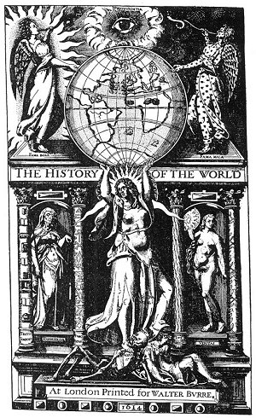  
TITLE PAGE OF THE FAMOUS FIRST EDITION OF SIR WALTER RALEGH'S HISTORY OF THE WORLD.

From Ralegh's *History of the World*.

*What was the mysterious knowledge which Sir Walter Ralegh possessed and which was declared to be detrimental to the British government? Why was he executed when the charges against him could not be proved? Was he a member of me of those feared and hated secret societies which nearly overthrew political and religious Europe during the sixteenth and seventeenth centuries? Was Sir Walter Ralegh an important factor in the Bacon-Shakspere-Rosicrucian-Masonic enigma? By those seeking the keys to this great controversy, he seems to have been almost entirely overlooked. His contemporaries are unanimous in their praise of his remarkable intellect, and he has long been considered me of Britain's most brilliant sons.*

*Sir Walter Ralegh--soldier, courtier, statesman, writer, poet, philosopher, and explorer--was a scintillating figure at the court of Queen Elizabeth. Upon this same man, King James--after the death of Elizabeth--heaped every indignity within his power. The cowardly James, who shuddered at the mention of weapons and cried like a child when he was crossed, was insanely jealous of the brilliant courtier. Ralegh's enemies, Playing upon the king's weakness, did not cease their relentless persecution until Ralegh had been hanged and his decapitated, quartered, and disemboweled body lay at their feet.*

*The title page reproduced above was used by Ralegh's political foes as a powerful weapon against him. They convinced James I that the face of the central figure upholding the globe was a caricature of his own, and the enraged king ordered every copy of the engraving destroyed. But a few copies escaped the royal wrath; consequently the plate is extremely rare. The engraving is a mass Rosicrucian and Masonic symbols, and the figures on the columns in all probability conceal a cryptogram. More significant still is the fact that the page facing this plate is a headpiece identical with that used in the 1623 Folio of "Shakespeare" and also in Bacon's Novum Organum.*

===================================================================================================================================================

END