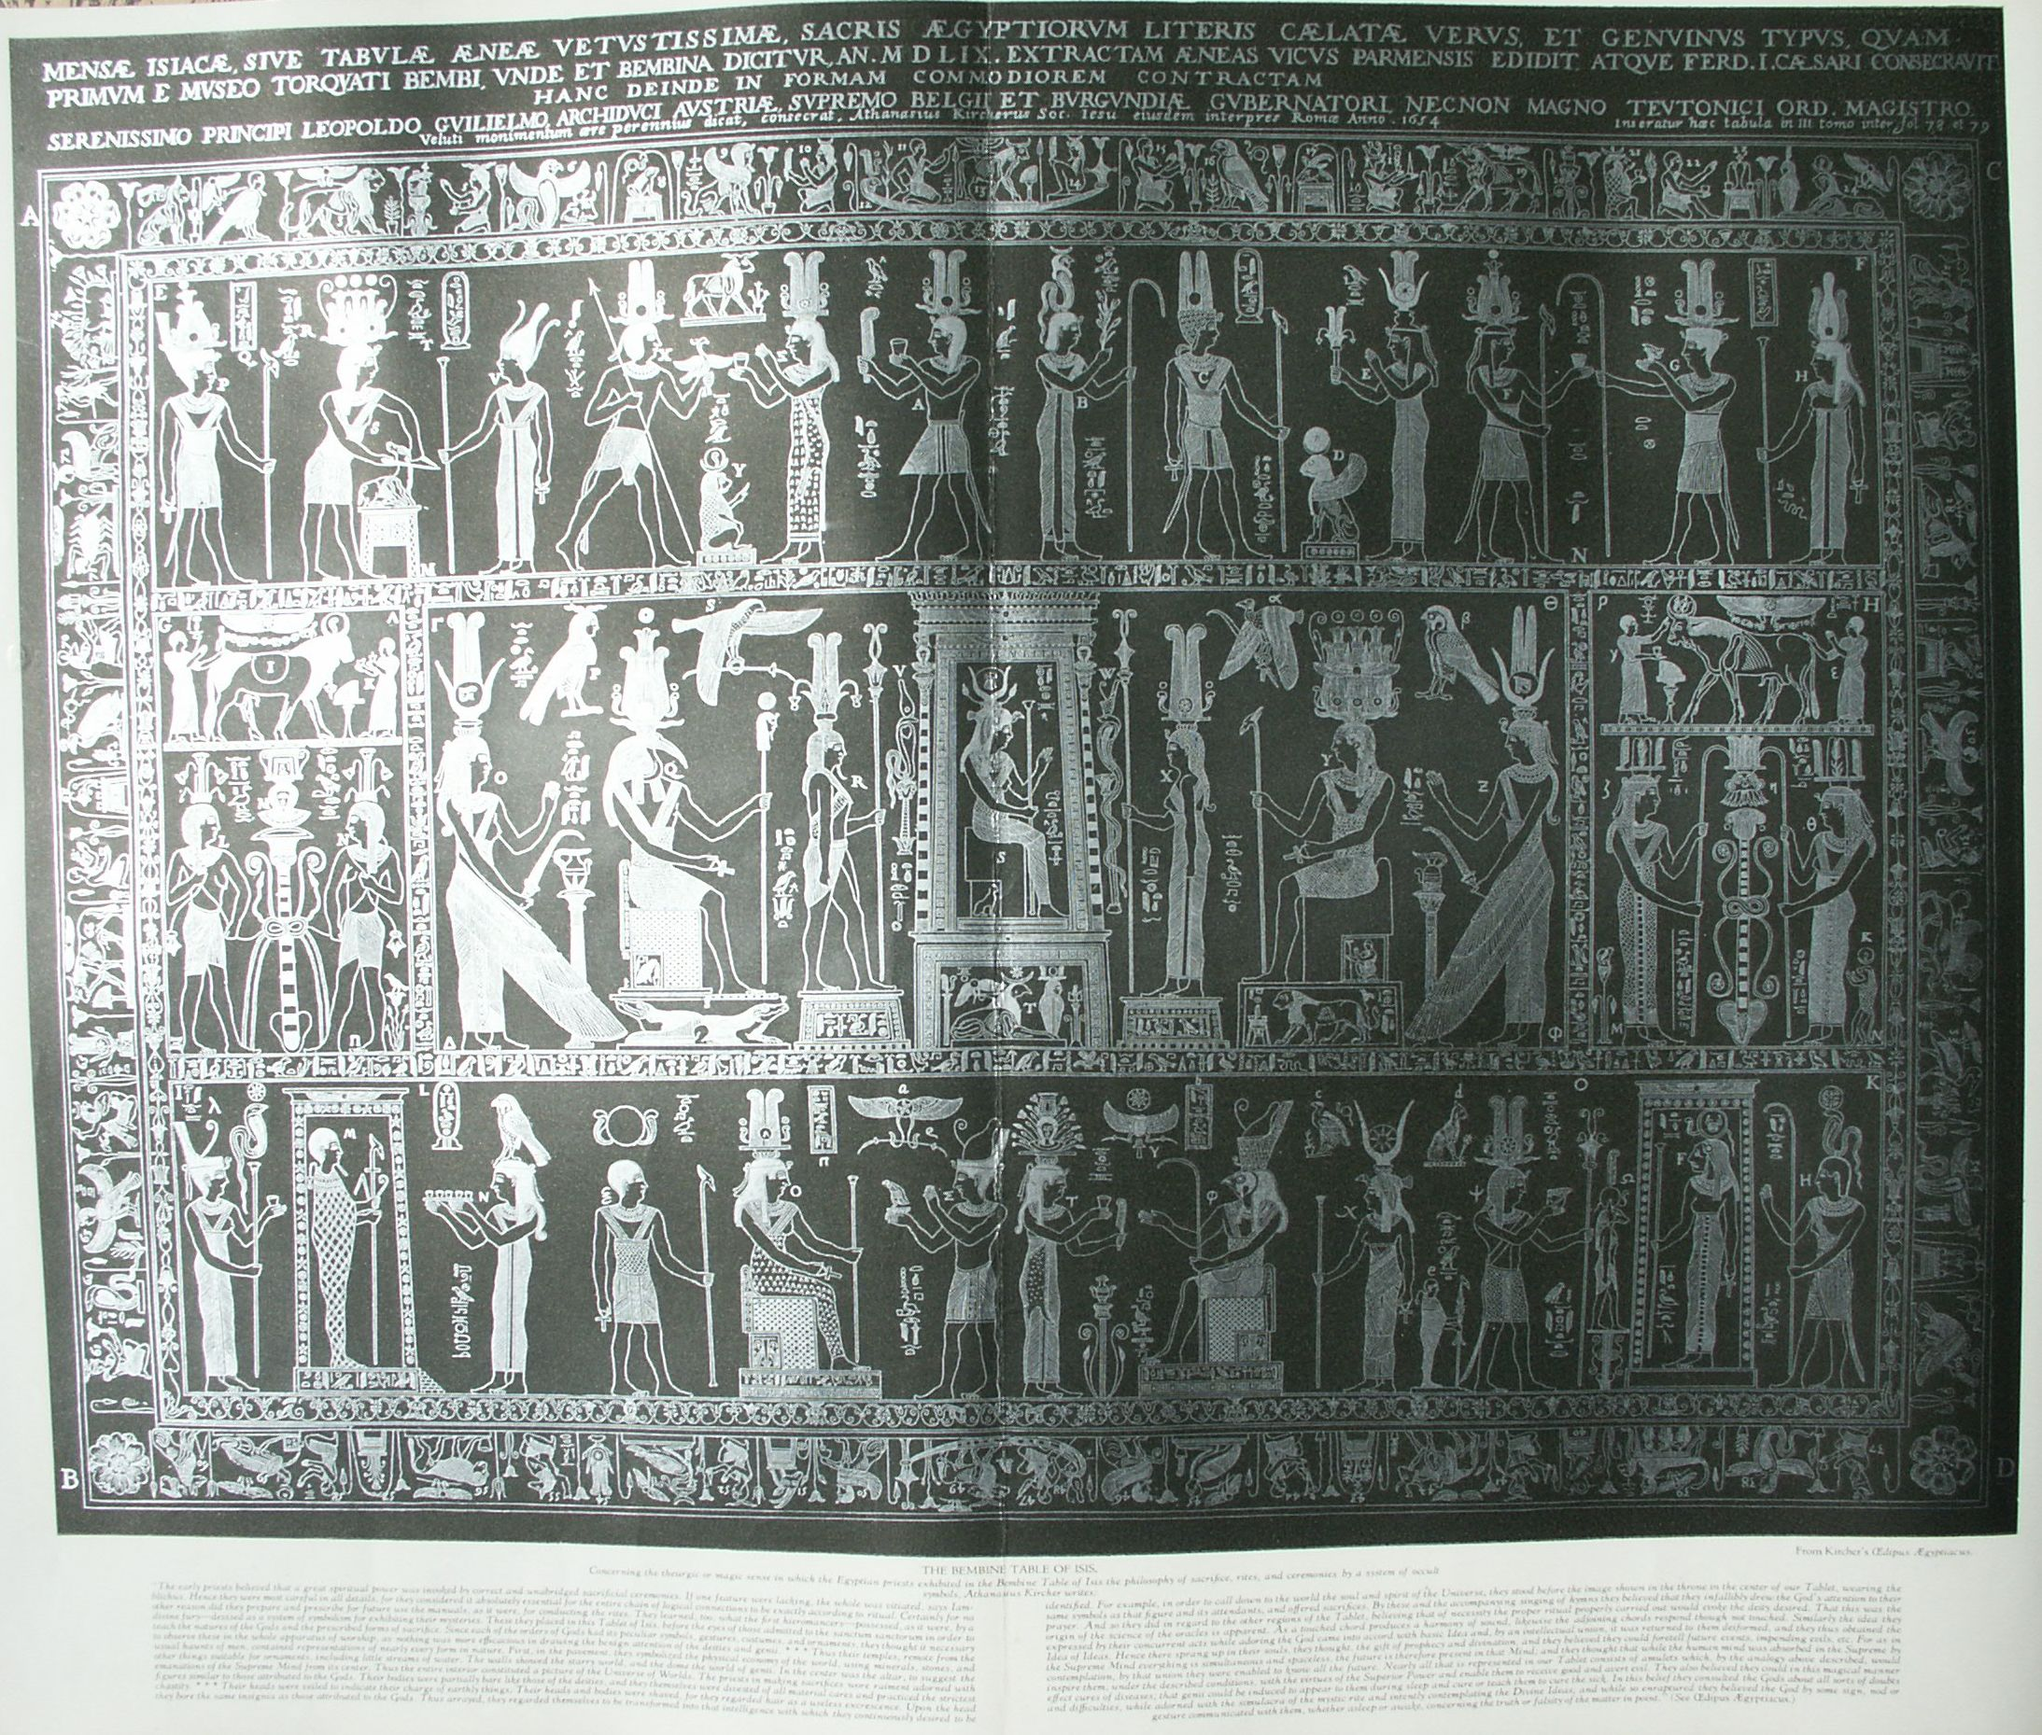

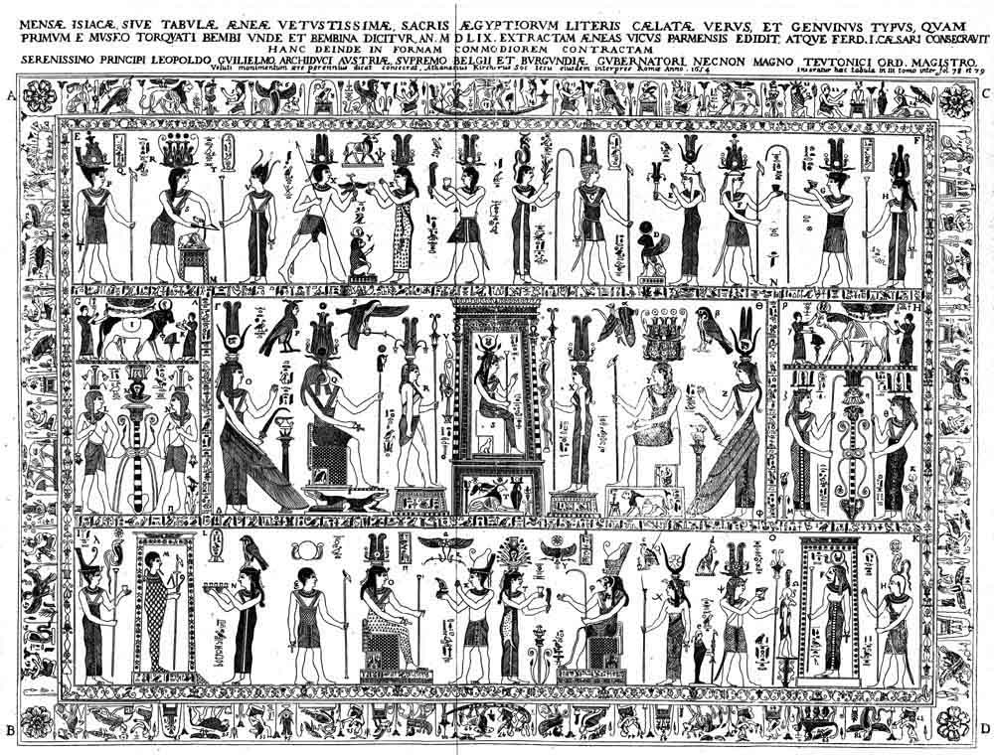

**The Bembine Table of Isis**

**The Secret Teachings of All Ages - Manly P. Hall 1928**

**THE BEMBINE TABLE OF ISIS  
Plato's initiation in the Great Pyramid--The history of the Bembine Table--Platonic theory of ideas--The interplay of the three philosophical zodiacs--The Chaldean philosophy of triads--The Orphic Egg.**

Concerning the theurgic or magic sense in which the Egyptian priests exhibited in the Bembine Table of Isis the philosophy of sacrifice, rites, and ceremonies by a system of occult symbols, Athanasius Kircher writes:

"The early priests believed that a great spiritual power was invoked by correct and unabridged sacrificial ceremonies. If one feature were lacking, the whole was vitiated, says Iamblichus. Hence they were most careful in all details, for they considered it absolutely essential for the entire chain of logical connections to be exactly according to ritual. Certainly for no other reason did they prepare and prescribe for future use the manuals, as it were, for conducting the rites. They learned, too, what the first hieromancers--possessed, as it were, by a divine fury--devised as a system of symbolism for exhibiting their mysteries. These they placed in this Tablet of Isis, before the eyes of those admitted to the sanctum sanctorum in order to teach the nature of the Gods and the prescribed forms of sacrifice. Since each of the orders of Gods had its own peculiar symbols, gestures, costumes, and ornaments, they thought it necessary to observe these in the whole apparatus of worship, as nothing was more efficacious in drawing the benign attention of the deities and genii. * * * Thus their temples, remote from the usual haunts of men, contained representations of nearly every form in nature. First, in the pavement, they symbolized the physical economy of the world, using minerals, stones and other things suitable for ornaments, including little streams of water. The walls showed the starry world, and the done the world of genii. In the center was the altar, to suggest the emanations of the Supreme Mind from its center. Thus the entire interior constituted a picture of the Universe of Worlds. The priests in making sacrifices wore raiment adorned with figures similar to those attributed to the Gods. Their bodies were partially bare like those of the deities, and they themselves were divested of all material cares and practices the strictest chastity. * * * Their heads were veiled to indicate their charge of earthly things. Their heads and bodies were shaved, for they regarded hair as a useless excrescence. Upon the head they bore the same insignia as those attributed to the Gods. Thus arrayed, they regarded themselves to be transformed into that intelligence with which they constantly desired to be identified. For example, in order to call down to the world the soul and spirit of the Universe, they stood before the image shown in the center of our Tablet, wearing the same symbols as that figure and its attendants, and offered sacrifices. By these and the accompanying singing of hymns they believed that they infallibly drew the God's attention to their prayer. And so they did in regard to other regions of the Tablet, believing of necessity the proper ritual properly carried out would evoke the deity desired. That this was the origin of the science of oracles is apparent. As a touched chord produces a harmony of sound, likewise the adjoining chords respond though not touched. Similarly the idea they expressed by their concurrent acts while adoring the God came into accord with basic Idea and, by an intellectual union, it was returned to them deiformed, and they thus obtained the Idea of Ideas. Hence there sprang up in their souls, they thought, the gift of prophecy and divination, and they believed they could foretell future events, impending evils, etc. For as in the Supreme Mind everything is simultaneous and spaceless, the future is therefore present in that Mind; and they thought that while the human mind was absorbed in the Supreme by contemplation, by that union they were enabled to know all the future. Nearly all that is represented in our Tablet consists of amulets which, by analogy above described, would inspire them, under the described conditions, with the virtues of the Supreme Power and enable them to receive good and avert evil. They also believed they could in this magical manner effect cures of diseases; that genii could be induced to appear to them during sleep and cure or teach them to cure the sick. In this belief they consulted the Gods about all sort of doubts and difficulties, while adorned with the simulacra of the mystic rite and intently contemplating the Divine Ideas; and while so enraptured they believed the God by some sign, nod or gesture communicated with them, whether asleep or awake, concerning the truth or falsity of the matter in point." (See *Œdipus Ægyptiacus*.)

A MANUSCRIPT by Thomas Taylor contains the following remarkable paragraph:

"Plato was initiated into the 'Greater Mysteries' at the age of 49. The initiation took place in one of the subterranean halls of the Great Pyramid in Egypt. The ISIAC TABLE formed the altar, before which the Divine Plato stood and received that which was always his, but which the ceremony of the Mysteries enkindled and brought from its dormant state. With this ascent, after three days in the Great Hall, he was received by the Hierophant of the Pyramid (the Hierophant was seen only by those who had passed the three days, the three degrees, the three dimensions) and given verbally the Highest Esoteric Teachings, each accompanied with Its appropriate Symbol. After a further three months' sojourn in the halls of the Pyramid, the Initiate Plato was sent out into the world to do the work of the Great Order, as Pythagoras and Orpheus had been before him."

Before the sacking of Rome in 1527 there is no historical mention of the *Mensa Isiaca*, (Tablet of Isis). At that time the Tablet came into the possession of a certain locksmith or ironworker, who sold it at an exorbitant price to Cardinal Bembo, a celebrated antiquary, historiographer of the Republic of Venice, and afterwards librarian of St. Mark's. After his death in 1547 the Isiac Tablet was acquired by the House of Mantua, in whose museum it remained until 1630, when troops of Ferdinand II captured the city of Mantua. Several early writers on the subject have assumed that the Tablet was demolished by the ignorant soldiery for the silver it contained. The assumption, however, was erroneous. The Tablet fell into the hands of Cardinal Pava, who presented it to the Duke of Savoy, who in turn presented it to the King of Sardinia. When the French conquered Italy in 1797 the Tablet was carried to Paris. In 1809, Alexandre Lenoir, writing of the *Mensa Isiaca*, said it was on exhibition at the Bibliothèque Nationale. Upon the establishment of peace between the two countries it was returned to Italy. In his Guide to Northern Italy, Karl Baedeker describes the *Mensa Isiaca* as being in the center of Gallery 2 in the Museum of Antiquities at Turin.

A faithful reproduction of the original Tablet was made in 1559 by the celebrated Æneas Vicus of Parma, and a copy of the engraving was given by the Chancellor of the Duke of Bavaria to the Museum of Hieroglyphics. Athanasius Kircher describes the Tablet as "five palms long and four wide." W. Wynn Westcott says it measures 50 by 30 inches. It was made of bronze and decorated with encaustic or smalt enamel and silver inlay. Fosbroke adds: "The figures are cut very shallow, and the contour of most of them is encircled by threads of silver. The bases upon which the figures were seated or reclined, and left blank in the prints, were of silver and are torn away." (See *Encyclopædia of Antiquities*.)

Those familiar with the fundamental principles of Hermetic philosophy will recognize in the *Mensa Isiaca* the key to Chaldean, Egyptian, and Greek theology. In his *Antiquities*, the learned Benedictine, Father Montfaucon, admits his inability to cope with the intricacies of its symbolism. He therefore doubts that the emblems upon the Tablet possess any significance worthy of consideration and ridicules Kircher, declaring him to be more obscure than the Tablet itself. Laurentius Pignorius reproduced the Tablet in connection with a descriptive essay in 1605, but his timidly advanced explanations demonstrated his ignorance concerning the actual interpretation of the figures.

In his *Œdipus Ægyptiacus*, published in 1654, Kircher attacked the problem with characteristic avidity. Being peculiarly qualified for such a task by years of research in matters pertaining to the secret doctrines of antiquity, and with the assistance of a group of eminent scholars, Kircher accomplished much towards an exposition of the mysteries of the Tablet. The master secret, however, eluded even him, as Eliphas Levi has shrewdly noted in his *History of Magic*.

"The learned Jesuit, " writes Levi, "divined that it contained the hieroglyphic key to sacred alphabets, though he was unable to develop the explanation. It is divided into three equal compartments; above are the twelve houses of heaven and below are the corresponding distributions of labor [work periods] throughout the year, while in the middle place are twenty-one sacred signs answering to the letters of the alphabet. In the midst of all is a seated figure of the pantomorphic IYNX, emblem of universal being and corresponding as such to the Hebrew *Yod*, or to that unique letter from which all the other letters were formed. The IYNX is encircled by the Ophite triad, answering to the Three Mother Letters of the Egyptian and Hebrew alphabets. On the right are the Ibimorphic and Serapian triads; on the left are those of Nepthys and Hecate, representing active and passive, fixed and volatile, fructifying fire and generating water. Each pair of triads in conjunction with the center produces a septenary, and a septenary is contained in the center. The three septenaries furnish the absolute number of the three worlds, as well as the complete number of primitive letters, to which a complementary sign is added, like zero to the nine numerals."

Levi's hint may be construed to mean that the twenty-one figures in the center section of the Table represent the twenty-one major trumps of the Tarot cards. If this be so, is not the zero card, cause of so much controversy, the nameless crown of the Supreme Mind, the crown being symbolized by the hidden triad in the upper part of the throne in the center of the Table? Might not the first emanation of this Supreme Mind be well symbolized by a juggler or magician with the symbols of the four lower worlds spread out on a table before him: the rod, the sword, the cup, and the coin? Thus considered, the zero card belongs nowhere among the others but is in fact the fourth dimensional point from which they all emanated and consequently is broken up into the twenty-one cards (letters) which, when gathered together, produce the zero. The cipher appearing upon this card would substantiate this interpretation, for the cipher, or circle, is emblematic of the superior sphere from which issue the lower worlds, powers, and letters.

Westcott carefully collected the all too meager theories advanced by various authorities and in 1887 published his now extremely rare volume, which contains the only detailed description of the Isiac Tablet published in English since Humphreys translated Montfaucon's worthless description in 1721. After explaining his reticence to reveal that which Levi evidently felt was better left concealed, Westcott sums up his interpretation of the Tablet as follows:

"The diagram of Levi, by which he explains the mystery of the Tablet, shows the Upper Region divided into the four seasons of the year, each with three signs of the Zodiac, and he has added the four-lettered sacred name, the Tetragrammaton, assigning Jod to Aquarius, that is Canopus, He to Taurus, that is Apis, Vau to Leo, that is Momphta, and He final to Typhon. Note the Cherubic parallel--Man, Bull, Lion and Eagle. The fourth form is found either as Scorpion or Eagle depending upon the Occult good or evil intention: in the Demotic Zodiac, the Snake replaces the Scorpion.

"The Lower Region he ascribes to the twelve *simple* Hebrew letters, associating them with the four quarters of the horizon. Compare the Sepher Yerzirah, Cap. v., sec. 1.

"The Central Region he ascribes to the Solar powers and the Planetary. In the middle we see above, the Sun, marked Ops, and below it is a Solomon's Seal, above a cross; a double triangle Hexapla, one light and one dark triangle superposed, the whole forming a sort of complex symbol of Venus. To the Ibimorphos he gives the three dark planets, Venus, Mercury, and Mars placed around a dark triangle erect, denoting Fire. To the Nephthæan triad he gives three light planets, Saturn, Luna, and Jupiter, around a light inverted triangle which denotes Water. There is a necessary connection between water, female power, passive principle, Binah, and Sephirotic Mother, and Bride. (See the *Kabbalah* by Mathers.) Note the ancient signs for the planets were all composed of a Cross, Solar Disc and Crescent: Venus is a cross below a Sun disc, Mercury, a disc With a crescent above and cross below, Saturn is a Cross whose lowest point touches the apex of the crescent; Jupiter is a Crescent whose lowest point touches the left hand end of a cross: all these are deep mysteries. Note that Levi in his original plate transposed Serapis and Hecate, but not the Apis noir and Apis blanc, perhaps because of the head of Bes being associated by him with Hecate. Note that having referred the 12 simple letters to the lower, the 7 double must correspond to the central region of the planets, and then the great triad A.M.S. the mother letters representing Air, Water, and Fire remain to be pictured, around S the Central Iynx, or Yod, by the Ophionian Triad the two Serpents and the Leonine Sphynx. Levi's word OPS in the centre is the Latin Ops, Terra, genius of the Earth; and the Greek Ops, Rhea, or Kubele (Cybele) often drawn as a goddess seated in a chariot drawn by lions; she is crowned with turrets, and holds a Key." (See *The Isiac Tablet*.)

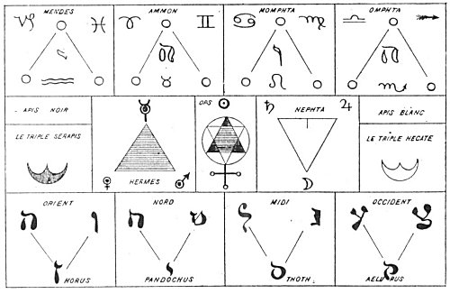  
LEVI'S KEY TO THE BEMBINE TABLE.

From Levi's *History of Magic*.

*"The Isiac Tablet, writes Levi, is a Key to the Ancient Book of Thoth, which has survived to some extent the lapse of centuries and is pictured to us in the still comparatively ancient set of Tarocchi Cards. To him the Book of Thoth was a résumé of the esoteric learning of the Egyptians, after the decadence of their civilization, this lore became crystallized in a hieroglyphic form as the Tarot; this Tarot having become partially or entirely forgotten or misunderstood, its pictured symbols fell into the hands of the sham diviners, and of the providers of the public amusement by games of Cards. The modem Tarot, or Tarocchi pack of cards consists of 78 cards, of which 22 form a special group of trumps, of pictorial design: the remaining 56 are composed of four suits of 10 numerals and four court cards, King, Queen, Knight, and Knave or Valet; the suits are Swords (Militaryism), Cups (Sacerdocy), Clubs or Wands (Agriculture), and Shekels or Coins (Commerce), answering respectively to our Spades, Hearts, Clubs and Diamonds. Our purpose is with the 22 trumps, these form the special characteristic of the Pack and are the lineal descendants of the Hieroglyphics of the Tarot. These 22 respond to the letters of the Hebrew and other sacred alphabets, which fall naturally into three classes of a Trio of Mothers, a Heptad of doubles, and a duodecad of simple letters. They are also considered as a triad of Heptads and one apart, a system of Initiation and an Uninitiate." (See Westcott's The Isiac Tablet.)*

The essay published in French by Alexandre Lenoir in 1809, while curious and original, contains little real information on the Tablet, which the author seeks to prove was an Egyptian calendar or astrological chart. As both Montfaucon and Lenoir--in fact all writers on the subject since 1651--either have based their work upon that of Kircher or have been influenced considerably by him, a careful translation has been made of the latter's original article (eighty pages of seventeenth century Latin). The double-page plate at the beginning of this chapter is a faithful reproduction made by Kircher from the engraving in the Museum of Hieroglyphics. The small letters and numbers used to designate the figures were added by him to clarify his commentary and will be used for the same purpose in this work.

Like nearly all religious and philosophical antiquities, the Bembine Table of Isis has been the subject of much controversy. In a footnote, A. E. Waite--unable to differentiate between the true and the purported nature or origin of the Tablet--echoes the sentiments of J.G. Wilkinson, another eminent *exotericus*: "The original [Table] is exceedingly late and is roughly termed a forgery." On the other hand, Eduard Winkelmann, a man of profound learning, defends the genuineness and antiquity of the Tablet. A sincere consideration of the Mensa Isiaca discloses one fact of paramount importance: that although whoever fashioned the Table was not necessarily an Egyptian, he was an initiate of the highest order, conversant with the most arcane tenets of Hermetic esotericism.

**SYMBOLISM OF THE BEMBINE TABLE**

The following necessarily brief elucidation of the Bembine Table is based upon a digest of the writings of Kircher supplemented by other information gleaned by the present author from the mystical writings of the Chaldeans, Hebrews, Egyptians, and Greeks. The temples of the Egyptians were so designed that the arrangement of chambers, decorations, and utensils was all of symbolic significance, as shown by the hieroglyphics that covered them. Beside the altar, which usually was in the center of each room, was the cistern of Nile water which flowed in and out through unseen pipes. Here also were images of the gods in concatenated series, accompanied by magical inscriptions. In these temples, by use of symbols and hieroglyphics, neophytes were instructed in the secrets of the sacerdotal caste.

The Tablet of Isis was originally a table or altar, and its emblems were part of the mysteries explained by priests. Tables were dedicated to the various gods and goddesses; in this case Isis was so honored. The substances from which the tables were made differed according to the relative dignities of the deities. The tables consecrated to Jupiter and Apollo were of gold; those to Diana, Venus, and Juno were of silver; those to the other superior gods, of marble; those to the lesser divinities, of wood. Tables were also made of metals corresponding to the planets governed by the various celestials. As food for the body is spread on a banquet table, so on these sacred altars were spread the symbols which, when understood, feed the invisible nature of man.

In his introduction to the Table, Kircher summarizes its symbolism thus: "It teaches, in the first place, the whole constitution of the threefold world--archetypal, intellectual, and sensible. The Supreme Divinity is shown moving from the center to the circumference of a universe made up of both sensible and inanimate things, all of which are animated and agitated by the one supreme power which they call the *Father Mind* and represented by a threefold symbol. Here also are shown three triads from the Supreme One, each manifesting one attribute of the first Trimurti. These triads are called the *Foundation*, or the base of all things. In the Table is also set forth the arrangement and distribution of those divine creatures that aid the Father Mind in the control of the universe. Here [in the upper panel] are to be seen the Governors of the worlds, each with its fiery, ethereal, and material insignia. Here also [in the lower panel] are the *Fathers of Fountains*, whose duty it is to care for and preserve the principles of all things and sustain the inviolable laws of Nature. Here are the gods of the spheres and also those who wander from place to place, laboring with all substances and forms (Zonia and Azonia), grouped together as figures of both sexes, with their faces turned to their superior deity."

The *Mensa Isiaca*, which is divided horizontally into three chambers or panels, may represent the ground plan of the chambers in which the Isiac Mysteries were given. The center panel is divided into seven parts or lesser rooms, and the lower has two gates, one at each end. The entire Table contains forty-five figures of first importance and a number of lesser symbols. The forty-five main figures are grouped into fifteen triads, of which four are in the upper panel, seven in the central, and four in the lower. According to both Kircher and Levi, the triads are divided in the following manner:

*In the upper section*

1. P, S, V--Mendesian Triad.

2. X, Z, A--Ammonian Triad.

3. B, C, D--Momphtæan Triad.

4. F, G, H-Omphtæan Triad.

*In the center section*

1. G, I, K--Isiac Triad.

2. L, M, N--Hecatine Triad.

3. O, Q, R--Ibimorphous Triad.

4. V, S, W--Ophionic Triad.

5. X, Y, Z--Nephtæan Triad.

6. ζ, η, θ--Serapæan Triad.

7. γ, δ (not shown), ε--Osirian Triad.

*In the lower section*

1. λ, Μ, Ν--Horæan Triad.

2. ξ, Ο, Σ--Pandochæan Triad.

3. Τ, Φ, Χ--Thaustic Triad.

4. Ψ, F, Η--Æluristic Triad.

Of these fifteen triads Kircher writes: "The figures differ from each other in eight highly important respects, i. e., according to form, position, gesture, act, raiment, headdress, staff, and, lastly, according to the hieroglyphics placed around them, whether these be flowers, shrubs, small letters or animals." These eight symbolic methods of portraying the secret powers of the figures are subtle reminders of the eight spiritual senses of cognition by means of which the Real Self in man may be comprehended. To express this spiritual truth the Buddhists used the wheel with eight spokes and raised their consciousness by means of the noble eightfold path. The ornamented border enclosing the three main panels of the Table contains many symbols consisting of birds, animals, reptiles, human beings, and composite forms. According to one reading of the Table, this border represents the four elements; the creatures are elemental beings. According to another interpretation, the border represents the archetypal spheres, and in its frieze of composite figures are the patterns of those forms which in various combinations will subsequently manifest themselves in the material world. The four flowers at the corners of the Table are those which, because their blossoms always face the sun and follow its course across the sky, are sacred emblems of that finer part of man's nature which delights in facing its Creator.

According to the secret doctrine of the Chaldeans, the universe is divided into four states of being (planes or spheres): archetypal, intellectual, sidereal, and elemental. Each of these reveals the others; the superior controlling the inferior, and the inferior receiving influence from the superior. The archetypal plane was considered synonymous with the intellect of the Triune Divinity. Within this divine, incorporeal, and eternal sphere are included all the lower manifestations of life-all that is, has been, or ever shall be. Within the Kosmic Intellect all things spiritual or material exist as archetypes, or divine thought-forms, which is shown in the Table by a chain of secret similes.

In the middle region of the Table appears the all-form-containing personified Spiritual Essence--the source and substance of all things. From this proceed the lower worlds as nine emanations in groups of three (the Ophionic, Ibimorphous, and Nephtæan Triads). Consider in this connection the analogy of the Qabbalistic Sephiroth, or the nine spheres issuing from Kether, the Crown. The twelve Governors of the Universe (the Mendesian, Ammonian, Momphtæan, and Omphtæan Triads)--vehicles for the distribution of the creative influences, and shown in the upper region of the Table-are directed in their activities by the Divine Mind patterns existing in the archetypal sphere, The archetypes are abstract patterns formulated in the Divine Mind and by them all the inferior activities are controlled.

In the lower region of the Table are the Father Fountains (the Horæan, Pandochæan, Thaustic, and Æluristic Triads), keepers of the great gates of the universe. These distribute to the lower worlds the influences descending from the Governors shown above.

In the theology of the Egyptians, goodness takes precedence and all things partake of its nature to a higher or lower degree. Goodness is sought by all. It is the Prime Cause of causes. Goodness is self-diffused and hence exists in all things, for nothing can produce that which it does not have in itself. The Table demonstrates that all is in God and God is in all; that all is in all and each is in each. In the intellectual world are invisible spiritual counterparts of the creatures which inhabit the elemental world. Therefore, the lowest exhibits the highest, the corporeal declares the intellectual, and the invisible i,. made manifest by its works. For this reason the Egyptians made images of substances existing in the inferior sensible world to serve as visible exemplars of superior and invisible powers. To the corruptible images they assigned the virtues of the incorruptible divinities, thus demonstrating arcanely that this world is but the shadow of God, the outward picture of the paradise within. All that is in the invisible archetypal sphere is revealed in the sensible corporeal world by the light of Nature.

The Archetypal and Creative Mind--first through its Paternal Foundation and afterwards through secondary Gods called Intelligences--poured our the whole infinity of its powers by continuous exchange from highest to lowest. In their phallic symbolism the Egyptians used the sperm to represent the spiritual spheres, because each contains all that comes forth from it. The Chaldeans and Egyptians also held that everything which is a result dwells in the cause of itself and turns to that cause as the lotus to the sun. Accordingly, the Supreme Intellect, through its Paternal Foundation, first created light--the angelic world. Out of that light were then created the invisible hierarchies of beings which some call the stars; and out of the stars the four elements and the sensible world were formed. Thus all are in all, after their respective kinds. All visible bodies or elements are in the invisible stars or spiritual elements, and the stars are likewise in those bodies; the stars are in the angels and the angels in the stars; the angels are in God and God is in all. Therefore, all are divinely in the Divine, angelically in the angels, and corporeally in the corporeal world, and vice versa. just as the seed is the tree folded up, so the world is God unfolded.

Proclus says: "Every property of divinity permeates all creation and gives itself to all inferior creatures. "One of the manifestations of the Supreme Mind is the power of reproduction according to species which it confers upon every creature of which it is the divine part. Thus souls, heavens, elements, animals, plants, and stones generate themselves each according to its pattern, but all are dependent upon the one fertilizing principle existing in the Supreme Mind. The fecundative power, though of itself a unit, manifests differently through the various substances, for in the mineral it contributes to material existence, in the plant it manifests as vitality, and in the animal as sensibility. It imparts motion to the heavenly bodies, thought to the souls of men, intellectuality to the angels, and superessentiality to God. Thus it is seen that all forms are of one substance and all life of one force, and these are co-existent in the nature of the Supreme One.

This doctrine was first expounded by Plato. His disciple, Aristotle, set it forth in these words: "We say that this Sensible World is an image of another; therefore since this world is vivid or alive, how much more, then, that other must live. * * * Yonder, therefore, above the stellar virtues, stand other heavens to be attained, like the heavens of this world; beyond them, because they are of a higher kind, brighter and vaster; nor are they distant from each Other like this one, for they are incorporeal. Yonder, too, exists an earth, not of inanimate matter, but vivid with animal life and all natural terrestrial phenomena like this one, but of other kinds and perfections. There are plants, also, and gardens, and flowing water; there are aquatic animals but of nobler species. Yonder is air and life appropriate to it, all immortal. And although the life there is analogous to ours, yet it is nobler, seeing that it is intellectual, perpetual and unalterable. For if anyone should object and ask, How in the world above do the plants, etc. above mentioned find footing, we should answer that they do not have objective existence, for they were produced by the primal Author in an absolute condition and without exteriorization. They are, therefore, in the same case as intellect and soul; they suffer no defect such as waste and corruption, since the beings yonder are full of energy, strength and joy, as living in a life sublime and being the issue of one fount and of one quality, compounded of all like sweet savors, delicate perfumes, harmonious color and sound, and other perfections. Nor do they move violently about nor intermix nor corrupt each other, but each perfectly preserves its own essential character; and they are simple and do not multiply as corporeal beings do."

In the midst of the Table is a great covered throne with a seated female figure representing Isis, but here called the Pantomorphic IYNX. G. R. S. Mead defines the IYNX as "a transmitting intelligence." Others have declared it to be a symbol of Universal Being. Over the head of the goddess the throne is surmounted by a triple crown, and beneath her feet is the house of material substance. The threefold crown is here symbolic of the Triune Divinity, called by the Egyptians the Supreme Mind, and described in the *Sepher ha Zohar* as being "hidden and unrevealed." According to the Hebrew system of Qabbalism, the Tree of the Sephiroth was divided into two parts, the upper invisible and the lower visible. The upper consisted of three parts and the lower of seven. The three uncognizable Sephiroth were called *Kether*, the Crown; *Chochmah*, Wisdom; and *Binah*, Understanding. These are too abstract to permit of comprehension, whereas the lower seven spheres that came forth from them were within the grasp of human consciousness. The central panel contains seven triads of figures. These represent the lower Sephiroth, all emanating from the concealed threefold crown over the throne.

Kircher writes: "The throne denotes the diffusion of the triform Supreme Mind along the universal paths of the three worlds. Out of these three intangible spheres emerges the sensible universe, which Plutarch calls the 'House of Horns' and the Egyptians, the 'Great Gate of the Gods.' The top of the throne is in the midst of diffused serpent-shaped flames, indicating that the Supreme Mind is filled with light and life, eternal and incorruptible, removed from all material contact. How the Supreme Mind communicated His fire to all creatures is clearly set forth in the symbolism of the Table. The Divine Fire is communicated c to lower spheres through the universal power of Nature personified by the World Virgin, Isis, here denominated the IYNX, or the polymorphous all-containing Universal Idea." The word Idea is here used in its Platonic sense. "Plato believed that there are eternal forms of all possible things which exist without matter; and to these eternal and immaterial forms he gave the name of *ideas*. In the Platonic sense, *ideas* were the patterns according to which the Deity fashioned the phenomenal or ectypal world." (Sir W. Hamilton.)

Kircher describes the 21 figures in the central panel thus: "Seven principal triads, corresponding to seven superior worlds, are shown in the central section of the Table. They all originate from the fiery, invisible archetype [the triple crown of the throne]. The first, the Ophionic or IYNX Triad, V S W, corresponds to the vital and fiery world and is the first intellectual world, called by the ancients the *Aetherium*. Zoroaster says of it: 'Oh, what rigorous rulers this world has!' The second, or Ibimorphous Triad, O Q R, corresponds to the second intellectual, or ethereal, world, and is concerned with the principle of humidity. The third, or Nephtæan Triad, X Y Z, corresponds to the third intellectual and ethereal [world] and is concerned with fecundity. These are the three triads of the ethereal worlds, which correspond to the Father Foundation. Then follow the four triads of the sensible, or material, worlds, of which the first two correspond to the sidereal worlds, G I K and γ δ ε, namely, Osiris and Isis, Sun and Moon, indicated by two bulls. They are followed by two triads--the Hecatine, LM N, and the Serapæan, ζ η θ, corresponding to the sublunary and subterranean worlds. These complete the seven worlds of primary Genii ruling the natural universe. Psellus quotes Zoroaster: 'The Egyptians and the Chaldeans, taught that there were seven corporeal worlds (i. e., worlds ruled by the intellectual powers);the first is of pure fire; the second, third, and fourth, ethereal; the fifth, sixth, and seventh, material; the seventh being the one called terrestrial and hater of light, and is located under the Moon, comprising within itself the matter called *fundus*, or foundation. 'These seven, plus the one invisible crown, constitute the eight worlds. * * *

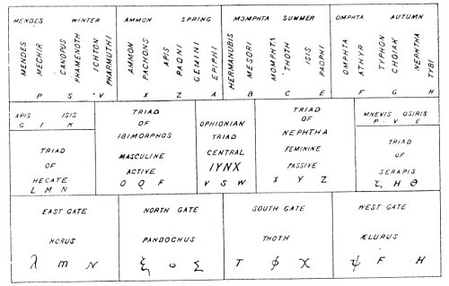  
WESTCOTT'S KEY TO THE BEMBINE TABLE.

From Westcott's *The Isiac Tablet*.

*Zoroaster declared that the number three shines throughout the world. This is revealed in the Bembine, Table by a series of triads representing the creative impulses. Of the Isiac Table Alexandre Lenoir writes: "The Isiac Table, as a work of art, is not of great interest. it is but a composition, rather cold and insignificant, whose figures, summarily sketched and methodically placed near each other, give but little impression of life. But, if on the contrary after examining it, we understand the purpose of the author, we become soon convinced that the Isiac Table is an image of the heavenly sphere divided in small parts to be used very like, for general teaching. According to that idea, we can conclude that the Isiac Table was originally the introduction to a collection followed by the Mysteries of Isis. It was engraved on copper in order to be used in the ceremonial of initiation." (See New Essay on the Isiac Table.)*

"Plato writes that it is needful for the philosopher to know how the seven circles beneath the first one are arranged according to the Egyptians. The first triad of fire denotes life; the second, water, over which rule the Ibimorphous divinities; and the third, air, ruled by Nephta. From the fire the heavens were created, from the water the earth, and air was the mediator between them. In the Sephira Yetzirah it is said that from the three originate the seven, i. e., the height, the depth, the East, the West, the North, and the South, and the Holy Temple in the center sustaining them all. Is not the Holy Temple in the center the great throne of the many-formed Spirit of Nature which is shown in the middle of the Tablet? What are the seven triads but the seven Powers that rule over the world? Psellus writes: 'The Egyptians worshipped the triad of faith, truth, and love; and the seven fountains: the Sun as ruler--the fountain of matter; then the fountain of the archangels; the fountain of the senses; of judgment; of lightning; of reflections; and of characters of unknown composition. They say that the highest material fountains are those of Apollo, Osiris, and Mercury--the fountains of the centers of the elements. 'Thus, they understood by the Sun as ruler the solar world; by the material archangelic, the lunar world; by the fountain of the senses, the world of Saturn; by judgment, Jupiter; by lightning, Mars; by that of the reflections, or mirrors, the world of Venus; by the fountain of characters, the world of Mercury. All these are shown by the figures in the center pane of the Tablet."

The upper panel contains the twelve figures of the zodiac arranged in four triads. The center figure in each group represents one of the four fixed signs of the zodiac. *S* is the sign of Aquarius; *Z*, Taurus; *C*, Leo; and *G*, Scorpio. These are called the *Fathers*. In the secret teachings of the Far East these four figures--the man, the bull, the lion, and the eagle--are called the winged globes or the four Maharajahs who stand upon the corners of creation. The four cardinal signs--*P*, Capricorn; *X*, Aries; *B*, Cancer; *F*, Libra--are called the Powers. The four common signs--*V*, Pisces; *A*, Gemini; *E*, Virgo; *H*, Sagittarius--are called the *Minds* of the Four Lords. This explains the meaning of the winged globes of Egypt, for the four central figures--Aquarius, Taurus, Leo, and Scorpio (called by Ezekiel the *Cherubim*)--are the globes; the cardinal and common signs on either side are the wings. Therefore the twelve signs of the zodiac may be symbolized by four globes, each with two wings.

The celestial triads are further shown by the Egyptians as a globe (the *Father*) from which issue a serpent (the *Mind*) and wings (the *Power*). These twelve forces are the fabricators of the world, and from them emanate the microcosm, or the mystery of the twelve sacred animals--representing in the universe the twelve parts of the world and in man the twelve parts of the human body. Anatomically, the twelve figures in the upper panel may well symbolize the twelve convolutions of the brain and the twelve figures in the lower panel the twelve zodiacal members and organs of the human body, for man is a creature formed of the twelve sacred animals with his members and organs under the direct control of the twelve governors or powers resident in the brain.

A more profound interpretation is found in the correspondences between the twelve figures in the upper panel and the twelve in the lower. This furnishes a key to one of the most arcane of ancient secrets--the relationship existing between the two great zodiacs the *fixed* and the *movable*. The *fixed* zodiac is described as an immense dodecahedron, its twelve surfaces representing the outermost walls of abstract space. From each surface of this dodecahedron a great spiritual power, radiating inward, becomes embodied as one of the hierarchies of the movable zodiac, which is a band of circumambulating so-called fixed stars. Within this *movable* zodiac are posited the various planetary and elemental bodies. The relation of these two zodiacs to the subzodiacal spheres has a correlation in the respiratory system of the human body. The great *fixed* zodiac may be said to represent the atmosphere, the *movable* zodiac the lungs, and the subzodiacal worlds the body. The spiritual atmosphere containing the vivifying energies of the twelve divine powers of the great *fixed* zodiac is inhaled by the cosmic lungs--the *movable* zodiac--and distributed by them through the constitution of the twelve holy animals which are the parts and members of the material universe. The functional cycle is completed when the poisonous effluvia of the lower worlds collected by the *movable* zodiac are exhaled into the great *fixed* zodiac, there to be purified by being passed through the divine natures of its twelve eternal hierarchies.

The Table as a whole is susceptible of many interpretations. If the border of the Table with its hieroglyphic figures be accepted as the spiritual source, then the throne in the center represents the physical body within which human nature is enthroned. From this point of view the entire Table becomes emblematic of the auric bodies of man, with the border as the outer extremity or shell of the *auric egg*. If the throne be accepted as the symbol of the spiritual sphere, the border typifies the elements, and the various panels surrounding the central one become emblematic of the worlds or planes emanating from the one divine source. If the Table be considered from a purely physical basis, the throne becomes symbolic of the generative system and the Table reveals the secret processes of embryology as applied to the formation of the material worlds. If a purely physiological and anatomical interpretation be desired, the central throne becomes the heart, the Ibimorphous Triad the mind, the Nephtæan Triad the generative system, and the surrounding hieroglyphics the various parts and members of the human body. From the evolutionary viewpoint the central gate becomes the point of both entrance and exit. Here also is set forth the process of initiation, in which the candidate after passing successfully through the various ordeals is finally brought into the presence of his own soul, which he alone is capable of unveiling.

If cosmogony be the subject of consideration, the central panel represents the spiritual worlds, the upper panel the intellectual worlds, and the lower panel the material worlds. The central panel may also symbolize the nine invisible worlds, and the creature marked *T* the physical nature--the footstool of Isis, the Spirit of Universal Life. Considered in the light of alchemy, the central panel contains the metals and the borders the alchemical processes. The figure seated on the throne is the Universal Mercury--the "stone of the wise"; the flaming canopy of the throne above is the Divine Sulphur; and the cube of earth beneath is the elemental salt.

The three triads--or the *Paternal Foundation*--in the central panel represent the Silent Watchers, the three invisible parts of the nature of man; the two panels on either side are the quaternary lower nature of man. In the central panel are 21 figures. This number is sacred to the sun--which consists of three great powers, each with seven attributes--and by Qabbalistic reduction 21 becomes 3, or the Great Triad.

It will yet be proved that the Table of Isis is directly connected with Egyptian Gnosticism, for in a Gnostic papyrus preserved in the Bodleian Library there is a direct reference to the twelve *Fathers* or *Paternities* beneath whom are twelve Fountains. (See *Egyptian Magic* by S.S.D.D.) That the lower panel represents the underworld is further emphasized by the two gates--the great gate of the East and the great gate of the West--for in the Chaldean theology the sun rises and sets through gates in the underworld, where it wanders during the hours of darkness. As Plato was for thirteen years under the instruction of the Magi Patheneith, Ochoaps, Sechtnouphis, and Etymon of Sebbennithis, his philosophy consequently is permeated with the Chaldean and Egyptian system of triads. The Bembine Table is a diagrammatic exposition of the so-called Platonic philosophy, for in its design is epitomized the entire theory of mystic cosmogony and generation. The most valuable guide to the interpretation of this Table is the *Commentaries of Proclus on the Theology of Plato*. The *Chaldean Oracles of Zoroaster* also contains many allusions to the theogonic principles which are demonstrated by the Table.

The *Theogony* of Hesiod contains the most complete account of the Greek cosmogony myth. Orphic cosmogony has left its impress upon the various forms of philosophy and religion--Greek, Egyptian, and Syrian--which it contacted. Chief of the Orphic symbols was the *mundane egg* from which Phanes sprang into light. Thomas Taylor considers the Orphic egg to be synonymous with the *mixture* from *bound* and *infinity* mentioned by Plato in the *Philebus*. The egg is furthermore the third Intelligible Triad and the proper symbol of the Demiurgus, whose auric body is the egg of the inferior universe.

Eusebius, on the authority of Porphyry, declared that the Egyptians acknowledged one intellectual Author or Creator of the world under the name of *Cneph* and that they worshiped him in a statue of human form and dark blue complexion, holding in his hand a girdle and a scepter, wearing on his head a royal plume, and thrusting forth an egg out of his mouth. (See *An Analysis of the Egyptian Mythology*) While the Bembine Table is rectangular-shaped, it signifies philosophically the Orphic egg of the universe with its contents. In the esoteric doctrines the supreme individual achievement is the breaking of the Orphic egg, which is equivalent to the return of the spirit to the Nirvana--the *absolute* condition--of the Oriental mystics.

*The New Pantheon* by Samuel Boyse contains three plates showing various sections of the Bembine Table. The author, however, makes no important contribution to the knowledge of the subject. In *The Mythology and Fables of the Ancients Explained from History*, the Abbé Banier devotes a chapter to a consideration of the *Mensa Isiaca*. After reviewing the conclusions of Montfaucon, Kircher, and Pignorius, he adds: "I am of the opinion that: it was a votive table, which some prince or private person had consecrated to Isis, as an acknowledgment for some benefit which he believed she had conferred upon him."

===================================================================================================================================================

END