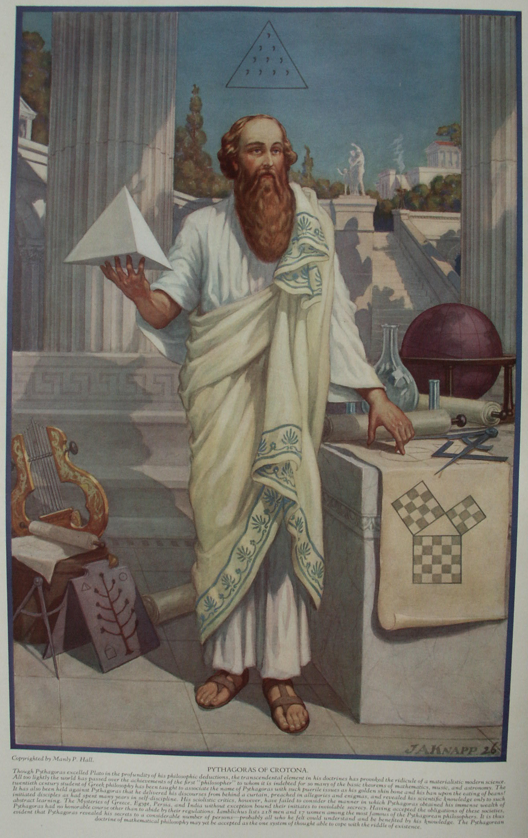

The Life and Philosophy of Pythagoras
The Secret Teachings of All Ages - Manly P. Hall 1928

THE LIFE AND PHILOSOPHY OF PYTHAGORAS
Pythagoras and the School of Crotona--Pythagoric fundamentals--The symmetrical solids--The symbolic aphorisms of Pythagoras--Pythagorean astronomy--Kepler's theory of the universe.
PYTHAGOREAN MATHEMATICS
The theory of numbers--The numerical values of letters--Method of securing the numerical Power of words--An introduction to the Pythagorean theory of numbers--The sieve of Eratosthenes--The meanings of the ten numbers.
THE PYTHAGOREAN THEORY OF MUSIC AND COLOR
Pythagoras and the diatonic scale--Therapeutic music--The music of the spheres--The use of color in symbolism--The colors of the spectrum and the musical scale--Zodiacal and planetary colors.

WHILE Mnesarchus, the father of Pythagoras, was in the city of Delphi on matters pertaining to his business as a merchant, he and his wife, Parthenis, decided to consult the oracle of Delphi as to whether the Fates were favorable for their return voyage to Syria. When the Pythoness (prophetess of Apollo) seated herself on the golden tripod over the yawning vent of the oracle, she did not answer the question they had asked, but told Mnesarchus that his wife was then with child and would give birth to a son who was destined to surpass all men in beauty and wisdom, and who throughout the course of his life would contribute much to the benefit of mankind. Mnesarchus was so deeply impressed by the prophecy that he changed his wife's name to Pythasis, in honor of the Pythian priestess. When the child was born at Sidon in Phœnicia, it was--as the oracle had said--a son. Mnesarchus and Pythasis named the child Pythagoras, for they believed that he had been predestined by the oracle.
Many strange legends have been preserved concerning the birth of Pythagoras. Some maintained that he was no mortal man: that he was one of the gods who had taken a human body to enable him to come into the world and instruct the human race. Pythagoras was one of the many sages and saviors of antiquity for whom an immaculate conception is asserted. In his Anacalypsis, Godfrey Higgins writes: "The first striking circumstance in which the history of Pythagoras agrees with the history of Jesus is, that they were natives of nearly the same country; the former being born at Sidon, the latter at Bethlehem, both in Syria. The father of Pythagoras, as well as the father of Jesus, was prophetically informed that his wife should bring forth a son, who should be a benefactor to mankind. They were both born when their mothers were from home on journeys, Joseph and his wife having gone up to Bethlehem to be taxed, and the father of Pythagoras having travelled from Samos, his residence, to Sidon, about his mercantile concerns. Pythais [Pythasis], the mother of Pythagoras, had a connexion with an Apolloniacal spectre, or ghost, of the God Apollo, or God Sol, (of course this must have been a holy ghost, and here we have the Holy Ghost) which afterward appeared to her husband, and told him that he must have no connexion with his wife during her pregnancy--a story evidently the same as that relating to Joseph and Mary. From these peculiar circumstances, Pythagoras was known by the same title as Jesus, namely, the son of God; and was supposed by the multitude to be under the influence of Divine inspiration."
This most famous philosopher was born sometime between 600 and 590 B.C., and the length of his life has been estimated at nearly one hundred years.
The teachings of Pythagoras indicate that he was thoroughly conversant with the precepts of Oriental and Occidental esotericism. He traveled among the Jews and was instructed by the Rabbins concerning the secret traditions of Moses, the lawgiver of Israel. Later the School of the Essenes was conducted chiefly for the purpose of interpreting the Pythagorean symbols. Pythagoras was initiated into the Egyptian, Babylonian, and Chaldean Mysteries. Although it is believed by some that he was a disciple of Zoroaster, it is doubtful whether his instructor of that name was the God-man now revered by the Parsees. While accounts of his travels differ, historians agree that he visited many countries and studied at the feet of many masters.
"After having acquired all which it was possible for him to learn of the Greek philosophers and, presumably, become an initiate in the Eleusinian mysteries, he went to Egypt, and after many rebuffs and refusals, finally succeeded in securing initiation in the Mysteries of Isis, at the hands of the priests of Thebes. Then this intrepid 'joiner' wended his way into Phoenicia and Syria where the Mysteries of Adonis were conferred upon him, and crossing to the valley of the Euphrates he tarried long enough to become versed in, the secret lore of the Chaldeans, who still dwelt in the vicinity of Babylon. Finally, he made his greatest and most historic venture through Media and Persia into Hindustan where he remained several years as a pupil and initiate of the learned Brahmins of Elephanta and Ellora." (See Ancient Freemasonry, by Frank C. Higgins, 32°.) The same author adds that the name of Pythagoras is still preserved in the records of the Brahmins as Yavancharya, the Ionian Teacher.
Pythagoras was said to have been the first man to call himself a philosopher; in fact, the world is indebted to him for the word philosopher. Before that time the wise men had called themselves sages, which was interpreted to mean those who know. Pythagoras was more modest. He coined the word philosopher, which he defined as one who is attempting to find out.
After returning from his wanderings, Pythagoras established a school, or as it has been sometimes called, a university, at Crotona, a Dorian colony in Southern Italy. Upon his arrival at Crotona he was regarded askance, but after a short time those holding important positions in the surrounding colonies sought his counsel in matters of great moment. He gathered around him a small group of sincere disciples whom he instructed in the secret wisdom which had been revealed to him, and also in the fundamentals of occult mathematics, music, and astronomy, which he considered to be the triangular foundation of all the arts and sciences.
When he was about sixty years old, Pythagoras married one of his disciples, and seven children resulted from the union. His wife was a remarkably able woman, who not only inspired him during the years of his life but after his assassination continued to promulgate his doctrines.
As is so often the case with genius, Pythagoras by his outspokenness incurred both political and personal enmity. Among those who came for initiation was one who, because Pythagoras refused to admit him, determined to destroy both the man and his philosophy. By means of false propaganda, this disgruntled one turned the minds of the common people against the philosopher. Without warning, a band of murderers descended upon the little group of buildings where the great teacher and his disciples dwelt, burned the structures and killed Pythagoras.
Accounts of the philosopher's death do not agree. Some say that he was murdered with his disciples; others that, on escaping from Crotona with a small band of followers, he was trapped and burned alive by his enemies in a little house where the band had decided to rest for the night. Another account states that, finding themselves trapped in the burning structure, the disciples threw themselves into the flames, making of their own bodies a bridge over which Pythagoras escaped, only to die of a broken heart a short time afterwards as the result of grieving over the apparent fruitlessness of his efforts to serve and illuminate mankind.
His surviving disciples attempted to perpetuate his doctrines, but they were persecuted on every hand and very little remains today as a testimonial to the greatness of this philosopher. It is said that the disciples of Pythagoras never addressed him or referred to him by his own name, but always as The Master or That Man. This may have been because of the fact that the name Pythagoras was believed to consist of a certain number of specially arranged letters with great sacred significance. The Word magazine has printed an article by T. R. Prater, showing that Pythagoras initiated his candidates by means of a certain formula concealed within the letters of his own name. This may explain why the word Pythagoras was so highly revered.

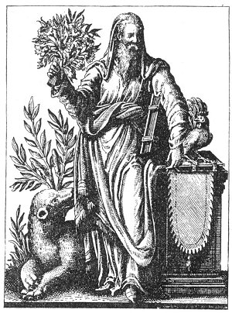
PYTHAGORAS, THE FIRST PHILOSOPHER.
From Historia Deorum Fatidicorum.
During his youth, Pythagoras was a disciple of Pherecydes and Hermodamas, and while in his teens became renowned for the clarity of his philosophic concepts. In height he exceeded six feet; his body was as perfectly formed as that of Apollo. Pythagoras was the personification of majesty and power, and in his presence a felt humble and afraid. As he grew older, his physical power increased rather than waned, so that as he approached the century mark he was actually in the prime of life. The influence of this great soul over those about him was such that a word of praise from Pythagoras filled his disciples with ecstasy, while one committed suicide because the Master became momentarily irritate over something he had dome. Pythagoras was so impressed by this tragedy that he never again spoke unkindly to or about anyone.

After the death of Pythagoras his school gradually disintegrated, but those who had benefited by its teachings revered the memory of the great philosopher, as during his life they had reverenced the man himself. As time went on, Pythagoras came to be regarded as a god rather than a man, and his scattered disciples were bound together by their common admiration for the transcendent genius of their teacher. Edouard Schure, in his Pythagoras and the Delphic Mysteries, relates the following incident as illustrative of the bond of fellowship uniting the members of the Pythagorean School:
"One of them who had fallen upon sickness and poverty was kindly taken in by an innkeeper. Before dying he traced a few mysterious signs (the pentagram, no doubt) on the door of the inn and said to the host, 'Do not be uneasy, one of my brothers will pay my debts.' A year afterwards, as a stranger was passing by this inn he saw the signs and said to the host, 'I am a Pythagorean; one of my brothers died here; tell me what I owe you on his account.'"
Frank C. Higgins, 32°, gives an excellent compendium of the Pythagorean tenets in the following outline:
"Pythagoras' teachings are of the most transcendental importance to Masons, inasmuch as they are the necessary fruit of his contact with the leading philosophers of the whole civilized world of his own day, and must represent that in which all were agreed, shorn of all weeds of controversy. Thus, the determined stand made by Pythagoras, in defense of pure monotheism, is sufficient evidence that the tradition to the effect that the unity of God was the supreme secret of all the ancient initiations is substantially correct. The philosophical school of Pythagoras was, in a measure, also a series of initiations, for he caused his pupils to pass through a series of degrees and never permitted them personal contact with himself until they had reached the higher grades. According to his biographers, his degrees were three in number. The first, that of 'Mathematicus,' assuring his pupils proficiency in mathematics and geometry, which was then, as it would be now if Masonry were properly inculcated, the basis upon which all other knowledge was erected. Secondly, the degree of 'Theoreticus,' which dealt with superficial applications of the exact sciences, and, lastly, the degree of 'Electus,' which entitled the candidate to pass forward into the light of the fullest illumination which he was capable of absorbing. The pupils of the Pythagorean school were divided into 'exoterici,' or pupils in the outer grades, and 'esoterici,' after they had passed the third degree of initiation and were entitled to the secret wisdom. Silence, secrecy and unconditional obedience were cardinal principles of this great order." (See Ancient Freemasonry.)

PYTHAGORIC FUNDAMENTALS
The study of geometry, music, and astronomy was considered essential to a rational understanding of God, man, or Nature, and no one could accompany Pythagoras as a disciple who was not thoroughly familiar with these sciences. Many came seeking admission to his school. Each applicant was tested on these three subjects, and if found ignorant, was summarily dismissed.
Pythagoras was not an extremist. He taught moderation in all things rather than excess in anything, for he believed that an excess of virtue was in itself a vice. One of his favorite statements was: "We must avoid with our utmost endeavor, and amputate with fire and sword, and by all other means, from the body, sickness; from the soul, ignorance; from the belly, luxury; from a city, sedition; from a family, discord; and from all things, excess." Pythagoras also believed that there was no crime equal to that of anarchy.
All men know what they want, but few know what they need. Pythagoras warned his disciples that when they prayed they should not pray for themselves; that when they asked things of the gods they should not ask things for themselves, because no man knows what is good for him and it is for this reason undesirable to ask for things which, if obtained, would only prove to be injurious.
The God of Pythagoras was the Monad, or the One that is Everything. He described God as the Supreme Mind distributed throughout all parts of the universe--the Cause of all things, the Intelligence of all things, and the Power within all things. He further declared the motion of God to be circular, the body of God to be composed of the substance of light, and the nature of God to be composed of the substance of truth.
Pythagoras declared that the eating of meat clouded the reasoning faculties. While he did not condemn its use or totally abstain therefrom himself, he declared that judges should refrain from eating meat before a trial, in order that those who appeared before them might receive the most honest and astute decisions. When Pythagoras decided (as he often did) to retire into the temple of God for an extended period of time to meditate and pray, he took with his supply of specially prepared food and drink. The food consisted of equal parts of the seeds of poppy and sesame, the skin of the sea onion from which the juice had been thoroughly extracted, the flower of daffodil, the leaves of mallows, and a paste of barley and peas. These he compounded together with the addition of wild honey. For a beverage he took the seeds of cucumbers, dried raisins (with seeds removed), the flowers of coriander, the seeds of mallows and purslane, scraped cheese, meal, and cream, mixed together and sweetened with wild honey. Pythagoras claimed that this was the diet of Hercules while wandering in the Libyan desert and was according to the formula given to that hero by the goddess Ceres herself.
The favorite method of healing among the Pythagoreans was by the aid of poultices. These people also knew the magic properties of vast numbers of plants. Pythagoras highly esteemed the medicinal properties of the sea onion, and he is said to have written an entire volume on the subject. Such a work, however, is not known at the present time. Pythagoras discovered that music had great therapeutic power and he prepared special harmonies for various diseases. He apparently experimented also with color, attaining considerable success. One of his unique curative processes resulted from his discovery of the healing value of certain verses from the Odyssey and the Iliad of Homer. These he caused to be read to persons suffering from certain ailments. He was opposed to surgery in all its forms and also objected to cauterizing. He would not permit the disfigurement of the human body, for such, in his estimation, was a sacrilege against the dwelling place of the gods.
Pythagoras taught that friendship was the truest and nearest perfect of all relationships. He declared that in Nature there was a friendship of all for all; of gods for men; of doctrines one for another; of the soul for the body; of the rational part for the irrational part; of philosophy for its theory; of men for one another; of countrymen for one another; that friendship also existed between strangers, between a man and his wife, his children, and his servants. All bonds without friendship were shackles, and there was no virtue in their maintenance. Pythagoras believed that relationships were essentially mental rather than physical, and that a stranger of sympathetic intellect was closer to him than a blood relation whose viewpoint was at variance with his own. Pythagoras defined knowledge as the fruitage of mental accumulation. He believed that it would be obtained in many ways, but principally through observation. Wisdom was the understanding of the source or cause of all things, and this could be secured only by raising the intellect to a point where it intuitively cognized the invisible manifesting outwardly through the visible, and thus became capable of bringing itself en rapport with the spirit of things rather than with their forms. The ultimate source that wisdom could cognize was the Monad, the mysterious permanent atom of the Pythagoreans.
Pythagoras taught that both man and the universe were made in the image of God; that both being made in the same image, the understanding of one predicated the knowledge of the other. He further taught that there was a constant interplay between the Grand Man (the universe) and man (the little universe).
Pythagoras believed that all the sidereal bodies were alive and that the forms of the planets and stars were merely bodies encasing souls, minds, and spirits in the same manner that the visible human form is but the encasing vehicle for an invisible spiritual organism which is, in reality, the conscious individual. Pythagoras regarded the planets as magnificent deities, worthy of the adoration and respect of man. All these deities, however, he considered subservient to the One First Cause within whom they all existed temporarily, as mortality exists in the midst of immortality.
The famous Pythagorean Υ signified the power of choice and was used in the Mysteries as emblematic of the Forking of the Ways. The central stem separated into two parts, one branching to the right and the other to the left. The branch to the right was called Divine Wisdom and the one to the left Earthly Wisdom. Youth, personified by the candidate, walking the Path of Life, symbolized by the central stem of the Υ, reaches the point where the Path divides. The neophyte must then choose whether he will take the left-hand path and, following the dictates of his lower nature, enter upon a span of folly and thoughtlessness which will inevitably result in his undoing, or whether he will take the right-hand road and through integrity, industry, and sincerity ultimately regain union with the immortals in the superior spheres.

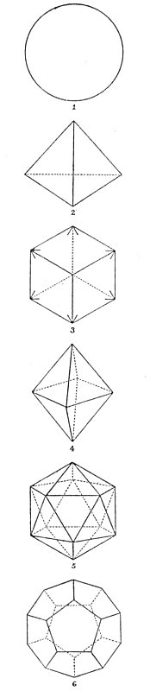
THE SYMMETRICAL GEOMETRIC SOLIDS.
To the five symmetrical solids of the ancients is added the sphere (1), the most perfect of all created forms. The five Pythagorean solids are: the tetrahedron (2) with four equilateral triangles as faces; the cube (3) with six squares as faces; the octahedron (4) with eight equilateral triangles as faces; the icosahedron (5) with twenty equilateral triangles as faces; and the dodecahedron (6) with twelve regular pentagons as faces.

It is probable that Pythagoras obtained his concept of the Υ from the Egyptians, who included in certain of their initiatory rituals a scene in which the candidate was confronted by two female figures. One of them, veiled with the white robes of the temple, urged the neophyte to enter into the halls of learning; the other, bedecked with jewels, symbolizing earthly treasures, and bearing in her hands a tray loaded with grapes (emblematic of false light), sought to lure him into the chambers of dissipation. This symbol is still preserved among the Tarot cards, where it is called The Forking of the Ways. The forked stick has been the symbol of life among many nations, and it was placed in the desert to indicate the presence of water.
Concerning the theory of transmigration as disseminated by Pythagoras, there are differences of opinion. According to one view, he taught that mortals who during their earthly existence had by their actions become like certain animals, returned to earth again in the form of the beasts which they had grown to resemble. Thus, a timid person would return in the form of a rabbit or a deer; a cruel person in the form of a wolf or other ferocious animal; and a cunning person in the guise of a fox. This concept, however, does not fit into the general Pythagorean scheme, and it is far more likely that it was given in an allegorical rather than a literal sense. It was intended to convey the idea that human beings become bestial when they allow themselves to be dominated by their own lower desires and destructive tendencies. It is probable that the term transmigration is to be understood as what is more commonly called reincarnation, a doctrine which Pythagoras must have contacted directly or indirectly in India and Egypt.
The fact that Pythagoras accepted the theory of successive reappearances of the spiritual nature in human form is found in a footnote to Levi's History of Magic: "He was an important champion of what used to be called the doctrine of metempsychosis, understood as the soul's transmigration into successive bodies. He himself had been (a) Aethalides, a son of Mercury; (b) Euphorbus, son of Panthus, who perished at the hands of Menelaus in the Trojan war; (c) Hermotimus, a prophet of Clazomenae, a city of Ionia; (d) a humble fisherman; and finally (e) the philosopher of Samos."
Pythagoras also taught that each species of creatures had what he termed a seal, given to it by God, and that the physical form of each was the impression of this seal upon the wax of physical substance. Thus each body was stamped with the dignity of its divinely given pattern. Pythagoras believed that ultimately man would reach a state where he would cast off his gross nature and function in a body of spiritualized ether which would be in juxtaposition to his physical form at all times and which might be the eighth sphere, or Antichthon. From this he would ascend into the realm of the immortals, where by divine birthright he belonged.
Pythagoras taught that everything in nature was divisible into three parts and that no one could become truly wise who did not view every problem as being diagrammatically triangular. He said, "Establish the triangle and the problem is two-thirds solved"; further, "All things consist of three." In conformity with this viewpoint, Pythagoras divided the universe into three parts, which he called the Supreme World, the Superior World, and the Inferior World. The highest, or Supreme World, was a subtle, interpenetrative spiritual essence pervading all things and therefore the true plane of the Supreme Deity itself, the Deity being in every sense omnipresent, omniactive, omnipotent, and omniscient. Both of the lower worlds existed within the nature of this supreme sphere.
The Superior World was the home of the immortals. It was also the dwelling place of the archetypes, or the seals; their natures in no manner partook of the material of earthiness, but they, casting their shadows upon the deep (the Inferior World), were cognizable only through their shadows. The third, or Inferior World, was the home of those creatures who partook of material substance or were engaged in labor with or upon material substance. Hence, this sphere was the home of the mortal gods, the Demiurgi, the angels who labor with men; also the dæmons who partake of the nature of the earth; and finally mankind and the lower kingdoms, those temporarily of the earth but capable of rising above that sphere by reason and philosophy.
The digits 1 and 2 are not considered numbers by the Pythagoreans, because they typify the two supermundane spheres. The Pythagorean numbers, therefore, begin with 3, the triangle, and 4, the square. These added to the 1 and the 2, produce the 10, the great number of all things, the archetype of the universe. The three worlds were called receptacles. The first was the receptacle of principles, the second was the receptacle of intelligences, and the third, or lowest, was the receptacle of quantities.
"The symmetrical solids were regarded by Pythagoras, and by the Greek thinkers after him, as of the greatest importance. To be perfectly symmetrical or regular, a solid must have an equal number of faces meeting at each of its angles, and these faces must be equal regular polygons, i. e., figures whose sides and angles are all equal. Pythagoras, perhaps, may be credited with the great discovery that there are only five such solids.* * *
'Now, the Greeks believed the world [material universe] to be composed of four elements--earth, air, fire, water--and to the Greek mind the conclusion was inevitable that the shapes of the particles of the elements were those of the regular solids. Earth-particles were cubical, the cube being the regular solid possessed of greatest stability; fire-particles were tetrahedral, the tetrahedron being the simplest and, hence, lightest solid. Water-particles were icosahedral for exactly the reverse reason, whilst air-particles, as intermediate between the two latter, were octahedral. The dodecahedron was, to these ancient mathematicians, the most mysterious of the solids; it was by far the most difficult to construct, the accurate drawing of the regular pentagon necessitating a rather elaborate application of Pythagoras' great theorem. Hence the conclusion, as Plato put it, that 'this (the regular dodecahedron) the Deity employed in tracing the plan of the Universe.' (H. Stanley Redgrove, in Bygone Beliefs.)
Mr. Redgrove has not mentioned the fifth element of the ancient Mysteries, that which would make the analogy between the symmetrical solids and the elements complete. This fifth element, or ether, was called by the Hindus akasa. It was closely correlated with the hypothetical ether of modern science, and was the interpenetrative substance permeating all of the other elements and acting as a common solvent and common denominator of them. The twelve-faced solid also subtly referred to the Twelve Immortals who surfaced the universe, and also to the twelve convolutions of the human brain--the vehicles of those Immortals in the nature of man.
While Pythagoras, in accordance with others of his day, practiced divination (possibly arithmomancy), there is no accurate information concerning the methods which he used. He is believed to have had a remarkable wheel by means of which he could predict future events, and to have learned hydromancy from the Egyptians. He believed that brass had oracular powers, because even when everything was perfectly still there was always a rumbling sound in brass bowls. He once addressed a prayer to the spirit of a river and out of the water arose a voice, "Pythagoras, I greet thee." It is claimed for him that he was able to cause dæmons to enter into water and disturb its surface, and by means of the agitations certain things were predicted.
After having drunk from a certain spring one day, one of the Masters of Pythagoras announced that the spirit of the water had just predicted that a great earthquake would occur the next day--a prophecy which was fulfilled. It is highly probable that Pythagoras possessed hypnotic power, not only over man but also over animals. He caused a bird to change the course of its flight, a bear to cease its ravages upon a community, and a bull to change its diet, by the exercise of mental influence. He was also gifted with second sight, being able to see things at a distance and accurately describe incidents that had not yet come to pass.

THE SYMBOLIC APHORISMS OF PYTHAGORAS
Iamblichus gathered thirty-nine of the symbolic sayings of Pythagoras and interpreted them. These have been translated from the Greek by Thomas Taylor. Aphorismic statement was one of the favorite methods of instruction used in the Pythagorean university of Crotona. Ten of the most representative of these aphorisms are reproduced below with a brief elucidation of their concealed meanings.
I. Declining from the public ways, walk in unfrequented paths. By this it is to be understood that those who desire wisdom must seek it in solitude.
II. Govern your tongue before all other things, following the gods. This aphorism warns man that his words, instead of representing him, misrepresent him, and that when in doubt as to what he should say, he should always be silent.
III. The wind blowing, adore the sound. Pythagoras here reminds his disciples that the fiat of God is heard in the voice of the elements, and that all things in Nature manifest through harmony, rhythm, order, or procedure the attributes of the Deity.
IV. Assist a man in raising a burden; but do not assist him in laying it down. The student is instructed to aid the diligent but never to assist those who seek to evade their responsibilities, for it is a great sin to encourage indolence.
V. Speak not about Pythagoric concerns without light. The world is herein warned that it should not attempt to interpret the mysteries of God and the secrets of the sciences without spiritual and intellectual illumination.
VI. Having departed from your house, turn not back, for the furies will be your attendants. Pythagoras here warns his followers that any who begin the search for truth and, after having learned part of the mystery, become discouraged and attempt to return again to their former ways of vice and ignorance, will suffer exceedingly; for it is better to know nothing about Divinity than to learn a little and then stop without learning all.
VII. Nourish a cock, but sacrifice it not; for it is sacred to the sun and moon. Two great lessons are concealed in this aphorism. The first is a warning against the sacrifice of living things to the gods, because life is sacred and man should not destroy it even as an offering to the Deity. The second warns man that the human body here referred to as a cock is sacred to the sun (God) and the moon (Nature), and should be guarded and preserved as man's most precious medium of expression. Pythagoras also warned his disciples against suicide.
VIII. Receive not a swallow into your house. This warns the seeker after truth not to allow drifting thoughts to come into his mind nor shiftless persons to enter into his life. He must ever surround himself with rationally inspired thinkers and with conscientious workers.
IX. Offer not your right hand easily to anyone. This warns the disciple to keep his own counsel and not offer wisdom and knowledge (his right hand) to such as are incapable of appreciating them. The hand here represents Truth, which raises those who have fallen because of ignorance; but as many of the unregenerate do not desire wisdom they will cut off the hand that is extended in kindness to them. Time alone can effect the redemption of the ignorant masses
X. When rising from the bedclothes, roll them together, and obliterate the impression of the body. Pythagoras directed his disciples who had awakened from the sleep of ignorance into the waking state of intelligence to eliminate from their recollection all memory of their former spiritual darkness; for a wise man in passing leaves no form behind him which others less intelligent, seeing, shall use as a mold for the casting of idols.

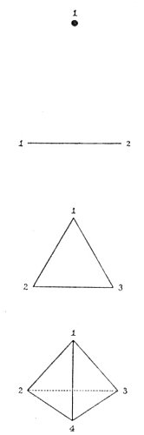
NUMBER RELATED TO FORM.
Pythagoras taught that the dot symbolized the power of the number 1, the line the power of the number 2, the surface the power of the number 3, and the solid the power of the number 4.

The most famous of the Pythagorean fragments are the Golden Verses, ascribed to Pythagoras himself, but concerning whose authorship there is an element of doubt. The Golden Verses contain a brief summary of the entire system of philosophy forming the basis of the educational doctrines of Crotona, or, as it is more commonly known, the Italic School. These verses open by counseling the reader to love God, venerate the great heroes, and respect the dæmons and elemental inhabitants. They then urge man to think carefully and industriously concerning his daily life, and to prefer the treasures of the mind and soul to accumulations of earthly goods. The verses also promise man that if he will rise above his lower material nature and cultivate self-control, he will ultimately be acceptable in the sight of the gods, be reunited with them, and partake of their immortality. (It is rather significant to note that Plato paid a great price for some of the manuscripts of Pythagoras which had been saved from the destruction of Crotona. See Historia Deorum Fatidicorum, Geneva, 1675.)

PYTHAGOREAN ASTRONOMY
According to Pythagoras, the position of each body in the universe was determined by the essential dignity of that body. The popular concept of his day was that the earth occupied the center of the solar system; that the planets, including the sun and moon, moved about the earth; and that the earth itself was flat and square. Contrary to this concept, and regardless of criticism, Pythagoras declared that fire was the most important of all the elements; that the center was the most important part of every body; and that, just as Vesta's fire was in the midst of every home, so in the midst of the universe was a flaming sphere of celestial radiance. This central globe he called the Tower of Jupiter, the Globe of Unity, the Grand Monad, and the Altar of Vesta. As the sacred number 10 symbolized the sum of all parts and the completeness of all things, it was only natural for Pythagoras to divide the universe into ten spheres, symbolized by ten concentric circles. These circles began at the center with the globe of Divine Fire; then came the seven planers, the earth, and another mysterious planet, called Antichthon, which was never visible.
Opinions differ as to the nature of Antichthon. Clement of Alexandria believed that it represented the mass of the heavens; others held the opinion that it was the moon. More probably it was the mysterious eighth sphere of the ancients, the dark planet which moved in the same orbit as the earth but which was always concealed from the earth by the body of the sun, being in exact opposition to the earth at all times. Is this the mysterious Lilith concerning which astrologers have speculated so long?
Isaac Myer has stated: "The Pythagoreans held that each star was a world having its own atmosphere, with an immense extent surrounding it, of aether." (See The Qabbalah.) The disciples of Pythagoras also highly revered the planet Venus, because it was the only planet bright enough to cast a shadow. As the morning star, Venus is visible before sunrise, and as the evening star it shines forth immediately after sunset. Because of these qualities, a number of names have been given to it by the ancients. Being visible in the sky at sunset, it was called vesper, and as it arose before the sun, it was called the false light, the star of the morning, or Lucifer, which means the light-bearer. Because of this relation to the sun, the planet was also referred to as Venus, Astarte, Aphrodite, Isis, and The Mother of the Gods. It is possible that: at some seasons of the year in certain latitudes the fact that Venus was a crescent could be detected without the aid of a telescope. This would account for the crescent which is often seen in connection with the goddesses of antiquity, the stories of which do not agree with the phases of the moon. The accurate knowledge which Pythagoras possessed concerning astronomy he undoubtedly secured in the Egyptian temples, for their priests understood the true relationship of the heavenly bodies many thousands of years before that knowledge was revealed to the uninitiated world. The fact that the knowledge he acquired in the temples enabled him to make assertions requiring two thousand years to check proves why Plato and Aristotle so highly esteemed the profundity of the ancient Mysteries. In the midst of comparative scientific ignorance, and without the aid of any modern instruments, the priest-philosophers had discovered the true fundamentals of universal dynamics.
An interesting application of the Pythagorean doctrine of geometric solids as expounded by Plato is found in The Canon. "Nearly all the old philosophers," says its anonymous author, "devised an harmonic theory with respect to the universe, and the practice continued till the old mode of philosophizing died out. Kepler (1596), in order to demonstrate the Platonic doctrine, that the universe was formed of the five regular solids, proposed the following rule. 'The earth is a circle, the measurer of all. Round it describe a dodecahedron; the circle inclosing this will be Mars. Round Mars describe a tetrahedron; the sphere inclosing this will be Jupiter. Describe a cube round Jupiter; the sphere containing this will be Saturn. Now inscribe in the earth an icosahedron; the circle inscribed in it will be Venus. Inscribe an octahedron in Venus; the circle inscribed in it will be Mercury' (Mysterium Cosmographicum, 1596). This rule cannot be taken seriously as a real statement of the proportions of the cosmos, fox it bears no real resemblance to the ratios published by Copernicus in the beginning of the sixteenth century. Yet Kepler was very proud of his formula, and said he valued it more than the Electorate of Saxony. It was also approved by those two eminent authorities, Tycho and Galileo, who evidently understood it. Kepler himself never gives the least hint of how his precious rule is to be interpreted." Platonic astronomy was not concerned with the material constitution or arrangement of the heavenly bodies, but considered the stars and planers primarily as focal points of Divine intelligence. Physical astronomy was regarded as the science of "shadows," philosophical astronomy the science of "realities."
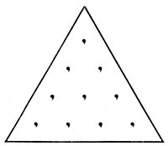
THE TETRACTYS.
Theon of Smyrna declares that the ten dots, or tetractys of Pythagoras, was a symbol of the greatest importance, for to the discerning mind it revealed the mystery of universal nature. The Pythagoreans bound themselves by the following oath: "By Him who gave to our soul the tetractys, which hath the fountain and root of ever-springing nature."
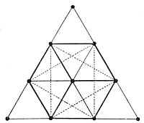
THE CUBE AND THE STAR.
By connecting the ten dots of the tetractys, nine triangles are formed. Six of these are involved in the forming of the cube. The same triangles, when lines are properly drawn between them, also reveal the six-pointed star with a dot in the center. Only seven dots are used in forming the cube and the star. Qabbalistically, the three unused corner dots represent the threefold, invisible causal nature of the universe, while the seven dots involved in the cube and the star are the Elohim--the Spirits of the seven creative periods. The Sabbath, or seventh day, is the central dot.

===================================================================================================================================================

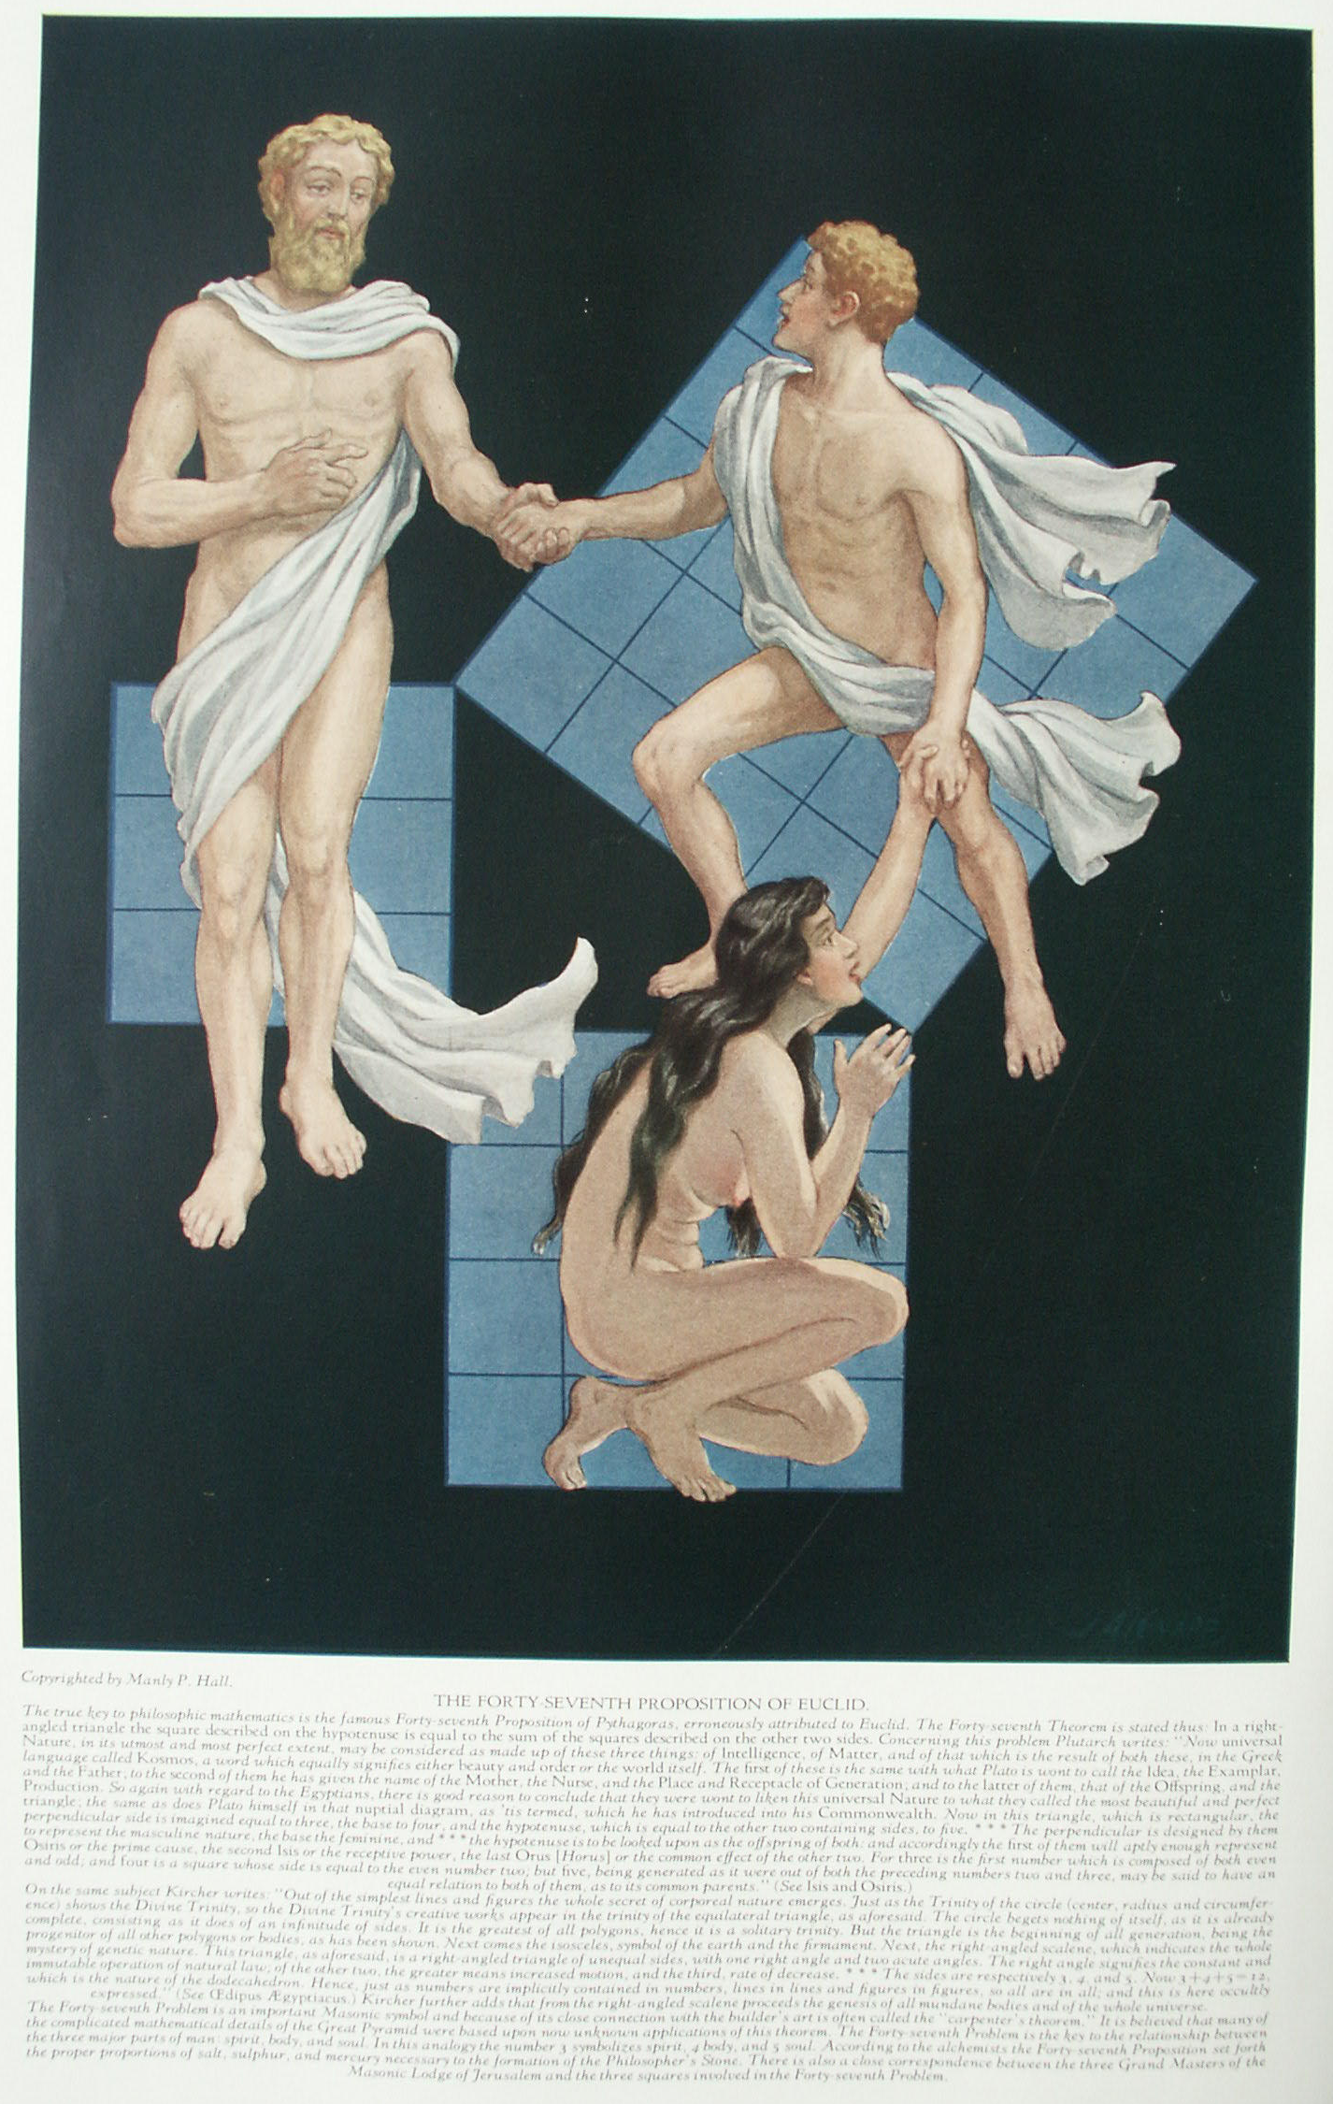

Pythagorean Mathematics

CONCERNING the secret significance of numbers there has been much speculation. Though many interesting discoveries have been made, it may be safely said that with the death of Pythagoras the great key to this science was lost. For nearly 2500 years philosophers of all nations have attempted to unravel the Pythagorean skein, but apparently none has been successful. Notwithstanding attempts made to obliterate all records of the teachings of Pythagoras, fragments have survived which give clues to some of the simpler parts of his philosophy. The major secrets were never committed to writing, but were communicated orally to a few chosen disciples. These apparently dated not divulge their secrets to the profane, the result being that when death sealed their lips the arcana died with diem.
Certain of the secret schools in the world today are perpetuations of the ancient Mysteries, and although it is quite possible that they may possess some of the original numerical formulæ, there is no evidence of it in the voluminous writings which have issued from these groups during the last five hundred years. These writings, while frequently discussing Pythagoras, show no indication of a more complete knowledge of his intricate doctrines than the post-Pythagorean Greek speculators had, who talked much, wrote little, knew less, and concealed their ignorance under a series of mysterious hints and promises. Here and there among the literary products of early writers are found enigmatic statements which they made no effort: to interpret. The following example is quoted from Plutarch:
"The Pythagoreans indeed go farther than this, and honour even numbers and geometrical diagrams with the names and titles of the gods. Thus they call the equilateral triangle head-born Minerva and Tritogenia, because it may be equally divided by three perpendiculars drawn from each of the angles. So the unit they term Apollo, as to the number two they have affixed the name of strife and audaciousness, and to that of three, justice. For, as doing an injury is an extreme on the one side, and suffering one is an extreme on the on the one side, and suffering in the middle between them. In like manner the number thirty-six, their Tetractys, or sacred Quaternion, being composed of the first four odd numbers added to the first four even ones, as is commonly reported, is looked upon by them as the most solemn oath they can take, and called Kosmos." (Isis and Osiris.)
Earlier in the same work, Plutarch also notes: "For as the power of the triangle is expressive of the nature of Pluto, Bacchus, and Mars; and the properties of the square of Rhea, Venus, Ceres, Vesta, and Juno; of the Dodecahedron of Jupiter; so, as we are informed by Eudoxus, is the figure of fifty-six angles expressive of the nature of Typhon." Plutarch did not pretend to explain the inner significance of the symbols, but believed that the relationship which Pythagoras established between the geometrical solids and the gods was the result of images the great sage had seen in the Egyptian temples.
Albert Pike, the great Masonic symbolist, admitted that there were many points concerning which he could secure no reliable information. In his Symbolism, for the 32° and 33°, he wrote: "I do not understand why the 7 should be called Minerva, or the cube, Neptune." Further on he added: "Undoubtedly the names given by the Pythagoreans to the different numbers were themselves enigmatical and symbolic-and there is little doubt that in the time of Plutarch the meanings these names concealed were lost. Pythagoras had succeeded too well in concealing his symbols with a veil that was from the first impenetrable, without his oral explanation * * *."
This uncertainty shared by all true students of the subject proves conclusively that it is unwise to make definite statements founded on the indefinite and fragmentary information available concerning the Pythagorean system of mathematical philosophy. The material which follows represents an effort to collect a few salient points from the scattered records preserved by disciples of Pythagoras and others who have since contacted his philosophy.

METHOD OF SECURING THE NUMERICAL POWER OF WORDS
The first step in obtaining the numerical value of a word is to resolve it back into its original tongue. Only words of Greek or Hebrew derivation can be successfully analyzed by this method, and all words must be spelled in their most ancient and complete forms. Old Testament words and names, therefore, must be translated back into the early Hebrew characters and New Testament words into the Greek. Two examples will help to clarify this principle.
The Demiurgus of the Jews is called in English Jehovah, but when seeking the numerical value of the name Jehovah it is necessary to resolve the name into its Hebrew letters. It becomes יהוה, and is read from right to left. The Hebrew letters are: ה, He; ו, Vau; ה, He; י, Yod; and when reversed into the English order from left to right read: Yod-He-Vau-He. By consulting the foregoing table of letter values, it is found that the four characters of this sacred name have the following numerical significance: Yod equals 10. He equals 5, Vau equals 6, and the second He equals 5. Therefore, 10+5+6+5=26, a synonym of Jehovah. If the English letters were used, the answer obviously would not be correct.
The second example is the mysterious Gnostic pantheos Abraxas. For this name the Greek table is used. Abraxas in Greek is Ἀβραξας. Α = 1, β = 2, ρ = 100, α = 1, ξ =60, α = 1, ς = 200, the sum being 365, the number of days in the year. This number furnishes the key to the mystery of Abraxas, who is symbolic of the 365 Æons, or Spirits of the Days, gathered together in one composite personality. Abraxas is symbolic of five creatures, and as the circle of the year actually consists of 360 degrees, each of the emanating deities is one-fifth of this power, or 72, one of the most sacred numbers in the Old Testament of the Jews and in their Qabbalistic system. This same method is used in finding the numerical value of the names of the gods and goddesses of the Greeks and Jews.
All higher numbers can be reduced to one of the original ten numerals, and the 10 itself to 1. Therefore, all groups of numbers resulting from the translation of names of deities into their numerical equivalents have a basis in one of the first ten numbers. By this system, in which the digits are added together, 666 becomes 6+6+6 or 18, and this, in turn, becomes 1+8 or 9. According to Revelation, 144,000 are to be saved. This number becomes 1+4+4+0+0+0, which equals 9, thus proving that both the Beast of Babylon and the number of the saved refer to man himself, whose symbol is the number 9. This system can be used successfully with both Greek and Hebrew letter values.
The original Pythagorean system of numerical philosophy contains nothing to justify the practice now in vogue of changing the given name or surname in the hope of improving the temperament or financial condition by altering the name vibrations.
There is also a system of calculation in vogue for the English language, but its accuracy is a matter of legitimate dispute. It is comparatively modern and has no relationship either to the Hebrew Qabbalistic system or to the Greek procedure. The claim made by some that it is Pythagorean is not supported by any tangible evidence, and there are many reasons why such a contention is untenable. The fact that Pythagoras used 10 as the basis of calculation, while this system uses 9--an imperfect number--is in itself almost conclusive. Furthermore, the arrangement of the Greek and Hebrew letters does not agree closely enough with the English to permit the application of the number sequences of one language to the number sequences of the others. Further experimentation with the system may prove profitable, but it is without basis in antiquity. The arrangement of the letters and numbers is as follows:
1 | 2 | 3 | 4 | 5 | 6 | 7 | 8 | 9
A | B | C | D | E | F | G | H | I
J | K | L | M | N | O | P | Q | R
S | T | U | V | W | X | Y | Z

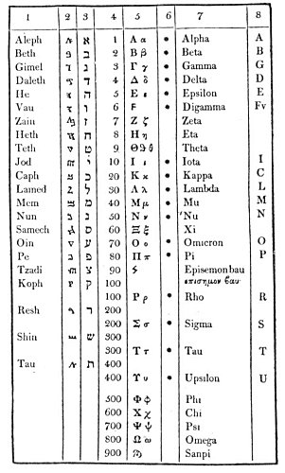
THE NUMERICAL VALUES OF THE HEBREW, GREEK, AND SAMARITAN ALPHABETS.
From Higgins' Celtic Druids.

Column
1 | Names of the Hebrew letters.
2 | Samaritan Letters.
3 | Hebrew and Chaldean letters.
4 | Numerical equivalents of the letters.
5 | Capital and small Greek letters.
6 | The letters marked with asterisks are those brought to Greece from Phœnicia by Cadmus.
7 | Name of the Greek letters.
8 | Nearest English equivalents to the Hebrew, Greek, and Samaritan Letters.
NOTE. When used at the end of a word, the Hebrew Tau has the numerical value 440, Caph 500, Mem 600, Nun 700, Pe 800, Tzadi 900. A dotted Alpha and a dashed Aleph have the value of 1,000.

The letters under each of the numbers have the value of the figure at: the top of the column. Thus, in the word man, M = 4, A = 1, N = 5: a total of 10. The values of the numbers are practically the same as those given by the Pythagorean system.

AN INTRODUCTION TO THE PYTHAGOREAN THEORY OF NUMBERS
(The following outline of Pythagorean mathematics is a paraphrase of the opening chapters of Thomas Taylor's Theoretic Arithmetic, the rarest and most important compilation of Pythagorean mathematical fragments extant.)
The Pythagoreans declared arithmetic to be the mother of the mathematical sciences. This is proved by the fact that geometry, music, and astronomy are dependent upon it but it is not dependent upon them. Thus, geometry may be removed but arithmetic will remain; but if arithmetic be removed, geometry is eliminated. In the same manner music depends upon arithmetic, but the elimination of music affects arithmetic only by limiting one of its expressions. The Pythagoreans also demonstrated arithmetic to be prior to astronomy, for the latter is dependent upon both geometry and music. The size, form, and motion of the celestial bodies is determined by the use of geometry; their harmony and rhythm by the use of music. If astronomy be removed, neither geometry nor music is injured; but if geometry and music be eliminated, astronomy is destroyed. The priority of both geometry and music to astronomy is therefore established. Arithmetic, however, is prior to all; it is primary and fundamental.
Pythagoras instructed his disciples that the science of mathematics is divided into two major parts. The first is concerned with the multitude, or the constituent parts of a thing, and the second with the magnitude, or the relative size or density of a thing.
Magnitude is divided into two parts--magnitude which is stationary and magnitude which is movable, the stationary pare having priority. Multitude is also divided into two parts, for it is related both to itself and to other things, the first relationship having priority. Pythagoras assigned the science of arithmetic to multitude related to itself, and the art of music to multitude related to other things. Geometry likewise was assigned to stationary magnitude, and spherics (used partly in the sense of astronomy) to movable magnitude. Both multitude and magnitude were circumscribed by the circumference of mind. The atomic theory has proved size to be the result of number, for a mass is made up of minute units though mistaken by the uninformed for a single simple substance.
Owing to the fragmentary condition of existing Pythagorean records, it is difficult to arrive at exact definitions of terms. Before it is possible, however, to unfold the subject further some light must he cast upon the meanings of the words number, monad, and one.
The monad signifies (a) the all-including ONE. The Pythagoreans called the monad the "noble number, Sire of Gods and men." The monad also signifies (b) the sum of any combination of numbers considered as a whole. Thus, the universe is considered as a monad, but the individual parts of the universe (such as the planets and elements) are monads in relation to the parts of which they themselves are composed, though they, in turn, are parts of the greater monad formed of their sum. The monad may also be likened (c) to the seed of a tree which, when it has grown, has many branches (the numbers). In other words, the numbers are to the monad what the branches of the tree are to the seed of the tree. From the study of the mysterious Pythagorean monad, Leibnitz evolved his magnificent theory of the world atoms--a theory in perfect accord with the ancient teachings of the Mysteries, for Leibnitz himself was an initiate of a secret school. By some Pythagoreans the monad is also considered (d) synonymous with the one.
Number is the term applied to all numerals and their combinations. (A strict interpretation of the term number by certain of the Pythagoreans excludes 1 and 2.) Pythagoras defines number to be the extension and energy of the spermatic reasons contained in the monad. The followers of Hippasus declared number to be the first pattern used by the Demiurgus in the formation of the universe.
The one was defined by the Platonists as "the summit of the many." The one differs from the monad in that the term monad is used to designate the sum of the parts considered as a unit, whereas the one is the term applied to each of its integral parts.
There are two orders of number: odd and even. Because unity, or 1, always remains indivisible, the odd number cannot be divided equally. Thus, 9 is 4+1+4, the unity in the center being indivisible. Furthermore, if any odd number be divided into two parts, one part will always be odd and the other even. Thus, 9 may be 5+4, 3+6, 7+2, or 8+1. The Pythagoreans considered the odd number--of which the monad was the prototype--to be definite and masculine. They were not all agreed, however, as to the nature of unity, or 1. Some declared it to be positive, because if added to an even (negative) number, it produces an odd (positive) number. Others demonstrated that if unity be added to an odd number, the latter becomes even, thereby making the masculine to be feminine. Unity, or 1, therefore, was considered an androgynous number, partaking of both the masculine and the feminine attributes; consequently both odd and even. For this reason the Pythagoreans called it evenly-odd. It was customary for the Pythagoreans to offer sacrifices of an uneven number of objects to the superior gods, while to the goddesses and subterranean spirits an even number was offered.
Any even number may be divided into two equal parts, which are always either both odd or both even. Thus, 10 by equal division gives 5+5, both odd numbers. The same principle holds true if the 10 be unequally divided. For example, in 6+4, both parts are even; in 7+3, both parts are odd; in 8+2, both parts are again even; and in 9+1, both parts are again odd. Thus, in the even number, however it may be divided, the parts will always be both odd or both even. The Pythagoreans considered the even number-of which the duad was the prototype--to be indefinite and feminine.
The odd numbers are divided by a mathematical contrivance--called "the Sieve of Eratosthenes"--into three general classes: incomposite, composite, and incomposite-composite.
The incomposite numbers are those which have no divisor other than themselves and unity, such as 3, 5, 7, 11, 13, 17, 19, 23, 29, 31, 37, 41, 43, 47, and so forth. For example, 7 is divisible only by 7, which goes into itself once, and unity, which goes into 7 seven times.
The composite numbers are those which are divisible not only by themselves and unity but also by some other number, such as 9, 15, 21, 25, 27, 33, 39, 45, 51, 57, and so forth. For example, 21 is divisible not only by itself and by unity, but also by 3 and by 7.
The incomposite-composite numbers are those which have no common divisor, although each of itself is capable of division, such as 9 and 25. For example, 9 is divisible by 3 and 25 by 5, but neither is divisible by the divisor of the other; thus they have no common divisor. Because they have individual divisors, they are called composite; and because they have no common divisor, they are called in, composite. Accordingly, the term incomposite-composite was created to describe their properties.
Even numbers are divided into three classes: evenly-even, evenly-odd, and oddly-odd.
The evenly-even numbers are all in duple ratio from unity; thus: 1, 2, 4, 8, 16, 32, 64, 128, 256, 512, and 1,024. The proof of the perfect evenly-even number is that it can be halved and the halves again halved back to unity, as 1/2 of 64 = 32; 1/2 of 32 = 16; 1/2 of 16 = 8; 1/2 of 8 = 4; 1/2 of 4 = 2; 1/2 of 2 = 1; beyond unity it is impossible to go.
The evenly-even numbers possess certain unique properties. The sum of any number of terms but the last term is always equal to the last term minus one. For example: the sum of the first and second terms (1+2) equals the third term (4) minus one; or, the sum of the first, second, third, and fourth terms (1+2+4+8) equals the fifth term (16) minus one.
In a series of evenly-even numbers, the first multiplied by the last equals the last, the second multiplied by the second from the last equals the last, and so on until in an odd series one number remains, which multiplied by itself equals the last number of the series; or, in an even series two numbers remain, which multiplied by each other give the last number of the series. For example: 1, 2, 4, 8, 16 is an odd series. The first number (1) multiplied by the last number (16) equals the last number (16). The second number (2) multiplied by the second from the last number (8) equals the last number (16). Being an odd series, the 4 is left in the center, and this multiplied by itself also equals the last number (16).
The evenly-odd numbers are those which, when halved, are incapable of further division by halving. They are formed by taking the odd numbers in sequential order and multiplying them by 2. By this process the odd numbers 1, 3, 5, 7, 9, 11 produce the evenly-odd numbers, 2, 6, 10, 14, 18, 22. Thus, every fourth number is evenly-odd. Each of the even-odd numbers may be divided once, as 2, which becomes two 1's and cannot be divided further; or 6, which becomes two 3's and cannot be divided further.
Another peculiarity of the evenly-odd numbers is that if the divisor be odd the quotient is always even, and if the divisor be even the quotient is always odd. For example: if 18 be divided by 2 (an even divisor) the quotient is 9 (an odd number); if 18 be divided by 3 (an odd divisor) the quotient is 6 (an even number).
The evenly-odd numbers are also remarkable in that each term is one-half of the sum of the terms on either side of it. For example: 10 is one-half of the sum of 6 and 14; 18 is one-half the sum of 14 and 22; and 6 is one-half the sum of 2 and 10.
The oddly-odd, or unevenly-even, numbers are a compromise between the evenly-even and the evenly-odd numbers. Unlike the evenly-even, they cannot be halved back to unity; and unlike the evenly-odd, they are capable of more than one division by halving. The oddly-odd numbers are formed by multiplying the evenly-even numbers above 2 by the odd numbers above one. The odd numbers above one are 3, 5, 7, 9, 11, and so forth. The evenly-even numbers above 2 are 4, 8, 16, 32, 64, and soon. The first odd number of the series (3) multiplied by 4 (the first evenly-even number of the series) gives 12, the first oddly-odd number. By multiplying 5, 7, 9, 11, and so forth, by 4, oddly-odd numbers are found. The other oddly-odd numbers are produced by multiplying 3, 5, 7, 9, 11, and so forth, in turn, by the other evenly-even numbers (8, 16, 32, 64, and so forth). An example of the halving of the oddly-odd number is as follows: 1/2 of 12 = 6; 1/2 of 6 = 3, which cannot be halved further because the Pythagoreans did not divide unity.

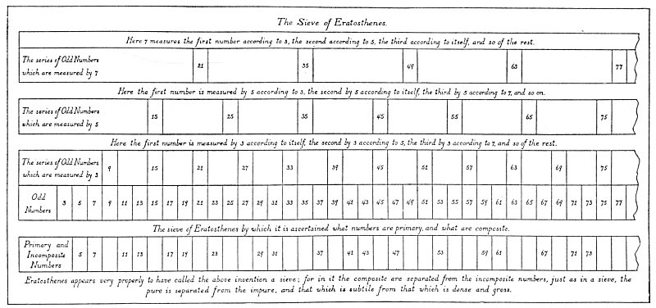
THE SIEVE OF ERATOSTHENES.
Redrawn from Taylor's Theoretic Arithmetic.
This sieve is a mathematical device originated by Eratosthenes about 230 B.C. far the purpose of segregating the composite and incomposite odd numbers. Its use is extremely simple after the theory has once been mastered. All the odd numbers are first arranged in their natural order as shown in the second panel from the bottom, designated Odd Numbers. It will then be seen that every third number (beginning with 3) is divisible by 3, every fifth number (beginning with 5;) is divisible by 5, every seventh number (beginning with 7) is divisible by 7, every ninth number (beginning with 9) is divisible by 9, every eleventh number (beginning with 11) is divisible by 11, and so on to infinity. This system finally sifts out what the Pythagoreans called the "incomposite" numbers, or those having no divisor other than themselves and unity. These will be found in the lowest panel, designated Primary and Incomposite Numbers. In his History of Mathematics, David Eugene Smith states that Eratosthenes was one of the greatest scholars of Alexandria and was called by his admirers "the second Plato." Eratosthenes was educated at Athens, and is renowned not only for his sieve but for having computed, by a very ingenious method, the circumference and diameter of the earth. His estimate of the earth's diameter was only 50 miles less than the polar diameter accepted by modern scientists. This and other mathematical achievements of Eratosthenes, are indisputable evidence that in the third century before Christ the Greeks not only knew the earth to be spherical in farm but could also approximate, with amazing accuracy, its actual size and distance from both the sun and the moon. Aristarchus of Samos, another great Greek astronomer and mathematician, who lived about 250 B.C., established by philosophical deduction and a few simple scientific instruments that the earth revolved around the sun. While Copernicus actually believed himself to be the discoverer of this fact, he but restated the findings advanced by Aristarchus seventeen hundred years earlier.
__________________________

Even numbers are also divided into three other classes: superperfect, deficient, and perfect.
Superperfect or superabundant numbers are such as have the sum of their fractional parts greater than themselves. For example: 1/2 of 24 = 12; 1/4 = 6; 1/3 = 8; 1/6 = 4; 1/12 = 2; and 1/24 = 1. The sum of these parts (12+6+8+4+2+1) is 33, which is in excess of 24, the original number.
Deficient numbers are such as have the sum of their fractional parts less than themselves. For example: 1/2 of 14 = 7; 1/7 = 2; and 1/14 = 1. The sum of these parts (7+2+1) is 10, which is less than 14, the original number.
Perfect numbers are such as have the sum of their fractional parts equal to themselves. For example: 1/2 of 28 = 14; 1/4 = 7; 1/7 = 4; 1/14 = 2; and 1/28 = 1. The sum of these parts (14+7+4+2+1) is equal to 28.
The perfect numbers are extremely rare. There is only one between 1 and 10, namely, 6; one between 10 and 100, namely, 28; one between 100 and 1,000, namely, 496; and one between 1,000 and 10,000, namely, 8,128. The perfect numbers are found by the following rule: The first number of the evenly-even series of numbers (1, 2, 4, 8, 16, 32, and so forth) is added to the second number of the series, and if an incomposite number results it is multiplied by the last number of the series of evenly-even numbers whose sum produced it. The product is the first perfect number. For example: the first and second evenly-even numbers are 1 and 2. Their sum is 3, an incomposite number. If 3 be multiplied by 2, the last number of the series of evenly-even numbers used to produce it, the product is 6, the first perfect number. If the addition of the evenly-even numbers does not result in an incomposite number, the next evenly-even number of the series must be added until an incomposite number results. The second perfect number is found in the following manner: The sum of the evenly-even numbers 1, 2, and 4 is 7, an incomposite number. If 7 be multiplied by 4 (the last of the series of evenly-even numbers used to produce it) the product is 28, the second perfect number. This method of calculation may be continued to infinity.
Perfect numbers when multiplied by 2 produce superabundant numbers, and when divided by 2 produce deficient numbers.
The Pythagoreans evolved their philosophy from the science of numbers. The following quotation from Theoretic Arithmetic is an excellent example of this practice:
"Perfect numbers, therefore, are beautiful images of the virtues which are certain media between excess and defect, and are not summits, as by some of the ancients they were supposed to be. And evil indeed is opposed to evil, but both are opposed to one good. Good, however, is never opposed to good, but to two evils at one and the same time. Thus timidity is opposed to audacity, to both [of] which the want of true courage is common; but both timidity and audacity are opposed to fortitude. Craft also is opposed to fatuity, to both [of] which the want of intellect is common; and both these are opposed to prudence. Thus, too, profusion is opposed to avarice, to both [of] which illiberality is common; and both these are opposed to liberality. And in a similar manner in the other virtues; by all [of] which it is evident that perfect numbers have a great similitude to the virtues. But they also resemble the virtues on another account; for they are rarely found, as being few, and they are generated in a very constant order. On the contrary, an infinite multitude of superabundant and diminished numbers may be found, nor are they disposed in any orderly series, nor generated from any certain end; and hence they have a great similitude to the vices, which are numerous, inordinate, and indefinite."

THE TABLE OF THE TEN NUMBERS
(The following outline of the Pythagorean numbers is a paraphrase of the writings of Nicomachus, Theon of Smyrna, Proclus, Porphyry, Plutarch, Clement of Alexandria, Aristotle, and other early authorities.)
Monad--1--is so called because it remains always in the same condition--that is, separate from multitude. Its attributes are as follows: It is called mind, because the mind is stable and has preeminence; hermaphrodism, because it is both male and female; odd and even, for being added to the even it makes odd, and to the odd, even; God, because it is the beginning and end of all, but itself has neither beginning nor end; good, for such is the nature of God; the receptacle of matter, because it produces the duad, which is essentially material.
By the Pythagoreans monad was called chaos, obscurity, chasm, Tartarus, Styx, abyss, Lethe, Atlas, Axis, Morpho (a name for Venus), and Tower or Throne of Jupiter, because of the great power which abides in the center of the universe and controls the circular motion of the planers about itself. Monad is also called germinal reason, because it is the origin of all the thoughts in the universe. Other names given to it were: Apollo, because of its relation to the sun; Prometheus, because he brought man light; Pyralios, one who exists in fire; geniture, because without it no number can exist; substance, because substance is primary; cause of truth; and constitution of symphony: all these because it is the primordial one.
Between greater and lesser the monad is equal; between intention and remission it is middle; in multitude it is mean; and in time it is now, because eternity knows neither past nor future. It is called Jupiter, because he is Father and head of the gods; Vesta, the fire of the home, because it is located in the midst of the universe and remains there inclining to no side as a dot in a circle; form, because it circumscribes, comprehends, and terminates; love, concord, and piety, because it is indivisible. Other symbolic names for the monad are ship, chariot, Proteus (a god capable of changing his form), Mnemosyne, and Polyonymous (having many names).
The following symbolic names were given to the duad--2--because it has been divided, and is two rather than one; and when there are two, each is opposed to the other: genius, evil, darkness, inequality, instability, movability, boldness, fortitude, contention, matter, dissimilarity, partition between multitude and monad, defect, shapelessness, indefiniteness, indeterminate ness, harmony, tolerance, root, feet of fountain-abounding idea, top, Phanes, opinion, fallacy, alterity, diffidence, impulse, death, motion, generation, mutation, division, longitude, augmentation, composition, communion, misfortune, sustentation, imposition, marriage, soul, and science.
In his book, Numbers, W. Wynn Westcott says of the duad: "it was called 'Audacity,' from its being the earliest number to separate itself from the Divine One; from the 'Adytum of God-nourished Silence,' as the Chaldean oracles say."
As the monad is the father, so the duad is the mother; therefore, the duad has certain points in common with the goddesses Isis, Rhea (Jove's mother), Phrygia, Lydia, Dindymene (Cybele), and Ceres; Erato (one of the Muses); Diana, because the moon is forked; Dictynna, Venus, Dione, Cytherea; Juno, because she is both wife and sister of Jupiter; and Maia, the mother of Mercury.
While the monad is the symbol of wisdom, the duad is the symbol of ignorance, for in it exists the sense of separateness--which sense is the beginning of ignorance. The duad, however, is also the mother of wisdom, for ignorance--out of the nature of itself--invariably gives birth to wisdom.
The Pythagoreans revered the monad but despised the duad, because it was the symbol of polarity. By the power of the duad the deep was created in contradistinction to the heavens. The deep mirrored the heavens and became the symbol of illusion, for the below was merely a reflection of the above. The below was called maya, the illusion, the sea, the Great Void, and to symbolize it the Magi of Persia carried mirrors. From the duad arose disputes and contentions, until by bringing the monad between the duad, equilibrium was reestablished by the Savior-God, who took upon Himself the form of a number and was crucified between two thieves for the sins of men.
The triad--3--is the first number actually odd (monad not always being considered a number). It is the first equilibrium of unities; therefore, Pythagoras said that Apollo gave oracles from a tripod, and advised offer of libation three times. The keywords to the qualities of the triad are friendship, peace, justice, prudence, piety, temperance, and virtue. The following deities partake of the principles of the triad: Saturn (ruler of time), Latona, Cornucopiæ, Ophion (the great serpent), Thetis, Hecate, Polyhymnia (a Muse), Pluto, Triton, President of the Sea, Tritogenia, Achelous, and the Faces, Furies, and Graces. This number is called wisdom, because men organize the present, foresee the future, and benefit by the experiences of the fast. It is cause of wisdom and understanding. The triad is the number of knowledge--music, geometry, and astronomy, and the science of the celestials and terrestrials. Pythagoras taught that the cube of this number had the power of the lunar circle.
The sacredness of the triad and its symbol--the triangle--is derived from the fact that it is made up of the monad and the duad. The monad is the symbol of the Divine Father and the duad of the Great Mother. The triad being made of these two is therefore androgynous and is symbolic of the fact that God gave birth to His worlds out of Himself, who in His creative aspect is always symbolized by the triangle. The monad passing into the duad was thus capable of becoming the parent of progeny, for the duad was the womb of Meru, within which the world was incubated and within which it still exists in embryo.
The tetrad--4--was esteemed by the Pythagoreans as the primogenial number, the root of all things, the fountain of Nature and the most perfect number. All tetrads are intellectual; they have an emergent order and encircle the world as the Empyreum passes through it. Why the Pythagoreans expressed God as a tetrad is explained in a sacred discourse ascribed to Pythagoras, wherein God is called the Number of Numbers. This is because the decad, or 10, is composed of 1, 2, 3, and 4. The number 4 is symbolic of God because it is symbolic of the first four numbers. Moreover, the tetrad is the center of the week, being halfway between 1 and 7. The tetrad is also the first geometric solid.
Pythagoras maintained that the soul of man consists of a tetrad, the four powers of the soul being mind, science, opinion, and sense. The tetrad connects all beings, elements, numbers, and seasons; nor can anything be named which does not depend upon the tetractys. It is the Cause and Maker of all things, the intelligible God, Author of celestial and sensible good, Plutarch interprets this tetractys, which he said was also called the world, to be 36, consisting of the first four odd numbers added to the first four even numbers, thus:
1 + 3 +5 +7 | = 16
2 + 4 + 6 + 8 | = 20
 | 36

Keywords given to the tetrad are impetuosity, strength, virility, two-mothered, and the key keeper of Nature, because the universal constitution cannot be without it. It is also called harmony and the first profundity. The following deities partook of the nature of the tetrad: Hercules, Mercury, Vulcan, Bacchus, and Urania (one of the Muses).
The triad represents the primary colors and the major planets, while the tetrad represents the secondary colors and the minor planets. From the first triangle come forth the seven spirits, symbolized by a triangle and a square. These together form the Masonic apron.
The pentad--5--is the union of an odd and an even number (3 and 2). Among the Greeks, the pentagram was a sacred symbol of light, health, and vitality. It also symbolized the fifth element--ether--because it is free from the disturbances of the four lower elements. It is called equilibrium, because it divides the perfect number 10 into two equal parts.
The pentad is symbolic of Nature, for, when multiplied by itself it returns into itself, just as grains of wheat, starting in the form of seed, pass through Nature's processes and reproduce the seed of the wheat as the ultimate form of their own growth. Other numbers multiplied by themselves produce other numbers, but only 5 and 6 multiplied by themselves represent and retain their original number as the last figure in their products.
The pentad represents all the superior and inferior beings. It is sometimes referred to as the hierophant, or the priest of the Mysteries, because of its connection with the spiritual ethers, by means of which mystic development is attained. Keywords of the pentad are reconciliation, alternation, marriage, immortality, cordiality, Providence, and sound. Among the deities who partook of the nature of the pentad were Pallas, Nemesis, Bubastia (Bast), Venus, Androgynia, Cytherea, and the messengers of Jupiter.
The tetrad (the elements) plus the monad equals the pentad. The Pythagoreans taught that the elements of earth, fire, air, and water were permeated by a substance called ether--the basis of vitality and life. Therefore, they chose the five-pointed star, or pentagram, as the symbol of vitality, health, and interpenetration.
It was customary for the philosophers to conceal the element of earth under the symbol of a dragon, and many of the heroes of antiquity were told to go forth and slay the dragon. Hence, they drove their sword (the monad) into the body of the dragon (the tetrad). This resulted in the formation of the pentad, a symbol of the victory of the spiritual nature over the material nature. The four elements are symbolized in the early Biblical writings as the four rivers that poured out of Garden of Eden. The elements themselves are under the control of the composite Cherubim of Ezekiel.
The Pythagoreans held the hexad--6--to represent, as Clement of Alexandria conceived, the creation of the world according to both the prophets and the ancient Mysteries. It was called by the Pythagoreans the perfection of all the parts. This number was particularly sacred to Orpheus, and also to the Fate, Lachesis, and the Muse, Thalia. It was called the form of forms, the articulation of the universe, and the maker of the soul.
Among the Greeks, harmony and the soul were considered to be similar in nature, because all souls are harmonic. The hexad is also the symbol of marriage, because it is formed by the union of two triangles, one masculine and the other feminine. Among the keywords given to the hexad are: time, for it is the measure of duration; panacea, because health is equilibrium, and the hexad is a balance number; the world, because the world, like the hexad, is often seen to consist of contraries by harmony; omnisufficient, because its parts are sufficient for totality (3 +2 + 1 = 6); unwearied, because it contains the elements of immortality.
By the Pythagoreans the heptad--7--was called "worthy of veneration." It was held to be the number of religion, because man is controlled by seven celestial spirits to whom it is proper for him to make offerings. It was called the number of life, because it was believed that human creatures born in the seventh month of embryonic life usually lived, but those born in the eighth month often died. One author called it the Motherless Virgin, Minerva, because it was nor born of a mother but out of the crown, or the head of the Father, the monad. Keywords of the heptad are fortune, occasion, custody, control, government, judgment, dreams, voices, sounds, and that which leads all things to their end. Deities whose attributes were expressed by the heptad were Ægis, Osiris, Mars, and Cleo (one of the Muses).
Among many ancient nations the heptad is a sacred number. The Elohim of the Jews were supposedly seven in number. They were the Spirits of the Dawn, more commonly known as the Archangels controlling the planets. The seven Archangels, with the three spirits controlling the sun in its threefold aspect, constitute the 10, the sacred Pythagorean decad. The mysterious Pythagorean tetractys, or four rows of dots, increasing from 1 to 4, was symbolic of the stages of creation. The great Pythagorean truth that all things in Nature are regenerated through the decad, or 10, is subtly preserved in Freemasonry through these grips being effected by the uniting of 10 fingers, five on the hand of each person.
The 3 (spirit, mind, and soul) descend into the 4 (the world), the sum being the 7, or the mystic nature of man, consisting of a threefold spiritual body and a fourfold material form. These are symbolized by the cube, which has six surfaces and a mysterious seventh point within. The six surfaces are the directions: north, east, south, west, up, and down; or, front, back, right, left, above, and below; or again, earth, fire, air, water, spirit, and matter. In the midst of these stands the 1, which is the upright figure of man, from whose center in the cube radiate six pyramids. From this comes the great occult axiom: "The center is the father of the directions, the dimensions, and the distances."
The heptad is the number of the law, because it is the number of the Makers of Cosmic law, the Seven Spirits before the Throne.
The ogdoad--8--was sacred because it was the number of the first cube, which form had eight corners, and was the only evenly-even number under 10 (1-2-4-8-4-2-1). Thus, the 8 is divided into two 4's, each 4 is divided into two 2's, and each 2 is divided into two 1's, thereby reestablishing the monad. Among the keywords of the ogdoad are love, counsel, prudence, law, and convenience. Among the divinities partaking of its nature were Panarmonia, Rhea, Cibele, Cadmæa, Dindymene, Orcia, Neptune, Themis, and Euterpe (a Muse).
The ogdoad was a mysterious number associated with the Eleusinian Mysteries of Greece and the Cabiri. It was called the little holy number. It derived its form partly from the twisted snakes on the Caduceus of Hermes and partly from the serpentine motion of the celestial bodies; possibly also from the moon's nodes.
The ennead--9--was the first square of an odd number (3x3). It was associated with failure and shortcoming because it fell short of the perfect number 10 by one. It was called the called the number of man, because of the nine months of his embryonic life. Among its keywords are ocean and horizon, because to the ancients these were boundless. The ennead is the limitless number because there is nothing beyond it but the infinite 10. It was called boundary and limitation, because it gathered all numbers within itself. It was called the sphere of the air, because it surrounded the numbers as air surrounds the earth, Among the gods and goddesses who partook in greater or less degree of its nature were Prometheus, Vulcan, Juno, the sister and wife of Jupiter, Pæan, and Aglaia, Tritogenia, Curetes, Proserpine, Hyperion, and Terpsichore (a Muse).
The 9 was looked upon as evil, because it was an inverted 6. According to the Eleusinian Mysteries, it was the number of the spheres through which the consciousness passed on its way to birth. Because of its close resemblance to the spermatozoon, the 9 has been associated with germinal life.
The decad--10--according to the Pythagoreans, is the greatest of numbers, not only because it is the tetractys (the 10 dots) but because it comprehends all arithmetic and harmonic proportions. Pythagoras said that 10 is the nature of number, because all nations reckon to it and when they arrive at it they return to the monad. The decad was called both heaven and the world, because the former includes the latter. Being a perfect number, the decad was applied by the Pythagoreans to those things relating to age, power, faith, necessity, and the power of memory. It was also called unwearied, because, like God, it was tireless. The Pythagoreans divided the heavenly bodies into ten orders. They also stated that the decad perfected all numbers and comprehended within itself the nature of odd and even, moved and unmoved, good and ill. They associated its power with the following deities: Atlas (for it carried the numbers on its shoulders), Urania, Mnemosyne, the Sun, Phanes, and the One God.
The decimal system can probably be traced back to the time when it was customary to reckon on the fingers, these being among the most primitive of calculating devices and still in use among many aboriginal peoples.

===================================================================================================================================================

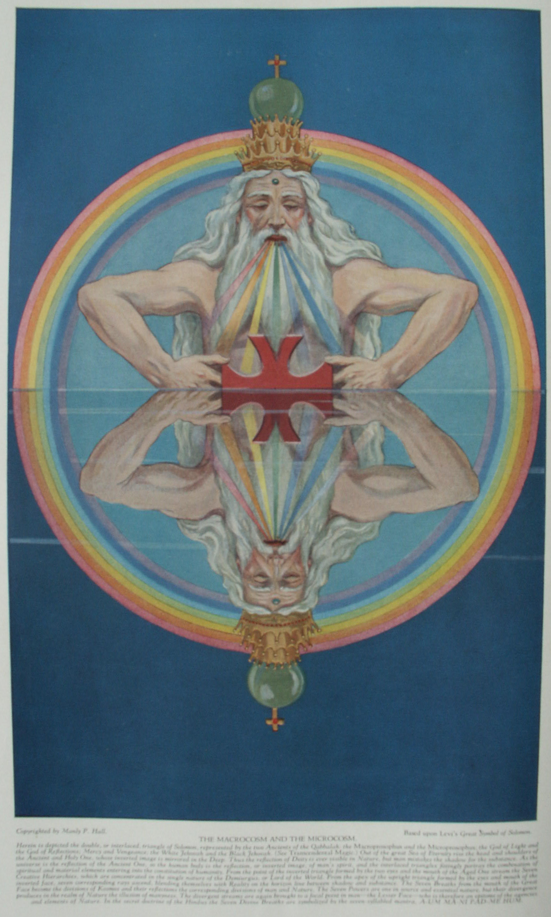

The Pythagorean Theory of Music and Color

HARMONY is a state recognized by great philosophers as the immediate prerequisite of beauty. A compound is termed beautiful only when its parts are in harmonious combination. The world is called beautiful and its Creator is designated the Good because good perforce must act in conformity with its own nature; and good acting according to its own nature is harmony, because the good which it accomplishes is harmonious with the good which it is. Beauty, therefore, is harmony manifesting its own intrinsic nature in the world of form.
The universe is made up of successive gradations of good, these gradations ascending from matter (which is the least degree of good) to spirit (which is the greatest degree of good). In man, his superior nature is the summum bonum. It therefore follows that his highest nature most readily cognizes good because the good external to him in the world is in harmonic ratio with the good present in his soul. What man terms evil is therefore, in common with matter, merely the least degree of its own opposite. The least degree of good presupposes likewise the least degree of harmony and beauty. Thus deformity (evil) is really the least harmonious combination of elements naturally harmonic as individual units. Deformity is unnatural, for, the sum of all things being the Good, it is natural that all things should partake of the Good and be arranged in combinations that are harmonious. Harmony is the manifesting expression of the Will of the eternal Good.

THE PHILOSOPHY OF MUSIC
It is highly probable that the Greek initiates gained their knowledge of the philosophic and therapeutic aspects of music from the Egyptians, who, in turn, considered Hermes the founder of the art. According to one legend, this god constructed the first lyre by stretching strings across the concavity of a turtle shell. Both Isis and Osiris were patrons of music and poetry. Plato, in describing the antiquity of these arts among the Egyptians, declared that songs and poetry had existed in Egypt for at least ten thousand years, and that these were of such an exalted and inspiring nature that only gods or godlike men could have composed them. In the Mysteries the lyre was regarded as the secret symbol of the human constitution, the body of the instrument representing the physical form, the strings the nerves, and the musician the spirit. Playing upon the nerves, the spirit thus created the harmonies of normal functioning, which, however, became discords if the nature of man were defiled.
While the early Chinese, Hindus, Persians, Egyptians, Israelites, and Greeks employed both vocal and instrumental music in their religious ceremonials, also to complement their poetry and drama, it remained for Pythagoras to raise the art to its true dignity by demonstrating its mathematical foundation. Although it is said that he himself was not a musician, Pythagoras is now generally credited with the discovery of the diatonic scale. Having first learned the divine theory of music from the priests of the various Mysteries into which he had been accepted, Pythagoras pondered for several years upon the laws governing consonance and dissonance. How he actually solved the problem is unknown, but the following explanation has been invented.
One day while meditating upon the problem of harmony, Pythagoras chanced to pass a brazier's shop where workmen were pounding out a piece of metal upon an anvil. By noting the variances in pitch between the sounds made by large hammers and those made by smaller implements, and carefully estimating the harmonies and discords resulting from combinations of these sounds, he gained his first clue to the musical intervals of the diatonic scale. He entered the shop, and after carefully examining the tools and making mental note of their weights, returned to his own house and constructed an arm of wood so that it: extended out from the wall of his room. At regular intervals along this arm he attached four cords, all of like composition, size, and weight. To the first of these he attached a twelve-pound weight, to the second a nine-pound weight, to the third an eight-pound weight, and to the fourth a six-pound weight. These different weights corresponded to the sizes of the braziers' hammers.
Pythagoras thereupon discovered that the first and fourth strings when sounded together produced the harmonic interval of the octave, for doubling the weight had the same effect as halving the string. The tension of the first string being twice that of the fourth string, their ratio was said to be 2:1, or duple. By similar experimentation he ascertained that the first and third string produced the harmony of the diapente, or the interval of the fifth. The tension of the first string being half again as much as that of the third string, their ratio was said to be 3:2, or sesquialter. Likewise the second and fourth strings, having the same ratio as the first and third strings, yielded a diapente harmony. Continuing his investigation, Pythagoras discovered that the first and second strings produced the harmony of the diatessaron, or the interval of the third; and the tension of the first string being a third greater than that of the second string, their ratio was said to be 4:3, or sesquitercian. The third and fourth strings, having the same ratio as the first and second strings, produced another harmony of the diatessaron. According to Iamblichus, the second and third strings had the ratio of 8:9, or epogdoan.
The key to harmonic ratios is hidden in the famous Pythagorean tetractys, or pyramid of dots. The tetractys is made up of the first four numbers--1, 2, 3, and 4--which in their proportions reveal the intervals of the octave, the diapente, and the diatessaron. While the law of harmonic intervals as set forth above is true, it has been subsequently proved that hammers striking metal in the manner described will not produce the various tones ascribed to them. In all probability, therefore, Pythagoras actually worked out his theory of harmony from the monochord--a contrivance consisting of a single string stretched between two pegs and supplied with movable frets.

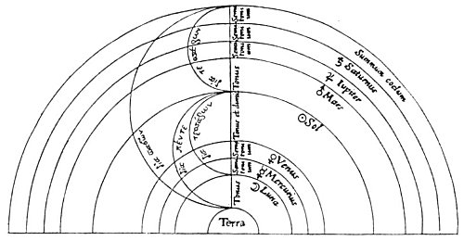
THE INTERVALS AND HARMONIES OF THE SPHERES.
From Stanley's The History of Philosophy.
In the Pythagorean concept of the music of the spheres, the interval between the earth and the sphere of the fixed stars was considered to be a diapason--the most perfect harmonic interval. The allowing arrangement is most generally accepted for the musical intervals of the planets between the earth and the sphere of the fixed stars: From the sphere of the earth to the sphere of the moon; one tone; from the sphere of the moon to that of Mercury, one half-tone; from Mercury to Venus, one-half; from Venus to the sun, one and one-half tones; from the sun to Mars, one tone; from Mars to Jupiter, one-half tone; from Jupiter to Saturn, one-half tone; from Saturn to the fixed stars, one-half tone. The sum of these intervals equals the six whole tones of the octave.

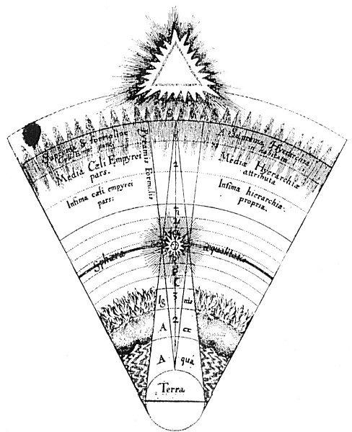
THE CONSONANCES OF THE MUNDANE MONOCHORD.
From Fludd's De Musica Mundana.
This diagrammatic sector represents the major gradations of energy and substance between elemental earth and absolute unconditioned force. Beginning with the superior, the fifteen graduated spheres descend in the following order: Limitless and Eternal Life; the superior, the middle, and the inferior Empyrean; the seven planets; and the four elements. Energy is symbolized by Fludd as a pyramid with its base upon the concave surface of the superior Empyrean, and substance as another Pyramid with its base upon the convex surface of the sphere (not planet) of earth. These pyramids demonstrate the relative proportions of energy and substance entering into the composition of the fifteen planes of being. It will be noted that the ascending pyramid of substance touches but does not pierce the fifteenth sphere--that of Limitless and Eternal Life. Likewise, the descending pyramid of energy touches but does not pierce the first sphere--the grossest condition of substance. The plane of the sun is denominated the sphere of equality, for here neither energy nor substance predominate. The mundane monochord consists of a hypothetical string stretched from the base of the pyramid of energy to the base of the pyramid of substance.

To Pythagoras music was one of the dependencies of the divine science of mathematics, and its harmonies were inflexibly controlled by mathematical proportions. The Pythagoreans averred that mathematics demonstrated the exact method by which the good established and maintained its universe. Number therefore preceded harmony, since it was the immutable law that governs all harmonic proportions. After discovering these harmonic ratios, Pythagoras gradually initiated his disciples into this, the supreme arcanum of his Mysteries. He divided the multitudinous parts of creation into a vast number of planes or spheres, to each of which he assigned a tone, a harmonic interval, a number, a name, a color, and a form. He then proceeded to prove the accuracy of his deductions by demonstrating them upon the different planes of intelligence and substance ranging from the most abstract logical premise to the most concrete geometrical solid. From the common agreement of these diversified methods of proof he established the indisputable existence of certain natural laws.
Having once established music as an exact science, Pythagoras applied his newly found law of harmonic intervals to all the phenomena of Nature, even going so far as to demonstrate the harmonic relationship of the planets, constellations, and elements to each other. A notable example of modern corroboration of ancient philosophical reaching is that of the progression of the elements according to harmonic ratios. While making a list of the elements in the ascending order of their atomic weights, John A. Newlands discovered at every eighth element a distinct repetition of properties. This discovery is known as the law of octaves in modern chemistry.
Since they held that harmony must be determined not by the sense perceptions but by reason and mathematics, the Pythagoreans called themselves Canonics, as distinguished from musicians of the Harmonic School, who asserted taste and instinct to be the true normative principles of harmony. Recognizing, however, the profound effect: of music upon the senses and emotions, Pythagoras did not hesitate to influence the mind and body with what he termed "musical medicine."
Pythagoras evinced such a marked preference for stringed instruments that he even went so far as to warn his disciples against allowing their ears to be defiled by the sounds of flutes or cymbals. He further declared that the soul could be purified from its irrational influences by solemn songs sung to the accompaniment of the lyre. In his investigation of the therapeutic value of harmonics, Pythagoras discovered that the seven modes--or keys--of the Greek system of music had the power to incite or allay the various emotions. It is related that while observing the stars one night he encountered a young man befuddled with strong drink and mad with jealousy who was piling faggots about his mistress' door with the intention of burning the house. The frenzy of the youth was accentuated by a flutist a short distance away who was playing a tune in the stirring Phrygian mode. Pythagoras induced the musician to change his air to the slow, and rhythmic Spondaic mode, whereupon the intoxicated youth immediately became composed and, gathering up his bundles of wood, returned quietly to his own home.
There is also an account of how Empedocles, a disciple of Pythagoras, by quickly changing the mode of a musical composition he was playing, saved the life of his host, Anchitus, when the latter was threatened with death by the sword of one whose father he had condemned to public execution. It is also known that Esculapius, the Greek physician, cured sciatica and other diseases of the nerves by blowing a loud trumpet in the presence of the patient.
Pythagoras cured many ailments of the spirit, soul, and body by having certain specially prepared musical compositions played in the presence of the sufferer or by personally reciting short selections from such early poets as Hesiod and Homer. In his university at Crotona it was customary for the Pythagoreans to open and to close each day with songs--those in the morning calculated to clear the mind from sleep and inspire it to the activities of the coming day; those in the evening of a mode soothing, relaxing, and conducive to rest. At the vernal equinox, Pythagoras caused his disciples to gather in a circle around one of their number who led them in song and played their accompaniment upon a lyre.
The therapeutic music of Pythagoras is described by Iamblichus thus: "And there are certain melodies devised as remedies against the passions of the soul, and also against despondency and lamentation, which Pythagoras invented as things that afford the greatest assistance in these maladies. And again, he employed other melodies against rage and anger, and against every aberration of the soul. There is also another kind of modulation invented as a remedy against desires." (See The Life of Pythagoras.)
It is probable that the Pythagoreans recognized a connection between the seven Greek modes and the planets. As an example, Pliny declares that Saturn moves in the Dorian mode and Jupiter in the Phrygian mode. It is also apparent that the temperaments are keyed to the various modes, and the passions likewise. Thus, anger--which is a fiery passion--may be accentuated by a fiery mode or its power neutralized by a watery mode.
The far-reaching effect exercised by music upon the culture of the Greeks is thus summed up by Emil Nauman: "Plato depreciated the notion that music was intended solely to create cheerful and agreeable emotions, maintaining rather that it should inculcate a love of all that is noble, and hatred of all that is mean, and that nothing could more strongly influence man's innermost feelings than melody and rhythm. Firmly convinced of this, he agreed with Damon of Athens, the musical instructor of Socrates, that the introduction of a new and presumably enervating scale would endanger the future of a whole nation, and that it was not possible to alter a key without shaking the very foundations of the State. Plato affirmed that music which ennobled the mind was of a far higher kind than that which merely appealed to the senses, and he strongly insisted that it was the paramount duty of the Legislature to suppress all music of an effeminate and lascivious character, and to encourage only s that which was pure and dignified; that bold and stirring melodies were for men, gentle and soothing ones for women. From this it is evident that music played a considerable part in the education of the Greek youth. The greatest care was also to be taken in the selection of instrumental music, because the absence of words rendered its signification doubtful, and it was difficult to foresee whether it would exercise upon the people a benign or baneful influence. Popular taste, being always tickled by sensuous and meretricious effects, was to be treated with deserved contempt. (See The History of Music.)
Even today martial music is used with telling effect in times of war, and religious music, while no longer developed in accordance with the ancient theory, still profoundly influences the emotions of the laity.

THE MUSIC OF THE SPHERES
The most sublime but least known of all the Pythagorean speculations was that of sidereal harmonics. It was said that of all men only Pythagoras heard the music of the spheres. Apparently the Chaldeans were the first people to conceive of the heavenly bodies joining in a cosmic chant as they moved in stately manner across the sky. Job describes a time "when the stars of the morning sang together," and in The Merchant of Venice the author of the Shakesperian plays writes: "There's not the smallest orb which thou behold'st but in his motion like an angel sings." So little remains, however, of the Pythagorean system of celestial music that it is only possible to approximate his actual theory.

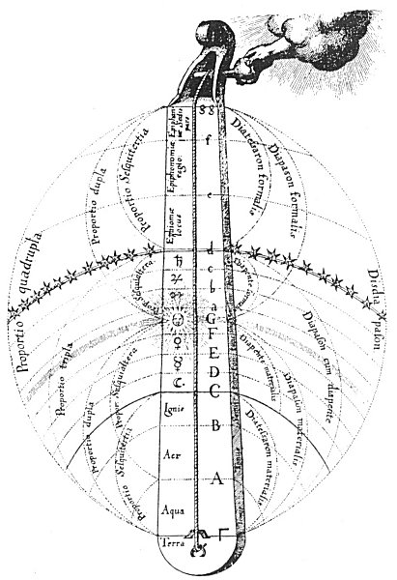
THE MUNDANE MONOCHORD WITH ITS PROPORTIONS AND INTERVALS.
From Fludd's De Musica Mundana.
In this chart is set forth a summary of Fludd's theory of universal music. The interval between the element of earth and the highest heaven is considered as a double octave, thus showing the two extremes of existence to be in disdiapason harmony. It is signifies that the highest heaven, the sun, and the earth have the same time, the difference being in pitch. The sun is the lower octave of the highest heaven and the earth the lower octave of the sun. The lower octave (Γ to G) comprises that part of the universe in which substance predominate over energy. Its harmonies, therefore, are more gross than those of the higher octave (G to g) wherein energy predominates over substance. "If struck in the more spiritual part," writes Fludd, "the monochord will give eternal life; if in the more material part, transitory life." It will be noted that certain elements, planets, and celestial spheres sustain a harmonic ratio to each other, Fludd advanced this as a key to the sympathies and antipathies existing between the various departments of Nature.

Pythagoras conceived the universe to be an immense monochord, with its single string connected at its upper end to absolute spirit and at its lower end to absolute matter--in other words, a cord stretched between heaven and earth. Counting inward from the circumference of the heavens, Pythagoras, according to some authorities, divided the universe into nine parts; according to others, into twelve parts. The twelvefold system was as follows: The first division was called the empyrean, or the sphere of the fixed stars, and was the dwelling place of the immortals. The second to twelfth divisions were (in order) the spheres of Saturn, Jupiter, Mars, the sun, Venus, Mercury, and the moon, and fire, air, water, and earth. This arrangement of the seven planets (the sun and moon being regarded as planets in the old astronomy) is identical with the candlestick symbolism of the Jews--the sun in the center as the main stem with three planets on either side of it.
The names given by the Pythagoreans to the various notes of the diatonic scale were, according to Macrobius, derived from an estimation of the velocity and magnitude of the planetary bodies. Each of these gigantic spheres as it rushed endlessly through space was believed to sound a certain tone caused by its continuous displacement of the æthereal diffusion. As these tones were a manifestation of divine order and motion, it must necessarily follow that they partook of the harmony of their own source. "The assertion that the planets in their revolutions round the earth uttered certain sounds differing according to their respective 'magnitude, celerity and local distance,' was commonly made by the Greeks. Thus Saturn, the farthest planet, was said to give the gravest note, while the Moon, which is the nearest, gave the sharpest. 'These sounds of the seven planets, and the sphere of the fixed stars, together with that above us [Antichthon], are the nine Muses, and their joint symphony is called Mnemosyne.'" (See The Canon.)This quotation contains an obscure reference to the ninefold division of the universe previously mentioned.
The Greek initiates also recognized a fundamental relationship between the individual heavens or spheres of the seven planets, and the seven sacred vowels. The first heaven uttered the sound of the sacred vowel Α (Alpha); the second heaven, the sacred vowel Ε (Epsilon); the third, Η (Eta); the fourth, Ι (Iota); the fifth, Ο (Omicron); the sixth, Υ (Upsilon); and the seventh heaven, the sacred vowel Ω (Omega). When these seven heavens sing together they produce a perfect harmony which ascends as an everlasting praise to the throne of the Creator. (See Irenæus' Against Heresies.) Although not so stated, it is probable that the planetary heavens are to be considered as ascending in the Pythagorean order, beginning with the sphere of the moon, which would be the first heaven.
Many early instruments had seven Strings, and it is generally conceded that Pythagoras was the one who added the eighth string to the lyre of Terpander. The seven strings were always related both to their correspondences in the human body and to the planets. The names of God were also conceived to be formed from combinations of the seven planetary harmonies. The Egyptians confined their sacred songs to the seven primary sounds, forbidding any others to be uttered in their temples. One of their hymns contained the following invocation: "The seven sounding tones praise Thee, the Great God, the ceaseless working Father of the whole universe." In another the Deity describes Himself thus: "I am the great indestructible lyre of the whole world, attuning the songs of the heavens. (See Nauman's History of Music.)
The Pythagoreans believed that everything which existed had a voice and that all creatures were eternally singing the praise of the Creator. Man fails to hear these divine melodies because his soul is enmeshed in the illusion of material existence. When he liberates himself from the bondage of the lower world with its sense limitations, the music of the spheres will again be audible as it was in the Golden Age. Harmony recognizes harmony, and when the human soul regains its true estate it will not only hear the celestial choir but also join with it in an everlasting anthem of praise to that Eternal Good controlling the infinite number of parts and conditions of Being.
The Greek Mysteries included in their doctrines a magnificent concept of the relationship existing between music and form. The elements of architecture, for example, were considered as comparable to musical modes and notes, or as having a musical counterpart. Consequently when a building was erected in which a number of these elements were combined, the structure was then likened to a musical chord, which was harmonic only when it fully satisfied the mathematical requirements of harmonic intervals. The realization of this analogy between sound and form led Goethe to declare that "architecture is crystallized music."
In constructing their temples of initiation, the early priests frequently demonstrated their superior knowledge of the principles underlying the phenomena known as vibration. A considerable part of the Mystery rituals consisted of invocations and intonements, for which purpose special sound chambers were constructed. A word whispered in one of these apartments was so intensified that the reverberations made the entire building sway and be filled with a deafening roar. The very wood and stone used in the erection of these sacred buildings eventually became so thoroughly permeated with the sound vibrations of the religious ceremonies that when struck they would reproduce the same tones thus repeatedly impressed into their substances by the rituals.
Every element in Nature has its individual keynote. If these elements are combined in a composite structure the result is a chord that, if sounded, will disintegrate the compound into its integral parts. Likewise each individual has a keynote that, if sounded, will destroy him. The allegory of the walls of Jericho falling when the trumpets of Israel were sounded is undoubtedly intended to set forth the arcane significance of individual keynote or vibration.

THE PHILOSOPHY OF COLOR
"Light," writes Edwin D. Babbitt, "reveals the glories of the external world and yet is the most glorious of them all. It gives beauty, reveals beauty and is itself most beautiful. It is the analyzer, the truth-teller and the exposer of shams, for it shows things as they are. Its infinite streams measure off the universe and flow into our telescopes from stars which are quintillions of miles distant. On the other hand it descends to objects inconceivably small, and reveals through the microscope objects fifty millions of times less than can be seen by the naked eye. Like all other fine forces, its movement is wonderfully soft, yet penetrating and powerful. Without its vivifying influence, vegetable, animal, and human life must immediately perish from the earth, and general ruin take place. We shall do well, then, to consider this potential and beautiful principle of light and its component colors, for the more deeply we penetrate into its inner laws, the more will it present itself as a marvelous storehouse of power to vitalize, heal, refine, and delight mankind." (See The Principles of Light and Color.)
Since light is the basic physical manifestation of life, bathing all creation in its radiance, it is highly important to realize, in part at least, the subtle nature of this divine substance. That which is called light is actually a rate of vibration causing certain reactions upon the optic nerve. Few realize how they are walled in by the limitations of the sense perceptions. Not only is there a great deal more to light than anyone has ever seen but there are also unknown forms of light which no optical equipment will ever register. There are unnumbered colors which cannot be seen, as well as sounds which cannot be heard, odors which cannot be smelt, flavors which cannot be tasted, and substances which cannot be felt. Man is thus surrounded by a supersensible universe of which he knows nothing because the centers of sense perception within himself have not been developed sufficiently to respond to the subtler rates of vibration of which that universe is composed.

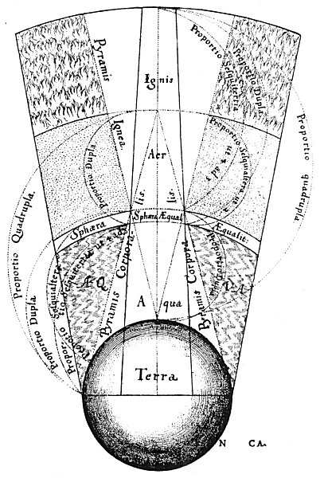
THE THEORY OF ELEMENTAL MUSIC.
From Fludd's De Musica Mundana.
In this diagram two interpenetrating pyramids are again employed, one of which represents fire and the other earth. It is demonstrated according to the law of elemental harmony that fire does not enter into the composition of earth nor earth into the composition of fire. The figures on the chart disclose the harmonic relationships existing between the four primary elements according to both Fludd and the Pythagoreans. Earth consists of four parts of its own nature; water of three parts of earth and one part of fire. The sphere of equality is a hypothetical point where there is an equilibrium of two parts of earth and two parts of fire. Air is composed of three parts of fire and one part of earth; fire, of four parts of its own nature. Thus earth and water bear to each other the ratio of 4 to 3, or the diatessaron harmony, and water and the sphere of equality the ratio of 3 to 2, or the diapente harmony. Fire and air also bear to each other the ratio of 4 to 3, or the diatessaron harmony, and air and the sphere of equality the ratio of 3 to 2, or the diapente harmony. As the sum of a diatessaron and a diapente equals a diapason, or octave, it is evident that both the sphere of fire and the sphere of earth are in diapason harmony with the sphere of equality, and also that fire and earth are in disdiapason harmony with each other.

Among both civilized and savage peoples color has been accepted as a natural language in which to couch their religious and philosophical doctrines. The ancient city of Ecbatana as described by Herodotus, its seven walls colored according to the seven planets, revealed the knowledge of this subject possessed by the Persian Magi. The famous zikkurat or astronomical tower of the god Nebo at Borsippa ascended in seven great steps or stages, each step being painted in the key color of one of the planetary bodies. (See Lenormant's Chaldean Magic.) It is thus evident that the Babylonians were familiar with the concept of the spectrum in its relation to the seven Creative Gods or Powers. In India, one of the Mogul emperors caused a fountain to be made with seven levels. The water pouring down the sides through specially arranged channels changed color as it descended, passing sequentially through all shades of the spectrum. In Tibet, color is employed by the native artists to express various moods. L. Austine Waddell, writing of Northern Buddhist art, notes that in Tibetan mythology "White and yellow complexions usually typify mild moods, while the red, blue, and black belong to fierce forms, though sometimes light blue, as indicating the sky, means merely celestial. Generally the gods are pictured white, goblins red, and devils black, like their European relative." (See The Buddhism of Tibet.)
In Meno, Plato, speaking through Socrates, describes color as "an effluence of form, commensurate with sight, and sensible." In Theætetus he discourses more at length on the subject thus: "Let us carry out the principle which has just been affirmed, that nothing is self-existent, and then we shall see that every color, white, black, and every other color, arises out of the eye meeting the appropriate motion, and that what we term the substance of each color is neither the active nor the passive element, but something which passes between them, and is peculiar to each percipient; are you certain that the several colors appear to every animal--say a dog--as they appear to you?"
In the Pythagorean tetractys--the supreme symbol of universal forces and processes--are set forth the theories of the Greeks concerning color and music. The first three dots represent the threefold White Light, which is the Godhead containing potentially all sound and color. The remaining seven dots are the colors of the spectrum and the notes of the musical scale. The colors and tones are the active creative powers which, emanating from the First Cause, establish the universe. The seven are divided into two groups, one containing three powers and the other four a relationship also shown in the tetractys. The higher group--that of three--becomes the spiritual nature of the created universe; the lower group--that of four--manifests as the irrational sphere, or inferior world.
In the Mysteries the seven Logi, or Creative Lords, are shown as streams of force issuing from the mouth of the Eternal One. This signifies the spectrum being extracted from the white light of the Supreme Deity. The seven Creators, or Fabricators, of the inferior spheres were called by the Jews the Elohim. By the Egyptians they were referred to as the Builders (sometimes as the Governors) and are depicted with great knives in their hands with which they carved the universe from its primordial substance. Worship of the planets is based upon their acceptation as the cosmic embodiments of the seven creative attributes of God. The Lords of the planets were described as dwelling within the body of the sun, for the true nature of the sun, being analogous to the white light, contains the seeds of all the tone and color potencies which it manifests.
There are numerous arbitrary arrangements setting forth the mutual relationships of the planets, the colors, and the musical notes. The most satisfactory system is that based upon the law of the octave. The sense of hearing has a much wider scope than that of sight, for whereas the ear can register from nine to eleven octaves of sound the eye is restricted to the cognition of but seven fundamental color tones, or one tone short of the octave. Red, when posited as the lowest color tone in the scale of chromatics, thus corresponds to do, the first note of the musical scale. Continuing the analogy, orange corresponds to re, yellow to mi, green to fa, blue to sol, indigo to la, and violet to si (ti). The eighth color tone necessary to complete the scale should be the higher octave of red, the first color tone. The accuracy of the above arrangement is attested by two striking facts: (1) the three fundamental notes of the musical scale--the first, the third, and the fifth--correspond with the three primary colors--red, yellow, and blue; (2) the seventh, and least perfect, note of the musical scale corresponds with purple, the least perfect tone of the color scale.
In The Principles of Light and Color, Edwin D. Babbitt confirms the correspondence of the color and musical scales: "As C is at the bottom of the musical scale and made with the coarsest waves of air, so is red at the bottom of the chromatic scale and made with the coarsest waves of luminous ether. As the musical note B [the seventh note of the scale] requires 45 vibrations of air every time the note C at the lower end of the scale requires 24, or but little over half as many, so does extreme violet require about 300 trillions of vibrations of ether in a second, while extreme red requires only about 450 trillions, which also are but little more than half as many. When one musical octave is finished another one commences and progresses with just twice as many vibrations as were used in the first octave, and so the same notes are repeated on a finer scale. In the same way when the scale of colors visible to the ordinary eye is completed in the violet, another octave of finer invisible colors, with just twice as many vibrations, will commence and progress on precisely the same law."
When the colors are related to the twelve signs of the zodiac, they are arranged as the spokes of a wheel. To Aries is assigned pure red; to Taurus, red-orange; to Gemini, pure orange; to Cancer, orange-yellow; to Leo, pure yellow; to Virgo, yellow-green; to Libra, pure green; to Scorpio, green-blue; to Sagittarius, pure blue; to Capricorn, blue-violet; to Aquarius, pure violet; and to Pisces, violet-red.
In expounding the Eastern system of esoteric philosophy, H. P, Blavatsky relates the colors to the septenary constitution of man and the seven states of matter as follows:
COLOR | PRINCIPLES OF MAN | STATES OF MATTER
Violet | Chaya, or Etheric Double | Ether
Indigo | Higher Manas, or Spiritual Intelligence | Critical State called Air
Blue | Auric Envelope | Steam or Vapor
Green | Lower Manas, or Animal Soul | Critical State
Yellow | Buddhi, or Spiritual Soul | Water
Orange | Prana, or Life Principle | Critical State
Red | Kama Rupa, or Seat of Animal Life | Ice

This arrangement of the colors of the spectrum and the musical notes of the octave necessitates a different grouping of the planets in order to preserve their proper tone and color analogies. Thus do becomes Mars; re, the sun; mi, Mercury; fa, Saturn; sol, Jupiter; la, Venus; si (ti) the moon. (See The E. S. Instructions.)
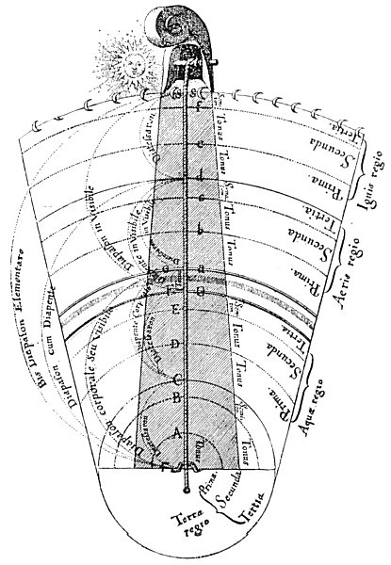
THE FOUR ELEMENTS AND THEIR CONSONANTAL INTERVALS.
From Fludd's De Musica Mundana.
In this diagram Fludd has divided each of the four Primary elements into three subdivisions. The first division of each element is the grossest, partaking somewhat of the substance directly inferior to itself (except in the case of the earth, which has no state inferior to itself). The second division consists of the element in its relatively pure state, while the third division is that condition wherein the element partakes somewhat of the substance immediately superior to itself. For example the lowest division of the element of water is sedimentary, as it contains earth substance in solution; the second division represents water in its most common state--salty--as in the case of the ocean; and the third division is water in its purest state--free from salt. The harmonic interval assigned to the lowest division of each element is one tone, to the central division also a tone, but to the higher division a half-tone because it partakes of the division immediately above it. Fludd emphasizes the fact that as the elements ascend in series of two and a half tones, the diatessaron is the dominating harmonic interval of the elements.

===================================================================================================================================================
END

