CELESTIAL VIRGIN WITH SUN GOD IN HER ARMS

http://www.gospelassemblyfree.com/facts/virgin.htm

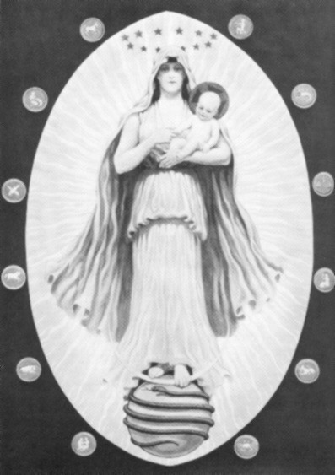

Primitive man was wont to associate the Creative Principle with the attributes of either the male or the female sex. In those days, human survival depended upon brawn rather than brain. The dominance of the male was unquestioned; hence masculine characteristics were assigned to God. Later, when man had reached a state of comparative physical security and had turned to the culture of ethical nature, his appreciation increased for the finer and more idealistic feminine qualities; these he subsequently incorporated into his concept of Deity. The God of the state thus became essentially masculine, the God of the church feminine, and the God of Philosophy androgynous. To these the modern world has contributed a fourth or scientific concept in which the Creative Agent is regarded as sexless. In the view of the theologian, the Madonna who gives birth to the Man Child signifies the priority of the mother aspect of Divinity, the maternal function being considered as the highest expression of being. The vesica piscis, or oval nimbus, in which the figure stands, represents the glorification of the Creative Power as exemplified in motherhood. The Christ Child always symbolizes Wisdom, the Virgin Mother, Faith. The figure therefore declares that Wisdom, born of Faith, shall redeem the world now encircled by the serpent of evil.

Copyrighted by Manly P. Hall

