Samuel Liddell MacGregor Mathers 1854-1918
http://en.wikipedia.org/wiki/Samuel_Liddell_MacGregor_Mathers
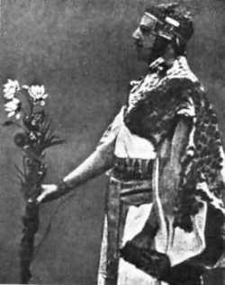 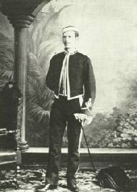 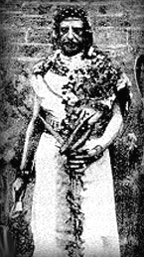 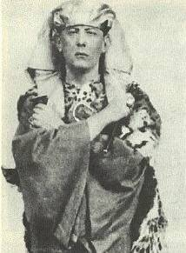 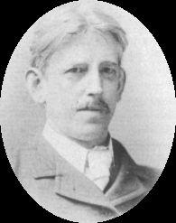 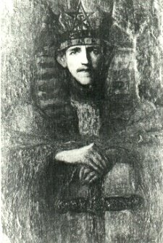 .

Samuel Liddell (or Liddel) "MacGregor" Mathers, born as Samuel Liddell (January, 1854 – November, 1918), was a famous magician and one of the most influential figures in modern Occultism. He is primarily known as one of the founders of the Hermetic Order of the Golden Dawn, a ceremonial magic order whose offshoots still exist today.

Biography
He was born on January 8 or January 11, 1854 in London, England, under the astrological sign of Capricorn. His father, William M. Mathers, died while Samuel Liddell was still a boy. His mother, whose maiden name was Collins, died in 1885. He attended the Bedford Grammar School.
Mathers was an eccentric whose chosen lifestyle was unusual in its time. He added the "MacGregor" surname as a claim to Highland Scottish heritage, although there is little evidence of such in his family background. He was a practicing vegetarian (possibly a vegan), an outspoken anti-vivisectionist, and a non-smoker. It is known that his main interests were magic and the theory of war (his first book was a military manual).
Mathers was initiated into an order of Freemasonry on October 4, 1877. On January 30, 1878 he became a Master Mason and in 1882 he was admitted to the Societas Rosicruciana in Anglia where he became a member of its High Council within four years.
His wife was Moina Bergson (also known as Mina Bergson, Moina Mathers, Mina Mathers), the sister of the philosopher Henri Bergson.
Mathers apparently knew how to read and translate a number of languages, including English, French, Latin, Greek, Hebrew, Gaelic and Coptic. His translations of such books as The Book of the Sacred Magic of Abramelin the Mage, The Kabbalah Unveiled, The Key of Solomon The King and The Lesser Key of Solomon, while probably justly criticized with respect to quality, were responsible for making what had been obscure and inaccessible material widely available to the non-academic English speaking world. They have had considerable influence on the development of occult and esoteric thought since their publication.
In addition to many supporters, he had many enemies and critics. One of his most notable enemies was one time friend and pupil Aleister Crowley, who portrayed Mathers as a villain named SRMD in his 1929 novel Moonchild.
Mathers died on November 5 or November 20, 1918. The manner of his death is unknown; his death certificate lists no cause of death. Violet Firth (Dion Fortune) claimed his death was the result of the Spanish influenza of 1918. As few facts are known about Mathers's private life, verification of such claims is very difficult.

See also
- Hermetic Order of the Golden Dawn
- Hermeticism
- Magic
- Occultism
- List of Occultists
- List of spirituality-related topics
- Mathers table
- William Robert Woodman

External links
- Biography from Kheper.net
- Biography from the Esoteric Order of the Golden Dawn
- Biography from the Hermetic Order of the Golden Dawn, Inc.
- The Truth about S.L. MacGregor Mathers
- Mathers at the Internet Sacred Text Archive
  - The Book of the Sacred Magic of Abramelin the Mage
  - The Kabbalah Unveiled
  - The Key of Solomon The King
  - The Lesser Key of Solomon
  - The Tarot
===================================================================================================================================
END

