William Morgan 1775-1826
www.theforbiddenknowledge.com/hardtruth
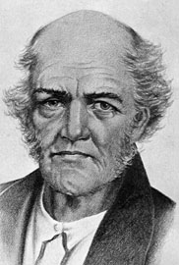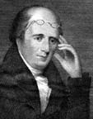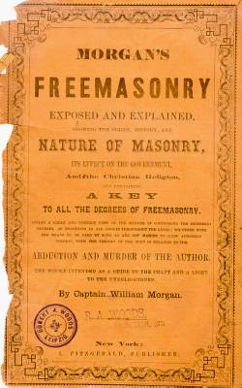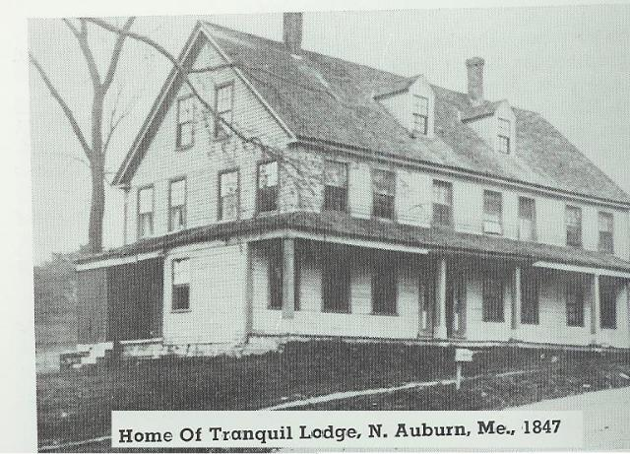

William Morgan (c. 1775-c. 1826) was a resident of Batavia, New York, whose disappearance in 1826 sparked the formation of a new political party and a powerful anti-Freemason movement in the United States.

Contents
[hide]
- 1 Early life
- 2 Association with Masonry
  - 2.1 Attempted to join local lodge
  - 2.2 Planned to write a book critical of Masons
- 3 "The Morgan Affair"
  - 3.1 The first arrest
  - 3.2 The second arrest
  - 3.3 Morgan's disappearance and theories
- 4 Anti-masonry movement
  - 4.1 Publication of Morgans' book
  - 4.2 Criticisms of Masons on the rise
- 5 Monument to Morgan
- 6 See also
- 7 External links
- 8 References

Early life
Born in Culpeper, Virginia about 1775, he married Lucinda Pendleton, a woman some 28 years his junior in Richmond in 1819. They were the parents of two children, Lucinda Wesley Morgan and Thomas Jefferson Morgan.^{[1]} Two years after his marriage, he moved to York, Upper Canada, where he operated a brewery.^{[2]}
When his business was destroyed by fire, he returned to the United States, settling first at Rochester, New York, and later in Batavia.
Morgan liked to claim that he had served with distinction as a captain during the War of 1812, though there is no evidence that he had done so.

[] Association with Masonry

[] Attempted to join local lodge
Morgan attempted to affiliate himself with the local Masonic lodge in Batavia, but was denied admission, most likely because no record of his admission existed.^{[3]} Morgan is known to have received the York Rite Royal Arch degree at Leroy, New York in 1825, and when a new Chapter was being formed in Batavia, Morgan's name was on the list of petitioners. Apparently, some Masons objected and a new petition was drawn up without Morgan on it.

[] Planned to write a book critical of Masons
Angered by his rejection, Morgan declared that it was his intention to publish a book, Illustrations of Masonry, critical of the Freemasons and describing their secret activities in great detail.
Morgan announced that a local newspaper publisher, David C. Miller, had given him a sizable advance for the work. Miller is said to have received the Entered Apprentice degree (the first degree of Freemasonry), but then been stopped from advancement by the objection of one or more of the Batavia lodge members.^{[2]} This would have given him motivation to join with Morgan. In fact, it seems that Morgan had entered into a half million dollar penal bond with three men: David C. Miller, John Davids (Morgan's landlord) and one Russel Dyer.^{[3]}

[] "The Morgan Affair"

[] The first arrest
If the local Masons had simply ignored Morgan's actions, that would have been the end of the matter. But some members of the Batavia lodge responded to Morgan's "betrayal" by publishing an advertisement denouncing Morgan, and several attempts were made by unknown individuals to set fire to Miller's newspaper office.^{[3]}
When these efforts failed, a group of Masons gathered at Morgan's house claiming that he owed them money. On September 11, 1826, Morgan was arrested: according to the law, he could be held in jail until the debt was paid. Learning of this, Miller went to the jail to pay the debt. After several failed attempts, he finally secured Morgan's release.

[] The second arrest
A few hours later, Morgan was arrested again, now for another apparent loan he had to pay back and for supposedly stealing some clothing. He was jailed again, this time in Canandaigua. On the night of September 11, someone appeared, claiming to be a friend of Morgan's and offering to pay his debt and have him released. Morgan was taken to a carriage that was waiting for him outside the prison. The next day, the carriage arrived at Fort Niagara.^{[2]}

[] Morgan's disappearance and theories
There are several tales of what happened to Morgan next. The most common one is that he was taken in a boat to the middle of the Niagara River and drowned. This theory was given credibility when a man named Henry L. Valance allegedly confessed to his part in the murder in 1848. This death bed confession is recounted in chapter 2 of Reverend C. G. Finney's book The Character, Claims, and Practical Workings of Freemasonry. A body did wash up about a month after Morgan left the jail, but it was positively identified as the body of a Canadian man who had disappeared.
On the other hand, some Freemasons generally deny that Morgan was killed, saying instead that he was paid $500 to leave the country. There have been numerous reports of Morgan being seen in other countries, but none have been confirmed.

[] Anti-masonry movement

[] Publication of Morgans' book
Soon after Morgan disappeared, Miller published Morgan's book (which was highly critical of Freemasonry). The book became a best-seller, and some people have speculated that the disappearance was an elaborate publicity stunt. According to them, Morgan assumed a new identity and settled in Albany, in Canada, or the Cayman Islands, or even was hanged as a pirate. New York governor De Witt Clinton, himself a Mason, offered a sizable reward of $2,000 for any information about Morgan's whereabouts, but no one ever claimed it. Three Masons, Loton Lawon, Nicholas Chesebro and Edward Sawyer were charged with, convicted and served sentences for kidnapping Morgan. ^{[4]}

[] Criticisms of Masons on the rise
Morgan's disappearance—and the minimal punishment received by his kidnappers—sparked a series of protests against the Freemasons throughout New York and the neighboring states. Despite the prompt disavowal of the actions of the kidnappers by the Masonic hierarchy, all Masons found themselves being criticised. Under the leadership of a New York politician named Thurlow Weed, an anti-Masonic and anti-Andrew Jackson (Jackson was a Mason) movement was formed, the Anti-Masonic political party, which ran a candidate for the presidency in 1828, gaining the support of such politicians as William H. Seward.
Its influence was such that other Jackson rivals, including John Quincy Adams, joined in denouncing the Masons. Adams in 1847 wrote a widely distributed book titled Letters on the Masonic Institution that was also highly critical of the Masons. In 1832, the party fielded William Wirt as its presidential candidate, though the party only received seven electoral votes. Three years later, the party had become moribund everywhere but Pennsylvania, as other issues, such as slavery, became the focus of national attention.

[] Monument to Morgan
On September 13, 1882 a large monument to Morgan was unveiled in the Batavia City cemetery by the National Christian Association, a group opposed to secret societies. The ceremony was witnessed by 1000 people, including representatives from local masonic lodges.^{[5]} The monument reads:
"Sacred to the memory of Wm. Morgan, a native of Virginia, a Capt. in the War of 1812, a respectable citizen of Batavia, and a martyr to the freedom of writing, printing and speaking the truth. He was abducted from near this spot in the year 1826, by Freemasons and murdered for revealing the secrets of their order. The court records of Genesee County, and the files of the Batavia Advocate, kept in the Recorders office contain the history of the events that caused the erection of this monument."
Despite many attempts to solve the riddle of Wiliam Morgan's disappearance, it remains a mystery.
Note: It was later alleged that Morgan's widow later became one of the plural wives of Mormon church founder Joseph Smith, Jr. According to these claims, William Morgan was given one of the first official post-mortem baptisms into the Church of the Latter Day Saints.^{[1]}

[] See also
- Freemasonry
- Anti-Masonic political party
- List of people who have disappeared
- Secret society
- Conspiracy theory

[] External links
- The Morgan affair
- Works by William Morgan at Project Gutenberg

[] References
- ^ ª ^{b} John E. Thompson, "The Mormon Baptism of William Morgan", The Philalethes, February, 1985; 38(1): p. 8.
- ^ ª ^{b} ^{c} Leo F. Tillotson, Ancient Craft Masonry in Vermont Online version
- ^ ª ^{b} ^{c} "The Morgan Affair", The Short Talk Bulletin, Vol. XI, March, 1933; No. 3. Online version
- ^ The Freemasons: A History of the World's Most Powerful Secret Society, by Jasper Ridley, pp. 180-181 (Arcade Publishing 1999)
- ^ "An Old Tragedy Revived; Erection Of A Memorial To Morgan, Who Divulged The Secrets Of Masonry", New York Times, September 14, 1882, Pg. 1., and "The Unveiling Ceremonies Witnessed by a Large Crowd Who Listen to Able and Interesting Addresses Substance of the Speeches Proceedings at the Convention A Letter from Thurlow Weed", The Daily News, Batavia, September 14, 1882. Online copy
======================================================================================================================================
EN

