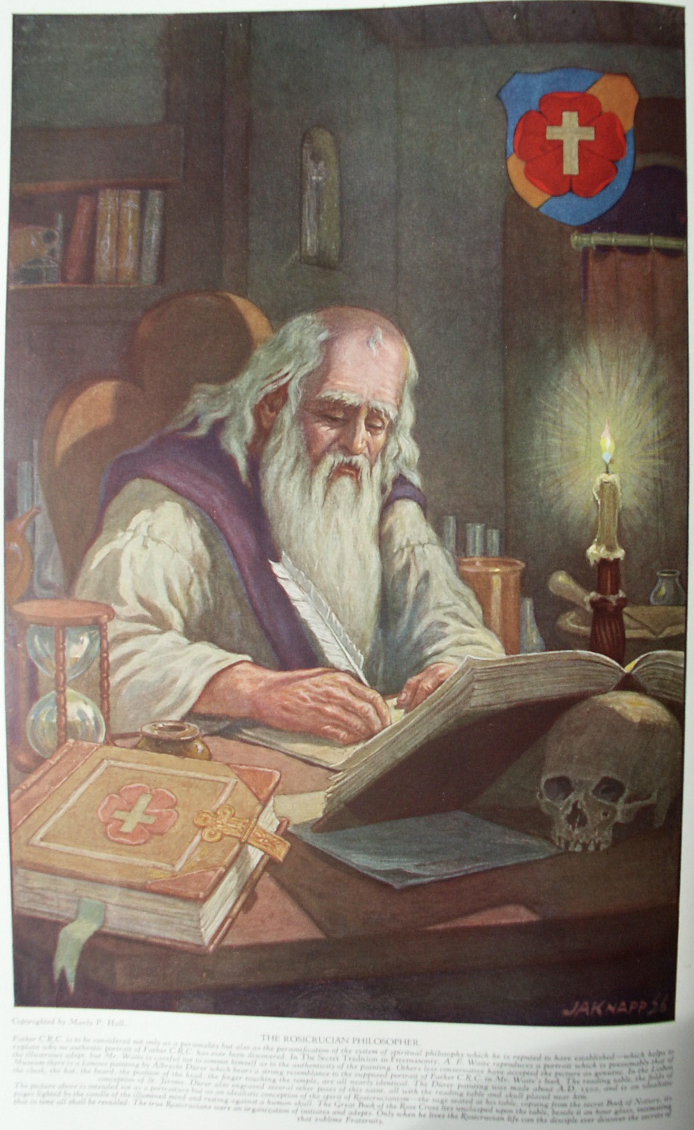

The Fraternity of the Rose Cross
The Secret Teachings of All Ages - Manly P. Hall 1928

THE FRATERNITY OF THE ROSE CROSS
The life of Father C.R.C.--Johann Valentin Andreæ--The alchemical teachings of the Rosicrucians--Significance of the Rose Cross--The Rosicrucian Temple--The adepts of the Rose Cross.
ROSICRUCIAN DOCTRINES AND TENETS
The Confessio Fraternitatis--The Anatomy of Melancholy--John Heydon on Rosicrucianism--The three mountains of the wise--The philosophical egg--The objects of the Rosicrucian Order.
FIFTEEN ROSICRUCIAN AND QABBALISTIC DIAGRAMS
Schamayim, the Ocean of Spirit--The Seven Days of Creation--The symbolic tomb of Christian Rosencreutz--The regions of the elements--The New Jerusalem--The grand secret of Nature.
THE CHEMICAL MARRIAGE
Christian Rosencreutz is invited to the Chemical Wedding--The Virgo Lucifera--The philosophical Inquisition--The Tower of Olympus--The homunculi--The Knights of the Golden Stone.

The Fraternity of the Rose Cross
WHO were the Rosicrucians? Were they an organization of profound thinkers rebelling against the inquisitional religious and philosophical limitations of their time or were they isolated transcendentalists united only by the similarity of their viewpoints and deductions? Where was the "House of the Holy Spirit, " in which, according to their manifestoes, they met once a year to plan the future activities of their Order? Who was the mysterious person referred to as "Our Illustrious Father and Brother C.R.C."? Did those three letters actually stand for the words "Christian Rosie Cross"? Was Christian Rosencreutz, the supposed author of the Chymical Nuptials, the same person who with three others founded "The Society of the Rose Cross"?
What relationship existed between Rosicrucianism and mediæval Freemasonry? Why were the destinies of these two organizations so closely interwoven? Is the "Brotherhood of the Rose Cross" the much-sought-after link connecting the Freemasonry of the Middle Ages with the symbolism and mysticism of antiquity, and are its secrets being perpetuated by modern Masonry? Did the original Rosicrucian Order disintegrate in the latter part of the eighteenth century, or does the Society still exist as an organization, maintaining the same secrecy for which it was originally famous? What was the true purpose for which the "Brotherhood of the Rose Cross" was formed? Were the Rosicrucians a religious and philosophic brotherhood, as they claimed to be, or were their avowed tenets a blind to conceal the true object of the Fraternity, which possibly was the political control of Europe? These are some of the problems involved in the study of Rosicrucianism.
There are four distinct theories regarding the Rosicrucian enigma. Each is the result of a careful consideration of the evidence by scholars who have spent their lives ransacking the archives of Hermetic lore. The conclusions reached demonstrate clearly the inadequacy of the records available concerning the genesis and early activities of the "Brethren of the Rose Cross."

THE FIRST POSTULATE
It is assumed that the Rosicrucian Order existed historically in accordance with the description of its foundation and subsequent activities published in its manifesto, the Fama Fraternitatis, which is believed to have been written in the year 1610, but apparently did not appear in print until 1614, although an earlier edition is suspected by some authorities. Intelligent consideration of the origin of Rosicrucianism requires a familiarity with the contents of the first and most important of its documents. The Fama Fraternitatis begins with a reminder to all the world of God's goodness and mercy, and it warns the intelligentsia that their egotism and covetousness cause them to follow after false prophets and to ignore the true knowledge which God in His goodness has revealed to them. Hence, a reformation is necessary, and God has raised up philosophers and sages for this purpose.
In order to assist in bringing about the reformation, a mysterious person called "The Highly Illuminated Father C.R.C.," a German by birth, descended of a noble family, but himself a poor man, instituted the "Secret Society of the Rose Cross." C.R.C. was placed in a cloister when only five years of age, but later becoming dissatisfied with its educational system, he associated himself with a brother of Holy Orders who was setting forth on a pilgrimage to the Holy Land. They started out together, but the brother died at Cyprus and C.R.C! continued alone to Damascus. Poor health prevented him from reaching Jerusalem, so he remained at Damascus, studying with the philosophers who dwelt there.
While pursuing his studies, he heard of a group of mystics and Qabbalists abiding in the mystic Arabian city of Damcar. Giving up his desire to visit Jerusalem, he arranged with the Arabians for his transportation to Damcar. C.R.C. was but sixteen years of age when he arrived at Damcar. He was received as one who had been long expected, a comrade and a friend in philosophy, and was instructed in the secrets of the Arabian adepts. While there, C.R.C. learned the Arabic tongue and translated the sacred book M into Latin; and upon returning to Europe he brought this important volume with him.
After studying three years in Damcar, C.R.C. departed for the city of Fez, where the Arabian magicians declared further information would be given him. At Fez he was instructed how to communicate with the Elementary inhabitants [probably the Nature spirits], and these disclosed to him many other great secrets of Nature. While the philosophers in Fez were not so great as those in Damcar, the previous experiences of C.R.C. enabled him to distinguish the true from the false and thus add greatly to his store of knowledge.
After two years in Fez, C.R.C. sailed for Spain, carrying with him many treasures, among them rare plants and animals accumulated during his wanderings. He fondly hoped that the learned men of Europe would receive with gratitude the rare intellectual and material treasures which he had brought for their consideration. Instead he encountered only ridicule, for the so-called wise were afraid to admit their previous ignorance lest their prestige be impaired. At this point in the narrative is an interpolation stating that Paracelsus, while not a member of the "Fraternity of the Rose Cross," had read the book M and from a consideration of its contents had secured information which made him the foremost physician of mediæval Europe.
Tired, but not discouraged, as the result of the fruitlessness of his efforts, C.R.C. returned to Germany, where he built a house in which he could quietly carry on his study and research. He also manufactured a number of rare scientific instruments for research purposes. While he could have made himself famous had he cared to commercialize his knowledge, he preferred the companionship of God to the esteem of men.
After five years of retirement he decided to renew his struggle for a reformation of the arts and sciences of his day, this time with the aid of a few trusted friends. He sent to the cloister where his early training had been received and called to himself three brethren, whom he bound by an oath to preserve inviolate the secrets he should impart and to write down for the sake of posterity the information he should dictate. These four founded the "Fraternity of the Rose Cross." They prepared its secret cipher language and, according to the Fama, a great dictionary in which all forms of wisdom were classified to the glorification of God. They also began the work of transcribing the book M, but found the task too difficult because of the demands of the great numbers of sick who came to them for healing.

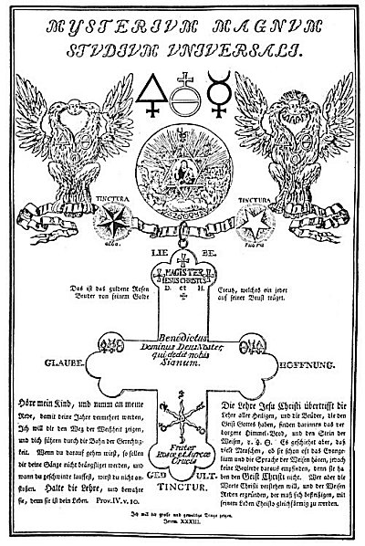
THE GOLDEN AND ROSY CROSS.
From Geheime Figuren der Rosenkreuzer.
It is said of this cross that it is made of spiritual gold and that each Brother wears it upon his breast. It bears the alchemical symbols of salt, sulphur, and mercury; also a star of the planets; and around it are the four words FAITH, HOPE, LOVE, and PATIENCE. The double-headed eagle, or Phœnix, subtly foreshadows the ultimate androgynous state of the human creature. Rosicrucian alchemy was not concerned with metals alone. Man's own body was the alchemical laboratory, and none could reach Rosicrucian adeptship until he had performed the supreme experiment of transmutation by changing the base metals of ignorance into the pure gold of wisdom and understanding.

Having completed a newer and larger building, which they called the "House of the Holy Spirit," they decided to include four new members in the Fraternity, thus increasing the number to eight, seven of whom were German. All were unmarried. Working industriously together, they speedily completed the arduous labor of preparing the documents, instructions, and arcana of the Order. They also put the house called "Sancti Spiritus" in order.
They then decided to separate and visit the other countries of the earth, not only that their wisdom might be given to others who deserved it but also that they might check and correct any mistakes existing in their own system. Before separating, the Brethren prepared six rules, or by-laws, and each bound himself to obey them. The first rule was that they should take to themselves no other dignity or credit than that they were willing to heal the sick without charge. The second was that from that time on forever they should wear no special robe or garment, but should dress according to the custom of the country wherein they dwelt. The third stated that every year upon a certain day they should meet in the "House of the Holy Spirit," or, if unable to do so, should be represented by an epistle. The fourth decreed that each member should search for a worthy person to succeed him at his own demise. The fifth stated that the letters "R.C." should be their seal, mark, and character from that time onward. The sixth specified that the Fraternity should remain unknown to the world for a period of one hundred years.
After they had sworn to this code five of the Brothers departed to distant lands, and a year later two of the others also went their way, leaving Father C.R. C. alone in the "House of the Holy Spirit." Year after year they met with great joy, for they had quietly and sincerely promulgated their doctrines among the wise of the earth.
When the first of the Order died in England, it was decided that the burial places of the members should be secret. Soon afterward Father C.R.C. called the remaining six together, and it is supposed that then he prepared his own symbolic tomb. The Fama records that none of the Brothers alive at the time of its writing knew when Father C.R.C. died or where he was buried. His body was accidentally discovered 120 years after his death when one of the Brothers, who possessed considerable architectural skill, decided to make some alterations in the "House of the Holy Spirit." [It is only suspected that the tomb was in this building.]
While making his alterations, the Brother discovered a memorial tablet upon which were inscribed the names of the early members of the Order. This he decided to transfer to a more imposing chapel, for at that time no one knew in what country Father C.R.C. had died, this information having been concealed by the original members. In attempting to remove the memorial tablet, which was held in place by a large nail, some stones and plastering were broken from the wall, disclosing a door concealed in the masonry. The members of the Order immediately cleared away the rest of the débris and uncovered the entrance to a vault. Upon the door in large letters were the words: POST CXX ANNOS PATEBO. This, according to the mystic interpretation of the Brethren, meant, "In 120 years I shall come forth."
The following morning the door was opened and the members entered a vault with seven sides and seven corners, each side five feet broad and eight feet high. Although the sun never penetrated this tomb, it was brilliantly illuminated by a mysterious light in the ceiling. In the center was a circular altar, upon which were brass plates engraved with strange characters. In each of the seven sides was a small door which, upon being opened, revealed a number of boxes filled with books, secret instructions, and the supposedly lost arcanum of the Fraternity.
Upon moving the altar to one side a brass cover was disclosed. Lifting this revealed a body, presumedly that of C.R.C., which, although it had lain there 120 years, was as well preserved as though it had just been interred. It was ornamented and attired in the robes of the Order, and in one hand was clasped a mysterious parchment which, next to the Bible, was the most valued possession of the Society. After thoroughly investigating the contents of the secret chamber, the brass plate and altar were put back in place, the door of the vault was again sealed, and the Brothers went their respective ways, their spirits raised and their faith increased by the miraculous spectacle which they had beheld.
The document ends by saying in effect, "In accordance with the will of Father C.R.C., the Fama has been prepared and sent forth to the wise and learned of all Europe in five languages, that all may know and understand the secrets of the august Fraternity. All of sincere soul who labor for the glory of God are invited to communicate with the Brethren and are promised that their appeal shall be heard, regardless of where they are or how the messages are sent. At the same time, those of selfish and ulterior motives are warned that only sorrow and misery will attend any who attempt to discover the Fraternity without a clean heart and a pure mind."
Such, in brief, is the story of the Fama Fraternitatis. Those who accept it literally regard Father C.R.C. as the actual founder of the Brotherhood, which he is believed to have organized about 1400. The fact that historical corroboration of the important points of the Fama has never been discovered is held against this theory. There is no proof that Father C.R.C. ever approached the learned men of Spain. The mysterious city of Damcar cannot be found, and there is no record that anywhere in Germany there existed a place where great numbers of the halt and sick came and were mysteriously healed. A. E. Waite's The Secret Tradition in Freemasonry contains a picture of Father C.R.C. showing him with a long beard upon his breast, sitting before a table upon which burns a candle. One hand is supporting his head and the other is resting the tip of its index finger on the temple of a human skull. The picture, however (see plate at head of chapter), proves nothing. Father C.R.C. was never seen by other than members of his own Order, and they did not preserve a description of him. That his name was Christian Rosencreutz is most improbable, as the two were not even associated until the writing of the Chymical Nuptials.

THE SECOND POSTULATE
Those Masonic brethren who have investigated the subject accept the historical existence of the "Brotherhood of the Rose Cross" but are divided concerning the origin of the Order. One group holds the society originated in mediæval Europe as an outgrowth of alchemical speculation. Robert Macoy, 33°, believes that Johann Valentin Andreæ, a German theologian, was the true founder, and he also believes it possible that this divine merely reformed and amplified an existing society which had been founded by Sir Henry Cornelius Agrippa. Some believe that Rosicrucianism represented the first European invasion of Buddhist and Brahmin culture. Still others hold the opinion that the "Society of the Rose Cross" was founded in Egypt during n the philosophic supremacy of that empire, and that it also perpetuated the Mysteries of ancient Persia and Chaldea.
In his Anacalypsis, Godfrey Higgins writes: "The Rosicrucians of Germany are quite ignorant of their origin; but, by tradition, they suppose themselves descendants of the ancient Egyptians, Chaldeans, Magi, and Gymnosophists." (The last was a name given by the followers of Alexander the Great to a caste of naked Wise Men whom they found meditating along the river banks in India.) The consensus among these factions is that the story of Father C.R.C., like the Masonic legend of Hiram Abiff, is an allegory and should not be considered literally. A similar problem has confronted students of the Bible, who have found not only difficult, but in the majority of cases impossible, their efforts to substantiate the historical interpretation of the Scriptures.
Admitting the existence of the Rosicrucians as a secret society with both philosophic and political ends, it is remarkable that an organization with members in all parts of Europe could maintain absolute secrecy throughout the centuries. Nevertheless, the "Brothers of the Rose Cross" were apparently able to accomplish this. A great number of scholars and philosophers, among them Sir Francis Bacon and Wolfgang von Goethe, have been suspected of affiliation with the Order, but their connection has not been established to the satisfaction of prosaic historians. Pseudo-Rosicrucians abounded, but the true members of the "Ancient and Secret Order of The Unknown Philosophers" have successfully lived up to their name; to this day they remain unknown.
During the Middle Ages a number of tracts appeared, purporting to be from the pens of Rosicrucians. Many of them, however, were spurious, being issued for their self-aggrandizement by unscrupulous persons who used the revered and magic name Rosicrucian in the hope of gaining religious or political power. This has greatly complicated the work of investigating the Society. One group of pseudo-Rosicrucians went so far as to supply its members with a black cord by which they were to know each other, and warned them that if they broke their vow of secrecy the cord would be used to strangle them. Few of the principles of Rosicrucianism have been preserved in literature, for the original Fraternity published only fragmentary accounts of its principles and activities.

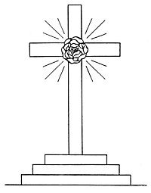
THE CRUCIFIED ROSE.
The original symbol of the Rosicrucian Fraternity was a hieroglyphic rose crucified upon a cross. The cross was often raised upon a three-stepped Calvary. Occasionally the symbol of a cross rising from a rose was used in connection with their activities. The Rosicrucian rose was drawn upon the Round Table of King Arthur, and is the central motif for the links forming the chain from which the "Great George" is suspended among the jewels of The Order of the Garter. Hargrave Jennings suspects this Order of having some connection with the Rosicrucians.

In his Secret Symbols of the Rosicrucians, Dr. Franz Hartmann describes the Fraternity as "A secret society of men possessing superhuman--if not supernatural--powers; they were said to be able to prophesy future events, to penetrate into the deepest mysteries of Nature, to transform Iron, Copper, Lead, or Mercury into Gold, to prepare an Elixir of Life, or Universal Panacea, by the use of which they could preserve their youth and manhood; and moreover it was believed that they could command the Elemental Spirits of Nature, and knew the secret of the Philosopher's Stone, a substance which rendered him who possessed it all-powerful, immortal, and supremely wise."
The same author further defines a Rosicrucian as "A person who by the process of spiritual awakening has attained a practical knowledge of the secret significance of the Rose and the Cross. * * * To call a person a Rosicrucian does not make him one, nor does the act of calling a person a Christian make him a Christ. The real Rosicrucian or Mason cannot be made; he must grow to be one by the expansion and unfoldment of the divine power within his own heart. The inattention to this truth is the cause that many churches and secret societies are far from being that which their names express."
The symbolic principles of Rosicrucianism are so profound that even today they are little appreciated. Their charts and diagrams are concerned with weighty cosmic principles which they treat with a philosophic understanding decidedly refreshing when compared with the orthodox narrowness prevalent in their day. According to the available records, the Rosicrucians were bound together by mutual aspirations rather than by the laws of a fraternity. The "Brothers of the Rose Cross" are believed to have lived unobtrusively, laboring industriously in trades and professions, disclosing their secret affiliation to no one--in many cases not even to their own families. After the death of C.R.C., most of the Brethren apparently had no central meeting place. Whatever initiatory ritual the Order possessed was so closely guarded that it has never been revealed. Doubtless it was couched in chemical terminology.
Efforts to join the Order were apparently futile, for the Rosicrucians always chose their disciples. Having agreed on one who they believed would do honor to their illustrious fraternity, they communicated with him in one of many mysterious ways. He might receive a letter, either anonymous or with a peculiar seal, usually bearing the letters "C.R.C. "or "R.C. "upon it. He would be instructed to go to a certain place at an appointed time. What was disclosed to him he never revealed, although in many cases his later writings showed that a new influence had come into his life, deepening his understanding and broadening his intellect. A few have written allegorically concerning what they beheld when in the august presence of the "Brethren of the Rose Cross."
Alchemists were sometimes visited in their laboratories by mysterious strangers, who delivered learned discourses concerning the secret processes of the Hermetic arts and, after disclosing certain processes, departed, leaving no trace. Others declared that the "Brothers of the Rose Cross" communicated with them through dreams and visions, revealing the secrets of Hermetic wisdom to them while they were asleep. Having been instructed, the candidate was bound to secrecy not only concerning the chemical formulæ which had been disclosed to him but also concerning the method by which he had secured them. While these nameless adepts were suspected of being ''Brothers of the Rose Cross," it could never be proved who they were, and those visited could only conjecture.
Many suspect the Rosicrucian rose to be a conventionalization of the Egyptian and Hindu lotus blossom, with the same symbolic meaning as this more ancient symbol. The Divine Comedy stamps Dante Alighieri as being familiar with the theory of Rosicrucianism. Concerning this point, Albert Pike in his Morals and Dogma makes this significant statement: "His Hell is but a negative Purgatory. His heaven is composed of a series of Kabalistic circles, divided by a cross, like the Pantacle of Ezekiel. In the center of this cross blooms a rose, and we see the symbol of the Adepts of the Rose-Croix for the first time publicly expounded and almost categorically explained."
Doubt has always existed as to whether the name Rosicrucian came from the symbol of the rose and cross, or whether this was merely a blind to deceive the uninformed and further conceal the true meaning of the Order. Godfrey Higgins believes that the word Rosicrucian is not derived from the flower but from the word Ros, which means dew. It is also interesting to note that the word Ras means wisdom, while Rus is translated concealment. Doubtless all of these meanings have contributed to Rosicrucian symbolism.
A. E. Waite holds with Godfrey Higgins that the process of forming the Philosopher's Stone with the aid of dew is the secret concealed within the name Rosicrucian. It is possible that the dew referred to is a mysterious substance within the human brain, closely resembling the description given by alchemists of the dew which, falling from heaven, redeemed the earth. The cross is symbolic of the human body, and the two symbols together--the rose on the cross--signify that the soul of man is crucified upon the body, where it is held by three nails.
It is probable that Rosicrucian symbolism is a perpetuation of the secret tenets of the Egyptian Hermes, and that the Society of Unknown Philosophers is the true link connecting modern Masonry, with its mass of symbols, to ancient Egyptian Hermeticism, the source of that symbolism. In his Doctrine and Literature of the Kabalah, A. E. Waite makes this important observation: "There are certain indications which point to a possible connection between Masonry and Rosicrucianism, and this, if admitted, would constitute the first link in its connection with the past. The evidence is, however, inconclusive, or at least unextricated. Freemasonry per se, in spite of the affinity with mysticism which I have just mentioned, has never exhibited any mystic character, nor has it a clear notion how it came by its symbols."
Many of those connected with the development of Freemasonry were suspected of being Rosicrucians; some, as in the case of Robert Fludd, even wrote defenses of this organization. Frank C. Higgins, a modern Masonic symbolist, writes: "Doctor Ashmole, a member of this fraternity [Rosicrucian], is revered by Masons as one of the founders of the first Grand Lodge in London." (See Ancient Freemasonry.) Elias Ashmole is but one of many intellectual links connecting Rosicrucianism with the genesis of Freemasonry. The Encyclopædia Britannica notes that Elias Ashmole was initiated into the Freemasonic Order in 1646, and further states that he was "the first gentleman, or amateur, to be 'accepted'."
On this same subject, Papus, in his Tarot of the Bohemians, has written: "We must not forger that the Rosicrucians were the Initiators of Leibnitz, and the founders of actual Freemasonry through Ashmole." If the founders of Freemasonry were initiated into the Great Arcanum of Egypt--and the symbolism of modern Masonry would indicate that such was the case--then it is reasonable to suppose that they secured their information from a society whose existence they admitted and which was duly qualified to teach them these symbols and allegories.
One theory concerning the two Orders is to the effect that Freemasonry was an outgrowth of Rosicrucianism; in other words, that the "Unknown Philosophers" became known through an organization which they created to serve them in the material world. The story goes on to relate that the Rosicrucian adepts became dissatisfied with their progeny and silently withdrew from the Masonic hierarchy, leaving behind their symbolism and allegories, but carrying away the keys by which the locked symbols could be made to give tip their secret meanings. Speculators have gone so far as to state that, in their opinion, modern Freemasonry has completely absorbed Rosicrucianism and succeeded it as the world's greatest secret society. Other minds of equal learning declare that the Rosicrucian Brotherhood still exists, preserving its individuality as the result of having withdrawn from the Masonic Order.
According to a widely accepted tradition, the headquarters of the Rosicrucian Order is near Carlsbad, in Austria (see Doctor Franz Hartmann). Another version has it that a mysterious school, resembling in general principles the Rosicrucian Fraternity, which calls itself "The Bohemian Brothers," still maintains its individuality in the Schwarzwald (Black Forest) of Germany. One thing is certain: with the rise of Freemasonry, the Rosicrucian Order in Europe practically disappeared, and notwithstanding existing statements to the contrary, it is certain that the 18th degree (commonly known as the Rose-Croix) perpetuates many of the symbols of the Rosicrucian Fire Alchemists.
In an anonymous unpublished manuscript of the eighteenth century bearing the earmarks of Rosicrucian Qabbalism appears this statement: "Yet will I now give the over-wise world a paradox to be solved, namely, that some illuminated men have undertaken to found Schools of Wisdom in Europe and these for some peculiar reason have called themselves Fratres Rosa: Crucis. But soon afterwards came false schools into existence and corrupted the good intentions of these wise men. Therefore, the Order no longer exists as most people would understand existence, and as this Fraternity of the Seculo Fili call themselves Brothers of the Rosie Cross, so also will they in the Seculo Spiritus Sancti call themselves Brothers of the Lily Cross and the Knights of the White Lion. Then will the Schools of Wisdom begin again to blossom, but why the first one chose their name and why the others shall also choose theirs, only those can solve who have understanding grounded in Nature."

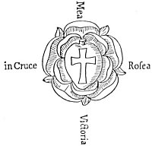
THE ROSICRUCIAN ROSE.
From Geheime Figuren der Rosenkreuzer.
The rose is a yonic symbol associated with generation, fecundity, and purity. The fact that flowers blossom by unfolding has caused them to be chosen as symbolic of spiritual unfoldment. The red color of the rose refers to the blood of Christ, and the golden heart concealed within the midst of the flower corresponds to the spiritual gold concealed within the human nature. The number of its petals being ten is also a subtle reminder of the perfect Pythagorean number. The rose symbolizes the heart, and the heart has always been accepted by Christians as emblematic of the virtues of love and compassion, as well as of the nature of Christ--the personification of these virtues. The rose as a religious emblem is of great antiquity. It was accepted by the Greeks as the symbol of the sunrise, or of the coming of dawn. In his Metamorphosis, or Golden Ass, Apuleius, turned into a donkey because of his foolishness, regained his human shape by eating a sacred rose given to him by the Egyptian priests.
The presence of a hieroglyphic rose upon the escutcheon of Martin Luther has been the basis of much speculation as to whether any connection existed between his Reformation and the secret activities of the Rose Cross.

Political aspirations of the Rosicrucians were expressed through the activities of Sir Francis Bacon, the Comte de St.-Germain, and the Comte di Cagliostro. The last named is suspected of having been an emissary of the Knights Templars, a society deeply involved in transcendentalism, as Eliphas Levi has noted. There is a popular supposition to the effect that the Rosicrucians were at least partial instigators of the French Revolution. (Note particularly the introduction to Lord Bulwer-Lytton's Rosicrucian novel Zanoni.)

THE THIRD POSTULATE
The third theory takes the form of a sweeping denial of Rosicrucianism, asserting that the so-called original Order never had any foundation in fact but was entirely a product of imagination. This viewpoint is best expressed by a number of questions which are still being asked by investigators of this elusive group of metaphysicians. Was the "Brotherhood of the Rose Cross" merely a mythical institution created in the fertile mind of some literary cynic for the purpose of deriding the alchemical and Hermetic sciences? Did the "House of the Holy Spirit" ever exist outside the imagination of some mediæval mystic? Was the whole Rosicrucian story a satire to ridicule the gullibility of scholastic Europe? Was the mysterious Father C.R.C. a product of the literary genius of Johann Valentin Andreæ, or another of similar mind, who, attempting to score alchemical and Hermetic philosophy, unwittingly became a great power in furthering the cause of its promulgation? That at least one of the early documents of the Rosicrucians was from the pen of Andreæ there is little doubt, but for just what purpose he compiled it still remains a matter of speculation. Did Andreæ himself receive from some unknown person, or persons, instructions to be carried out? If he wrote the Chymical Nuptials of Christian Rosencreutz when only fifteen years old, was he overshadowed in the preparation of that book?
To these vital questions no answers are forthcoming. A number of persons accepted the magnificent imposture of Andreæ as absolute truth. It is maintained by many that, as a consequence, numerous pseudo-societies sprang up, each asserting that it was the organization concerning which the Fama Fraternitatis and the Confessio Fraternitatis were written. Beyond doubt there are many spurious orders in existence today; but few of them can offer valid claims that their history dates back farther than the beginning of the nineteenth century.
The mystery associated with the Rosicrucian Fraternity has resulted in endless controversy. Many able minds, notable among them Eugenius Philalethes, Michael Maier, John Heydon, and Robert Fludd, defended the concrete existence of "The Society of Unknown Philosophers." Others equally qualified have asserted it to be of fraudulent origin and doubtful existence. Eugenius Philalethes, while dedicating books to the Order, and himself writing an extended exposition of its principles, disclaims all personal connection with it. Many others have done likewise.
Some are of the opinion that Sir Francis Bacon had a hand in the writing of the Fama and Confessio Fraternitatis, on the basis that the rhetorical style of these works is similar to that of Bacon's New Atlantis. They also contend that certain statements in the latter work point to an acquaintance with Rosicrucian symbology. The elusiveness of the Rosicrucians has caused them to be favorite subject's for literary works. Outstanding among the romances which have been woven around them is Zanoni. The author, Lord Bulwer-Lytton, is regarded by some as a member of the Order, while others assert that he applied for membership but was rejected. Pope's Rape of the Lock, &c. Comte de Gabalis by Abbé de Villars, and essays by De Quincy, Hartmann, Jennings, Mackenzie, and others, are examples of Rosicrucian literature. Although the existence of these mediæval Rosicrucians is difficult to prove, sufficient evidence is at hand to make it extremely probable that there existed in Germany, and afterwards in France, Italy, England, and other European countries, a secret society of illuminated savants who made contributions of great import to the sum of human knowledge, while maintaining absolute secrecy concerning their personalities and their organization.

THE FOURTH POSTULATE
The apparent incongruities of the Rosicrucian controversy have also been accounted for by a purely transcendental explanation. There is evidence that early writers were acquainted with such a supposition--which, however, was popularized only after it had been espoused by Theosophy. This theory asserts that the Rosicrucians actually possessed all the supernatural powers with which they were credited; that they were in reality citizens of two worlds: that, while they had physical bodies for expression on the material plane, they were also capable, through the instructions they received from the Brotherhood, of functioning in a mysterious ethereal body not subject to the limitations of time or distance. By means of this "astral form" they were able to function in the invisible realm of Nature, and in this realm, beyond reach of the profane, their temple was located.
According to this viewpoint, the true Rosicrucian Brotherhood consisted of a limited number of highly developed adepts, or initiates, those of the higher degrees being no longer subject to the laws of mortality; candidates were accepted into the Order only after long periods of probation; adepts possessed the secret of the Philosopher's Stone and knew the process of transmuting the base metals into gold, but taught that these were only allegorical terms concealing the true mystery of human regeneration through the transmutation of the "base elements" of man's lower nature into the "gold" of intellectual and spiritual realization. According to this theory, those who have sought to record the events of importance in connection with the Rosicrucian controversy have invariably failed because they approached their subject from a purely physical or materialistic angle.
These adepts were believed to have been able to teach man how to function away from his physical body at will by assisting him to remove the "rose from the cross." They taught that the spiritual nature was attached to the material form at certain points, symbolized by the "nails" of the crucifixion; but by three alchemical initiations which took place in the spiritual world, in the true Temple of the Rose Cross, they were able to "draw" these nails and permit the divine nature of man to come down from its cross. They concealed the processes by which this was accomplished under three alchemical metaphoric expressions: "The Casting of the Molten Sea," "The Making of the Rose Diamond," and "The Achieving of the Philosopher's Stone."
While the intellectualist flounders among contradictory theories, the mystic treats the problem in an entirely different manner. He believes that the true Rosicrucian Fraternity, consisting of a school of supermen (not unlike the fabled Mahatmas of India), is an institution existing not in the visible world bur in its spiritual counterpart, which he sees fit to call the "inner planes of Nature"; that the Brothers can be reached only by those who are capable of transcending the limitations of the material world. To substantiate their viewpoint, these mystics cite the following significant statement from the Confessio Fraternitatis: "A thousand times the unworthy may clamour, a thousand times may present themselves, yet God hath commanded our ears that they should hear none of them, and hath so compassed us about with His clouds that unto us, His servants, no violence can be done; wherefore now no longer are we beheld by human eyes, unless they have received strength borrowed from the eagle." In mysticism the eagle is a symbol of initiation (the spinal Spirit Fire), and by this is explained the inability of the unregenerated world to understand the Secret Order of the Rose Cross.
Those professing this theory regard the Comte de St.-Germain as their highest adept and assert that he and Christian Rosencreutz were one and the same individual. They accept fire as their universal symbol because it was the one element by means of which they could control the metals. They declared themselves the descendants of Tubal-cain and Hiram Abiff, and that the purpose of their existence was to preserve the spiritual nature of man through ages of materiality. "The Gnostic sects, the Arabs, Alchemists, Templars, Rosicrucians, and lastly the Freemasons, form the Western chain in the transmission of occult science." (See The Tarot of the Bohemians translated by A. E. Waite from the French of Papus.)
Max Heindel, the Christian mystic, described the Rosicrucian Temple as an "etheric structure" located in and around the home of a European country gentleman. He believed that this invisible building would ultimately be moved to the American continent. Mr. Heindel referred to the Rosicrucian Initiates as so advanced in the science of life that "death had forgotten them."
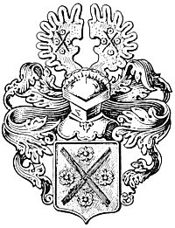
THE CREST OF JOHANN VALENTIN ANDREÆ.
From Chymische Hochzeit.
The reference to four red roses and a white cross in the Chymical Marriage of Christian Rosencreutz identified Johann Valentin Andreæ as its author, for his family crest, shown above, consisted of four red roses and a white cross.

===================================================================================================================================================

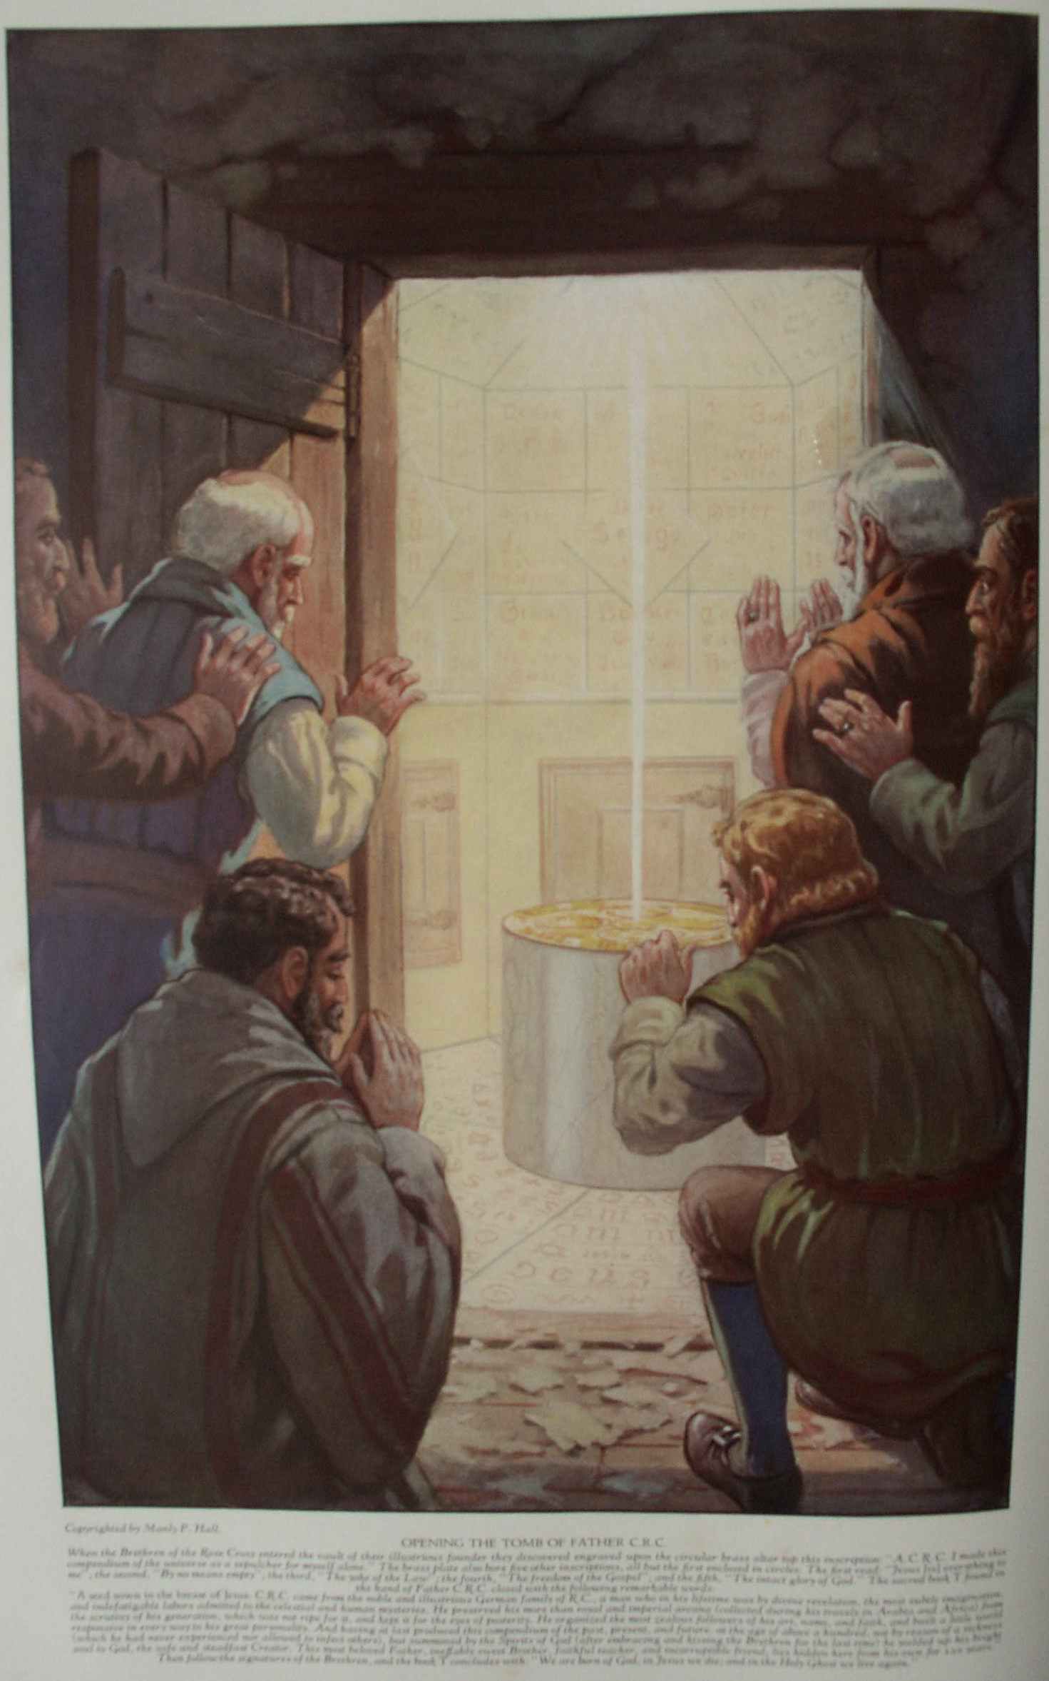

Rosicrucian Doctrines and Tenets

TRUSTWORTHY information is unavailable concerning the actual philosophical beliefs, political aspirations, and humanitarian activities of the Rosicrucian Fraternity. Today, as of old, the mysteries of the Society are preserved inviolate by virtue of their essential nature; and attempts to interpret Rosicrucian philosophy are but speculations, anything to the contrary notwithstanding.
Evidence points to the probable existence of two distinct Rosicrucian bodies: an inner organization whose members never revealed their identity or teachings to the world, and an outer body under the supervision of the inner group. In all probability, the symbolic tomb of Christian Rosencreutz, Knight of the Golden Stone, was in reality this outer body, the spirit of which is in a more exalted sphere. For a period of more than a century subsequent to 1614, the outer body circulated tracts and manifestoes under either its own name or the names of various initiated members. The purpose of these writings was apparently to confuse and mislead investigators, and thus effectively to conceal the actual designs of the Fraternity.
When Rosicrucianism became the philosophical "fad" of the seventeenth century, numerous documents on the subject were also circulated for purely commercial purposes by impostors desirous of capitalizing its popularity. The cunningly contrived artifices of the Fraternity itself and the blundering literary impostures of charlatans formed a double veil behind which the inner organization carried on its activities in a manner totally dissimilar to its purposes and principles as publicly disseminated. The Fratres Rosa Crucis naively refer to the misunderstandings which they have for obvious reasons permitted to exist concerning themselves as being "clouds" within which they labor and behind which they are concealed.
An inkling of the substance of Rosicrucianism--its esoteric doctrines--can be gleaned from an analysis of its shadow--its exoteric writings. In one of the most important of their "clouds," the Confessio Fraternitatis, the Brethren of the Fraternity of R.C. seek to justify their existence and explain (?) the purposes and activities of their Order. In its original form the Confessio is divided into fourteen chapters, which are here epitomized.

CONFESSIO FRATERNITATIS R. C. AD ERUDITOS EUROPÆ
Chapter I. Do not through hasty judgment or prejudice misinterpret the statements concerning our Fraternity published in our previous manifesto--the Fama Fraternitatis. Jehovah, beholding the decadence of civilization, seeks to redeem humanity by revealing to the willing and by thrusting upon the reluctant those secrets which previously He had reserved for His elect. By this wisdom the godly shall be saved, but the sorrows of the ungodly shall be multiplied. While the true purpose of our Order was set forth in the Fama Fraternitatis, misunderstandings have arisen through which we have been falsely accused of heresy and treason. In this document we hope so to clarify our position that the learned of Europe will be moved to join with us in the dissemination of divine knowledge according to the will of our illustrious founder.
Chapter II. While it is alleged by many that the philosophic cide (sic. JBH) of our day is sound, we declare it to be false and soon to die of its own inherent weakness. just as Nature, however, provides a remedy for each new disease that manifests itself, so our Fraternity has provided a remedy for the infirmities of the world's philosophic system. The secret philosophy of the R.C. is founded upon that knowledge which is the sum and head of all faculties, sciences, and arts. By our divinely revealed system--which partakes much of theology and medicine but little of jurisprudence--we analyze the heavens and the earth; but mostly we study man himself, within whose nature is concealed the supreme secret. If the learned of out day will accept our invitation and join themselves to our Fraternity, we will reveal to them undreamed-of secrets and wonders concerning the hidden workings of Nature.
Chapter III. Do not believe that the secrets discussed in this brief document are lightly esteemed by us. We cannot describe fully the marvels of our Fraternity lest the uninformed be overwhelmed by our astonishing declarations and the vulgar ridicule the mysteries which they do not comprehend. We also fear that many will be confused by the unexpected generosity of our proclamation, for not understanding the wonders of this sixth age they do nor realize the great changes which are to come. Like blind men living in a world full of light, they discern only through the sense of feeling. [By sight is implied spiritual cognition: by feeling, the material senses.]
Chapter IV. We firmly believe that through deep meditation on the inventions of the human mind and the mysteries of life, through the cooperation of the angels and spirits, and through experience and long observation, our loving Christian Father C.R.C. was so fully illumined with God's wisdom that were all the books and writings of the world lost and the foundations of science overturned, the Fraternity of R.C. could reestablish the structure of world thought upon the foundation of divine truth and integrity. Because of the great depth and perfection of our knowledge, those desiring to understand the mysteries of the Fraternity of R. C. cannot attain to that wisdom immediately, but must grow in understanding and knowledge. Therefore, our Fraternity is divided into grades through which each must ascend step by step to the Great Arcanum. Now that it has pleased God to lighten unto us His sixth candelabrum, is it not better to seek truth in this way than to wander through the labyrinths of worldly ignorance?
Furthermore, those who receive this knowledge shall become masters of all arts and crafts; no secret shall be hidden from them; and all good works of the past, present, and future shall be accessible to them. The whole world shall become as one book and the contradictions of science and theology shall be reconciled. Rejoice, O humanity! for the time has come when God has decreed that the number of our Fraternity shall be increased, a labor that we have joyously undertaken. The doors of wisdom are now open to the world, but only to those who have earned the privilege may the Brothers present themselves, for it is forbidden to reveal our knowledge even to our own children. The right to receive spiritual truth cannot be inherited: it must be evolved within the soul of man himself.
Chapter V. Though we may be accused of indiscretion in offering our treasures so freely and promiscuously--without discriminating between the godly, the wise, the prince, the peasant--we affirm that we have not betrayed our trust; for although we have published our Fama in five languages, only those understand it who have that right. Our Society is not to be discovered by curiosity seekers, but only by serious and consecrated thinkers; nevertheless we have circulated our Fama in five mother tongues so that the righteous of all nations may have an opportunity to know of us, even though they be not scholars. A thousand times the unworthy may present themselves and clamor at the gates, but God has forbidden us of the Fraternity of R.C. to hear their voices, and He has surrounded us with His clouds and His protection so that no harm may come to us, and God has decreed that we of the Order of R.C. can no longer be seen by mortal eyes unless they have received strength borrowed from the eagle. We further affirm that we shall reform the governments of Europe and pattern them according to the system applied by the philosophers of Damcar. All men desirous of securing knowledge shall receive as much as they are capable of understanding. The rule of false theology shall be overthrown and God shall make His will known through His chosen philosophers.

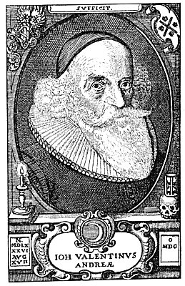
JOHANN VALENTIN ANDREÆ.
From a rare print.
In certain esoteric circles there are vague rumors which intimate that the humble personality of Johann Valentin Andreæ masked an exalted emissary of the Rose Cross. While there is sufficient evidence at hand to establish the actual existence of a German theologian by the name of Andreæ, there are many discrepancies in his biography which have net been cleared up to the satisfaction of critical investigators. A comparison of the face shown above with that of Sir Francis Bacon discloses striking resemblances in spite of the differences due to age. If Lord Bacon borrowed the name and identity of William Shakspere, he could also assume, after his mock funeral in England, the personality of Johann Valentin Andreæ. The crescent below the bust is significant, as it also appears upon the crest of Lord Bacon; to denote that he was the second son of Sir Nicholas Bacon. Further, the four letters (O MDC) in the frame at the lower right corner of the plate, by a very simple Baconian cipher, can be changed into number whose sum gives 33--the numerical equivalent of the name Bacon. These several points of interest, when considered together, go far towards clearing up the mystery surrounding the authorship of the first Rosicrucian manifestoes.

Chapter VII. Because of the need of brevity, it is enough to say that our Father C.R.C. was born in the year 1378 and departed at the age of 106, leaving to us the labor of spreading die doctrine of philosophic religion to the entire world. Our Fraternity is open to all who sincerely seek for truth; but we publicly warn the false and impious that they cannot betray or injure us, for God has protected our Fraternity, and all who seek to do it harm shall have their evil designs return and destroy them, while the treasures of our Fraternity shall remain untouched, to be used by the Lion in the establishment of his kingdom.
Chapter VII. We declare that God, before the end of the world, shall create a great flood of spiritual light to alleviate the sufferings of humankind. Falsehood and darkness which have crept into the arts, sciences, religions, and governments of humanity--making it difficult for even the wise to discover the path of reality--shall be forever removed and a single standard established, so that all may enjoy the fruitage of truth. We shall not be recognized as those responsible for this change, for people shall say that it is the result of the progressiveness of the age. Great are the reforms about to take place; but we of the Fraternity of R.C. do not arrogate to ourselves the glory for this divine reformation, since many there are, not members of our Fraternity but honest, true and wise men, who by their intelligence and their writings shall hasten its coming. We testify that sooner the stones shall rise up and offer their services than that there shall be any lack of righteous persons to execute the will of God upon earth.
Chapter VIII. That no one may doubt, we declare that God has sent messengers and signs in the heavens, namely, the i new stars in Serpentarius and Cygnus, to show that a great Council of the Elect is to take place. This proves that God reveals in visible nature--for the discerning few--signs and symbols of all things that are coming to pass. God has given man two eyes, two nostrils, and two ears, but only one tongue. Whereas the eyes, the nostrils, and the ears admit the wisdom of Nature into the mind, the tongue alone may give it forth. In various ages there have been illumined ones who have seen, smelt, tasted, or heard the will of God, but it will shortly come to pass that those who have seen, smelt, tasted, or heard shall speak, and truth shall be revealed. Before this revelation of righteousness is possible, however, the world must sleep away the intoxication of her poisoned chalice (filled with the false life of the theological vine) and, opening her heart to virtue and understanding, welcome the rising sun of Truth.
Chapter IX. We have a magic writing, copied from that divine alphabet with which God writes His will upon the face of celestial and terrestrial Nature. With this new language we read God's will for all His creatures, and just as astronomers predict eclipses so we prognosticate the obscurations of the church and how long they shall last. Our language is like unto that of Adam and Enoch before the Fall, and though we understand and can explain our mysteries in this our sacred language, we cannot do so in Latin, a tongue contaminated by the confusion of Babylon.
Chapter X. Although there are still certain powerful persons who oppose and hinder us--because of which we must remain concealed--we exhort those who would become of our Fraternity to study unceasingly the Sacred Scriptures, for such as do this cannot be far from us. We do not mean that the Bible should be continually in the mouth of man, but that he should search for its true and eternal meaning, which is seldom discovered by theologians, scientists, or mathematicians because they are blinded by the opinions of their sects. We bear witness that never since the beginning of the world has there been given to man a more excellent book than the Holy Bible. Blessed is he who possesses it, more blessed he who reads it, most blessed he who understands it, and most godlike he who obeys it.
Chapter XI. We wish the statements we made in the Fama Fraternitatis concerning the transmutation of metals and the universal medicine to be lightly understood. While we realize that both these works are attainable by man, we fear that many really great minds may be led away from the true quest of knowledge and understanding if they permit themselves to limit their investigation to the transmutation of metals. When to a man is given power to heal disease, to overcome poverty, and to reach a position of worldly dignity, that man is beset by numerous temptations and unless he possess true knowledge and full understanding he will become a terrible menace to mankind. The alchemist who attains to the art of transmuting base metals can do all manner of evil unless his understanding be as great as his self-created wealth. We therefore affirm that man must first gain knowledge, virtue, and understanding; then all other things may be added unto him. We accuse the Christian Church of the great sin of possessing power and using it unwisely; therefore we prophesy that it shall fall by the weight of its own iniquities and its crown shall be brought to naught.
Chapter XII. In concluding our Confessio, we earnestly admonish you to cast aside the worthless books of pseudo-alchemists and philosophers (of whom there are many in our age), who make light of the Holy Trinity and deceive the credulous with meaningless enigmas. One of the greatest of these is a stage player, a man with sufficient ingenuity for imposition. Such men are mingled by the Enemy of human welfare among those who seek to do good, thus making Truth more difficult of discovery. Believe us, Truth is simple and unconcealed, while falsehood is complex, deeply hidden, proud, and its fictitious worldly knowledge, seemingly a glitter with godly luster, is often mistaken for divine wisdom. You that are wise will turn from these false teachings and come to us, who seek not your money but freely offer you our greater treasure. We desire not your goods, but that you should become partakers of our goods. We do not deride parables, but invite you to understand all parables and all secrets. We do not ask you to receive us, but invite you to come unto our kingly houses and palaces, not because of ourselves but because we are so ordered by the Spirit of God, the desire of our most excellent Father C.R.C., and the need of the present moment, which is very great.

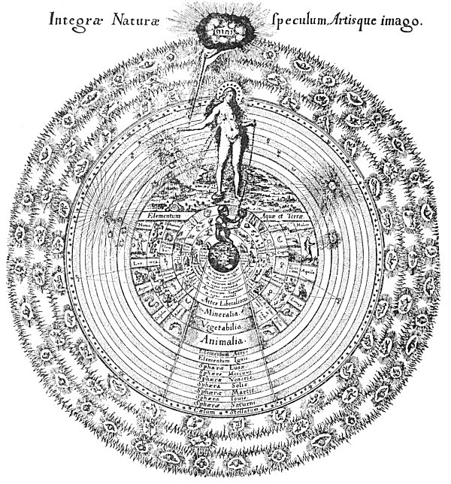
A SYMBOLIC DIAGRAM OF THE OPERATIONS OF NATURE.
From Fludd's Collectio Operum.
This plate, engraved by de Bry, is the most famous of the diagrams illustrating the philosophic principles of Robert Fludd (Robertus de Fluctibus). Three figures are outstanding links between Rosicrucianism and Freemasonry: Michael Maier, Elias Ashmole, and Robert Fludd. De Quincey considers Robert Fludd to be the immediate father of Freemasonry. (See The Rosicrucians and Freemasons.) Edward Waite considers Robert Fludd as second to none of the disciples of Paracelsus, even going as far as to declare that Fludd far surpassed his master. He further adds, "The central figure of Rosicrucian literature, towering as an intellectual giant above the crowd of souffleurs, theosophists, and charlatanic Professors of the magnum opus, who, directly or otherwise, were connected with the mysterious Brotherhood, is Robertus de Fluctibus, the great English mystical philosopher of the seventeenth century, a man of immense erudition, of exalted mind, and, to judge by his writings, of extreme personal sanctity. " (See The Real History of the Rosicrucians.) Robert Fludd was born in 1574 and died in 1637.
The de Bry diagram shown above is almost self-explanatory. Outside the circle of the starry heavens are the three fiery rings of the empyreum--the triple fire of the Supreme Creator--in which dwell the celestial creatures. Within he, of the stars are the circles of the planets and elements. After the element of air comes the circle of the world (earth). The circle of animals is followed by the circle of plants, which, in turn is followed by the circle of he minerals. Then come various industries and in the center is a terrestrial globe with an ape-man sitting upon it, measuring a sphere with a pair of compasses. This little figure represents the animal creation. In the outer ring of fire, above is the sacred name of Jehovah surrounded by clouds. From these clouds issues a hand holding a chain. Between the divine sphere and the lower world personified by the ape is the figure of a woman. It is to be specially noted that the female figure is merely holding the chain connecting her with the lower world, but the chain connecting her with the higher world ends in a shackle about her wrist. This female figure is capable of several interpretations: she may represent humanity suspended between divinity and the beast; she may represent Nature as the link between God and the lower world; or she may represent the human soul--the common denominator between the superior and the inferior.

Chapter XIII. Now that we have made our position clear that we sincerely confess Christ; disavow the Papacy; devote our lives to true philosophy and worthy living; and daily invite and admit into our Fraternity the worthy of all nations, who thereafter share with us the Light of God: will you not join yourselves with us to the perfection of yourselves, the development of all the arts, and the service of the world? If you will take this step, the treasures of every part of the earth shall be at one time given unto you, and the darkness which envelopes human knowledge and which results in the vanities of material arts and sciences shall be forever dispelled.
Chapter XIV. Again we warn those who are dazzled by the glitter of gold or those who, now upright, might be turned by great riches to a life of idleness and pomp, not to disturb our sacred silence with their clamorings; for though there be a medicine which will cure all diseases and give unto all men wisdom, yet it is against the will of God that men should attain to understanding by any means other than virtue, labor, and integrity. We are not permitted to manifest ourselves to any man except it be by the will of God. Those who believe that they can partake of our spiritual wealth against the will of God or without His sanction will find that they shall sooner lose their lives in seeking us than attain happiness by finding us.

FRATERNITAS R.C.
Johann Valentin Andreæ is generally reputed to be the author of the Confessio. It is a much-mooted question, however, whether Andreæ did not permit his name to be used as a pseudonym by Sir Francis Bacon. Apropos of this subject are two extremely significant references occurring in the introduction to that remarkable potpourri, The Anatomy of Melancholy. This volume first appeared in 1621 from the pen of Democritus junior, who was afterwards identified as Robert Burton, who, in turn, was a suspected intimate of Sir Francis Bacon. One reference archly suggests that at the time of publishing The Anatomy of Melancholy in 1621 the founder of the Fraternity of R.C. was still alive. This statement--concealed from general recognition by its textual involvement--has escaped the notice of most students of Rosicrucianism. In the same work there also appears a short footnote of stupendous import. It contains merely the words: "Job. Valent. Andreas, Lord Verulam." This single line definitely relates Johann Valentin Andreæ to Sir Francis Bacon, who was Lord Verulam, and by its punctuation intimates that they are one and the same individual.
Prominent among Rosicrucian apologists was John Heydon, who inscribes himself "A Servant of God, and a Secretary of Nature." In his curious work, The Rosie Cross Uncovered, he gives an enigmatic but valuable description of the Fraternity of R.C. in the following language:
"Now there are a kind of men, as they themselves report, named Rosie Crucians, a divine fraternity that inhabit the suburbs of heaven, and these are the officers of the Generalissimo of the world, that are as the eyes and ears of the great King, seeing and hearing all things: they say these Rosie Crucians are seraphically illuminated, as Moses was, according to this order of the elements, earth refin'd to water, water to air, air to fire." He further declares that these mysterious Brethren possessed polymorphous powers, appearing in any desired form at will. In the preface of the same work, he enumerates the strange powers of the Rosicrucian adepts:
"I shall here tell you what Rosie Crucians are, and that Moses was their Father, and he was Θεοῦ παῖς; some say they were of the order of Elias, some say the Disciples of Ezekiel; * * * For it should seem Rosie Crucians were not only initiated into the Mosaical Theory, but have arrived also to the power of working miracles, as Moses, Elias, Ezekiel, and the succeeding Prophets did, as being transported where they please, as Habakkuk was from Jewry to Babylon, or as Philip, after he had baptized the Eunuch to Azorus, and one of these went from me to a friend of mine in Devonshire, and came and brought me an answer to London the some day, which is four days journey; they caught me excellent predictions of Astrology and Earthquakes; they slack the Plague in Cities; they silence the violent Winds and Tempests; they calm the rage of the Sea and Rivers; they walk in the Air, they frustrate the malicious aspects of Witches; they cure all Diseases."
The writings of John Heydon are considered a most important contribution to Rosicrucian literature. John Heydon was probably related to Sir Christopher Heydon, "a Seraphically Illuminated Rosie Crucian, " whom the late F. Leigh Gardner, Hon. Secretary Sec. Ros. in Anglia, believes to have been the source of his Rosicrucian knowledge. In his Bibliotheca Rosicruciana he makes the following statement concerning John Heydon: "On the whole, from the internal evidence of his writings, he appears to have gone through the lower grade of the R. C. Order and to have given out much of this to the world." John Heydon traveled extensively, visiting Arabia, Egypt, Persia, and various parts of Europe, as related in a biographical introduction to his work, The Wise-Mans Crown, Set with Angels, Planets, Metals, etc., or The Glory of the Rosie Cross--a work declared by him to be a translation into English of the mysterious book M brought from Arabia by Christian Rosencreutz.
Thomas Vaughan (Eugenius Philalethes), another champion of the Order, corroborates the statement of John Heydon concerning the ability of the Rosicrucian initiates to make themselves invisible at will: "The Fraternity of R.C. can move in this white mist. 'Whosoever would communicate with us must be able to see in this light, or us he will never see unless by our own will.'"
The Fraternity of R.C. is an august and sovereign body, arbitrarily manipulating the symbols of alchemy, Qabbalism, astrology, and magic to the attainment of its own peculiar purposes, but entirely independent of the cults whose terminology it employs. The three major objects of the Fraternity are:
1. The abolition of all monarchical forms of government and the substitution therefor of the rulership of the philosophic elect. The present democracies are the direct outgrowth of Rosicrucian efforts to liberate the maws from the domination of despotism. In the early part of the eighteenth century the Rosicrucians turned their attention to the new American Colonies, then forming the nucleus of a great nation in the New World. The American War of Independence represents their first great political experiment and resulted in the establishment of a national government founded upon the fundamental principles of divine and natural law. As an imperishable reminder of their sub rosa activities, the Rosicrucians left the Great Seal of the United States. The Rosicrucians were also the instigators of the French Revolution, but in this instance were not wholly successful, owing to the fact that the fanaticism of the revolutionists could not be controlled and the Reign of Terror ensued.

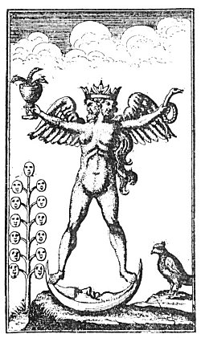
THE ALCHEMICAL ANDROGYNE
From the Turbæ Philosophorum.
The Turbæ Philosophorum is one of the earliest known documents on alchemy in the Latin tongue. Its exact origin is unknown. It is sometimes referred to as The Third Pythagorical Synod. As its name implies, it is an assembly of the sages and sets forth the alchemical viewpoints of many of the early Greek philosophers. The symbol reproduced above is from a rare edition of the Turbæ Philosophorum published in Germany in 1750, and represents by a hermaphroditic figure the accomplishment of the magnum opus. The active and passive principles of Nature were often depicted by male and female figures, and when these two principle, were harmoniously conjoined in any one nature or body it was customary to symbolize this state of perfect equilibrium by the composite figure above shown.
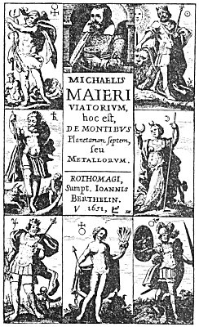
A ROSICRUCIAN TITLE PAGE.
From Maier's Viatorium.
Count Michael Maier, physician to Rudolph II., was an outstanding figure in the Rosicrucian controversy. There is little doubt that he was an initiated member of the Rosicrucian Fraternity, empowered by the Order to promulgate its secrets among the philosophic elect of Europe. The above title page shows the seven planets represented by appropriate figures. Behind the central figure in each case is a smaller emblem, signifying the zodiacal sign in which the planet is enthroned. In the arch over the title itself is a portrait of the learned Maier. The volume of which this is the title page is devoted to an analysis of the nature and effect of the seven planets, and is couched in alchemical terminology throughout. Michael Maier concealed his knowledge so cunningly that it is exceedingly difficult to tract from his writings the secrets which he possessed. He was profuse in his use of emblems and the greater part of his philosophical lore is concealed in the engravings which illustrate his books.

2. The reformation of science, philosophy, and ethics. The Rosicrucians declared that the material arts and sciences were but shadows of the divine wisdom, and that only by penetrating the innermost recesses of Nature could man attain to reality and understanding. Though calling themselves Christians, the Rosicrucians were evidently Platonists and also profoundly versed in the deepest mysteries of early Hebrew and Hindu theology. There is undeniable evidence that the Rosicrucians desired to reestablish the institutions of the ancient Mysteries as the foremost method of instructing humanity in the secret and eternal doctrine. Indeed, being in all probability the perpetuators of the ancient Mysteries, the Rosicrucians were able to maintain themselves against the obliterating forces of dogmatic Christianity only by absolute secrecy and the subtlety of their subterfuges. They so carefully guarded and preserved the Supreme Mystery--the identity and interrelationship of the Three Selves--that no one to whom they did not of their own accord reveal themselves has ever secured any satisfactory information regarding either the existence or the purpose of the Order. The Fraternity of R.C., through its outer organization, is gradually creating an environment or body in which the Illustrious Brother C.R.C. may ultimately incarnate and consummate for humanity the vast spiritual and material labors of the Fraternity.
3. The discovery of the Universal Medicine, or panacea, for all forms of disease. There is ample evidence that the Rosicrucians were successful in their quest for the Elixir of Life. In his Theatrum Chemicum Britannicum, Elias Ashmole states that the Rosicrucians were not appreciated in England, but were welcomed on the Continent. He also states that Queen Elizabeth was twice cured of the smallpox by the Brethren of the Rosy Cross, and that the Earl of Norfolk was healed of leprosy by a Rosicrucian physician. In the quotations that follow it is .hinted by John Heydon that the Brothers of the Fraternity possessed the secret of prolonging human existence indefinitely, but not beyond the time appointed by the will of God:
"And at last they could restore by the same course every Brother that died to life again, and so continue many ages; the rules you find in the fourth book. * * * After this manner began the Fraternity of the Rosie Cross, first by four persons, who died and rose again until Christ, and then they came to worship as the Star guided them to Bethlehem of Judea, where lay our Saviour in his mother's arms; and then they opened their treasure and presented unto him gifts, gold, frankincense, and myrrh, and by the commandment of God went home to their habitation. These four waxing young again successively many hundreds of years, made a magical language and writing, with a large dictionary, which we yet daily use to God's praise and glory, and do find great wisdom therein. * * * Now whilst Brother C.R. was in a proper womb quickening, they concluded to draw and receive yet others more into their Fraternity."
The womb herein referred to was apparently the glass casket, or container, in which the Brothers were buried. This was also called the philosophical egg. After a certain period of time the philosopher, breaking the shell of his egg, came forth and functioned for a prescribed period, after which he retired again into his shell of glass, The Rosicrucian medicine for the healing of all human infirmities may be interpreted either as a chemical substance which produces the physical effects described or as spiritual understanding--the true healing power which, whet a man has partaken of it, reveals truth to him. Ignorance is the worst form of disease, and that: which heals ignorance is therefore the most potent of all medicines. The perfect Rosicrucian medicine was for the healing of nations, races, and individuals.
In an early unpublished manuscript, an unknown philosopher declares alchemy, Qabbalism, astrology, and magic to have been divine sciences originally, but that through perversion they had become false doctrines, leading seekers after wisdom ever farther from their goal. The same author gives a valuable key to esoteric Rosicrucianism by dividing the path of spiritual attainment into three steps, or schools, which he calls mountains. The first and lowest of these mountains is Mount Sophia; the second, Mount Qabbalah; and the third, Mount Magia. These three mountains are sequential stages of spiritual growth. The unknown author then states:
"By philosophy is to be understood the knowledge of the workings of Nature, by which knowledge man learns to climb to those higher mountains above the limitations of sense. By Qabbalism is to be understood the language of the angelic or celestial beings, and he who masters it is able to converse with the messengers of God. On the highest of the mountains is the School of Magia (Divine Magic, which is the language of God) wherein man is taught the true nature of all things by God Himself."
There is a growing conviction that if the true nature of Rosicrucianism were divulged, it would cause consternation, to say the least. Rosicrucian symbols have many meanings, but the Rosicrucian meaning has not yet been revealed. The mount upon which stands the House of the Rosy Cross is still concealed by clouds, in which the Brethren hide both themselves and their secrets. Michael Maier writes: "What is contained in the Fama and Confessio is true. It is a very childish objection that the brotherhood have promised so much and performed so little. With them, as elsewhere, many are called but few are chosen. The masters of the order hold out the rose as the remote prize, but they impose the cross on those who are entering." (See Silentium post Clamores, by Maier, and The Rosicrucians and the Freemasons, by De Quincey.)
The rose and the cross appear upon the stained glass windows of Lichfield Chapter House, where Walter Conrad Arensberg believes Lord Bacon and his mother to have been buried. A crucified rose within a heart is watermarked into the dedication page of the 1628 edition of Robert Burton's Anatomy of Melancholy.
The fundamental symbols of the Rosicrucians were the rose and the cross; the rose female and the cross male, both universal phallic emblems. While such learned gentlemen as Thomas Inman, Hargrave Jennings, and Richard Payne Knight have truly observed that the rose and the cross typify the generative processes, these scholars seem unable to pierce the veil of symbolism; they do not realize that the creative mystery in the material world is merely a shadow of the divine creative mystery in the spiritual world. Because of the phallic significance of their symbols, both the Rosicrucians and the Templars have been falsely accused of practicing obscene rites in their secret ceremonials. While it is quite true that the alchemical retort symbolizes the womb, it also has a far more significant meaning concealed under the allegory of the second birth. As generation is the key to material existence, it is natural that the Fraternity of R.C. should adopt as its characteristic symbols those exemplifying the reproductive processes. As regeneration is the key to spiritual existence, they therefore founded their symbolism upon the rose and the cross, which typify the redemption of man through the union of his lower temporal nature with his higher eternal nature. The rosy cross is also a hieroglyphic figure representing the formula of the Universal Medicine.
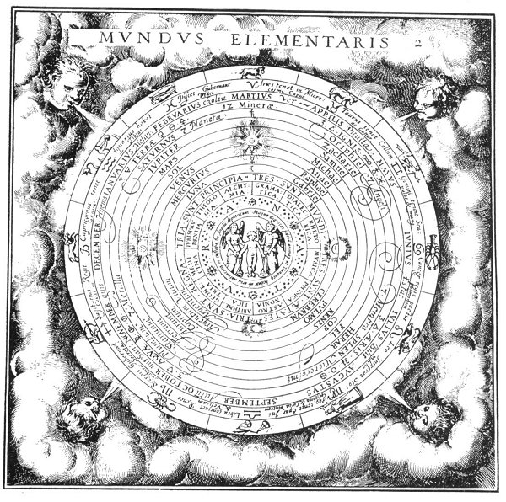
THE ELEMENTARY WORLD.
From Musæum Hermeticum Reformatum et Amplificatum.
The outer circle contains the figures of the Zodiac; the second, their signs and that part of the human body which they rule; the third, the months of the year, with brief notes concerning temperaments, etc. The fourth circle contains the elements accompanied by their appropriate symbols, and the following seven circles mark the orbits of the planets; also the planetary angels, the seven major members of the Universal Man, and the seven metals, each division appearing under its appropriate element according to the elemental names in the fourth circle. In the twelfth circle appear the words: "There are Three Principles, Three Worlds, Three Ages, and Three Kingdoms." In the thirteenth circle appear the names of the twelve arts and sciences which are considered essential to spiritual growth. In the fourteenth circle is the word Nature. The fifteenth circle contains the following words. "It is the great honour of faithful souls, that from their very birth an angel is appointed to preserve and keep each of them." (See first English translation, London, 1893.)

===================================================================================================================================================

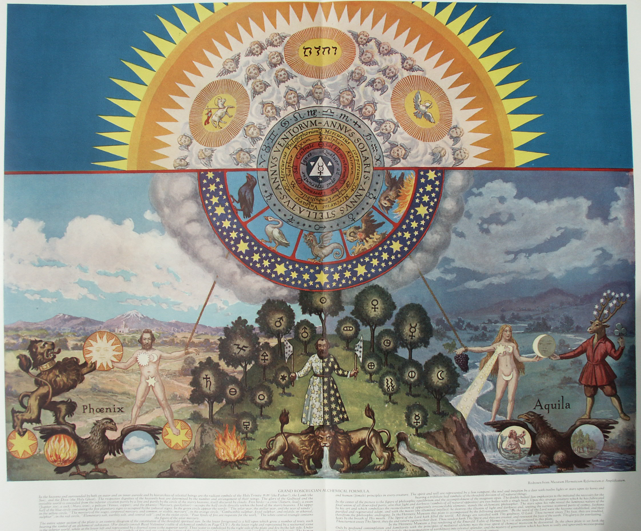

Fifteen Rosicrucian and Qabbalistic Diagrams

IN his well-known work, The Rosicrucians, Their Rites and Mysteries, Hargrave Jennings reproduces five Qabbalistic charts which he declares to be genuine Rosicrucian drawings. He gives no information concerning their origin nor does he attempt an elucidation of their symbolism. A recent writer who reproduced one of these charts correlated it to the emblematic tomb of Father C.R.C., thus exposing the true nature of Christian Rosencreutz.
The five plates reproduced in Hargrave Jennings' book are part of a series of fifteen diagrams which appear in The Magical, Qabbalistical, and Theosophical Writings of Georgius von Welling, on the Subject of Salt, Sulphur, and Mercury. This extremely rare volume was published at Frankfort and Leipzig in 1735 and 1760. The numbers and figures on the charts refer to the chapters and sections of the Writings. These fifteen charts constitute a remarkable and invaluable addition to the few other known admittedly authentic Qabbalistic and Rosicrucian diagrams.
Lucifer is the greatest mystery of symbolism. The secret knowledge of the Rosicrucians concerning Lucifer is nowhere so plainly set forth as in these plates, which virtually reveal his true identity, a carefully guarded secret about which little has been written. Lucifer is represented by the number 741.
Von Welling does not give a complete exposition of the fifteen charts; to have done so would have been contrary to the principles of Qabbalistic philosophy. The deeper significance of the symbols is revealed only by profound study and contemplation.
TABLE I, Figures 1-11. Figure 1 is a Ptolemaic chart showing the true relationship existing between the primordial elements. Its secret significance is as follows: The outer ring enclosed by the lines A and B is the region of Schamayim, a Qabbalistic name for the Supreme Deity, signifying the expanse of the heavens, or a spiritual fiery water. Schamayim is "The Ocean of Spirit, " within which all created and uncreated things exist and by the life of which they are animated. In the lower worlds Schamayim becomes the astral light.
The space between B and C marks the orbits or planes of the seven Spiritual Intelligences called the Divine Planets (not the visible planets). According to the Mysteries, the souls of men enter the lower worlds through ring B, the fixed stars. All creation reflects the glory of Schamayim, the energy that filters into the spheres of the elements through the windows of the stars and planets. Between C and D lies the region of the subtle, spiritual air, a subdivision of ether. D to E marks the surface of the earth and sea, by which are also meant grades of ether. E to F marks the lower region, called "The Gathering of the Waters and the Production of the Virgin Earth, " or "Ares. " The alchemists called this "quicksand," the true mystic foundation of the solid earth. F to G marks the circle of the subterranean air, which is more dense and coarse than that in the outer space, C to D. In this denser atmosphere the stellar influences and celestial impulses are crystallized into corporeal spirits, thus forming the multitude of forms which exist without knowledge of their own fiery source. G is the region of the central fire of the element earth, a coarse fire in contradistinction to the divine fiery Schamayim. The sphere of the starry heavens likewise has its opposite in the sphere of the subterranean air; and the sphere of the upper air (or subtle vaporous water) has its opposite in the sphere E to F. The focal point, D to E, between the three higher and the three lower spheres, is called "The Reservoir." It receives impressions from both the superior and the inferior regions and is common to both.
Figure 2 is the Qabbalistic symbol of elemental water; Figure 9 represents the spiritual invisible water. Figure 3 is the Qabbalistic symbol of elemental air; Figure 7 represents the spiritual and invisible air. Figure 4 is the Qabbalistic sign of the elemental earth; Figure 8 represents the spiritual and invisible earth. Figure 5 is the Qabbalistic sign of the elemental fire; Figure 6 represents the spiritual and invisible fire. Figures 6, 7, 8, and 9 symbolize the four elements before the descent of Lucifer. They are the four rivers spoken of in Genesis, having their source in the one river, Figure W, which represents the elements superimposed on one another. The golden ball in the center is Schamayim, the fiery source of all elements. Figure 11 is the emblem of the beginning and the end of all creatures. From it all things proceed and to it all must return again, to become one with the fiery water of divine understanding.
TABLE II, Figures 12-51. Figures 12, 13, 14 demonstrate the sphere as a symbol of motion to be emblematic of fire, water, and air; and the cube as a symbol of weight to be emblematic of earth. The sphere rests upon a point, the cube upon a surface; the sphere is therefore used to symbolize spirit, and the cube, matter. Figure 14 demonstrates that atmosphere rushing in behind a falling object increases its velocity and apparently adds to its weight. The essential nature of each element is occultly signified by the peculiar symbol and character assigned to it.
Of Figure 15, the symbol of salt, von Welling writes, in substance: The cube has six sides, corresponding to the six days of creation, with the point of rest (the seventh day) in the center of the cube. On each surface of the cube appear the signs of the four elements [triangles]. The alchemists declared that salt was the first created substance produced by the fire (Schamayim) which flowed out of God. In salt all creation is concentrated; in salt are the beginning and end of all things. The cube, furthermore, is composed of twelve bodies, each of which has six sides. These bodies are the twelve fundamental pillars of the true invisible church, and when these twelve bodies are multiplied by their six sides the magical number 72 results. The wise have said that nothing is perfect until it has been dissolved, separated, and again united so that it becomes a body composed of twelve bodies, like the cube. The cube also consists of six pyramids with the six surfaces of the cube as their bases. The points of these six pyramids meet at the center of the cube. These six pyramids, each consisting of four triangles, signify the elements, and produce the magical number 24, which refers to the Elders before the Throne. The six surfaces and the point constitute the magical number 7. If 7 be multiplied by 7 again, and so on 7 times, the answer will reveal the method used by the ancients for measuring the periods of eternity; thus: (1) 7 X 7 = 49; (2) 49 X 7 = 343; (3) 343 X 7 = 2,401; (4) 2,401 X 7 = 16,807; (5):16,807 X 7 = 117,649; (6) 117,649 X 7 = 823,543; (7) 823,543 X 7 = 5,764,801. (This is not to be taken as earth years or times.) The 5,000, 000 represents the great hall year; the 700,000 the great Sabbath year, wherein all human beings gradually gain true understanding and become heirs to their original and eternal inheritance, which was lost when they were enmeshed in the lower elements. The 64,800 is the number of the fallen angels, and the last one year signifies the liberation of Lucifer and return to his original estate.
Figure 16 is another symbol of salt, while Figure 17 (the dot) is the sign of spirit, gold, the sun, or the germ of life. If the dot be moved before itself it becomes a line, Figure 18. This motion of the dot is the first motion. The beginning and end of every line is a dot. Figure 19 is the circle. It is the second motion and the most perfect of all lines. Out of it are formed all figures and bodies imaginable. Figure 20 represents the outpouring of the upper and spiritual life into manifestation. Figure 21 represents darkness, for it is the loosening of the subterrene destructive principle. Figure 20 is also the symbol of day, and Figure 21 of night.

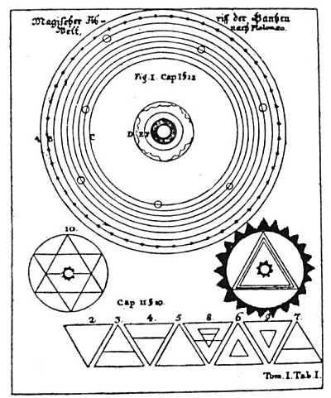
TABLE I, Figures 1-11.

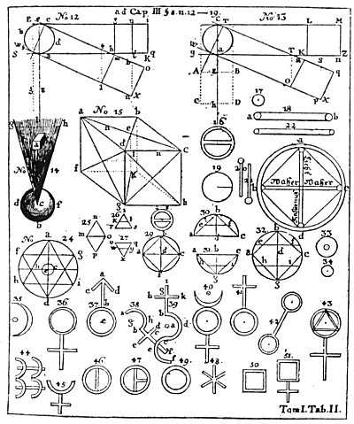
TABLE II, Figures 12-51.

Figure 22 is a symbol of water; Figure 23 is the complete universal character of light and darkness. The upright triangle represents Schamayim; the inverted triangle the dark earth which imprisons the infernal subterranean fire. It is "The First Day of Creation," or the time of the separation of Schamayim and Ares. Figure 24 represents the six days of creation and proves that the elements are an outflow of the Divine Fire which, breaking up, becomes the substances of the tangible universe, as signified in Figure 25.
Figure 26 is the character of the air, showing that air is born out of the Eternal Light and the ethereal water. Figure 27 is the character of water. It is the inversion of Figure 26, indicating that its origin is from the lower fire and not the higher. Its upper part signifies that water does not lack the Divine element, but as a universal mirror reflects the heavenly influences. Figures 28 and 29 are symbols of salt, showing that it is both fire and water in one. Figure 30 is the character of fire in all its attributes, and Figure M (the same inverted), water in all its powers. Figure 32 is the character of salt in all its attributes. Figure 33 represents both gold and the sun. Their essential natures are identical, being formed from the first fire out of Schamayim. They are perfect, as can be seen from their symbol, for no more perfect form can be produced out of the dot than the circle.
Figure 34 is the character of the greater and lesser worlds; as the dot is surrounded by its circumference, this world is surrounded by Schamayim. Man (the Little World) is included in this symbol because his inner nature is potential gold (Aphar Min Haadamah), which gold is his eternal indestructible spiritual body. Gold is the masculine principle of the universe.
Figure 35 is the character of silver and the moon. It signifies that silver (like gold) is a perfect metal, except that the red part of its nature is turned inward. Silver is the feminine principle of the universe.
Figure 36 is the character of copper and Venus; Figure 37, of iron and Mars; Figure 38, of tin and Jupiter; Figure 39, of lead and Saturn; Figure 40, of Mercury (both the planet and the element); Figure 41, of antimony, the key metal of the earth itself; Figure 42, of arsenic; Figure 43, of sulphur; Figure 44, of cinnabar; Figure 45, of quicklime; Figure 46, of nitre; and Figure 47, of vitriol. Figure 48 is the character of sal ammoniac, which element derives its name from the Temple of Jupiter Ammon in an Egyptian desert, where it was found. Figure 49 is the character of alum; Figure 50, of alkali, a name of Arabian origin; and Figure 51, of sal tartar, a substance possessing great occult virtue.
TABLE Ill, Figure 52. The eight globes and the central square represent the seven days of creation. The three worlds wherein creation occurs are symbolized by three concentric rings. The German words in the outer ring are extracts from the first chapter of Genesis. The words around the outside of the outer ring are The First Day. The four small globes inside the outer ring deal with the abstract phases of creation. The upper globe containing the triangle encloses the words Heaven and Earth. The globe to the right contains the word Light, and the one to the left, Jehovah Elohim in the upper part and Darkness in the lower part. The globe at the bottom contains the word Day in the upper half and Night in the lower.
The four globes within the second ring depict the second, third, fourth, and fifth days of creation. The white globe above divided by a dotted line is designated The Second Day; the globe to the left with the mountains, The Third Day; the globe to the right with the planetary rings, The Fourth Day; and the globe below bisected by a dotted line, The Fifth Day. The square in the central ring containing the human form is marked The Sixth Day. This chart is a diagrammatic exposition of the three layers of the macrocosmic and microcosmic auric eggs, showing the forces active within them.
TABLE IV, Figure. 53. Figure 53 has been designated the symbolic tomb of Christian Rosencreutz. The upper circle is the first world--the Divine Sphere of God. The triangle in the center is the throne of God. The small circles at the points of the star symbolize the seven great Spirits before the throne, mentioned in the Book of Revelation, in the midst of which walks the Alpha and Omega--the Son of God. The central triangle contains three flames--the Divine Trinity. From the lowest of these flames proceeds the first divine outflow, shown by two parallel lines descending through the throne of Saturn (the Spirit Orifelis, through whom God manifested Himself). Passing through the boundary of the celestial universe and the 22 spheres of the lower system, the lines end at point B, the throne of Lucifer, in whom the divine outpouring is concentrated and reflected. From him the divine light irradiates in succession to d (Capricorn), e (Gemini), f (Libra), g (Taurus), h (Pisces), i (Aquarius), k (Cancer), l (Virgo), m (Aries), n (Leo), o (Scorpio), p (Sagittarius), thence back to d. The zodiacal circles represent twelve orders of great and beneficent Spirits, and the smaller circles within the ring of fixed stars mark the orbits of the sacred planets.
TABLE V, Figure 54. Figure 54 is similar to Figure 53, but represents the universe at the time God manifested Himself through the character of Jupiter, the Spirit Sachasiel. Von Welling gives no reason for the change in the order of influx into the twelve orders of spirits, for the third world, for the adding of another circle and the interlaced triangles in the upper world, or for the letters Y and Z. In the upper triangle, A represents the Father Principle, F the divine outflow, G the point of influx into the twelve orders of spirits (probably Sagittarius). The letters H, I, J, K, L, M, N, O, P, Q, S, and T denote the sequential points of irradiations to each other; W and X, the World of the Sons of God; and B, C, D, and E, the World of Lucifer. This plate shows the universe after the descent of Lucifer into matter. According to von Welling, when Lucifer wanted to control power, the influx of the divine light instantly ceased. Lucifer's world (which later became the solar system), with all its legions of spirits (who in their essence were Schamayim) reflecting his ideas and inverting the divine light, was turned into darkness. Lucifer's Schamayim thereupon became a contracted disc, a tangible substance; and Chaos came into existence.

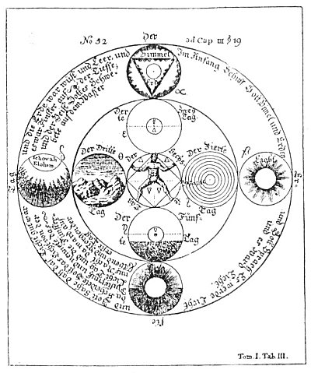
Table III, Figure 52

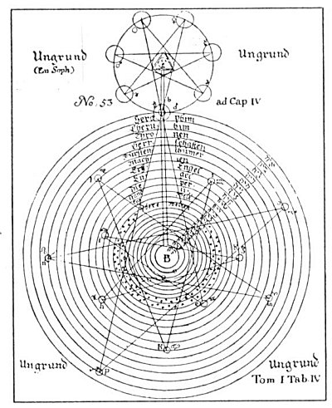
Table IV, Figure 53

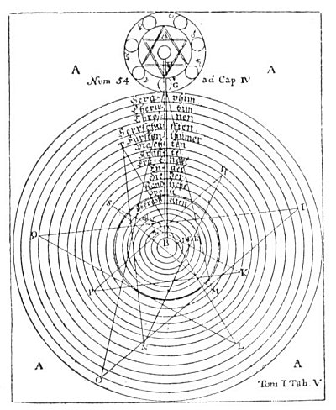
Table V, Figure 54

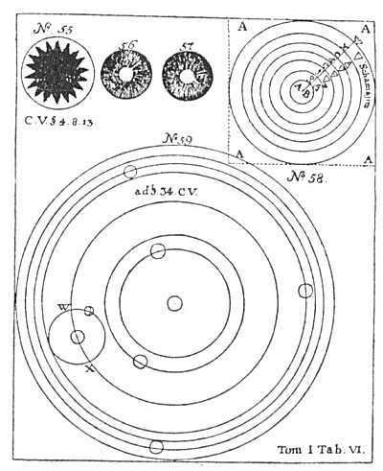
Table VII, Figures 1-5, 7 and 8

TABLE VI, Figures 55-59. Figure 55 symbolizes the Chaos of Lucifer; Figure 56, the separation of light from darkness; Figure 57, the light in the midst of the darkness; and Figure 58, the regions of the elements and their inhabitants. The four A's signify the Abyss surrounding all things. The A B is the fiery throne of Lucifer. The plane of g is the subterranean air; f, the subterranean water; c, the earth region; d, the outer water; e, the outer air, W and X the region of Schamayim. The elemental inhabitants of the planes differ in goodness according to their proximity to the center of wickedness (A B). The earth's surface (c) divides the subterranean elementals from those of the outer water, air, and fire (d, c, and X). The elementals of the upper strata (the upper half of c, and all of d, e, and X) represent an ascending scale of virtue, while those of the lower strata (the lower half of c, and all of f, g, and A B) represent a descending scale of depravity.
The region of air (e) is a partial exception to this order. While air is close to the light and filled with beautiful spirits, it is also the habitation of Beelzebub, the Evil Spirit of the air, with his legion of elemental demons. Upon the subtle element of air are impressed the influences of the stars; the thoughts, words, and deeds of man; and a myriad of mysterious influences from the various planes of Nature. Man inhales these impressions, and they produce diverse effects upon his mind. In air are suspended also the seed germs by which water is impregnated and made capable of bringing forth forms of organic and inorganic life. The grotesque figures seen in crystal caves and frost pictures upon windows are caused by these aerial impressions. While the air elementals are great and wise, they are treacherous and confused because amenable to both good and evil impressions. The mighty elemental beings who inhabit the watery light fire of the region X cannot be deceived by the spirits of darkness. They love the creatures of the waters, for the watery element (d) proceeded from the fiery water (X). Mortal man cannot endure the society of these fiery spirits, but gains wisdom from them through the creatures of the waters in which they continually mirror themselves. Figure 59 represents this solar system, with W and X as the locality of the Garden of Eden.
TABLE VII, Figures 1-5, 7, 8. (Table VIII has Figure 6.) Figure 1 is the triune divine sulphur, the All-Perfect out of the All-Perfect, the Soul of creatures. The threefold Divine One is symbolized by three interlaced circles designated alchemically salt, sulphur, and mercury. In the central triangle is the divine name Ehieh. Geist means spirit. The other words require no translation. Figure 2 is common destructive sulphur. A bar placed in the triangle makes it the character of earth. Figure 3 is true oil of vitriol, composed of a circle with two diameters and two reversed half-circles hanging below. In this are hidden the characters of all metals. Tin is symbolized by Figure 4 and iron by Figure 5. Figure 7 is the solar system according to Copernicus. Figure 8 is the last judgment. The sun is removed from the center of the solar system and replaced by the earth. This changes the respective positions of all the other planets except Mars, Jupiter, and Saturn, which retain their respective circles. The letter a signifies the circle of the sun; b, that of Mercury; c, that of Venus; d, (sic) that of the moon; and E, that of the earth. Inward from the sphere h are the great circles of damnation.
TABLE VII., Figure 6. In Figure 6 the letter a marks the center of eternity. The motion of the rays toward b, d, and c was the first divine manifestation and is symbolized by the equilateral triangle, b, d, c. The eternal world within the inner circle became manifest in the water (salt), the light (mercury), and the fire (sulphur) of the archetypal world, represented by the three circles (f, e, g) within the triangle of complete equality (h, i, k), which is in turn surrounded by the circle of the high throne. The circle f is named understanding; e, wisdom; g, reason. In circle i is the word Father; in circle h, Son; in circle k, Spirit. The seven outer circles are the seven spirits before the throne. The lower part of the figure is similar to Figures 53 and 54. The outer circles are the angelic world ending in the cognizable world of the Sons of God. Then comes the circle of the visible constellations and fixed stars; within this is the solar system with the sun as the center (l). Ungrund means the Abyss.
TABLE IX, Figure 9. Figure 9 is a synthesis of the Old and New Testaments and represents the interblending planes of being. In the right margin the seven outer circles contain the names of the planetary angels. The words in the graduated circles from the top triangle downward read: (1) Abyss of Compassion; (2) Zion; (3) The New Heaven and the New Earth; (4) The New Jerusalem; (5) Paradise; (6) The Bosom of Abraham; (7) The Outer Courts of the Lord. From below the circles of darkness reach upward, each divine principle being opposed by an infernal opposite. The small circle on the left containing a triangle and cross is named The Tree of Life, and that on the right The Tree of the Knowledge of Good and Evil. In the center of the diagram is the Trinity, joined with the superior and inferior planes by lines of activity.
TABLE X, Figures 10-15. Figure 10 shows the New Jerusalem in form of a cube, with the names of the twelve tribes of Israel written on the twelve lines of the cube. In the center is the eye of God. The words round the outer circle are from the Book of Revelation. Figures 11, 12, 13, 14, and 15 possibly are cipher symbols of the angels of the plagues, the name of the Antichrist, the signature of the beast of Babylon, and the name of the woman riding on the beast of blasphemy.

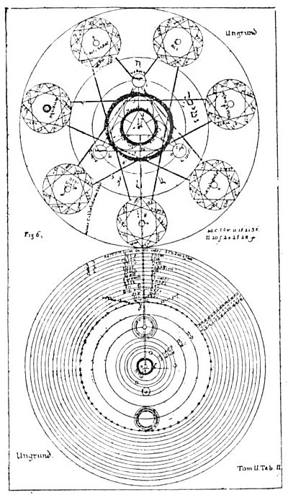
Table VIII, Figure 6.

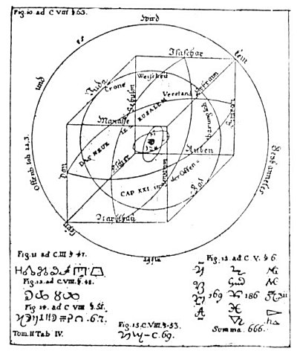
Table X, Figures 10-15.

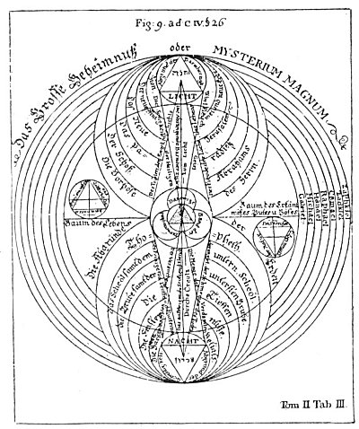
Table IX, Figure 9.

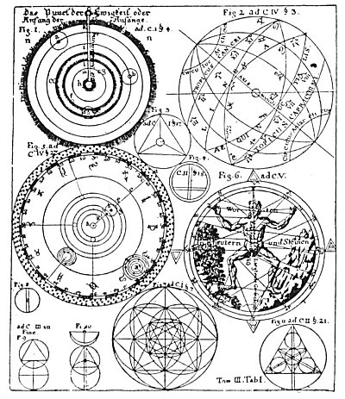
Table XI, Figures 1-11

TABLE XI, Figures 1.-11. Figure 1 is the solar system according to Genesis. The o on top of the radius of the circle is the dot of Eternity--the Beginning of Beginnings. The whole diameter is the outflow of God, manifesting first in the heaven of heavens--the Schamayim, in which region human understanding cannot function. The space from k to i contains the heavens of Saturn, Jupiter, and Mars; l to m, the heavens of Venus and Mercury; m to h, the heavens of the sun. The letter e is the moon, the circle of the earth.
Figure 2 is the globe of the earth, showing the houses and signs of the zodiac. Figure 3 is the character of the Universal Mercury (Divine Life) in its triune aspect of mercury, sulphur, and salt. Figure 4 is true saltpetre purified with quicklime and alkali. Figure 5 shows the exact degree or angle of the planets' places as well as the individual fixed stars in the zodiac. The letter a is the sun and b is the earth. From k to i are the circles of Mercury and Venus; g to h, the circles of earth and moon; f to e and e to c, of Jupiter and Saturn; c to d, the starry belt or zodiac. Figure 6 is the Microcosm, with the planets and signs of the zodiac corresponding to the different parts of its form. The words upon the figure read: Know thyself. In words, herbs, and stones lies a great power. Figure 7 is the universal character from which all characters have been taken. Figures 8, 9, and 10 are left to the solution of the reader. Figure 11 is the radiating Universal Mercury.
TABLE XII, Figures 12-19. Figure 12 is called A Mirror of Astrological Aspects. Below it is an astrologer's wheel. Figure 13 is similar to Figure 12. Figure 14 is a secret alchemical formula. The words around the circle read: Out of one in all is all. Figure 15 is an unsatisfactory attempt to show the comparative sizes of the suns and planets and their distances from each other. Figure 16 is the solar system with its internal and spiritual heavens. A B is the solar system; C is the sphere of fixed stars; D, E, F, G are the systems of the spiritual worlds; H is the throne of the living God; J, K, L, M, and N are the Great Beyond, unmeasurable.
Figure 17 shows the creation of the solar system out of the ring of the Divine Eternity. The four A's are the Abyss, B is the first revelation of God out of the Abyss, and from this revelation C, D, E, F, and G were created. C and D represent the spiritual hierarchies; D and E, the upper worlds, or constellations; E and F, the distance from Jupiter to the upper worlds; F and G, the solar system with its planets and their heavens; B and C the throne of Christ.
Figure 18 describes the division according to Genesis of the waters above the heavens (D) from the waters below (A, B, and C). Figure 19 is the mercury of the philosophers, essential to material existence.
TABLE XIII, Figures 1-4. Figure 1 is Ain Soph, the Incomprehensible Abyss of Divine Majesty, an endless welling up, limitless in time and space. Figure 2 symbolizes the three Divine Principles--Father, Son, and Holy Ghost. Around the triangle is written: I Shall Be That I Shall Be. At the apex of the triangle is the word Crown; in the left point, Wisdom; in the right point, Understanding. Figure 3 represents the Trinity with its outflow. The words above the upper sphere are Revelation of the Divine Majesty in Jehovah Elohim. The lower circles contain the names of the Hierarchies controlling the lower worlds. The words within the circle of stars read: Lucifer the Son of the Aurora of the morning. The letter C represents the Universal Mercury. The words within the circle read: The first beginning of all creatures. Figure 4 represents the abode of Lucifer and his angels, the Chaos spoken of in Genesis.
TABLE XIV, Figures 5, 7, 8. Figure 5 shows the triangle of triune Divinity in the midst of a cross. At the left is a small triangle containing the words The Secrets of Elohim, and at the right is another inscribed The Secrets of Nature. On the horizontal arms of the cross are the words The Tree of Life and The Tree of the Knowledge of Good and Evil. The plate explains the interblending of the spiritual and infernal powers in the creation of the universe. Figure 7 is called The Road to Paradise. It probably indicates the positions of the sun, moon, and planets at the moment of their genesis. Figure 8 is the earth before the flood, when it was watered by a mist or vapor. The words at the left are The Tree of Life; those at the right, The Tree of the Knowledge of good and Evil. The diagram with the symbol of Mars is devoted to a consideration of the rainbow.
TABLE XV, Figures 6, 9, 10. Figure 6 is similar to Figure 5 and is called The Secret of Nature. An interesting diagram is shown on either side of the central figure, each consisting of a triangle with circles radiating from its points. The diagram on the left is called The Secrets of the Upper World, and the one on right The Secrets of the Underworld.
Figure 9 is the solar system. Around the central part are the words The Place of the Damned. Figure 10 shows the dot, or point of rest, surrounded by a triangle enclosing a circle containing the names of the twelve tribes of Israel. It represents completion of the process of regeneration and the consummation of the Great Work.

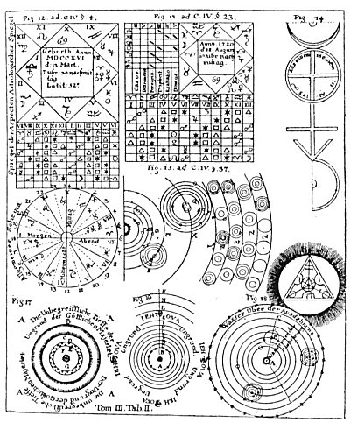
Table XII, Figures 12-19

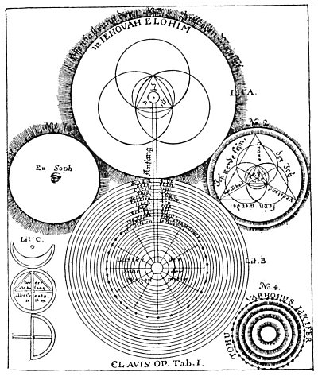
Table XIII, Figures 1-4

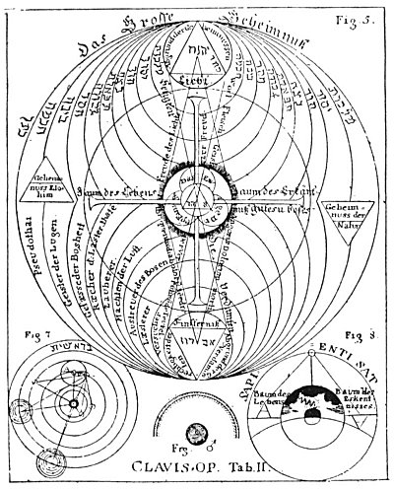
Table XIV, Figures 5, 7, and 8

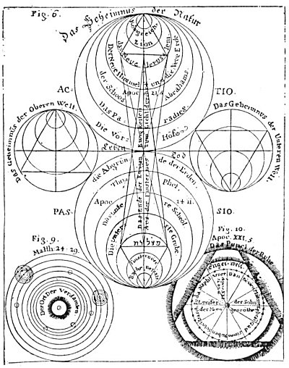
Table XV, Figures 6, 9, and 10

===================================================================================================================================================

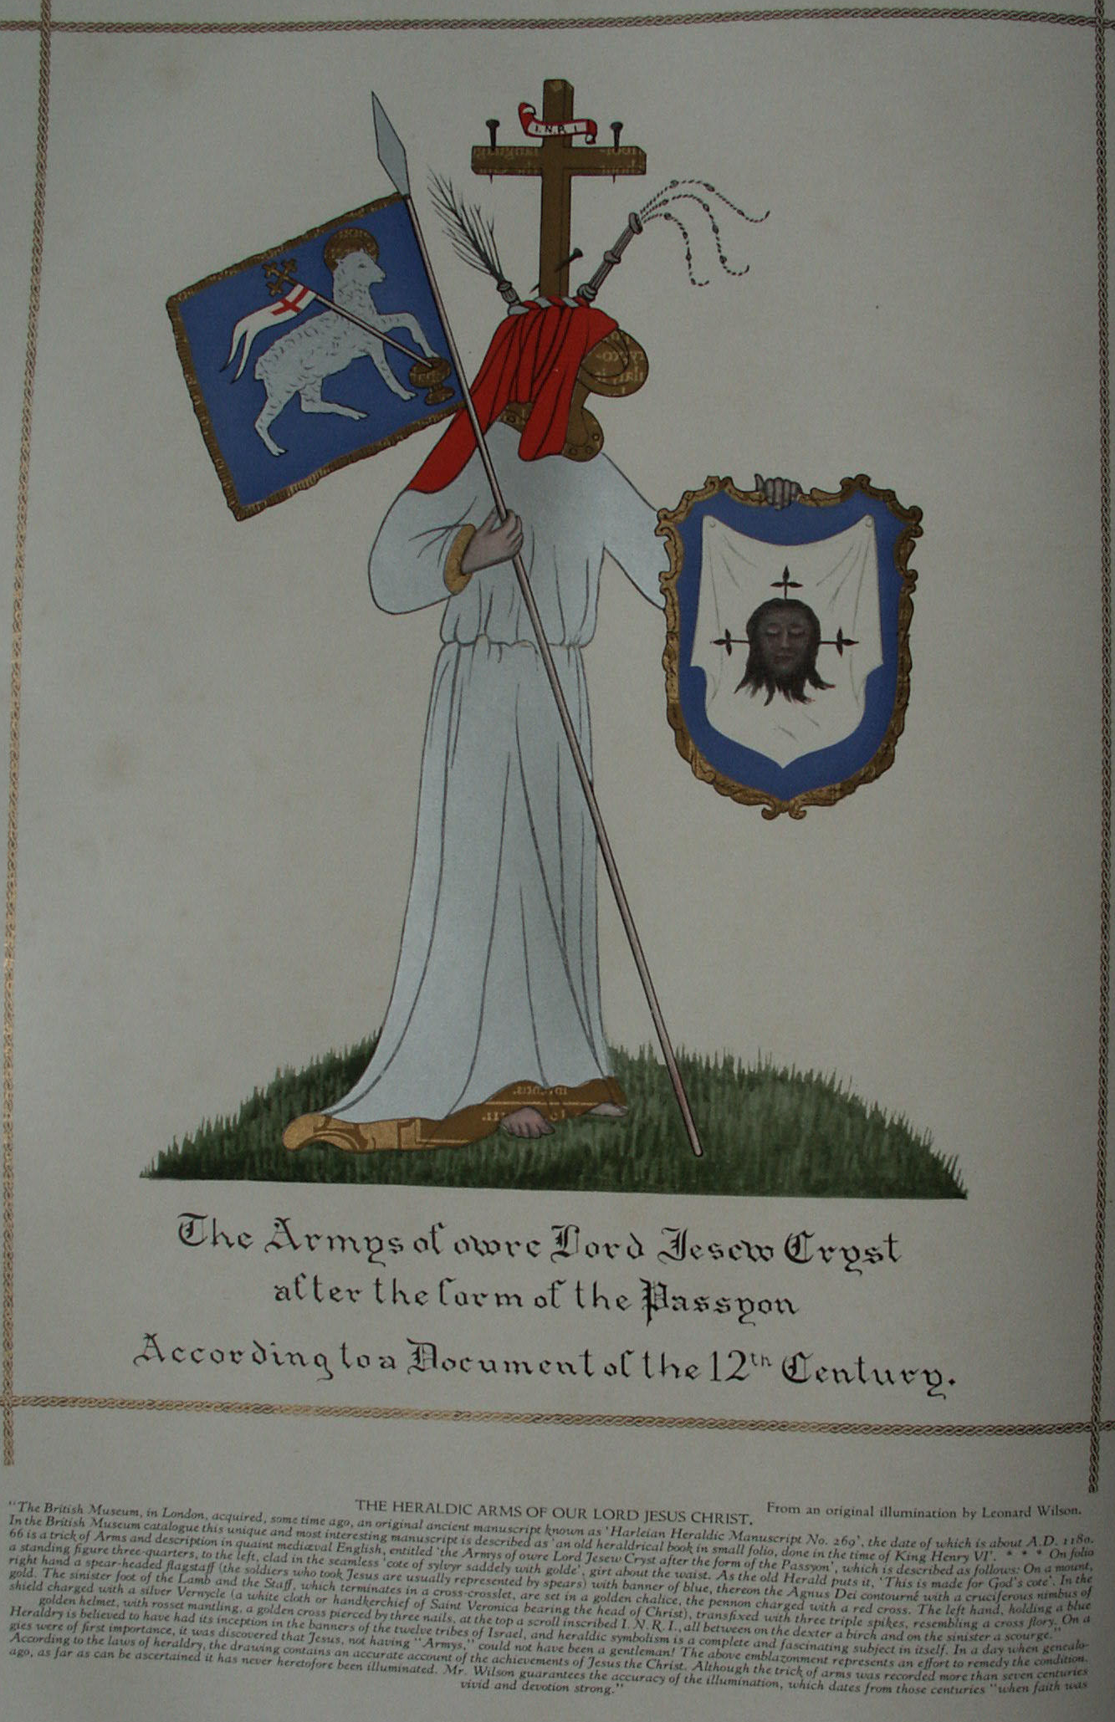

The Chemical Marriage

THE self-admitted author of The Chemical Marriage, Johann Valentin Andreæ, born in Württemberg in 1586, was twenty-eight years of age when that work was first published. It was presumably written about twelve years prior to its publication--or when the author was fifteen or sixteen years old. The fact is almost incredible that one so young could produce a volume containing the wealth of symbolic thought and philosophy hidden between the lines of The Chemical Marriage. This book makes the earliest known reference to Christian Rosencreutz, and is generally regarded as the third of the series of original Rosicrucian manifestoes. As a symbolic work, the book itself is hopelessly irreconcilable with the statements made by Andreæ concerning it. The story of The Chemical Marriage relates in detail a series of incidents occurring to an aged man, presumably the Father C.R.C. of the Fama and Confessio. If Father C.R.C. was born in 1378, as stated in the Confessio, and is identical with the Christian Rosencreutz of The Chemical Marriage, he was elevated to the dignity of a Knight of the Golden Stone in the eighty-first year of his life (1459). In the light of his own statements, it is inconceivable that Andreæ could have been Father Rosy Cross.
Many figures found in the various books on symbolism published in the early part of the seventeenth century bear a striking resemblance to the characters and episodes in The Chemical Marriage. The alchemical wedding may prove to be the key to the riddle of Baconian Rosicrucianism. The presence in the German text of The Chemical Marriage of some words in English indicates its author to have been conversant also with that language. The following summary of the main episodes of the seven days of The Chemical Marriage will give the reader a fairly comprehensive idea of the profundity of its symbolism.

THE FIRST DAY
Christian Rosencreutz, having prepared in his heart the Paschal Lamb together with a small unleavened loaf, was disturbed while at prayer one evening before Easter by a violent storm which threatened to demolish not only his little house but the very hill on which it stood. In the midst of the tempest he was touched on the back and, turning, he beheld a glorious woman with wings filled with eyes, and robed in sky-colored garments spangled with stars. In one hand she held a trumpet and in the other a bundle of letters in every language. Handing a letter to C.R.C., she immediately ascended into the air, at the same time blowing upon her trumpet a blast which shook the house. Upon the seal of the letter was a curious cross and the words In hoc signo vinces. Within, traced in letters of gold on an azure field, was an invitation to a royal wedding.
C.R.C. was deeply moved by the invitation because it was the fulfillment of a prophecy which he had received seven years before, but so unworthy did he feel that he was paralyzed with fear. At length, after resorting to prayer, he sought sleep. In his dreams he found himself in a loathsome dungeon with a multitude of other men, all bound and fettered with great chains. The grievousness of their sufferings was increased as they stumbled over each other in the darkness. Suddenly from above came the sound of trumpets; the cover of the dungeon was lifted, and a ray of light pierced the gloom. Framed in the light stood a hoary-headed man who announced that a rope would be lowered seven times and whoever could cling to the rope would be drawn up to freedom.
Great confusion ensued. All sought to grasp the rope and many were pulled away from it by others. C.R.C. despaired of being saved, but suddenly the rope swung towards him and, grasping it, he was raised from the dungeon. An aged woman called the "Ancient Matron" wrote in a golden yellow book the names of those drawn forth, and each of the redeemed was given for remembrance a piece of gold bearing the symbol of the sun and the letters D L S. C.R.C., who had been injured while clinging to the rope, found it difficult to walk. The aged woman bade him not to worry, but to thank God who had permitted him to come into so high a light. Thereupon trumpets sounded and C.R.C. awoke, but so vivid was the dream that he was still sensible of the wounds received while asleep.
With renewed faith C. R. C. arose and prepared himself for the Hermetic Marriage. He donned a white linen coat and bound a red ribbon crosswise over his shoulders. In his hat he stuck four roses and for food he carried bread, water, and salt. Before leaving his cottage, he knelt and vowed that whatever knowledge was revealed to him he would devote to the service of his neighbor. He then departed from his house with joy.

THE SECOND DAY
As he entered the forest surrounding his little house, it seemed to C.R.C. that all Nature had joyously prepared for the wedding. As he proceeded singing merrily, he came to a green heath in which stood three great cedars, one bearing a tablet with an inscription describing the four paths that led to the palace of the King: the first short and dangerous, the second circuitous, the third a pleasant and royal road, and the fourth suitable only for incorruptible bodies. Weary and perplexed, C.R.C. decided to rest and, cutting a slice of bread, was about to partake thereof when a white dove begged it from him. The dove was at once attacked by a raven, and in his efforts to separate the birds C.R.C. unknowingly ran a considerable distance along one of the four paths--that leading southward. A terrific wind preventing him from retracing his steps, the wedding guest resigned himself to the loss of his bread and continued along the road until he espied in the distance a great gate. The sun being low, he hastened towards the portal, upon which, among other figures, was a tablet bearing the words Procul hinc procul ite profani.
A gatekeeper in sky-colored habit immediately asked C.R.C. for his letter of invitation and, on receiving it, bade him enter and requested that he purchase a token. After describing himself as a Brother of the Red Rosie Cross, C.R.C. received in exchange for his water bottle a golden disk bearing the letters S C. Night drawing near, the wanderer hastened on to a second gate, guarded by a lion, and to which was affixed a tablet with the words Date et dabitur volis, where he presented a letter given him by the first gatekeeper. Being urged to purchase a token bearing the letters S M, he gave his little package of salt and then hastened on to reach the palace gates before they were locked for the night.
A beautiful virgin called Virgo Lucifera was extinguishing the castle lights as C.R.C. approached, and he was barely able to squeeze through the closing gates. As they closed they caught part of his coat, which he was forced to leave behind. Here his name was written in the Lord Bridegroom's little vellum book and he was presented with a new pair of shoes and also a token bearing the letters S P N. He was then conducted by pages to a small chamber where the "ice-grey locks" were cut from the crown of his head by invisible barbers, after which he was ushered into a spacious hall where a goodly number of kings, princes, and commoners were assembled. At the sound of trumpets each seated himself at the table, taking a position corresponding to his dignity, so that C.R.C. received a very humble seat. Most of the pseudo-philosophers present being vain pretenders, the banquet became an orgy, which, however, suddenly ceased at the sound of stately and inspired music. For nearly half an hour no one spoke. Then amidst a great sound the door of the dining hall swung open and thousands of lighted tapers held by invisible hands entered. These were followed by the two pages lighting the beautiful Virgo Lucifera seated on a self-moving throne. The white-and-gold-robed Virgin then rose and announced that to prevent the admission of unworthy persons to the mystical wedding a set of scales would be erected the following day upon which each guest would be weighed to determine his integrity. Those unwilling to undergo this ordeal she stated should remain in the dining hall. She then withdrew, but many of the tapers stayed to accompany the guests to their quarters for the night.

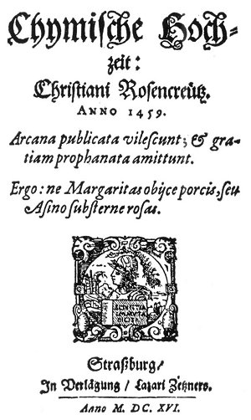
TITLE PAGE OF 1616 EDITION OF CHYMISCHE HOCHZEIT: CHRISTIAN ROSENCREUTZ.
From Rosencreutz' Chemical Marriage.
The most remarkable of all the publications involved in the Rosicrucian controversy is that of The Chemical Marriage, published in Strasbourg. This work, which is very rare, should be reproduced in exact facsimile to provide students with the opportunity of examining the actual text for the various forms of cipher employed. Probably no other volume in the history or literature created such a profound disturbance as this unpretentious little book. Immediately following its publication the purpose for which the volume was intended became the subject of popular speculation. It was both attacked and defended by theologians and philosophers alike, but when the various contending elements are simmered down the mysteries surrounding the book remain unsolved. That its author was a man of exceptional learning was admitted, and it is noteworthy that those minds which possessed the deepest understanding of Nature's mysteries were among those profoundly impressed by the contents of The Chemical Marriage.

Most of those present were presumptuous enough to believe that they could be safety weighed, but nine--including C.R.C.--felt their shortcomings so deeply that they feared the outcome and remained in the hall while the others were led away to their sleeping chambers. These nine were bound with ropes and left alone in darkness. C.R.C. then dreamed that he saw many men suspended over the earth by threads, and among them flew an aged man who, cutting here and there a thread, caused many to fall to earth. Those who in arrogance had soared to lofty heights accordingly fell a greater distance and sustained more serious injury than the more humble ones who, falling but a short distance, often landed without mishap. Considering this dream to be a good omen, C.R.C. related it to a companion, continuing in discourse with him until dawn.

THE THIRD DAY
Soon after dawn the trumpets sounded and the Virgo Lucifera, arrayed in red velvet, girded with a white sash, and crowned with a laurel wreath, entered accompanied by two hundred men in red-and-white livery. She intimated to C.R.C. and his eight companions that they might fare better than the other, self-satisfied guests. Golden scales were then hung in the midst of the hall and near them were placed seven weights, one good-sized, four small, and two very large. The men in livery, each carrying a naked sword and a strong rope, were divided into seven groups and from each group was chosen a captain, who was given charge of one of the weights. Having remounted her high throne, Virgo Lucifera ordered the ceremony to begin. The first to step on the scales was an emperor so virtuous that the balances did not tip until six weights had been placed upon the opposite end. He was therefore turned over to the sixth group. The rich and poor alike stood upon the scales, but only a few passed the test successfully. To these were given velvet robes and wreaths of laurel, after which they were seated upon the steps of Virgo Lucifera's throne. Those who failed were ridiculed and scourged.
The "inquisition" being finished, one of the captains begged Virgo Lucifera to permit the nine men who had declared themselves unworthy also to be weighed, and this caused C.R.C. anguish and fear. Of the first seven one succeeded and was greeted with joy. C.R.C. was the eighth and he not only withstood all the weights but even when three men hung on the opposite end of the beam he could not be moved. A page cried out: "THAT IS HE!" C.R.C. was quickly set at liberty and permitted to release one of the captives. He chose the first emperor. Virgo Lucifera then requested the red roses that C.R.C. carried, which he immediately gave her. The ceremony of the scales ended about ten o'clock in the forenoon.
After agreeing upon the penalties to be imposed upon those whose shortcomings had been thus exposed, a dinner was served to all. The few successful "artists," including C.R.C., were given the chief seats, after which the Golden Fleece and a Flying Lion were bestowed upon them in the name of the Bridegroom. Virgo Lucifera then presented a magnificent goblet to the guests, stating that the King had requested all to share its contents, Following this, C.R.C. and his companions were taken out upon a scaffolding where they beheld the various penalties suffered by those who failed. Before leaving the palace, each of the rejected guests was given a draught of forgetfulness. The elect then returned to the castle, where to each was assigned a learned page, who conducted them through the various parts of the edifice. C.R.C. saw many things his companions were not privileged to behold, including the Royal Sepulcher, where he learned "more than is extant in all books." He also visited a magnificent library and an observatory containing a great globe thirty feet in diameter and with all the countries of the world marked upon it.
At supper the various guests propounded enigmas and C.R.C. solved the riddle which Virgo Lucifera asked concerning her own identity. Then entered the dining hall two youths and six virgins beautifully robed, followed by a seventh virgin wearing a coronet. The latter was called the Duchess, and was mistaken for the Hermetic Bride. The Duchess told C.R.C. that he had received more than the others, therefore should make a greater return. The Duchess then asked each of the virgins to pick up one of the seven weights which still remained in the great room. To Virgo Lucifera was given the heaviest weight, which was hung in the Queen's chamber during the singing of a hymn. In the second chamber the first virgin hung her weight during a similar ceremony; thus they proceeded from room to room until the weights had been disposed of. The Duchess then presented her hand to C. R. C. and his companions and, followed by her virgins, withdrew. Pages then conducted the guests to their sleeping chambers. The one assigned to C.R.C. was hung with rare tapestries and with beautiful paintings.

THE FOURTH DAY
After washing and drinking in the garden from a fountain which bore several inscriptions--among them one reading, "Drink, brothers, and live"--the guests, led by Virgo Lucifera, ascended the 365 steps of the royal winding stairs. The guests were given wreaths of laurel and, a curtain being raised, found themselves in the presence of the King and Queen. C.R.C. was awestruck by the glory of the throne room and especially by the magnificence of the Queen's robes, which were so dazzling that he could not gaze upon them. Each guest was presented to the King by one of the virgins and after this ceremony the Virgo Lucifera made a short speech in which she recited the achievements of the honest "artists" and begged that each be questioned as to whether she had properly fulfilled her duty. Old Atlas then stepped forward and in the name of their Royal Majesties greeted the intrepid band of philosophers and assured Virgo Lucifera that she should receive a royal reward.
The length of the throne room was five times its width. To the west was a great porch in which stood three thrones, the central one elevated. On each throne sat two persons: on the first an ancient king with a young consort; on the third a black king with a veiled matron beside him; and on the central throne two young persons over whose heads hung a large and costly crown, about which hovered a little Cupid who shot his arrows first at the two lovers and then about the hall. Before the Queen a book bound in black velvet lay on a small altar, on which were golden decorations. Beside this were a burning candle, a celestial globe, a small striking-watch, a little crystal pipe from which ran a stream of clear blood-red liquor, and a skull with a white serpent crawling in and out of the orbits. After their presentations, the guests retired down the winding stairs to the great hall.
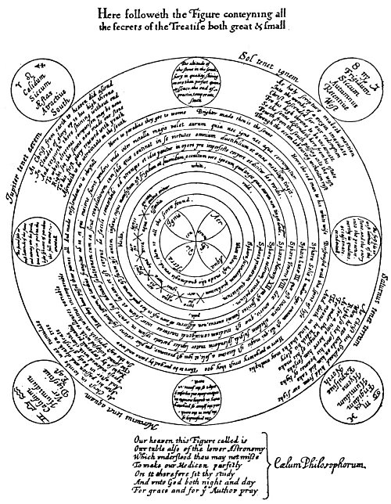
KEY TO THE GREAT PHILOSOPHICAL SECRET.
From Ashmole's Theatrum Chemicum Britannicum.
This plate, which is the key to mystic Christian alchemy, is missing from almost every copy of the Theatrum Chemicum Britannicum, a work compiled by Elias Ashmole and containing about a score of pieces by English poets treating of the Philosopher's Stone and the Hermetic mysteries. In view of the consistent manner in which the plate disappeared, it is possible that the diagram was purposely removed because it revealed too plainly the Rosicrucian arcana. Worthy of notice also is the care with which owners' names have been effaced from early books pertaining to alchemy and Hermeticism. The original names are usually rendered illegible being covered with heavy ink lines, the procedure often seriously defacing the volume, While an occasional exception is found, in practically every instance the mutilated books either deal with Rosicrucianism or contain cryptic writings of suspected Rosicrucian origin. It is presumed that this Practice of obliterating the owners names was to prevent the early Rosicrucians and Hermetists from being discovered through the volumes composing their libraries. Elias Ashmole's plate shows the analogies between the life of Christ and the four grand divisions of the alchemical process. Herein is also revealed the teaching that the Philosopher's Stone itself is a macrocosm and a microcosm, embodying the principles of astronomy and cosmogony, both universal and human.

Later the Virgo Lucifera announced that a comedy was to be performed for the benefit of the six royal guests in a building called the House of the Sun. C.R.C. and his companions formed part of the royal procession, which after a considerable walk arrived at the theater. The play was in seven acts, and after its happy ending all returned through the garden and up the winding stairs to the throne room. C.R.C. noticed the young King was very sad and that at the banquet following he often sent meat to the white serpent in the skull. The feast over, the young King, holding in his hand the little black book from the altar, asked the guests if they would all be true to him through prosperity and adversity, and when they tremblingly agreed he asked that each should sign his name in the little black book as proof of his fealty. The royal persons then drank from the little crystal fountain, the others afterwards doing likewise. This was called the "Draught of Silence." The royal persons then sadly shook hands with all present. Suddenly a little bell tinkled and immediately the kings and queens took off their white garments and donned black ones, the room was hung in sable draperies, and the tables were removed. The eyes of the royal persons were bound with six black taffeta scarfs and six coffins were placed in the center of the room. An executioner, a Moor, robed in black and bearing an axe, entered, and beheaded in turn each of the six royal persons. The blood of each was caught in a golden goblet, which was placed in the coffins with the body. The executioner was also decapitated and his head placed in a small chest.
The Virgo Lucifera, after assuring C.R.C. and his companions that all should be well if they were faithful and true, ordered the pages to conduct them to their rooms for the night while she remained to watch with the dead. About midnight C.R.C. awakened suddenly and, looking from his window, beheld seven ships sailing upon a lake. Above each hovered a flame; these he believed to be the spirits of the beheaded. When the ships reached shore, the Virgo Lucifera met them and on each of six of the vessels was placed a covered coffin. As soon as the coffins had been thus disposed of, the lights were extinguished and the flames passed back over the lake so that there remained but one light for a watch in each ship. After beholding this strange ceremony, C.R.C. returned to his bed and slept till morning.

THE FIFTH DAY
Rising at daybreak and entreating his page to show him other treasures of the palace, C.R.C. was conducted down many steps to a great iron door bearing a curious inscription, which he carefully copied. Passing through, he found himself in the royal treasury, the light in which came entirely from some huge carbuncles. In the center stood the triangular sepulcher of Lady Venus. Lifting a copper door in the pavement, the page ushered C.R.C. into a crypt where stood a great bed upon which, when his guide had raised the coverlets, C.R.C. beheld the body of Venus. Led by his page, C.R.C. then rejoined his companions, saying nothing to them of his experience.
Virgo Lucifera, robed in black velvet and accompanied by her virgins, then led the guests out into the courtyard where stood six coffins, each with eight pallbearers. C.R.C. was the only one of the group of "artists" who suspected the royal bodies were no longer in these coffins. The coffins were lowered into graves and great stones rolled over them. The Virgo Lucifera then made a short oration in which she exhorted each to assist in restoring the royal persons to life, declaring that they should journey with her to the Tower of Olympus, where the medicines necessary to the resurrection of the six royal persons could alone be found. C.R.C. and his companions followed Virgo Lucifera to the seashore, where all embarked on seven ships disposed according to a certain strange order. As the ships sailed across the lake and through a narrow channel into the open sea, they were attended by sirens, nymphs, and sea goddesses, who in honor of the wedding presented a great and beautiful pearl to the royal couple. When the ships came in sight of the Tower of Olympus, Virgo Lucifera ordered the discharge of cannon to signal their approach. Immediately a white flag appeared upon the tower and a small gilded pinnace, containing an ancient man--the warden of the tower--with his white-clad guards came out to meet the ships.
The Tower of Olympus stood upon an island which was exactly square and was surrounded by a great wall. Entering the gate, the group was led to the bottom of the central tower, which contained an excellent laboratory where the guests were fain to beat and wash plants, precious stones, and all sorts of things, extract their juice and essence, and put these latter into glasses. Virgo Lucifera set the "artists" to work so arduously that they felt they were mere drudges. When the day's work was finished, each was assigned a mattress on the stone floor. Being unable to sleep, C.R.C. wandered about contemplating the stars. Chancing upon a flight of steps leading to the top of the wall, he climbed up and looked out upon the sea. Remaining here for some time, about midnight he beheld seven flames which, passing over the sea towards him, gathered themselves on the top of the spire of the central tower. Simultaneously the winds arose, the sea became tempestuous, and the moon was covered with clouds. With some fear C.R.C. ran down the stairs and returned to the tower and, lying down on his mattress, was lulled to sleep by the sound of a gently flowing fountain in the laboratory.

THE SIXTH DAY
The next morning the aged warden of the tower, after examining the work performed by the wedding guests in the laboratory and finding it satisfactory, caused ladders, ropes, and large wings to be brought forth, and addressed the assembled "artists" thus: "My dear sons, one of these three things must each of you this day constantly bear about with him." Lots were cast and to C.R.C., much to his chagrin, fell a heavy ladder. Those who secured wings had them fastened to their backs so cunningly that it was impossible to detect that they were artificial. The aged warden then locked the "artists" in the lower room of the tower, but in a short time a round hole was uncovered in the ceiling and Virgo Lucifera invited all to ascend. Those with wings flew at once through the opening, those with ropes had many difficulties, while C.R.C. with his ladder made reasonable speed. On the second floor the wedding guests, musicians, and Virgo Lucifera gathered about a fountain-like contrivance containing the bodies of the six royal persons.
Virgo Lucifera then placed the if Moor's head in a kettle-like receptacle in the upper part of the fountain and poured upon it the substances prepared on the previous day in the laboratory. The virgins placed lamps beneath. These substances when they boiled passed out through holes in the sides of the kettle and, falling upon the bodies in the fountain below, dissolved them. The six royal bodies having been reduced thus to a liquid state, a tap was opened in the lower end of the fountain and the fluid drained into an immense golden globe, which, when filled, was of great weight. All but the wedding guests then retired and shortly a hole in the ceiling opened as before and the guests ascended pell-mell to the third floor. Here the globe were suspended by a strong chain. The walls of the apartment were of glass, and mirrors were so arranged that the sun's rays were concentrated upon the central globe, thus causing it to become very hot. Later the sun's rays were deflected and the globe permitted to cool, after which it was cut open with a diamond, revealing a beautiful white egg. Carrying this with her, Virgo Lucifera departed.
The guests, having ascended through another trap door, found themselves upon the fourth floor, where stood a square kettle filled with silver sand warmed by a gentle fire. The great white egg was placed upon the warm sand to mature. In a short time it cracked and there emerged an ugly, ill-tempered bird, which was fed with the blood of the beheaded royal persons diluted with prepared water. At each feeding its feathers changed color; from black they turned to white and at last they became varicolored, the disposition of the bird improving the while. Dinner was then served, after which Virgo Lucifera departed with the bird. The guests ascended with ropes, ladders, and wings to the fifth floor, where a bath colored with fine white powder had been prepared for the bird, which enjoyed bathing in it until the lamps placed beneath the bath caused the water to become uncomfortably warm. When the heat had removed all the bird's feathers it was taken out, but the fire continued until nothing remained in the bath save a sediment in the form of a blue stone. This was later pounded up and made into a pigment; with this, all of the bird except the head was painted.

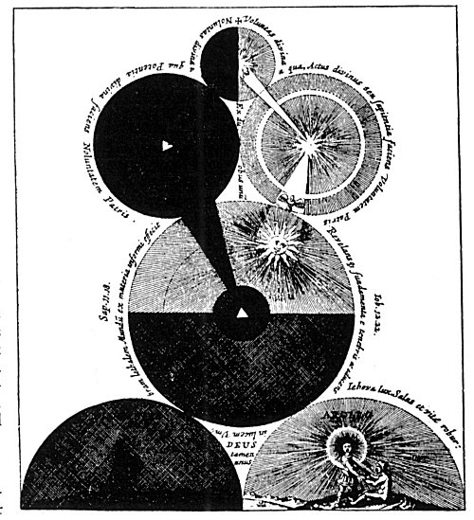
THE UNIVERSE CREATED BY THE DUAL PRINCIPLE OF LIGHT AND DARKNESS.
From Fludd's Philosophia Mosaica.
The Supreme Deity is symbolized by the small globe at the top, which is divided into two hemispheres, the dark half representing the divine darkness with which the Deity surround Himself and which serves as His hiding place. The radiant hemisphere signifies the divine light which is in God and which, pouring forth, manifests as the objective creative power. The large dark globe to the left and beneath the dark half of the upper sphere signifies the potential darkness which was upon the face of the primordial deep and within which moved the Spirit of God. The light globe to the right is the Deity who is revealed out of the darkness. Here the shining Word has dissipated the shadows and a glorious universe has been formed. The divine power of this radiant globe is cognizable to man as the sun. The large light and a dark section represents the created universes partaking of the light and darkness which are in the nature of the Creator. The dark half represents the Deep, or Chaos, the Eternal Waters pouring forth out of the Deity; the light half-circle containing the figure of Apollo represents the diurnal hemisphere of the world, which in the ancient Mysteries was ruled over by Apollo. The dark half-circle is the nocturnal hemisphere ruled over by Dionysius (Dionysos), whose figure is faintly visible in the gloom.

The guests thereupon ascended to the sixth floor, where stood a small altar resembling that in the King's throne room. The bird drank from the little fountain and was fed with the blood of the white serpent which crawled through the openings in the skull. The sphere by the altar revolved continuously. The watch struck one, two, and then three, at which time the bird, laying its neck upon the book, suffered itself to be decapitated. Its body was burned to ashes, which were placed in a box of cypress wood. Virgo Lucifera told C.R.C. and three of his comrades that they were lazy and sluggish "labourators" and would therefore be excluded from the seventh room. Musicians were sent for, who with cornets were to "blow" the four in ridicule from the chamber. C.R.C. and his three companions were disheartened until the musicians told them to be of good cheer and led them up a winding stair to the eighth floor of the tower directly beneath the roof. Here the old warden, standing upon a little round furnace, welcomed them and congratulated them upon being chosen by Virgo Lucifera, for this greater work. Virgo Lucifera then entered, and after laughing at the perplexity of her guests, emptied the ashes of the bird into another vessel, filling the cypress box with useless matter. She thereupon returned to the seventh floor, presumably to mislead those assembled there by setting them to work upon the false ashes in the box.
C.R.C. and his three friends were set to work moistening the bird's ashes with specially prepared water until the mixture became of doughlike consistency, after which it was heated and molded into two miniature forms. Later these were opened, disclosing two bright and almost transparent human images about four inches high (homunculi), one male and the other female. These tiny forms were laid upon satin cushions and fed drop by drop with the blood of the bird until they grew to normal size and of great beauty. Though the bodies had the consistency of flesh, they showed no signs of life, for the soul was not in them. The bodies were next surrounded with torches and their faces covered with silk. Virgo Lucifera then appeared, bearing two curious white garments. The virgins also entered, among them six bearing great trumpets. A trumpet was placed upon the mouth of one of the two figures and C.R.C. saw a tiny hole open in the dome of the tower and a ray of light descend through the tube of the trumpet and enter the body. This process was repeated three times on each body. The two newly ensouled forms were then removed upon a traveling couch. In about half an hour the young King and Queen awakened and the Virgo Lucifera presented them with the white garments. These they donned and the King in his own person most graciously returned thanks to C.R.C. and his companions, after which the royal persons departed upon a ship. C.R.C. and his three privileged friends then rejoined the other "artists," making no mention of that which they had seen. Later the entire party were assigned handsome chambers, where they rested till morning.

THE SEVENTH DAY
In the morning Virgo Lucifera announced that each of the wedding guests had become a "Knight of the Golden Stone. " The aged warden then presented each man with a gold medal, bearing on one side the inscription "At. Nat. Mi. " and on the other, "Tem. Na. F." The entire company returned in twelve ships to the King's palace. The flags on the vessels bore the signs of the zodiac, and C.R.C. sat under that of Libra. As they entered the lake, many ships met them and the King and Queen, together with their lords, ladies, and virgins, rode forth on a golden barge to greet the returning guests. Atlas then made a short oration in the King's behalf, also asking for the royal presents. In reply the aged warden delivered to Cupid, who hovered about the royal pair, a small, curious-shaped casket. C.R.C. and the old lord, each bearing a snow-white ensign with a red cross on it, rode in the carriage with the King. At the first gate stood the porter with blue clothes, who, upon seeing C.R.C., begged him to intercede with the King to release him from that post of servitude. The King replied that the porter was a famous astrologer who was forced to keep the gate as a punishment for the crime of having gazed upon Lady Venus reposing upon her couch. The King further declared that the porter could be released only when another was found who had committed the same crime. Upon hearing this, C.R.C.'s heart sank, for he realized himself to be the culprit, but he remained silent at that time.
The newly created Knights of the Golden Stone were obliged to subscribe to five articles drawn up by His Royal Highness: (1) That they would ascribe their Order only to God and His handmaid, Nature. (2) That they should abominate all uncleanness and vice. (3) That they should always be ready to assist the worthy and needy. (4) That they should not use their knowledge and power for the attainment of worldly dignity. (5) That they should not desire to live longer than God had decreed. They were then duly installed as Knights, which ceremony was ratified in a little chapel where C. R. C. hung up his Golden Fleece and his hat for an eternal memorial, and here he inscribed the following: Summa Scientia nihil Scire, Fr. Christianus Rosencreutz. Eques aurei Lapidis. Anno 1459.
After the ceremony, C.R.C. admitted that he was the one who had beheld Venus and consequently must become the porter of the gate. The King embraced him fondly and he was assigned to a great room containing three beds--one for himself, one for the aged lord of the tower, and the third for old Atlas.
The Chemical Marriage here comes to an abrupt end, leaving the impression that C.R.C. was to assume his duties as porter on the following morning. The book ends in the middle of a sentence, with a note in italics presumably by the editor.
Under the symbolism of an alchemical marriage, mediæval philosophers concealed the secret system of spiritual culture whereby they hoped to coordinate the disjecta membra of both the human and social organisms. Society, they maintained, was a threefold structure and had its analogy in the triune constitution of man, for as man consists of spirit, mind, and body, so society is made up of the church, the state, and the populace. The bigotry of the church, the tyranny of the state, and the fury of the mob are the three murderous agencies of society which seek to destroy Truth as recounted in the Masonic legend of Hiram Abiff. The first six days of The Chemical Marriage set forth the processes of philosophical "creation" through which every organism must pass. The three kings are the threefold spirit of man and their consorts the corresponding vehicles of their expression in the lower world. The executioner is the mind, the higher part of which--symbolized by the head--is necessary to the achievement of the philosophical labor. Thus the parts of man--by the alchemists symbolized as planets and elements--when blended together according to a certain Divine formula result in the creation of two philosophic "babes" which, fed upon the blood of the alchemical bird, become rulers of the world.
From an ethical standpoint, the young King and Queen resurrected at the summit of the tower and ensouled by Divine Life represent the forces of Intelligence and Love which must ultimately guide society. Intelligence and Love are the two great ethical luminaries of the world and correspond to enlightened spirit and regenerated body. The bridegroom is reality and the bride the regenerated being who attains perfection by becoming one with reality through a cosmic marriage wherein the mortal part attains immortality by being united with its own immortal Source. In the Hermetic Marriage divine and human consciousness are united in holy wedlock and he in whom this sacred ceremony takes place is designated as "Knight of the Golden Stone"; he thereby becomes a divine philosophic diamond composed of the quintessence of his own sevenfold constitution.
Such is the true interpretation of the mystical process of becoming "a bride of the Lamb." The Lamb of God is signified by the Golden Fleece that Jason was forced to win before he could assume his kingship. The Flying Lion is illumined will, an absolute prerequisite to the achievement of the Great Work. The episode of weighing the souls of men has its parallel in the ceremony described in the Egyptian Book of the Dead. The walled city entered by C.R.C. represents the sanctuary of wisdom wherein dwell the real rulers of the world--the initiated philosophers.
Like the ancient Mysteries after which it was patterned, the Order of the Rose Cross possessed a secret ritual which was lived by the candidate for a prescribed number of years before he was eligible to the inner degrees of the society. The various floors of the Tower of Olympus represent the orbits of the planets. The ascent of the philosophers from one floor to another also parallels certain rituals of the Eleusinian Mysteries and the rites of Mithras wherein the candidate ascended the seven rungs of a ladder or climbed the seven steps of a pyramid in order to signify release from the influences of the Planetary Governors. Man becomes master of the seven spheres only when he transmutes the impulses received from them. He who masters the seven worlds and is reunited with the Divine Source of his own nature consummates the Hermetic Marriage.

===================================================================================================================================================
END

