The Order of Skull and Bones

http://en.wikipedia.org/wiki/Skull_and_Bones

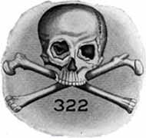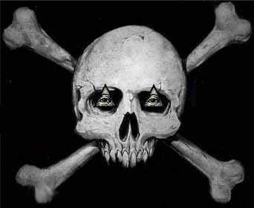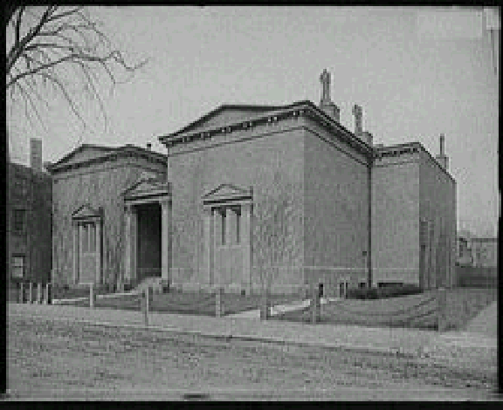

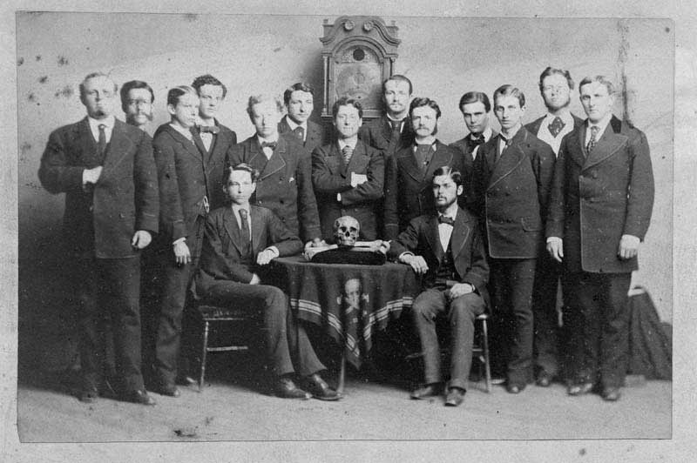

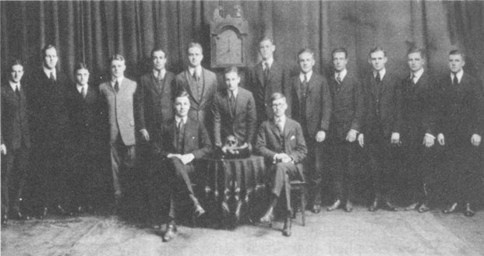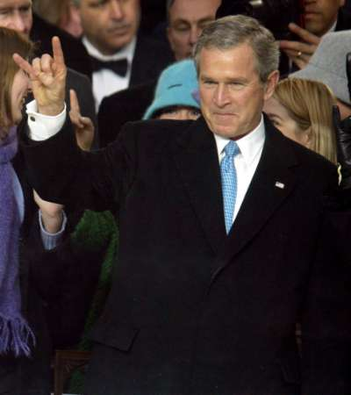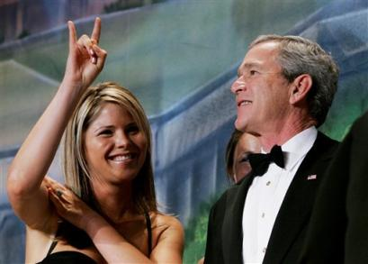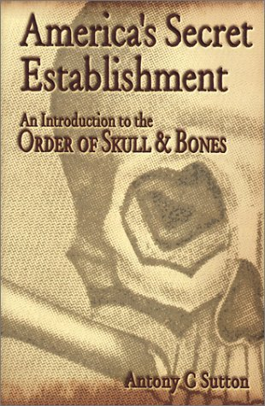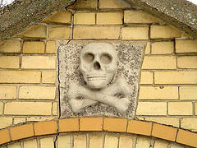
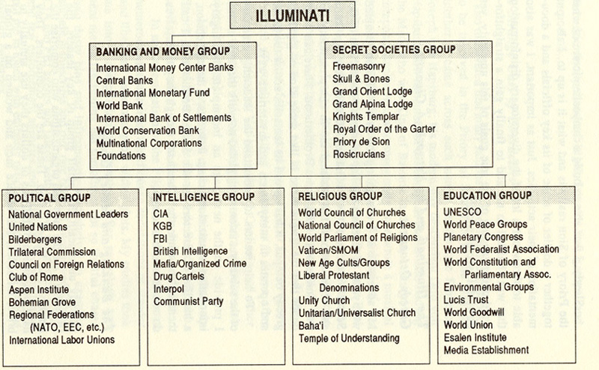
---------------------------------------------------------------------------------------------------------------------------------------------------------------------------------------------------------------

For the pirate flag see Jolly Roger; for the international poison symbol see skull and crossbones; for the Cypress Hill album see Skull & Bones.
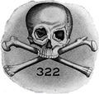
Emblem of the Skull and Bones society
The Order of Skull and Bones is a secret group based at Yale University, in New Haven, Connecticut.

Contents
- 1 History
- 2 Bonesmen
- 3 The Skull and Bones "Tomb"
- 4 Numerical symbolism "322"
- 5 Trivia
- 6 References
- 7 Further reading
- 8 External links

History
The group was founded in 1832 by Phi Beta Kappa pledges William Huntington Russell and Alphonso Taft. ^{[1]} The first Skull and Bones class, or "cohort," was the very next year, 1832-33. The society was all male until 1992.
Traditionally, the Yale Daily News published the names of newly "tapped" members of all major secret societies at Yale, but this practice was abandoned during the student rebellion of the sixties. It has since been reinstated informally by the campus tabloid The Rumpus. Hence, while the society's current membership rosters and activities are not officially disclosed, the membership is in fact a matter of knowledge among the incoming and outgoing Yale senior class, university administration, active alumni from other societies, and underclassmen. This may be said of the other societies, as well, particularly Scroll and Key and Wolf's Head.
The society inducts only incoming seniors, during the late junior year prior to their graduation.
By reputation, "Bones" tapped the current football and heavyweight rowing captains as well as notables from the Yale Daily News and Yale Lit dating back to the days of "Dink Stover"; however, Yale's co-education, managed by Bonesman R. Inslee Clark, Jr. (1963), eventually made even more precious a position among the elected when Bones coeducated decades later. Numerous undergraduate constituencies are better represented among the recently-tapped membership compared to the cohorts, or delegations, that included the 27th, 41st and 43rd Presidents of the United States.

Bonesmen
Main article: List of Skull and Bones Members
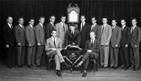
Skull and Bones 1947, with George H.W. Bush just left of clock
Many people believe that the membership of Skull and Bones had been totally secret. However the membership for each year is held in the Yale University archives. The membership rosters cover the years 1833-1985, with some additional years. The top repetitive families in Skull and Bones are also known because in 1985 an anonymous source leaked rosters to a private researcher, Antony C. Sutton. This leaked 1985 data was kept privately for over 15 years, as Sutton feared that the photocopied pages could somehow identify the member who leaked it. The information was finally reformatted as an appendix in the book Fleshing out Skull and Bones, a compilation edited by Kris Millegan, published in 2003.
Many influential figures have been in Bones, and influential families have often had multiple members over successive generations. Bonesmen range from U.S. Presidents such as George H. W. Bush, and William Howard Taft along with Supreme Court Justices, business leaders and U.S.
Both John Kerry and George W. Bush were members of Skull and Bones. They refused to talk about their common membership in Skull and Bones, despite being asked on television about it.
Bush: "It's so secret I can't talk about it."
Interviewer: "What does that mean for America?"
Bush refused to answer that question. In another interview, when Kerry was in turn asked what could he reveal about Skull and Bones, Kerry said: "Well not much, because it's a secret... Sorry, I wish there was something I could manifest... [and then he quickly changed the subject]."

The Skull and Bones "Tomb"
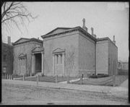
The Skull and Bones tomb.
Beginning in 1833, one of the responsibilities of the cohort of fifteen seniors is to select fifteen new junior members to replace them, which is called being "tapped" for the society. Tapped members meet in the Bones "Tomb" on certain evenings of each week for the duration of their senior year.
According to "dissident" Bones members interviewed by Alexandra Robbins for her book Secrets of The Tomb [p. 5], members dine off a set of Adolf Hitler's silverware while in the tomb, consuming expensive gourmet meals with each other over the span of the year. Members are given new code names. The members call themselves "Knights," and simultaneously call everyone else in the world at large "barbarians." Another dissociation is that clocks in the Bones "tomb" run intentionally five minutes ahead of the rest of the world, to give the members an ongoing sense that the Bonesmen's space is a totally separate world — and a world just a bit ahead of the curve of the rest of the "barbarians" outside.

Numerical symbolism "322"
Skull and Bones paid obeisance to Eulogia, the goddess of eloquence, who took her place in the pantheon upon the death of the orator Demosthenes, in 322 B.C., and who is said to have returned in a kind of Second Coming on the occasion of the society's inception. Today the numerical symbolism number 322, recalling the date of Demosthenes' and Aristotles' (Greek: Ἀριστοτέλης, Aristotélēs) death, appears on society stationery. The number has such mystical overtones that in 1967 a graduate student with no ties to Skull and Bones donated $322,000 to the society.
The number 322 has also been a particular favorite of conspiracy-minded hunters for evidence of Skull and Bones's global connections. It was the combination to Averell Harriman's briefcase when he carried classified dispatches between London and Moscow during World War II. Antony C. Sutton claims that 322 doubles as a reminder of the society's mother organization in Germany; the American group, founded in 1832, is the second chapter -- thus 32-2. [2]

Trivia
Some information in this article or section has not been verified and may not be reliable.
Please check for any inaccuracies, and modify and cite sources as needed.
- The only known chapter of Skull and Bones outside Yale was a chapter at nearby Wesleyan University in 1870, which in 1872 became an independent society under the name 'Theta Nu Epsilon'.
- Other claims are made for chapters and "groves" in Germanic areas of Europe for other "death cults", but this does not seem to be realistic, since German fraternities with comparable influence like Askania-Burgundia are organized in a quite different way.
- Still other sources claim the funding for the bonesman was derived from one family by the use of American ships faster than British ships of the day, smuggling opiates and spices out of the Orient past any blockades to avoid UK taxes to the crown. It is suggested as a reason as to why the skull and crossbones is the emblem. The connection for the British East India flag coincidence of Washington's choice for a flag is also suggested.
- Skull & Bones inspired the secret society in the 2000 film The Skulls.
- A letter, sent by member Winter Mead to member F. Trubee Davison in 1918, said Geronimo's skull and other remains were taken from the leader's burial site and deposited at the Skull and Bones headquarters.[3]
- The fictional character Montgomery Burns on The Simpsons is a Bonesman from the class of 1914.

[edit] References
- ^ "An Irrepressible Urge to Join," Yale Alumni Magazine, March 2001.[1]

[edit] Further reading
- Millegan, Kris, ed. Fleshing Out Skull and Bones: Investigations into America's Most Powerful Secret Society. Walterville, OR: Trine Day, 2003. ISBN 0-9720207-2-1
- Sutton, Antony C. America's Secret Establishment: An Introduction to the Order of Skull & Bones. Walterville, OR: Trine Day, 2003. ISBN 0-9720207-0-5
- Tarpley, Webster, et al. George Bush: The Unauthorized Biography. Washington, D.C.: Executive Intelligence Review, 1992. ISBN 0-943235-05-7. Available free on the web: http://www.tarpley.net/bushb.htm
- Robbins, Alexandra. Secrets of the Tomb: Skull and Bones, the Ivy League, and the Hidden Paths of Power. Back Bay Books, 2003. ISBN 0-316-73561-2
- "1918 Letter Claims Geronimo's Bones Found—Yale Historian Discovers 1918 Letter Claiming to Find the Bones of Indian Leader Geronimo," Associated Press (AP), May 8, 2006
- "Whose Skull and Bones?," Kathrin Day Lassila '81 and Mark Alden Branch '86, Yale Alumni Magazine, May/June 2006
- "Geronimo's family calls on Bush to help return his skeleton." The Independent, June 1, 2006.
Skull & Bones Society A rare look inside Skull and Bones, the Yale secret society and sometime haunt of the presumptive Republican nominee for President
by Alexandra Robbins
http://skullandcrossbones.org/articles/skullandbones.htm

[edit] External links
Wikimedia Commons has media related to:
Skull and bones
Wikinews has news related to:
Apaches accuse Prescott Bush of robbing Geronimo's grave
- Alex Jones' Skull and Bones archive
- Clip showing Skull and Bones members
- List of Bones members with some biographical information
- A The New American Article on the Skull and Bones Society, and its political influences
- Audio and transcript of the April 23, 2001 ABC News television report on hidden video caught of a Skull and Bones ritual by New York Observer reporter Ron Rosenbaum
- Skull and Bones: an intimate look at the US Ruling Class
- Skull and Bones video
- MSNBC Video on the history of Skull and Bones
- John Kerry on "Meet the Press" with Tim Russert confirming Skull and Bones membership
- George W. Bush on "Meet the Press" with Tim Russert confirming Skull and Bones membership
- "Fleshing Out Skull & Bones", book by Antony C. Sutton et al.
- Secrets of the Tomb
- Skull and Bones documentary
- How the Secret Societies Got That Way (Yale Alumni Magazine)
- Yale Old Campus, Skull and Bones Tomb. opens in Google earth
- Skull and Bones property: Deer Island opens in Google earth
Video The Rise of the Police State
==========================================================================================================================
END

