Skull & Bones, America's Secret Establishment
"America's Secret Establishment"
by Antony C. Sutton, 1986
http://www.geocities.com/Area51/Shadowlands/6583/secret021.html
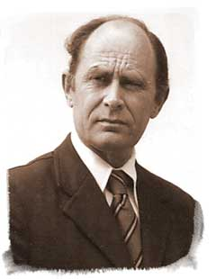
Antony C. Sutton — Jan. 17, 1925 - June 17, 2002

Page 5-6, states: "Those on the inside know it as The Order. Others have known it for more than 150 years as Chapter 322 of a German secret society. More formally, for legal purposes, The Order was incorporated as The Russell Trust in 1856. It was also once known as the "Brotherhood of Death". Those who make light of it, or want to make fun of it, call it 'Skull & Bones', or just plain Bones'.
The American chapter of this German order was founded in 1833 at Yale University by General William Huntington Russell and Alphonso Taft who, in 1876, became Secretary of War in the Grant Administration. Alphonso Taft was the father of William Howard Taft, the only man to be both President and Chief Justice of the United States.
The order is not just another Greek letter fraternal society with passwords and handgrips common to most campuses. Chapter 322 is a secret society whose members are sworn to silence. It only exists on the Yale campus (that we know about). It has rules. It has ceremonial rites. It is not at all happy with prying, probing citizens - known among initiates as 'outsiders' or 'vandals'. Its members always deny membership (or are supposed to deny membership) and in checking hundreds of autobiographical listings for members we found only half a dozen who cited an affiliation with Skull & Bones. The rest were silent. An interesting point is whether the many members in various Administrations or who hold government positions have declared their members in the biographical data supplied for FBI 'background checks'.
Above all, The Order is powerful, unbelievably powerful. If the reader will persist and examine the evidence to be presented - which is overwhelming - there is no doubt his view of the world will suddenly come sharply into focus, with almost frightening clarity.
It is a Senior year society which exists only at Yale. Members are chosen in their Junior year and spend only one year on campus, the Senior year, with Skull & Bones. In other words, the organization is oriented to the graduate outside world. The Order meets annually - patriarchies only - on Deer Island in the St. Lawrence River.
Senior societies are unique to Yale. There are two other senior societies at Yale, but none elsewhere. Scroll & Key and Wolf's Head are supposedly competitive societies founded in the mid-19 th century. We believe these to be part of the same network. Rosenbaum commented in his "Esquire" article, very accurately, that anyone in the Eastern Liberal Establishment who is not a member of Skull & Bones is almost certainly a member of either Scroll & Key or Wolf's Head.
.. The selection procedure for new members of The Order has not changed since 1832. Each year 15, and only 15, never fewer, are selected. In the past 150 years about 2500 Yale graduates have been initiated into The Order. At any time about 500-600 are alive and active. Roughly about one-quarter of these take an active role in furthering the objectives of The Order. The others either lose interest or change their minds. They are silent drop-outs.
.. The most likely potential member is from a Bones family, who is energetic, resourceful, political and probably an amoral team player. ... Honors and financial rewards are guaranteed by the power of The Order. But the price of these honors and rewards is sacrifice to the common goal, the goal of The Order. Some, perhaps many, have not been willing to pay this price.
The Old Line American families and their descendants involved in the Skull & Bones are names such as: Whitney, Perkins, Stimson, Taft, Wadsworth, Gilman, Payne, Davidson, Pillsbury, Sloane, Weyerhaeuser, Harriman, Rockefeller, Lord, Brown, Bundy, Bush and Phelps.
For a complete and accurate discussion of the Skull & Bones Society and the secret shadow government in control of this nation, you should purchase a copy of American Secret Establishment, by Antony C. Sutton, available from RIE.

http://cia-drugs.com/Merchant2/merchant.mv?Screen=PROD&Store_Code=CS&Product_Code=B0002

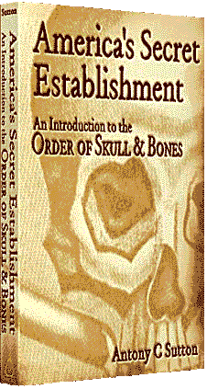
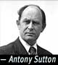
There are two ways of looking at the world. You can take the morning paper at face value and believe the world oscillates between the dumb-show of "left-wing" and "right-wing". Or you can begin to question this national hypnosis.
From the Preface:
"After 16 books and 25 years in basic research I thought I'd heard it all ... the world was a confused mess, probably beyond understanding and certainly beyond salvation - and there was little I could do about it. Back in 1968 my Western Technology and Soviet Economic Development was published by the Hoover Institution at Stanford University. In three substantial volumes I detailed how the West had built the Soviet Union. However, the work generated a seemingly insoluble puzzle - why have we done this? Why did we build the Soviet Union, while we also transferred technology to Hitler's Germany? Why does Washington want to conceal these facts? Why have we boosted Soviet military power? And simultaneously boosted our own? In subsequent books, the Wall Street series, I added more questions - but no answers. I had more or less arrived at the conclusion that there was no rational answer that could be proven. Then a year or so ago I received an eight-inch batch of documents nothing less than the membership lists of an American secret society. Glancing through the sheets it was more than obvious - this was no ordinary group. The names spelled Power, with a capital P. As I probed each individual a pattern emerged ... and a formerly fuzzy world became crystal clear. The book you will read here is a combined version of a series reporting on this research. Each volume builds on the previous volume in a logical step-by-step process. These volumes will explain why the West built the Soviets and Hitler; why we go to war, to lose; why Wall Street loves Marxists and Nazis; why the kids can't read; why the Churches have become propaganda founts; why historical facts are suppressed, why politicians lie and a hundred other whys."
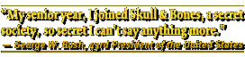
"This series is infinitely more important than the original Western Technology series on technological transfers. If I have a magnum opus, this is it". - Antony C. Sutton.
Other books by Mr. Sutton include Wall Street & the Bolshevik Revolution, Trilaterals Over Washington, and The Best Enemy Money Can Buy."

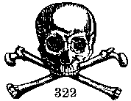
 |  |  |  |  |  | - New -
 |  |  |  |  |  | - New - |  |  |  |  | Any questions?
 |  |  |  |  | 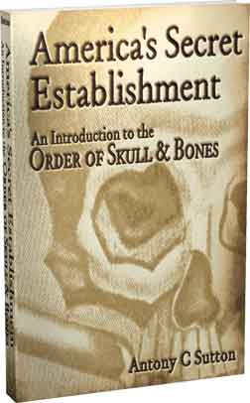 |  |  |  |  |  | Any questions?
 |  |  |  |  |  |  |  |  |  | 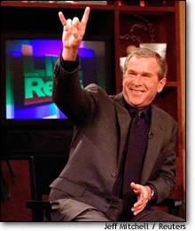
The Boodle Boys
RA Kris Millegan@1999-text
 | 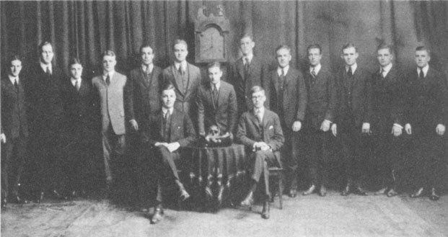
Begin the journey . . .
Skull and Bones Membership lists:
By Alpha
By Class-year
What hath Women Wrought a short essay from 2/2001
An early essay Everything You Ever Wanted to Know About Skull and Bones But Were Afraid to . . . 1/96
Mind Control, the Illuminati and the JFK Assassination 11/96
Antony Sutton web page
Whitewash, Smokescreen, Disinformation and Modified Limited Hang-out 9/02
Recent Yale graduate, Alexandra Robbins’s new book, Secrets of the Tomb – Skull and Bones, The Ivy League, And The Hidden Paths of Power portends to be an exposé, but in reality is a response by Bones to its critics, an apologia and… more skullduggery.
 |  |  |  |  |  |  |  | 