Skull and Bones - Yales Elite Satanic Secret Society
http://www.freemasonrywatch.org/theskulls.html

'The initiation ritual is right out of Harry Potter meets Dracula'

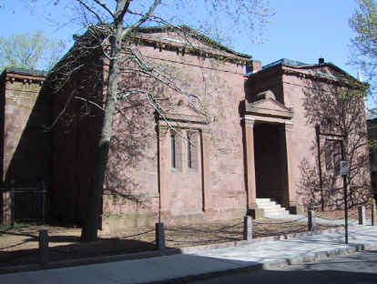
Listen to indepth BBC Report on Satanic Skull and Bones Society and Ritual

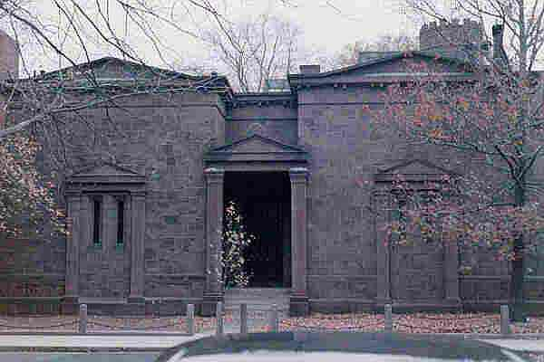

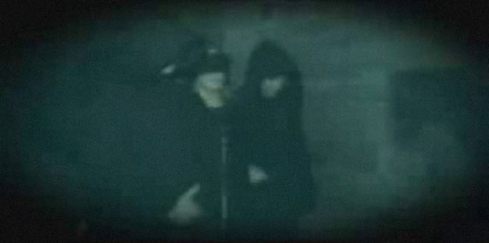
Skull and Bones functions like an independent elite lodge of Freemasonry performing a role similar to P2 USA. It's origins or 'Charter of Transmission' came from the 'Brotherhood of Death' at Inglostadt Germany, an offshoot of Contintental Freemason Baron Von Hund's 'Strict Observance' Rite, who was also instrumental in the founding of the Illuminati of Bavaria. The rituals 'worked' by Skull and Bones are Ancient and 'authentically' Satanic.

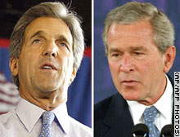

CBS News - 60 Minutes
http://www.cbsnews.com/stories/2003/10/02/60minutes/main576332.shtml
Skull And Bones
Oct. 5, 2003
Morley Safer, Correspondent
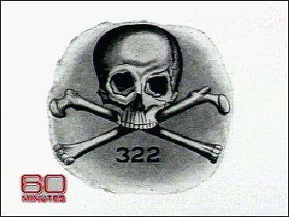
(CBS) There are secrets that George W. Bush guards at least as carefully as any entrusted to a president.
He's forbidden to share these secrets even with the vice president -- secrets he has held ever since his days as an undergraduate at Yale.
In his senior year, Mr. Bush - like his father and his grandfather - belonged to Skull and Bones, an elite secret society that includes some of the most powerful men of the 20th century.
All Bonesmen, as they're called, are forbidden to reveal what goes on in their inner sanctum, the windowless building on the Yale campus that is called "The Tomb."
There are conspiracy theorists who see Skull and Bones behind everything that goes wrong, and occasionally even right in the world.
Apart from presidents, Bones has included cabinet officers, spies, Supreme Court justices, statesmen and captains of industry - and often their sons, and lately their daughters, too.
Its a social and political network like no other. And they've responded to outsiders with utter silence – until an enterprising Yale graduate, Alexandra Robbins, managed to penetrate the wall of silence in her book, Secrets of the Tomb.¡± Correspondent Morley Safer reports.
--------------------------------------------------------------------------------
I spoke with about 100 members of Skull and Bones and they were members who were tired of the secrecy, and that's why they were willing to talk to me,¡± says Robbins. ¡°But probably twice that number hung up on me, harassed me, or threatened me.¡±
Secret or not, Skull and Bones is as essential to Yale as the Whiffenpoofs, the tables down at a pub called Mory's, and the Yale mascot - that ever-slobbering bulldog.
Skull and Bones, with all its ritual and macabre relics, was founded in 1832 as a new world version of secret student societies that were common in Germany at the time. Since then, it has chosen or "tapped" only 15 senior students a year who become patriarchs when they graduate -- lifetime members of the ultimate old boys' club.
Skull and Bones is so tiny. That's what makes this staggering,¡± says Robbins. There are only 15 people a year, which means there are about 800 living members at any one time.¡±
But a lot of Bonesmen have gone on to positions of great power, which Robbins says is the main purpose of this secret society: to get as many members as possible into positions of power.
They do have many individuals in influential positions,¡± says Robbins. And that's why this is something that we need to know about.¡±
President Bush has tapped five fellow Bonesmen to join his administration. Most recently, he selected William Donaldson, Skull and Bones 1953, the head of the Securities and Exchange Commission. Like the President, he's taken the Bones oath of silence.
--------------------------------------------------------------------------------
Ron Rosenbaum, author and columnist for the New York Observer, has become obsessed with cracking that code of secrecy.
I think there is a deep and legitimate distrust in America for power and privilege that are cloaked in secrecy. It's not supposed to be the way we do things,¡± says Rosenbaum. We're supposed to do things out in the open in America. And so that any society or institution that hints that there is something hidden is, I think, a legitimate subject for investigation.¡±
His investigation is a 30-year obsession dating back to his days as a Yale classmate of George W. Bush. Rosenbaum, a self-described undergraduate nerd, was certainly not a contender for Bones. But he was fascinated by its weirdness.
It's this sepulchral, tomblike, windowless, granite, sandstone bulk that you can't miss. And I lived next to it,¡± says Rosenbaum. I had passed it all the time. And during the initiation rites, you could hear strange cries and whispers coming from the Skull and Bones tomb.¡±
Despite a lifetime of attempts to get inside, the best Rosenbaum could do was hide out on the ledge of a nearby building a few years ago to videotape a nocturnal initiation ceremony in the Tomb's courtyard.
A woman holds a knife and pretends to slash the throat of another person lying down before them, and there's screaming and yelling at the neophytes,¡± he says.
Robbins says the cast of the initiation ritual is right out of Harry Potter meets Dracula: There is a devil, a Don Quixote and a Pope who has one foot sheathed in a white monogrammed slipper resting on a stone skull. The initiates are led into the room one at a time. And once an initiate is inside, the Bonesmen shriek at him. Finally, the Bonesman is shoved to his knees in front of Don Quixote as the shrieking crowd falls silent. And Don Quixote lifts his sword and taps the Bonesman on his left shoulder and says, ¡®By order of our order, I dub thee knight of Euloga.¡¯"
Its a lot of mumbo-jumbo, says Robbins, but it means a lot to the people who are in it.
Prescott Bush, George W's grandfather, and a band of Bonesmen, robbed the grave of Geronimo, took the skull and some personal relics of the Apache Chief and brought them back to the tomb,¡± says Robbins. ¡°There is still a glass case, Bonesmen tell me, within the tomb that displays a skull that they all refer to as Geronimo.¡±
The preoccupation with bones, mortality, with coffins, lying in coffins, standing around coffins, all this sort of thing I think is designed to give them the sense that, and it's very true, life is short,¡± says Rosenbaum. ¡°You can spend it, if you have a privileged background, enjoying yourself, contributing nothing, or you can spend it making a contribution.¡±
And plenty of Bonesmen have made a contribution, from William Howard Taft, the 27th President; Henry Luce, the founder of Time Magazine; and W. Averell Harriman, the diplomat and confidant of U.S. presidents.
What's important about the undergraduate years of Skull and Bones, as opposed to fraternities, is that it imbues them with a kind of mission for moral leadership,¡± says Rosenbaum. ¡°And it's something that they may ignore for 30 years of their life, as George W. Bush seemed to successfully ignore it for quite a long time. But he came back to it.¡±
Mr. Bush, like his father and grandfather before him, has refused to talk openly about Skull and Bones. But as a Bonesman, he was required to reveal his innermost secrets to his fellow Bones initiates.
They're supposed to recount their entire sexual histories in sort of a dim, a dimly-lit cozy room. The other 14 members are sitting on plush couches, and the lights are dimmed,¡± says Robbins. ¡°And there's a fire roaring. And the, this activity is supposed to last anywhere from between one to three hours.¡±
--------------------------------------------------------------------------------
Whats the point of this?
¡± I believe the point of the year in the tomb is to forge such a strong bond between these 15 new members that after they graduate, for them to betray Skull and Bones would mean they'd have to betray their fourteen closest friends,¡± says Robbins.
One can't help but make certain comparisons with the mafia, for example. Secret society, bonding, stakes may be a little higher in one than the other. But everybody knows everything about everybody, which is a form of protection.
I think Skull and Bones has had slightly more success than the mafia in the sense that the leaders of the five families are all doing 100 years in jail, and the leaders of the Skull and Bones families are doing four and eight years in the White House,¡± says Rosenbaum.
Bones is not restricted to the Republican Party. Yet another Bonesman has his eye on the Oval Office: Senator John Kerry, Democrat, Skull & Bones 1966.
It is fascinating isn't it? I mean, again, all the people say, Oh, these societies don't matter. The Eastern Establishment is in decline.¡¯ And you could not find two more quintessential Eastern establishment, privileged guys,¡± says Rosenbaum. ¡°I remember when I was a nerdy scholarship student in the reserve book room at, at the Yale Library, and John Kerry, who at that point styled himself ¡®John F. Kerry¡¯ would walk in.¡±
There was always a little buzz,¡± adds Rosenbaum. ¡°Because even then he was seen to be destined for higher things. He was head of the Yale Political Union, and a tap for Skull and Bones was seen as the natural sequel to that.¡±
--------------------------------------------------------------------------------
David Brooks, a conservative commentator who has published a book on the social dynamics of the upwardly mobile, says that while Skull & Bones may be elite and secret, it's anything but exciting.
My view of secret societies is they're like the first class cabin in airplanes. They're really impressive until you get into them, and then once you're there they're a little dull. So you hear all these conspiracy theories about Skull and Bones,¡± says Brooks.
And to me, to be in one of these organizations, you have to have an incredibly high tolerance for tedium 'cause you're sittin' around talking, talking, and talking. You're not running the world, you're just gassing.¡±
Gassing or not, the best-connected white man's club in America has moved reluctantly into the 21st Century.
Skull and Bones narrowly endorsed admitting women,¡± says Robbins. The day before these women were supposed to be initiated, a group of Bonesmen, including William F. Buckley, obtained a court order to block the initiation claiming that letting women into the tomb would lead to date rape. Again more legal wrangling; finally it came down to another vote and women were admitted and initiated.¡±
But Skull & Bones now has women, and its become more multicultural.
It has gays who got the SAT scores, it's got the gays who got the straight A's,¡± says Brooks. It's got the blacks who are the president of the right associations. It's different criteria. More multicultural, but it's still an elite, selective institution.¡±
On balance, it may be bizarre, but on a certain perspective, does it provide something of value?
You take these young strivers, you put them in this weird castle. They spill their guts with each other, fine. But they learn something beyond themselves. They learn a commitment to each other, they learn a commitment to the community,¡± says Brooks. And maybe they inherit some of those old ideals of public service that are missing in a lot of other parts of the country.¡±
And is that relationship, in some cases, stronger that family or faith?
Absolutely,¡± says Robbins. You know, they say, they say the motto at Yale is, For God, for country, and for Yale.¡¯ At Bones, I would think it's For Bones.'¡±
copy; MMIII, CBS Worldwide Inc. All Rights Reserved.


A Journalists Introduction to Skull and Bones
This brief introduction to Skull and Bones is dedicated to those journalists in America who have both the courage and the ability to inform the public regarding what others may consider to be a taboo subject -- a foreign-born secret society that has exported itself to this nation and may succeed in securing the highest office in the land for still another of its sworn initiates. The two main characters in this story so far are Antony C. Sutton and David Armstrong. The first is a scholar of the first order to began the definitive work on this subject and then vanished. The second came to Texas from California, became the editor of the most liberal Texas magazine, wrote a series of very insightful articles on the Bush family and then, like Sutton, was apparently muzzled.
INTRODUCTION
In May of 1994 a Texas Monthly story (p. 146) by Skip Hollandsworth, on George W. Bush, briefly stated: "Although he did not graduate Phi Beta Kappa as his father had, he did follow his father into the university's Skull and Bones Club, a secret society for the males of prominent families."
The majority of Bonesmen are from old-line Puritan families. They include the following families: Whitney, Lord, Phelps. Wadsworth, Allen, Bundy, Adams, Stimson, Taft, Gilman and Perkins. A second group of families in the Skull & Bones are: Harriman, Rockefeller, Payne, Davison, Pillsbury and Weyerhauser. The Order of Skull and Bones was once called the "Brotherhood of Death."(1)
At any given time, only about 600 or so members of the Order are alive. Of that number only 150 (about one-quarter) take an active role in the society. It is estimated that a core of perhaps 20-30 families run the Order. Recent Bones inductees include a few blacks, gays, and even some foreign students. In 1991 Skull and Bones began to admit women members. Each initiate gets \$15,000 and a grandfather clock. A neophyte's name is changed to Knight so and so. The old Knights are known as Patriarchs. Outsiders are known as Gentiles and vandals. It meets annually-patriarchs only-on Deer Island in the St. Lawrence River.(2)
THE SECRECY OF BONES
"Initiates are sworn to secrecy. They are required to leave the room if The Order comes into discussion. They cannot-under oath-answer questions on The Order and its organization." -- Antony C. Sutton(3)
The Senior secret societies at Yale, wrote Lymann Bogg, "never mention their names."(4) Not even the inquisitive Pamela Churchill Harriman could get her third husband to talk about Bones: "(Averell) Harriman regularly went back to the tomb (the Bone's Temple) on High Street, once even lamenting that his duties as chief negotiator at the Paris Peace Talks prevented him from attending a reunion. So complete was his trust in Bone's code of secrecy that in conversations at annual dinners he spoke openly about national security affairs. He refused, however, to tell his family anything about Bones. Soon after she became Harriman's third wife in 1971, Pamela Churchill Harriman received an odd letter addressing her by a name spelled in hieroglyphics. 'Oh, that's Bones,' Harriman said. 'I must tell you about that sometime. Uh, I mean I can't tell you about that.'"(5)
UNIVERSITIES AS SPAWNING GROUNDS OF THREE DIFFERENT SECRET SOCIETIES
Between 1983-1986, the British-born conspiracy scholar Antony C. Sutton wrote a series of pamphlets about the Order of Skull & Bones. Sutton said that his series was "based on several sources, including contemporary 'moles.'"(6) The short pamphlets were compiled into one volume and published as a book in 1986. Sutton noted that secret societies had been organized at three universities: "The Illuminati was founded at (the) University of Ingolstadt. The (Cecil Rhodes) Group was founded at All Souls College, Oxford University in England, and the Order was founded at Yale University in the United States."(7) He noted: "The paradox is that institutions supposedly devoted to the search for truth and freedom have given birth to institutions devoted to world enslavement."
BUT, WHAT'S WRONG WITH SECRET SOCIETIES?
Sutton's "magnum opus" laid out his views regarding secret societies: "Secret political organizations can be-and have been-extremely dangerous to the social health and constitutional validity of a society. In a truly free society the exercise of political power must always be open and known."(8) He then stated: "Moreover, organizations devoted to violent overthrow of political structures have always, by necessity, been secret organizations. Communist revolutionary cells are an obvious example. In fact, such revolutionary organizations can only function if their existence was secret."(9) Further, said Sutton: "In brief, secrecy in matters political is historically associated with coercion. Furthermore, the existence of secrecy in organizations with political ambitions or with a history of political actions is always suspect. Freedom is always associated with open political action and discussion while coercion is always associated with secrecy."(10)
A pamphlet on Bones described the walls of the tomb as "adorned with pictures of the founders of Bones at Yale and of the members of the Society in Germany when the Chapter was established here in 1832."(11) Sutton asked: "Think about this: Skull and Bones is not American at all. It is a branch of a FOREIGN secret society."(12) Sutton concluded that Skull and Bones "is a clear and obvious threat to constitutional freedom in the United States. Its secrecy, power and use of influence is greater by far than the masons, or any other semi-secret mutual or fraternal organization."(13)
SUTTON COMPARED BONES TO THE BAVARIAN ILLUMINATI
While critics concede that the Illuminati "was an actual group that existed from 1776 until 1785..." it is also explained that: "Given the fact that Weishaupt's ideas ran counter to the authoritarian, church-intertwined-with-state power structure, he was forced to keep his Illuminati secret and work through Masonic lodges. He was not successful."(14)
Sutton made numerous tentative comparisons between the Illuminati and Bones. Each member, according to a 1876 anonymous satire, has an "inside name" and "these names bear a remarkable resemblance to those used by the Illuminati, e.g., Chilo, Eumenes, Glaucus, Pristicus and Arbaces."(15) He added: "During its time, the Illuminati had widespread and influential membership. After suppression by the Bavarian Government in 1788 it was quiet for some years and then reportedly revived."(16) Sutton promised that "in a subsequent book, we will trace the order to the Illuminati..."(17) Also, Sutton stated: "The significance of this study is that the methods and objectives (of the Illuminati) parallel those of the Order. In fact, infiltration of the Illuminati into New England is known and will be the topic of a forthcoming volume."(18) He later wrote: "At this point we want to draw a comparison between the Order known as Skull and Bones and The Order known as Illuminati in 18th century Bavaria. This is not the time and place to draw final conclusions."(19) Sutton noted that "It (Bones) was introduced into the United States by William Russell, later General William Russell, who brought a charter back from his student days in Germany."(20) [So far a check of Russell's biographies has revealed no hint of a German education]. When the Skull and Bones "Temple" was raided in 1876 a card was found that read: "From the German Chapter. Presented by Patriarch D.C. Gilman of D. 50."(21) The Yale Bones catalogs indicate that Skull and Bones began in the U.S. in the 3rd decade of the second period of the organization. The first decade of the second period would be 1800 with the first period being 1790-1800: "That places us in the time frame of the elimination of Illuminati by the Bavarian Elector."(22)
Two years later Sutton, in 1988, wrote The Two Faces of George Bush. In this work he identified George W. Bush as a Bonesman like his soon-to-be President father. Sutton has not written further on the Order. At least one close associate claimed that Sutton became and remains "a fugitive in his own adopted country."
EDITOR OF TEXAS OBSERVER, DAVID ARMSTRONG, LASTS EIGHT MONTHS
On March 22, 1991, a crusading journalist named David Armstrong became the editor of the Texas Observer. His career at the most liberal and outspoken Texas magazine lasted just over eight months. On April 5, 1991, he wrote an article entitled "The Great S&L Robbery: Spookbuster Pete Brewton Tells All." On July 26, 1991 another article by Armstrong was entitled: "Oil in the Family." On September 20, 1991, Armstrong wrote another piece entitled: "Global Entanglements." The cover featured a cartoon of George "W" Bush with "Harken" on his head and CIA agents (spies) all around him.
On November 29, 1991 David Armstrong's name appeared on the masthead of the Texas Observer for the last time. Armstrong deplored and described what he termed a trend of preemptive journalism: "Mainstream media have never demonstrated a keen interest in challenging the status quo. Contrary to the popular image of an independent and adversarial press, U.S. corporate media are, in fact, little more than lackeys for elite interests."
Armstrong also blasted criticism of Stone's JFK movie prior to the scenes even being shot. He criticized Times Harken coverage as "half-measures." His last Texas Observer words were: "Time's handling of the Harken story is just one more example of the disturbing trend toward preemptive journalism. The consequences of this practice are serious indeed, for it has the potential to not only diffuse and obscure information, but to prevent it from ever being debated in the public arena at all. Unlike the alternative press, mainstream sources are widely available and well indexed. For that reason, they are widely cited and help shape official history. Twenty years from now when George W. Bush is running for president, researchers and journalists interested in his business activities in Texas will likely turn to Time magazine and other mainstream sources of their information. But if they're interested in reading the whole story, they'll have to look elsewhere."(23)
Thus ended David Armstrong's editorship at the Texas Observer. It is believed that there was a last conversation between Armstrong and his publisher but no explanation was ever written that explained his departure to the Observer's readership. Armstrong's prophecy of a run for the presidency by George "W" Bush has now come true. But his pen is no longer telling more of the real Bush story.
1. Antony C. Sutton, America's Secret Establishment 5 (1986).
2. Antony C. Sutton, America's Secret Establishment 5 (1986).
3. Antony C. Sutton, America's Secret Establishment 213 (1986).
4. Antony C. Sutton, America's Secret Establishment 186 (1986).
5. Walter Isaacson and Evan Thomas, The Wise Men 82 (1986).
6. Antony C. Sutton, America's Secret Establishment 186 (1986).
7. Antony C. Sutton, America's Secret Establishment 80 (1986).
8. Antony C. Sutton, America's Secret Establishment 185 (1986).
9. Antony C. Sutton, America's Secret Establishment 185 (1986).
10. Antony C. Sutton, America's Secret Establishment 185 (1986).
11. Antony C. Sutton, America's Secret Establishment 188 (1986).
12. Antony C. Sutton, America's Secret Establishment 188 (1986).
13. Antony C. Sutton, America's Secret Establishment 186 (1986).
14. John George and Laird Wilcox, American Extremists 81 (1996).
15. Antony C. Sutton, America's Secret Establishment 189 (1986).
16. Antony C. Sutton, America's Secret Establishment 80 (1986).
17. Antony C. Sutton, America's Secret Establishment 77 (1986).
18. Antony C. Sutton, America's Secret Establishment 80 (1986).
19. Antony C. Sutton, America's Secret Establishment 212 (1986).
20. Antony C. Sutton, America's Secret Establishment 212 (1986).
21. Antony C. Sutton, America's Secret Establishment 212 (1986).
22. Antony C. Sutton, America's Secret Establishment 214 (1986).
23. David Armstrong, "Preemptive Journalism," 12 Texas Observer
(November 29, 1991).

