Robert Crosbie 1849-1919
http://en.wikipedia.org/wiki/Robert_Crosbie
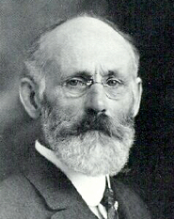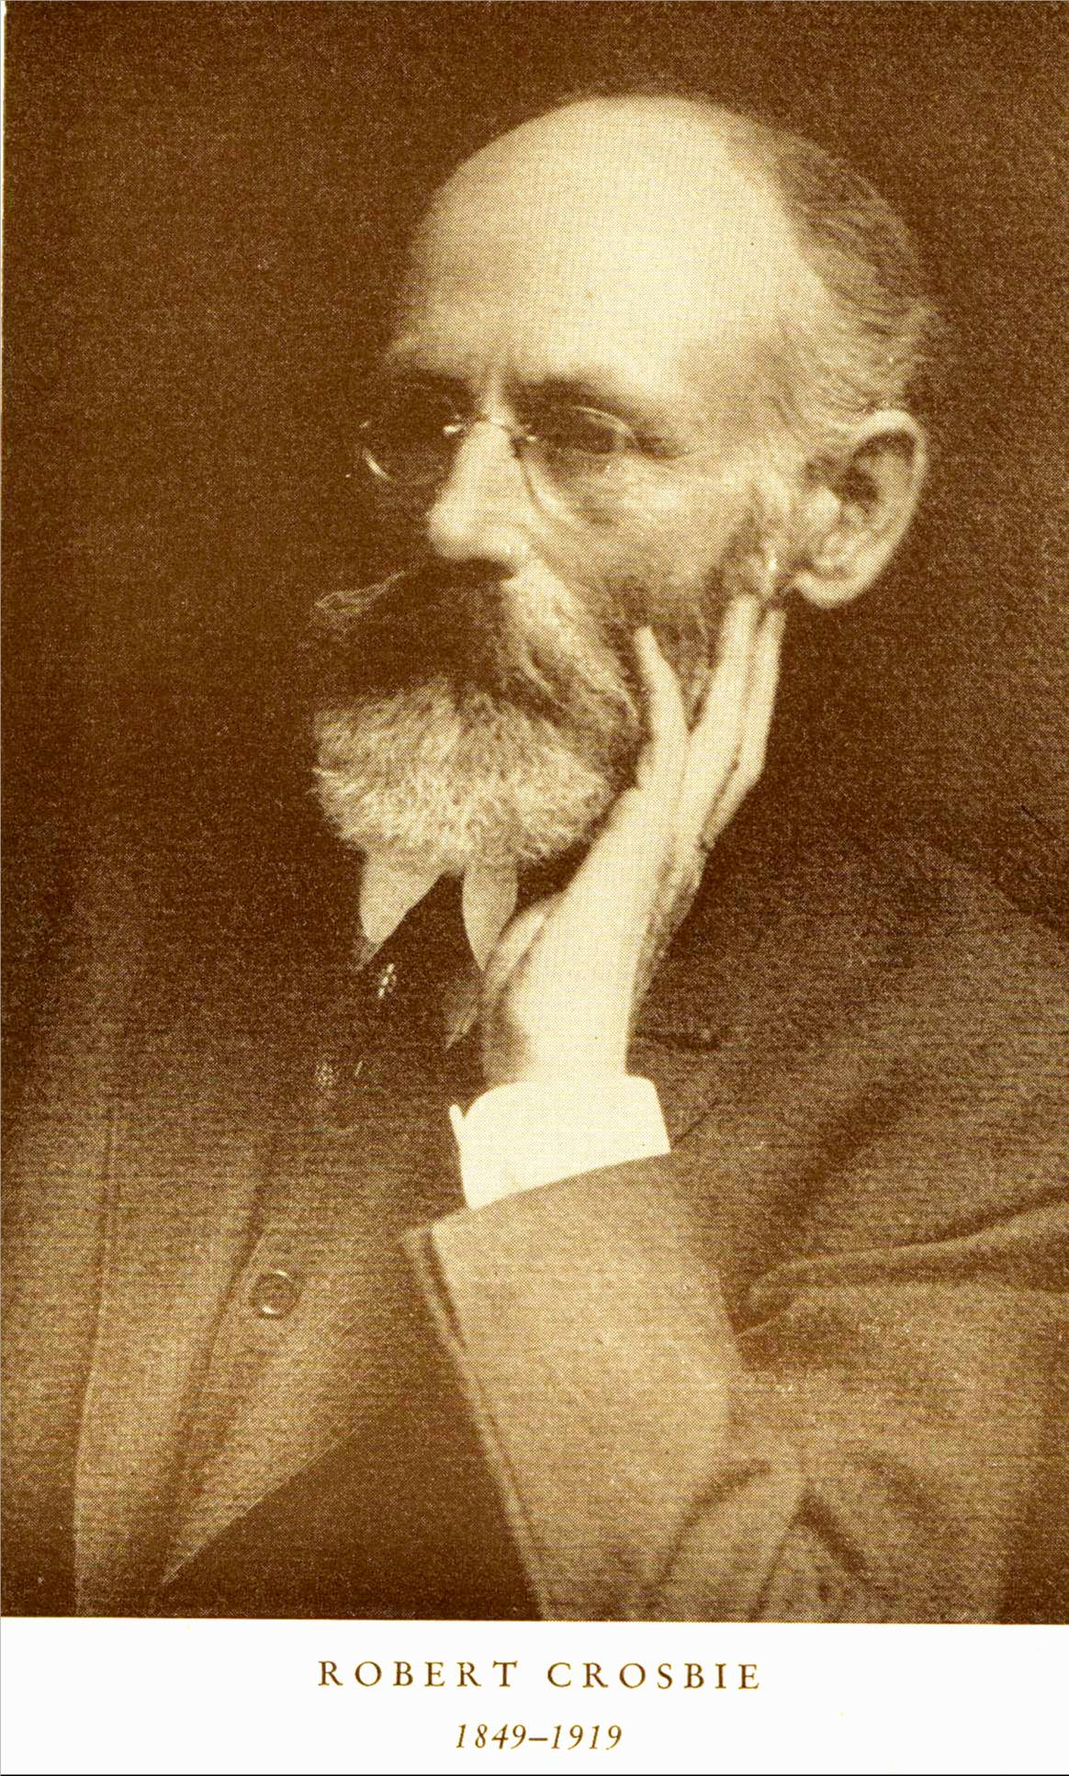

Robert Crosbie (born 10 January 1849 in Montréal, Canada; died 25 June 1919 in the USA) was a theosophist and founder of the United Lodge of Theosophists (ULT).
In 1902 he moved to Lomaland, Point Loma, California where he helped in building a theosophical community. In 1908 he published a letter To all open-minded Theosophists about his thoughts on the Theosophical Society. On February 1909 he founded the ULT in Los Angeles. The organization had no presidents or hierarchical structures.
In 1912 he first published the theosophical magazine "Theosophy". He also founded the Theosophical School. In 1916 two new lodges of the ULT were opened in San Francisco and Berkeley, California.

Works
- The friendly philosopher, Letters and talks on theosophy and the theosophical life. The Theosophy company, Los Angeles 1934

External links
- Biography of Robert Crosbie by Dalles Tenbroeck
- Letters by Robert Crosbie on Katherine Tingley
=============================================================================================================================
END

