Gottfried de Purucker 1874-1942
http://en.wikipedia.org/wiki/Gottfried_de_Purucker
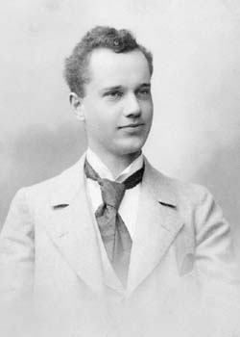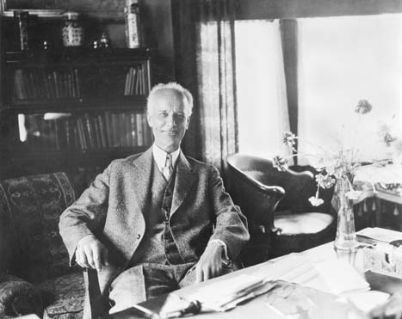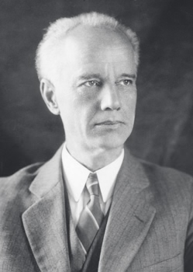

Gottfried de Purucker (January 15, 1874, Suffern, New York - September 27, 1942) was an author and Theosophist who joined the Theosophical Society on August 16, 1893. At one time he was the leader of the Theosophical_Society_Pasadena.
Asked how to say his name, he told The Literary Digest it was poo-ROO-ker and added "Because I was brought up and educated largely in French Switzerland, in Geneva, I frequently, in fact commonly, sign my name 'G. de Purucker,' using the French particle de instead of the German von, following in this the custom of many people of German origin who live or have lived in French-speaking countries." (Charles Earle Funk, What's the Name, Please?, Funk & Wagnalls, 1936.)

Works
- Wind of the Spirit
- Fundamentals of the Esoteric Philosophy
- Occult Glossary
- Encyclopedic Theosophical Glossary (Editor-in-Chief)
- Golden Precepts of Esotericism
- Man in Evolution
- The Esoteric Tradition
- Fountain-Source of Occultism
- The Path of Compassion
- The Four Sacred Seasons
- Studies in Occult Philosophy
- Questions We All Ask
- The Dialogues of G. de Purucker
- Messages to Conventions
- The Masters and the Path of Occultism
- The Story of Jesus
- Word Wisdom in Esoteric Tradition

External links
- Books by Purucker
- Books by Purucker
===========================================================================================================================
END

