[](https://matthewehret.substack.com/)

**Theosophy, Black Magick and Jack the Ripper Edgar Poe as Cultural Warrior part 13**

[Matthew Ehret](https://substack.com/@matthewehret)

Aug 02, 2024

[[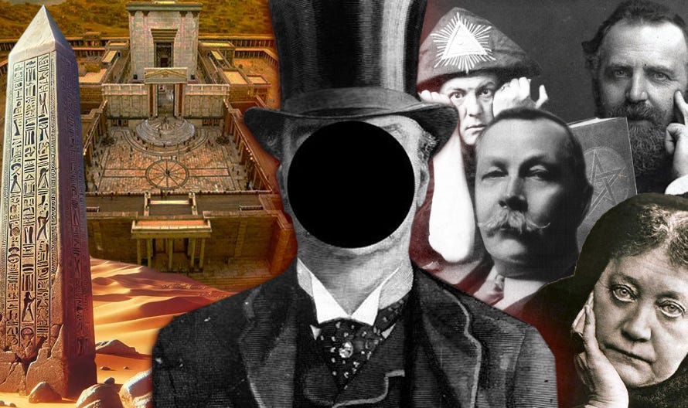](https://substackcdn.com/image/fetch/f_auto,q_auto:good,fl_progressive:steep/https%3A%2F%2Fsubstack-post-media.s3.amazonaws.com%2Fpublic%2Fimages%2F22ccea44-1acb-4632-a538-6b5544521ecf_890x528.jpeg)](https://substackcdn.com/image/fetch/f_auto,q_auto:good,fl_progressive:steep/https%3A%2F%2Fsubstack-post-media.s3.amazonaws.com%2Fpublic%2Fimages%2F22ccea44-1acb-4632-a538-6b5544521ecf_890x528.jpeg" \t "_blank)

Having explained the real reasons behind the ritual murder of New York’s Mary Cecilia Rogers in parts 9-11 of this series, the stage has now been set for the long-awaited true story of Jack the Ripper.

Hang onto your seats, because this will be a wild ride and will have everything to do with the occult revival closely associated with the reconstruction of Solomon’s Temple and the restoration of an age of pagan mystery cults.

[[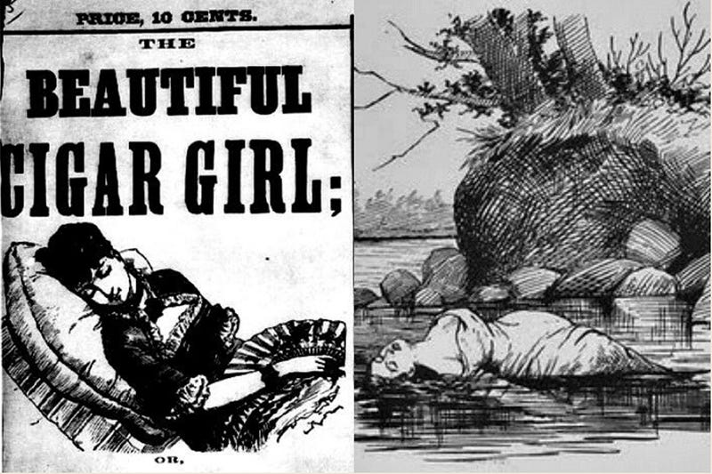](https://substackcdn.com/image/fetch/f_auto,q_auto:good,fl_progressive:steep/https%3A%2F%2Fsubstack-post-media.s3.amazonaws.com%2Fpublic%2Fimages%2F3f963053-42fa-4f15-9bd6-58e1a370e7f0_800x533.jpeg)](https://substackcdn.com/image/fetch/f_auto,q_auto:good,fl_progressive:steep/https%3A%2F%2Fsubstack-post-media.s3.amazonaws.com%2Fpublic%2Fimages%2F3f963053-42fa-4f15-9bd6-58e1a370e7f0_800x533.jpeg" \t "_blank)

The legendary Whitechapel murderer whose gruesome wave of killings in 1888 have shaped our collective imaginations for over 140 years, and an entire field of research dubbed ‘ripperology’ has been created with thousands of books, films, television shows and documentaries speculating ad infinitum about the identity of the serial killer known only as ‘Jack’.

Despite entire careers devoted obsessively to unravelling this mystery, it appears that the world is no closer to cracking the case of the Ripper’s identity than we were when they were happening.

In this final leg of our journey, we will begin by demonstrating the irrefutable proof of the occult ritualistic reasons for the Ripper murders and then we will do what no one else has done before by shedding light on the larger occult revival for a new aeon and new world religion which coincided with two new insidious movements that emerged in the late 19th century: The Theosophists and the Hermetic Order of the Golden Dawn.

To begin our tale, let us review the figure of Sir Arthur Conan Doyle.

[[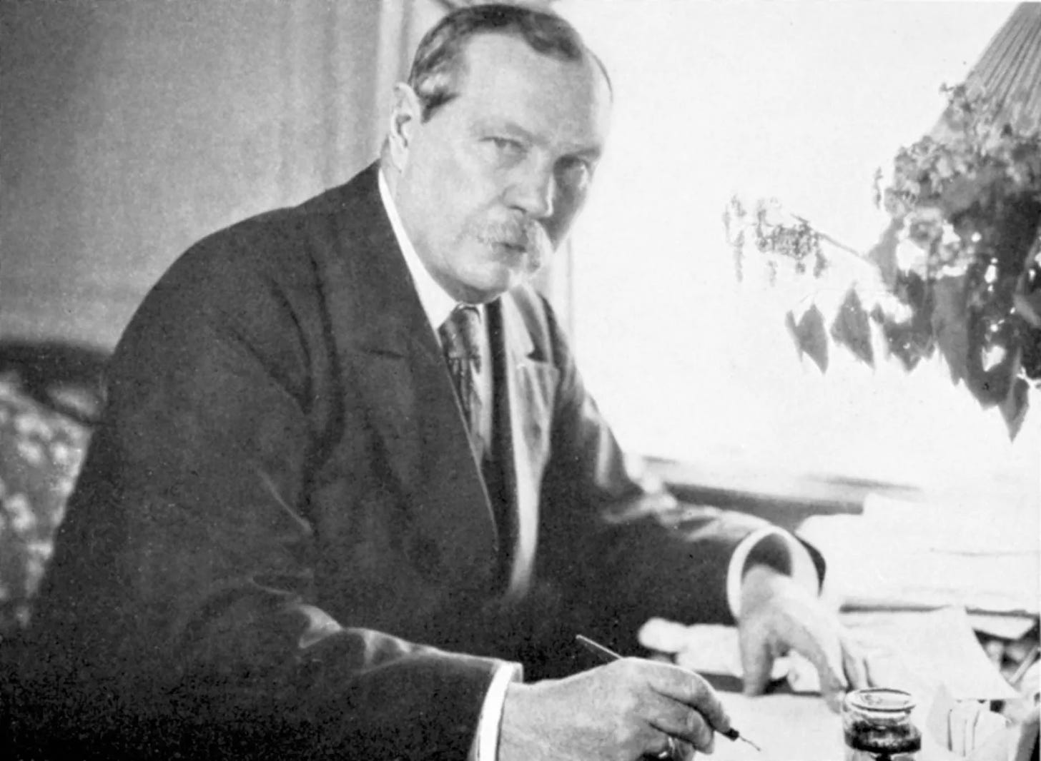](https://substackcdn.com/image/fetch/f_auto,q_auto:good,fl_progressive:steep/https%3A%2F%2Fsubstack-post-media.s3.amazonaws.com%2Fpublic%2Fimages%2F2e543cc1-7aa0-417b-ae7a-0ed59c47ce74_1600x1171.webp)](https://substackcdn.com/image/fetch/f_auto,q_auto:good,fl_progressive:steep/https%3A%2F%2Fsubstack-post-media.s3.amazonaws.com%2Fpublic%2Fimages%2F2e543cc1-7aa0-417b-ae7a-0ed59c47ce74_1600x1171.webp" \t "_blank)

**Why Sherlock ignored Jack**

Over the years, many have wondered why Sir Arthur Conan Doyle never created a Sherlock Holmes story featuring the tale of Jack the Ripper?

After all, the gruesome story has all of the elements of a detective mystery and it happened at the same period in history, and in the same part of the world that Doyle himself had chosen to create his famous heroine-addicted sleuth.

Even Doyle’s personal mentor, and the man who served as the inspiration for Sherlock Holmes (Dr. Joseph Bell) [was hired by London Metropolitan Police Commissioner Sir Charles Warren to track down the Whitechapel killer](https://matthewehret.substack.com/p/the-real-sherlock-holmes-dr-joseph).

[[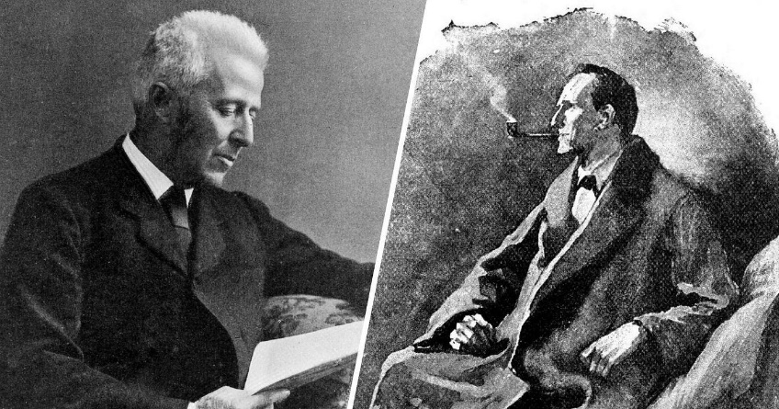](https://substackcdn.com/image/fetch/f_auto,q_auto:good,fl_progressive:steep/https%3A%2F%2Fsubstack-post-media.s3.amazonaws.com%2Fpublic%2Fimages%2F494fdbe4-1ceb-4b42-a387-265a1b7a9ee2_1400x737.jpeg)](https://substackcdn.com/image/fetch/f_auto,q_auto:good,fl_progressive:steep/https%3A%2F%2Fsubstack-post-media.s3.amazonaws.com%2Fpublic%2Fimages%2F494fdbe4-1ceb-4b42-a387-265a1b7a9ee2_1400x737.jpeg" \t "_blank)

YET, Doyle never infused this morbid tale into any of his writings.

Why?

I believe that by adopting Edgar Poe’s method of ratiocination [as showcased in part three of this series](https://matthewehret.substack.com/p/edgar-poe-as-cultural-warrior-part-6ac) (ie: an art of thinking completely banned by Doyle’s famous detective), we will make more progress towards an answer to the questions “who was Jack the Ripper” and most importantly, “**why** did those murders occur, when and where they did?”

**Setting the Stage…**

In the course of this exercise, we will start with a mapping of anomalies in the official unsolved murder mystery, and then situate some players in the drama who would have played a direct role in the murders themselves. We will also have to deal with the black magic rituals behind those murders holding in mind the lessons learned in the previous story of the occult takeover of the USA which was punctuated [by the ritual murder of Mary Cecilia Rogers in 1841](https://matthewehret.substack.com/p/the-occult-underpinnings-of-mary).

The first anomaly that will be addressed is: ***WHY*** did Arthur Ignatius Conan Doyle situate the home of his character Sherlock Holmes at the very same address located exactly two buildings away from the address that the man who carried out the Jack the Ripper murders was to actually live and work between 1890-1892?

[[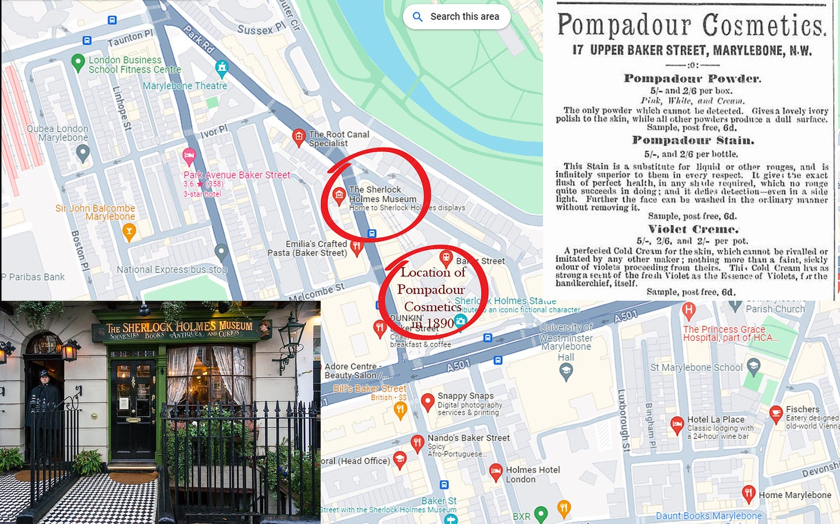](https://substackcdn.com/image/fetch/f_auto,q_auto:good,fl_progressive:steep/https%3A%2F%2Fsubstack-post-media.s3.amazonaws.com%2Fpublic%2Fimages%2F3af9ee83-53e2-4047-84fc-bf1cb1898fd3_1697x1061.jpeg)](https://substackcdn.com/image/fetch/f_auto,q_auto:good,fl_progressive:steep/https%3A%2F%2Fsubstack-post-media.s3.amazonaws.com%2Fpublic%2Fimages%2F3af9ee83-53e2-4047-84fc-bf1cb1898fd3_1697x1061.jpeg" \t "_blank)

Doyle made this strange decision in 1887… a full year BEFORE the Jack the Ripper murders even began.

Did he have clairvoyance?

Was it just a coincidence?

Or… was something darker afoot?

Let us leave our unexamined axioms at the door and begin this investigation in earnest.

**Evidence for Ritual Murder**

As researcher Ivor Edwards astutely noted in his [*Jack the Ripper’s Black Magic Rituals*](https://archive.org/details/jackrippersblack0000edwa), the murders of the five women could not have been done without an extreme degree of planning, top-down coordination, and collaboration among a variety of players.

Edwards also makes a firm case that the motive for the killings was nothing short of a black magic ritual.

For one thing, the location of the bodies were positioned perfectly east, west, north and south, while the mutilated bodies themselves featured instances of missing organs, such as the uterus and kidney, while the long intestines were tossed over the left shoulders of two victims.

Edwards additionally charts the distances from the victims are also of interest:

Distance from victim 1 to victim 2 = 930 yards  
Distance from victim 2 to victim 4 = 930 yards  
Distance from victim 3 to victim 4 = 950 yards  
Distance from victim 3 to victim 5 = 950 yards  
Distance from the center of the plan to cite 3 = 500 yards  
Distance from the center of the plan to cite 4 = 500 yards  
Distance from the center of the plan to cite 5 = 500 yards

Edwards notes that the geometric positions of the murders falls directly upon corners of two triangles (or one parallelogram) contained within two overlapping circles. This figure has been dubbed the ‘Vesica Piscis’ by occultists for millennia.

[[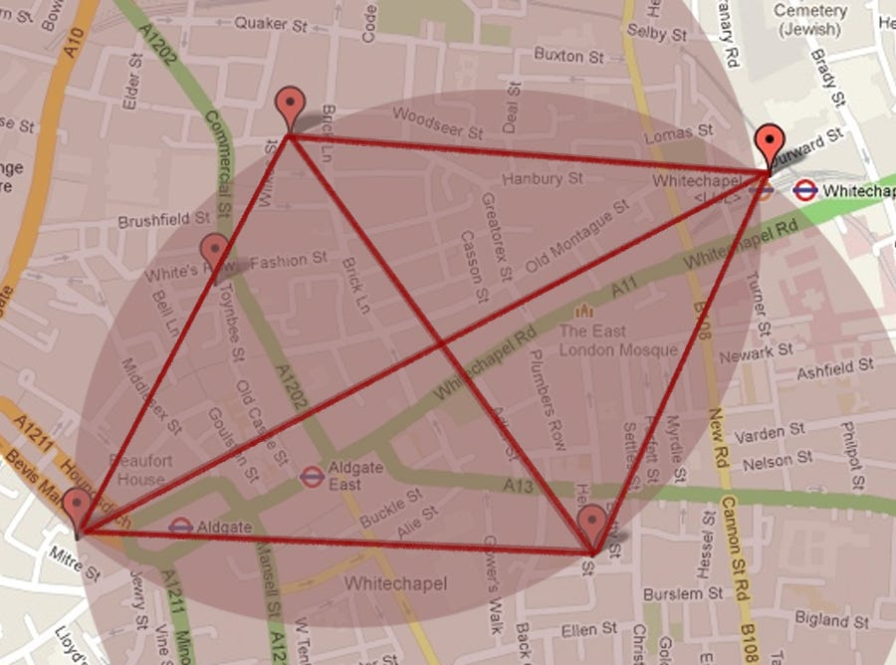](https://substackcdn.com/image/fetch/f_auto,q_auto:good,fl_progressive:steep/https%3A%2F%2Fsubstack-post-media.s3.amazonaws.com%2Fpublic%2Fimages%2F96bd6bc5-29e7-4f68-8ad9-15d43319399b_900x668.jpeg)](https://substackcdn.com/image/fetch/f_auto,q_auto:good,fl_progressive:steep/https%3A%2F%2Fsubstack-post-media.s3.amazonaws.com%2Fpublic%2Fimages%2F96bd6bc5-29e7-4f68-8ad9-15d43319399b_900x668.jpeg" \t "_blank)

What is the relevance of the Vesica Piscis?

Occult symbolists have held a special reverence for this geometric configuration for a very long time for a variety of reasons.

The word itself literally translates into “fish bladder” but has taken on much more complex symbology among occultists. One relevant occult website described the symbol in the following terms:

*“Within occult traditions, the vesica piscis is considered a potent symbol of hidden knowledge and esoteric wisdom. It is often used in magical rituals, talismanic designs and sigil work to channel spiritual energies and invoke supernatural forces. Occultists view the vesica piscis as a doorway to the unseen realms…”*

[[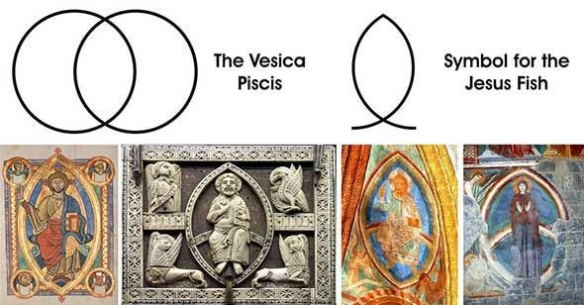](https://substackcdn.com/image/fetch/f_auto,q_auto:good,fl_progressive:steep/https%3A%2F%2Fsubstack-post-media.s3.amazonaws.com%2Fpublic%2Fimages%2Fa9cc2779-e379-4fdf-9a92-4053692df103_590x308.jpeg)](https://substackcdn.com/image/fetch/f_auto,q_auto:good,fl_progressive:steep/https%3A%2F%2Fsubstack-post-media.s3.amazonaws.com%2Fpublic%2Fimages%2Fa9cc2779-e379-4fdf-9a92-4053692df103_590x308.jpeg" \t "_blank)

[[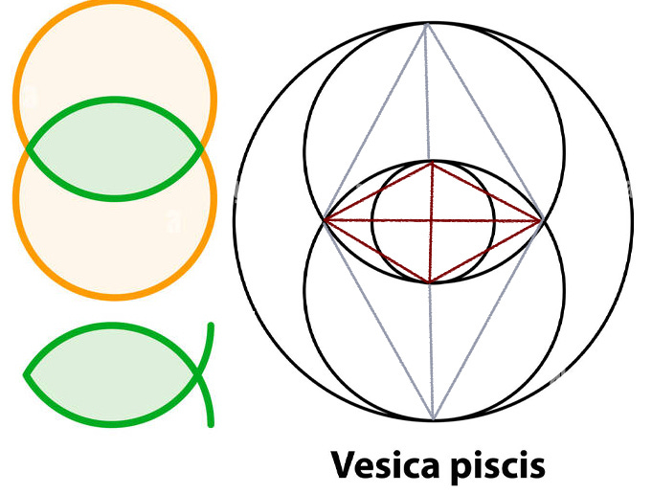](https://substackcdn.com/image/fetch/f_auto,q_auto:good,fl_progressive:steep/https%3A%2F%2Fsubstack-post-media.s3.amazonaws.com%2Fpublic%2Fimages%2F6512a129-5a21-4fdd-9c11-6fba2cd0322b_681x516.jpeg)](https://substackcdn.com/image/fetch/f_auto,q_auto:good,fl_progressive:steep/https%3A%2F%2Fsubstack-post-media.s3.amazonaws.com%2Fpublic%2Fimages%2F6512a129-5a21-4fdd-9c11-6fba2cd0322b_681x516.jpeg" \t "_blank)

In an article titled ‘[On Ancient Mesopotamian Beliefs](https://syriacpress.com/blog/2022/03/18/ancient-mesopotamian-beliefs-vesica-piscis/)’, Yawsef Beth Turo and Nurgül Çelebi discuss how the pagan symbolism of the vesica piscis adapted to the Christian worldview in the 2nd century AD:

*“It is thought that this symbol was used as of the second century after Jesus. It is known that it was used in this way in ancient pagan times and symbolizes the uterus and vagina. But over time, the symbolism of the fish became integrated with the physical and imaginary fish symbol. Thus, the “fish”, which is mentioned both in the drawings and in various discourses, has actually come to represent the “female energy”, that is, the “goddess”. It is well known in the esoteric tradition that the fish symbolizes the uterus and vagina.”*

[[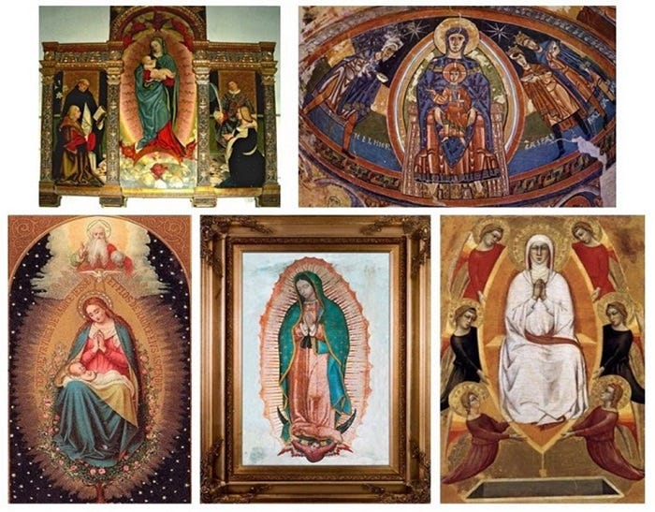](https://substackcdn.com/image/fetch/f_auto,q_auto:good,fl_progressive:steep/https%3A%2F%2Fsubstack-post-media.s3.amazonaws.com%2Fpublic%2Fimages%2F542481ae-e434-473e-8fe2-58cfe67380ee_700x547.jpeg)](https://substackcdn.com/image/fetch/f_auto,q_auto:good,fl_progressive:steep/https%3A%2F%2Fsubstack-post-media.s3.amazonaws.com%2Fpublic%2Fimages%2F542481ae-e434-473e-8fe2-58cfe67380ee_700x547.jpeg" \t "_blank)

The obsession with the Vesica Piscis among gnostics is longstanding and has nothing to do with the actual practice of Christianity. The imagery itself pre-dates Christianity among various pagan cultures and even finds expression in Indian iconography.

[[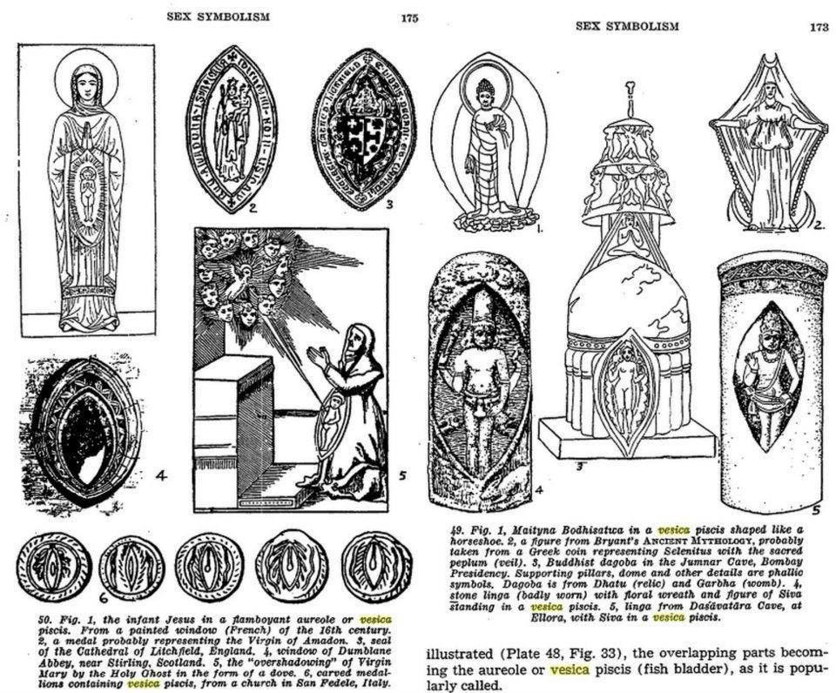](https://substackcdn.com/image/fetch/f_auto,q_auto:good,fl_progressive:steep/https%3A%2F%2Fsubstack-post-media.s3.amazonaws.com%2Fpublic%2Fimages%2F910bbf96-d541-4d3b-87c1-1d6a8f43542a_960x796.jpeg)](https://substackcdn.com/image/fetch/f_auto,q_auto:good,fl_progressive:steep/https%3A%2F%2Fsubstack-post-media.s3.amazonaws.com%2Fpublic%2Fimages%2F910bbf96-d541-4d3b-87c1-1d6a8f43542a_960x796.jpeg" \t "_blank)

During the Roman Empire, the Emperor Caligula brought in an obelisk from Heliopolis, Egypt in honor of the pontifex maximus that was the cult of the emperor which was challenged by the bishop at Rome during the early centuries of Christianity.

In 1586, Caligula’s obelisk (an homage to the Cult of Isis-Serapis) was moved to Saint Peters Square and under the direction of [Venetian grand-inquisitor turned Pope Sixtus V](https://en.wikipedia.org/wiki/Pope_Sixtus_V). Sixtus employed neo-Platonic artist (and Renaissance eroticist) Gian Lorenzo Bernini, to redesign the square around a vesica piscis overlooked by St Peter’s Basilica- the house of the Papacy in Vatican City.

[[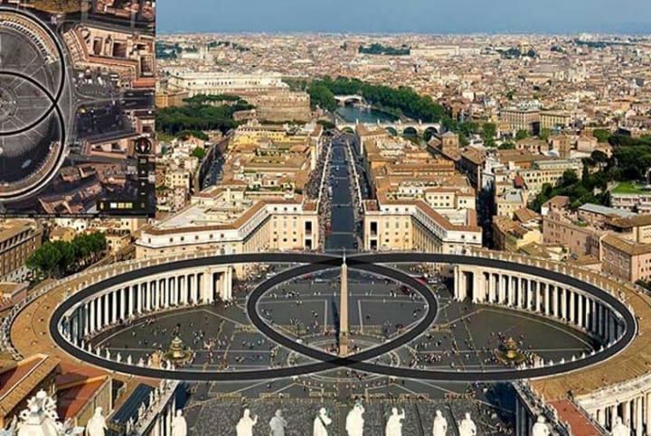](https://substackcdn.com/image/fetch/f_auto,q_auto:good,fl_progressive:steep/https%3A%2F%2Fsubstack-post-media.s3.amazonaws.com%2Fpublic%2Fimages%2Ff77eb4bc-ef0e-4250-b8b6-d6aa758fae3f_720x483.jpeg)](https://substackcdn.com/image/fetch/f_auto,q_auto:good,fl_progressive:steep/https%3A%2F%2Fsubstack-post-media.s3.amazonaws.com%2Fpublic%2Fimages%2Ff77eb4bc-ef0e-4250-b8b6-d6aa758fae3f_720x483.jpeg" \t "_blank)

The infusion of pagan symbology into early Christianity can only be understood when one appreciates the stark battle between moral world views that raged between the polytheistic cults of Isis, Mithra and Cybele in opposition to the young Christian monotheistic movement during the time of the Roman Empire, and will be addressed more fully in a future segment of this series.

**The Vesica Piscis and Solomon’s Temple**

Modern freemasonry has tended toward a consensus (through the efforts of Sir Charles Warren and Sir Walter Besant of the Palestinian Exploration Fund), that the Vesica Pisces was used in the foundation for Solomon’s Temple as well in the rituals associated with Kabbalah (ie: the Jewish mystical tradition tied to the supposed ‘secret teachings of Moses’ passed down through initiates, and which formed the basis of the gnostic cults of Simon Magus and Marcian that warred with early Christianity in the 1st through 5th centuries).

[[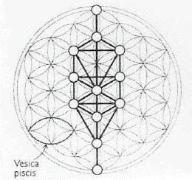](https://substackcdn.com/image/fetch/f_auto,q_auto:good,fl_progressive:steep/https%3A%2F%2Fsubstack-post-media.s3.amazonaws.com%2Fpublic%2Fimages%2Fd6c3bd7a-ff7b-4a58-9884-b472f12d621d_260x244.jpeg)](https://substackcdn.com/image/fetch/f_auto,q_auto:good,fl_progressive:steep/https%3A%2F%2Fsubstack-post-media.s3.amazonaws.com%2Fpublic%2Fimages%2Fd6c3bd7a-ff7b-4a58-9884-b472f12d621d_260x244.jpeg" \t "_blank)

Freemason and researcher Kevin L. Gest writes in “*The Secrets of Solomon’s Temple*” that the secret of ‘Solomon’s Seal’ is found in *“the geometric shape of the interlocking triangles…derived from the interlocking circles of Vesica Pisces, which indicates an understanding of ancient/sacred geometry; Vesica Pisces being the basis of Solomon’s Seal, is the key to the ground plan and dimensions of the temple.”*

These facts will become extremely important as we move through our tale…

**Anomalies in the five victims**

The five principal Whitechapel victims murdered between August 31-November 9, 1888 were:   
  
1) **Mary Ann Nichols** who was disembowled on Buck's Row on August 31 with her neck cut to the spine and her vagina repeatedly stabbed,   
  
2) **Annie Chapman**'s death on September 8 on Hambury Street with her uterus, bladder and vagina removed, neck cut to the bone, abdomen ripped open with small intestines pulled over her right shoulder. Laid at her feet were two brass rings, two new farthings and a few coins. Here, researcher Stephen Knight points out that the symbolism of brass rings may be related to the Masonic significance of the legendary Hiram Abiff, the architect of Solomon’s Temple who was a worker in brass who reputedly supervised the moulding of two hollow brass pillars which reputedly stood at the entrance of Solomon’s Temple. Within Masonic lore (at least since the late 19th century), two brass rings have been used to represent the temple’s entrance.  
  
3) **Elizabeth Stride** whose body was discovered on September 30 featuring only a deeply slashed neck but no other mutilations implying the killer abandoned the work before finishing,   
  
4) **Catherine Eddowes** who was discovered 45 minutes after Stride (on September 30) on Mitre Square in the City of London with her left kidney and uterus removed, and intestines pulled over her right shoulder. Her face was disfigured with cuts on eyelids and two triangular cuts on each cheek. The masonic significance here is that two triangles represent the altar top of the Holy Royal Arch rite and is additionally constructed through the Vesica Pisces. It should also be noted that this was the only murder to occur within the confines of “the square mile” City of London and on the grounds of the cloister of the Holy Trinity Priori built in the wake of the 1st Crusade by Templar patron Matilde of Scotland. “Mitre Square” also quite literally refers to the instrument used by architects to construct angles beyond 90 degrees and has profound significants for masons and in the 19th century had been the meeting place for masons belonging to Hiram’s Lodge in London.

5) Finally **Mary Jane Kelly**’s body was discovered on November 9, 1888 on Dorset Street. Her body was completely mutilated with her uterus and kidneys placed beneath her head and her heart was missing

Rather than being random victims selected spontaneously by the killer, researcher Stephen Knight demonstrates in “Jack the Ripper: The Final Solution,” that all five women not only would have known each other, but all came from Dorset Street, and two of them lived in the same building. Citing the research of Walter Sickert, Knight writes:

*“Three of the four Ripper victims whom Sickert claimed knew each other all came from Dorset Street. Two of them were living at the same house. Two frequented the same pub. The evidence that they knew each other seems overwhelming. The fourth victim whom Sickert said was part of the same circle, though she was murdered nearly a mile away in Bucks Row, lived less than a hundred yards from the others and doubtless frequented the same pub… In a metropolis the size and character of the East End, it is inconceivable that a random killer could have cut down, in places up nearly a mile apart, four women who just happened to know each other.” [1]*

**An Anomolous Cast of Characters: Sir Charles Warren**

Sir [Charles Warren](https://www.jack-the-ripper.org/sir-charles-warren.htm) (1840-1927), was London Metropolitan Commissioner from 1886-1888) and Grand Master of King Edward VII’s Quatuor Coronati Lodge.

[[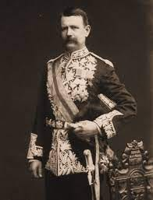](https://substackcdn.com/image/fetch/f_auto,q_auto:good,fl_progressive:steep/https%3A%2F%2Fsubstack-post-media.s3.amazonaws.com%2Fpublic%2Fimages%2F65a58534-5d69-4068-b7e4-bd276d918c72_196x257.jpeg)](https://substackcdn.com/image/fetch/f_auto,q_auto:good,fl_progressive:steep/https%3A%2F%2Fsubstack-post-media.s3.amazonaws.com%2Fpublic%2Fimages%2F65a58534-5d69-4068-b7e4-bd276d918c72_196x257.jpeg" \t "_blank)

Sir Charles Warren

Warren is among the most notable characters in this story because he was not only among the most powerful freemasons in the world, but was among the most decorated generals of the empire.

As Stephen Knight writes in [*Jack the Ripper: The Final Solution*](https://www.amazon.com/Jack-Ripper-solution-Stephen-Knight/dp/0245527249):

*“In the twenty-seven years between his passing the Royal Arch and the Whitechapel Murders, Warren became not only one of England’s highest ranking masons, but one of the most powerful in the world. A lodge in South Africa was named after him; in England he was a founder of the Quatuor Coronati Lodge of Masonic Research and Past Grand Sojourner in the Supreme Grand Chapter; and in 1891 he became District Grand Master of the Eastern Archipelago.” [2]*

Warren was also the singular individual most responsible for the excavation of Mount Moria in Jerusalem.

In 1864, a new phase of the British Empire’s plans for global conquest was launched with a two fold operation to: 1) wrest away control of Jerusalem from a dying Ottoman Empire and 2) establishing a movement to extract European and Russian Jews from their homelands by sending them into the desert. [3]

As hard as it may be to believe, the ultimate ambition was to use a new Kabbalistic eschatology to reconstruct a New Babylon as part of a vision to usher in a new age of humanity.

[[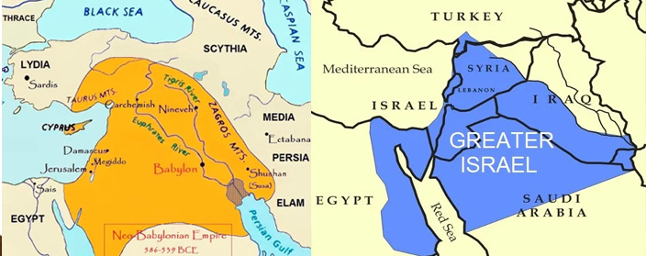](https://substackcdn.com/image/fetch/f_auto,q_auto:good,fl_progressive:steep/https%3A%2F%2Fsubstack-post-media.s3.amazonaws.com%2Fpublic%2Fimages%2F9c1b54fb-b5a6-4a21-a2c4-2b2bbece3712_704x279.jpeg)](https://substackcdn.com/image/fetch/f_auto,q_auto:good,fl_progressive:steep/https%3A%2F%2Fsubstack-post-media.s3.amazonaws.com%2Fpublic%2Fimages%2F9c1b54fb-b5a6-4a21-a2c4-2b2bbece3712_704x279.jpeg" \t "_blank)

On the other side of this plan, the stage was also set for the reconstruction of Solomon’s Temple by a British Masonic effort led by an agency called ‘The Palestinian Exploration Fund’ (PEF) founded in 1864.

The Palestinian Exploration Fund was created by British Freemasons under the direction of Prince Edward VII, Grandmaster of the United Grand Lodge and undisputed leader of global freemasonry from 1862 until his death in 1910. The PEF was assigned to excavate the vast catacombs, and tunnels under the Temple Mount in Jerusalem (the purported site of today’s Dome of the Rock and previous two temples destroyed in 587 BC and 70 AD).

In 1867, Sir Charles Warren arrived in Palestine to oversee the PEF’s work.

In the coming years, Charles Warren became known as the dominant authority of Solomon’s Temple authoring such foundational texts as *The Recovery of Jerusalem* in 1871, *The Land of the Promise* in 1875, and *Underground Jerusalem* in 1876.

[[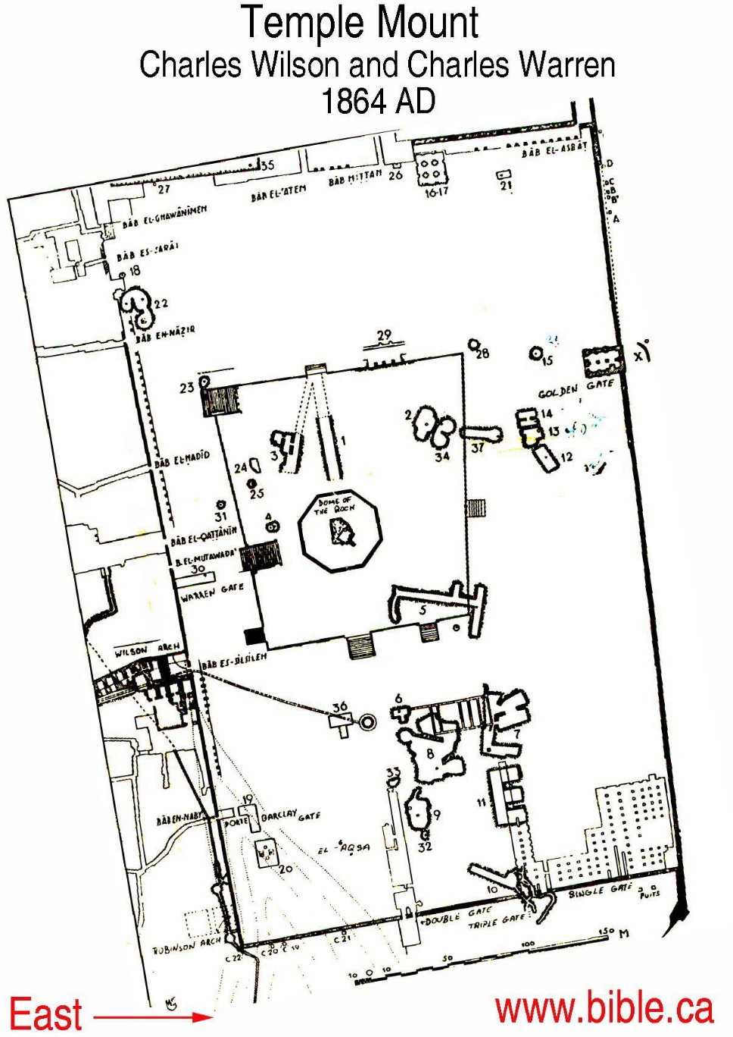](https://substackcdn.com/image/fetch/f_auto,q_auto:good,fl_progressive:steep/https%3A%2F%2Fsubstack-post-media.s3.amazonaws.com%2Fpublic%2Fimages%2F1cc89268-737c-4b20-b17f-4b73462dea50_1205x1703.jpeg)](https://substackcdn.com/image/fetch/f_auto,q_auto:good,fl_progressive:steep/https%3A%2F%2Fsubstack-post-media.s3.amazonaws.com%2Fpublic%2Fimages%2F1cc89268-737c-4b20-b17f-4b73462dea50_1205x1703.jpeg" \t "_blank)

Warren worked closely with Sir Walter Besant (handler of Theosophist leader Annie Besant) in founding the Quatuor Coronati Lodge and oversaw a renovation of United Grand Lodge Freemasonry, infusing new rites into the ceremonies including the Royal Arch degree, and even presided over the first Freemasonic Ceremony in Solomon’s mines underneath the Temple Mount in 1868.

Between 1870 to 1886, Warren became a Commander of the Order of Saint Michael and Saint George, a Knight of the Order of Bath, Knight of the Order of Saint John of Jerusalem and Grand Decon of the United Grand Lodge.

[[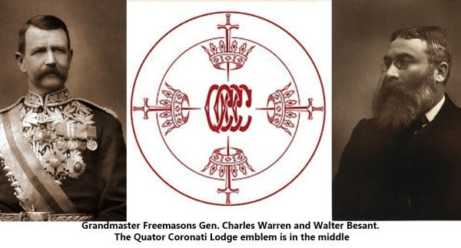](https://substackcdn.com/image/fetch/f_auto,q_auto:good,fl_progressive:steep/https%3A%2F%2Fsubstack-post-media.s3.amazonaws.com%2Fpublic%2Fimages%2F32f98c51-3e74-40f1-8609-3e8e7eb93c8f_600x323.jpeg)](https://substackcdn.com/image/fetch/f_auto,q_auto:good,fl_progressive:steep/https%3A%2F%2Fsubstack-post-media.s3.amazonaws.com%2Fpublic%2Fimages%2F32f98c51-3e74-40f1-8609-3e8e7eb93c8f_600x323.jpeg" \t "_blank)

With such impressive qualifications as one of the most influential occultists of the British Empire, it is a wonder ***why*** Sir Warren was placed in charge of the London Police from 1886 to 1888?

Warren’s decision to resign from his post mere hours before the final ripper victim was discovered on November 9, 1888 is also an anomaly worth holding in mind.

**The Anomalous Case of Sir Robert Anderson**

During the Ripper murders, Charles Warren worked closely with fellow freemason Sir Robert Anderson (1841-1918), second Assistant Commissioner (of the Crime Division) of the London Metropolitan Police and Knight of the Order of Bath.

[[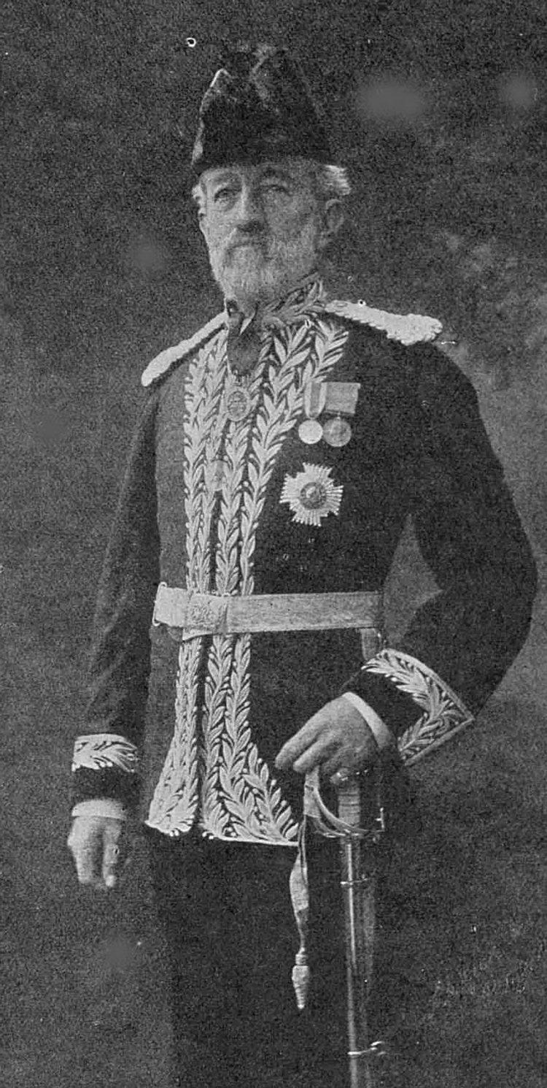](https://substackcdn.com/image/fetch/f_auto,q_auto:good,fl_progressive:steep/https%3A%2F%2Fsubstack-post-media.s3.amazonaws.com%2Fpublic%2Fimages%2F2d9fae0d-f95c-43af-b17c-1fc3afdc9f42_750x1490.jpeg)](https://substackcdn.com/image/fetch/f_auto,q_auto:good,fl_progressive:steep/https%3A%2F%2Fsubstack-post-media.s3.amazonaws.com%2Fpublic%2Fimages%2F2d9fae0d-f95c-43af-b17c-1fc3afdc9f42_750x1490.jpeg" \t "_blank)

Sir Robert Anderson

The systemic incompetence displayed by Warren and Anderson in their handling of the Whitechapel murders has become legendary. Throughout their tenure, their [incompetence involved vast miscarriages of justice](https://www.jack-the-ripper-tour.com/generalnews/the-london-police-1888/), false arrests of hundreds of accused Ripper suspects, the encouragement of misinformation campaigns and a systematic demoralization of the entire London Police Force.

For example, leading up to the killings, Warren ensured that the entire police force led a crusade to stop rabid dogs instead of preventing actual cases of crime throughout London.

[[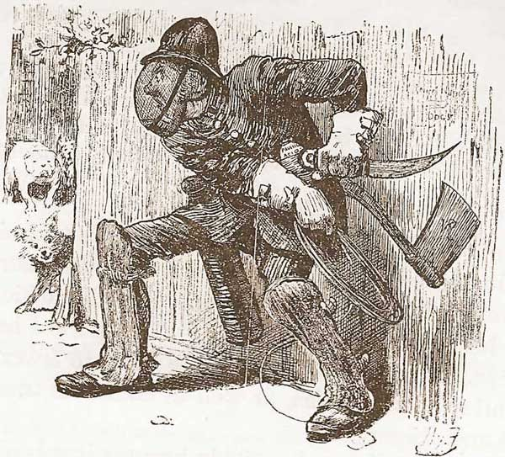](https://substackcdn.com/image/fetch/f_auto,q_auto:good,fl_progressive:steep/https%3A%2F%2Fsubstack-post-media.s3.amazonaws.com%2Fpublic%2Fimages%2F92deb612-67d7-415f-9893-d404276f0bd1_600x543.jpeg)](https://substackcdn.com/image/fetch/f_auto,q_auto:good,fl_progressive:steep/https%3A%2F%2Fsubstack-post-media.s3.amazonaws.com%2Fpublic%2Fimages%2F92deb612-67d7-415f-9893-d404276f0bd1_600x543.jpeg" \t "_blank)

London cartoon mocking the war against dogs overseen by Charles Warren

Sir Robert Anderson’s involvement with The Plymouth Brethren cult is the first anomaly worth considering before zeroing in on the hands behind the Jack the Ripper murders.

The Plymouth Brethren was a sect of supposedly puritan Christians created in 1829 by [an agent of the British East India Company](https://www.sermonindex.net/modules/articles/index.php?view=article&aid=16173) named Anthony Norris Groves. [Groves was sent to the Ottoman Empire and then India](https://www.readcentral.com/chapters/Anthony-Norris-Groves/Journal-of-a-Residence-at-Bagdad/003) in 1830 as an orientalist engaged in recruiting young elites to train in British universities while carrying out espionage under the banner of Christian missionary work. Groves was soon joined by John Nelson Darby (godson of Admiral Horatio Nelson and father of modern rapture theology).

[[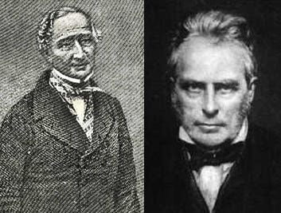](https://substackcdn.com/image/fetch/f_auto,q_auto:good,fl_progressive:steep/https%3A%2F%2Fsubstack-post-media.s3.amazonaws.com%2Fpublic%2Fimages%2F10e1e22d-c8d5-4887-ae65-9cd1fad24d31_353x267.jpeg)](https://substackcdn.com/image/fetch/f_auto,q_auto:good,fl_progressive:steep/https%3A%2F%2Fsubstack-post-media.s3.amazonaws.com%2Fpublic%2Fimages%2F10e1e22d-c8d5-4887-ae65-9cd1fad24d31_353x267.jpeg" \t "_blank)

Anthony Norris Groves and John Nelson Darby

Darby, who considered himself a prophet, conducted six tours of the US seeding his doctrine into dozens of gnostic cults. [Each one taught followers to interpret Bible prophecy the same way.](https://www.bible.ca/rapture-origin-john-nelson-darby-1830ad.htm) This obviously required sending all Jews to Palestine, at which point a “secret rapture” for believers would unfold—followed by a Hellscape of pain for heathens left to burn under the fires of global war and the anti-Christ. [4] Over the years, Darby and Sir Anderson delivered sermons together promoting their peculiar new brand of Christianity that has come to be known as “Christian Zionism” and “pre-millennial dispensationalism” today.

The Plymouth Brethren were not a typical Christian sect but rather featured an esoteric (secret) face dubbed ‘The Exclusive Brethren’ and exoteric (public) face for the uninitiated. Among the most well known figures who emerged from this group was British Intelligence occultist Aleister Crowley.

[[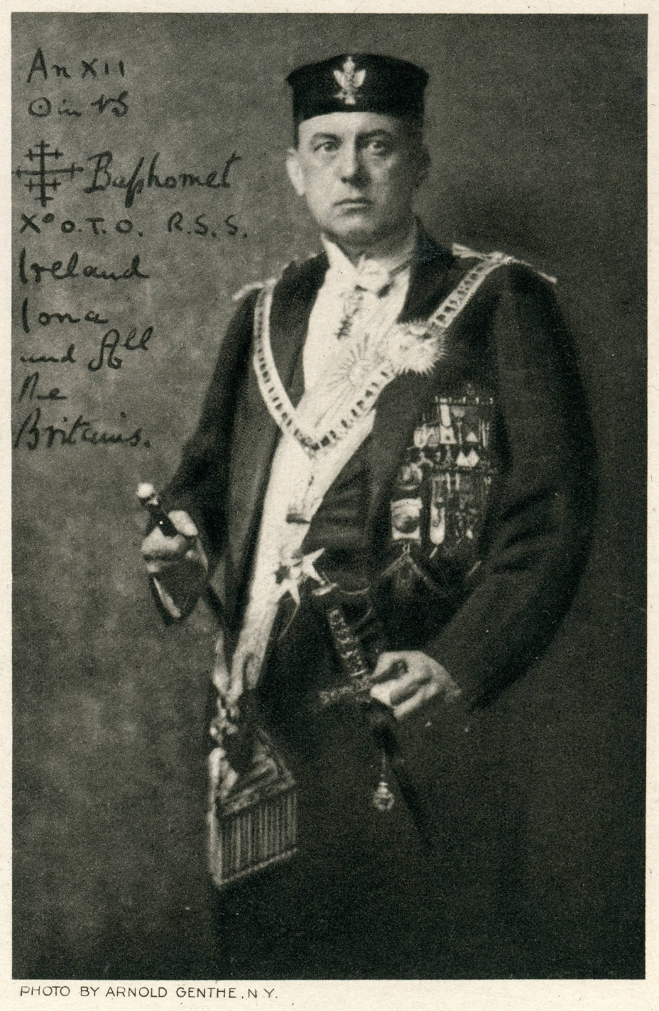](https://substackcdn.com/image/fetch/f_auto,q_auto:good,fl_progressive:steep/https%3A%2F%2Fsubstack-post-media.s3.amazonaws.com%2Fpublic%2Fimages%2Ffb680c33-b86f-48b8-9b24-bf6bc4433e80_2909x4476.jpeg)](https://substackcdn.com/image/fetch/f_auto,q_auto:good,fl_progressive:steep/https%3A%2F%2Fsubstack-post-media.s3.amazonaws.com%2Fpublic%2Fimages%2Ffb680c33-b86f-48b8-9b24-bf6bc4433e80_2909x4476.jpeg" \t "_blank)

Sir Robert Anderson’s involvement with Darby’s Exclusive Brethren places him in direct contact with a Solomon’s Temple cult revival, and the effort to eliminate the Jews of Europe by sending them into Palestine.

Anderson did much to enflame the anti-semitism of Europe at the time by promoting the notion that the [Ripper was definitely](https://allthingsthriller.com/2019/04/15/antisemitism-jack-the-rippers-accomplice-hype-his-disguise/#:~:text=Assistant%20Commissioner%20Sir%20Robert%20Anderson,) a “low class Polish Jew” writing:

*“I am almost tempted to disclose the identity of the murderer… But no public benefit would result from such a course, and the traditions of my old department would suffer. I would merely add that the only person who ever had a good view of the murderer unhesitatingly identified the suspect the instant he was confronted with him; but he refused to give evidence against him. In saying he was a Polish Jew I am merely stating a definitely ascertained fact.”*

The spread of anti-Jewish hostility across Europe was of course an invaluable component to the success of zionism in those early years as Jews tended to resist leaving their ancestral homes in favor of a desert lifestyle.

**The Case of William Melville: Scotland Yard Investigator**

Both Anderson and Warren also worked [with investigator William Melville](https://www.dailymail.co.uk/news/article-3927334/How-former-police-detective-later-head-Secret-Service-Bureau-British-spy-codenamed-M-50-years-James-Bond-cryptonym-famous.html) on the Jack the Ripper case. William Melville (1850-1918) was the head of the Special Irish Branch of Scotland Yard in 1883 and later super-intendant of Scotland in 1893 where he infamously staged anarchist terrorist attacks in order to justify illegal state interventions into republican movements such as the Fenians.

[[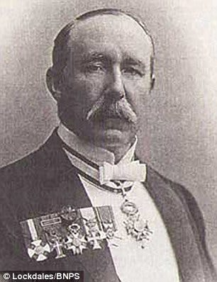](https://substackcdn.com/image/fetch/f_auto,q_auto:good,fl_progressive:steep/https%3A%2F%2Fsubstack-post-media.s3.amazonaws.com%2Fpublic%2Fimages%2F8c98b56a-787e-4de9-8ef5-9481740e7b45_306x398.jpeg)](https://substackcdn.com/image/fetch/f_auto,q_auto:good,fl_progressive:steep/https%3A%2F%2Fsubstack-post-media.s3.amazonaws.com%2Fpublic%2Fimages%2F8c98b56a-787e-4de9-8ef5-9481740e7b45_306x398.jpeg" \t "_blank)

Melville’s code name was ‘M’, he co-created MI5 and MI6 in later years and served as the inspiration for the character of the same name in Ian Flemming’s James Bond.

**The Case of William Wynn Westcott: London Coroner**

Another participant in the Jack the Ripper case was none other than William Wynn Westcott (1848-1925), co-founder of the Hermetic Order of the Golden Dawn, Theosophist, Grand Magus of the Rosicrucian Society of England (itself founded by Sir Edward Bulwer Lytton) and London coroner during the Whitechapel killings.

[[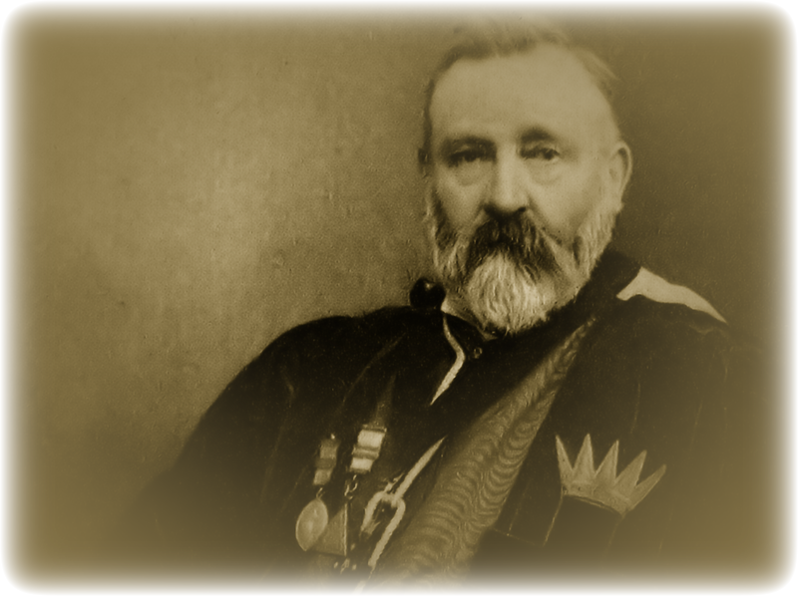](https://substackcdn.com/image/fetch/f_auto,q_auto:good,fl_progressive:steep/https%3A%2F%2Fsubstack-post-media.s3.amazonaws.com%2Fpublic%2Fimages%2F862558ce-879e-4180-b6c7-4b828d5e7504_800x598.png)](https://substackcdn.com/image/fetch/f_auto,q_auto:good,fl_progressive:steep/https%3A%2F%2Fsubstack-post-media.s3.amazonaws.com%2Fpublic%2Fimages%2F862558ce-879e-4180-b6c7-4b828d5e7504_800x598.png" \t "_blank)

William Wynn Westcott

Westcott worked closely with Aleister Crowley, Sir Arthur Conan Doyle [and Nikola Tesla’s mentor Sir William Crookes](https://matthewehret.substack.com/p/the-occult-tesla-part-10) through the Golden Dawn and more than a few researchers [have speculated](https://www.martock.org.uk/bridge-house/) that Westcott played a direct role in the killings themselves.

As stated earlier [in part 7 of this series](https://matthewehret.substack.com/p/the-mormon-role-in-the-the-purge), Westcott collaborated with Albert Pike’s lieutenant John Yarker as a founding member of the Rosicrucian ‘Society of Eight’ in 1883… which gave rise to the Hermetic Order of the Golden Dawn founded in 1886.

[[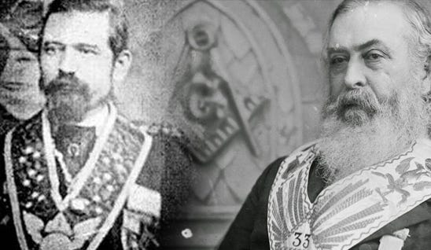](https://substackcdn.com/image/fetch/f_auto,q_auto:good,fl_progressive:steep/https%3A%2F%2Fsubstack-post-media.s3.amazonaws.com%2Fpublic%2Fimages%2F33fd5fed-e0d9-42df-a7d2-79da2356db11_548x318.jpeg)](https://substackcdn.com/image/fetch/f_auto,q_auto:good,fl_progressive:steep/https%3A%2F%2Fsubstack-post-media.s3.amazonaws.com%2Fpublic%2Fimages%2F33fd5fed-e0d9-42df-a7d2-79da2356db11_548x318.jpeg" \t "_blank)

John Yarker and Albert Pike

Westcott didn’t found the Golden Dawn alone, but with two other adepts of ceremonial magic, alchemy and Kabbalah named Macgregor Mathers and William Robert Woodman. All three were obsessed with Solomon’s Temple and Kabbalah with Mathers co-writing [The Magical Books of Solomon](https://www.amazon.ca/Magical-Books-Solomon-Greater-Testament/dp/B095GL6S68) (with Aleister Crowley) which had a vast impact on occult beliefs and rites in the 20th century.

The Golden Dawn was created out of British Freemasonry and based itself on 60 Cipher Manuscripts that had been decoded by the three occultists which formed the basis of the new rites and rituals used by the organization.

[[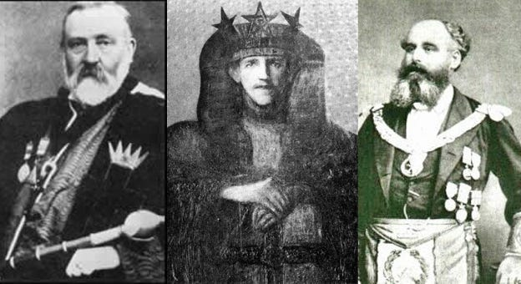](https://substackcdn.com/image/fetch/f_auto,q_auto:good,fl_progressive:steep/https%3A%2F%2Fsubstack-post-media.s3.amazonaws.com%2Fpublic%2Fimages%2Ffc1ca8ea-5e00-4739-9cc5-d3a6e52a5106_624x340.jpeg)](https://substackcdn.com/image/fetch/f_auto,q_auto:good,fl_progressive:steep/https%3A%2F%2Fsubstack-post-media.s3.amazonaws.com%2Fpublic%2Fimages%2Ffc1ca8ea-5e00-4739-9cc5-d3a6e52a5106_624x340.jpeg" \t "_blank)

William Wynn Westcott, Macgregor Mathers and William Robert Woodman

All three Rosicrucians would also be early members of Blavatsky’s Theosophists prior to creating the Golden Dawn and in Westcott’s official biography we find that he *“was soon admitted to the nucleus of the Theosophical Society, the Esoteric Section, and became close friends with Anna Kingsford and Edward Maitland who were proponents of Christian Esotericism.* ***When the members of the Esoteric Section broke away from the Theosophical Society, they formed the Hermetic Society…*** *and Westcott was invited to join as an honorary member.”*

It made sense to combine both mystery cults since they had many points of common theology.

Both cults embraced:

1) A devotion to a gnostic revival and overthrow of Christianity,

2) A Manichean light/darkness dualism which presumed a necessary existence and thus ‘goodness’ to the universal force of evil,

3) A syncretization of global occult systems, and

4) A belief in ‘secret chiefs’, sometimes dubbed ‘ascended masters’ which communicated astrally with adepts of either lodge.

The satanic underpinnings of this Esoteric section of the Theosophists was laid out in the “merging evil with good” philosophy of Theosophist leaders Anna Kingsford and Maitland who wrote:

*“Many names hath God given him, names of mystery, secret and terrible. God called him Satan the Adversary… and the Destroyer…. and the Avenger… and the Sifter… and the Deceiver… and the Tempter… For Satan is the doorkeeper of the Temple of the King: He standeth in Solomon’s porch; He holdeth the Keys to the Sanctuary… For Satan is the magistrate of the Justice of God; he beareth the balance and the sword, to execute judgement and vengeance upon all who come short of the commandments of God; to weigh their Works, to measure their desire and to number their days… Therefore Satan is the Minister of God, Lord of the seven mansions of Ilades, the Angle of the manifest worlds”.*

Throughout his life, Westcott was also an important contributor to Theosophy’s official journal Lucifer Magazine, which will also play into the Jack the Ripper story in surprising ways.

**Baroness Vittoria Cremers and Lucifer Magazine**

Another important, yet overlooked group of characters in this story closely tied to Westcott and Crowley are the Theosophists Mabel Collins (editor-in-chief of Theosophy’s Lucifer Magazine and co-founder of the Estoteric Section, and Baroness Vittoria Cremers (manager of [Lucifer Magazine](https://www.gutenberg.org/files/60852/60852-h/60852-h.htm) 1888-1890) and confidante of Mabel Collins who lived and worked together at 15 Baker Street after both women left the Theosophists.

[Vittoria Cremers was an American theosophist](https://www.patheos.com/blogs/marginalia/2024/02/miss-cremers-and-the-ripper/), born of an English nobleman and Italian mother who married a Russian diplomat in 1886, earning her the title ‘baronesse’. In 1912, she became the business manager to Aleister Crowley.

[Her 1943 interviews](https://issuu.com/lemisanthrope/docs/jack-the-ripper-and-black-magic-victorian-conspira/s/14440380) with **American journalist Bernard O’Donnell having formed an invaluable component of the available information tying the Golden Dawn, Theosophists and Jack the Ripper Murders together.**

[Lucifer Magazine](https://www.gutenberg.org/files/60852/60852-h/60852-h.htm) had been created by Madame Blavatsky in 1887 as the official voice for the Theosophists, and after the 1891 death of Blavatsky, was run by Annie Besant.

[[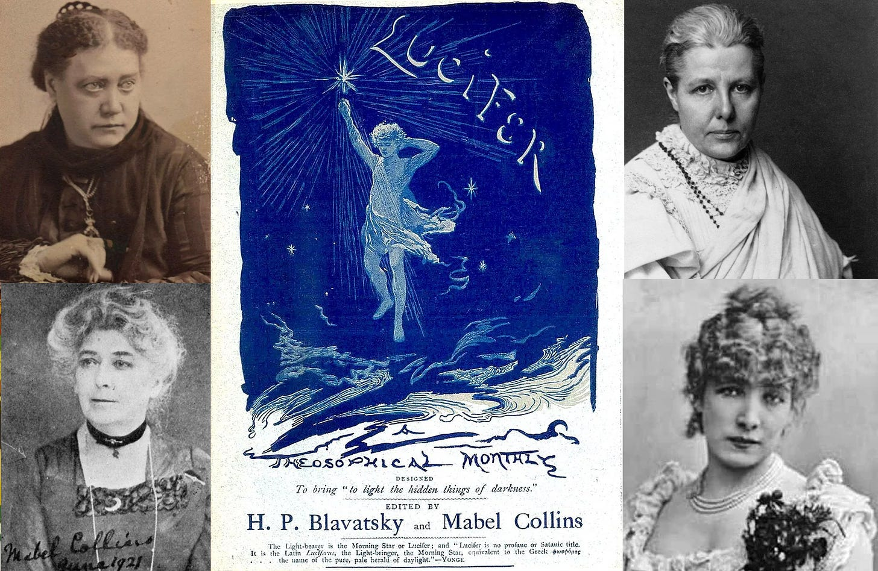](https://substackcdn.com/image/fetch/f_auto,q_auto:good,fl_progressive:steep/https%3A%2F%2Fsubstack-post-media.s3.amazonaws.com%2Fpublic%2Fimages%2Fb58e409f-841d-4f77-9df9-0f9c1f672894_1630x1061.jpeg)](https://substackcdn.com/image/fetch/f_auto,q_auto:good,fl_progressive:steep/https%3A%2F%2Fsubstack-post-media.s3.amazonaws.com%2Fpublic%2Fimages%2Fb58e409f-841d-4f77-9df9-0f9c1f672894_1630x1061.jpeg" \t "_blank)

Before embracing spiritualism, Besant was well known as a Fabian Society eugenicist and social reformer.

After discovering spirituality through Theosophy, she continued to promote eugenics, except now infusing the racist doctrine with a thick coloring of spiritual Aryanism and the ‘root race theory’ invented by Sir Edward Bulwer Lytton and promoted by Blavatsky. During this period, Annie’s brother in law was Sir Walter Besant, an intimate of Sir Charles Warren who acted as Treasurer of the Palestinian Exploration Fund, member of Quatuor Coronati Lodge and expert in Kabbalism.

Like Sir Charles Warren, Walter Besant believed it to be necessary to rebuild Solomon’s Temple as part of a ritual to usher in a New Age for humanity.

In 1922, another follower of Blavatsky named Alice Bailey transformed Lucifer Magazine into ‘The Lucifer Publishing Company’ which quickly changed its name to ‘Lucis Publishing’ becoming the principal printing agency for the United Nations.

[[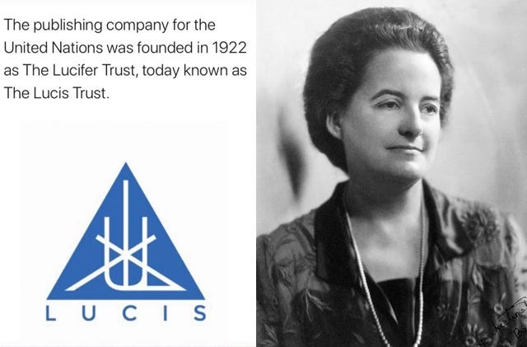](https://substackcdn.com/image/fetch/f_auto,q_auto:good,fl_progressive:steep/https%3A%2F%2Fsubstack-post-media.s3.amazonaws.com%2Fpublic%2Fimages%2F6b6a6286-f6f5-4955-bd69-7e514625c24f_640x421.jpeg)](https://substackcdn.com/image/fetch/f_auto,q_auto:good,fl_progressive:steep/https%3A%2F%2Fsubstack-post-media.s3.amazonaws.com%2Fpublic%2Fimages%2F6b6a6286-f6f5-4955-bd69-7e514625c24f_640x421.jpeg" \t "_blank)

Annie Besant and the logo for Lucis Trust

**Mabel Collins: Spiritual Vampire**

From 1885-1888, Mabel Collins appeared to be a devoted follower of Madame Helena Blavatsky with whom she lived for several months after Blavatsky left India due to the controversy of [the Hodgson Report of 1885.](https://theamericanminvra.com/2018/04/17/the-hodgson-coulomb-case-and-other-charges-against-helena-blavatsky/)

Mabel came to occultism under a series of strange circumstances surrounding an Obelisk [dubbed ‘Cleopatra’s Needle’ t](https://thames.me.uk/s00115.htm)hat was installed in 1878 just outside her apartment in Adelphi, Westminster, on the banks of the Thames.

[[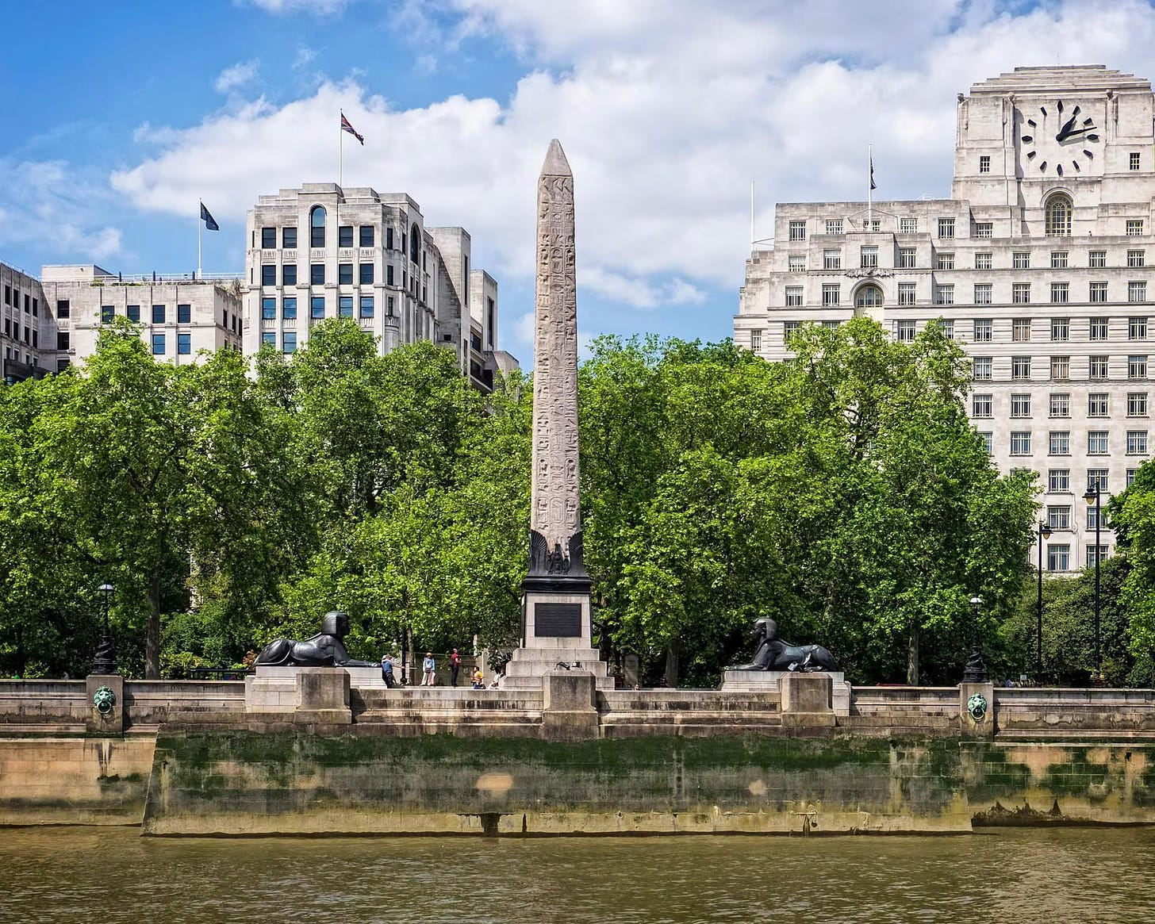](https://substackcdn.com/image/fetch/f_auto,q_auto:good,fl_progressive:steep/https%3A%2F%2Fsubstack-post-media.s3.amazonaws.com%2Fpublic%2Fimages%2Fbaedce60-e4bb-4b1e-bfa5-c9f3aff11e0a_1920x1536.avif)](https://substackcdn.com/image/fetch/f_auto,q_auto:good,fl_progressive:steep/https%3A%2F%2Fsubstack-post-media.s3.amazonaws.com%2Fpublic%2Fimages%2Fbaedce60-e4bb-4b1e-bfa5-c9f3aff11e0a_1920x1536.avif" \t "_blank)

Since the days of Ancient Rome, the River Thames has been known as ‘The River Isis’ due to the [site of the Temple of Isis](https://www.heritagedaily.com/2016/04/did-you-know-london-was-once-home-to-an-ancient-roman-temple-dedicated-to-the-goddess-isis/110561#google_vignette) in Londonium- the capital of Roman Britain that was created after the Claudian invasion of 47 AD and located at the site of the current ‘City of London’ (aka: ‘The Square Mile’).

Cleopatra’s Needle was itself a gift to the British Empire offered by the ruler of Egypt and Sudan Muhammad Ali in 1819 to commemorate the victory of Admiral Horatio Nelson at the 1798 Battle of the Nile. It must be recalled that Admiral Nelson was the godfather of Plymouth Brethren leader John Nelson Darby, co-founder of Christian Zionism and rapture theology whom we were introduced to earlier in this story.

[[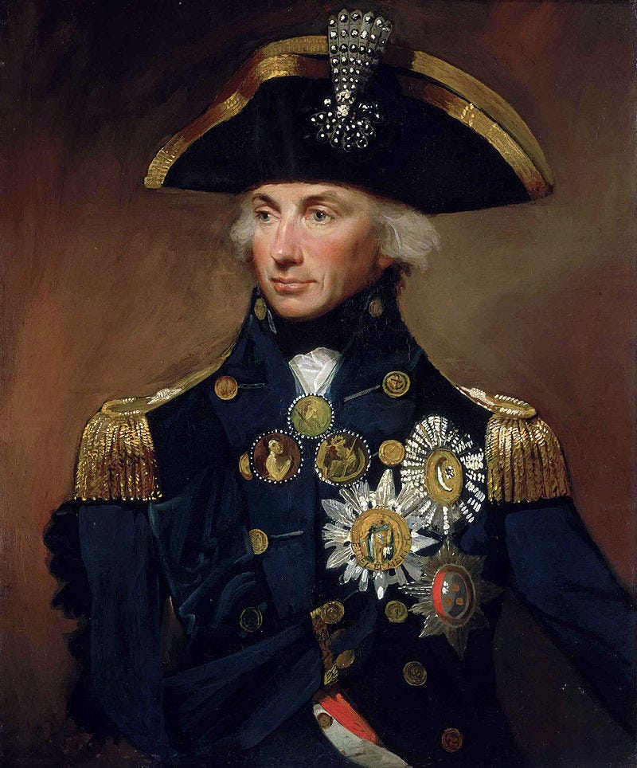](https://substackcdn.com/image/fetch/f_auto,q_auto:good,fl_progressive:steep/https%3A%2F%2Fsubstack-post-media.s3.amazonaws.com%2Fpublic%2Fimages%2F6abaff52-a87c-4ded-a6a3-13d77454e5a4_800x964.jpeg)](https://substackcdn.com/image/fetch/f_auto,q_auto:good,fl_progressive:steep/https%3A%2F%2Fsubstack-post-media.s3.amazonaws.com%2Fpublic%2Fimages%2F6abaff52-a87c-4ded-a6a3-13d77454e5a4_800x964.jpeg" \t "_blank)

*Rear-Admiral Sir Horatio Nelson*, [Lemuel Francis Abbott](https://en.wikipedia.org/wiki/Lemuel_Francis_Abbott), 1800, [National Maritime Museum](https://en.wikipedia.org/wiki/National_Maritime_Museum)

The name of the township of “Adelphi” on the banks of the Thames is itself a direct reference to the system of oracles or ‘sibyls’ spread out across the ancient world and the power of the famous seventh sibyl described by Virgil in the form of the Oracle of Apollo at Delphi.

After the obelisk was imported from Egypt, Mabel Collins, then a recently married young woman began hearing voices and obsessed over spirits stuck inside the phallic rock.

Theosophist researcher Shawn Higgins [writes of Collins’ experience as follows](https://www.patheos.com/blogs/marginalia/2024/02/miss-cremers-and-the-ripper/):

*“Mabel soon noticed that “strange-looking men” began visiting the obelisk—men who were “dressed in a peculiar garb.” One day a group of such men, a procession of white-robed priests entered her house through the front door and walked up the stairs into her room and encircled her. This event would be repeated regularly, and each time they visited, Mabel would enter a trance state of psychography, or automatic-writing, whereby a different consciousness took control of her hands to produce “sheet after sheet” of composition that would later be published under the title The Idyll of the White Lotus.”*

This strange experience (smelling of a proto-MK Ultra event) resulted in Collins’ newfound belief that she was channelling spirits and demons from another dimension, and from 1885-1889, Collins wrote several books that became foundational in Theosophical literature (and which later inspired Crowley’s satanic cosmology and black mass).

Before leaving Theosophy in 1889, Mabel had claimed that her books were communicated from the same ‘ascended masters’ that had been communicating telepathically to Madame Blavatsky for several years.

[[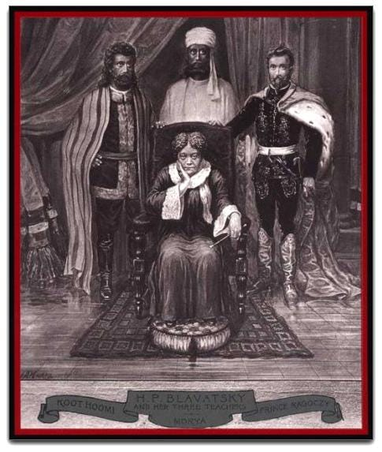](https://substackcdn.com/image/fetch/f_auto,q_auto:good,fl_progressive:steep/https%3A%2F%2Fsubstack-post-media.s3.amazonaws.com%2Fpublic%2Fimages%2F30d30c5e-3905-433e-ad83-fccb8fb90b64_485x573.jpeg)](https://substackcdn.com/image/fetch/f_auto,q_auto:good,fl_progressive:steep/https%3A%2F%2Fsubstack-post-media.s3.amazonaws.com%2Fpublic%2Fimages%2F30d30c5e-3905-433e-ad83-fccb8fb90b64_485x573.jpeg" \t "_blank)

In professing to channel the voices of spirit beings and deities from other dimensions, Collins, Blavatsky, Besant and literally ***every member of the esoteric section and Golden Dawn*** took up the baton as modern Delphic oracles and Sibyls of the modern age.

[[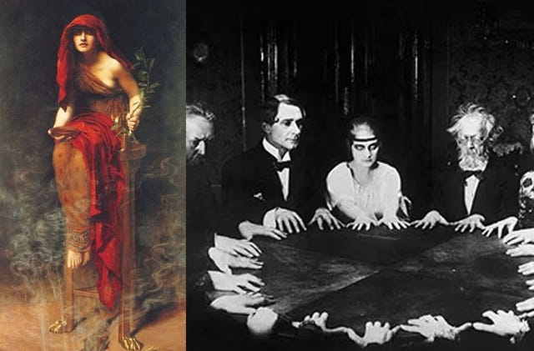](https://substackcdn.com/image/fetch/f_auto,q_auto:good,fl_progressive:steep/https%3A%2F%2Fsubstack-post-media.s3.amazonaws.com%2Fpublic%2Fimages%2Fd621cd02-38d3-47aa-8a8c-9492ce4587f0_640x421.jpeg)](https://substackcdn.com/image/fetch/f_auto,q_auto:good,fl_progressive:steep/https%3A%2F%2Fsubstack-post-media.s3.amazonaws.com%2Fpublic%2Fimages%2Fd621cd02-38d3-47aa-8a8c-9492ce4587f0_640x421.jpeg" \t "_blank)

**Mabel’s Role in a Theosophist Coup**

In May 1889, Mabel Collins created a scandal among Theosophists by suing Madame Blavatsky for libel, and was duly kicked out of the cult.

[[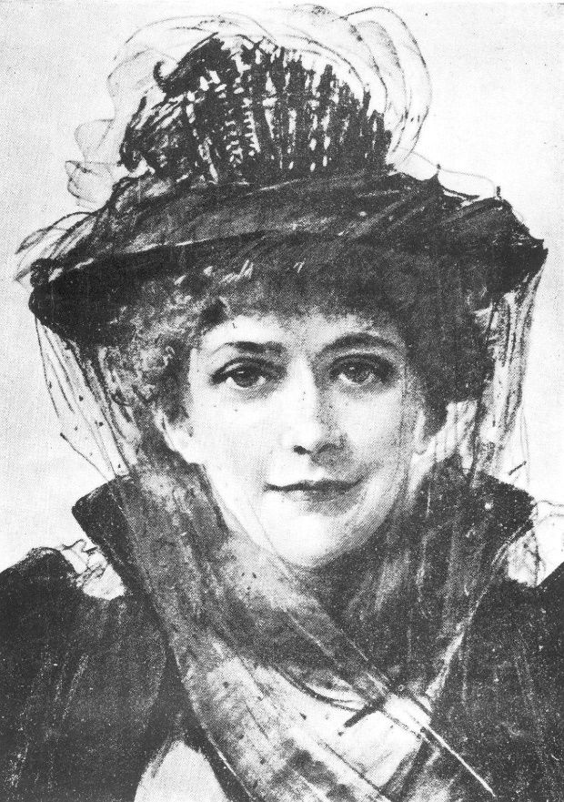](https://substackcdn.com/image/fetch/f_auto,q_auto:good,fl_progressive:steep/https%3A%2F%2Fsubstack-post-media.s3.amazonaws.com%2Fpublic%2Fimages%2Fe150204c-1c07-47d3-94b9-1d6442fe0ec1_1200x1714.jpeg)](https://substackcdn.com/image/fetch/f_auto,q_auto:good,fl_progressive:steep/https%3A%2F%2Fsubstack-post-media.s3.amazonaws.com%2Fpublic%2Fimages%2Fe150204c-1c07-47d3-94b9-1d6442fe0ec1_1200x1714.jpeg" \t "_blank)

Mabel Collins

This scandal occured during a sensitive period that saw Blavatsky’s reputation already suffering due to the damage caused by the Hodgson Report of 1885 (which proved that she had lied publicly about her mystical connection to the ‘ascended masters’ of the great white lodge.) [5]

Behind this public scandal, Mabel Collins was playing a direct role in the effort to replace Blavatsky with the more controllable Annie Besant as head of the Theosophist society. Aleister Crowley- who knew both Collins and Cremers [wrote](https://www.patheos.com/blogs/marginalia/2024/02/miss-cremers-and-the-ripper/) of this scandal: *“At the critical moment of her mission, Madame Blavatsky had been most foully betrayed by Mabel Collins with the help, according to the stratagems and at the instigation of Vittoria, who not only justified, but boasted of her conduct.” [6]*

While both Collins, Cremers and Blavatsky were members of the new Esoteric Section along with leading members of the Golden Dawn, after leaving The Theosophical Society, the duo lived and worked with a certain black magician/journalist named Robert D’Onston Stephenson from April 1890-July 1891.

[[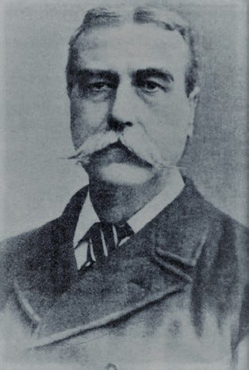](https://substackcdn.com/image/fetch/f_auto,q_auto:good,fl_progressive:steep/https%3A%2F%2Fsubstack-post-media.s3.amazonaws.com%2Fpublic%2Fimages%2F13dc7401-cffd-4650-8a43-10b03b8b5670_314x467.jpeg)](https://substackcdn.com/image/fetch/f_auto,q_auto:good,fl_progressive:steep/https%3A%2F%2Fsubstack-post-media.s3.amazonaws.com%2Fpublic%2Fimages%2F13dc7401-cffd-4650-8a43-10b03b8b5670_314x467.jpeg" \t "_blank)

Robert D’Onston Stephenson

**Footnotes**

[1] Stephen Knight, Jack the Ripper: The Final Solution, Harper Collins, 1994, p. 147

[2] Knight, Stephen, *Jack the Ripper: The Final Solution*, p. 155

[3] This British imperial origin of Zionism was told in [*Sir Henry Kissinger: Midwife to New Babylon*](https://canadianpatriot.org/2023/12/21/sir-henry-kissinger-midwife-to-new-babylon/).

[4] Among those American Christian movements influenced (and even created by Darby and the Plymouth Brethren sect), we have Cyrus Scofield. Scofield’s 1909 reference bible became the most popular in the US during the 20th century [and drew heavily upon Darby’s works](https://creation.com/darby-and-scofield-bible). Darby’s influence can also be seen in the works of Charles Fox Parham (the founder of Pentecostalism), George Pember, ([the originator of the ‘fallen Nephilim’ interpretation](https://br.pinterest.com/pin/408701734915679664/) of demonology now advanced by the alien disclosure movement), Dwight Lyman Moody (founder Moody Bible College), and James Hall Brookes (founding father and president of the Niagara Bible Conference, which helped spread Dispensationalism across America).

[5] As outlined [in Part 9 of this series](https://matthewehret.substack.com/p/the-occult-tesla-part-9), the Hodgson Report was overseen by the British Society for Psychical Research and Quatuor Coronati Lodge and involved a palace coup within the Theosophist leadership to remove the volatile and compromised Madame Blavatsky in favor of the more reliable Annie Besant.

[6] Crowley, Aleister. (eds) Grant, Kenneth; Symonds, John. *The Confessions of Aleister Crowley*. Arkana/Penguin. London, England. (1988): 690-692.

***Also watch for free our RTF Docu-Series “***[***Escaping Calypso’s Island: A Journey Out of Our Green Delusion***](https://matthewehret.substack.com/p/introducing-a-new-video-series-escaping)***” and our CP Docu-Series “***[***The Hidden Hand Behind UFOs***](https://matthewehret.substack.com/p/i-am-proud-to-announce-that-episode)***”.***

Oct 18, 2023 •

[Matthew Ehret](https://substack.com/@matthewehret)

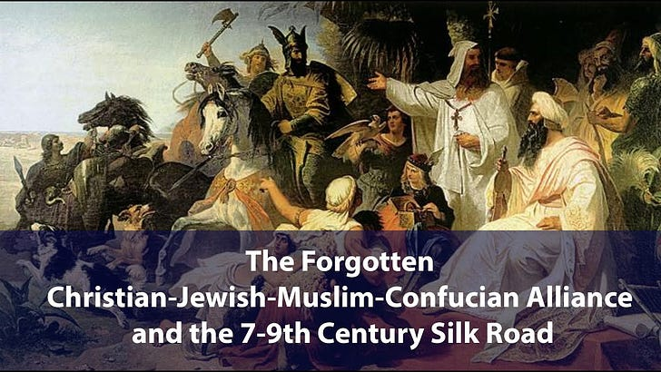

Ready for more?

© 2024 Matthew Ehret

[Privacy](https://substack.com/privacy) ∙ [Terms](https://substack.com/tos) ∙ [Collection notice](https://substack.com/ccpa#personal-data-collected)

[Start Writing](https://substack.com/signup?utm_source=substack&utm_medium=web&utm_content=footer)[Get the app](https://substack.com/app/app-store-redirect?utm_campaign=app-marketing&utm_content=web-footer-button)

[Substack](https://substack.com) is the home for great culture

===========================================================================================