Katherine Tingley, A Biographical Sketch

By Grace F. Knoche

www.theosociety.org/pasadena/sunrise/47-97-8
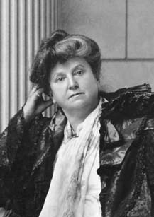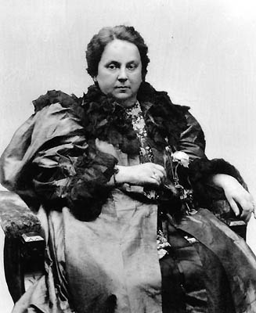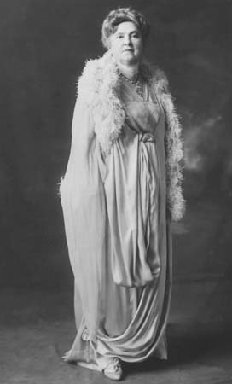

It is impossible in a brief survey to portray a rounded picture of a world-figure whose many-faceted nature attracted both staunch supporters and harsh detractors. Autocratic, yet compassionate to a fault, this gifted woman, organizer, educator, orator, benefactor of prisoners and the forgotten poor, sought consistently for thirty-three years as leader of the theosophical movement to bring "Truth, Light, Liberation to Discouraged Humanity."
Born July 6, 1847, at Newbury, Massachusetts, Catharine Augusta Westcott was educated in the Newburyport schools and by private tutors; also studying piano, voice, and harp. But, she said,
I always felt that my real teacher, if it can be called a teacher, was within myself. Even as a child I used to talk in this way, which led my father to fear that by the time I was twenty-one years of age I would be somewhat demented! Nevertheless, the conviction that my real teacher was within me was very strong. When I was four or five years old, I used to disturb my people by telling them that I heard the trees sing and many things along that line, which seemed very uncanny to people of those days in New England, where the power of dogmatism and convention was very strong. So all through my childhood I led quite an isolated life, except for the inspiring companionship of my grandfather.
. . . When others went to church, I would skip out into the woods with my dog. It was there that I learned some of the great secrets of life. . . . It was there that I found myself; it was there that I found the little spiritual strength that I had. It was there that I had the vision, in a sense, that real life was wonderful and beautiful, but that humanity as a whole was living in the valley of the shadows because as a people we had not reached up higher, we had not trusted ourselves, because we had been hemmed in by the false teachings of the past. -- The Splendor of the Soul, ch. 1
Under the great oaks and pines that edged the Merrimack River, Catharine would dream of the White City she would one day build in the golden land of the West. But the young girl had much to experience in personal sorrow and the cruel indifference of human nature. In her early teens she first encountered "the horror and appalling insanity" of war. Her father, as Regimental Captain, moved the family to Virginia in 1861. After The Seven Days Battle, Catharine and her brother watched from their window as soldiers straggled back to their encampment near the Westcott house. "Suddenly, I could stand it no longer, and summoned my mammy . . . to come down into the kitchen with me and there we . . . requisitioned anything and everything" and went out to feed and comfort the men. (1) Her father was horrified. Fearing that her impulsive, compassionate nature might lead her into serious difficulties, he soon enrolled her in the Villa Marie Convent in Montreal, Quebec -- to the "great annoyance" of her grandfather. During her stay there, a fire broke out in Quebec and Catharine marshalled her classmates and formed a "charitable organization for the benefit of the fire sufferers." (2)
After leaving the convent, two unsuccessful marriages followed, both childless. Living in New York City, the plight of prisoners and the wretched conditions of the East Side weighed heavily on her. In 1887 she formed the "Ladies Society of Mercy" to visit hospitals and prisons. The next spring she married Philo B. Tingley, steamship employee and inventor, and from their home she launched one philanthropy after another for those "worsted in the struggle for life."
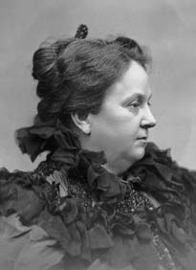
Katherine Tingley (1896)

In 1893 in one of the worst slum areas she set up an emergency Do-Good Mission to provide hot soup and bread for the destitute. One morning during a blizzard she arrived early, only to find hundreds of families waiting for food. While urging patience until the soup was ready, she noticed in the distance a gentleman watching her. Thinking him also in need, she turned to ask an assistant to approach him. But when she looked again, he had gone. In a day or so he presented his card at her home: William Q. Judge, Vice-President of the Theosophical Society and head of its American Section.
It was he who first gave me glimpses of the power of thought and made me realize what it will do to build or ruin the destiny of a human being. And in doing so, he showed me how to find in theosophy solution of all the problems that had vexed me: how it points the way to the right treatment of the downtrodden and outcast of humanity, and to the real remedies for poverty, vice, and crime. On all these subjects the first word of theosophy is this: he who would enter upon the path that leads to truth must put new interpretations on the failings and mistakes of his fellowmen. He must come to understand the law of eternal justice -- karma, that "whatsoever a man soweth, that shall he also reap" -- and to know the necessity it implies for an unconquerable compassion, because those who fail and fall short do so always through ignorance, and there can be no cure for it until this is recognized. -- The Gods Await, pp. 65-6
Katherine Tingley was deeply moved: this confirmed her strong feeling that no matter how depraved a person has become, or how severely handicapped -- physically, emotionally, even spiritually -- human beings have unlimited capacity for improvement.
That meeting proved to be a turning point -- for her, for Judge, and for the Theosophical Society. Here was the philosophy she had longed for and an organization whose high purposes, when implemented in daily experience, could act as a spiritual antidote to the entrenched attitudes humanity has held for centuries toward religion, education, treatment of prisoners, toward whoever was born "on the wrong side" of life, and likewise serve as an antidote to the barbaric notion that wars are unavoidable because they are the only means of resolving conflicts -- civil, national, racial, or religious.
Katherine Tingley joined the Theosophical Society on October 13, 1894, and a fortnight later Judge accepted her into the Esoteric Section. She worked closely with him. But Judge was to live a scarce eleven months after the delegates in convention, on April 28, 1895, by a near unanimous vote declared "entire autonomy" for the American Section and elected Judge "President for life," at the same time recognizing "the long and efficient services" of Colonel H. S. Olcott as President-Founder.3 Judge died in New York City on March 21, 1896, just short of his 45th birthday.
In some of his papers Judge had alluded to Mrs. Tingley and, shortly after his death, she was recognized as his successor by those closest to him. Almost immediately she felt the urgency to start a new current of thought, to strike anew the brotherhood note, and to move the thinking and attitude of the nations -- and theosophists everywhere -- from the inevitability of war to its universal abolition by directing their will and energies toward world peace and the pacific settlement of disputes. If we want peace tomorrow, she believed, we must start with the children of today.
Step by step she moved toward these ends. At the Second Annual Convention in April 1896 an announcement was made of the prospective founding of a School for the Revival of the Lost Mysteries of Antiquity (SRLMA). Further, a Proclamation of fraternal good will and kindly feeling toward theosophists and Theosophical Societies over the world was made. Next, on June 7th a ten-month World Theosophical Crusade was inaugurated for the purpose of visiting theosophical centers, forming new branches, and holding Brotherhood Suppers for the poor. (3)
A second public meeting was held in Madison Square Garden in New York on June 12th. The next day KT and party set sail for England with successive meetings held on board for first- and second-class passengers, and those in the steerage. In England they first greeted oldtime members at the London headquarters, then went to Liverpool. Their first public meeting there set the tone of the Crusade by serving in the heart of the slums a Brotherhood Supper for over 300 of "the very poorest of the poor, each one having been personally invited by the Liverpool theosophists." Throughout the major cities in Britain, public meetings were held and, where funds allowed, Brotherhood Suppers; thence through the European countries, stopping long enough in Athens to feed hundreds of Armenian refugees, on to Egypt, then India where famine relief was instituted, and to Australia, New Zealand, and Samoa.
On the final leg of her world tour, Katherine Tingley arrived February 13, 1897, in California, the land of her childhood vision. Ten days later at Point Loma, in an impressive ceremony witnessed by nearly a thousand, she presided at the laying of the cornerstone of the School for the Revival of the Lost Mysteries of Antiquity, stating that "the school will be international in character, . . . a temple of living light, lighting up the dark places of the earth."
Returning to New York, KT formed the International Brotherhood League on April 29 to consolidate and expand her philanthropic activities. The next year in January, the Universal Brotherhood organization was founded and a month later, on February 18, the Theosophical Society in America (TSA) under its own Constitution became an integral part of this new organization. The principal purpose of the TSA was to "publish and disseminate literature relating to Theosophy, Brotherhood, ancient and modern religions, philosophies, sciences and arts," as well as to "establish and build up a great library" of ancient and modern source books supporting the cause of universal brotherhood. Katherine Tingley was acknowledged Leader and Official Head of all departments of the work by the Universal Brotherhood and the Theosophical Society in America, later known as the "Universal Brotherhood and Theosophical Society" (UB & TS). (4)
KT's aim was to shift the emphasis of theosophists toward humanitarianism in thought and deed. In 1899 in an effort to mitigate the growing fear in Europe of imminent war, she called three Universal Brotherhood Congresses: at Point Loma on April 13; at Stockholm, Sweden, on September 13, with a reception attended by King Oscar II and his suite; and in Brighton, England, on October 6.
On February 13, 1900, KT transferred the Society's international headquarters from New York City to Point Loma, California. Within six months with five pupils she founded the Raja-Yoga School, a department of the School of Antiquity -- by 1914 an Academy and College, and in 1919 Theosophical University. What differentiated the Raja-Yoga system of education from the schools of the time was the balanced development of the entire nature, physical, mental, moral, and spiritual, no one aspect to be cultivated at the expense of the others.
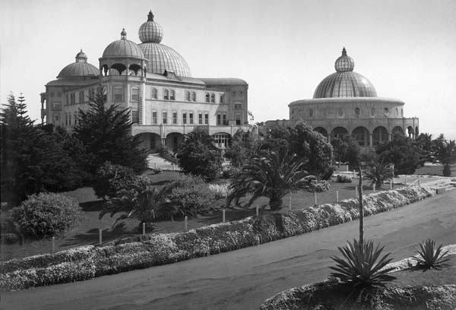
Raja-Yoga Academy and Temple of Peace, International Theosophical Headquarters, Point Loma, California
Another feature was the inclusion of music, drama, and the arts as integral parts of the regular curriculum, starting with three-year-olds -- not as a privilege for the gifted, as all students, with or without talent, learned to play an instrument, sang in the choir, took drawing and painting, and participated in some form in the dramatic work, all being early exposed to the Greek and Shakespearean dramas that were performed under the personal direction of Katherine Tingley in the Open-air Greek Theater erected by her in 1901.
On her World Crusade KT had taken note of those members whom she could invite to serve as professors and instructors not alone for the required collegiate courses, but also in music and the visual arts. The Raja-Yoga schools were imbued with the ideals and objectives of the SRLMA which permeated every phase of the life and activities at Point Loma -- philanthropic, dramatic, educational, literary, musical, or horticultural, all of which served as a guide and stimulus to theosophists throughout the world. The SRLMA's activities included private theosophical meetings for various adult students, with transcripts shared worldwide. For example, from 1924 to 1927 KT inaugurated a lecture series by G. de Purucker on H. P. Blavatsky's Secret Doctrine, later issued as Fundamentals of the Esoteric Philosophy.
Since girlhood Katherine Tingley's heart had reached out to all peoples, with particular empathy for the underprivileged -- her philanthropies both intimate and large-scale continuing until her death. In her boarding and day schools at Point Loma, San Diego, San Francisco, Cuba, Sweden, and Britain, tuition was charged, it being understood that, where circumstances warranted, children would be admitted without charge. At Point Loma hundreds of children, for shorter or long periods, received free education. In addition, several contingents of boys and girls (many of them orphaned by the Spanish-American War) were brought to Point Loma and educated gratis, as also in Santiago del Cuba, Pinar del Rio, and Santa Clara, Cuba, where Raja-Yoga Academies had been founded and run by theosophic volunteers.
Another notable activity was the production of theosophical literature. The bindery and photo & engraving departments were set up south of the Greek Theater shortly after the removal of the international headquarters from New York to Point Loma. There the Press published introductory literature, pamphlets, several monthly magazines -- some lavishly illustrated -- as well as theosophical books by HPB, Judge, and KT; also by Kenneth Morris. One has only to scan the contents of Lauren R. Brown's The Point Loma Theosophical Society: A List of Publications 1898-1942 (5) to be impressed by the quantity of output and quality of craftsmanship, which won an award in the 1914 book and graphic competition in Leipzig, Germany.
Alongside her educational and philanthropic achievements must be placed KT's consistent efforts for world peace before, during, and after World War I. While she acknowledged the constructive efforts of The Hague peace conferences, societies, and conventions, our psychology, she felt, was morally twisted, out of balance: we are convinced that periodic wars are inevitable, so we concentrate on building ever more deadly weaponry. "In times of peace, we are told, we should prepare for war. In times of peace, were we decently fearless and had the least spiritual insight, we should prepare only for a higher peace." (6)
On March 3, 1913, she founded the "Parliament of Peace and Universal Brotherhood." Ten days later she announced that during midsummer week she would hold an International Theosophical Peace Congress on the island of Visingso in Lake Vattern, Sweden. Lomaland artists contributed paintings, and photograph albums of the grounds and school activities at Point Loma were also sent. Her aim was to sow broadcast the regenerating ideas of brotherhood, peace, friendship, and respect among all nationalities. Despite opposition from the local clergy, the Peace Congress took place June 22-9, attended by some 2,000 theosophists and admirers of Katherine Tingley's humanitarian work, drawn from all over Sweden and theosophical centers in Europe.
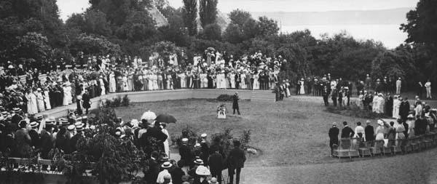

International Theosophical Peace Congress, Visingso, Sweden, June 1913
KT had also invited 24 Raja-Yoga College students to accompany her to sing, perform chamber music, and teach at the summer school she planned to set up on Visingso. The Raja-Yoga Choir was invited to sing three songs (lyrics by Kenneth Morris, music composed at Visingso by Rex Dunn, Raja-Yoga student) on August 18, the close of the first session of the Twentieth World Peace Congress in session at the Ridderzaal, The Hague, Netherlands.
On August 4, 1914, the fateful shot at Sarajevo catapulted Europe into WWI. Though pained beyond comprehension, KT immediately wrote to the German membership and also to other countries where there were theosophic centers, urging all to be "international in spirit" and hold themselves doubly responsible at this crucial time. "Those attacking and those attacked need our compassionate consideration." (7)
On August 26th Katherine Tingley, as president of the Parliament of Peace and Universal Brotherhood, called for a Sacred Peace Day for the Nations to be observed in San Diego. A few days later, she telegraphed an appeal to President Woodrow Wilson to select a day for all people of every religion and every race "to meet together on the level of their common humanity, . . . and as a loving tribute to the cause of Universal Peace, and to send a message of sympathy and encouragement to the suffering mothers and wives and children in Europe." She also enlisted the sympathies and support of the Mayor and City Council of San Diego, the Governor of California, and Governors and mayors in other states. On September 28, the US Marine Corps from Camp Pendleton led the Peace Parade of Point Loma children, students, and resident members.
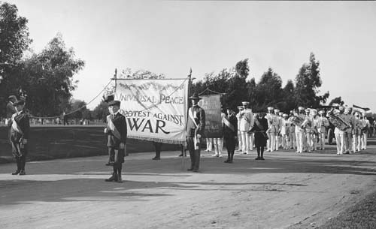

Raja-Yoga College Band, Peace Parade, Balboa Park, September 28, 1914
Throughout the 1920s, KT continued her educational and philanthropic work. She lectured in the US and Europe, battling against war, poverty, dogmatism, and the ill-treatment of prisoners. To her all men and women were divine in essence; no matter how heinous the crime they may have committed, there is always another chance to redeem the erring soul. Everything she did during her leadership was influenced by her vow to revivify confidence in the soul of children and their parents. To free humanity from the bane of "original sin" and the limitation of the one-life theory would restore spiritual dignity to humankind. Education is the key, bringing the child up with noble ideals of service and compassion in beautiful surroundings, with music, the arts, and drama along with the school curriculum; all the while gentling and disciplining the unruly selfish nature to allow the higher soul qualities to assume command.
Katherine Tingley died July 11, 1929, at the age of 82 while on a European lecture tour. "To live in harmony with one another in heart and mind" was the vision that empowered her life work, for if brotherhood and peace were common practice, humanity's ills would be vastly diminished.
Back of the imaginings and hopes and dreams of my childhood and womanhood, deeper than the pain caused by the contrasts I have observed in human life, there is a consciousness of the love of God and the spiritual dignity of man. And it is this consciousness that is needed now to make the world better, to bring man to his own, to give him the key to life's problems, so that he can combat difficulties understandingly, overcome injustice through knowledge, and live in the joy of life in the truest and noblest sense. -- The Wine of Life, ch. 10
• (From Sunrise magazine, April/May 1998. Copyright © 1998 by Theosophical University Press.)

FOOTNOTES:
1. Raja-Yoga Messenger, September 1929, p. 210.
2. New York Tribune, April 11, 1897.
3. Ninth Annual Convention of the American Section, T.S., Boston, Massachusetts, April 28-29, 1895, pp. 16-17.
4. Resolution, Preamble, and Constitution of the Universal Brotherhood; Proclamation to the Members of The Theosophical Society in America by Katherine A. Tingley; Constitution of the Theosophical Society in America -- adopted by the Convention held in Chicago, February 18, 1898.
5. Published by Friends of the UCSD Library, University of California, San Diego, La Jolla, 1977, 132 pages.
6. The Gods Await, p. 36.
7. Sacred Peace Day for the Nations, September 28, 1914
===================================================================================================================================
END

