THREE ONGOING PROJECTS

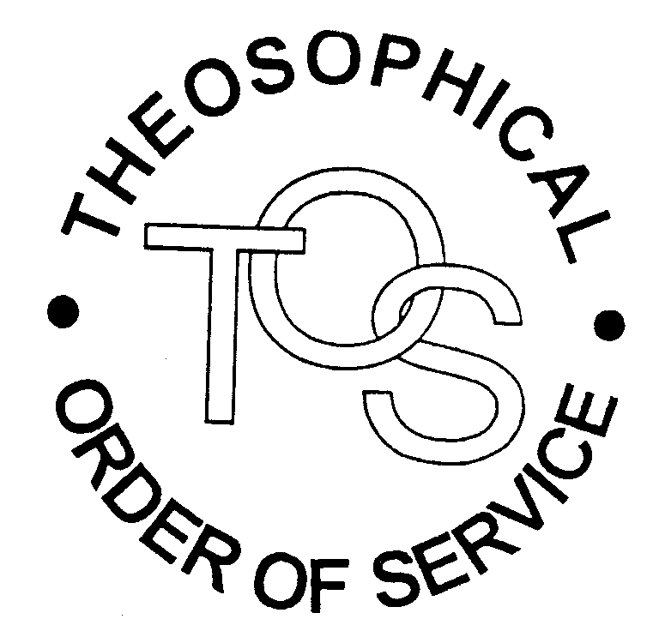
I N C A N A D A

The Theosophical Order of Service (TOS) in Canada supports charitable projects that are linked to the international TOS or TS. There are many such worthy charities established throughout the world. Each project adopted in Canada has been carefully selected in consultation with the International TOS.

Three ongoing TOS supported projects in Canada are:

- Animal Welfare Work at Adyar

- Golden Link School in the Philippines, and

- Tibetan Delek Hospital in Dharamsala

Donations to the TOS in Canada go towards supporting our three projects.

*********************************

1 - ANIMAL WELFARE WORK AT ADYAR

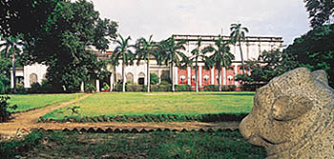

How we treat our younger brothers, the animals, is an accurate measuring stick on how we treat each other. Cruelty towards animals breeds callousness towards the weak and helpless. This can easily escalate into violence towards fellow humans. A mark of a highly developed civilization is demonstrated by its compassionate regard for the welfare of the animal kingdom.

From its inception, the Theosophical Society has been at the forefront in promoting Animal Welfare. This in is in keeping with the first object of the Society, extending the idea of Universal Brotherhood to embrace all forms of life. The TOS in Canada has a history of supporting all efforts to protect the rights of our animal brothers. We believe that to be a true Theosophist is to love all life – not just human life. In recent years the TOS in Canada has made several large donations to help carry out the fine work on behalf of animals that is being done at Adyar. The work is described in the following article written by TOS International Secretary, Diana Dunningham Chapotin.

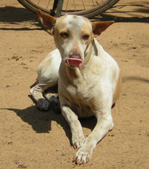
Karthiyayini, the ebullient female dog
attached to the Garden Department at Adyar

Any idea how many animals are treated per year at the animal shelter at our International HQ? Over ten thousand – almost all free of charge. How many staff members are there? Eight, including three veterinarians. How long has Adyar been engaged in animal welfare work? Since the early 1900s, according to the Adyar Newsletter of May 2000, when members treated injured animals, mangy dogs and so on, and conducted vigorous and successful campaigns to stop animal sacrifices in temples in neighbouring areas. When, in 1964, a member of the English Section, Mrs. Dora Crockford, made a donation for animal welfare, it was used to build a dispensary in Besant Gardens to look after sick animals. Many thousands of animals have benefited since.

What’s the latest news? An airy and well-equipped operating theatre was opened in September 2003. In a message to Lorraine Christensen who recently forwarded a donation to the Centre on behalf of the TOS in Canada, our TOS International President Radha Burnier reported: ‘Recently all the buildings in the Centre – dispensary, kennels, etc. – were repaired and repainted, while the theatre was being prepared, which meant making it as antiseptic as possible, providing a refrigerator, a shadowless operation lamp and other necessary equipment. The care includes not only surgery for injured animals but a programme of birth control. We shelter animals needing post-operative care until they are fit. We also have to look after puppies, kittens and even older animals that are abandoned near the gate at Adyar or thrown in. It is of course not easy to find homes for these little creatures. There are a number of dogs and cats in our compound that are fed and cared for because they have no other home and have wandered in. We have started neutering them as well.’

Plans for the future? Radha continues, ‘We hope to start an Outreach Programme. The Environmental Society of Madras donated a van, but it had to be thoroughly repaired and fixed with a refrigerator and other equipment. The veterinarian in charge will go in the van to villages where there are no veterinary facilities and treat animals in need of care. It may be possible to cover five or six villages in day, two days a week. Of course the treatment is given free.’

How is all this work financed? By you! By us! That is to say by members of the TOS and TS around the world. Without our donations to the Animal Welfare Fund, the work would stop.

Diana Dunningham Chapotin
~~~~~~~~~~~~~~~~~~~~~~~~~~~~~~~~~~~~~

ADYAR AS A NATURE SANCTUARY

In 1882, The Adyar Estate consisted of 28 acres of woodlands and gardens. Since then, the compound has grown to about 250 acres and become a sanctuary for all manner of flora and fauna. Adyar is home to over 150 species of birds alone. Various members of the animal kingdom come into the estate and find food, shelter and affection there. Various kinds of animal life are cared for at Adyar, including birds, cats, dogs, monkeys, squirrels, lizards, mongooses, hares and even a wild pig.
Animal Welfare has always been an important part of Adyar life. International presidents George Arundale, N. Sri Ram and Radha Burnier have been staunch advocates of Animal Welfare. In 2005, the Animal Welfare Committee, founded by Arundale, was revived.

2 - THE GOLDEN LINK SCHOOL IN THE PHILIPPINES

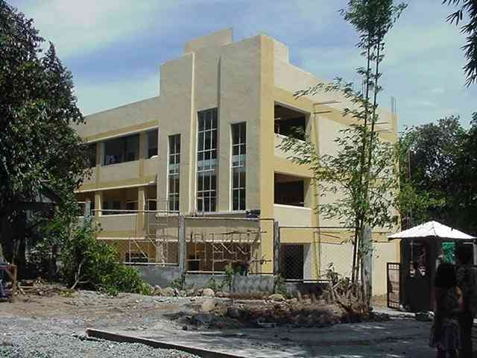

Individuals at peace with themselves will ultimately create a world at peace.
Vicente Hao Chin Jr. President of TSP

The TOS in Canada is pleased to support the work of the Golden Link School in the Philippines, where each year we raise enough funds to sponsor two children from impoverished families for one year’s tuition. The Golden Link School comes under the administration of the Theosophical Foundation and was founded by Vicente Hao Chin, Jr., President of the TS in the Philippines. His vision for the School is one of Transformative Education where creativity is nurtured and students are helped to develop physically, emotionally, intellectually and spiritually. Peace education is incorporated into the School’s curriculum.

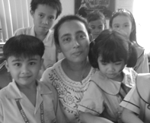
Rekha Nahar, Administrator of Golden Link School

GOLDEN LINK SUMMER SCHOOL PROGRAM
By Vic Hao Chin Jr.

Each year, Golden Link Summer School begins in mid April. The following is a condensed version of the April 17, 2007 message sent to the TOS in Canada from Vic Hao Chin, Director of the TOS in the Philippines, and printed with his permission.

We have have just opened our free summer classes, and we have about six hundred enrolled (we have two hundred in our regular classes). About 90% of these are not our regular students. And most of them come from very poor families

What struck me was the fact that there were a number of parents/students who came from very far places to enrol their children because of what they heard about Golden Link. One student comes from Nueva Vizcaya, a province eight hours away. Five are from Cavite (two hours or more away from Golden Link). Several are from Manila who need to travel about an hour to be at school. Two of these families have looked for apartments or rooms in the vicinity of the School so that they need not travel very far. What further struck me was that it is not just the parents who were keen to enrol their children, but many of the children themselves looked eager to attend the summer classes (instead of being free to play for two months).
Considering that we do not advertise (except distributing leaflets in the neighbourhood), the interest of many parents towards Golden Link seems quite a phenomenon. It is mainly by word of mouth via parents whose children are already enrolled. Yesterday, on the second day of classes, 38 more children enrolled -- again because they heard about the Golden Link from other parents and they rushed to ask whether their children can still be accepted. We did. We practically refuse no one for the free summer classes.

Last night, Rekha Nahar was telling me about a mother who came to her crying because her daughter in Grade 2 would not want to go to school anymore due to a traumatic experience she had in her last school. When the parents enrolled her in other schools the girl did not even want to enter those schools. Then the mother heard about the Golden Link through her factory co-workers. She and her husband brought the child to Golden Link School yesterday and for some reason the child did not show any hesitation to go around the school building, and before she left she even replied to Rekha that she was coming the next day at 12:30 pm for the 1 pm class.

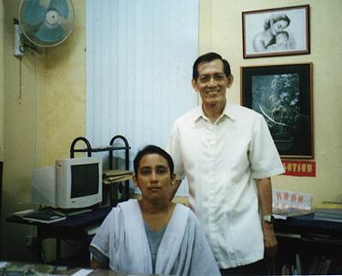
Rekha Nahar, Administrator of Golden Link School with Vicente Hao Chin, Jr.,
General Secretary of the TS in the Philippines

Golden Link seems to be developing a reputation for being able to do something about children with problems or difficulties -- problems with parents, with character, retardation, lack of interest in studying, severe shyness, low self-confidence, violent tendencies, etc. Yet we don't have a single teacher who specializes in special education. There is an atmosphere of love, care, discipline and cheerfulness in the campus exuded by Rekha and the teachers that is probably the most significant factor in making Golden Link what it is. This is the ingredient that draws out the best in the children, that makes them love to learn and to come to school even during holidays, that makes them drop their anti-social or violent tendencies.
One father told me, "I found that there is a way of distinguishing students who study in Golden Link School from those who do not." I was curious to hear what he was about to say -- because he has an elder son who is not studying in Golden Link and two younger children who are. "Why? How do you distinguish them?" I asked. "The children from Golden Link bring their plates and utensils to the washing sink immediately after a meal, while the ones who do not study in Golden Link just leave their plates on the table expecting others to do it for them."
This same father had previously told me how his son, who had transferred from one school to another (four schools in all) and who hated to study -- often getting into fights and trouble -- suddenly became a model child within one year after enrolling in Golden Link School. The father noticed that upon getting home, this boy began to voluntarily get his book and read or do homework without being told. He has developed a loving sensitivity that he tries to observe. If his parents need anything, he would offer to do it for them. He no longer gets into fights and violence. In fact he has become a very responsible boy.
To many parents, especially the poor, Golden Link seems to offer hope to the bleak future of their children who may be doomed because they have been receiving a kind of education that is so dismal, not just in language but in almost everything else. Indeed it is not just about the problem of these transiting students in Golden Link. It is about the general education, particularly in public schools. It is about the future of the next generation of voters, leaders, citizens and parents.

~~~~~~~~~~~~~~~~~~~~~~~~~~~~~~~~~~~~~
3 – TIBETAN DELEK HOSPITAL IN DHARAMSALA

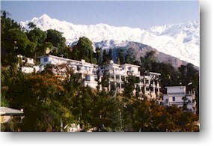

The TOS in Canada follows the example of the TOS in France by supporting the work of the Tibetan Delek Hospital in Dharamsala, as in providing care for its poor and destitute patients. The hospital operates for the most part on donations and volunteers, being largely dependent on volunteer physicians to provide care. Traditional Tibetan medicine is combined with Western medical practices and allopathic remedies.

The choice of this project rose out of the motivation of several of our members who have been helping the Tibetans for many years and who honour the longstanding friendly ties which the TS has with the Tibetan people and their leaders, going back to the days of Madame Blavatsky.

The following mission statement of the Tibetan Delek Hospital resonates well with the first object of the Theosophical Society:

We, at the Tibetan Delek Hospital, are committed to serving all who come to us, irrespective of their race, religion, gender, or country of origin. We promise to treat all people in a compassionate and respectful manner, and pledge to give the finest treatment commensurate with our resources, regardless of our clients’ social or financial status.

The Hospital's service charges are very minimal. For example, an inpatient pays about forty rupees for one day (equivalent to one Canadian dollar) which provides food, a bed and medical services. Patients who cannot afford that amount are not turned away. The Poor and Destitute Patient Relief Fund has been set up to help pay for their care. Tibetan Delek Hospital receives no grants from any government. Major sources of income are from donors.

Amongst Tibetans, the Hospital looks after those who have recently arrived and have stayed beyond the period when the Reception Centre looks after them. But there are also Tibetans who are single and destitute or unemployed and have fallen sick. There are also many poor Indian villagers who cannot afford treatment at private and Indian government health institutions because even in free health centres there may not be adequate medical supplies, so they make these patients purchase the supplies, which are unaffordable. Then we get the occasional western patient who is a tourist but has run out of cash and is uninsured!
Compassionate care and concern for the poor and destitute is the Hospital’s main goal. Therefore if any poor and destitute are admitted into the Hospital, or even attend an outdoor clinic, they are eligible for totally free care. In the event of needing supplies from outside the Hospital, it is not uncommon for a kind Hospital staff member to buy this for the patient or even cook a special meal if the patient cannot eat the hospital food. The neighbouring monastery also serves hot water and milk free of cost for all patients.

The TOS in Canada has two contacts with the Tibetan Delek Hospital. In Canada we work through the Tibetan Community of Alberta and its president, Mr. Tashi Phuntsok of Calgary. In Dharamsala our contact person is Mr. Tashi Dhondup.

Recent Photos – Courtesy of Mr. Tashi Phntsok, Canadian Contact for Tibetan Delek Hospital -

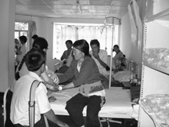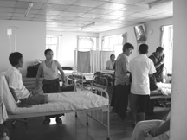

In-Patient Wards

Where is the Greatest Need?

Our regular donations to the Poor and Destitute Patient Relief Fund are greatly appreciated as the fund helps poor and destitute patients, including refugees newly arriving from Tibet, who otherwise have no one to fall back on. Tashi Dhondup, our Delek Hospital contact in Dharamsala, informs us that there is also a great need for funding to support the Hospital’s Community Health Project which caters to the basic health needs of 19 Tibetan settlements in the Himachal Pradesh State. Mobile field trips are made twice a year by a team of a Delek doctor, TB health worker, and occasionally a public health manager. The hospital also organizes free eye and dental camps for local Indian villages as well as for the Tibetans.

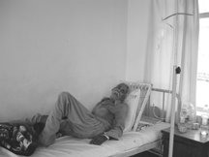 A Local Patient

May I become at all times,
Both now and for ever,
A protector for the helpless,
A guide for the lost ones,
A ship for those to cross oceans,
And a bridge to cross rivers,
A sanctuary for those in danger,
A lamp for those in darkness,
A refuge for those who need shelter,
A servant to all in need.

A Favourite Prayer of the Dalai Lama



