The Wizard of Oz

The Motion Picture, 1939. Metro-Goldwyn-Mayer. Book by L. Frank Baum; Adaption by Noel Langley; Screenplay by Noel Langley, Florence Ryerson, and Edgar Allan Woolf; Lyrics by E.Y. Harburg; Produced by Mervyn Leroy, Directed by Victor Fleming.

Just as you can read between the gory lines in the newspaper on any day and discover clues issued by the powers that be - if you look hard enough - as to what is actually going on, such notice can also be found in lighter fare, like the movies. Such a movie is the Wizard of Oz, an allegory for the new state of affairs in America in the 1930's following the stock market crash and factual bankruptcy of the U.S. Government immediately thereafter.

The setting was Kansas: heartland America, and geographic centre of the U.S.A. In comes the twister, the tornado, i.e. whirling confusion - the stock market crash, theft of America’s gold, U.S. bankruptcy, the Great Depression - and whisks Dorothy and Toto up into a new artificial dimension somewhere above the solid ground of Kansas. When they finally landed in OZ, Dorothy comments to her little companion: “Toto, I have a feeling we’re not in Kansas anymore.”

After the bankruptcy, Kansas was no longer just plain old Kansas - it was now “KS,” artificial corporate venue of the bankrupt United States, newly established “federal territory,” part of the “Federal Zone” and Dorothy and Toto were “in this state”.

In the 1930's, the all-capital-letters written straw man, newly created artificial aspect of the former American sovereigns, had no brain - and Americans were too confused and distracted by all the commotion to figure out that they even had a straw man (TRADE-NAME ). The scarecrow identified his straw-man persona for Dorothy: “Some people without brains do an awful lot of talking. Of course, I’m not bright about doing things.”

And in his classic song, “If I only had a brain,” the scarecrow/straw man succinctly augured: “I’d unravel every riddle, for every ‘individdle’, in trouble or in pain.”

Translation: Once discovered that his straw men exists, all political and legal mysteries, complexities, and confusions are resolved - and once one reclaims the legal title attached thereto, he can protect himself from legal trouble and damage.

The Tin man, or “T-I-N” - Taxpayer Identification Number - man, was a hollow man of metal, a “vessel”, a vehicle newly created commercial code words for the straw man. Just like then scarecrow/straw man who had no brain, this Tin Man vessel had no heart. Both were artificial persons. One of the definition of “tin” in Webster’s is “counterfeit”. The Tin man also represented the mechanical and heartless aspect of commerce and commercial law. Just like they say in the Mafia: “Nothing personal - its just business.” the heartless Tin Man also carried an axe, traditional symbol for God - i.e. modern commercial law - in most earlier, dominant civilizations, including fascist states. In the words of the Tin Man, expressing relief after Dorothy had oiled his arm: “I’ve held that axe up for ages.”

The word “ace is etymological related to the word “axe, and in a deck of cards, the only one above the King is an Ace. I.e. God. One of the “Axis” of powers of World War II, Italy, was a fascist state. ( The root word of fascist is fas; Latin for Right; justice; the divine law. In primitive times it was the will of the gods, embodied in rules regulating not only ceremonials, but the conduct of men. The original Pontiff’s of the Roman Regal Empire were the Priests of Fasi. Fascinating is it not!?! careful not to rule by it though. ) The symbol for fascism is the “fasces,” a bundle of rods with an axe bound in the middle and its blade projecting. The fasces may be found on the reverse of the American mercury-head Dime. ( The Roman deity Mercury was the God of commerce ), and on the wall behind, and each side of the speakers podium in the U.S. senate ( each glided fasces is approximately six feet in height; at the base of the seal of the U.S. Senate are two crossed fasces), and directly below Abraham Lincoln’s hands on the face of the arms of the chair in which Lincoln is sitting at the Lincoln Memorial in Washington D.C.
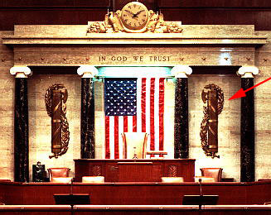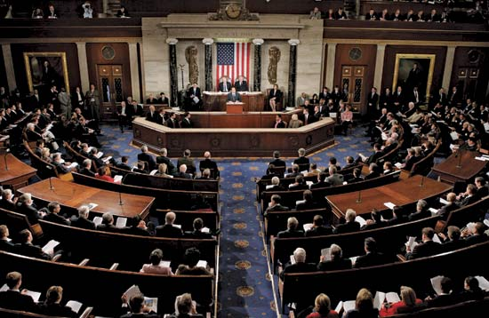
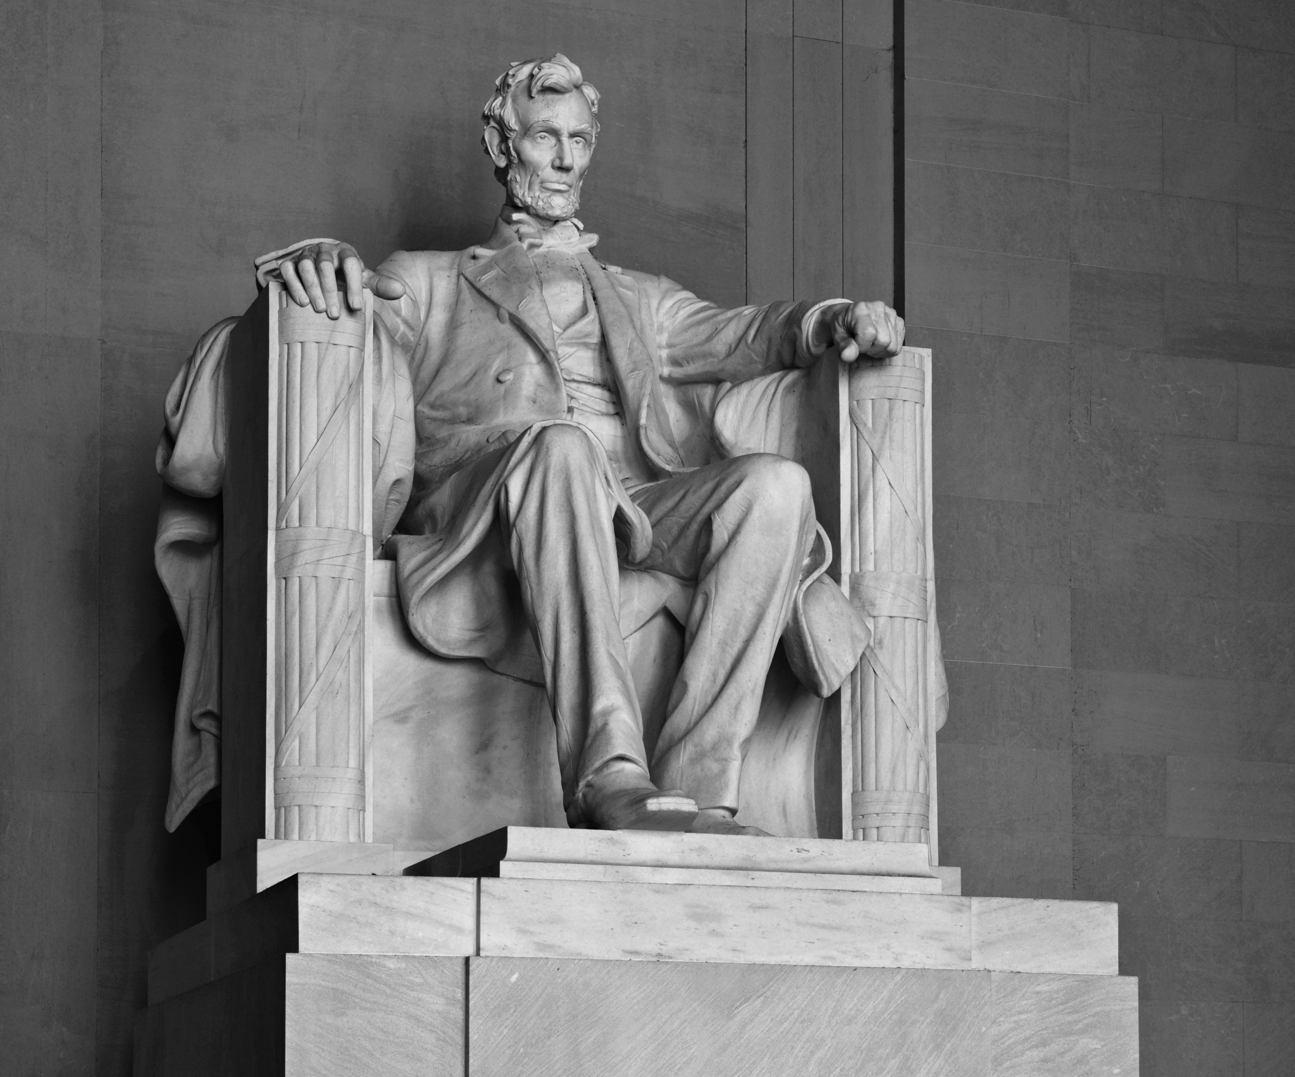

The Lion, or “king of beasts” - a denigration in itself - representing the once fearless American people, who have lost its courage. After your first round with the UCC constituted IRS “defending” your T-I-N man dummy-corporation vessel/vehicle, individual employee public corporation, all-capital-letters-written juristic name, artificial person straw man TRADE-NAME, you probably lost some of your courage too. You didn’t know it, but the IRS has been dealing with you strictly under the laws of commerce, and just like the Tin man, commerce is heartless.

To find the Wizard you had to “follow the yellow brick road,” i.e. follow the trail of America’s stolen gold and you will find the thief who stole it. In the beginning of the movie, the wizard was represented by the traveling mystic, “Professor Marvel,” whom Dorothy encountered when she ran away with Toto. His macabre shingle touted that he was “Acclaimed by the Crown Heads of Europe, Past, Present and Future.” Boy that Professor must have been a regular Wizard to be acclaimed by the future crowned heads of Europe, before they were even crowned! Before bankers stole America, they had long since disempowered the Christian monarchies of Europe and looted their kingdoms. Maybe this “Professor Marvel” fellow knew something of the future that other folks didn’t. With a human skull peering down from its painted perch above the door inside his wagon, the good professor lectured Dorothy of the priests of Isis and Orisis and the days of the pharaohs of Egypt.

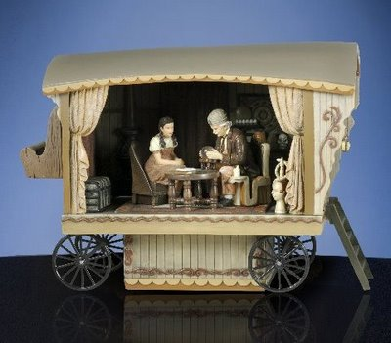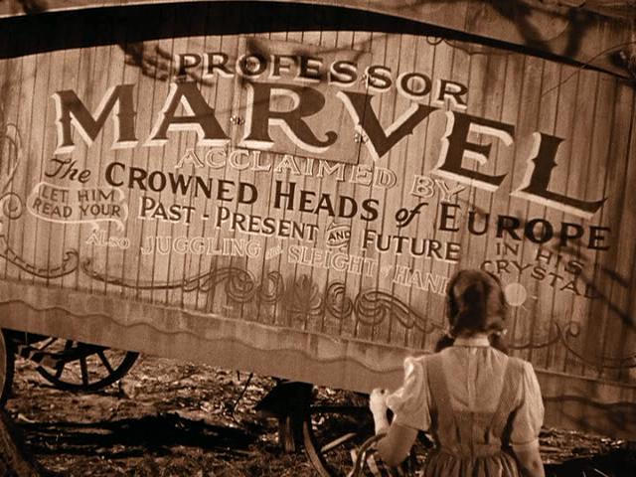

When Dorothy Gale and her new friends emerged from the forest, they were elated to see the Emerald City before them, only a short jaunt away. The Wicked witch of the West, desperate for the ruby slippers that Dorothy was wearing, would have to make her move before our heroes were inside the walls. A significant point here, is that in the original book, The wonderful Wizard of Oz, published in 1900, ( 30 years earlier ), the slippers were not ruby, or red, but silver, and the value of one once of gold was set at 15 ounces of silver. Silver was the more plentiful of the two metals. Just as the silver slippers carried Dorothy, America’s stockpile of silver and gold, the country to a position of pre-eminence throughout the world at that time. But as mentioned, when the movie came out in 1939, the slippers were not silver but red.

Between 1916 and 1933, virtually all of America’s gold ended up in England and Germany, as directed by the owners of the Federal Reserve bank. The reason for this was that Federal Reserve Notes could be redeemed in gold and the use of the Federal Reserve Notes carried an interest penalty that could only be paid in gold. The American’s traded their gold in exchange for the use of ( worthless ) paper with green ink on it, whereas their original currency, United States Notes, carried no such interest requirement. But such was the bargain that came with the Federal Reserve Notes. When bankruptcy was declared in 1933, American’s were required to turn in all gold coin, gold bullion, and gold certificates by May 1st - May Day. ( the birthday of Communism in Bavaria in 1776, the birthday of the IRS, and celebrated worldwide as the “International Workers Holiday - a holy day to the Wizard and his tribe). Consulting people who were alive at the time, you may find out that the general sentiment toward such thievery bordered on a second revolution. Maybe it was just to much of a clue, too much salt in the wound, for Dorothy to be skipping down the “Yellow Brick Road” in a pair of “silver slippers” so, for whatever reason, a colour less likely to annoy and provoke was selected.

Regarding the choice of “ruby” ( red coloured ) slippers: Red’s primary significance, at least on documents and the like, is that it is the colour of blood, as in flesh and blood and symbolizes a living, breathing man/woman, i.e. non-corporate/artificial. It also signifies “private,” rather than “public.” the new Social Security card in America has a red serial number on the reverse, likely signifying the private-side account associated with the TRADE-NAME public side Social Security Account Number ( before redemption ). For postal employees, the red sticker Registered mail means “personal accountability” ( private ), all other mail carries “limited liability” ( public ). It is likely that the ruby slippers symbolized the American people with blood in their veins, and not “citizens of the United States” straw man TRADE-NAMES with the counterfeit “corporate blood” of Blue/black ink on a birth certificate. No matter their colour in the movie, the Wicked Witch of the West wanted those slippers at any cost and had to move fast before Dorothy and crew could make it into Emerald City.

Her tactic was to cover the countryside with poppy flowers, or “poppies”, the source of heroin, opium and morphine, symbolically drugging them into unconsciousness, and then just waltz in a snatch the slippers. In other words, the best way to subjugate the American people and boost the goods was to dull their senses by getting them hooked on drugs ( Note: LSD was created the same year, 1939, by Dr Albert Hoffman ). The poppies/drugs worked on Dorothy, the Lion and Toto, our flesh and blood friends, but have no effect on the scarecrow or the Tim Man, the artificial entities. The two of them cried out for help and Glenda, the Good Witch of the North, answered their prayers with a blanket of snow - i.e. cocaine a stimulant - nullifying the narcotic effect of then poppies/opium on Dorothy, the Lion and Toto. At this writing, aside from marijuana, the two most available drugs on the streets of America are heroin and cocaine in their various forms.

As they all scampered toward the Emerald City, the city of green ( Federal Reserve Notes, the new fiat “money” or “money by decree”), we heard the Munchkins singing on the glory of the Wizard’s creation:
“You’re out of the woods, You’re out of the dark, You’re out of the night, Step into the sun, step into the light, keep straight ahead for, The most glorious place on the face of the Earth or the stars!” The jingle abounds with Illumunist-Luciferian symbols and metaphors re darkness and light.

The Wicked Witch of the West made her home in a round medieval watchtower, ancient symbol of the Knight Templars of Freemasonry, who are given to practice witchcraft and also credited as the originators of the modern banking, circa 1099 A.D. The Wicked Witch of the West was also dressed in black, the colour symbolizing the planet Saturn, sacred icon of the Knight Templar, and the colour choice of judges and priests for their robes. Who was the Wicked Witch of the West? Remember in the first part of the film her counterpart was “Almira Gulch,” who, according to Aunt Em, “owned half the country.” Miss Gulch alleged that Dorothy’s dog, Toto, had bitten her, She came to the farm with an “order from the sheriff” demanding that they surrender Toto into her custody. Aunt Em was not immediately co-operative, and answered Miss Gulch’s allegations that Toto had bitten her. “ he’s really gentle. With gentle people that is.” Could gentle mean Gentile? When Miss Gulch defied them to withhold Toto and “go against the law”, dear old Aunt Em was relegated to “pushing the party line” for Big Brother. She dutifully succumbed under the pressure and counseled Dorothy reluctantly: “ we can’t go against the law Dorothy, I’m afraid poor Toto will have to go.” When Dorothy refused to surrender Toto, Miss Gulch lashed out: “ If you don’t hand over that dog I’ll bring a damned suit that’ll take your whole farm!”

Today, 70% of all attorneys in the world reside in the West - America to be exact - and 95% of all lawsuits in the world are filed under U.S. jurisdiction. The Wicked Witch of the West and Miss Gulch, my dear friends, represent esquires ( judges and attorneys ) i.e. the American legal system ( including the attorney-run U.S. Congress and White House ). Executioner and primary henchman for the transferring of all wealth in America - everything - from the people into the possession of banks and the government. The Wicked Witch of the west wanted the silver slippers - the precious metals - and her counterpart, Miss Gulch, wanted Toto. What does word “Toto” mean in attorney language, i.e. in Latin? “Everything”.

Dorothy and the gang fell for the Wizard’s illusion in the beginning, but soon wised up and discovered the Wizard for what he was: a confidence man. When asked about helping the Scarecrow/Strawman among other babblings about “getting a brain” and “universities” the Wizard also cited “the land of E Pluribus Unum,” which is Latin for “one out of many.” i.e. converting the many into one = New World Order, Novus Ordo Seclorum, a Latin phrase placed on the American One Dollar Bill shortly after bankruptcy. He also proudly revealed/confessed that he was: “Born and breed in the heart of the Western Wilderness, an old Kansas man myself!” The bankers did pretty well in Europe, but as the Wizard pointed out, they made a killing in the “Western Wilderness.” i.e. America, with the theft of American gold, labour and property from the - quoting John D. Rockerfeller - “ Grateful and responsive rural folk” who populated the country at the time.

When Dorothy asked Glenda the Good witch of the North ( Santa Claus, Christianity ), for help in getting back to Kansas, Glenda replied: “ you don’t need to be helped. You’ve always had the power to go back to Kansas.” Translation: You’ve always had the right and power to exercise your sovereignty, you just forgot. The actual act of asserting your sovereignty - remedy - a Common law copyright notice and a UCC Financing Statement for filing with the secretary of state can be completed from scratch in no time.

America and Americans have intimate, firsthand knowledge of the heartless mechanics of the laws of commerce, religiously applied by the unregistered foreign agents at the Internal Revenue Service. The IRS, accountancy firm and collection agency for the private Federal Reserve Bank, was constituted under the UCC at its inception in 1954, and has been operating strictly in that realm ever since.

You may have wondered what is the meaning behind the title “The Wizard of Oz.” Look them up in a dictionary. Like almost everything else, its right out there in the open for you to see if you will just look closely enough. One definition of “Wizard” is: “a very clever of skillful person.” “O-Z” is an abbreviation of “onza,” o-n-z-a, the Italian word for “ounces”, or “ounces,” the unit of measurement of gold, silver and other precious metals. No matter how large the quantity of gold/silver being discussed, the amount is always in ounces. E.g. rather than hundreds of tons of gold, its so many million ounces of gold. As attested by the factual history of this country: the “Wizard of Oz was the Wizard of Ounces.

Everything worked out for Dorothy, i.e. the American people, in the end and she “made it home”. Meaning there is remedy in law. It’s there - it was encoded and disguised and camouflaged. Fortunately, the code has been cracked, and there is a way home, just like in the movies. Like Dorothy said, “ There’s no place like home” - and there isn’t! There nothing like sovereignty for a sovereign! We have commercial remedy in the redemption process. Will you continue to be conned by the confidence men and worship the Wizard’s light show, or will you wise up like Dorothy did and “look behind the scenes”?

