Edward George Earl Bulwer-Lytton 1803-1873
http://en.wikipedia.org/wiki/Edward_Bulwer-Lytton,_1st_Baron_Lytton
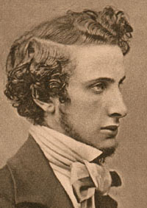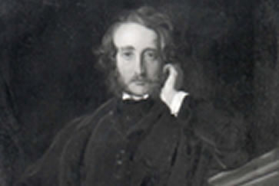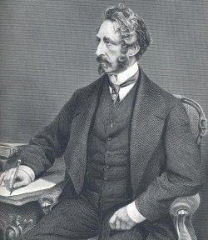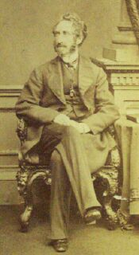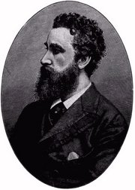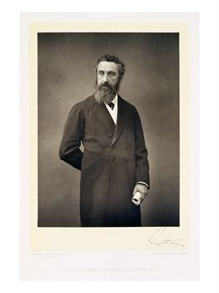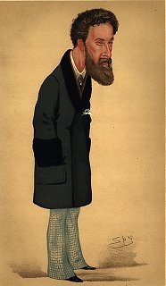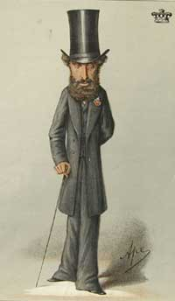
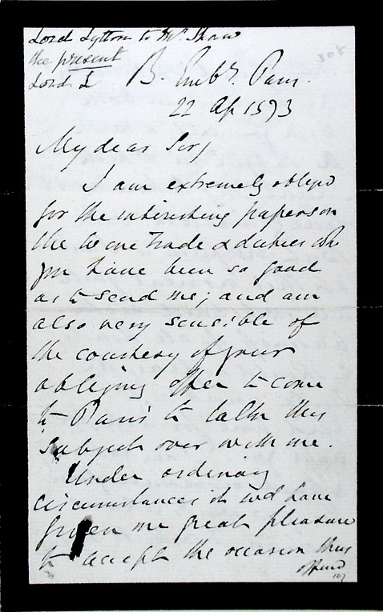

The Lord Lytton
Novelist and politician

Edward George Earl Bulwer-Lytton, 1st Baron Lytton (May 25, 1803–January 18, 1873) was an English novelist, playwright, and politician. Lord Lytton was a florid, popular writer of his day, who coined such phrases as "the great unwashed", "pursuit of the almighty dollar", "the pen is mightier than the sword", and the infamous incipit "It was a dark and stormy night." Today his name is known as a byword for bad writing. San Jose State University’s annual Bulwer-Lytton Fiction Contest for bad writing is named after him.
He was the youngest son of General William Earle Bulwer of Heydon Hall and Wood Dalling, and Elizabeth Barbara Lytton, daughter of Richard Warburton Lytton of Knebworth, Hertfordshire. He had two brothers, William (1799-1877) and Henry (1801-1872), afterwards Lord Dalling. His son Robert Bulwer-Lytton, 1st Earl of Lytton was viceroy of India from 1876 to 1880.

Contents
- 1 Life
- 2 Political career
- 3 Literary career
- 4 Legacy
- 5 Other
- 6 Further reading
- 7 External links

Life
Bulwer's father died when he was four years old, after which his mother moved to London. A delicate and neurotic, but precocious, child, he was sent to various boarding schools, where he was always discontented until a Mr Wallington at Baling encouraged him to publish, at the age of fifteen, an immature work, Ishmael and Other Poems. In 1822 he entered Trinity College, Cambridge, but moved shortly afterwards to Trinity Hall, and in 1825 won the Chancellor’s medal for English verse. In the following year he took his B.A. degree and printed for private circulation a small volume of poems, Weeds and Wild Flowers. He purchased a commission in the army, but sold it again without serving, and in August 1827 married, in opposition to his mother’s wishes, Rosina Doyle Wheeler (1802-1882). Upon their marriage, Bulwer’s mother withdrew his allowance, and he was forced to set to work seriously.
His writing and his efforts in the political arena took a toll upon his marriage to Rosina, and they were legally separated in 1836. Three years later, she published a novel called Cheveley, or the Man of Honour, in which Bulwer was bitterly caricatured. In June 1858, when her husband was standing as parliamentary candidate for Hertfordshire, she appeared at the hustings and indignantly denounced him. She was consequently placed under restraint as insane, but liberated a few weeks later. This was chronicled in her book A Blighted Life. For years she continued her attacks upon her husband’s character; she would outlive him by nine years.
According to Fulham Football Club, he once resided in the original Craven Cottage, which has since been destroyed by fire. Upon being rebuilt, the club started to play their games nearby it and eventually built a stadium on the land, which is still used today.

[] Political career
Bulwer began his career as a follower of Jeremy Bentham. In 1831 he was elected member for St Ives in Huntingdon, after which he was returned for Lincoln in 1832, and sat in parliament for that city for nine years.
He spoke in favour of the Reform Bill, and took the leading part in securing the reduction, after vainly essaying the repeal, of the newspaper stamp duties.
His influence was perhaps most keenly felt when, on the Whigs’ dismissal from office in 1834, he issued a pamphlet entitled A Letter to a Late Cabinet Minister on the Crisis. Lord Melbourne, then Prime Minister, offered him a lordship of the admiralty, which he declined as likely to interfere with his activity as an author.
In 1838 Bulwer, then at the height of his popularity, was created a baronet, and on succeeding to the Knebworth estate in 1843 added Lytton to his surname, under the terms of his mother’s will. In 1845, he left Parliament and spent some years in continental travel, reentering the political field in 1852; this time, having differed from the policy of Lord John Russell over the Corn Laws, he stood for Hertfordshire as a Conservative. Bulwer held that seat till 1866, when he was raised to the peerage as Baron Lytton. In 1858 he entered Lord Derby’s government as Secretary of State for the Colonies, thus serving alongside his old friend Disraeli. In the House of Lords he was comparatively inactive.
He took a proprietary interest in the development of the Crown Colony of British Columbia and wrote with great passion to the Royal Engineers upon assigning them their duties there. The former HBC Fort Dallas at Camchin, the confluence of the Thompson and Fraser Rivers, was renamed in his honour as Lytton, British Columbia.

[] Literary career
Bulwer-Lytton's literary career began in 1820, with the publication of his first book of poems, and spanned much of the nineteenth century. He wrote in a variety of genres, including historical fiction, mystery, romance, the occult and science fiction.
In 1828 he attracted general attention with Pelham, an intimate study of the dandyism of the age that kept gossips busy in identifying the characters with the leading men of the time. By 1833, he had reached the height of his popularity with Godolphin, followed by The Pilgrims of the Rhine (1834), The Last Days of Pompeii (1834), Rienzi (1835), and Harold: Last of the Saxon Kings (1848). The Last Days of Pompeii was inspired by the painting on the same subject by Russian painter Karl Briullov (Carlo Brullo) which Bulwer-Lytton saw in Milan. He also wrote The Haunted and the Haunters (1857), also known as The House and the Brain, included by Isaac Asimov in his anthology Tales of the Occult (1989, ed. Prometheus, ISBN 0-87975-531-8).
Pelham had been partly inspired by Benjamin Disraeli’s first novel Vivian Grey. Bulwer-Lytton was an admirer of Benjamin’s father Isaac D’Israeli, himself a noted literary figure, and had corresponded with him. Bulwer-Lytton and Disraeli began corresponding themselves in the late 1820s, and met for the first time in March of 1830, when Disraeli dined at Bulwer-Lytton’s house. Also present that evening were Charles Pelham Villiers and Alexander Cockburn. Although young at the time, Villiers went on to an exceptionally long parliamentary career, while Cockburn became Lord Chief Justice of England in 1859.
He penned many other works, including Vril: The Power of the Coming Race, which drew heavily on his interest in the occult and contributed to the birth of the science fiction genre. Some believe the book helped to inspire Nazi mysticism. Unquestionably, its story of a subterranean race of men waiting to reclaim the surface is one of the first science fiction novels.

[] Legacy
Although he was popular in his day, Bulwer-Lytton’s prose strikes many contemporary readers as anachronistic and overly embellished, though at least one of his works (The Last Days of Pompeii) is still regularly read.
His name lives on in the annual Bulwer-Lytton Fiction Contest, in which contestants have to supply the openings of terrible (imaginary) novels, inspired by his novel Paul Clifford, which opens with the famous words:
“It was a dark and stormy night”
or to give the sentence in its full glory:
“It was a dark and stormy night; the rain fell in torrents—except at occasional intervals, when it was checked by a violent gust of wind which swept up the streets (for it is in London that our scene lies), rattling along the housetops, and fiercely agitating the scanty flame of the lamps that struggled against the darkness.”
Entrants in the contest seek to capture the rapid changes in point of view, the florid language, and the atmosphere of the full sentence.
The shorter form of the opening sentence was popularized by the Peanuts comic strip, in which it usually began Snoopy's sessions with the typewriter. It is also the first sentence of Madeleine L'Engle’s Newbery Medal novel A Wrinkle in Time.
Bulwer-Lytton’s most famous respected turn of phrase is "the pen is mightier than the sword," although its original quote is led with the phrase "beneath the rule of men entirely great," in the play Richelieu. He also gave the world the memorable phrase “pursuit of the almighty dollar.” Finally, he is widely cred for "the great unwashed." Unfortunately, many citations claim The Last Days of Pompeii as their source, but perusal of the original work indicates that this is not the case. However, the term "the Unwashed," with the same meaning, appears in The Parisians—"He says that Paris has grown so dirty since the 4th September, that it is only fit for the feet of the Unwashed."
Several of his novels were made into operas, one of which (Rienzi, by Richard Wagner) eventually became considerably more famous than the novel on which it was based. Leonora by William Henry Fry, the first opera composed in the United States of America, is from Bulwer-Lytton's novel The Lady of Lyons.
In 1831 Bulwer-Lytton undertook the orship of the New Monthly but resigned the following year. In 1841, he started the Monthly Chronicle, a semi-scientific magazine. During his career he wrote poetry, prose, and stage plays; his last novel was Kenelm Chillingly, which was in course of publication in Blackwood’s Magazine at the time of his death in 1873.
His works of fiction and non-fiction were translated in his day and since then into many languages, including German, Norwegian, Swedish, French, Finnish, and Spanish.

[] Other
After his death, the incomplete work of history, Athens: Its Rise and Fall was published.

[] Further reading
- T. H. S. Escott, Edward Bulwer, 1st Baron Lytton of Knebworth (1910).
- L. Mitchell, Bulwer Lytton, The Rise and Fall of a Victorian Man of Letters (2003).
=================================================================================================================================
END

