Arthur Charles Clarke 1917 - 2008

http://en.wikipedia.org/wiki/Arthur_C._Clarke

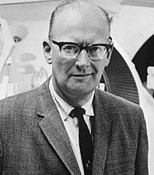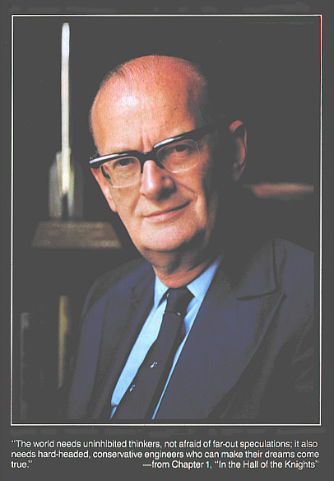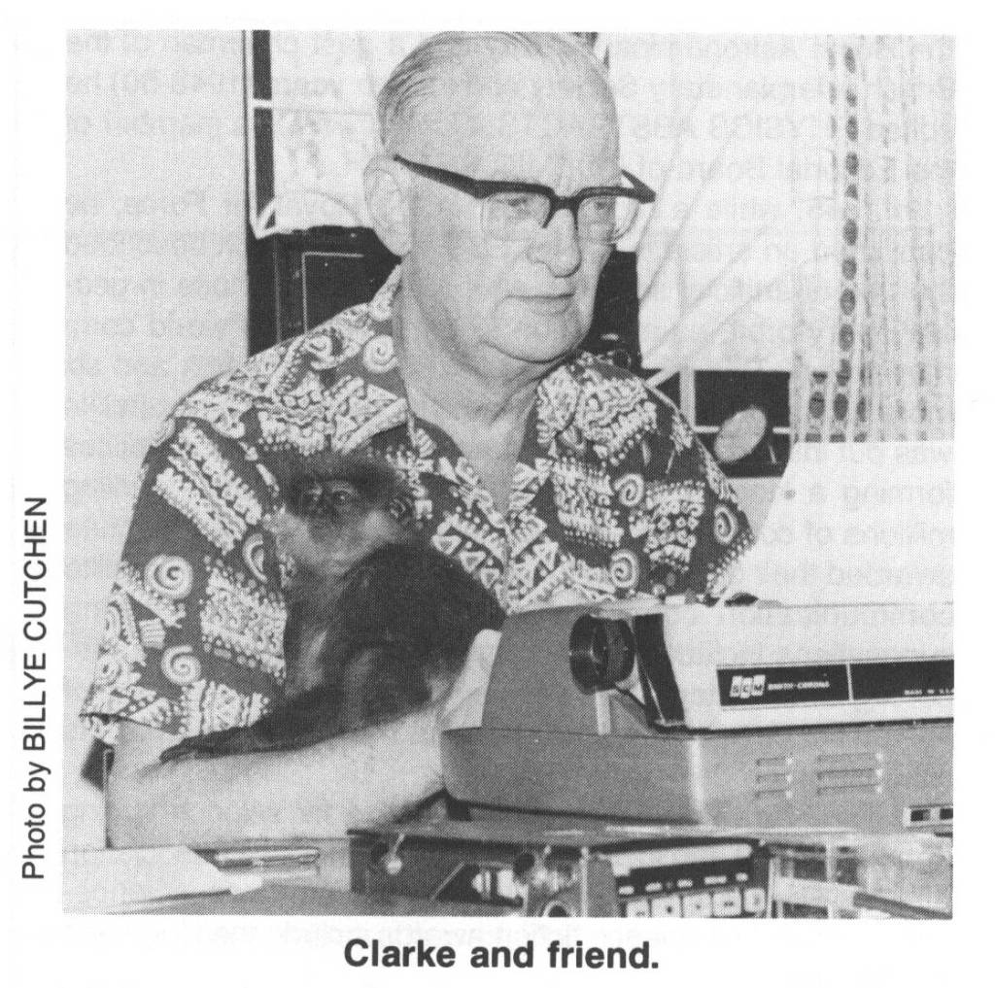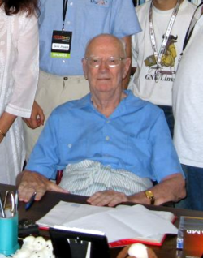

Sir Arthur Charles Clarke, CBE (born 16 December 1917) is a British science-fiction author and inventor, most famous for his novel 2001: A Space Odyssey, and for collaborating with director Stanley Kubrick on the film of the same name. Clarke is the last surviving member of what was sometimes known as the "Big Three" of science fiction, which included Robert A. Heinlein and Isaac Asimov.

Contents
[hide]
- 1 Biography
- 2 Knighthood and false accusation
- 3 Themes, style, and influences
- 4 Adapted screenplays
  - 4.1 2001: A Space Odyssey
  - 4.2 2010
- 5 Essays and short stories
- 6 Concept of the geostationary communications satellite
- 7 Awards, honours and other recognition
- 8 Partial bibliography
  - 8.1 Novels
  - 8.2 Omnibus editions
  - 8.3 Short story collections
  - 8.4 Non-fiction
- 9 In popular culture
- 10 Quotes
- 11 See also
- 12 Cited references
- 13 External links

Biography
Clarke was born in Minehead, Somerset, England, and as a boy enjoyed stargazing and reading old American science-fiction magazines (pulp magazines, many of which made their way to England in ships with sailors who read them to pass the time). After secondary school and studying at Huish's Grammar School, Taunton, he was unable to afford a university education and got a job as an auditor in the pensions section of the Board of Education.
During the Second World War, he served in the Royal Air Force as a radar specialist and was involved in the early warning radar defence system which contributed to the RAF's success during the Battle of Britain. Clarke actually spent most of his service time working on Ground Controlled Approach (GCA) radar, as documented in his semi-autobiographical novel Glide Path. GCA did not see much practical use in the war, but after several more years of development, it was vital to the Berlin Airlift of 1948-49. He was demobilised with the rank of Flight Lieutenant. After the war, he earned a first-class degree in mathematics and physics at King's College London.
In the postwar years, Clarke became involved with the British Interplanetary Society and served for a time as its chairman. His most important contribution may be the idea that geostationary satellites would be ideal telecommunications relays. He was the first in the world to propose this in a paper privately circulated among the core technical members of the BIS in 1945. The concept was later published in Wireless World in October of that year.^{[1][2]} Clarke has also written a number of non-fiction books describing the technical details and societal implications of rocketry and space flight. The most notable of these may be The Exploration of Space (1951) and The Promise of Space (1968). In recognition of this a geostationary orbit is sometimes called a 'Clarke' orbit.
While Clarke had a few stories published in fanzines between 1937 and 1945, his first professional sales appeared in Astounding Science Fiction in 1946: "Loophole" was published in April, while "Rescue Party", his first sale, was published in May. Along with his writing, Clarke worked briefly as Assistant Editor of Science Abstracts (1949) before devoting himself to writing full-time from 1951. Clarke also contributed to the Dan Dare series, and his first three published novels were for a juvenile audience.
In 1948, he wrote "The Sentinel" for a BBC competition. Though the story was rejected, it changed the course of Clarke's career. Not only the basis for A Space Odyssey, "The Sentinel" introduced a more mystical and cosmic element to Clarke's work. Many of Clarke's later works feature a technologically advanced but prejudiced mankind being confronted by a superior alien intelligence. In the cases of The City and the Stars, Childhood's End, and the 2001 series, this encounter produces a conceptual breakthrough that accelerates humanity into the next stage of its evolution.
In 1953, Clarke met and quickly married Marilyn Mayfield, a twenty-two year old American divorcee with a young son. They separated permanently after six months, although a divorce was not finalized until 1964.^{[3]}
He has lived in Sri Lanka since 1956, immigrating when it was still called Ceylon, first in Unawatuna on the south coast, and then in Colombo. Clarke holds citizenship of both the UK and Sri Lanka.^{[4]} He has long been an avid scuba diver and a member of the Underwater Explorers Club, and living in Sri Lanka has afforded him the opportunity to visit the ocean year-round. It also inspired the locale for his novel The Fountains of Paradise, in which he describes a space elevator. This, he believes, will ultimately be his legacy, more so than geostationary satellites, once space elevators make space shuttles obsolete.^{[5]}
His many predictions culminated in 1958 when he began a series of essays in various magazines that eventually became Profiles of the Future, published in book form in 1962. A timetable^{[6]} up to the year 2100 describes inventions and ideas including such things as a "global library" for 2005.
Early in his career, Clarke had a fascination with the paranormal, and has stated that it was part of the inspiration for his novel Childhood's End. He has also said that he was one of several who were fooled by a Uri Geller demonstration at Birkbeck College. Although he has long since dismissed and distanced himself from nearly all pseudoscience, he still advocates research into purported instances of psychokinesis and other similar phenomena.
In the early 1970s he signed a three-book publishing deal, a record for a science-fiction writer at the time. The first of the three was Rendezvous with Rama in 1973, which won him all the main genre awards and has spawned sequels that, along with the 2001 series, formed the backbone of Clarke's later career.
In 1975, his short story "The Star" was not included in a new high school English textbook in Sri Lanka because of concerns that it might offend Roman Catholics even though it had already been selected. The same textbook also caused controversy because it replaced Shakespeare's work with that of Bob Dylan, John Lennon, and Isaac Asimov.
In the 1980s Clarke became well known to many for his television programmes Arthur C. Clarke's Mysterious World and Arthur C. Clarke's World of Strange Powers.
In 1988, he was diagnosed with post-polio syndrome and has since needed to use a wheelchair most of the time. On 10 September 2007, while commenting on the Cassini probe's flyby of Iapetus (which plays an important role in 2001: A Space Odyssey), Clarke mentioned that he is now completely wheelchair-bound by polio, and does not plan to leave Sri Lanka again.^{[7]}
Clarke was the first Chancellor of the International Space University, serving from 1989 to 2004, and Chancellor of Moratuwa University, Sri Lanka, from 1979 to 2002.

Knighthood and false accusation
In early 1998 Clarke was scheduled to be made a knight, with Prince Charles visiting Sri Lanka in order to make the investiture. Just before the ceremony, a British tabloid, The Sunday Mirror, claimed in a sensationalist story that Clarke was an avowed paedophile, giving supposed quotations from Clarke about the harmlessness of his predilection for boys. Clarke released a statement saying that "the accusations are such nonsense that I have found it difficult to treat them with the contempt that they deserve." He also said, "I categorically state that The Sunday Mirror's article is grossly defamatory and contains statements which in themselves and by innuendo are quite false, grossly inaccurate and extremely harmful." He later asked that the investiture of his knighthood be delayed "in order to avoid embarrassment to His Royal Highness the Prince of Wales during his visit to Sri Lanka." In answer to the newspaper's allegations, Clarke was investigated by Sri Lankan authorities, with the accusations eventually being dismissed. The newspaper later printed a retraction and Clarke was made a Knight Bachelor on May 26, 2000, in a ceremony in Colombo, Sri Lanka.^{[8][9][10]}

Themes, style, and influences
Clarke's work is marked by an optimistic view of science empowering mankind's exploration of the solar system. His early published stories would usually feature the extrapolation of a technological innovation or scientific breakthrough into the underlying decadence of his own society.
The Sentinel (1948) introduced a religious theme to Clarke's work, a theme that he later explored more deeply in The City and the Stars. His interest in the paranormal was influenced by Charles Fort and embraced the belief that humanity may be the property of an ancient alien civilization. Surprisingly for a writer who is often held up as an example of hard science fiction's obsession with technology, three of Clarke's novels have this as a theme^{[citation needed]}. Another theme of The Sentinel was the notion that the evolution of an intelligent species would eventually make them something close to gods, which was also explored in his 1953 novel Childhood's End. He also briefly touched upon this idea in his novel Imperial Earth. This idea of transcendence through evolution seems to have been influenced by Olaf Stapledon, who wrote a number of books dealing with this theme. Clarke has said of Stapledon's 1930 book Last and First Men that "No other book had a greater influence on my life....[It] and its successor Star Maker (1937) are the twin summits of [Stapledon's] literary career".^{[11]}

Adapted screenplays

2001: A Space Odyssey
Clarke's first venture into film was the Stanley Kubrick-directed 2001: A Space Odyssey. Kubrick and Clarke had met in 1964 to discuss the possibility of a collaborative film project. As the idea developed, it was decided that the story for the film was to be loosely based on Clarke's short story The Sentinel, written in 1948 as an entry in a BBC short story competition. Originally, Clarke was going to write the screenplay for the film, but this proved to be more tedious than he had estimated. Instead, Kubrick and Clarke decided it would be best to write a novel first and then adapt it for the film upon its completion. However, as Clarke was finishing the book, the screenplay was also being written simultaneously.
Clarke's influence on the directing of 2001: A Space Odyssey is also felt in one of the most memorable scenes in the movie when astronaut Bowman shuts down HAL by removing modules from service one by one. As this happens, we witness HAL's consciousness degrading. By the time HAL's logic is completely gone, he begins singing the song Daisy Bell. This song was chosen due to a coincidence when in 1962 Clarke visited his friend and colleague John Pierce at the Bell Labs Murray Hill facility. A remarkable speech synthesis demonstration by physicist John Larry Kelly, Jr was taking place at the time. Kelly was using an IBM 704 computer to synthesize speech. His voice recorder synthesizer vocoder reproduced the vocal for Daisy Bell, with musical accompaniment from Max Mathews, creating one of the most famous moments in the history of Bell Labs. Arthur C. Clarke was so impressed that he later told Kubrick to use it in this climactic scene.^{[12]}
Due to the hectic schedule of the film's production, Kubrick and Clarke had difficulty collaborating on the book. Clarke completed a draft of the novel at the end of 1964 with the plan to publish in 1965 in advance of the film's release in 1966. After many delays the film was released in the spring of 1968, before the book was completed. The book was credited to Clarke alone. Clarke later complained that this had the effect of making the book into a novelisation, that Kubrick had manipulated circumstances to downplay his authorship. For these and other reasons, the details of the story differ slightly from the book to the movie. The film is a bold artistic piece with little explanation for the events taking place. Clarke, on the other hand, wrote thorough explanations of "cause and effect" for the events in the novel. Despite their differences, both film and novel were well received.^{[13][14][15]}
In 1972, Clarke published The Lost Worlds of 2001, which included his account of the production and alternate versions of key scenes. The "special edition" of the novel A Space Odyssey (released in 1999) contains an introduction by Clarke, documenting his account of the events leading to the release of the novel and film.

2010
In 1982 Clarke continued the 2001 epic with a sequel, 2010: Odyssey Two. This novel was also made into a film, 2010: The Year We Make Contact, directed by Peter Hyams for release in 1984. Due to the political environment in America in the 1980s, the novel and film present a Cold War theme, with the looming tensions of nuclear war. The film was not considered to be as revolutionary or artistic as 2001, but the reviews were still positive and it has earned over 40 million dollars since its release in North America.^{[13]}
Clarke's email correspondence with Hyams was published in 1984. Titled The Odyssey File: The Making of 2010, and co-authored with Hyams, it illustrates his fascination with the then-pioneering medium and its use for them to communicate on an almost daily basis at the time of planning and production of the film while living on different continents. The book also includes Clarke's list of the best science-fiction films ever made.

Essays and short stories
Most of Clarke's essays (from 1934 to 1998) can be found in the book Greetings, Carbon-Based Bipeds! (2000). Most of his short stories can be found in the book The Collected Stories of Arthur C. Clarke (2001). Another collection of early essays was published in The View from Serendip (1977), which also included one short piece of fiction, "When the Twerms Came". He has also written short stories under the pseudonyms of E. G. O'Brien and Charles Willis. He also wrote a story called "The Secret."

Concept of the geostationary communications satellite
Clarke's most important contribution may be the idea that geostationary satellites would be ideal telecommunications relays. He proposed this concept in a paper titled "Extra-Terrestrial Relays — Can Rocket Stations Give Worldwide Radio Coverage?", published in Wireless World in October 1945. The geostationary orbit is now sometimes known as the Clarke Orbit or the Clarke Belt in his honour.
However, it is not clear that this article was actually the inspiration for the modern telecommunications satellite. John R. Pierce, of Bell Labs, arrived at the idea independently in 1954, and he was actually involved in the Echo satellite and Telstar projects. Moreover, Pierce stated that the idea was "in the air" at the time and certain to be developed regardless of Clarke's publication. Nevertheless, Clarke described the idea so thoroughly that his article has been cited as prior art in judgements denying patents on the concept.^{[citation needed]}
The geostationary orbit itself had been described earlier, for example in Hermann Oberth's 1923 book Die Rakete zu den Planetenräumen ^{[16]}(The Rocket into Interplanetary Space) and in Herman Potočnik's (written by pseudonym Hermann Noordung) 1928 book Das Problem der Befahrung des Weltraums - der Raketen-Motor (The Problem of Space Travel - The Rocket Motor) published in Berlin.

Awards, honours and other recognition
- Following the release of 2001, Clarke became much in demand as a commentator on science and technology, especially at the time of the Apollo space program. The fame of 2001 was enough to get the Command Module of the Apollo 13 craft named "Odyssey".
- In 1986, Clarke provided a grant to fund the prize money (initially £1,000) for the Arthur C. Clarke Award for the best science fiction novel published in Britain in the previous year. In 2001 the prize was increased to £2001, and its value now matches the year (e.g., £2005 in 2005).
- Clarke was knighted in 2000. Clarke's health did not allow him to travel to London to receive the honour personally from the Queen, so the United Kingdom's High Commissioner to Sri Lanka awarded him the title of Knight Bachelor at a ceremony in Colombo.
- The 2001 Mars Odyssey orbiter is named in honour of Sir Arthur's works.
- In 2003, Sir Arthur was awarded the Telluride Tech Festival Award of Technology where he appeared on stage via a 3-D hologram with a group of old friends which included Jill Tarter, Neil Armstrong, Lewis Branscomb, Charles Townes, Freeman Dyson, Bruce Murray and Scott Brown.
- In 2005 he lent his name to the inaugural Sir Arthur Clarke Awards — dubbed "the Space Oscars". His brother attended the awards ceremony, and presented an award specially chosen by Arthur (and not by the panel of judges who chose the other awards) to the British Interplanetary Society.
- On 14 November 2005 Sri Lanka awarded Arthur C. Clarke its highest civilian award, the Sri Lankabhimanya (The Pride of Sri Lanka) , for his contributions to science and technology and his commitment to his adopted country.
- Sir Arthur is currently the Honorary Board Chair of the Institute for Cooperation in Space, founded by Carol Rosin, and serves on the Board of Governors of the National Space Society, a space advocacy organisation originally founded by Dr. Wernher von Braun.
- An asteroid is named in Clarke's honour, 4923 Clarke (the number was assigned prior to, and independently of, the name - 2001, however appropriate, was unavailable, having previously been assigned to Albert Einstein).
- A species of ceratopsian dinosaur, Serendipaceratops arthurcclarkei, discovered in Inverloch in Australia.
- The Learning Resource Center at Richard Huish College, Taunton, which Clarke attended when it was Huish Grammar School, is named after him.
- Clarke is a distinguished vice-president of the H. G. Wells Society, being strongly influenced by H. G. Wells as a science-fiction writer.
- The Divine Comedy (band) had a song called "Arthur C. Clark's Mysterious World" which is about Arthur C. Clark's TV Show.

Partial bibliography

Novels
- Prelude to Space (1951)
- The Sands of Mars (1951)
- Islands in the Sky (1952)
- Against the Fall of Night (1953)
- Childhood's End (1953)
- Earthlight (1955)
- The City and the Stars (1956)
- The Deep Range (1957)
- A Fall of Moondust (1961)
- Dolphin Island (1963)
- Glide Path (1963)
- 2001: A Space Odyssey (1968)
- Rendezvous with Rama (1972)
- Imperial Earth (1975)
- The Fountains of Paradise (1979)
- 2010: Odyssey Two (1982)
- The Songs of Distant Earth (1986)
- 2061: Odyssey Three (1988)
- A Meeting with Medusa (1988)
- Cradle (1988) (with Gentry Lee)
- Rama II (1989) (with Gentry Lee)
- Beyond the Fall of Night (1990) (with Gregory Benford)
- The Ghost from the Grand Banks (1990)
- The Garden of Rama (1991) (with Gentry Lee)
- Rama Revealed (1993) (with Gentry Lee)
- The Hammer of God (1993)
- Richter 10 (1996) (with Mike McQuay)
- 3001: The Final Odyssey (1997)
- The Trigger (1999) (with Michael P. Kube-McDowell)
- The Light of Other Days (2000) (with Stephen Baxter)
- Time's Eye (2003) (with Stephen Baxter)
- Sunstorm (2005) (with Stephen Baxter)
- Firstborn (2007) (with Stephen Baxter)

Omnibus editions
- Across the Sea of Stars (1959) (including Childhood's End, Earthlight and 18 short stories)
- From the Ocean, From the Stars (1962) (including The City and the Stars, The Deep Range and The Other Side of the Sky)
- An Arthur C. Clarke Omnibus (1965) (including Childhood's End, Prelude to Space and Expedition to Earth)
- Prelude to Mars (1965) (including Prelude to Space and The Sands of Mars)
- The Lion of Comarre & Against the Fall of Night (1968)
- An Arthur C. Clarke Second Omnibus (1968) (including A Fall of Moondust, Earthlight and The Sands of Mars)
- Four Great SF Novels (1978) (including The City and the Stars, The Deep Range, A Fall of Moondust, Rendezvous with Rama)
- The Space Trilogy (2001) (including Islands in the Sky, Earthlight and The Sands of Mars)
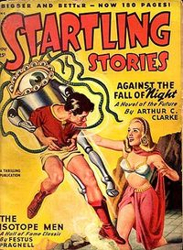
Against the Fall of Night in Startling Stories.

Non-fiction
- Interplanetary Flight; an introduction to astronautics. London: Temple Press, 1950
- The Exploration of Space. New York: Harper, 1951
- The Coast of Coral. New York: Harper, 1957 — Volume 1 of the Blue planet trilogy
- The Reefs of Taprobane; Underwater Adventures around Ceylon. New York: Harper, 1957 — Volume 2 of the Blue planet trilogy
- The Making of a Moon: the Story of the Earth Satellite Program. New York: Harper, 1957
- Boy beneath the sea, Photos by Mike Wilson. Text by Arthur C. Clarke. New York: Harper, 1958
- The Challenge of the Space Ship: Previews of Tomorrow’s World. New York: Harper, 1959
- The Challenge of the Sea. New York: Holt, Rinehart and Winston, 1960
- Profiles of the Future; an Inquiry into the Limits of the Possible. New York: Harper & Row, 1962
- The Treasure of the Great Reef. New York: Harper & Row, 1964 — Volume 3 of the Blue planet trilogy
- Voices from the Sky: Previews of the Coming Space Age. New York: Harper & Row, 1965
- The Promise of Space. New York: Harper, 1968
- Into Space: a Young Person’s Guide to Space, by Arthur C. Clarke and Robert Silverberg. New York: Harper & Row, 1971
- Report on Planet Three and Other Speculations. New York: Harper & Row, 1972
- The Lost Worlds of 2001. London: Sidgwick and Jackson, 1972
- Voice Across the Sea. HarperCollins, 1975
- The View from Serendip. Random House, 1977
- The Odyssey File. Email correspondence with Peter Hyams. London: Panther Books, 1984
- 1984, Spring: a Choice of Futures. New York: BallantIne Books, 1984
- Ascent to Orbit, a Scientific Autobiography: The Technical Writings of Arthur C. Clarke. New York: John Wiley & Sons, 1984
- Astounding Days: A Science Fictional Autobiography. London: Gollancz, 1989
- How the World Was One: Beyond the Global Village. New York : Bantam Books, 1992 — A history and survey of the communications revolution
- By Space Possessed. London: Gollancz, 1993
- The Snows of Olympus - A Garden on Mars (1994, picture album with comments)
- An Encyclopedia of Claims, Frauds, and Hoaxes of the Occult and Supernatural, 1995, St. Martin's Press ISBN 0-312-15119-5 (Online Version)
- Fractals: The Colors of Infinity (1997, narrator)
- Greetings, Carbon-Based Bipeds! : Collected Works 1934-1988. New York: St. Martin’s Press, 1999
- From Narnia to a Space Odyssey: The War of Letters Between Arthur C. Clarke and C.S. Lewis (2003) with C. S. Lewis
- The Coming of the Space Age; famous accounts of man's probing of the universe, selected and edited by Arthur C. Clarke.

In popular culture
- Clarke had a brief friendship with C.S. Lewis in the mid-1940s in which they would often meet in bars in the Oxford area to discuss science fiction. Clarke, after Lewis's death, voiced great praise for him, saying the Ransom Trilogy was one of the few works of science fiction that could be considered literature.
- Clarke attempted to write a six word story as part of a Wired Magazine article but wrote ten words instead. ("God said, 'Cancel Program GENESIS.' The universe ceased to exist.") He refused to lower the word count.^{[17]}
- At the start of the movie 2010, Dr. Heywood Floyd is engaged in a conversation in front of the White House. Clarke is the man feeding the pigeons to the left of the shot. Later on in the movie, in the hospital scene where Mrs. Bowman dies, the cover of Time shows a photograph of Clarke as the American president, and one of Kubrick as the Russian Premier.
- He survived the tsunami caused by the 2004 Indian Ocean earthquake, which did however claim his diving school at Hikkaduwa(^{[18][19]}), which has since been rebuilt.
- He is a Distinguished Supporter of the British Humanist Association

Quotes
- Clarke's three laws:
- "When a distinguished but elderly scientist states that something is possible, he is almost certainly right. When he states that something is impossible, he is very probably wrong."
- "The only way of discovering the limits of the possible is to venture a little way past them into the impossible."
- "Any sufficiently advanced technology is indistinguishable from magic."
- "The truth, as always, will be far stranger."
- "Sometimes I think we're alone in the universe, and sometimes I think we're not. In either case the idea is quite staggering."
- "How inappropriate to call this planet Earth, when clearly it is Ocean."
- Of UFOs: "They tell us absolutely nothing about intelligence elsewhere in the universe, but they do prove how rare it is on Earth."
- "Somewhere in me is a curiosity sensor. I want to know what's over the next hill. You know, people can live longer without food than without information. Without information, you'd go crazy"

See also
- Clarke's three laws
- science fiction: authors – novels – short stories – television shows
- Space Odyssey
- Religious ideas in science fiction

Cited references
- ^ Peacetime Uses for V2 (JPG). Wireless World (February 1945). Retrieved on 2007-02-08.
- ^ EXTRA-TERRESTRIAL RELAYS Can Rocket Stations Give World-wide Radio Coverage?. Wireless World (October 1945). Retrieved on 2007-02-08.
- ^ McAleer, Neil. "Arthur C. Clarke: The Authorized Biography", Contemporary Books, Chicago, 1992. ISBN 0-8092-3720-2
- ^ Happy Birthday Sir Arthur C. Clarke!. Sunday Observer (20051211). Retrieved on 2007-02-08.
- ^ Personal e-mail from Sir Arthur Clarke to Jerry Stone, Director of the Sir Arthur Clarke Awards, 1 November 2006
- ^ Chart of the Future. Retrieved on 2007-02-08.
- ^ Video greeting to NASA JPL by Arthur C. Clarke. Retrieved 24 September 2007
- ^ Clarke Denies Pedophile Allegations. Science Fiction News of the Week (19980206). Retrieved on 2007-02-08.
- ^ Arthur C. Clarke. Retrieved on 2007-02-08.
- ^ Arthur C. Clarke. NNDB. Retrieved on 2007-02-08.
- ^ Arthur C. Clarke Quotes. Retrieved on 2007-02-08.
- ^ Bell Labs: Where "HAL" First Spoke (Bell Labs Speech Synthesis website). Retrieved on 2007-02-08.
- ^ ª ^{b} Box Office Mojo. Retrieved on 2007-02-08.
- ^ Movies. Go.com. Retrieved on 2007-02-08.
- ^ Amazon.com. Retrieved on 2007-02-08.
- ^ Kelso, Dr. T. S. (1998-05-01). Basics of the Geostationary Orbit. Satellite Times. Retrieved on 2007-02-08.
- ^ http://wired.com/wired/archive/14.11/sixwords.html
- ^ http://sify.com/news/fullstory.php?id=13638567
- ^ http://thestar.com.my/news/story.asp?file=/2004/12/30/latest/20462ArthurC&sec=latest

External links
A Recent Interview with Sir Arthur C. Clarke
- ArthurCClarke.net : fan community & discussion site
- Sir Arthur C. Clarke links & image archive
- Clarke's 1945 Communication Satellite Idea
- The Arthur C. Clarke Foundation
- Sir Arthur Clarke Awards 2005
- Arthur C. Clarke at the Internet Speculative Fiction Database
- Arthur C. Clarke at the Internet Movie Database
- Arthur Clarke Fansite His novel & short story reviews. And reading guides by story quality, theme, or technology idea.
- Arthur C. Clarke's online fiction at Free Speculative Fiction Online

Persondata
NAME | Clarke, Arthur Charles
ALTERNATIVE NAMES | Clarke, Arthur C.
SHORT DESCRIPTION | British and Sri Lankan Author and Inventor
DATE OF BIRTH | December 16, 1917 (age 89)
PLACE OF BIRTH | Minehead, Somerset, England, United Kingdom
DATE OF DEATH
PLACE OF DEATH
Retrieved from "http://en.wikipedia.org/wiki/Arthur_C._Clarke"
Categories: All articles with unsourced statements | Articles with unsourced statements since February 2007 | Articles with trivia sections from July 2007 | Arthur C. Clarke | English science fiction writers | Worldcon Guests of Honor | Science Fiction Hall of Fame | Hugo Award winning authors | Nebula Award winning authors | SETI | SFWA Grand Masters | Space exploration | English inventors | English agnostics | English humanists | English essayists | British military personnel of World War II | British sceptics | Royal Air Force officers | Sri Lankan writers | Alumni of King's College London | People from Minehead | Commanders of the Order of the British Empire | Knights Bachelor | 1917 births | Living people
==================================================================================================================================

