Khalil Gibran 1883–1931
http://en.wikipedia.org/wiki/Khalil_Gibran
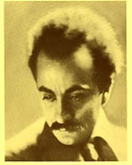
Khalil Gibran (born Gibran Khalil Gibran, Arabic: جبران خليل جبران, Syriac: ܓ̰ܒܪܢ ܚܠܝܠ ܓ̰ܒܪܢ) (January 6, 1883 – April 10, 1931) was an artist, poet and writer. He was born in Lebanon and spent much of his productive life in the United States.

Contents

- 1 Youth in Lebanon
- 2 Youth in America
- 3 Art and poetry
- 4 Death and legacy
- 5 Selected works
- 6 Trivia
- 7 References
- 8 External links

Youth in Lebanon
According to his relative of the same name, the Gibran family's origins are obscure. Though his mother was the "offspring of a priestly, and important family", the Gibran clan was "small and undistinguished." He was born in the Maronite town of Bsharri in northern Lebanon, and grew up in the region of Bsharri.
As a result of his family's poverty, Gibran did not receive any formal schooling during his youth in Lebanon. However, priests visited him regularly and taught him about the Bible, as well as the Syriac and Arabic languages. During these early days, Gibran began developing ideas that would later form some of his major works. In particular, he conceived of The Prophet at this time.
After Gibran's father went to prison for fraud and tax evasion, Ottoman authorities confiscated his family's property. Authorities released Gibran's father in 1894, but the family had by then lost their home. Gibran's mother, Kamilah, decided to follow Gibran's uncle and emigrate to the United States. Gibran's father chose to remain in Lebanon. Gibran's mother, along with Khalil, his younger sisters Mariana and Sultana, and his half-brother Peter (a.k.a. Butros) left for New York on June 25, 1895.

[] Youth in America
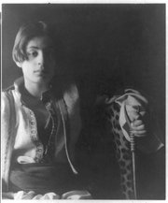
Khalil Gibran, Photograph by Fred Holland Day, c. 1898

At the time the second largest Lebanese-American community was in Boston's South End, so the Gibrans decided to settle there. His mother began working as a peddler to bring in money for the family, and Gibran started school on September 30, 1895. Since he had had no formal schooling in Lebanon, school officials placed him in a special class for immigrants to learn English. Gibran's English teacher suggested that he Anglicise the spelling of his name in order to make it more acceptable to American society. Kahlil Gibran was the result.
In his early teens, the artistry of Gibran's drawings caught the eye of his teachers and he was introduced to the avant-garde Boston artist, photographer, and publisher Fred Holland Day, who encouraged and supported Gibran in his creative endeavors.

[] Art and poetry
A publisher used some of Gibran's drawings for book covers in 1898, and Gibran held his first art exhibition in 1904 in Boston. During this exhibition, Gibran met Mary Elizabeth Haskell, a respected headmistress ten years his senior. The two formed an important friendship that lasted the rest of Gibran's life. Haskell influenced not only Gibran's personal life, but his career as well. In 1908, Gibran went to study art with Auguste Rodin in Paris for two years. He later studied art in Boston.
While most of Gibran's early writing was in Arabic, most of his work published after 1918 was in English. Gibran also took part in the New York Pen League, also known as Al-Mahjar ("immigrant poets"), alongside other important Arab American authors Ameen Rihani ("the father of Arab American literature"), Mikhail Naimy and Elia Abu Madi.
Much of Gibran's writings deal with Christianity, mostly condemning the corrupt practices of the Eastern churches and their clergies during that era. His poetry is notable for its use of formal language, as well as insights on topics of life using spiritual terms.
Gibran's best-known work is The Prophet, a book composed of 26 poetic essays. During the 1960s, The Prophet became especially popular with the American counterculture and New Age movements. The Prophet remains famous to this day, with passages often read at weddings and christenings.
Perhaps his most famous line of poetry in the English speaking world is from 'Sand and Foam' (1926), which reads : 'Half of what I say is meaningless, but I say it so that the other half may reach you'. This was taken by John Lennon and placed, though in a slightly altered form, into the song Julia from The Beatles' 1968 album The Beatles (a.k.a. The White Album).
Juliet Thompson, one of Khalil Gibran's acquaintances, said that Gibran told her that he thought of `Abdu'l-Bahá, the divine leader of the Bahá'í Faith in his lifetime, all the way through writing The Prophet. `Abdu'l-Bahá's personage also influenced Jesus, The Son of Man, another book by Gibran. It is certain that Gibran did two portraits of him during this period.[1]

[] Death and legacy
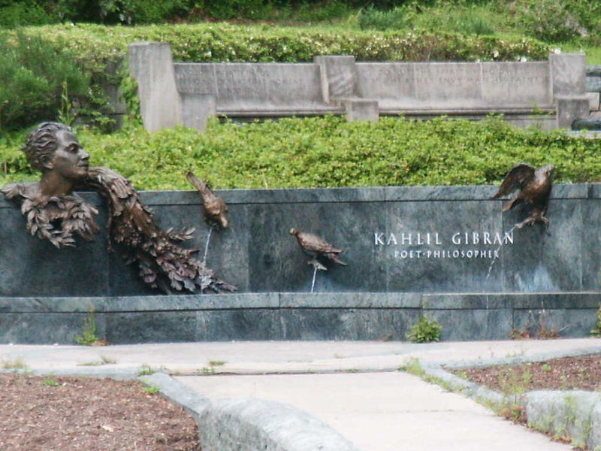
Khalil Gibran memorial in Washington, D.C.

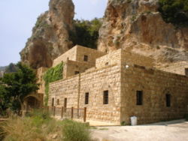
The Gibran Museum and Gibran's final resting place, located in Bsharri, Lebanon

Gibran died in New York City on April 10, 1931: the cause was determined to be cirrhosis of the liver and tuberculosis. Before his death, Gibran expressed the wish that he be buried in Lebanon. This wish was fulfilled in 1932, when Mary Haskell and his sister Mariana purchased the Mar Sarkis Monastery in Lebanon. Gibran remains the most popular Lebanese-American writer ever.

[] Selected works
- Ara'is al-Muruj (Nymphs of the Valley, also translated as Spirit Brides, 1906)
- al-Arwah al-Mutamarrida (Spirits Rebellious, 1908)
- al-Ajniha al-Mutakassira (Broken Wings, 1912)
- Dam'a wa Ibtisama (A Tear and A Smile, 1914)
- The Madman (1918)
- al-Mawakib (The Processions, 1919)
- al-‘Awāsif (The Tempests, 1920)
- The Forerunner (1920)
- al-Bada'i' waal-Tara'if (The New and the Marvellous,1923)
- The Prophet, (1923)
- Sand and Foam (1926)
- The Son of Man (1928)
- The Earth Gods (1929)
- The Wanderer (1932)
- The Garden of The Prophet (1933)

[] Trivia
- Khalil Gibran is referenced briefly in the episode Wingmen of the show The Boondocks. When Huey (the central character) is asked by his grandfather to say something "deep", he recites part of the poem "On Pain" from The Prophet.
- The Prophet is seen in the Johnny Cash biopic Walk The Line when June Carter hands it to J.R to read in the motel.
- In the popular video game Deus Ex, one of the three possible ending quotes is Gibran's quote: "Yesterday we obeyed kings and bent our necks before emperors. But today we kneel only to truth..." The western spelling of his name, Kahlil Gibran, was used to cr him.
- Jackie Mclean's "Kahlil the Prophet" is on Destination...Out! (1963) (Blue Note BLP 4165)

[] References
Gibran, Kahlil. Kahlil Gibran: His Life and Works.

[] External links
- Comprehensive Gibran Site (All his works, photos, artwork, bio, downloads etc)
- Works by Khalil Gibran at Project Gutenberg
- Gibran Archive of Paintings and Books
- A Voice of Consciousness
- Khalil Gibran (1883-1931)
- Online copies of texts by Gibran
- Biography, searchable texts, paintings
- Kahlil Gibran Fan Site
- On Children, a poem by Kahlil Gibran with animation and sound. From Geometry from the Land of the Incas
- The Gibran Archive: Biography, Timeline, Drawings/Paintings and many Full Text books
- Chronological Biography of Gibran
- The Only Gibran Site In China
- Khalil Gibran and the Bahá'í Faith
- The Prophet by Khalil Gibran - pdf eBook with images
- Selection of Excerpts from "The Prophet" by Gibran Khalil Gibran.
- Meeting in another dream - The Prophet reborn as Myriam of Lebanon
- Khalil Gibran at h2g2
- Children of Al-Mahjar: Arab American Literature Spans a Century general history of Arab American literature
===========================================================================================================================
END

