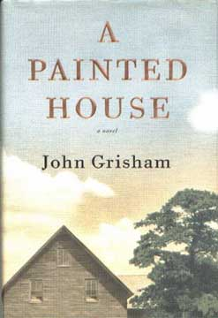 A Painted House
Inspired by Grisham’s own childhood.
The narrator, Luke Chandler, is a farm boy who lives in the cotton fields of Arkansas with his parents and grandparents in a house that’s never been painted.
For six weeks, they pick cotton, battling the heat, the rain, the fatigue and, sometimes, each other. As the weeks pass, Luke sees and hear things no seven-year-old could possibly be prepared for, and finds himself keeping secrets that not only threaten the crop but will change the lives of the Chandlers forever.
(Taken from the cover of A Painted House.)

