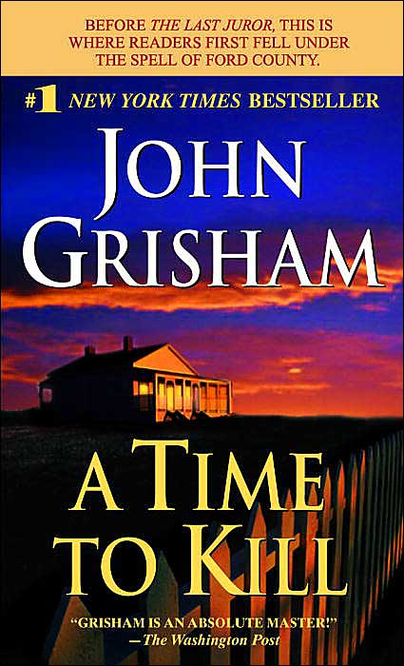 A Time to Kill
In this searing courtroom drama, Grisham probes the savage depths of racial violence as he delivers a compelling tale of uncertain justice in a small southern town, Clanton, Mississippi. The life of a ten-year-old girl is shattered by two drunken and remorseless young men.
The mostly white town reacts with shock and horror at the inhuman crime-- until her black father acquires an assault rifle and takes justice into his own outraged hands. For ten days, as burning crosses and the crack of sniper fire spread through the streets of Clanton, the nation sits spellbound as young defense attorney Jake Brigance struggles to save his client's life--and then his own.
(Taken from the cover of A Time to Kill.)

