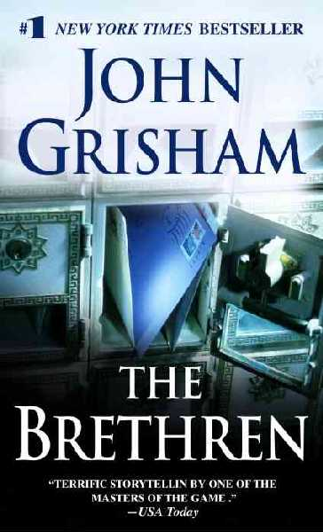 The Brethren
Trumble is a minimum-security federal prison, a “camp” home to the usual assortment of relatively harmless criminals - including three former judges who call themselves the Brethren. They meet each day in the law library, where they write briefs, handle cases for other inmates, practice law without a license, and sometimes dispense jailhouse justice. And they spend time writing letters. They are fine-tuning a mail scam, and it’s starting to really work.
The money is pouring in. Then their little scam goes awry. It ensnares the wrong victim, a powerful man on the outside, a man with dangerous friends, and the Brethren’s days of quietly marking time are over.
(Taken from the cover of The Brethren.)

